Федеральное государственное бюджетное образовательное учреждение

высшего образования

«Саратовский государственный технический университет

имени Гагарина Ю.А.»

Кафедра «Прикладные информационные технологии»

**ОТЧЕТ**

**по лабораторной работе номер 1**

Студента гр. б2-ИФСТ22.

Макаева Владислава Витальевича

Проверил доцент кафедрыПИТ:

Бровко Александр Валерьевич

Саратов 2019

1. **Person**

XML:

<?xml version = "1.0"?>

<PEOPLE>

    <PERSON>

            <PersonId>E01</PersonId>

            <Name>Tony Blair</Name>

            <Address>10 Downing Street, London, UK</Address>

            <Telephone>(061) 98765</Telephone>

            <Fax>(061) 98765</Fax>

            <E-Mail>blair@everywhere.com</E-Mail>

    </PERSON>

    <PERSON>

            <PersonId>E02</PersonId>

            <Name>Bill Clinton</Name>

            <Address>White House, USA</Address>

            <Telephone>(001) 6400 98765</Telephone>

            <Fax>(001) 6400 98765</Fax>

            <E-Mail>bill@everywhere.com</E-Mail>

    </PERSON>

    <PERSON>

            <PersonId>E03</PersonId>

            <Name>Tom Cruise</Name>

            <Address>57 Jumbo Street, New York, USA</Address>

            <Telephone>(001) 4500 67859</Telephone>

            <Fax>(001) 4500 67859</Fax>

            <E-Mail>cruise@everywhere.com</E-Mail>

    </PERSON>

    <PERSON>

            <PersonId>E04</PersonId>

            <Name>Lorena Bobbit</Name>

            <Address>78 Crux Lane, London, UK</Address>

            <Telephone>(061) 54 56789</Telephone>

            <Fax>(061) 54 56789</Fax>

            <E-Mail>lorena@everywhere.com</E-Mail>

    </PERSON>

    <PERSON>

            <PersonId>E05</PersonId>

            <Name>Abraham Lincoln</Name>

            <Address>White House, USA</Address>

            <Telephone>(001) 6400 98765</Telephone>

            <Fax>(001) 6400 98765</Fax>

            <E-Mail>alincoln@everywhere.com</E-Mail>

    </PERSON>

    <PERSON>

            <PersonId>E06</PersonId>

            <Name>Margaret Tatcher</Name>

            <Address>10 Downing Street, London, UK</Address>

            <Telephone>(061) 98765</Telephone>

            <Fax>(061) 98765</Fax>

            <E-Mail>mtatcher@everywhere.com</E-Mail>

    </PERSON>

</PEOPLE>

Скрин:

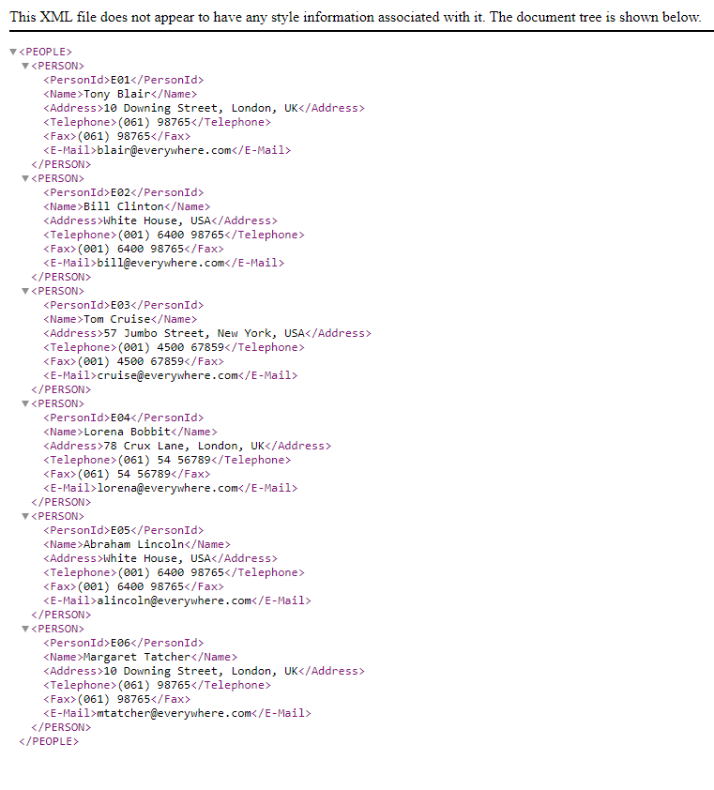

1. **Countries**

<?xml version = "1.0"?>

<COUNTRIES>

    <COUNTRY>

            <CountryName>China</CountryName>

            <Tom>9.8</Tom>

            <Cathy>9.5</Cathy>

            <George>9.4</George>

            <Chang>9.2</Chang>

            <Jimmy>9.0</Jimmy>

            <Sufi>8.5</Sufi>

            <Alex>8.8</Alex>

            <Mack>9.9</Mack>

            <Jason>9.2</Jason>

            <Harry>9.1</Harry>

    </COUNTRY>

    <COUNTRY>

            <CountryName>USA</CountryName>

            <Tom>9.9</Tom>

            <Cathy>9.9</Cathy>

            <George>9.3</George>

            <Chang>8.9</Chang>

            <Jimmy>8.8</Jimmy>

            <Sufi>8.9</Sufi>

            <Alex>8.4</Alex>

            <Mack>9.0</Mack>

            <Jason>9.9</Jason>

            <Harry>9.5</Harry>

    </COUNTRY>

    <COUNTRY>

            <CountryName>Japan</CountryName>

            <Tom>10</Tom>

            <Cathy>9.1</Cathy>

            <George>9.0</George>

            <Chang>9.2</Chang>

            <Jimmy>9.1</Jimmy>

            <Sufi>9.0</Sufi>

            <Alex>9.4</Alex>

            <Mack>9.2</Mack>

            <Jason>8.9</Jason>

            <Harry>8.8</Harry>

    </COUNTRY>

    <COUNTRY>

            <CountryName>France</CountryName>

            <Tom>9.0</Tom>

            <Cathy>8.5</Cathy>

            <George>8.8</George>

            <Chang>9.9</Chang>

            <Jimmy>9.2</Jimmy>

            <Sufi>9.1</Sufi>

            <Alex>9.9</Alex>

            <Mack>9.9</Mack>

            <Jason>9.3</Jason>

            <Harry>8.9</Harry>

    </COUNTRY>

    <COUNTRY>

            <CountryName>Russia</CountryName>

            <Tom>9.8</Tom>

            <Cathy>9.5</Cathy>

            <George>9.4</George>

            <Chang>9.2</Chang>

            <Jimmy>9.1</Jimmy>

            <Sufi>9.0</Sufi>

            <Alex>9.2</Alex>

            <Mack>9.1</Mack>

            <Jason>9.1</Jason>

            <Harry>9.0</Harry>

    </COUNTRY>

    <COUNTRY>

            <CountryName>Italy</CountryName>

            <Tom>9.9</Tom>

            <Cathy>9.9</Cathy>

            <George>9.3</George>

            <Chang>8.9</Chang>

            <Jimmy>8.8</Jimmy>

            <Sufi>9.0</Sufi>

            <Alex>9.4</Alex>

            <Mack>9.2</Mack>

            <Jason>8.9</Jason>

            <Harry>8.8</Harry>

    </COUNTRY>

    <COUNTRY>

            <CountryName>Australia</CountryName>

            <Tom>9.0</Tom>

            <Cathy>8.5</Cathy>

            <George>8.8</George>

            <Chang>9.9</Chang>

            <Jimmy>9.2</Jimmy>

            <Sufi>9.1</Sufi>

            <Alex>9.4</Alex>

            <Mack>9.2</Mack>

            <Jason>9.1</Jason>

            <Harry>9.1</Harry>

    </COUNTRY>

    <COUNTRY>

            <CountryName>Germany</CountryName>

            <Tom>9.8</Tom>

            <Cathy>9.5</Cathy>

            <George>9.4</George>

            <Chang>9.2</Chang>

            <Jimmy>9.1</Jimmy>

            <Sufi>9.5</Sufi>

            <Alex>9.4</Alex>

            <Mack>9.2</Mack>

            <Jason>9.0</Jason>

            <Harry>8.5</Harry>

    </COUNTRY>

    <COUNTRY>

            <CountryName>Taiwan</CountryName>

            <Tom>9.9</Tom>

            <Cathy>9.3</Cathy>

            <George>8.9</George>

            <Chang>8.8</Chang>

            <Jimmy>8.9</Jimmy>

            <Sufi>8.4</Sufi>

            <Alex>9.0</Alex>

            <Mack>9.1</Mack>

            <Jason>9.0</Jason>

            <Harry>9.2</Harry>

    </COUNTRY>

</COUNTRIES>

Скрин:

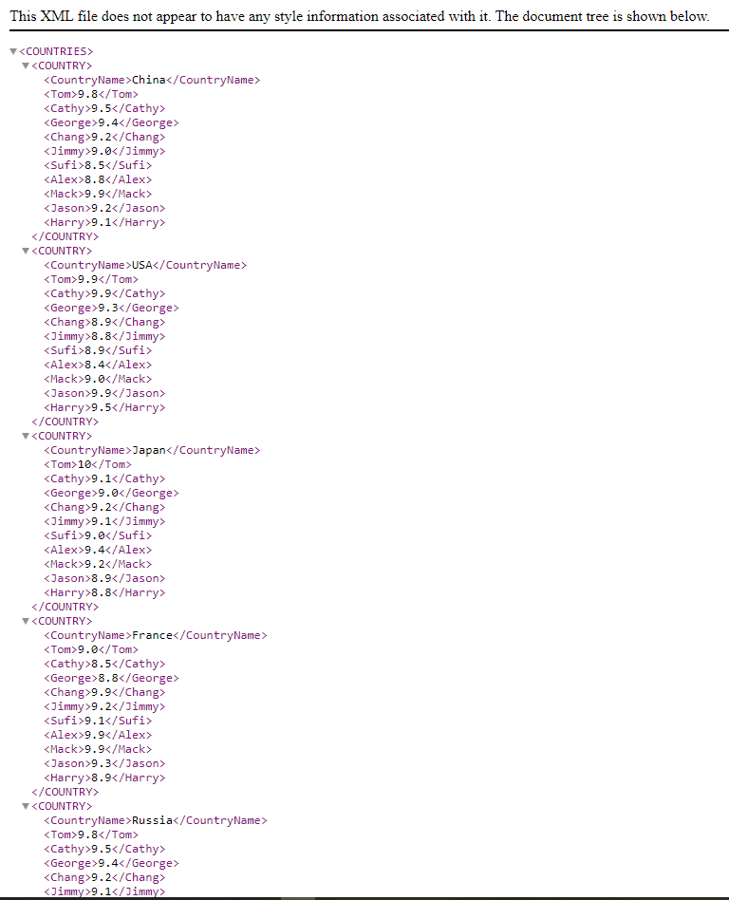

1. **Family**

<?xml version = "1.0"?>

<PEOPLE>

    <PERSON>

        <Nouse_No>1</Nouse_No>

        <Name>Robert</Name>

        <Description>Father</Description>

    </PERSON>

    <PERSON>

        <Nouse_No>1</Nouse_No>

        <Name>Gloria</Name>

        <Description>Mother</Description>

    </PERSON>

    <PERSON>

        <Nouse_No>1</Nouse_No>

        <Name>Susan</Name>

        <Description>Child 1</Description>

    </PERSON>

    <PERSON>

        <Nouse_No>1</Nouse_No>

        <Name>Stephen</Name>

        <Description>Child 2</Description>

    </PERSON>

    <PERSON>

        <Nouse_No>2</Nouse_No>

        <Name>John</Name>

        <Description>Father</Description>

    </PERSON>

    <PERSON>

        <Nouse_No>2</Nouse_No>

        <Name>Mary</Name>

        <Description>Mother</Description>

    </PERSON>

    <PERSON>

        <Nouse_No>2</Nouse_No>

        <Name>Joseph</Name>

        <Description>Child 1</Description>

    </PERSON>

    <PERSON>

        <Nouse_No>3</Nouse_No>

        <Name>Linda</Name>

        <Description>Individual</Description>

    </PERSON>

</PEOPLE>

Скрин:

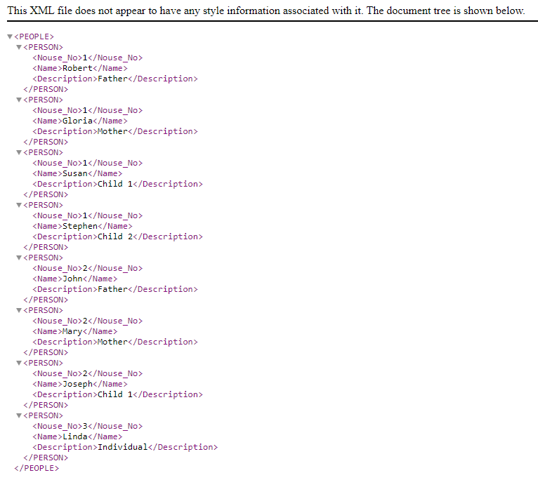

1. **Students**

<?xml version = "1.0"?>

<SCHOOL>

    <CLASS>

        <Num>1</Num>

        <No_of_Students>120</No_of_Students>

        <No_of_Present>117</No_of_Present>

        <No_of_Sections>4</No_of_Sections>

    </CLASS>

    <CLASS>

        <Num>2</Num>

        <No_of_Students>110</No_of_Students>

        <No_of_Present>103</No_of_Present>

        <No_of_Sections>3</No_of_Sections>

    </CLASS>

    <CLASS>

        <Num>3</Num>

        <No_of_Students>90</No_of_Students>

        <No_of_Present>89</No_of_Present>

        <No_of_Sections>2</No_of_Sections>

    </CLASS>

    <CLASS>

        <Num>4</Num>

        <No_of_Students>140</No_of_Students>

        <No_of_Present>100</No_of_Present>

        <No_of_Sections>4</No_of_Sections>

    </CLASS>

    <CLASS>

        <Num>5</Num>

        <No_of_Students>80</No_of_Students>

        <No_of_Present>79</No_of_Present>

        <No_of_Sections>5</No_of_Sections>

    </CLASS>

    <CLASS>

        <Num>6</Num>

        <No_of_Students>85</No_of_Students>

        <No_of_Present>85</No_of_Present>

        <No_of_Sections>4</No_of_Sections>

    </CLASS>

    <CLASS>

        <Num>7</Num>

        <No_of_Students>89</No_of_Students>

        <No_of_Present>89</No_of_Present>

        <No_of_Sections>3</No_of_Sections>

    </CLASS>

    <CLASS>

        <Num>8</Num>

        <No_of_Students>90</No_of_Students>

        <No_of_Present>85</No_of_Present>

        <No_of_Sections>2</No_of_Sections>

    </CLASS>

    <CLASS>

        <Num>9</Num>

        <No_of_Students>85</No_of_Students>

        <No_of_Present>80</No_of_Present>

        <No_of_Sections>3</No_of_Sections>

    </CLASS>

    <CLASS>

        <Num>10</Num>

        <No_of_Students>89</No_of_Students>

        <No_of_Present>79</No_of_Present>

        <No_of_Sections>2</No_of_Sections>

    </CLASS>

    <CLASS>

        <Num>11</Num>

        <No_of_Students>60</No_of_Students>

        <No_of_Present>58</No_of_Present>

        <No_of_Sections>1</No_of_Sections>

    </CLASS>

    <CLASS>

        <Num>12</Num>

        <No_of_Students>65</No_of_Students>

        <No_of_Present>56</No_of_Present>

        <No_of_Sections>1</No_of_Sections>

    </CLASS>

</SCHOOL>

Скрин:

