Федеральное государственное бюджетное образовательное учреждение

высшего образования

«Саратовский государственный технический университет

имени Гагарина Ю.А.»

Кафедра «Прикладные информационные технологии»

**ОТЧЕТ**

**по лабораторной работе номер 3**

Студента гр. б2-ИФСТ22.

Макаева Владислава Витальевича

Проверил доцент кафедрыПИТ:

Бровко Александр Валерьевич

Саратов 2019

XML:

<?xml version="1.0"?>

<?xml-stylesheet type="text/css" href="style.css"?>

<People>

    <Font1>

        style is applied for this line

    </Font1>

    <Font2>

        No style is applied for this line

    </Font2>

</People>

CSS:

Font1 {

    font-size: 45px;

    color: rgb(255, 0, 85);

    display: block;

}

People {

    opacity: .5;

}





XML: <?xml version="1.0"?>

<?xml-stylesheet type="text/css" href="style.css"?>

<!DOCTYPE PEOPLE

[

    <!ELEMENT PEOPLE (PERSON+)>

    <!ELEMENT PERSON (PersonId, Name, Address, Telephone, Fax, E-Mail)>

    <!ELEMENT PersonId (#PCDATA)>

    <!ELEMENT Name (#PCDATA)>

    <!ELEMENT Address (#PCDATA)>

    <!ELEMENT Telephone (#PCDATA)>

    <!ELEMENT Fax (#PCDATA)>

    <!ELEMENT E-Mail (#PCDATA)>

]

>

<PEOPLE>

    <PERSON>

        <PersonId>E01</PersonId>

        <Name>Tony Blair</Name>

        <Address>10 Downing Street, London, UK</Address>

        <Telephone>(061) 98765</Telephone>

        <E-Mail>blair@everywhere.com</E-Mail>

    </PERSON>

    <PERSON>

        <PersonId>E02</PersonId>

        <Name>Bill Clinton</Name>

        <Address>White House, USA</Address>

        <Telephone>(001) 6400 98765</Telephone>

        <E-Mail>bill@everywhere.com</E-Mail>

    </PERSON>

    <PERSON>

        <PersonId>E03</PersonId>

        <Name>Tom Cruise</Name>

        <Address>57 Jumbo Street, New York, USA</Address>

        <Telephone>(001) 4500 67859</Telephone>

        <E-Mail>cruise@everywhere.com</E-Mail>

    </PERSON>

    <PERSON>

        <PersonId>E04</PersonId>

        <Name>Lorena Bobbit</Name>

        <Address>78 Crux Lane, London, UK</Address>

        <Telephone>(061) 54 56789</Telephone>

        <E-Mail>lorena@everywhere.com</E-Mail>

    </PERSON>

    <PERSON>

        <PersonId>E05</PersonId>

        <Name>Abraham Lincoln</Name>

        <Address>White House, USA</Address>

        <Telephone>(001) 6400 98765</Telephone>

        <E-Mail>alincoln@everywhere.com</E-Mail>

    </PERSON>

    <PERSON>

        <PersonId>E06</PersonId>

        <Name>Margaret Tatcher</Name>

        <Address>78 10 Downing Street, London, UK</Address>

        <Telephone>(061) 98765</Telephone>

        <E-Mail>mtatcher@everywhere.com</E-Mail>

    </PERSON>

</PEOPLE>

CSS:

PERSON {

    display: block;

}

PersonId {

    display: block;

}

Name {

    font-size: 30px;

    display: block;

}

Address {

    display: block;

}

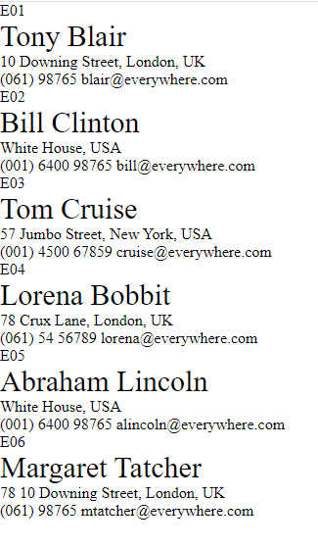



XML: <?xml version="1.0"?>

<?xml-stylesheet type="text/css" href="style.css"?>

<!DOCTYPE PEOPLE

[

    <!ELEMENT PEOPLE (PERSON+)>

    <!ELEMENT PERSON (PersonId, Name, Address, Telephone, Fax, E-Mail)>

    <!ELEMENT PersonId (#PCDATA)>

    <!ELEMENT Name (#PCDATA)>

    <!ELEMENT Address (#PCDATA)>

    <!ELEMENT Telephone (#PCDATA)>

    <!ELEMENT Fax (#PCDATA)>

    <!ELEMENT E-Mail (#PCDATA)>

]

>

<PEOPLE>

    <Main>

    <PERSON>

        <PersonId>E01</PersonId>

        <Name>Tony Blair</Name>

        <Address>10 Downing Street, London, UK</Address>

        <Telephone>(061) 98765</Telephone>

        <E-Mail>blair@everywhere.com</E-Mail>

    </PERSON>

    <PERSON>

        <PersonId>E02</PersonId>

        <Name>Bill Clinton</Name>

        <Address>White House, USA</Address>

        <Telephone>(001) 6400 98765</Telephone>

        <E-Mail>bill@everywhere.com</E-Mail>

    </PERSON>

    <PERSON>

        <PersonId>E03</PersonId>

        <Name>Tom Cruise</Name>

        <Address>57 Jumbo Street, New York, USA</Address>

        <Telephone>(001) 4500 67859</Telephone>

        <E-Mail>cruise@everywhere.com</E-Mail>

    </PERSON>

    <PERSON>

        <PersonId>E04</PersonId>

        <Name>Lorena Bobbit</Name>

        <Address>78 Crux Lane, London, UK</Address>

        <Telephone>(061) 54 56789</Telephone>

        <E-Mail>lorena@everywhere.com</E-Mail>

    </PERSON>

    <PERSON>

        <PersonId>E05</PersonId>

        <Name>Abraham Lincoln</Name>

        <Address>White House, USA</Address>

        <Telephone>(001) 6400 98765</Telephone>

        <E-Mail>alincoln@everywhere.com</E-Mail>

    </PERSON>

    <PERSON>

        <PersonId>E06</PersonId>

        <Name>Margaret Tatcher</Name>

        <Address>78 10 Downing Street, London, UK</Address>

        <Telephone>(061) 98765</Telephone>

        <E-Mail>mtatcher@everywhere.com</E-Mail>

    </PERSON>

    </Main>

</PEOPLE>

CSS:

Main {

    display: block;

    border: 4px black solid;

    padding: 10px;

    height: 400px;

    width: 400px;

    overflow-y : auto;

}

PERSON {

    display: block;

}

PersonId {

    display: block;

}

Name {

    font-size: 30px;

    display: block;

}

Address {

    display: block;

}

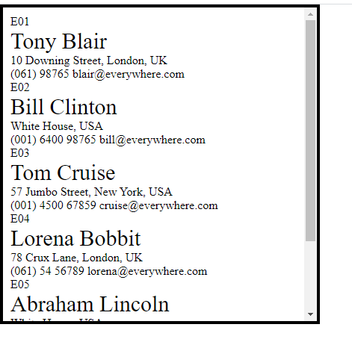



XML: <?xml version="1.0"?>

<?xml-stylesheet type="text/css" href="style.css"?>

<!DOCTYPE PEOPLE

[

    <!ELEMENT PEOPLE (PERSON+)>

    <!ELEMENT PERSON (PersonId, Name, Address, Telephone, Fax, E-Mail)>

    <!ELEMENT PersonId (#PCDATA)>

    <!ELEMENT Name (#PCDATA)>

    <!ELEMENT Address (#PCDATA)>

    <!ELEMENT Telephone (#PCDATA)>

    <!ELEMENT Fax (#PCDATA)>

    <!ELEMENT E-Mail (#PCDATA)>

]

>

<PEOPLE>

    <Main>

    <PERSON>

        <PersonId>E01</PersonId>

        <Name>Tony Blair</Name>

        <Address>10 Downing Street, London, UK</Address>

        <Telephone>(061) 98765</Telephone>

        <E-Mail>blair@everywhere.com</E-Mail>

    </PERSON>

    <PERSON>

        <PersonId>E02</PersonId>

        <Name>Bill Clinton</Name>

        <Address>White House, USA</Address>

        <Telephone>(001) 6400 98765</Telephone>

        <E-Mail>bill@everywhere.com</E-Mail>

    </PERSON>

    <PERSON>

        <PersonId>E03</PersonId>

        <Name>Tom Cruise</Name>

        <Address>57 Jumbo Street, New York, USA</Address>

        <Telephone>(001) 4500 67859</Telephone>

        <E-Mail>cruise@everywhere.com</E-Mail>

    </PERSON>

    <PERSON>

        <PersonId>E04</PersonId>

        <Name>Lorena Bobbit</Name>

        <Address>78 Crux Lane, London, UK</Address>

        <Telephone>(061) 54 56789</Telephone>

        <E-Mail>lorena@everywhere.com</E-Mail>

    </PERSON>

    <PERSON>

        <PersonId>E05</PersonId>

        <Name>Abraham Lincoln</Name>

        <Address>White House, USA</Address>

        <Telephone>(001) 6400 98765</Telephone>

        <E-Mail>alincoln@everywhere.com</E-Mail>

    </PERSON>

    <PERSON>

        <PersonId>E06</PersonId>

        <Name>Margaret Tatcher</Name>

        <Address>78 10 Downing Street, London, UK</Address>

        <Telephone>(061) 98765</Telephone>

        <E-Mail>mtatcher@everywhere.com</E-Mail>

    </PERSON>

    </Main>

</PEOPLE>

XSL:

<?xml version="1.0"?>

<xsl:stylesheet version="1.0" xmlns:xsl="http://www.w3.org/1999/XSL/Transform">

    <xsl:template match="/">

        <h1 STYLE="font-weigth:540">My Favorite People</h1>

        <table style="width:100%; border-spacing: 0px;" >

            <tr>

                <th style="border:1px solid">PersonId</th>

                <th style="border:1px solid">Name</th>

                <th style="border:1px solid">Address</th>

                <th style="border:1px solid">Telephone</th>

                <th style="border:1px solid">Fax</th>

                <th style="border:1px solid">E-Mail</th>

            </tr>

            <xsl:for-each select="PEOPLE/Main/PERSON">

                <tr>

                    <td STYLE="border:1px solid"><xsl:value-of select="PersonId"/></td>

                    <td STYLE="border:1px solid"><xsl:value-of select="Name"/></td>

                    <td STYLE="border:1px solid"><xsl:value-of select="Address"/></td>

                    <td STYLE="border:1px solid"><xsl:value-of select="Telephone"/></td>

                    <td STYLE="border:1px solid"><xsl:value-of select="Fax"/></td>

                    <td STYLE="border:1px solid"><xsl:value-of select="E-Mail"/></td>

                </tr>

            </xsl:for-each>

        </table>

    </xsl:template>

</xsl:stylesheet>

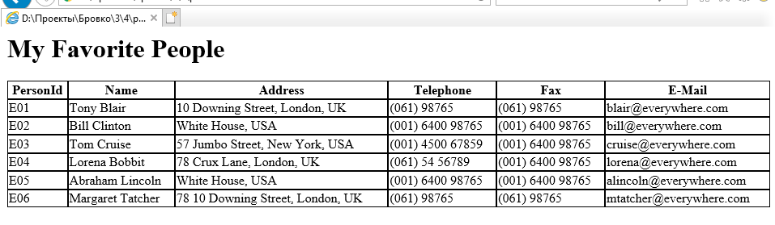



XML: <?xml version="1.0"?>

<?xml-stylesheet type="text/css" href="style.css"?>

<!DOCTYPE PEOPLE

[

    <!ELEMENT PEOPLE (PERSON+)>

    <!ELEMENT PERSON (PersonId, Name, Address, Telephone, Fax, E-Mail)>

    <!ELEMENT PersonId (#PCDATA)>

    <!ELEMENT Name (#PCDATA)>

    <!ELEMENT Address (#PCDATA)>

    <!ELEMENT Telephone (#PCDATA)>

    <!ELEMENT Fax (#PCDATA)>

    <!ELEMENT E-Mail (#PCDATA)>

]

>

<PEOPLE>

    <Main>

    <PERSON>

        <PersonId>E01</PersonId>

        <Name>Tony Blair</Name>

        <Address>10 Downing Street, London, UK</Address>

        <Telephone>(061) 98765</Telephone>

        <E-Mail>blair@everywhere.com</E-Mail>

    </PERSON>

    <PERSON>

        <PersonId>E02</PersonId>

        <Name>Bill Clinton</Name>

        <Address>White House, USA</Address>

        <Telephone>(001) 6400 98765</Telephone>

        <E-Mail>bill@everywhere.com</E-Mail>

    </PERSON>

    <PERSON>

        <PersonId>E03</PersonId>

        <Name>Tom Cruise</Name>

        <Address>57 Jumbo Street, New York, USA</Address>

        <Telephone>(001) 4500 67859</Telephone>

        <E-Mail>cruise@everywhere.com</E-Mail>

    </PERSON>

    <PERSON>

        <PersonId>E04</PersonId>

        <Name>Lorena Bobbit</Name>

        <Address>78 Crux Lane, London, UK</Address>

        <Telephone>(061) 54 56789</Telephone>

        <E-Mail>lorena@everywhere.com</E-Mail>

    </PERSON>

    <PERSON>

        <PersonId>E05</PersonId>

        <Name>Abraham Lincoln</Name>

        <Address>White House, USA</Address>

        <Telephone>(001) 6400 98765</Telephone>

        <E-Mail>alincoln@everywhere.com</E-Mail>

    </PERSON>

    <PERSON>

        <PersonId>E06</PersonId>

        <Name>Margaret Tatcher</Name>

        <Address>78 10 Downing Street, London, UK</Address>

        <Telephone>(061) 98765</Telephone>

        <E-Mail>mtatcher@everywhere.com</E-Mail>

    </PERSON>

    </Main>

</PEOPLE>

XSL:

<?xml version="1.0" encoding="UTF-8"?>

<xsl:stylesheet version="1.0" xmlns:xsl="http://www.w3.org/1999/XSL/Transform">

    <xsl:template match="/">

        <h1 STYLE="font-weigth:540">My Favorite People</h1>

        <table style="width:100%; border-spacing: 0px;" >

            <tr>

                <th style="border:1px solid">PersonId</th>

                <th style="border:1px solid">Name</th>

                <th style="border:1px solid">Address</th>

                <th style="border:1px solid">Telephone</th>

                <th style="border:1px solid">Fax</th>

                <th style="border:1px solid">E-Mail</th>

            </tr>

            <xsl:for-each select="PEOPLE/Main/PERSON[PersonId='E06']">

                <tr>

                    <td STYLE="border:1px solid"><xsl:value-of select="PersonId"/></td>

                    <td STYLE="border:1px solid"><xsl:value-of select="Name"/></td>

                    <td STYLE="border:1px solid"><xsl:value-of select="Address"/></td>

                    <td STYLE="border:1px solid"><xsl:value-of select="Telephone"/></td>

                    <td STYLE="border:1px solid"><xsl:value-of select="Fax"/></td>

                    <td STYLE="border:1px solid"><xsl:value-of select="E-Mail"/></td>

                </tr>

            </xsl:for-each>

        </table>

    </xsl:template>

</xsl:stylesheet>

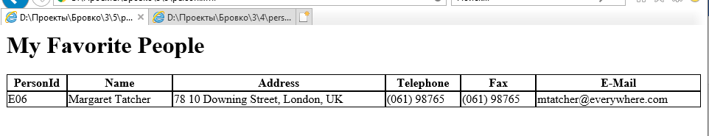



XML: <?xml version="1.0"?>

<?xml-stylesheet type="text/css" href="style.css"?>

<!DOCTYPE PEOPLE

[

    <!ELEMENT PEOPLE (PERSON+)>

    <!ELEMENT PERSON (PersonId, Name, Address, Telephone, Fax, E-Mail)>

    <!ELEMENT PersonId (#PCDATA)>

    <!ELEMENT Name (#PCDATA)>

    <!ELEMENT Address (#PCDATA)>

    <!ELEMENT Telephone (#PCDATA)>

    <!ELEMENT Fax (#PCDATA)>

    <!ELEMENT E-Mail (#PCDATA)>

]

>

<PEOPLE>

    <Main>

    <PERSON>

        <PersonId>E01</PersonId>

        <Name>Tony Blair</Name>

        <Address>10 Downing Street, London, UK</Address>

        <Telephone>(061) 98765</Telephone>

        <E-Mail>blair@everywhere.com</E-Mail>

    </PERSON>

    <PERSON>

        <PersonId>E02</PersonId>

        <Name>Bill Clinton</Name>

        <Address>White House, USA</Address>

        <Telephone>(001) 6400 98765</Telephone>

        <E-Mail>bill@everywhere.com</E-Mail>

    </PERSON>

    <PERSON>

        <PersonId>E03</PersonId>

        <Name>Tom Cruise</Name>

        <Address>57 Jumbo Street, New York, USA</Address>

        <Telephone>(001) 4500 67859</Telephone>

        <E-Mail>cruise@everywhere.com</E-Mail>

    </PERSON>

    <PERSON>

        <PersonId>E04</PersonId>

        <Name>Lorena Bobbit</Name>

        <Address>78 Crux Lane, London, UK</Address>

        <Telephone>(061) 54 56789</Telephone>

        <E-Mail>lorena@everywhere.com</E-Mail>

    </PERSON>

    <PERSON>

        <PersonId>E05</PersonId>

        <Name>Abraham Lincoln</Name>

        <Address>White House, USA</Address>

        <Telephone>(001) 6400 98765</Telephone>

        <E-Mail>alincoln@everywhere.com</E-Mail>

    </PERSON>

    <PERSON>

        <PersonId>E06</PersonId>

        <Name>Margaret Tatcher</Name>

        <Address>78 10 Downing Street, London, UK</Address>

        <Telephone>(061) 98765</Telephone>

        <E-Mail>mtatcher@everywhere.com</E-Mail>

    </PERSON>

    </Main>

</PEOPLE>

XSL:

<?xml version="1.0" encoding="UTF-8"?>

<xsl:stylesheet xmlns:xsl="http://www.w3.org/1999/XSL/Transform" version='1.0'>

    <xsl:template match="/">

        <html>

            <body>

                <h1 style="font-weigth:540">My Favorite People</h1>

                <table style="width:100wh; border-spacing: 0px;" >

                    <tr>

                        <td style="border:1px solid">PersonId</td>

                        <td style="border:1px solid">Name</td>

                        <td style="border:1px solid">Address</td>

                        <td style="border:1px solid">Telephone</td>

                        <td style="border:1px solid">Fax</td>

                        <td style="border:1px solid">E-Mail</td>

                    </tr>

                    <xsl:for-each select="PEOPLE/Main/PERSON">

                        <xsl:sort select="Name" order="ascending"/>

                        <tr>

                            <td style="border:1px solid"><xsl:value-of select="PersonId"/></td>

                            <td style="border:1px solid"><xsl:value-of select="Name"/></td>

                            <td style="border:1px solid"><xsl:value-of select="Address"/></td>

                            <td style="border:1px solid"><xsl:value-of select="Telephone"/></td>

                            <td style="border:1px solid"><xsl:value-of select="Fax"/></td>

                            <td style="border:1px solid"><xsl:value-of select="E-Mail"/></td>

                        </tr>

                    </xsl:for-each>

                </table>

            </body>

        </html>

    </xsl:template>

</xsl:stylesheet>

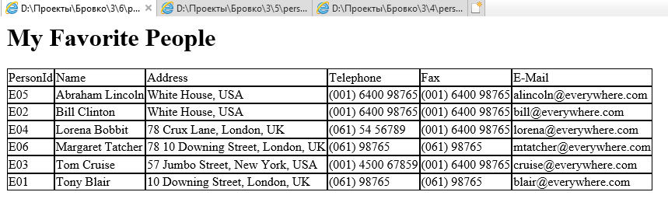



XML: <?xml version="1.0"?>

<?xml-stylesheet type="text/css" href="style.css"?>

<!DOCTYPE PEOPLE

[

    <!ELEMENT PEOPLE (PERSON+)>

    <!ELEMENT PERSON (PersonId, Name, Address, Telephone, Fax, E-Mail)>

    <!ELEMENT PersonId (#PCDATA)>

    <!ELEMENT Name (#PCDATA)>

    <!ELEMENT Address (#PCDATA)>

    <!ELEMENT Telephone (#PCDATA)>

    <!ELEMENT Fax (#PCDATA)>

    <!ELEMENT E-Mail (#PCDATA)>

]

>

<PEOPLE>

    <Main>

    <PERSON>

        <PersonId>E01</PersonId>

        <Name>Tony Blair</Name>

        <Address>10 Downing Street, London, UK</Address>

        <Telephone>(061) 98765</Telephone>

        <E-Mail>blair@everywhere.com</E-Mail>

    </PERSON>

    <PERSON>

        <PersonId>E02</PersonId>

        <Name>Bill Clinton</Name>

        <Address>White House, USA</Address>

        <Telephone>(001) 6400 98765</Telephone>

        <E-Mail>bill@everywhere.com</E-Mail>

    </PERSON>

    <PERSON>

        <PersonId>E03</PersonId>

        <Name>Tom Cruise</Name>

        <Address>57 Jumbo Street, New York, USA</Address>

        <Telephone>(001) 4500 67859</Telephone>

        <E-Mail>cruise@everywhere.com</E-Mail>

    </PERSON>

    <PERSON>

        <PersonId>E04</PersonId>

        <Name>Lorena Bobbit</Name>

        <Address>78 Crux Lane, London, UK</Address>

        <Telephone>(061) 54 56789</Telephone>

        <E-Mail>lorena@everywhere.com</E-Mail>

    </PERSON>

    <PERSON>

        <PersonId>E05</PersonId>

        <Name>Abraham Lincoln</Name>

        <Address>White House, USA</Address>

        <Telephone>(001) 6400 98765</Telephone>

        <E-Mail>alincoln@everywhere.com</E-Mail>

    </PERSON>

    <PERSON>

        <PersonId>E06</PersonId>

        <Name>Margaret Tatcher</Name>

        <Address>78 10 Downing Street, London, UK</Address>

        <Telephone>(061) 98765</Telephone>

        <E-Mail>mtatcher@everywhere.com</E-Mail>

    </PERSON>

    </Main>

</PEOPLE>

XSL:

<?xml version="1.0" encoding="UTF-8"?>

<xsl:stylesheet xmlns:xsl="http://www.w3.org/1999/XSL/Transform" version='1.0'>

    <xsl:template match="/">

        <html>

            <body>

                <h1 STYLE="font-weigth:540">My Favorite People</h1>

                <xsl:apply-templates select="PEOPLE/Main/PERSON"/>

            </body>

        </html>

    </xsl:template>

    <xsl:template match="PEOPLE/Main/PERSON">

        <html>

            <body>

                <span>Title:</span>

                <xsl:value-of select="PersonId"/>

                <br/>

                <span>Name:</span>

                <xsl:value-of select="Name"/>

                <br/>

                <br/>

            </body>

        </html>

    </xsl:template>

</xsl:stylesheet>

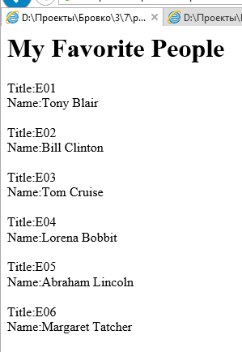



XML:

<?xml version="1.0"?>

<?xml-stylesheet type='text/xsl' href='sheets.xsl'?>

<Classes>

    <Class value="1">

        <No_of_Students>120</No_of_Students>

        <No_of_Present>117</No_of_Present>

        <No_of_Section>4</No_of_Section>

    </Class>

    <Class value="2">

        <No_of_Students>110</No_of_Students>

        <No_of_Present>103</No_of_Present>

        <No_of_Section>3</No_of_Section>

    </Class>

    <Class value="3">

        <No_of_Students>90</No_of_Students>

        <No_of_Present>89</No_of_Present>

        <No_of_Section>2</No_of_Section>

    </Class>

    <Class value="4">

        <No_of_Students>120</No_of_Students>

        <No_of_Present>117</No_of_Present>

        <No_of_Section>4</No_of_Section>

    </Class>

    <Class value="5">

        <No_of_Students>120</No_of_Students>

        <No_of_Present>117</No_of_Present>

        <No_of_Section>4</No_of_Section>

    </Class>

    <Class value="6">

        <No_of_Students>120</No_of_Students>

        <No_of_Present>117</No_of_Present>

        <No_of_Section>4</No_of_Section>

    </Class>

    <Class value="7">

        <No_of_Students>120</No_of_Students>

        <No_of_Present>117</No_of_Present>

        <No_of_Section>4</No_of_Section>

    </Class>

    <Class value="8">

        <No_of_Students>120</No_of_Students>

        <No_of_Present>117</No_of_Present>

        <No_of_Section>4</No_of_Section>

    </Class>

    <Class value="9">

        <No_of_Students>120</No_of_Students>

        <No_of_Present>117</No_of_Present>

        <No_of_Section>4</No_of_Section>

    </Class>

    <Class value="10">

        <No_of_Students>120</No_of_Students>

        <No_of_Present>117</No_of_Present>

        <No_of_Section>4</No_of_Section>

    </Class>

    <Class value="11">

        <No_of_Students>120</No_of_Students>

        <No_of_Present>117</No_of_Present>

        <No_of_Section>4</No_of_Section>

    </Class>

    <Class value="12">

        <No_of_Students>120</No_of_Students>

        <No_of_Present>117</No_of_Present>

        <No_of_Section>4</No_of_Section>

    </Class>

</Classes>

XSL:

<?xml version="1.0"?>

<xsl:stylesheet xmlns:xsl="http://www.w3.org/1999/XSL/Transform" version='1.0'>

    <xsl:template match="/">

        <html>

            <body>

                <h1 style="font-weight:540">My University</h1>

                <table>

                    <tr>

                        <td style="border:1px solid grey">Class(Аудитория)</td>

                        <td style="border:1px solid grey">Noofstudents(Кол-во студентов)</td>

                        <td style="border:1px solid grey">Noofpresent(Кол-во присутствующих)</td>

                        <td style="border:1px solid grey">Noofsections(Кол-во групп)</td>

                    </tr>

                    <xsl:apply-templates select="Classes/Class"/>

                </table>

            </body>

        </html>

    </xsl:template>

    <xsl:template match='Classes/Class'>

        <tr>

            <xsl:if test="@value = 1">

                <td style="border:1px solid grey"><xsl:value-of select="@value"/><span>st</span></td>

            </xsl:if>

            <xsl:if test="@value = 2">

                <td style ="border:1px solid grey"><xsl:value-of select="@value"/><span>nd</span></td>

            </xsl:if>

            <xsl:if test="@value = 3">

                <td style ="border:1px solid grey"><xsl:value-of select="@value"/><span>rd</span></td>

            </xsl:if>

            <xsl:if test="@value != 3">

                <td style ="border:1px solid grey"><xsl:value-of select="@value"/><span>th</span></td>

            </xsl:if>

            <td style ="border:1px solid grey"><xsl:value-of select="No_of_Students"/></td>

            <td style ="border:1px solid grey"><xsl:value-of select="No_of_Present"/></td>

            <td style ="border:1px solid grey"><xsl:value-of select="No_of_Section"/></td>

        </tr>

    </xsl:template>

</xsl:stylesheet>

