Федеральное государственное бюджетное образовательное учреждение

высшего образования

«Саратовский государственный технический университет

имени Гагарина Ю.А.»

Кафедра «Прикладные информационные технологии»

**ОТЧЕТ**

**по лабораторной работе номер 4**

Студента гр. б2-ПИНФ21.

Макаева Владислава Витальевича

Проверил доцент кафедрыПИТ:

Бровко Александр Валерьевич

Саратов 2019

XML:

<?xml version="1.0" encoding="unicode"?>

<BOOK>

<TITLE>The Adventures of Huckleberry Finn</TITLE>

<AUTHOR>Mark Twain</AUTHOR>

<BINDING>mass market paperback</BINDING>

<PAGES>298</PAGES>

<PRICE>$5.49</PRICE>

</BOOK>

HTM:

<!-- Имя файла: DomDemo Fixed.htm -->

<HTML>

<HEAD>

<TITLE>Book Description</TITLE>

<SCRIPT LANGUAGE="JavaScript" FOR="window" EVENT="ONLOAD">

var xhttp = new XMLHttpRequest();

xhttp.onreadystatechange = function() {

if (this.readyState == 4 && this.status == 200) {

myFunction(this);

}

};

xhttp.open("GET", "Book.xml", true);

xhttp.send();

function myFunction(xml) {

var xmlDoc = xml.responseXML;

document.getElementById("title").innerHTML =

xmlDoc.getElementsByTagName("TITLE")[0].childNodes[0].nodeValue;

document.getElementById("author").innerHTML =

xmlDoc.getElementsByTagName("AUTHOR")[0].childNodes[0].nodeValue;

document.getElementById("binding").innerHTML =

xmlDoc.getElementsByTagName("BINDING")[0].childNodes[0].nodeValue;

document.getElementById("pages").innerHTML =

xmlDoc.getElementsByTagName("PAGES")[0].childNodes[0].nodeValue;

document.getElementById("price").innerHTML =

xmlDoc.getElementsByTagName("PRICE")[0].childNodes[0].nodeValue;

}

</SCRIPT>

</HEAD>

<BODY>

<H2>Book Description</H2>

<SPAN STYLE="font-style:italic">Title: </SPAN>

<SPAN ID="title" STYLE="font-weight:bold; color: red"></SPAN>

<BR>

<SPAN STYLE="font-style:italic">Author: </SPAN>

<SPAN ID="author"></SPAN>

<BR>

<SPAN STYLE="font-style:italic">Binding: </SPAN>

<SPAN ID="binding"></SPAN>

<BR>

<SPAN STYLE="font-style:italic">Number of pages: </SPAN>

<SPAN ID="pages"></SPAN>

<BR>

<SPAN STYLE="font-style:italic">Price: </SPAN>

<SPAN ID="price" STYLE="color: green"></SPAN>

</BODY>

</HTML>

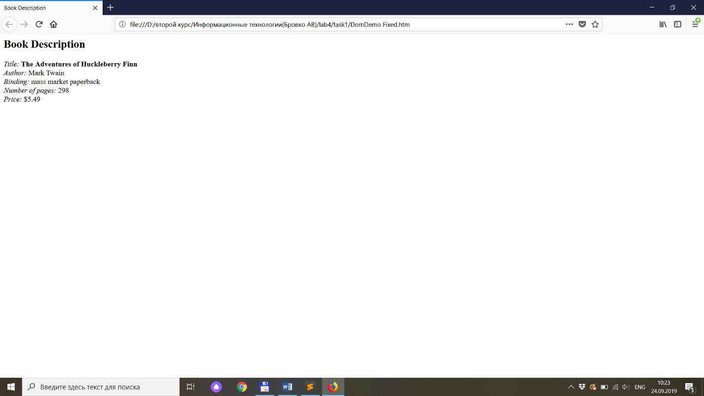

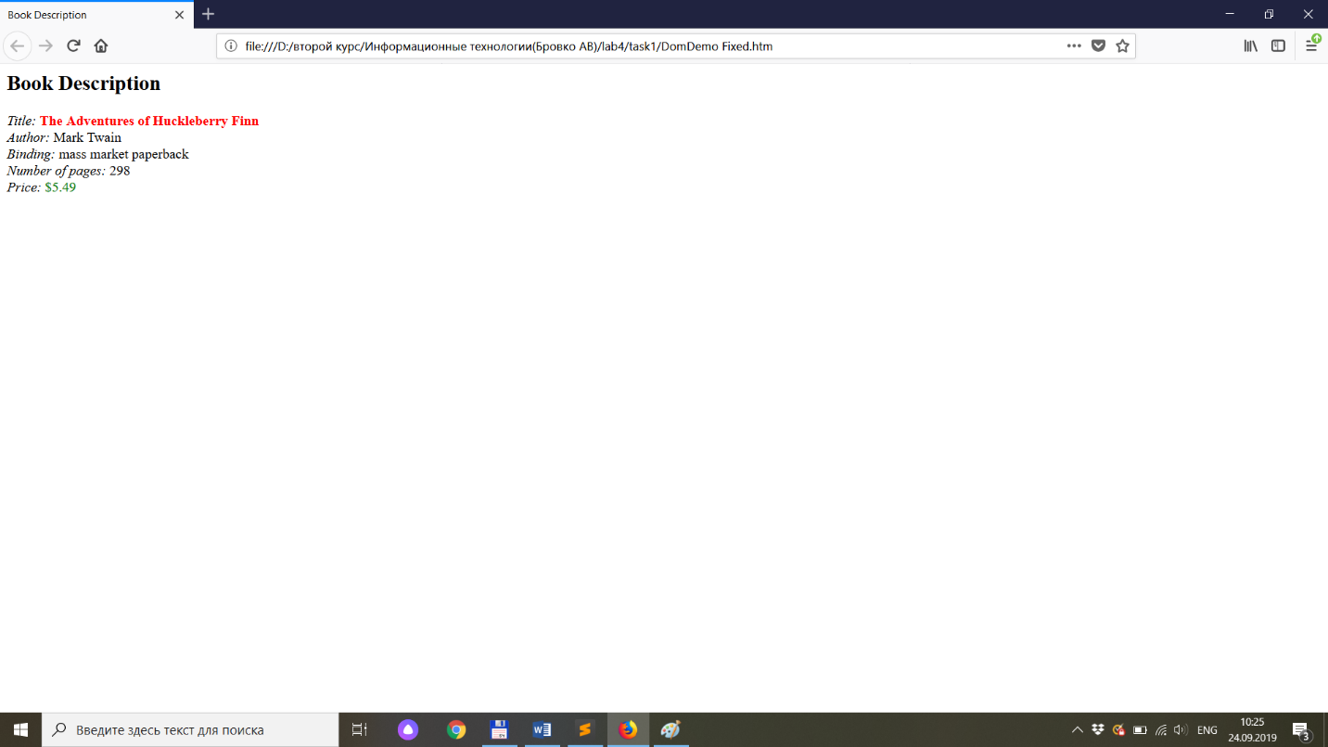

2.

XML:

<?xml version="1.0" encoding="unicode"?>

<INVENTORY>

<BOOK>

<TITLE>The Adventures of Huckleberry Finn</TITLE>

<AUTHOR>Mark Twain</AUTHOR>

<BINDING>mass market paperback</BINDING>

<PAGES>298</PAGES>

<PRICE>$5.49</PRICE>

</BOOK>

<BOOK>

<TITLE>Leaves of Grass</TITLE>

<AUTHOR>Walt Whitman</AUTHOR>

<BINDING>hardcover</BINDING>

<PAGES>462</PAGES>

<PRICE>$7.75</PRICE>

</BOOK>

<BOOK>

<TITLE>The Legend of Sleepy Hollow</TITLE>

<AUTHOR>Washington Irving</AUTHOR>

<BINDING>mass market paperback</BINDING>

<PAGES>98</PAGES>

<PRICE>$2.95</PRICE>

</BOOK>

<BOOK>

<TITLE>The Marble Faun</TITLE>

<AUTHOR>Nathaniel Hawthorne</AUTHOR>

<BINDING>trade paperback</BINDING>

<PAGES>473</PAGES>

<PRICE>$10.95</PRICE>

</BOOK>

<BOOK>

<TITLE>Moby-Dick</TITLE>

<AUTHOR>Herman Melville</AUTHOR>

<BINDING>hardcover</BINDING>

<PAGES>724</PAGES>

<PRICE>$9.95</PRICE>

</BOOK>

<BOOK>

<TITLE>The Portrait of a Lady</TITLE>

<AUTHOR>Henry James</AUTHOR>

<BINDING>mass market paperback</BINDING>

<PAGES>256</PAGES>

<PRICE>$4.95</PRICE>

</BOOK>

<BOOK>

<TITLE>The Scarlet Letter</TITLE>

<AUTHOR>Nathaniel Hawthorne</AUTHOR>

<BINDING>trade paperback</BINDING>

<PAGES>253</PAGES>

<PRICE>$4.25</PRICE>

</BOOK>

<BOOK>

<TITLE>The Turn of the Screw</TITLE>

<AUTHOR>Henry James</AUTHOR>

<BINDING>trade paperback</BINDING>

<PAGES>384</PAGES>

<PRICE>$3.35</PRICE>

</BOOK>

</INVENTORY>

HTM:

<HTML>

<HEAD>

<TITLE>Book Inventory</TITLE>

<SCRIPT LANGUAGE="JavaScript" FOR="window" EVENT="ONLOAD">

var xhttp = new XMLHttpRequest();

xhttp.onreadystatechange = function() {

if (this.readyState == 4 && this.status == 200) {

myFunction(this);

}

};

xhttp.open("GET", "Inventory.xml", true);

xhttp.send();

var k = 1;

function myFunction(xml) {

var xmlDoc = xml.responseXML;

HTMLCode = "";

var bookList = xmlDoc.getElementsByTagName("BOOK");

for (i=0; i < bookList.length; i++)

{

HTMLCode += k++ + ")" +

"<SPAN STYLE='font-style:italic'>Title: </SPAN>"

+ bookList[i].getElementsByTagName("TITLE")[0].childNodes[0].nodeValue

+ "<BR>"

+ "<SPAN STYLE='font-style:italic'>Author: </SPAN>"

+ bookList[i].getElementsByTagName("AUTHOR")[0].childNodes[0].nodeValue

+ "<BR>"

+ "<SPAN STYLE='font-style:italic'>Binding: </SPAN>"

+ bookList[i].getElementsByTagName("BINDING")[0].childNodes[0].nodeValue

+ "<BR>"

+ "<SPAN STYLE='font-style:italic'>Number of pages: "

+ "</SPAN>"

+ bookList[i].getElementsByTagName("PAGES")[0].childNodes[0].nodeValue

+ "<BR>"

+ "<SPAN STYLE='font-style:italic'>Price: </SPAN>"

+ bookList[i].getElementsByTagName("PRICE")[0].childNodes[0].nodeValue

+ "<P>";

}

DisplayDIV.innerHTML = HTMLCode;

}

</SCRIPT>

</HEAD>

<BODY>

<H2>Book Inventory</H2>

<DIV ID="DisplayDIV"></DIV>

</BODY>

</HTML>

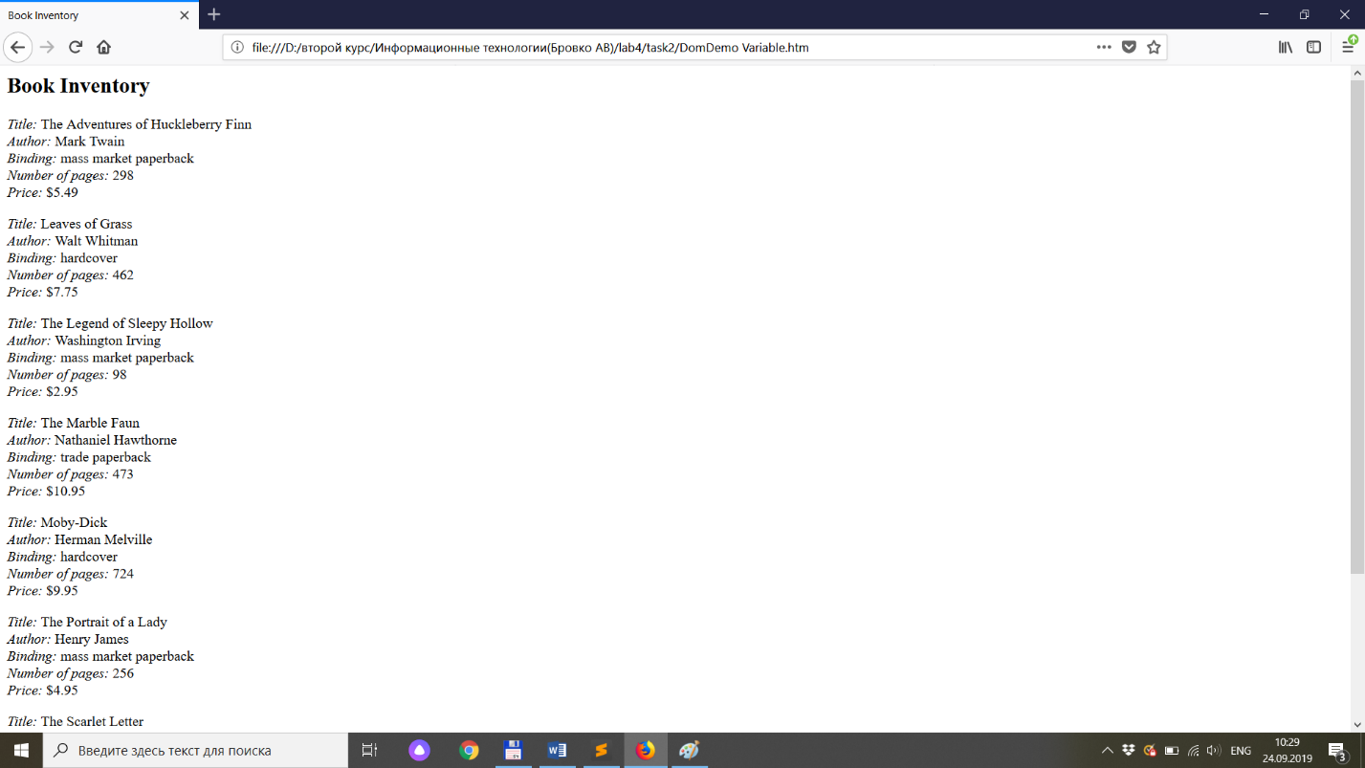

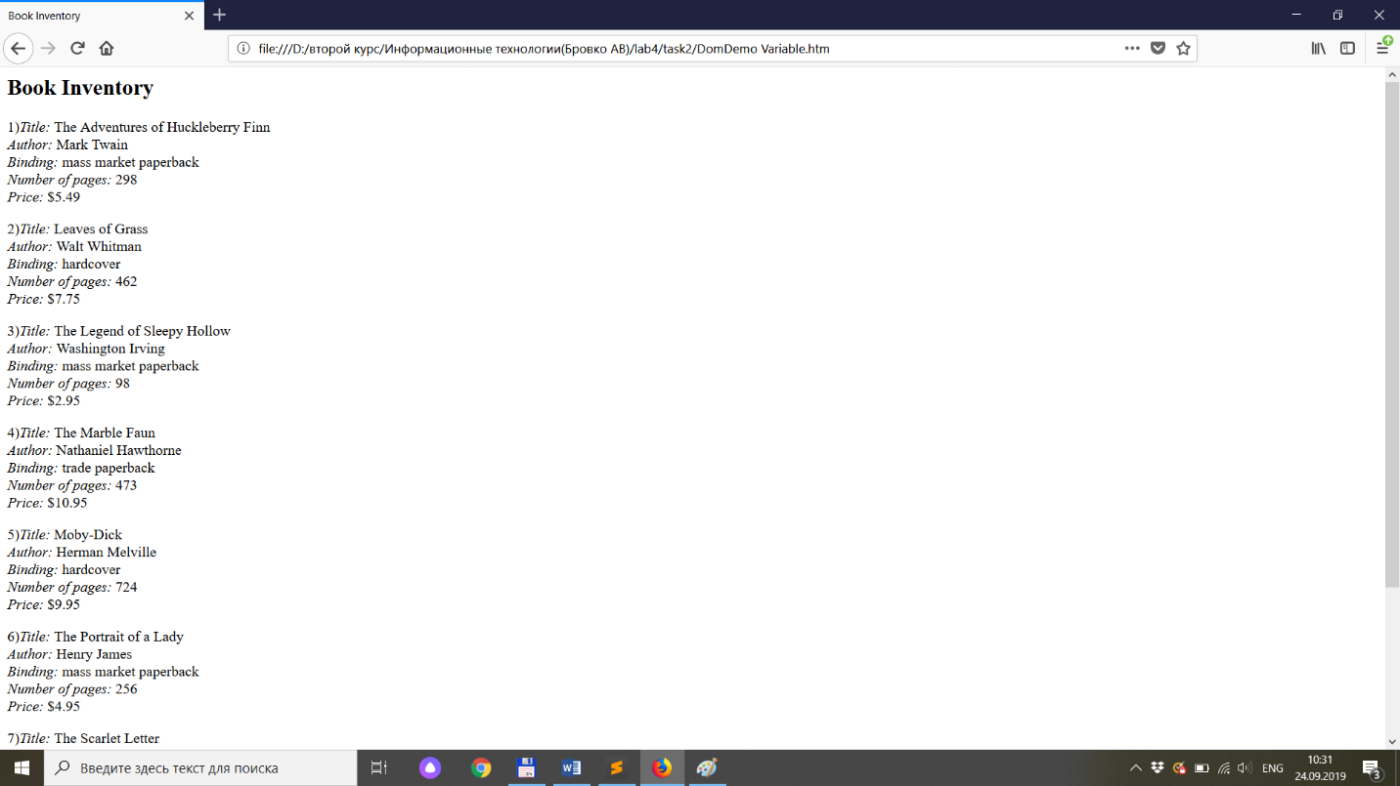

3.

XML:

<?xml version="1.0" encoding="unicode"?>

<INVENTORY>

<BOOK>

<TITLE>The Adventures of Huckleberry Finn</TITLE>

<AUTHOR>Mark Twain</AUTHOR>

<BINDING>mass market paperback</BINDING>

<PAGES>298</PAGES>

<PRICE>$5.49</PRICE>

</BOOK>

<BOOK>

<TITLE>Leaves of Grass</TITLE>

<AUTHOR>Walt Whitman</AUTHOR>

<BINDING>hardcover</BINDING>

<PAGES>462</PAGES>

<PRICE>$7.75</PRICE>

</BOOK>

<BOOK>

<TITLE>The Legend of Sleepy Hollow</TITLE>

<AUTHOR>Washington Irving</AUTHOR>

<BINDING>mass market paperback</BINDING>

<PAGES>98</PAGES>

<PRICE>$2.95</PRICE>

</BOOK>

<BOOK>

<TITLE>The Marble Faun</TITLE>

<AUTHOR>Nathaniel Hawthorne</AUTHOR>

<BINDING>trade paperback</BINDING>

<PAGES>473</PAGES>

<PRICE>$10.95</PRICE>

</BOOK>

<BOOK>

<TITLE>Moby-Dick</TITLE>

<AUTHOR>Herman Melville</AUTHOR>

<BINDING>hardcover</BINDING>

<PAGES>724</PAGES>

<PRICE>$9.95</PRICE>

</BOOK>

<BOOK>

<TITLE>The Portrait of a Lady</TITLE>

<AUTHOR>Henry James</AUTHOR>

<BINDING>mass market paperback</BINDING>

<PAGES>256</PAGES>

<PRICE>$4.95</PRICE>

</BOOK>

<BOOK>

<TITLE>The Scarlet Letter</TITLE>

<AUTHOR>Nathaniel Hawthorne</AUTHOR>

<BINDING>trade paperback</BINDING>

<PAGES>253</PAGES>

<PRICE>$4.25</PRICE>

</BOOK>

<BOOK>

<TITLE>The Turn of the Screw</TITLE>

<AUTHOR>Henry James</AUTHOR>

<BINDING>trade paperback</BINDING>

<PAGES>384</PAGES>

<PRICE>$3.35</PRICE>

</BOOK>

</INVENTORY>

HTM:

<HTML>

<HEAD>

<TITLE>Element Finder</TITLE>

<SCRIPT LANGUAGE="JavaScript">

const optionsArray = [];

const xhttp = new XMLHttpRequest();

xhttp.open("GET", "Inventory.xml", true);

xhttp.send();

xhttp.onreadystatechange = function () {

if (this.readyState == 4 && this.status == 200) {

const options = xhttp.responseXML.querySelector('BOOK').children;

setOptions(options);

showOptions();

}

}

function setOptions(array) {

for (let i = 0; i < array.length; i++) {

optionsArray[i] = array[i].tagName;

}

}

function showOptions() {

const options = document.querySelector('#ElementName');

for (let i = 0; i < optionsArray.length; i++) {

const option = document.createElement('option');

option.innerHTML = optionsArray[i];

options.appendChild(option);

console.log(options, option);

}

};

function myFunction(xml) {

var xmlDoc = xml.responseXML;

NodeList =

xmlDoc.getElementsByTagName(ElementName.value);

ResultHTML = "";

for (i=0; i < NodeList.length; ++i)

ResultHTML += NodeList[i].childNodes[0].nodeValue + "\n\n";

if (ResultHTML == "")

ResultDiv.innerText = "<no matching elements found>";

else

ResultDiv.innerText = ResultHTML;

}

</SCRIPT>

</HEAD>

<BODY>

<H2>Find Elements by Element Name</H2>

Element name: <select id='ElementName'>

<select>&nbsp;

<BUTTON onclick='myFunction(xhttp)'>Show Elements</BUTTON>

<HR>

<DIV ID=ResultDiv></DIV>

</BODY>

</HTML>

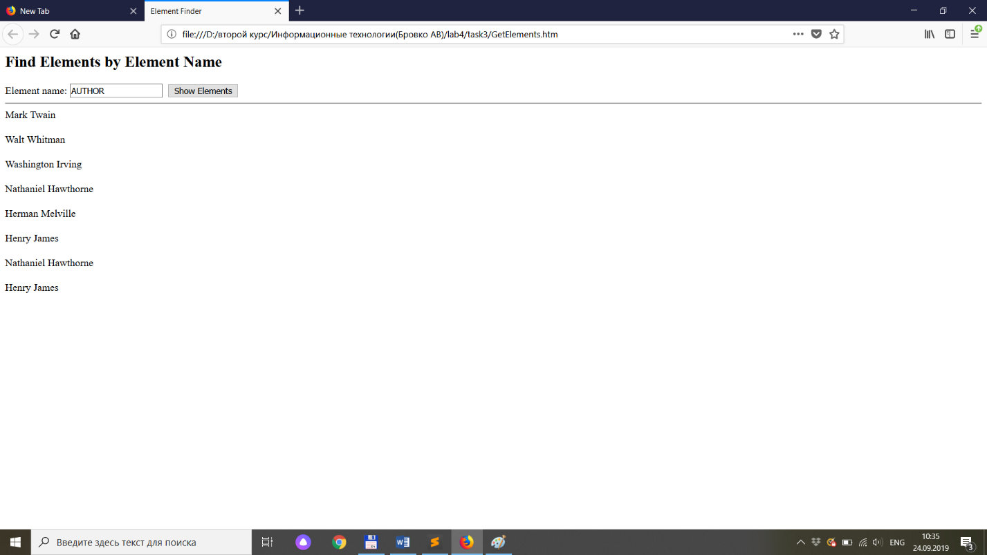

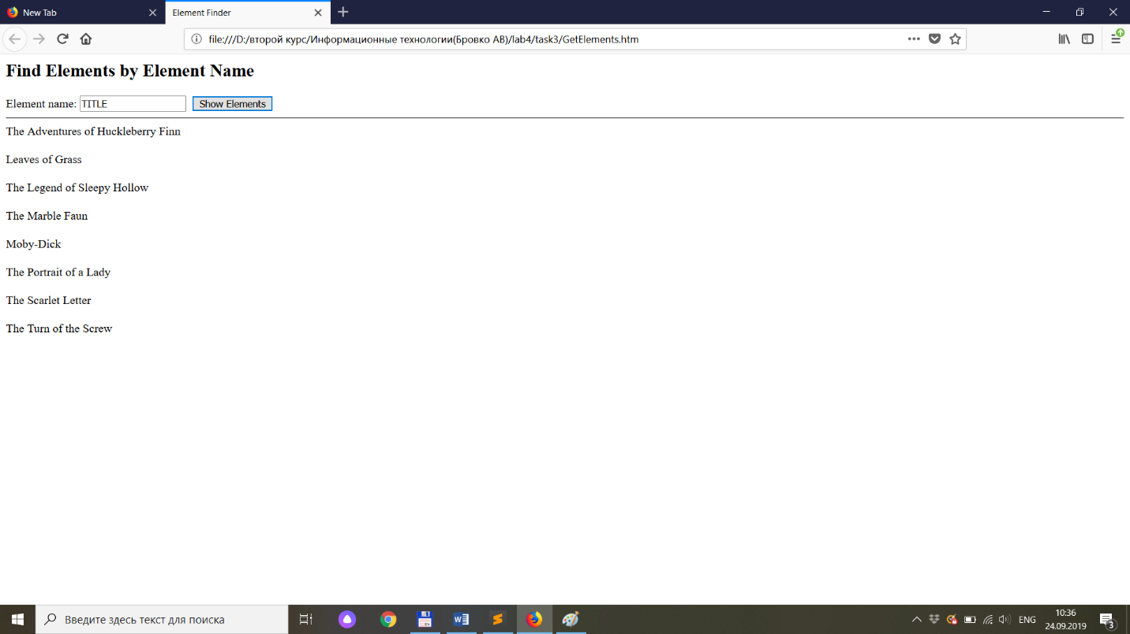

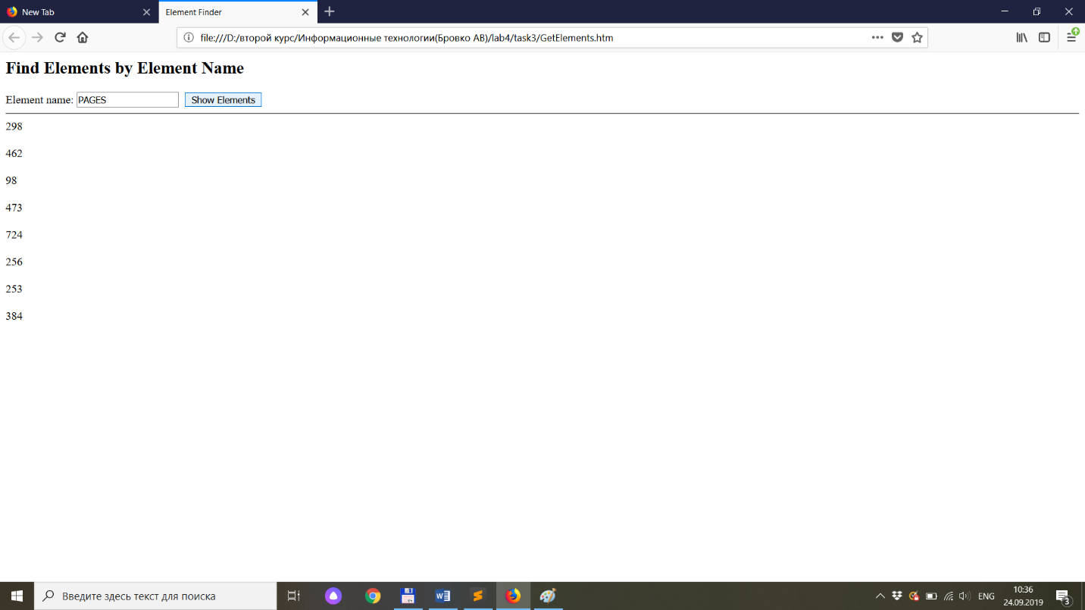

4.

XML:

<?xml version="1.0" encoding="unicode" ?>

<!-- Имя файла: Inventory Attributes.xml -->

<INVENTORY>

<BOOK Binding="mass market paperback" InStock="yes"

Review="***">

<TITLE>The Adventures of Huckleberry Finn</TITLE>

<AUTHOR Born="1835">Mark Twain</AUTHOR>

<PAGES>298</PAGES>

<PRICE>$5.49</PRICE>

</BOOK>

<BOOK Binding="hardcover" InStock="no">

<TITLE>Leaves of Grass</TITLE>

<AUTHOR Born="1819">Walt Whitman</AUTHOR>

<PAGES>462</PAGES>

<PRICE>$7.75</PRICE>

</BOOK>

<BOOK Binding="mass market paperback" InStock="yes"

Review="****">

<TITLE>The Legend of Sleepy Hollow</TITLE>

<AUTHOR>Washington Irving</AUTHOR>

<PAGES>98</PAGES>

<PRICE>$2.95</PRICE>

</BOOK>

</INVENTORY>

HTM (1):

<HTML>

<HEAD>

<TITLE>Element Finder</TITLE>

<SCRIPT LANGUAGE="JavaScript">

const optionsArray = [];

const xhttp = new XMLHttpRequest();

xhttp.open("GET", "Inventory Attributes.xml", true);

xhttp.send();

xhttp.onreadystatechange = function () {

if (this.readyState == 4 && this.status == 200) {

const options = xhttp.responseXML.querySelector('BOOK');

setOptions(options.attributes);

showOptions();

}

}

function setOptions(array) {

for (let i = 0; i < array.length; i++) {

optionsArray[i] = {attr: array[i].localName, value: array[i].nodeValue};

}

console.log(array);

}

function showOptions() {

var s = "";

console.log(optionsArray);

optionsArray.forEach((item) => {

s+=(item.attr + " : " + item.value + " ; ");

})

alert(s);

};

</SCRIPT>

</HEAD>

<BODY>

</BODY>

</HTML>

HTM (2):

<HEAD>

<TITLE>Element Finder</TITLE>

<SCRIPT LANGUAGE="JavaScript">

const optionsArray = [];

const xhttp = new XMLHttpRequest();

xhttp.open("GET", "Inventory Attributes.xml", true);

xhttp.send();

xhttp.onreadystatechange = function () {

if (this.readyState == 4 && this.status == 200) {

const options = xhttp.responseXML.querySelectorAll('BOOK');

console.log(options);

setOptions(options);

showOptions();

}

}

function setOptions(array) {

for(var i = 0; i < array.length; i++) {

optionsArray[i] = array[i];

}

console.log(optionsArray);

}

function showOptions() {

console.log(optionsArray);

for(var i = 0; i < optionsArray.length; i++) {

var s = "";

for(var j = 0; j < optionsArray[i].attributes.length; j++) {

s+= optionsArray[i].attributes[j].localName + " : "+ optionsArray[i].attributes[j].nodeValue + ", "

}

alert(s);

}

};

</SCRIPT>

</HEAD>

<BODY>

</BODY>

</HTML>

