Федеральное государственное бюджетное образовательное учреждение

высшего образования

«Саратовский государственный технический университет

имени Гагарина Ю.А.»

Кафедра «Прикладные информационные технологии»

**ОТЧЕТ**

**по лабораторной работе номер 5**

Студента гр. б2-ИФСТ22.

Макаева Владислава Витальевича

Проверил доцент кафедрыПИТ:

Бровко Александр Валерьевич

Саратов 2019

C#:

using System;

using System.Text;

using System.Xml;

class Program

{

const String file = "Inventory.xml";

static void PrintBooks()

{

int counter = 1;

XmlDocument doc = new XmlDocument();

doc.Load(file);

XmlElement root = doc.DocumentElement;

Console.WriteLine("\nBooks listing: ");

foreach (XmlNode node in root)

{

XmlNodeList childList = node.ChildNodes;

Console.WriteLine(counter++ + ") \nTitle: " + childList.Item(0).InnerText);

Console.WriteLine("Author: " + childList.Item(1).InnerText);

Console.WriteLine("Binding: " + childList.Item(2).InnerText);

Console.WriteLine("Pages: " + childList.Item(3).InnerText);

Console.WriteLine("Price: " + childList.Item(4).InnerText);

}

}

static void createBook(String title, String author, String binding, String pages, String price)

{

XmlDocument doc = new XmlDocument();

doc.Load(file);

XmlElement root = doc.DocumentElement;

XmlElement addElem = doc.CreateElement("BOOK");

XmlElement ch1 = doc.CreateElement("TITLE");

XmlElement ch2 = doc.CreateElement("AUTHOR");

XmlElement ch3 = doc.CreateElement("BINDING");

XmlElement ch4 = doc.CreateElement("PAGES");

XmlElement ch5 = doc.CreateElement("PRICE");

ch1.InnerText = title;

ch2.InnerText = author;

ch3.InnerText = binding;

ch4.InnerText = pages;

ch5.InnerText = price;

addElem.AppendChild(ch1);

addElem.AppendChild(ch2);

addElem.AppendChild(ch3);

addElem.AppendChild(ch4);

addElem.AppendChild(ch5);

root.AppendChild(addElem);

doc.Save("Inventory.xml");

}

static void delete(String title)

{

XmlDocument doc = new XmlDocument();

doc.Load(file);

XmlElement root = doc.DocumentElement;

for (int i = 0; i < root.ChildNodes.Count; i++)

{

if (root.ChildNodes.Item(i).ChildNodes.Item(0).InnerText == title)

root.RemoveChild(root.ChildNodes.Item(i));

}

doc.Save("Inventory.xml");

}

static void refactor(String title, String elem, String newTxt)

{

XmlDocument doc = new XmlDocument();

doc.Load(file);

XmlElement root = doc.DocumentElement;

foreach (XmlNode node in root)

{

if (node.ChildNodes.Item(0).InnerText == title)

{

foreach (XmlNode child in node.ChildNodes)

if (child.Name == elem)

child.InnerText = newTxt;

}

}

doc.Save("Inventory.xml");

}

static void Main(string[] args)

{

while (true)

{

Console.OutputEncoding = Encoding.UTF8;

Console.WriteLine("Select option: \n1 - Print information \n2 - Create book \n3 - Delete book \n4 - Add information about book");

ConsoleKeyInfo key = Console.ReadKey();

switch (key.KeyChar)

{

case '1': PrintBooks(); break;

case '2':

{

Console.WriteLine("\nEnter parameters \nBook name: ");

String title = Console.ReadLine();

Console.WriteLine("Author: ");

String author = Console.ReadLine();

Console.WriteLine("Binding: ");

String binding = Console.ReadLine();

Console.WriteLine("Num of pages: ");

String pages = Console.ReadLine();

Console.WriteLine("Price: ");

String price = Console.ReadLine();

createBook(title, author, binding, pages, price);

break;

}

case '3':

{

Console.WriteLine("\nRemovable book name:");

delete(Console.ReadLine());

break;

}

case '4':

{

Console.WriteLine("\nMutable book name:");

String bookName = Console.ReadLine();

Console.WriteLine("Mutable parameter:");

String param = Console.ReadLine();

Console.WriteLine("New text:");

String txt = Console.ReadLine();

refactor(bookName, param, txt);

break;

}

}

Console.WriteLine("\n");

}

}

}

XML:

<?xml version="1.0" encoding="utf-8"?>

<INVENTORY>

<BOOK>

<TITLE>The Adventures of Huckleberry Finn</TITLE>

<AUTHOR>Mark Twain</AUTHOR>

<BINDING>mass market paperback</BINDING>

<PAGES>298</PAGES>

<PRICE>$5.49</PRICE>

</BOOK>

<BOOK>

<TITLE>Leaves of Grass</TITLE>

<AUTHOR>Walt Whitman</AUTHOR>

<BINDING>hardcover</BINDING>

<PAGES>462</PAGES>

<PRICE>$7.75</PRICE>

</BOOK>

<BOOK>

<TITLE>The Legend of Sleepy Hollow</TITLE>

<AUTHOR>Washington Irving</AUTHOR>

<BINDING>mass market paperback</BINDING>

<PAGES>98</PAGES>

<PRICE>$777</PRICE>

</BOOK>

<BOOK>

<TITLE>The Marble Faun</TITLE>

<AUTHOR>Nathaniel Hawthorne</AUTHOR>

<BINDING>trade paperback</BINDING>

<PAGES>473</PAGES>

<PRICE>$10.95</PRICE>

</BOOK>

<BOOK>

<TITLE>Moby-Dick</TITLE>

<AUTHOR>Herman Melville</AUTHOR>

<BINDING>hardcover</BINDING>

<PAGES>724</PAGES>

<PRICE>$9.95</PRICE>

</BOOK>

<BOOK>

<TITLE>The Portrait of a Lady</TITLE>

<AUTHOR>Henry James</AUTHOR>

<BINDING>mass market paperback</BINDING>

<PAGES>256</PAGES>

<PRICE>$4.95</PRICE>

</BOOK>

<BOOK>

<TITLE>The Scarlet Letter</TITLE>

<AUTHOR>Nathaniel Hawthorne</AUTHOR>

<BINDING>trade paperback</BINDING>

<PAGES>253</PAGES>

<PRICE>$4.25</PRICE>

</BOOK>

<BOOK>

<TITLE>123</TITLE>

<AUTHOR>eff</AUTHOR>

<BINDING>123</BINDING>

<PAGES>123</PAGES>

<PRICE>123</PRICE>

</BOOK>

</INVENTORY>

Работа программы:

1. Вывести список книг

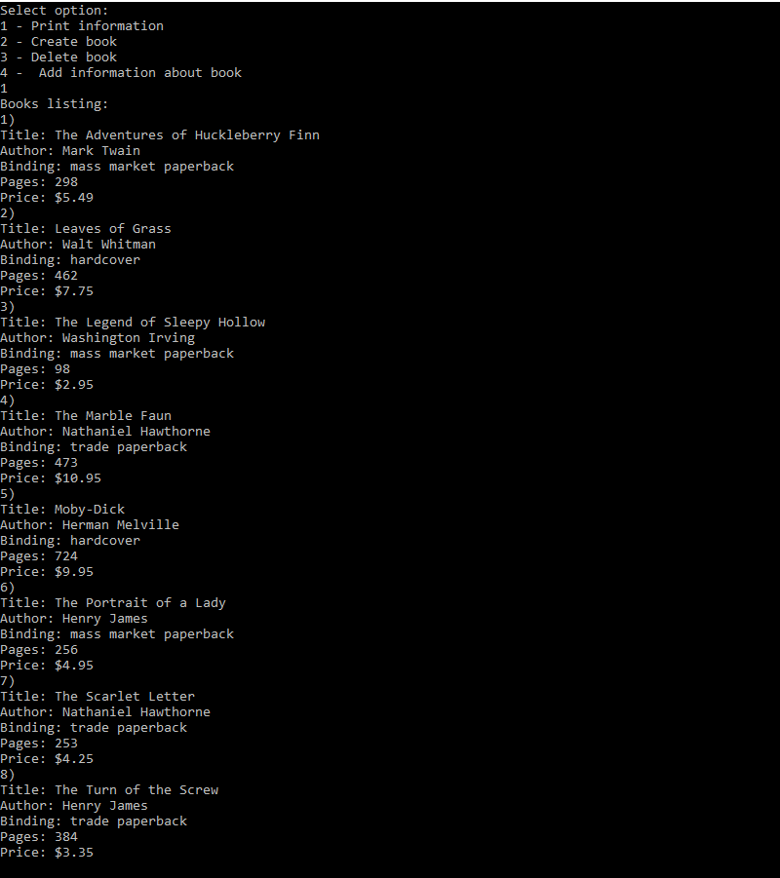

1. Добавить книгу

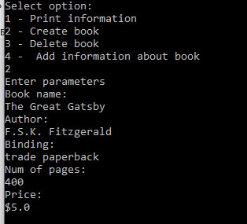

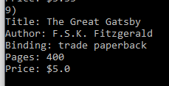

1. Изменить книгу

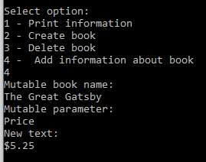

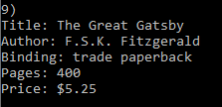

1. Удалить книгу

