EUROPEAN HUMANITIES UNIVERSITY
Public Institution "European Humanities University" branch
School of Digital Competencies
Study program Informatics

ROMAN RADCHENKO
4 year student

AUTOMASPEC: A PLATFORM FOR TEST SPECIFICATION MANAGEMENT AND AUTOMATED TEST GENERATION

BACHELOR THESIS/PROJECT

Supervisor: Volha Kuzniatsova

Vilnius, 2026

ABSTRACT
Roman Radchenko
AUTOMASPEC: a platform for test specification management and automated test generation
Keywords: _testing, specifications, qa, automation, next.js_
The object of the project is the process of creating and maintaining test documentation and automated tests in software development teams. The goal is to build a web platform that centralizes test specifications (folders → specs → requirements → tests), provides clear coverage/status tracking, and accelerates automated test creation by generating Vitest code with the help of LLMs. To achieve this goal, the following tasks were solved: domain and tool analysis; data model and access control design; implementation of a UI for managing specifications and requirements; integration of AI-based test generation; test result aggregation and analytics; project setup for testing, building, and deployment. The practical value of the project is reduced time spent on test creation and improved visibility of test coverage across an organization.

TABLE OF CONTENTS
INTRODUCTION 6
1. ANALYTICAL PART 7
1.1. Problem and motivation 7
1.2. Analysis of existing solutions 7
1.2. Target audience and scenarios 7
1.3. System requirements and constraints 8
2. REQUIREMENTS SPECIFICATION 9
2.1. Functional requirements (detailed) 9
2.2. Non-functional requirements (detailed) 9
3. DESIGN PART 11
2. DESIGN PART 12
2.1. High-level architecture 12
2.2. Component decomposition 12
2.2. Data model 12
2.3. Data consistency and aggregation 12
2.3. Security and access control 13
4. IMPLEMENTATION 14
3.1. Technology stack 14
3.2. UI and interaction model 14
3.2. Test hierarchy management 14
3.3. API design and data flow 14
3.4. AI-based test generation 14
3.5. Analytics and reporting 15
5. TESTING AND QUALITY 16
5.1. Testing strategy 16
6. DEPLOYMENT 17
6.1. Local environment and configuration 17
7. USER GUIDE 18
8. RESULTS AND EVALUATION 19
8.1. Achievement of goals 19
8.2. Key deliverables 19
8.3. Quality evidence 19
9. LIMITATIONS AND FUTURE WORK 20
9.1. Current limitations 20
9.2. Future improvements 20
10. DATABASE DESIGN AND MIGRATIONS 21
10.1. Design principles 21
10.2. Storage of test code and status 21
10.3. Migration workflow 21
11. SECURITY, PRIVACY, AND RELIABILITY 22
11.1. Threat model overview 22
11.2. Enforcement strategy 22
11.3. Reliability considerations 22
12. PROJECT MANAGEMENT AND PROCESS 23
12.1. Development approach 23
12.2. Risks and mitigation 23
13. DETAILED ARCHITECTURE AND IMPLEMENTATION NOTES 24
13.1. End-to-end request flow 24
13.2. Typed API contracts 24
13.3. Client-side caching and synchronization 24
13.4. Consistent organization scoping 24
14. TESTING IMPLEMENTATION DETAILS 26
14.1. What is covered by tests 26
14.2. Why testing matters for this project 26
15. DEPLOYMENT AND OPERATIONS DETAILS 27
15.1. Build artifacts and reproducibility 27
15.2. Configuration and secrets 27
CONCLUSIONS 28
REFERENCES 29
APPENDICES 30
APPENDIX A. UI SCREENSHOTS 30
APPENDIX B. ADDITIONAL MATERIALS 32

INTRODUCTION
Modern software teams use many tools for planning and quality control: issue trackers, wikis, spreadsheets, CI/CD reports, and source-code repositories. In practice, test documentation and actual automated tests often live in different places: requirements are described in one system, checklists in another, test run results in CI, and test code in the repository. This fragmentation makes it hard to maintain a single source of truth, increases maintenance cost, and reduces visibility of test coverage.
The topic is relevant for QA engineers and developers who need a centralized structure for test specifications and mechanisms that speed up writing automated tests. Large language models (LLMs) further enable automation of routine work, including generating test code from requirements written in natural language.
The goal of the project is to develop Automaspec, a web platform for managing test specifications and accelerating automated test creation.
To achieve this goal, the following tasks were completed:
- analyze the domain, users, and existing solutions
- define functional and non-functional requirements
- design the data model and core entities: organization, folder, spec, requirement, test
- implement a UI for managing the hierarchy of test artifacts and their statuses
- implement the server-side API and organization-based authorization
- integrate AI-based Vitest test generation and store the produced test code
- implement analytics views (status summaries and reports)
- prepare the development environment, testing, and build pipeline
The object of the project is the process of creating and maintaining test documentation and automated tests in software development teams. The subject of the project is methods and software tools for centralized storage of test specifications, requirements, and tests, as well as AI integration to speed up test creation.
Methods and tools used: comparative analysis of existing solutions, relational data modeling, full-stack web development with Next.js, type-safe APIs with oRPC, ORM usage with Drizzle, unit/component testing with Vitest, and analysis of testing results.

1. ANALYTICAL PART

1.1. Problem and motivation
The core problem is the lack of a unified structure and a single place to store test specifications, requirements, and automated tests, and to connect them to actual execution results. When documentation is scattered, typical outcomes follow: duplicated requirements, outdated documents, limited coverage visibility, regression growth, and increased effort to keep tests and documentation consistent.
Automaspec addresses this by providing:
- a single workspace context per organization
- a hierarchy: folders → specs → requirements → tests
- status tracking and aggregation for quick progress assessment
- an AI assistant to generate tests and accelerate routine work

1.2. Analysis of existing solutions
Test management and documentation are commonly handled using a combination of tools rather than a single platform. The most typical setups include:
- issue trackers (requirements and acceptance criteria)
- documentation tools (test plans, checklists, knowledge bases)
- test runners and CI systems (execution results)
- source code repositories (automated tests)
This tool fragmentation has a clear benefit: each tool is optimized for its domain. However, it creates a structural gap between what should be tested (specifications and requirements) and what is actually tested (test code and CI results). When teams try to close this gap manually, they spend time on synchronization and still risk inconsistencies.
Automaspec focuses on a narrower and more explicit scope: it provides an opinionated hierarchy for test artifacts and keeps the relationship between requirements and tests as a first-class concept. Instead of replacing issue trackers, it acts as a central workspace for test artifacts and their statuses, while providing optional AI assistance for generating initial test implementations.

1.2. Target audience and scenarios
Primary users:
- QA engineers: create specs, describe requirements, validate status, review tests
- developers: create tests, use AI-generated scaffolding, keep artifacts up to date
- team leads: review coverage state, manage organizations and access
Key scenarios:
- create a folder/spec structure for a project
- add requirements to a spec and attach tests
- generate tests from requirements and save the code
- view analytics: counts, status distribution, overall progress

1.3. System requirements and constraints
Functional requirements:
- user registration and authentication
- organizations and roles (Owner/Admin/Member)
- management of folders, specs, requirements, and tests
- storing test code and statuses
- analytics summaries per spec and per organization
- integration with external AI providers for test generation
Non-functional requirements:
- type-safe API contracts and boundary validation
- usable UI on desktop and mobile devices
- reproducible build and deployment (including containerization)
- unit/component tests for critical logic
Constraints and assumptions:
- the product is designed as a web application that must work in modern browsers
- the database layer should remain simple to operate in both local and hosted environments
- the API surface should be type-safe and testable
- the UI should be accessible and consistent, avoiding custom components that are hard to maintain
- integration tests that require a live database must be optional

2. REQUIREMENTS SPECIFICATION

2.1. Functional requirements (detailed)
Authentication and organizations:
- users can register and sign in with credentials
- a user can create multiple organizations
- organization membership defines access to all resources inside the organization
- roles define the permission level: Owner, Admin, Member
- owners can manage organization settings and members
Test artifact management:
- users can create folders and nested folders
- users can create specs inside folders
- users can define requirements inside a spec with ordering support
- users can attach one or more tests to a requirement
- each test has a framework identifier and a status
AI-assisted workflows:
- users can request AI generation of a test implementation from a requirement description
- generated test code is persisted and can be edited
- the system can support different providers via a unified API layer
Analytics:
- a spec provides an aggregated summary of its tests (status breakdown and total count)
- organization-level views provide summary metrics for dashboards
- analytics must reflect updates when tests or requirements change

2.2. Non-functional requirements (detailed)
Reliability and correctness:
- input validation must be enforced on API boundaries
- test artifacts must remain consistent (no orphaned references)
- all destructive actions must be scoped to the active organization and role
Performance:
- navigation inside the hierarchy should be responsive for typical sizes (hundreds of nodes)
- list rendering must remain stable under frequent updates
- API responses should avoid unnecessary payloads
Security:
- all sensitive operations must require an authenticated session
- organization boundaries must be enforced consistently
- secrets must not be stored in the repository and must be supplied via environment variables
Maintainability:
- end-to-end type-safety across API contracts and consumers
- consistent code style and automated checks in hooks and CI
- modular structure that allows adding new features without large refactors

3. DESIGN PART

2. DESIGN PART

2.1. High-level architecture
Automaspec is implemented as a single full-stack Next.js application that serves both the UI and server APIs. The client communicates with the server via type-safe oRPC contracts and caches data via TanStack Query. Persistent storage is provided by libSQL (Turso) accessed through Drizzle ORM.

2.2. Component decomposition
The system can be described using the following logical components:
- presentation layer: pages, forms, and interactive UI components
- application layer: feature-level orchestration (actions, commands, query/mutation flows)
- API layer: oRPC routers and contracts for type-safe client/server communication
- persistence layer: Drizzle schema and query functions targeting libSQL/Turso
- external integration layer: AI providers, authentication provider, and optional CI artifacts
The choice of a single Next.js project for both UI and API reduces deployment complexity. It also allows sharing types and validation schemas across server and client, which is critical for predictable behavior and faster iteration.

2.2. Data model
The system includes user and organization entities and the following test-management entities:
- `testFolder`: hierarchical grouping
- `testSpec`: a test specification with aggregated statuses and counters
- `testRequirement`: a requirement inside a spec
- `test`: an individual test with code and status
The model supports multi-user access within an organization, and roles define permissions for managing resources.

2.3. Data consistency and aggregation
A key design decision is storing both raw artifacts (tests and their statuses) and aggregated values at the spec level. Aggregation provides fast summary views without scanning all tests on every page render. Typical aggregated fields include:
- total number of tests in a spec
- status breakdown (passed, failed, skipped, pending, etc.)
To keep aggregated values correct, mutations that modify tests or requirements must update the corresponding spec summaries. This approach reduces query complexity for the dashboard, at the cost of more careful mutation logic.

2.3. Security and access control
Authentication is implemented via better-auth. Authorization is based on the active organization context and member role. Input validation is performed with schemas (Zod) at API boundaries.

4. IMPLEMENTATION

3.1. Technology stack
The project uses Next.js 16 (App Router) and React 19 for UI, Tailwind CSS v4 and Radix UI for accessible UI primitives. The backend is built on Next.js and oRPC. Data persistence uses libSQL (Turso) with Drizzle ORM. Testing is done with Vitest and React Testing Library.

3.2. UI and interaction model
The application follows a workspace model: once a user selects an organization, all subsequent navigation and operations are scoped to it. The main workspace consists of:
- a left-side hierarchical tree for folders/specs navigation
- a main content area for spec details, requirements, and tests
- a header area for organization switching and user actions
The hierarchy tree enables quick navigation with minimal context switching. For mobile devices, the hierarchy is accessible via a drawer or alternative navigation patterns.

3.2. Test hierarchy management
The key functionality is managing a hierarchy of test artifacts. Users build a folder tree, place specs inside folders, create requirements within specs, and attach tests to requirements. Specs maintain aggregated statuses to quickly assess overall testing progress.

3.3. API design and data flow
The API is designed around typed contracts. Each operation defines input and output schemas, enabling:
- consistent validation rules for all clients
- predictable error handling
- reduced integration bugs when refactoring data structures
On the client side, TanStack Query handles query caching and synchronization. Mutations update server state and then trigger query invalidation so that analytics and lists stay consistent.

3.4. AI-based test generation
To accelerate automated test creation, the system integrates AI providers through an SDK. Users write a requirement, then the system generates Vitest test code and stores it. The generated code can be edited and used as a starting point for production-grade tests.
The generation flow can be described as:
- user selects a requirement and requests generation
- the server constructs a prompt based on requirement text and target framework (Vitest)
- the AI provider returns a candidate test implementation
- the system stores the code and sets an initial status for the test
- the spec aggregates are recalculated/updated
This workflow emphasizes practicality: the generated code is treated as scaffolding that reduces repetitive work, not as a fully trusted final artifact.

3.5. Analytics and reporting
The UI provides per-spec status summaries and organization-level aggregates. This allows teams to see which areas are covered, which parts are blocked, and which requirements need attention.
The analytics layer is intentionally lightweight. It focuses on counts and status breakdowns that provide immediate project insight. Future analytics extensions can include:
- historical trends across test runs
- per-folder aggregates
- progress tracking over time

5. TESTING AND QUALITY
The project uses Vitest and React Testing Library. The repository contains unit and component tests, and optional integration tests when a reachable database is available. Current test run summary: 53 test suites and 119 tests; all tests pass.
Code quality is enforced with static analysis and formatting (oxlint, oxfmt) and git hooks (lefthook) to run checks before commits.

5.1. Testing strategy
The testing strategy uses several layers:
- unit tests for pure logic and data transformations
- component tests for interactive UI behavior
- optional integration tests that require database connectivity
- optional end-to-end tests for critical user flows
This layered approach helps keep most tests fast and reliable while still allowing deeper validation when infrastructure is available.

6. DEPLOYMENT
The application can be run locally (Next.js dev) and deployed in a Docker container. Production builds use the Next.js standalone output. The database is provided by libSQL (Turso) or a compatible local instance. Configuration is provided via environment variables.
The project supports CI steps for build, lint, and tests, and can be deployed using Docker Compose.

6.1. Local environment and configuration
To run locally, the project requires:
- Node.js and pnpm for dependency management
- environment variables for database access and optional AI providers
- database migrations applied through the provided scripts
The separation between local database development and hosted database usage is achieved via configuration. This supports both lightweight development (local) and realistic environments (hosted) without changes to application logic.

7. USER GUIDE
Users open the web application, sign up/sign in, create an organization, and build a folder/spec structure. For each spec, they add requirements and tests, and optionally generate tests with AI. A dedicated analytics section provides coverage and status summaries.
Typical workflow:
- create an organization and invite members
- create folders for products/modules/features
- add specs as test plans for features
- define requirements and attach tests
- generate test scaffolding with AI when needed
- monitor analytics to understand coverage and gaps

8. RESULTS AND EVALUATION

8.1. Achievement of goals
The project goal was to build a web platform that centralizes test specifications and accelerates automated test creation. The implemented system achieves this goal by providing an organization-scoped workspace, a strict hierarchy of artifacts (folders → specs → requirements → tests), status aggregation for quick coverage visibility, and an AI-assisted workflow that generates Vitest test code from requirement descriptions.
From a reviewer perspective, the main result is a coherent end-to-end workflow that connects documentation and implementation artifacts. Requirements and tests are stored in a structured form, and dashboards provide summarized status information for both individual specs and organization-level overviews.

8.2. Key deliverables
The diploma project produced the following deliverables:
- a production-ready full-stack web application implementing the core features
- a documented data model and database schema supporting organizations and test artifacts
- an AI integration layer that can work with multiple providers
- automated tests and a quality enforcement setup (linting/formatting/hooks)
- containerization and scripts for repeatable builds and deployments

8.3. Quality evidence
Quality is supported by:
- type-safe API contracts and validation at boundaries
- automated tests that cover UI and application logic
- consistent formatting and linting enforced via hooks and scripts
At the time of preparing this note, the repository test run reports 53 test suites and 119 tests, all passing.

9. LIMITATIONS AND FUTURE WORK

9.1. Current limitations
The current implementation is intentionally scoped to remain feasible within the diploma timeframe. This results in several limitations:
- analytics focus on status aggregation and counts rather than historical trends across runs
- AI-generated tests are treated as scaffolding and require human review and adaptation
- integrations with external systems (issue trackers, CI providers) can be expanded but are not the primary focus
- large organizations with very deep hierarchies may require additional performance optimizations and pagination

9.2. Future improvements
Possible directions for further development include:
- supporting multiple testing frameworks and project templates beyond Vitest
- adding run history and trend analytics (per spec, per folder, organization-wide)
- enhancing CI/CD integrations to automatically import results and attach them to specific tests
- adding import/export capabilities for specifications (Markdown, JSON, integrations with issue trackers)
- improving collaboration features (comments, reviews, change history, notifications)

10. DATABASE DESIGN AND MIGRATIONS

10.1. Design principles
The database model is based on a small set of core principles:
- organizational isolation: every domain entity is scoped to an organization
- explicit hierarchy: folder → spec → requirement → test relationships are stored directly
- predictable ordering: requirements use an ordering field to keep stable presentation order
- minimal coupling: the schema avoids unnecessary cross-links that would complicate migrations
These principles are aligned with the main use case: fast navigation and consistent representation of testing artifacts in the UI.

10.2. Storage of test code and status
Each test stores:
- a framework identifier, allowing future extension to other frameworks
- a status representing current execution or review state
- the generated or manually edited test code
This design allows the platform to act as a repository of test implementations that are directly connected to requirements. The code is not meant to replace the project’s source repository, but rather to provide a structured and searchable storage for test artifacts and their current state.

10.3. Migration workflow
The migration workflow ensures that the schema remains consistent across environments:
- schema changes are described in a type-safe manner
- migrations are generated and applied through scripts
- local development uses the same migration sequence as production
This reduces the risk of “works on my machine” differences and makes it easier for reviewers to reproduce the database state.

11. SECURITY, PRIVACY, AND RELIABILITY

11.1. Threat model overview
The system operates in a multi-tenant mode where organizations share the same application deployment. The most critical security requirements are:
- authentication must be enforced for all non-public actions
- organization boundaries must prevent data leakage
- role permissions must be respected for all write operations

11.2. Enforcement strategy
The enforcement strategy relies on:
- session-based authentication
- organization context attached to requests
- validation at the API boundary using schemas
- consistent server-side authorization checks for organization-scoped resources

11.3. Reliability considerations
Reliability is supported by:
- deterministic database migrations
- automated tests for key UI and logic paths
- strict linting and formatting checks to reduce accidental regressions
Optional integration tests are separated because they require external connectivity. This keeps the default test suite stable and fast.

12. PROJECT MANAGEMENT AND PROCESS

12.1. Development approach
The project was implemented iteratively, focusing on delivering a working vertical slice early and then expanding functionality:
- initial slice: authentication, organization context, and basic CRUD
- domain features: folder/spec/requirement/test hierarchy and editing flows
- AI features: generation of test code and storage in domain entities
- analytics: aggregated status views and counts for dashboards
- hardening: tests, hooks, and deployment scripts
This approach reduces delivery risk because each stage produces a testable system with clear boundaries.

12.2. Risks and mitigation
Key risks and mitigations:
- authorization bugs: mitigated by enforcing organization context consistently and validating inputs
- inconsistent aggregates: mitigated by updating aggregates in the same mutation flow as raw entities
- variability of AI output: mitigated by treating generated tests as editable scaffolding
- time constraints: mitigated by prioritizing end-to-end completeness over niche features

13. DETAILED ARCHITECTURE AND IMPLEMENTATION NOTES

13.1. End-to-end request flow
The application follows a straightforward full-stack flow designed for predictable behavior and easy debugging:
- the UI triggers a query or mutation
- the client calls the typed API surface
- the server validates inputs, applies authorization, and executes domain logic
- the persistence layer reads/writes data through a single DB connection abstraction
- the server returns a typed result
- the client updates UI state and, when needed, invalidates caches
This flow is intentionally uniform across features. A consistent pattern reduces accidental security gaps and makes the project easier to extend.

13.2. Typed API contracts
The API layer is built around explicit contracts that define:
- inputs and outputs for each operation
- validation rules and constraints
- predictable error handling
This approach provides several practical benefits:
- refactoring is safer because type mismatches are caught early
- the UI can rely on stable return shapes
- the boundary between client and server is easy to audit

13.3. Client-side caching and synchronization
The client uses a query cache to reduce redundant network calls and keep the UI responsive. A typical pattern is:
- queries are keyed by organization and feature scope
- mutations update the server state
- after a successful mutation, affected queries are invalidated
This model prevents stale analytics summaries after changes to requirements or tests. It also avoids heavy “refetch everything” strategies by focusing on invalidating only the relevant cache keys.

13.4. Consistent organization scoping
Multi-tenant correctness is achieved by enforcing organization scoping at multiple layers:
- the active organization is part of the session context
- server-side operations reject access when organization context is missing
- queries and mutations always filter by organization id
This reduces the risk of accidental cross-organization access even if new endpoints are added later.

14. TESTING IMPLEMENTATION DETAILS

14.1. What is covered by tests
The test suite focuses on validating behaviors that are most likely to regress:
- UI behavior for creating and editing test artifacts
- data flow and state synchronization after mutations
- correctness of aggregation logic for spec status summaries
The tests are designed to be deterministic and to minimize reliance on external services. Where database connectivity is required, integration tests are optional and can be enabled only when the environment is available.

14.2. Why testing matters for this project
This project combines several sources of complexity:
- a hierarchical domain model
- organization and role-based authorization
- cache invalidation and UI synchronization
- AI-assisted generation that produces variable outputs
Automated tests provide evidence that core flows remain correct as new features are introduced and as the data model evolves.

15. DEPLOYMENT AND OPERATIONS DETAILS

15.1. Build artifacts and reproducibility
The build produces a standalone server bundle for production usage. This keeps deployments predictable and avoids differences between local and production runtime behavior.
Containerization is used to package the application consistently. The overall goal is to allow the reviewer (or a future maintainer) to reproduce the production environment with minimal manual steps.

15.2. Configuration and secrets
The system relies on environment variables for configuration, including:
- database connection settings
- authentication-related values
- optional AI provider keys
This approach keeps secrets out of version control and makes it possible to run the same codebase in multiple environments without modifications.

CONCLUSIONS
As part of the diploma project, Automaspec was developed as a platform for centralized test specification management and faster automated test creation. The system supports multi-user organization workspaces, hierarchical test artifacts, test storage and editing, AI-based test code generation, and analytics views. A reproducible development environment and quality checks were set up, and a test suite was implemented.
Future improvements include multi-framework test support, expanded analytics (run history and trends), deeper CI/CD integration, and import/export of specifications.

REFERENCES
- Next.js Documentation. URL: https://nextjs.org/docs (accessed: 2026-01-15).
- React Documentation. URL: https://react.dev/ (accessed: 2026-01-15).
- Drizzle ORM Documentation. URL: https://orm.drizzle.team/ (accessed: 2026-01-15).
- Turso (libSQL) Documentation. URL: https://docs.turso.tech/ (accessed: 2026-01-15).
- TanStack Query Documentation. URL: https://tanstack.com/query/latest (accessed: 2026-01-15).
- Vitest Documentation. URL: https://vitest.dev/ (accessed: 2026-01-15).
- Better Auth Documentation. URL: https://www.better-auth.com/ (accessed: 2026-01-15).

APPENDICES

APPENDIX A. UI SCREENSHOTS
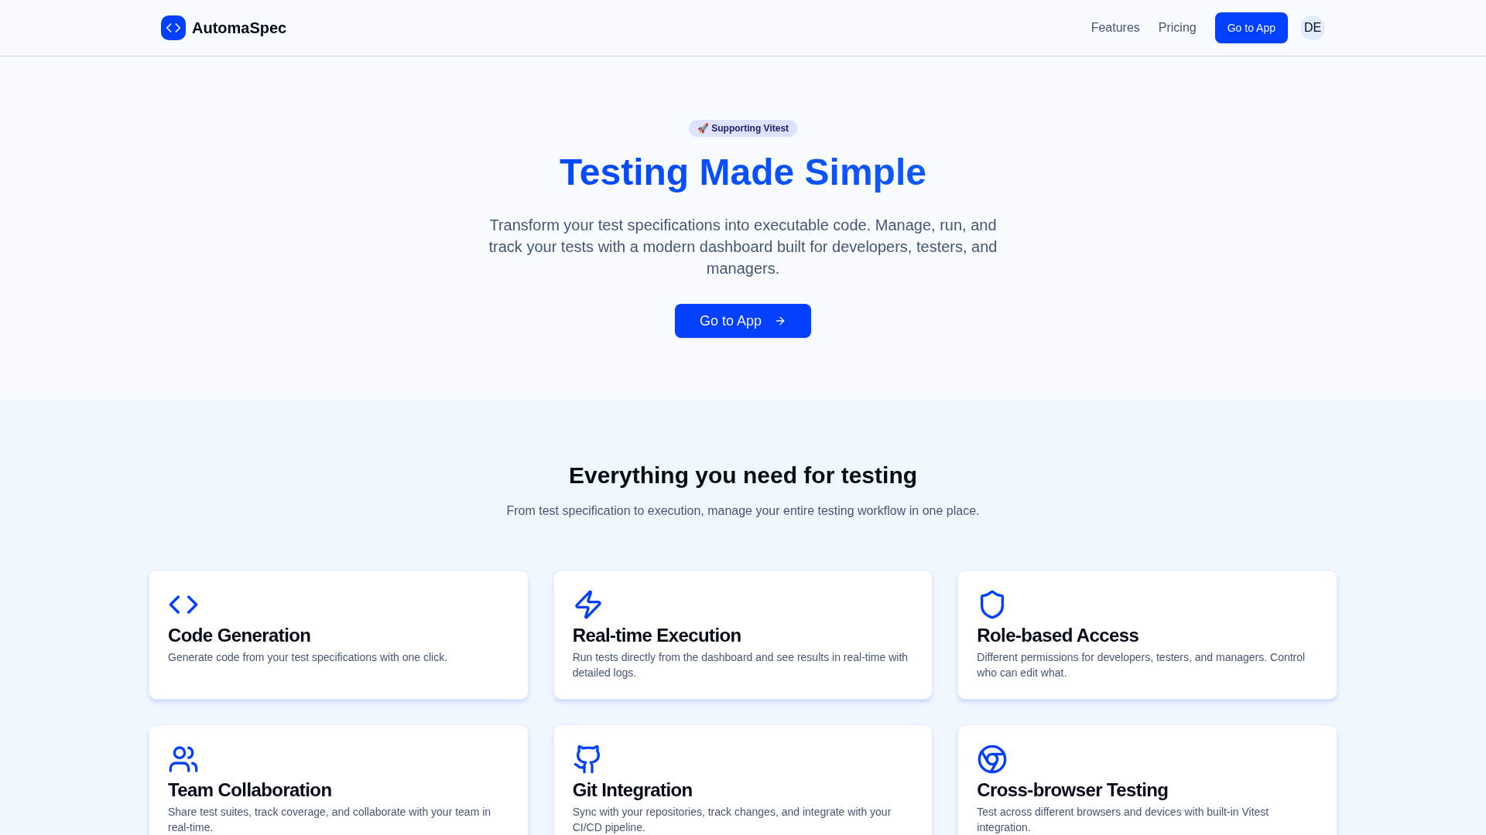
Figure A.1. Home page (desktop).
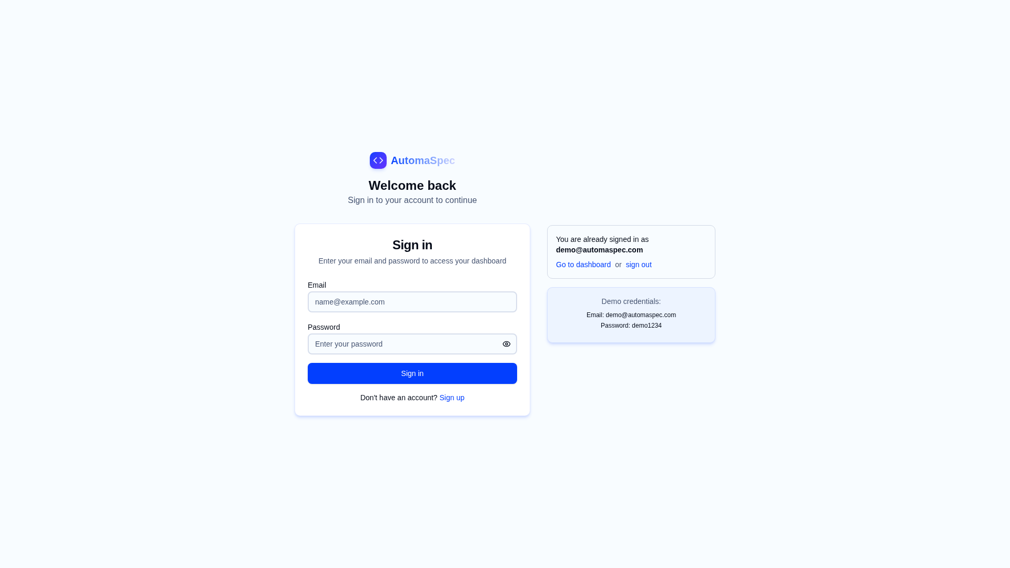
Figure A.2. Login screen (desktop).
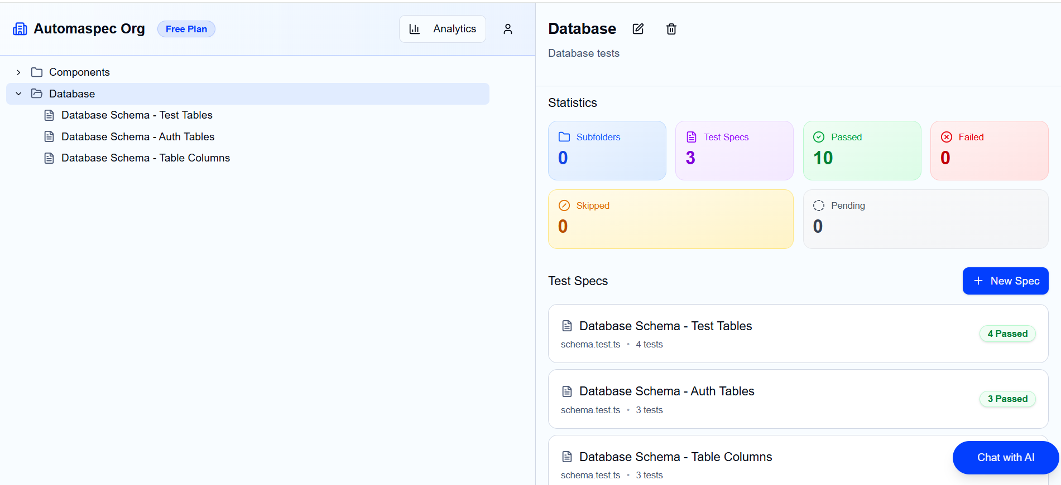
Figure A.3. Dashboard (desktop).
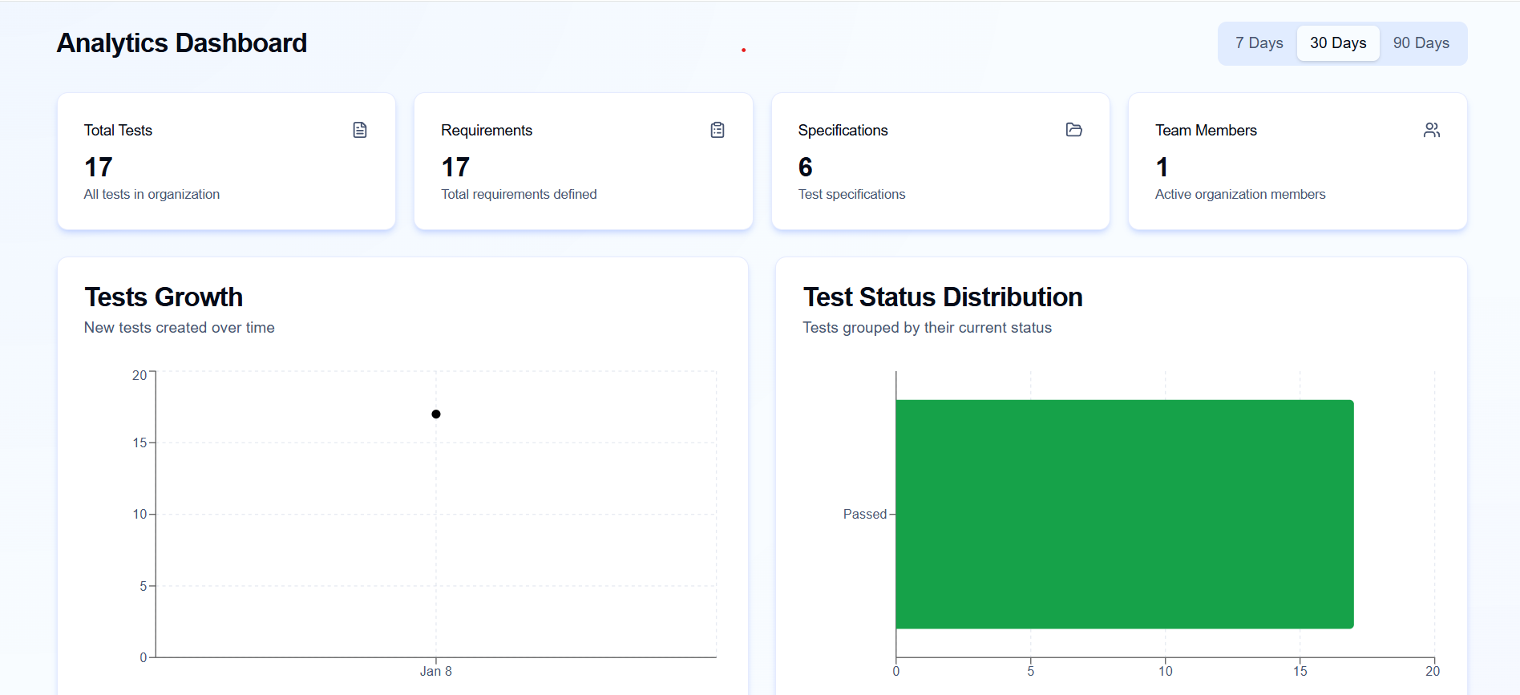
Figure A.4. Analytics (desktop).

APPENDIX B. ADDITIONAL MATERIALS
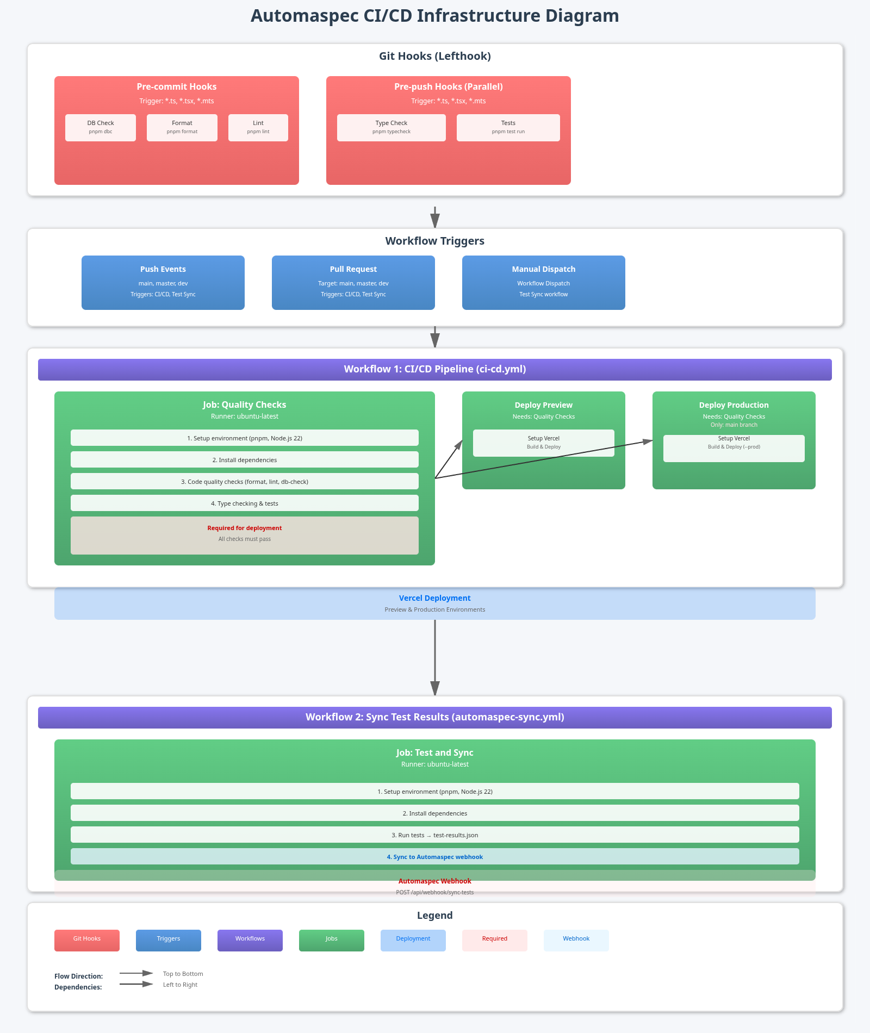
Figure B.1. CI/CD diagram.

