Date:12/2/2025

Program 1

Write a program in html implementing heading tags and paragraph tag. Also apply formatting to the paragraph.

<html>
<head>
<title> HTML Web Page </title>
</head>
<body bgcolor="beige">
<h1> Introduction to HTML </h1> <br>

<p> HTML (HyperText Markup Language) is the standard language for creating webpages.<br> It structures content using elements (tags) that define headings, paragraphs, links, images, tables, forms, and more.<br> HTML is the foundation of web development.<br>It structures web pages, integrates with CSS for styling and JavaScript for interactivity. <br> Learning HTML is the first step to becoming a web developer. </p> <I></body>
</html>

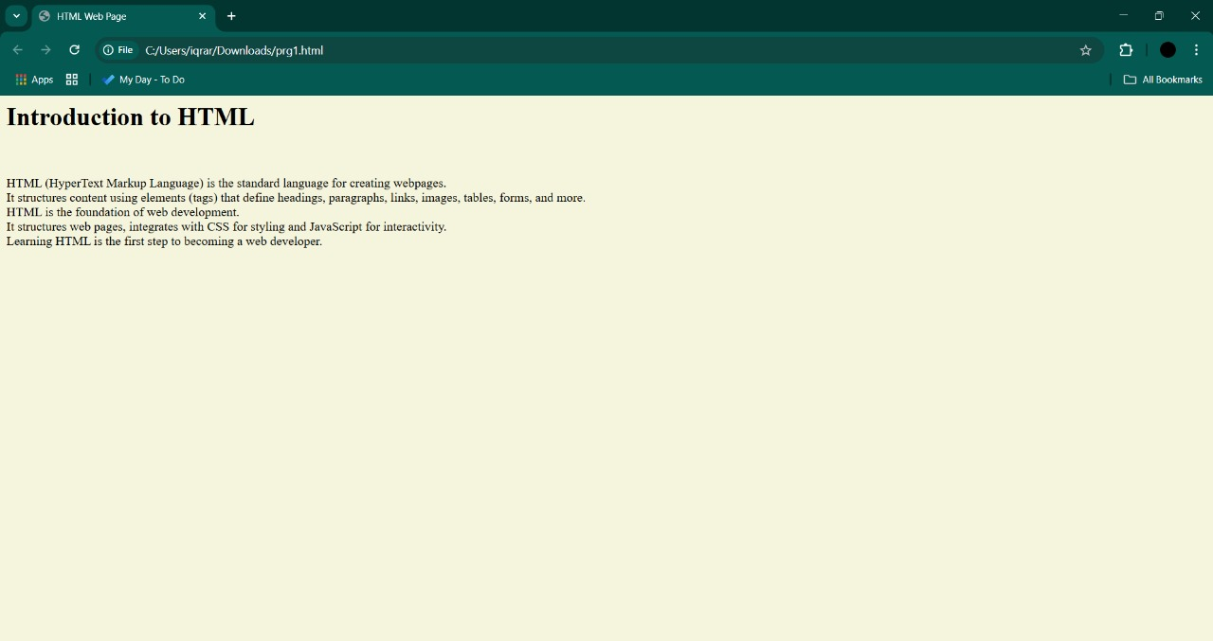
Output

Date:13/02/25

Program 2

Write an HTML program that demonstrates the following:

1. Set the background color of the webpage to yellow and the text color to red.
2. Display a paragraph using the "Arial" font, size 5, and blue color.
3. Show five lines of text using different color formats: named color , hexadecimal color, HSL color and RGB color .
4. Highlight a specific part of a sentence with a yellow background.
5. Display bold, italic, and underlined text in separate lines.

<html>
<head>
<title> HTML WEB PAGE </title>
</head>
<body bgcolor="yellow">
<h1> Introduction to HTML </h1>
<p> <font face="Arial" size="5" color="rgb(0,0,255"></font>
<font color="purple"> <b> HTML (HyperText Markup Language) is the standard language for creating webpages.</b> </font>
<font color="#000fff"> <br>It structures content using elements (tags) that define headings, paragraphs, links, images, tables, forms, and more.<br> HTML is the foundation of web development.</font>
<font color="rgb(0,0,0)" ><br> Features - </i> </font> <br> It structures web pages, integrates with CSS for styling and JavaScript for interactivity. <br> Learning HTML is the first step to becoming a web developer.<br>
<font color="hsl(36,82,561)"><u><br>HyperText →</u></font> Links between web pages.
<font color="hsl(36,82,561)"><u><br>Markup Language → </u> </font> Uses tags (p, h1, a, etc.) to format content </p>
</body> ddd
</html>

Output
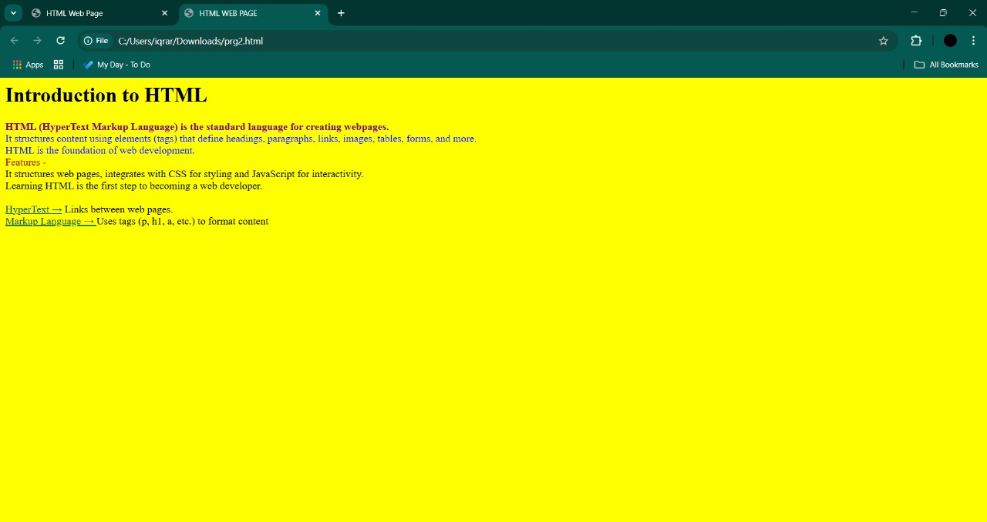

Date: 19/02/2025
Program 3

Write a program to display food menu of a restaurant using HTML lists.

<html lang="en">
<head>
<title>Restaurant Menu</title>
<style>
body {
font-family: Times New Roman, sans-serif;
}
h2 {
text-align: center; }
li {
margin-bottom: 10px; }
</style>
</head>
<body bgcolor="Beige">
<h2 style="background-color:rgb(246,224,181);"> <b>Menu <b></h2>

<h3> <u>Appestizers </u></h3>
<ul= type square>
<li> Hummus - $8.99</li>
<li> Guacamole - $10.99</li>
<li>Nachos - $7.99</li>
</ul>
<h3 > <u>Main Courses</u></h3>
<ul= type square>
<li>Chicken Parmesan - $15.99</li>
<li>Beef Wellington - $22.99</li>
<li>Pasta Carbonara - $14.99</li>
<li>Vegetable Curry - $12.99</li>
</ul>

<h3><u>Desserts</u></h3>
<ul= type square>
<li>Tiramisu - $6.99</li>
<li>Chocolate Cake - $7.99</li>
<li>Key Lime Pie - $6.99</li>
</ul>
</body>
</html>

Output
