**后端架构**

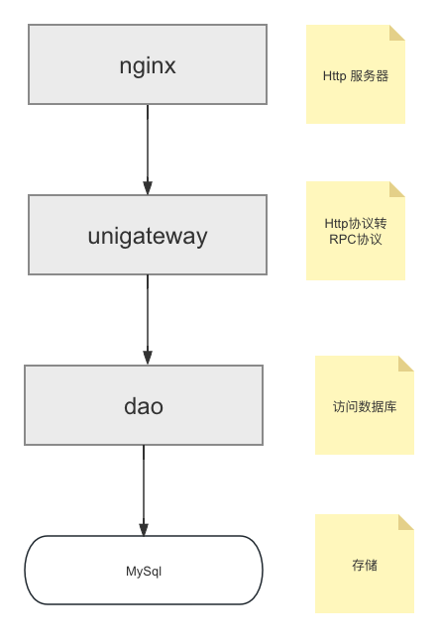

**一．nginx 部署**

配置server部分

server {

listen 443 ssl;

server_name localhost;

# ssl_certificate cert.pem;

# ssl_certificate_key cert.key;

ssl_certificate "/usr/local/nginx/xxxxxxxxx.crt";

ssl_certificate_key "/usr/local/nginx/xxxxxxx.key";

ssl_session_cache shared:SSL:1m;

ssl_session_timeout 10m;

ssl_ciphers HIGH:!aNULL:!MD5;

ssl_prefer_server_ciphers on;

# location / {

# root html;

# index index.html index.htm;

# }

location /unigame/ {

proxy_pass http://0.0.0.0:9991;

proxy_set_header Host $host;

proxy_http_version 1.1;

proxy_set_header X-real-ip $remote_addr;

proxy_set_header X-Forwarded-For $remote_addr;

}

}

**二．部署 unigateway服务**

1. multilogin.go 代码中 "AppID", "AppSecret"替换成自己小游戏的信息
2. go build 编译出 unigateway 可执行文件
3. 启动 unigateway 服务 nohup ./unigateway > /data/log/unigateway.log 2>&1 &
4. **部署 dao 服务**
5. 修改代码 tables/base.go 修改如下访问数据库的参数，使用自己的密码，IP和端口

"xmetau:Password@(127.0.0.1:3306)/xmetau?charset=utf8mb4&parseTime=True&loc=Local"

1. 编译代码，go build, 生成可执行文件dao
2. 启动dao服务 nohup ./dao > /data/log/dao.log 2>&1 &
3. **部署Mysql和建表**

1. 创建数据库 CREATE DATABASE xmetau;

2. 创建如下数据库表

// 登陆账号表

CREATE TABLE IF NOT EXISTS `T_LoginAccount`(

`FId` BIGINT UNSIGNED AUTO_INCREMENT COMMENT '主键ID',

`FUserId` BIGINT NOT NULL COMMENT '用户ID',

`FLoginType` INT NOT NULL DEFAULT '0' COMMENT '登录类型',

`FAppId` VARCHAR(32) NOT NULL DEFAULT '' COMMENT '业务ID',

`FOpenId` VARCHAR(255) NOT NULL DEFAULT '' COMMENT '业务唯一键',

`FUnionId` VARCHAR(255) NOT NULL DEFAULT '' COMMENT '业务统一键',

`FCreateTime` timestamp NOT NULL DEFAULT CURRENT_TIMESTAMP COMMENT '创建时间',

`FModifyTime` timestamp NOT NULL DEFAULT CURRENT_TIMESTAMP ON UPDATE CURRENT_TIMESTAMP COMMENT '修改时间',

PRIMARY KEY (`FId`),

UNIQUE INDEX IndexUserId(`FUserId`),

UNIQUE INDEX IndexLoginOpenId(`FOpenId`,`FAppId`),

UNIQUE INDEX IndexUnionId(`FUnionId`)

) ENGINE=InnoDB AUTO_INCREMENT=1 DEFAULT CHARSET=utf8mb4 COLLATE=utf8mb4_unicode_ci;

// 用户属性表

CREATE TABLE IF NOT EXISTS `T_UserAttribute`(

`FId` bigint(20) unsigned NOT NULL AUTO_INCREMENT COMMENT '主键ID',

`FUserId` bigint(20) NOT NULL COMMENT '用户ID',

`FNickName` varchar(512) COLLATE utf8mb4_unicode_ci NOT NULL,

`FAvatarUrl` varchar(2048) CHARACTER SET utf8 NOT NULL DEFAULT '' COMMENT '头像',

`FNoviceTraining` int(11) NOT NULL DEFAULT '0' COMMENT '是否完成新手训练',

`FPlayLevel` int(11) NOT NULL DEFAULT '0' COMMENT '棋力等级',

`FGoldCoin` int(11) NOT NULL DEFAULT '0' COMMENT '金币',

`FWinNum` int(11) NOT NULL DEFAULT '0' COMMENT '赢棋次数',

`FLoseNum` int(11) NOT NULL DEFAULT '0' COMMENT '输棋次数',

`FTieNum` int(11) NOT NULL DEFAULT '0' COMMENT '平局次数',

`FGameName` varchar(64) COLLATE utf8mb4_unicode_ci NOT NULL DEFAULT 'douzi' COMMENT '游戏名称',

`FCreateTime` timestamp NOT NULL DEFAULT CURRENT_TIMESTAMP COMMENT '创建时间',

`FModifyTime` timestamp NOT NULL DEFAULT CURRENT_TIMESTAMP ON UPDATE CURRENT_TIMESTAMP COMMENT '修改时间',

PRIMARY KEY (`FId`),

UNIQUE KEY `IndexUserId` (`FUserId`)

) ENGINE=InnoDB AUTO_INCREMENT=1 DEFAULT CHARSET=utf8mb4 COLLATE=utf8mb4_unicode_ci;

// 游戏设置表

CREATE TABLE IF NOT EXISTS `T_GameSetting` (

`FId` bigint(20) unsigned NOT NULL AUTO_INCREMENT COMMENT '主键ID',

`FSetType` int(11) unsigned NOT NULL DEFAULT '0' COMMENT '设置类型',

`FSetId` bigint(20) NOT NULL COMMENT '设置ID',

`FSetKey` varchar(128) NOT NULL DEFAULT '' COMMENT '设置Key',

`FSetValue` varchar(4096) NOT NULL DEFAULT '' COMMENT '设置值',

`FCreateTime` timestamp NOT NULL DEFAULT CURRENT_TIMESTAMP COMMENT '创建时间',

`FModifyTime` timestamp NOT NULL DEFAULT CURRENT_TIMESTAMP ON UPDATE CURRENT_TIMESTAMP COMMENT '修改时间',

PRIMARY KEY (`FId`),

UNIQUE KEY `IndexTypeUserKey` (`FSetId`,`FSetKey`,`FSetType`),

KEY `IndexUserId` (`FSetId`)

) ENGINE=InnoDB AUTO_INCREMENT=1 DEFAULT CHARSET=utf8mb4 COLLATE=utf8mb4_unicode_ci;