1 Product Overview

The RF detection device detects radio signals emitted by UAVs. Using RF spectrum analysis, AOA direction finding, protocol decoding and other technologies, it enables identification, warning and direction finding of UAVs within the detection range, and can identify and report the serial numbers of mainstream UAVs, as well as UAV position, pilot position and other information.
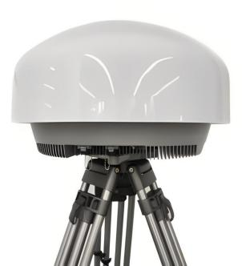
Figure 1 Fixed RF Detection Device

2 Key Features

The system provides comprehensive detection, identification, positioning and tracking of UAV radio signals.
The product offers the following main features in practical applications:
● Passive Detection
The device uses passive detection technology, receiving signals without actively transmitting. It provides high concealment and no radiation.
● Broad UAV Model Recognition
Supports recognition of mainstream consumer UAVs such as DJI and Autel, as well as modified UAVs, FPV racing drones, Wi-Fi UAVs and others.
● Blacklist and Whitelist
Allows whitelist UAVs to be added or removed, distinguishing friendly UAVs from non-friendly UAVs.
● Networked Positioning
For mainstream models, one device can locate both the UAV and its pilot. For other models,
two or more devices can be networked for positioning and tracking.
● Strong Adaptability and High Reliability
The device offers strong adaptability and high reliability. It can operate at night, in dense fog and in severe weather, and supports continuous 24/7 operation.
● Unattended Operation
With unattended operation enabled, no manual intervention is required. It automatically records the detection time, model, azimuth, UAV serial number, controller coordinates,
UAV coordinates, distance, altitude and other information for detected mainstream UAVs.

Basic Specifications
Operating Mode | RF Detection
Target Links | Uplink flight-control link; downlink video-transmission link
Operating Frequency Band | 300MHz~6GHz
Detection Response Time | ≤2s
Detection Angle | Azimuth 360°; elevation -20° to 70° for precise direction finding, -70° to 90° for accurate identification
Detection Radius | 5-10 km (varies with RF environment and target model)
Swarm Detection | ≥40 UAVs (simultaneously)
Direction-Finding Accuracy | ≤3°
Positioning Accuracy | ≤2 m (based on protocol decoding); ≤30 m (cross-positioning by two or more devices)
Total Power Consumption | 75W
Protection Rating | IP66
Operating Temperature | -45℃~+70℃
Device Dimensions | Φ590mm×H350mm
Device Weight | ≤25Kg

