[Year]

<student name/s>

<student number/s>

[Date]

<your application name>

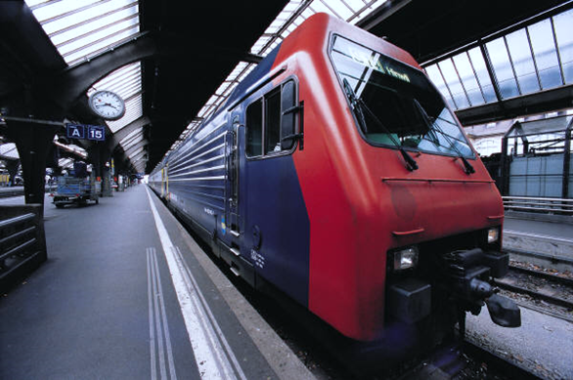

Replace image with one with some relevance to your application here

CAB432

<assignment number>

Contents

Introduction 2

Purpose & description 2

Services used 2

API 1 2

API 2 2

API n 2

Use cases 2

US 1 2

US 2 2

US n 2

Technical breakdown 3

Architecture 3

Context diagram 3

Sequence Diagram 3

Process flow Diagram 3

Network diagrams (Cloud specific) 4

Client / server demarcation of responsibilities 4

Response filtering / data object correlation 5

Test plan 6

Difficulties / Exclusions / unresolved & persistent errors 7

Extensions 7

User guide 7

References 7

Appendices as you require them 7

*This is a template for your assignment you don’t have to use it / all of it*

*Just ensure you cover all the areas to qualify for a good mark*

*This report should be around 12-15 pages including screenshots*

*Please note there are examples for previous students work in this template & examples from Google searches. They are here to give you ideas on what you can do* ***We do not guarantee their accuracy*** *You must do your own research to ensure you are producing well formed examples*

## Introduction

### Purpose & description

Professional & discursive

The why statement, explain to us the need for your app (What is it going to do that no one else is providing)

### Services used

[Need not be 3 in total for assignment 2. Check spec for assignment 1]

Overview of what API endpoints are used & what they are providing – data sources? Analysis?

#### API 1

#### API 2

#### API n

## Use cases

[Need not be 3 in total for assignment 2. Check spec for assignment 1]

Your User stories

Include a short description of the user stories and how you have implemented them – clear but not necessarily technical at this stage.

#### US 1

|  |  |
| --- | --- |
| As a |  |
| I want |  |
| So that |  |

#### US 2

|  |  |
| --- | --- |
| As a |  |
| I want |  |
| So that |  |

#### US n

|  |  |
| --- | --- |
| As a |  |
| I want |  |
| So that |  |

## Technical breakdown

### Architecture

Explain how your system operates, making it clear how data flows around the system through requests and responses.

Explain what libraries you used & what you used them for

It is very important to include Diagram/s – especially the overall architecture. Many students use diagram generators such as the tools at <https://cloudcraft.co/>. For assignment 2, this is the most important diagram used to document your approach. The ‘network diagrams’ below show some more complicated alternatives.

Below you will find some examples of the types of diagrams you could consider. Other than the architecture diagram, which is essential for assignment 2, none of these are compulsory. However, if it helps you to explain what is going on, then you should use them.

#### Context diagram

|  |  |
| --- | --- |
|  |  |

#### Sequence Diagram

|  |  |
| --- | --- |
|  | C:\Users\denbi\AppData\Local\Microsoft\Windows\INetCache\Content.MSO\5B3F0D8D.tmp |

#### Process flow Diagram

|  |  |
| --- | --- |
|  |  |

#### Network diagrams (Cloud specific)

|  |  |
| --- | --- |
|  |  |

#### Client / server demarcation of responsibilities

Explain to us what is doing what & where. Refer to the architecture diagram and any others that you find appropriate. This is particularly effective if you support your comments with well-chosen code fragments. These should be short and focused and you should give us any context that we need to work with them.

#### Response filtering / data object correlation

Show us how you manipulated the data. The same comments apply about referring to the diagrams and supporting your work with code fragments as appropriate.

*An example of how to show this diagramatically. Please note that this example is quite specific to the system being explained. Yours might have an entirely different look, but do a similar job.*



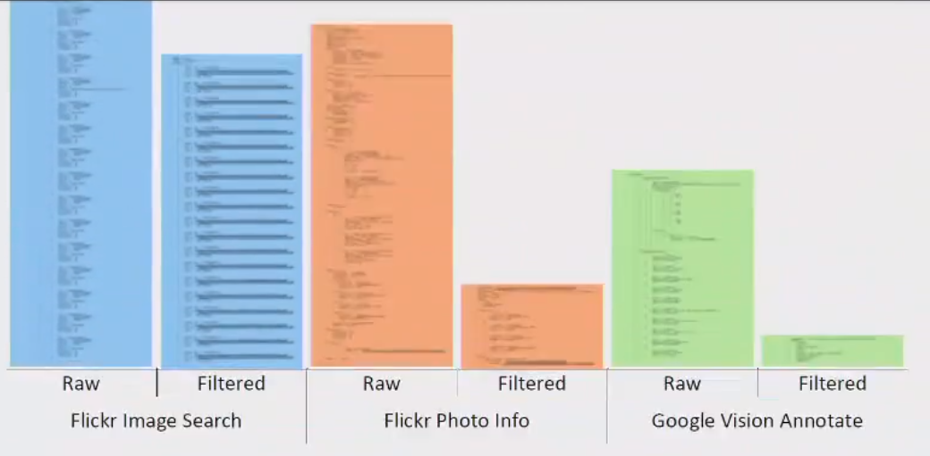

You could instead use a data relationship diagram:

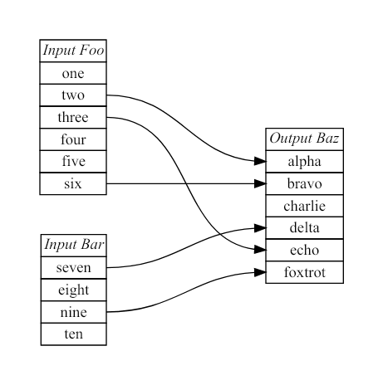

### Test plan

Manual testing is fine

A suite of tests that can be performed

Don’t forget to cover:

* Positive outcome cases
* Negative outcome cases (error scenarios)
* edge cases
* non-functional cases

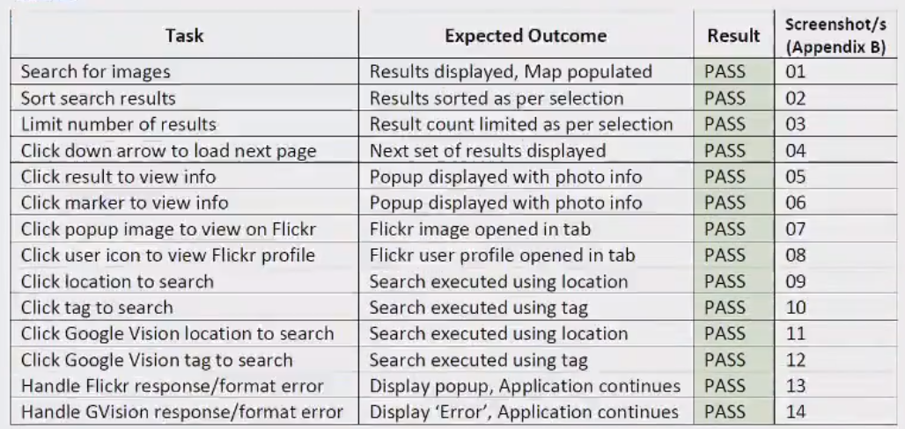

As they are common in industry you could define your *Acceptance Criteria* as *GWT statements.*  You will find a guide here: <https://www.agilealliance.org/glossary/gwt/>. Here is an example:

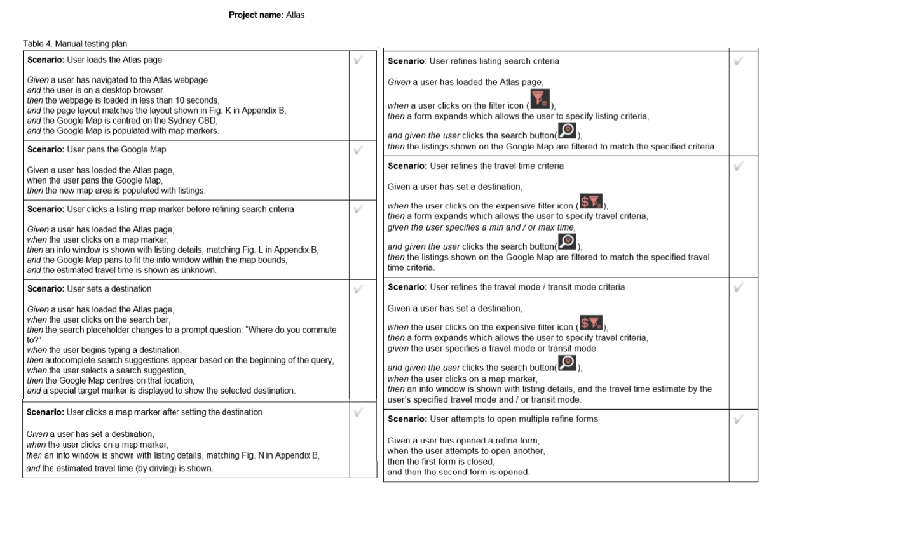

Difficulties / Exclusions / unresolved & persistent errors /

Topics to include here could be:

* What were your major roadblocks / how did you resolve them
* Any functionality you didn’t or couldn’t finish
* Is there any differences between your brief and what you delivered, explain why
* Is there any outstanding bugs

## Extensions

Where could you take this:

tell us about Potential future extensions / improvements for your app

## User guide

Tell us how to use your application

Use screenshot liberally here

## References

Don’t forget to use QUT cite

## Appendices as you require them

[Our thanks to those students who allowed us to use their work in the examples presented here.]