# TC 303801-Estimated Line Item Reimbursement Impact Summary

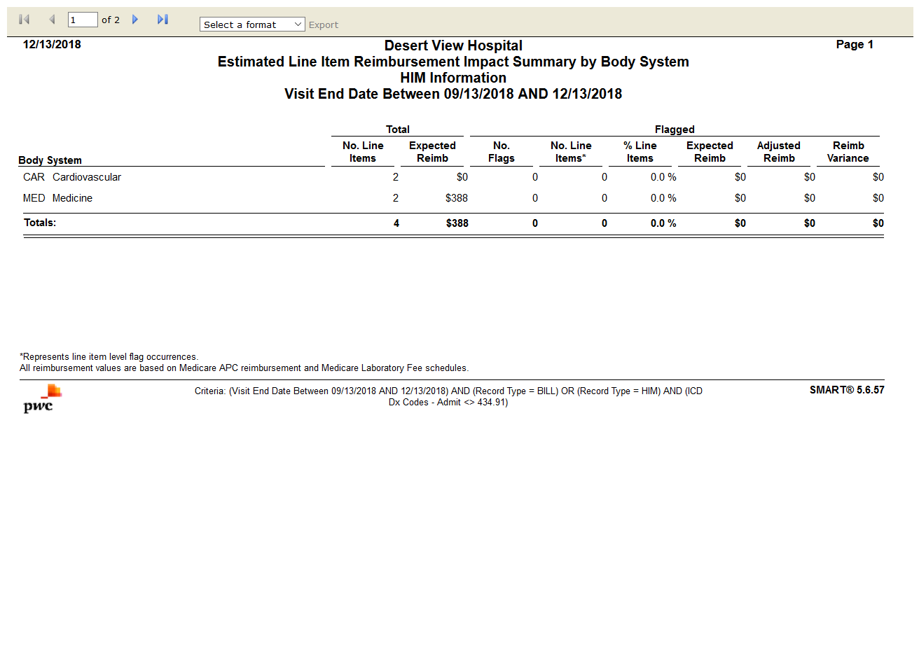

# TC 303802-Estimated Reimbursement Impact Summary

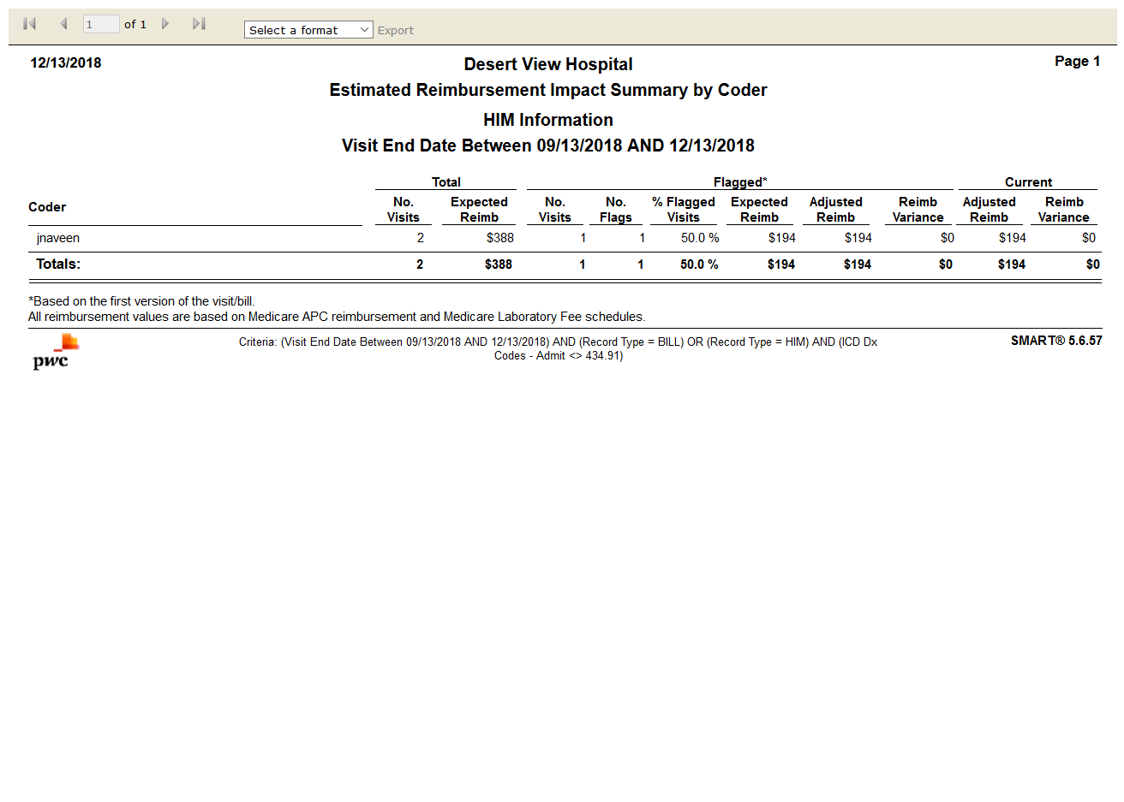

# TC 303803-Flag Comparison

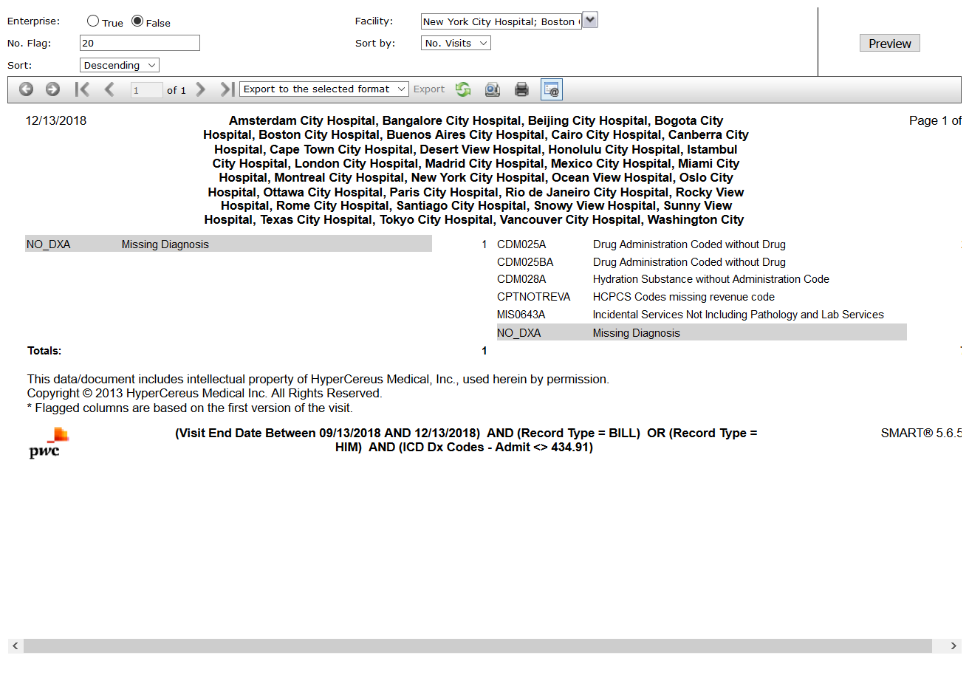

# TC 303804-Frequency Summary

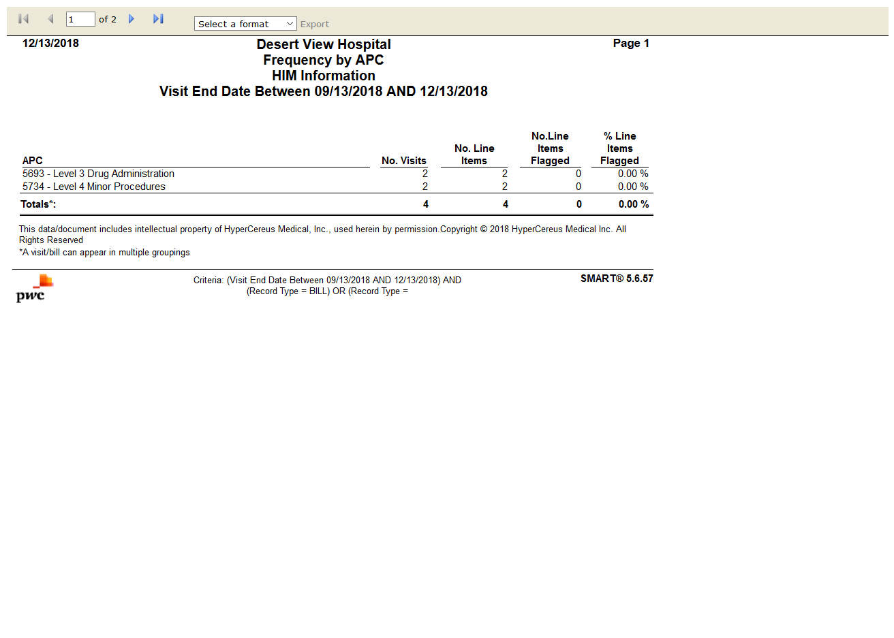

# TC 303805-Payer OCE Claim Disposition

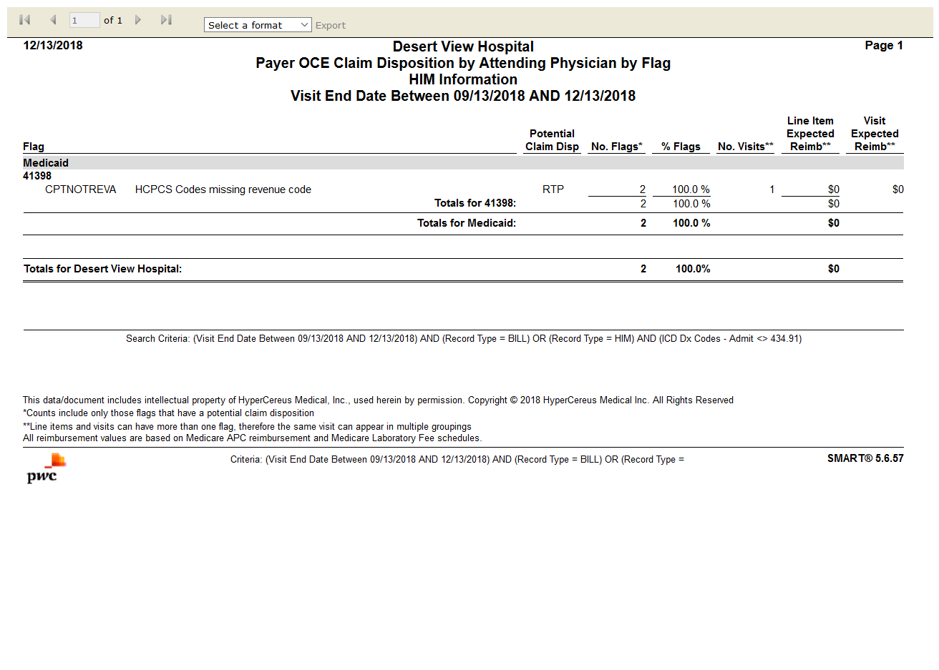

# TC 303806-Medicare Medical Necessity Flags

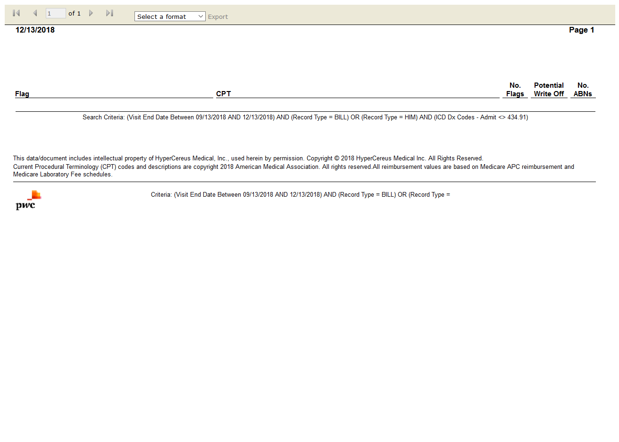

# TC 303808-Profile

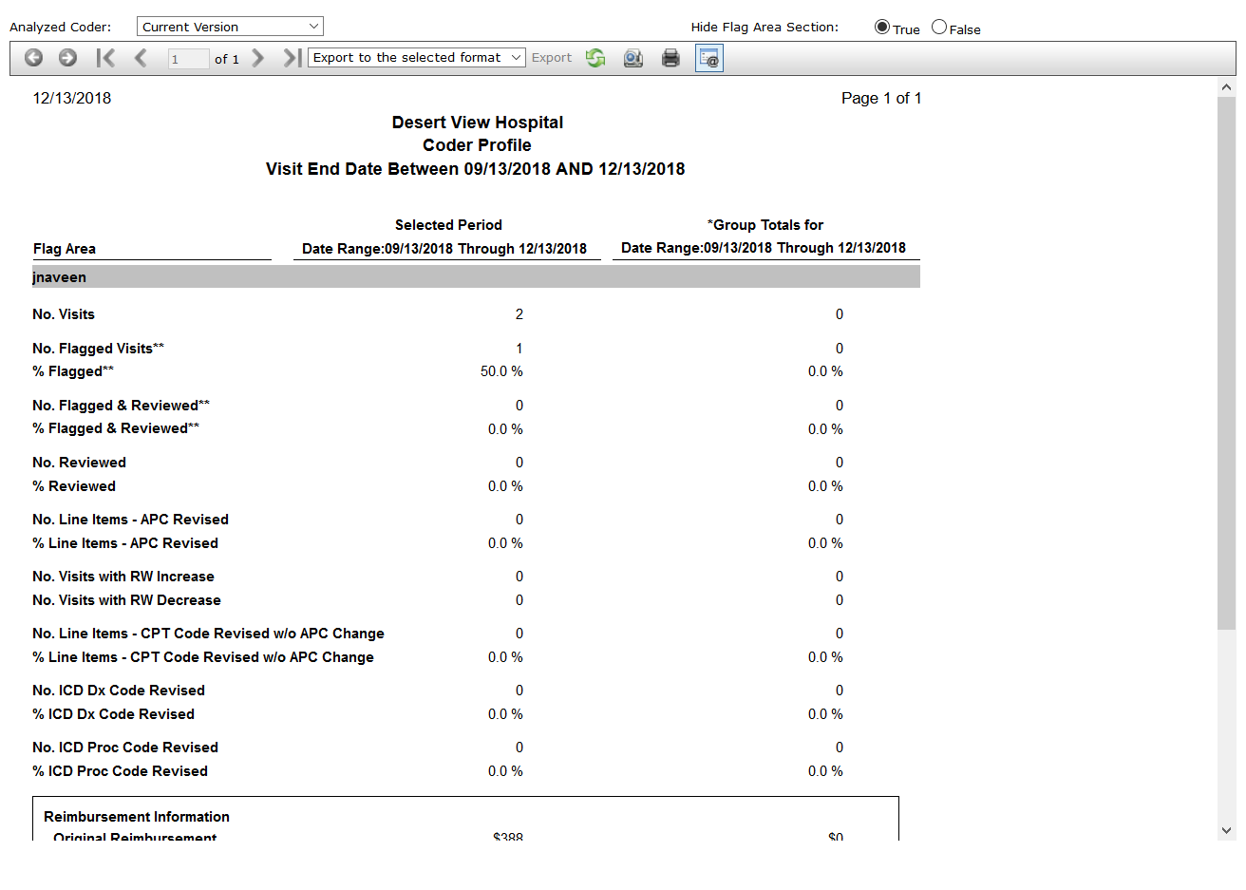

# TC 303809-Coder Profile



# TC 303810-Query Activity Report

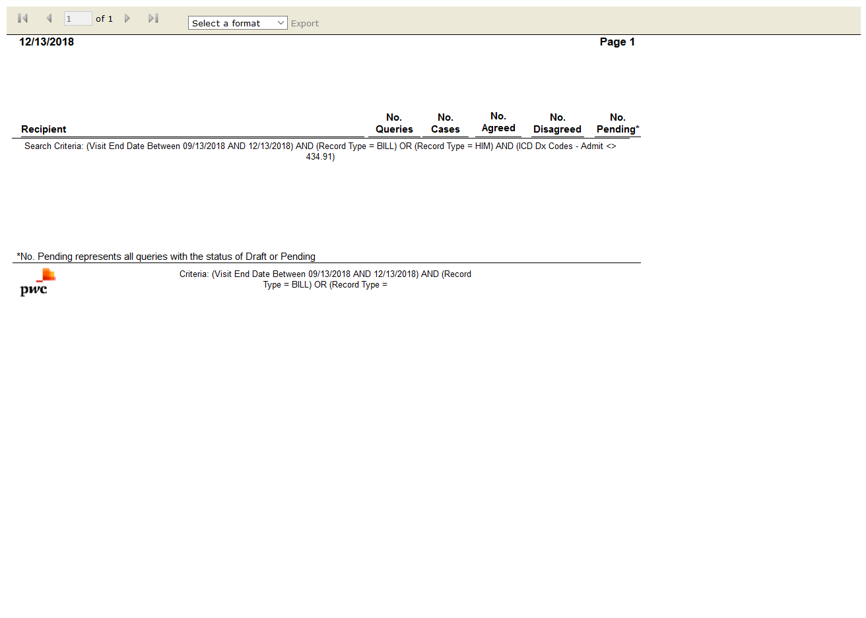

# TC 303811-Query Response Time

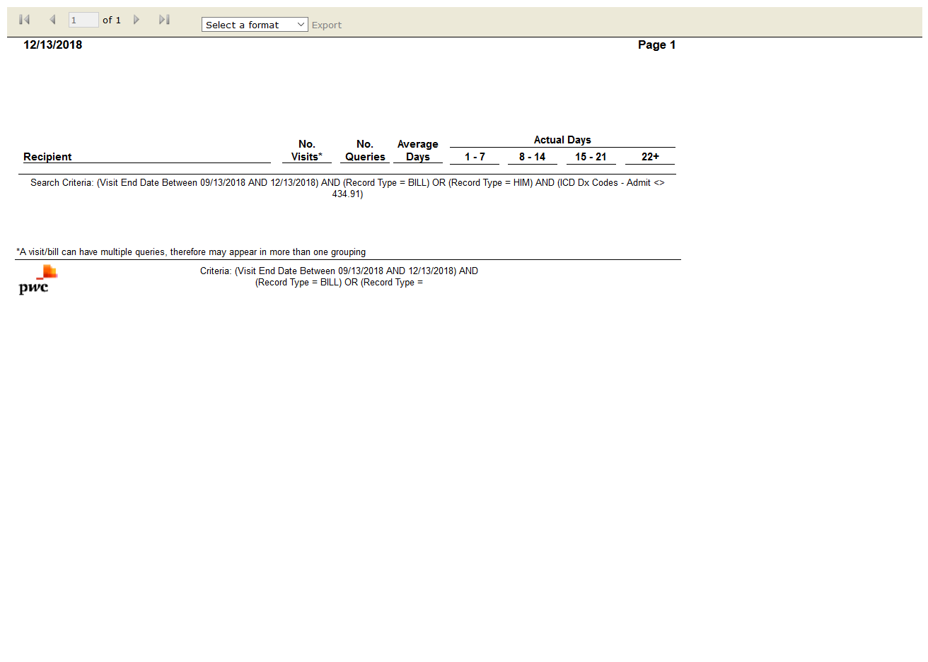

# TC 303812-Reimbursement Version Detail

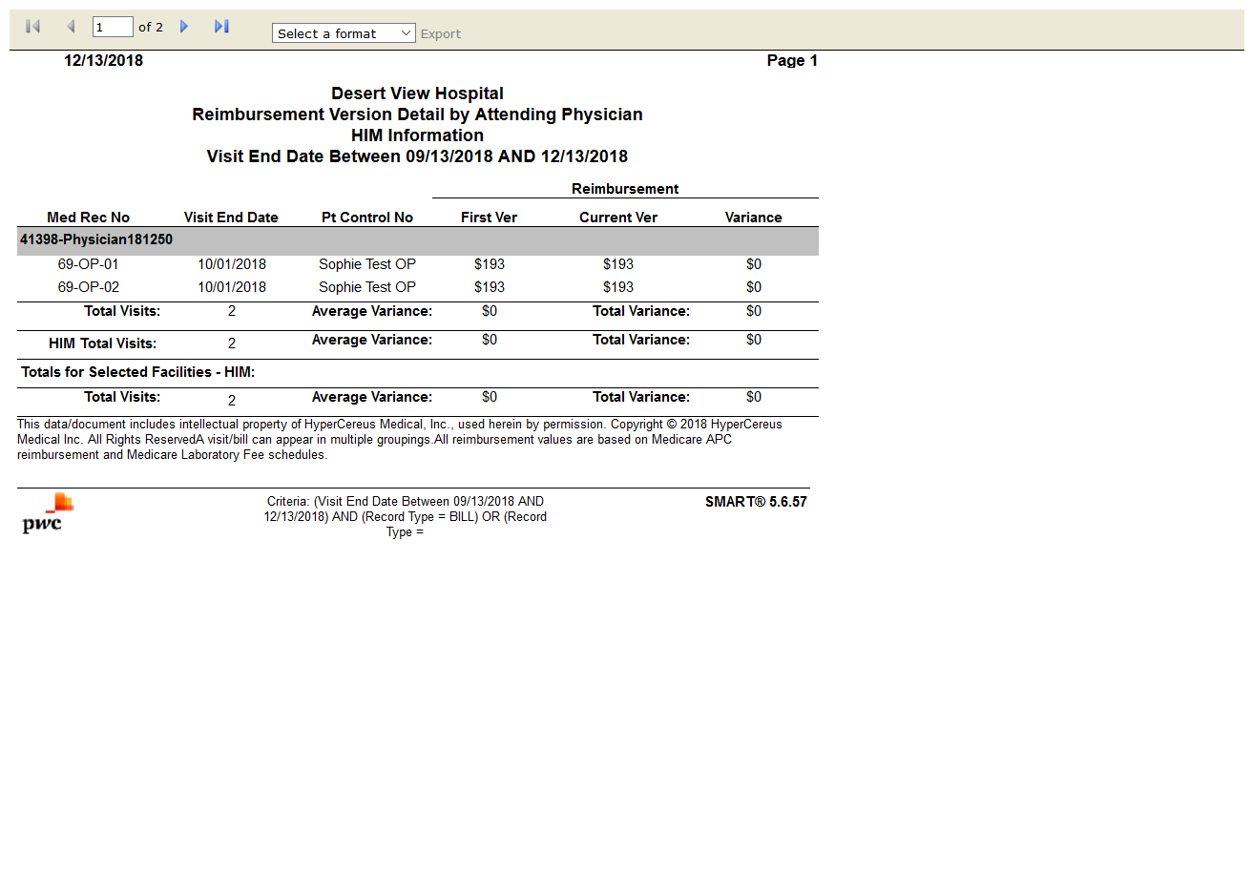

# TC 303813-Review Worksheet

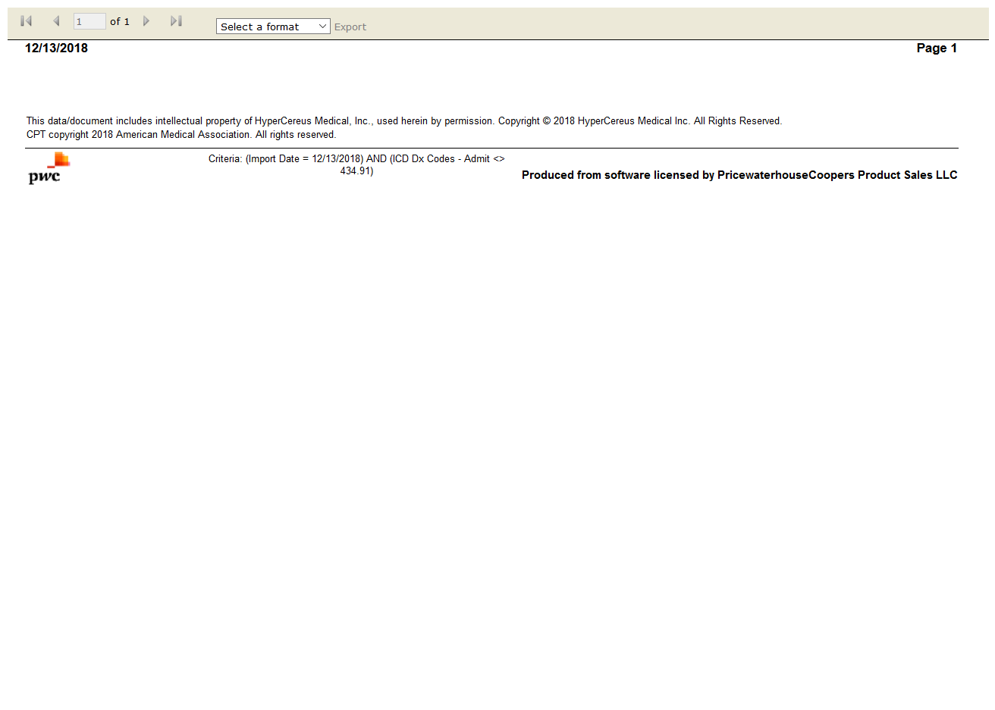

# TC 303814-Reimbursement Change Summary

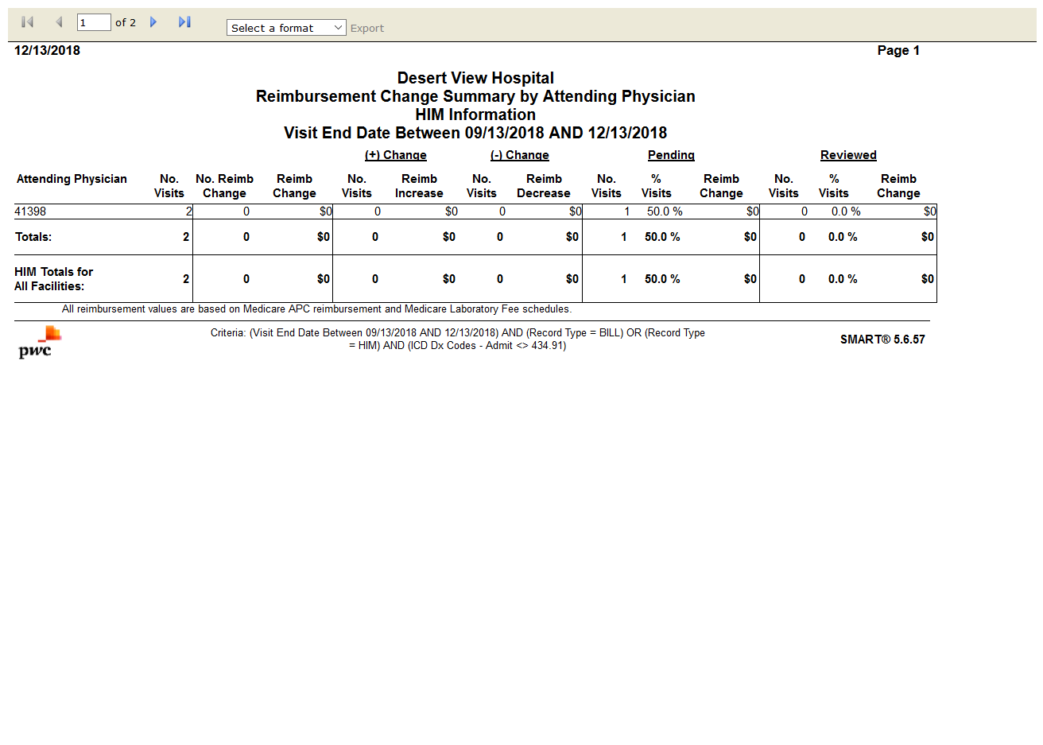

# TC 303815-SMART Reimbursement Activity by Year

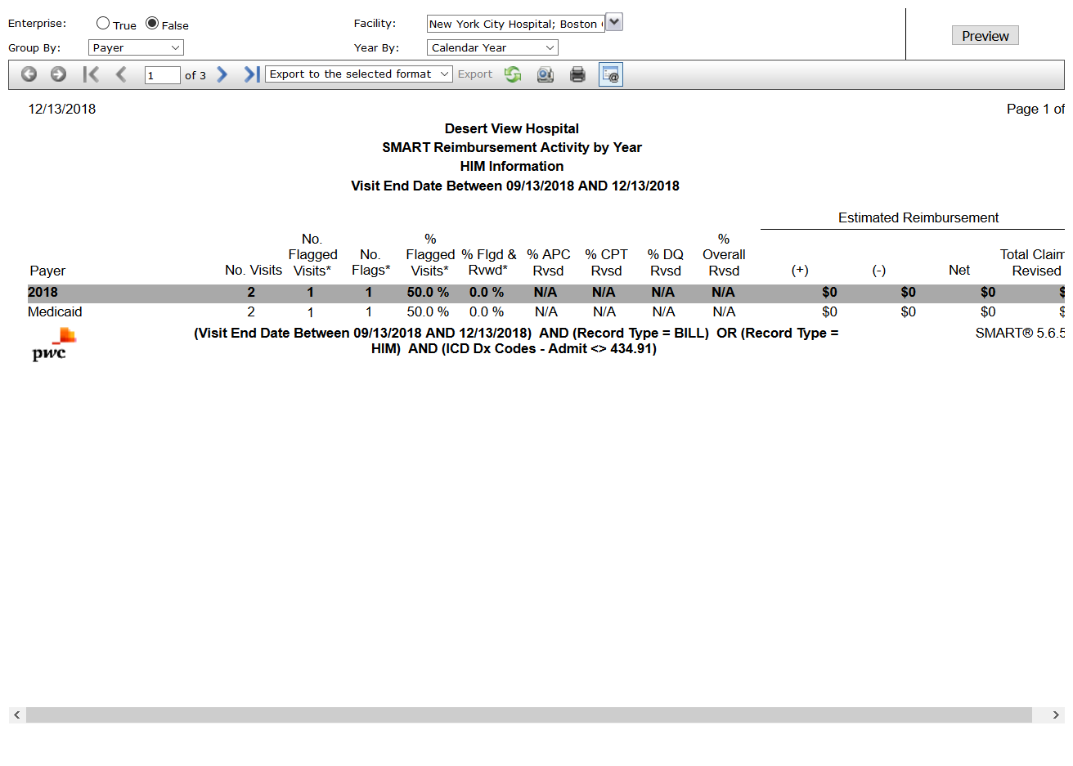

# TC 303816-Visit Change Results

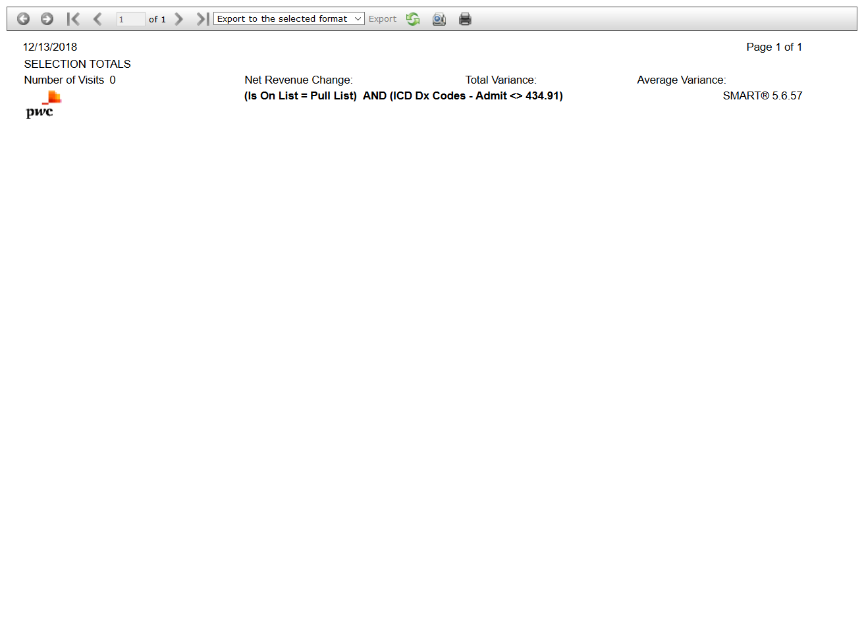

# TC 303817-Visit Flag Summary

