**Use HTMLTestRunner to generate test report treads**

tags: [Unittest test framework](http://www.programmersought.com/tag/Unittest+test+framework/" \o "Unittest test framework)  [HTMLTestRunner generates test report](http://www.programmersought.com/tag/HTMLTestRunner+generates+test+report/" \o "HTMLTestRunner generates test report)

**HTTPTestRuuner cannot generate test report in pycharm**

Refer to the tutorial and write a simple demo of fried chicken, but it can't be tested without repeated tests. code show as below:

#!/usr/bin/env python

# -*- coding:utf-8 -*-

import unittest

import HTMLTestRunner

class CaseTest(unittest.TestCase):

@classmethod

def setUpClass(cls):

print('this is setUpClass')

def setUp(self):

print('this is setUp')

def test_01(self):

print('this is case01')

# @unittest.skip('CaseTest')# Skip this case

def test_02(self):

print('this is case02')

def tearDown(self):

print('this is tearDown')

@classmethod

def tearDownClass(cls):

print('this is tearDownClass')

if __name__ == '__main__':

print('hello 123')

# unittest.main()

suite = unittest.TestSuite()

suite.addTest(CaseTest('test_02'))

suite.addTest(CaseTest('test_01'))

# unittest.TextTestRunner().run(suite)

html_file = "G:\\AppiumPython\\report\\report.html"

fp = open(html_file,'wb')

runner = HTMLTestRunner.HTMLTestRunner(

stream=fp,

title=u'testing report',

description=u'Use case execution: ')

runner.run(suite)

fp.close()

* 1
* 2
* 3
* 4
* 5
* 6
* 7
* 8
* 9
* 10
* 11
* 12
* 13
* 14
* 15
* 16
* 17
* 18
* 19
* 20
* 21
* 22
* 23
* 24
* 25
* 26
* 27
* 28
* 29
* 30
* 31
* 32
* 33
* 34
* 35
* 36
* 37
* 38
* 39
* 40
* 41
* 42
* 43

First of all, make sure that the code of your run may be different when you right-click on the run in the different places of the .py file.  
The test report was not generated above. It is likely that the code below the if statement was not executed, and then a print was added to test it. Sure enough, the print statement was not executed. Looking through the data found that pycharm executes py files in several ways:  
1, unittest framework  
2, pytest framework  
3, the default  
4, etc.  
is also related to the way the code is executed for the first time.  
Here you can do this:  
One: Click here:  
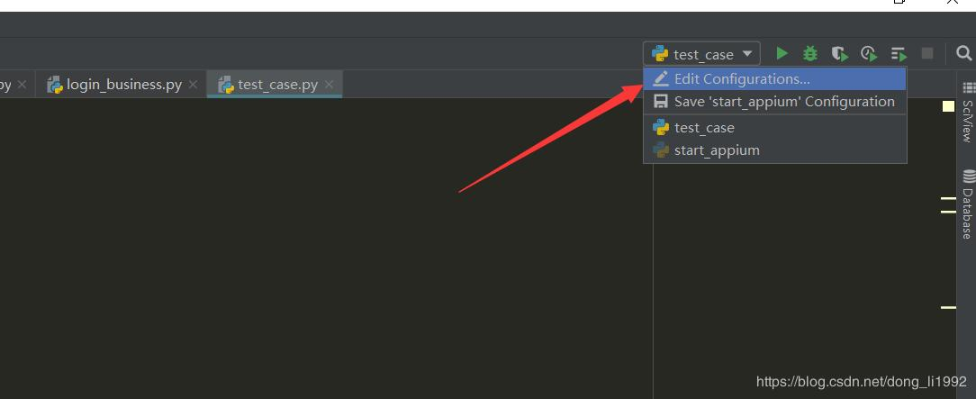  
Two: Then remove the py file below this option, all click the "-" sign to remove:  
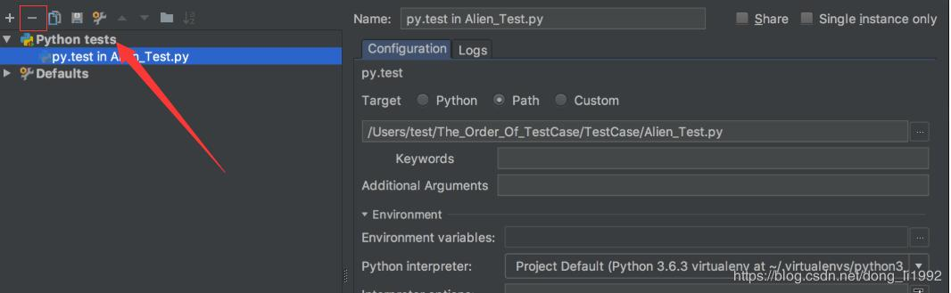  
Three: The next step is to enter the settings, find this option, you can see, you can choose the way to execute the py file, I used to use pytest, and later did not generate a test report, After the second step, in step 3, I chose unittest here and click Save.  
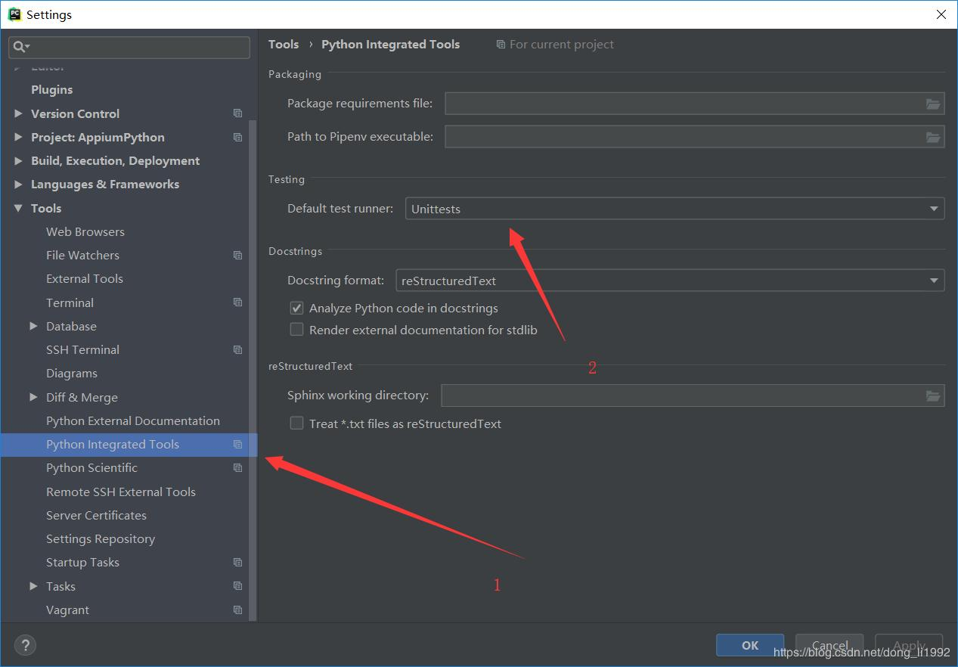  
Four: Next, click Run on the menu bar. (Note that run is the name of the py file, which is the current py file), and then you can view the test report.  
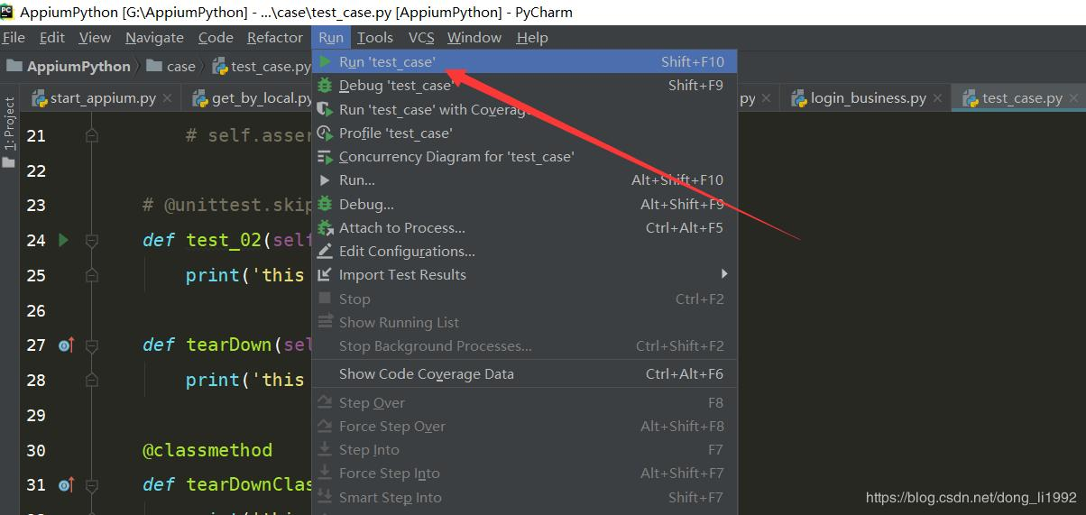  
Step 4 You also saw that there is a run below. When you click on this run, the option will come out.  
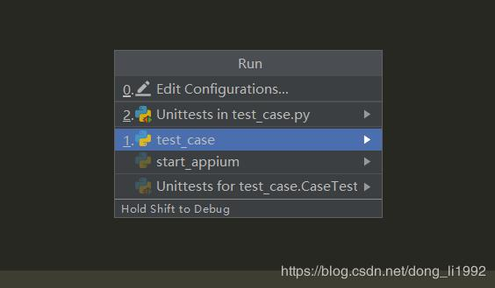  
This is back, letting you choose which mode to use to execute the py file.  
This article is written well, you can refer to the following (reproduced):<https://blog.csdn.net/chenmozhe22/article/details/81700504>