使用Ant打包apk程序
- Android程序打包过程
使用ANT来对应用打包，一般会经过以下几个步骤：
- 用aapt命令生成R.java文件
- 用aidl命令生成相应java文件
- 用javac命令编译java源文件生成class文件
- 用dx.bat将class文件转换成classes.dex文件
- 用aapt命令生成资源包文件resources.ap_
- 用apkbuilder.bat打包资源和classes.dex文件,生成unsigned.apk
- 用jarsinger命令对apk认证,生成signed.apk
- cmd到sdk\tools目录
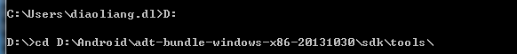

- 通过Eclipse创建一个Android工程，命名为Fdda

- 增加Ant支持
Cmd下执行指令:
D:\Android\adt-bundle-windows-x86-20131030\sdk\tools>android update project -n Fdda -t 7 -p C:\Users\Administrator\workspace\Fdda
指令的格式：
android update project -n 项目名 -t Android版本 -p 项目路径
执行完以后，刷新一下工程，工程里会出现新增两个文件。
Build.xml 和local.propertities
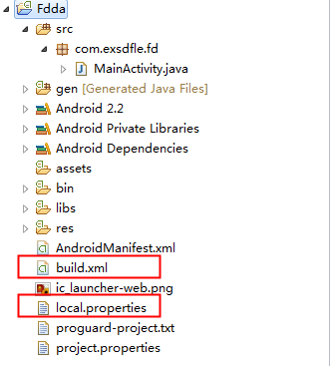
- 编写build.xml
刚生成的build.xml里的代码如下：
<?xml version="1.0" encoding="UTF-8"?>
<project name="Fdda" default="help">

<!-- The local.properties file is created and updated by the 'android' tool.
It contains the path to the SDK. It should *NOT* be checked into
Version Control Systems. -->
<property file="local.properties" />

<!-- The ant.properties file can be created by you. It is only edited by the
'android' tool to add properties to it.
This is the place to change some Ant specific build properties.
Here are some properties you may want to change/update:

source.dir
The name of the source directory. Default is 'src'.
out.dir
The name of the output directory. Default is 'bin'.

For other overridable properties, look at the beginning of the rules
files in the SDK, at tools/ant/build.xml

Properties related to the SDK location or the project target should
be updated using the 'android' tool with the 'update' action.

This file is an integral part of the build system for your
application and should be checked into Version Control Systems.

-->
<property file="ant.properties" />

<!-- if sdk.dir was not set from one of the property file, then
get it from the ANDROID_HOME env var.
This must be done before we load project.properties since
the proguard config can use sdk.dir -->
<property environment="env" />
<condition property="sdk.dir" value="${env.ANDROID_HOME}">
<isset property="env.ANDROID_HOME" />
</condition>
<!-- The project.properties file is created and updated by the 'android'
tool, as well as ADT.

This contains project specific properties such as project target, and library
dependencies. Lower level build properties are stored in ant.properties
(or in .classpath for Eclipse projects).

This file is an integral part of the build system for your
application and should be checked into Version Control Systems. -->
<loadproperties srcFile="project.properties" />

<!-- quick check on sdk.dir -->
<fail
message="sdk.dir is missing. Make sure to generate local.properties using 'android update project' or to inject it through the ANDROID_HOME environment variable."
unless="sdk.dir"
/>

<!--
Import per project custom build rules if present at the root of the project.
This is the place to put custom intermediary targets such as:
-pre-build
-pre-compile
-post-compile (This is typically used for code obfuscation.
Compiled code location: ${out.classes.absolute.dir}
If this is not done in place, override ${out.dex.input.absolute.dir})
-post-package
-post-build
-pre-clean
-->
<import file="custom_rules.xml" optional="true" />

<!-- Import the actual build file.

To customize existing targets, there are two options:
- Customize only one target:
- copy/paste the target into this file, *before* the
<import> task.
- customize it to your needs.
- Customize the whole content of build.xml
- copy/paste the content of the rules files (minus the top node)
into this file, replacing the <import> task.
- customize to your needs.

***********************
****** IMPORTANT ******
***********************
In all cases you must update the value of version-tag below to read 'custom' instead of an integer,
in order to avoid having your file be overridden by tools such as "android update project"
-->
<!-- version-tag: 1 -->
<import file="${sdk.dir}/tools/ant/build.xml" />
</project>

编写build.xml前，先在local.properties中定义要用到的变量，包括编译过程中的输出目录，输出文件名称，以及混淆代码的配置文件路径，编译命令的路径等。具体代码如下：
# This file is automatically generated by Android Tools.
# Do not modify this file -- YOUR CHANGES WILL BE ERASED!
#
# This file must *NOT* be checked into Version Control Systems,
# as it contains information specific to your local configuration.

# location of the SDK. This is only used by Ant
# For customization when using a Version Control System, please read the
# header note.

#SDK
sdk-dir=D:\\Android\\adt-bundle-windows-x86-20131030\\sdk
#proguard.jar path
proguard=D:\\Android\\proguard\\lib\\proguard.jar
#jarsiger
jarsigner=C:\\Program Files (x86)\\Java\\jdk1.6.0_10\\bin\\jarsigner.exe
#key path
keystore=D:\\Android\\keystore\\Fdda.keystore
keyalias=Fdda.keystore
password=1060220789
#resource file path
res-dir=res
#Manifest file path
manifest-file=AndroidManifest.xml
#UA smartphone type
UA=totphone
#assets file path
assets-dir=assets
#output path
out-release-dir=D:\\output
#Version num
TYSX_VER=1.0.0.0
#android version
android_ver=AD23
#apk file name
#ToT-UA-VersionNum-android version
release-apk-file=ToT-${UA}-${TYSX_VER}-MH-${android_ver}.apk

JAVA_HOME=C:\\Program Files (x86)\\Java\\jdk1.6.0_10
# location of the SDK. This is only used by Ant
# For customization when using a Version Control System, please read the
# header note.
sdk.dir=D:\\Android\\adt-bundle-windows-x86-20131030\\sdk

然后编写build.xml，具体代码如下，
<?xml version="1.0" encoding="UTF-8"?>
<project name="Fdda" default="release" >
<!-- 指定配置文件 -->
<property file="project.properties" />
<property file="local.properties" />

<!-- 定义工具目录 -->
<property name="sdk.dir" value="${sdk-dir}" />
<property name="android.tools.dir" value="${sdk.dir}/tools" />
<property name="android.platformtools.dir" value="${sdk.dir}/platform-tools" />
<property name="android.platforms.dir" value="${sdk.dir}/platforms/${target}" />

<property name="android.tools.absolute.dir" location="${android.tools.dir}" />
<property name="android.platformtools.absolute.dir" location="${android.platformtools.dir}" />
<property name="android.platforms.absolute.dir" location="${android.platforms.dir}" />

<!-- 定义工具
<property name="verbose" value="false" />-->
<condition property="exe" value=".exe" else="">
<os family="windows" />
</condition>
<property name="jar.proguard" value="${proguard}" />
<property name="jar.android" value="${android.platforms.absolute.dir}/android.jar" />
<property name="tools.dx" value="${android.platformtools.absolute.dir}/dx.bat" />
<property name="tools.apkbuilder" value="${android.tools.absolute.dir}/apkbuilder.bat" />
<property name="tools.adb" value="${android.tools.absolute.dir}/adb${exe}" />
<property name="tools.zipalign" value="${android.tools.absolute.dir}/zipalign${exe}" />
<property name="tools.aapt" value="${android.platformtools.absolute.dir}/aapt${exe}" />
<!--<property name="tools.aidl" value="${android.platformtools.absolute.dir}/aidl${exe}" />-->
<property name="tools.jarsigner" value="${JAVA_HOME}/bin/jarsigner${exe}" />

<!-- 定义引入工具库
<path id="android.antlibs">
<pathelement path="${sdk.dir}/tools/lib/anttasks.jar" />
<pathelement path="${sdk.dir}/tools/lib/sdklib.jar" />
<pathelement path="${sdk.dir}/tools/lib/androidprefs.jar" />
<pathelement path="${sdk.dir}/tools/lib/apkbuilder.jar" />
<pathelement path="${sdk.dir}/tools/lib/jarutils.jar" />
</path>

定义任务
<taskdef name="aaptexec" classname="com.android.ant.AaptExecLoopTask" classpathref="android.antlibs" />
<taskdef name="apkbuilder" classname="com.android.ant.ApkBuilderTask" classpathref="android.antlibs" />
<taskdef name="xpath" classname="com.android.ant.XPathTask" classpathref="android.antlibs" />
-->

<!-- 定义源代码及资源等输入目录 -->
<property name="in.source.dir" value="src" />
<property name="in.resource.dir" value="${res-dir}" />
<property name="in.asset.dir" value="${assets-dir}" />

<property name="in.source.absolute.dir" location="${in.source.dir}" />
<property name="in.resource.absolute.dir" location="${in.resource.dir}" />
<property name="in.asset.absolute.dir" location="${in.asset.dir}" />

<!-- 定义本地库/第三方工具库文件目录 -->
<property name="in.external.libs.dir" value="libs" />
<property name="in.native.libs.dir" value="libs" />

<property name="in.external.libs.absolute.dir" location="${in.external.libs.dir}" />
<property name="in.native.libs.absolute.dir" location="${in.native.libs.dir}" />

<!-- 定义输入文件 -->
<property name="in.manifest.file" value="${manifest-file}" />
<!--<property name="in.android.aidl.file" value="${android.platforms.dir}/framework.aidl" />-->

<property name="in.manifest.absolute.file" location="${in.manifest.file}" />
<!--<property name="in.android.aidl.absolute.file" location="${in.android.aidl.file}" />-->

<!-- 定义输出文件目录 -->
<property name="out.gen.dir" value="gen" />
<property name="out.dir" value="bin" />
<property name="out.classes.dir" value="${out.dir}/classes" />

<property name="out.gen.absolute.dir" location="${out.gen.dir}" />
<property name="out.absolute.dir" location="${out.dir}" />
<property name="out.classes.absolute.dir" location="${out.classes.dir}" />
<property name="release.absolute.dir" location="${release-dir}" />

<!-- 定义输出文件 -->
<property name="out.dex.file" value="${ant.project.name}-classes.dex" />
<property name="out.resource.package.file" value="${ant.project.name}-resource.apk" />
<property name="out.unsigned.package.file" value="${ant.project.name}-unsigned.apk" />
<property name="out.signed.package.file" value="${ant.project.name}-signed.apk" />
<property name="out.aligned.package.file" value="${ant.project.name}-aligned.apk" />
<property name="release.package.file" value="${release-apk-file}" />

<property name="out.dex.absolute.file" location="${out.dir}/${out.dex.file}" />
<property name="out.resource.package.absolute.file" location="${out.dir}/${out.resource.package.file}" />
<property name="out.unsigned.package.absolute.file" location="${out.dir}/${out.unsigned.package.file}" />
<property name="out.signed.package.absolute.file" location="${out.dir}/${out.signed.package.file}" />
<property name="out.aligned.package.absolute.file" location="${out.dir}/${out.aligned.package.file}" />
<property name="release.package.absolute.file" location="${release.absolute.dir}/${release.package.file}" />

<target name="-clean">
<echo>Creating output directories if needed...</echo>
<delete dir="${out.absolute.dir}" />
<delete dir="${out.gen.absolute.dir}" />
</target>

<target name="-dirs" depends="-clean">
<echo>Creating output directories if needed...</echo>
<mkdir dir="${in.resource.absolute.dir}" />
<mkdir dir="${in.external.libs.absolute.dir}" />
<mkdir dir="${out.gen.absolute.dir}" />
<mkdir dir="${out.absolute.dir}" />
<mkdir dir="${out.classes.absolute.dir}" />
</target>

<!--
第一步 生成R.java类文件：
Eclipse中会自动生成R.java，ant和命令行使用android SDK提供的aapt.ext程序生成R.java。
-->
<target name="-resource-src" depends="-dirs">
<echo>Generating R.java / Manifest.java from the resources...</echo>
<exec executable="${tools.aapt}" failonerror="true">
<arg value="package" />
<arg value="-m" />
<arg value="-J" />
<arg path="${out.gen.absolute.dir}" />
<arg value="-M" />
<arg path="${in.manifest.absolute.file}" />
<arg value="-S" />
<arg path="${in.resource.absolute.dir}" />
<arg value="-I" />
<arg path="${jar.android}" />
</exec>
</target>

<!--
第二步 将.aidl文件生成.java类文件：
Eclipse中自动生成，ant和命令行使用android SDK提供的aidl.exe生成.java文件。
-->
<!-- Generates java classes from .aidl files.
<target name="-aidl" depends="-dirs">
<echo>Compiling aidl files into Java classes...</echo>
<apply executable="${tools.aidl}" failonerror="true">
<arg value="-p${in.android.aidl.file}" />
<arg value="-I${in.source.absolute.dir}" />
<arg value="-o${out.gen.absolute.dir}" />
<fileset dir="${in.source.absolute.dir}">
<include name="**/*.aidl" />
</fileset>
</apply>
</target>
-->
<!--
第三步 编译.java类文件生成class文件：
Eclipse中自动生成，ant和命令行使用jdk的javac编译java类文件生成class文件。
-->
<!-- Compiles this project's .java files into .class files. -->
<target name="compile" depends="-resource-src" >
<echo>Compiles project's .java files into .class files</echo>
<javac encoding="utf-8" target="1.5" debug="true" extdirs="" srcdir="."
destdir="${out.classes.absolute.dir}" bootclasspath="${jar.android}">
<classpath>
<fileset dir="${in.external.libs.absolute.dir}" includes="*.jar" />
<fileset dir="${in.external.libs.absolute.dir}" includes="*.zip" />
</classpath>
</javac>
</target>

<!--执行代码混淆和优化 必须在java文件编译以后-->
<target name="optimize" depends="compile">
<echo>optimize classes are put to "${out.absolute.dir}" .</echo>
<jar basedir="${out.classes.absolute.dir}" destfile="${out.absolute.dir}/temp.jar"/>
<taskdef resource="proguard/ant/task.properties" classpath="${jar.proguard}" />
<proguard>
-injars ${out.absolute.dir}/temp.jar
-outjars ${out.absolute.dir}/optimized.jar
-libraryjars ${jar.android}
-optimizationpasses 5
-dontskipnonpubliclibraryclasses
-dontpreverify
-verbose
-optimizations !code/simplification/arithmetic,!field/*,!class/merging/*
-include proguard-project.txt
</proguard>
<delete file="${out.absolute.dir}/temp.jar"/>
<delete dir="${out.classes.dir}" failonerror="false" />
<mkdir dir="${out.classes.dir}"/>
<unzip src="${out.absolute.dir}/optimized.jar" dest="${out.classes.absolute.dir}"/>
<delete file="${out.absolute.dir}/optimized.jar"/>
</target>

<!--
第四步 将class文件打包生成classes.dex文件：
Eclipse中自动生成,ant和命令行使用android SDK提供的dx.bat命令行脚本生成classes.dex文件。
-->
<target name="dex" depends="optimize">
<echo>Converting compiled files and external libraries into ${out.absolute.dir}/${out.dex.file} ...</echo>
<apply executable="${tools.dx}" failonerror="true" parallel="true">
<arg value="--dex" />
<arg value="--output=${out.dex.absolute.file}" />
<arg path="${out.classes.absolute.dir}" />
<fileset dir="${in.external.libs.absolute.dir}" includes="*.jar"/>
</apply>
<!-- <delete dir="${out.classes.absolute.dir}"/> -->
</target>

<!--
第五步 打包资源文件（包括res、assets、androidmanifest.xml等）：
Eclipse中自动生成,ant和命令行使用Android SDK提供的aapt.exe生成资源包文件。
-->
<target name="package-resource">
<echo>Packaging resources and assets ${out.resource.package.absolute.file} ...</echo>
<exec executable="${tools.aapt}" failonerror="true">
<arg value="package" />
<arg value="-f" />
<arg value="-M" />
<arg value="${in.manifest.file}" />
<arg value="-S" />
<arg value="${in.resource.absolute.dir}" />
<arg value="-A" />
<arg value="${in.asset.absolute.dir}" />
<arg value="-I" />
<arg value="${jar.android}" />
<arg value="-F" />
<arg value="${out.resource.package.absolute.file}" />
</exec>
</target>

<!--
第六步 生成未签名的apk安装文件：
Eclipse中自动生成debug签名文件存放在bin目录中，ant和命令行使用android SDK提供的apkbuilder.bat命令脚本生成未签名的apk安装文件。
-->
<target name="package" depends="dex, package-resource">
<echo>Packaging ${out.unsigned.package.absolute.file} for release...</echo>
<java classpath="${android.tools.dir}/lib/sdklib.jar" classname="com.android.sdklib.build.ApkBuilderMain">
<arg value="${out.unsigned.package.absolute.file}" />
<arg value="-u" />
<arg value="-z" />
<arg value="${out.resource.package.absolute.file}" />
<arg value="-f" />
<arg value="${out.dex.absolute.file}" />
<arg value="-rf" />
<arg value="${in.source.absolute.dir}" />
<arg value="-rj" />
<arg value="${in.external.libs.absolute.dir}" />
</java>
<echo>It will need to be signed with jarsigner before being published.</echo>
<!-- <delete file="${out.resource.package.absolute.file}" />
<delete file="${out.dex.absolute.file}" /> -->
</target>

<!--
第七步 对未签名的apk进行签名生成签名后的android文件：
-->
<target name="jarsigner" depends="package">
<echo>Packaging ${out.unsigned.package.absolute.file} for release...</echo>
<exec executable="${tools.jarsigner}" failonerror="true">
<arg value="-keystore" />
<arg value="${keystore}" />
<arg value="-storepass" />
<arg value="${password}" />
<arg value="-keypass" />
<arg value="${password}" />
<arg value="-signedjar" />
<arg value="${out.signed.package.absolute.file}" />
<arg value="${out.unsigned.package.absolute.file}" />
<arg value="${keyalias}" />
</exec>
<!-- <delete file="${out.unsigned.package.absolute.file}" /> -->
</target>

<!--
第八步 签名的文件进行字节对齐；
Zipalign就是一个对Apk文件进行存档对齐的优化工具，
它的目的是确保所有的未压缩数据都从文件的开始位置以
指定的对齐方式排列。尤其是.apk压缩包中的图片资源
和未加工处理的相关文件，对齐的方式是以4字节对齐。
其好处是能够减少应用程序的RAM内存资源消耗
-->
<target name="zipalign" depends="jarsigner">
<echo>Zipalign ${out.aligned.package.absolute.file} for release...</echo>
<exec executable="${tools.zipalign}">
<arg value="-f" />
<arg value="-v" />
<arg value="4" />
<arg value="${out.signed.package.absolute.file}" />
<arg value="${out.aligned.package.absolute.file}" />
</exec>
<!-- <delete file="${out.signed.package.absolute.file}" /> -->
</target>

<!--
第九步 发布签名后的apk；
-->
<target name="release" depends="zipalign">
<copy tofile="${release.package.absolute.file}">
<fileset dir="${out.absolute.dir}" includes="${out.aligned.package.file}"/>
</copy>
<!-- <delete file="${out.aligned.package.absolute.file}" /> -->
</target>
</project>

- 打包应用
选中build.xml文件，右击选择run as，再选择Ant build即可开始打包
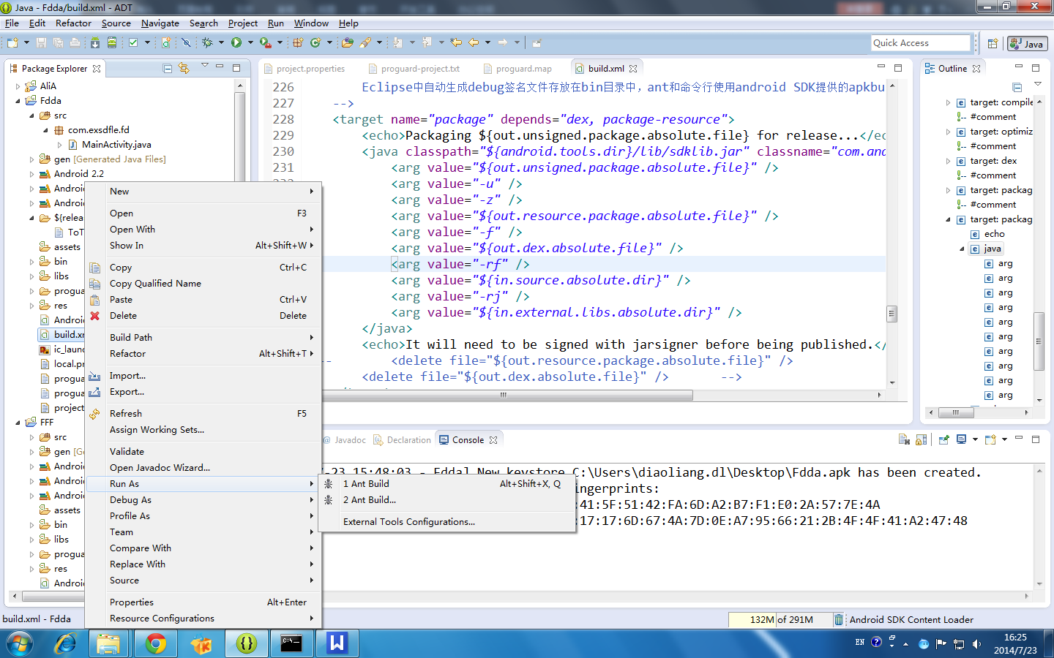
打包结束后，刷新整个工程，在release-dir文件夹下会查看到打包好的apk。
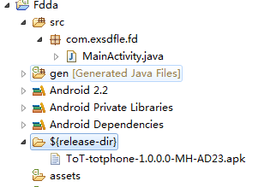
错误搜集：
Error1：路径错误，找不到指定的命令
BUILD FAILED
C:\Users\Administrator\workspace\Fdda\build.xml:117: Execute failed: java.io.IOException: Cannot run program "D:\Android\android-sdk-windows\platform-tools\aapt.exe":
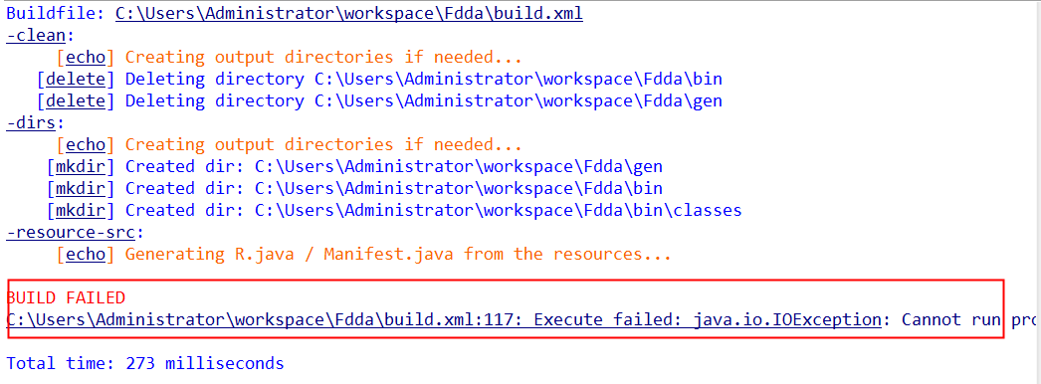
写错了路径，aapt命令的路径在我的本机的
adt-bundle-windows-x86-20131030\\sdk文件夹下，要多一串数字。

解决办法：
单击出错信息，红框标注的地方，会跳转到找不到命令的地方，
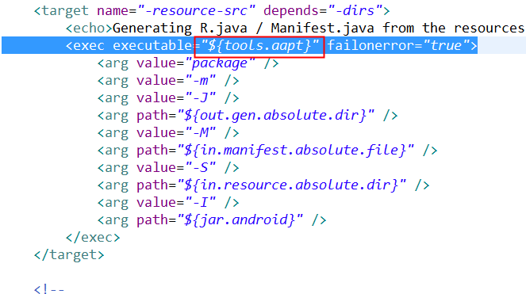
再次查找变量tools.aapt，
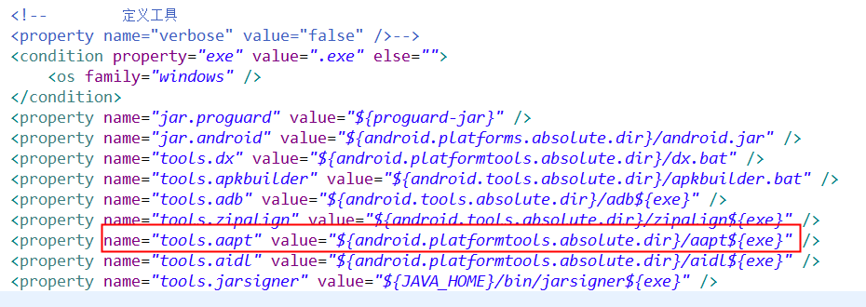
再查找android.platformtools.absolute.dir
再查找android.platformtools.dir
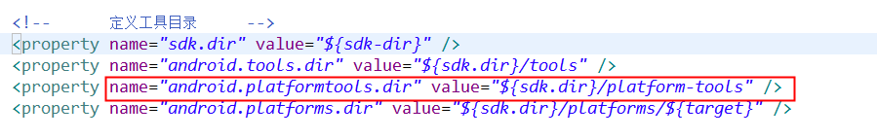
再查找sdk.dir
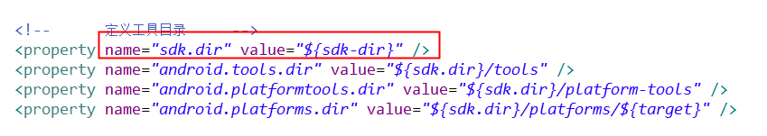
再到local.properties文件中查找sdk-dir
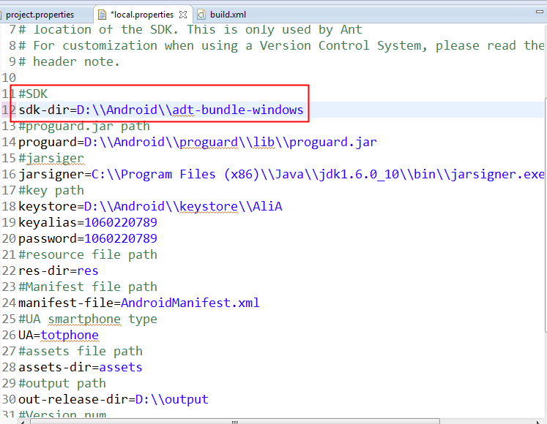
修改成正确路径即可。改后如下图所示。
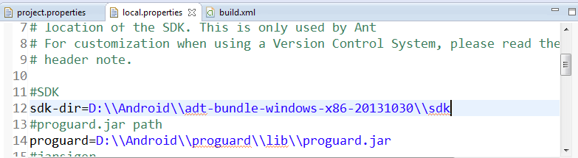

Error2:找不到android.jar
注意一个问题，target变量是在project.properties中定义的，要引用就必须要把project.properties引入到build.xml中。
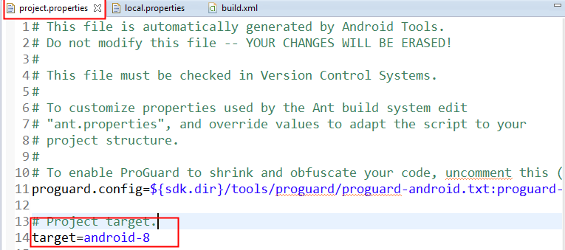
打开build.xml的前面几行，红框中的路径错误。修改为project.properties，而且android2.3以后的版本创建的工程里就都叫project.properties了。
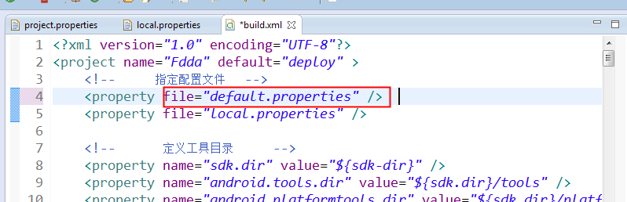
修改后：
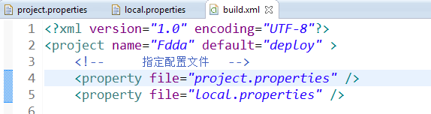
这样才能找到以下目录里的android.jar.
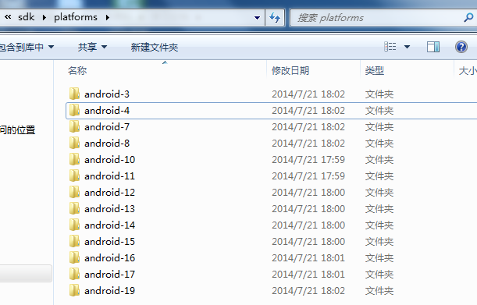
Error3:apkbuilder.bat
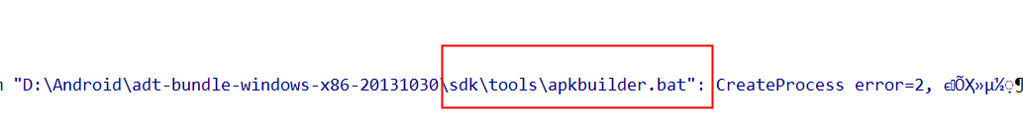
apkbuilder找不到，sdk更新3.0以后貌似apkbuilder已经被删除，并且一些命令的目录也换了。下面就说一下怎么在没有apkbuilder的情况下生成apk文件，其实apkbuilder是一个批处理文件，打开里面就能发现，其实他内部执行的是sdklib.jar里面的一个class，所以就知道怎么做了，很简单，直接去调用java去执行这个类。
原来的代码：
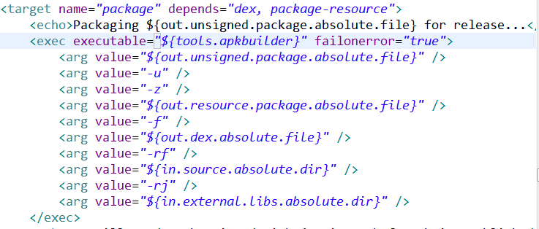
修改后代码：
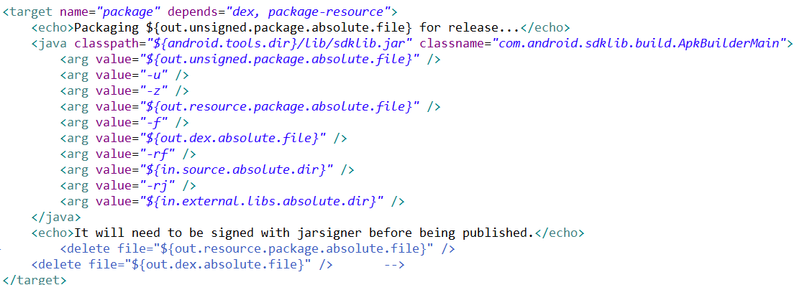
Error4:用jarsigner签名apk时报错
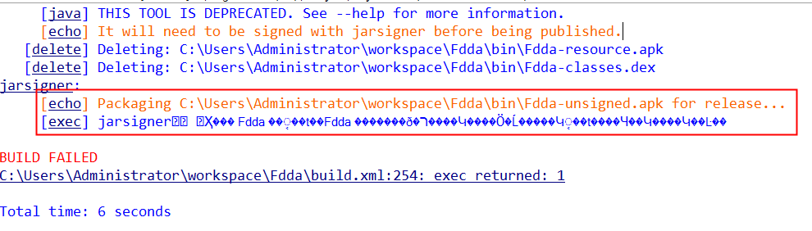
报错信息只能看出是命令jarsigner节出错，但是具体原因还是不太清楚，唯一的有用信息是那个Fdda，经过尝试，发现jarsinger节的参数的值传错了。Build.xml中签名的taget节如下：
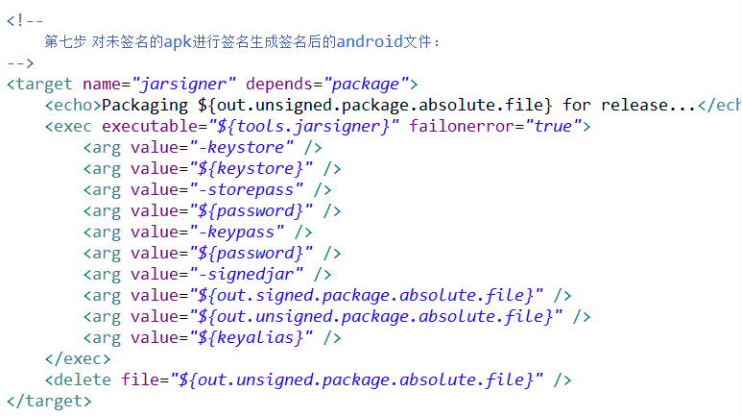

在local.properties中，对应的参数如下：
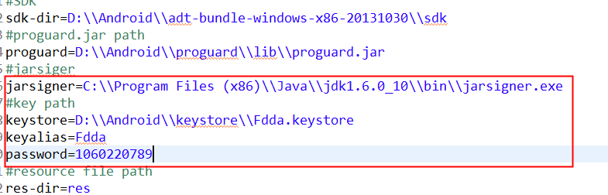
主要用到的变量是keystore、keyalias和password，首先，要生成这个keystore后缀的文件，cmd到jdk安装目录，用keytool命令生成该文件即可。
命令：keytool -genkey -alias Fdda.keystore -keyalg RSA -validity 20000 -keystore Fdda.keystore
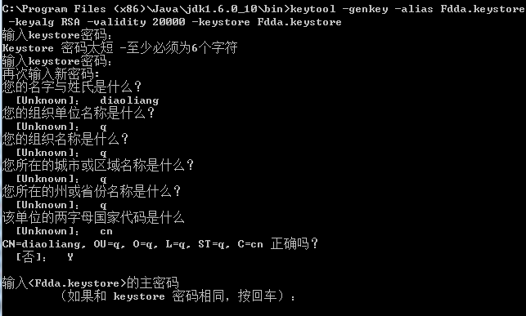
参数的含义：
参数-validity为证书有效天数，这里我们写的大些20000天。还有在输入密码时没有回显，只管输入就可以了，一般位数建议使用20位，最后需要记下来后面还要用。-alias后面的参数Fdda.keystrore 就是变量keyalias的值。所以之前填错了。
如果是通过Eclipse的Android tools 中的export signed...命令来生成的keystore文件的话，也会要求你填写相关参数，而且Eclipse生成的签名文件是没有后缀的，但是效果一样。
更正后的local.properties的文件内容如下：
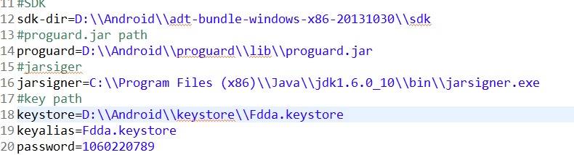
Error5:项目中找不到aidl
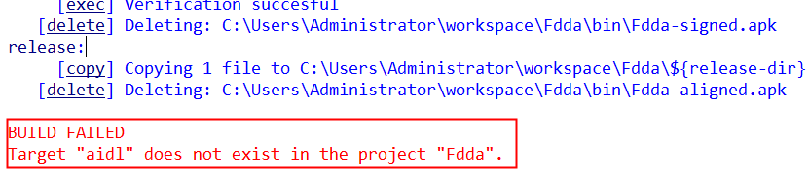
如果项目中有aidl文件的话，才需要在build.xml中添加对aidl的处理
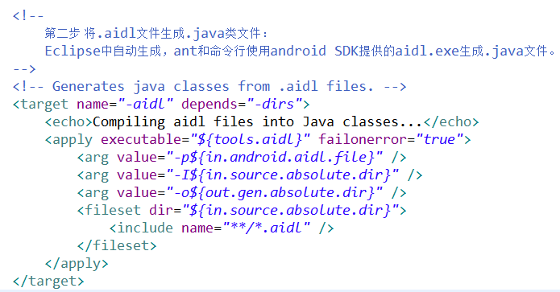
如果工程中没有用到aidl文件的话，就不需要编辑了。删除或或者注释掉即可，同时还要删除其他taget对该aidl 的依赖，以及删除所有与aidl有关的属性定义等。例如：
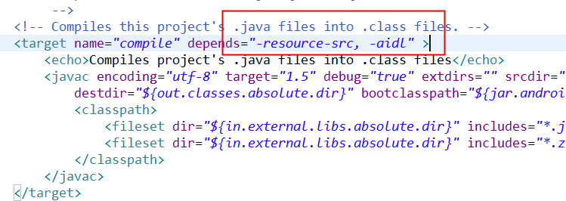
如果工程中使用到了aidl文件的话，就需要用该命令来把aidl文件编译成java文件。
例如工程为：
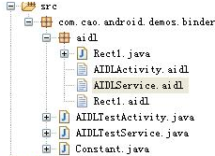
Aidl是什么？
aidl是 Android Interface definition language的缩写，是一种android内部进程通信接口的描述语言，通过它我们可以定义进程间的通信接口。
icp:interprocess communication :内部进程通信

如果注释掉以后还是提示一样的错误，选中build.xml,右键，选择run as..，选择Ant Build...,第二个。
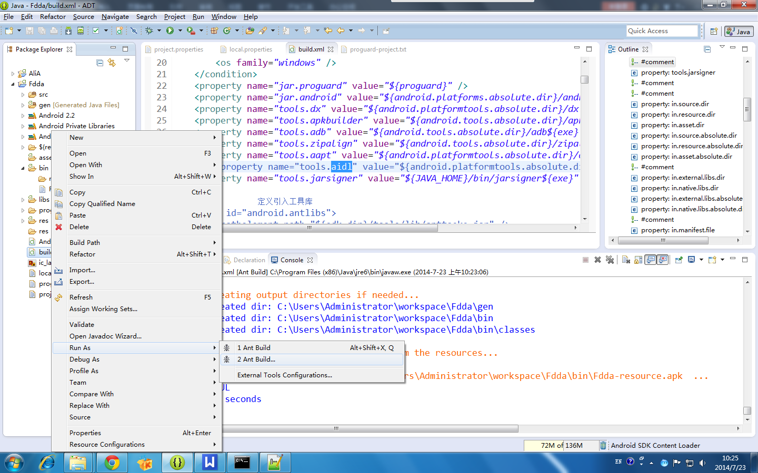

全部选中里面要配置的项，再次执行即可。
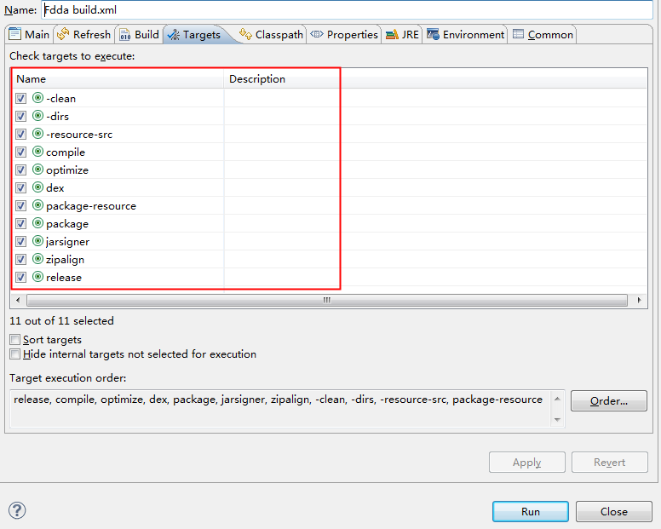

最后打包成功后，截图如下：
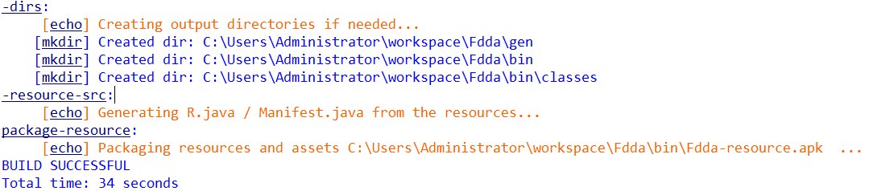
在bin目录下会自动生成已经打包好的apk.
