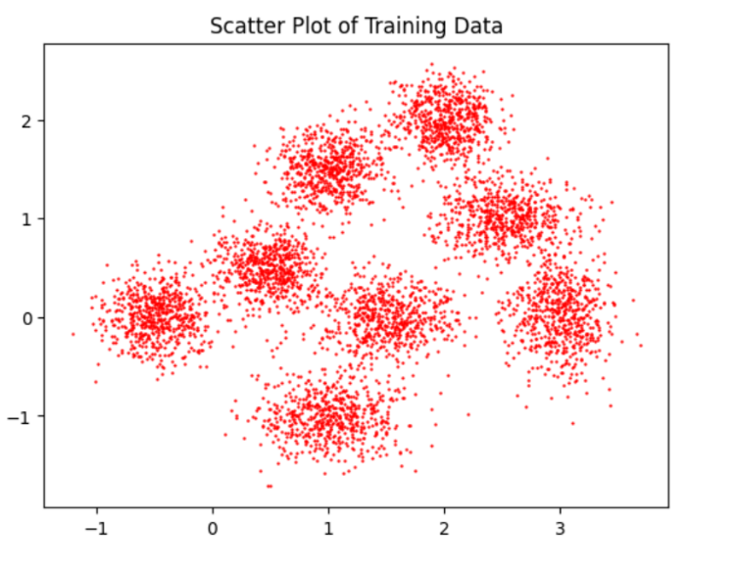Visualization of the Training Set

It looks like having 8 “groups”, so I will set the K to 8 in the following programming.

Task 1:

Subtask1:

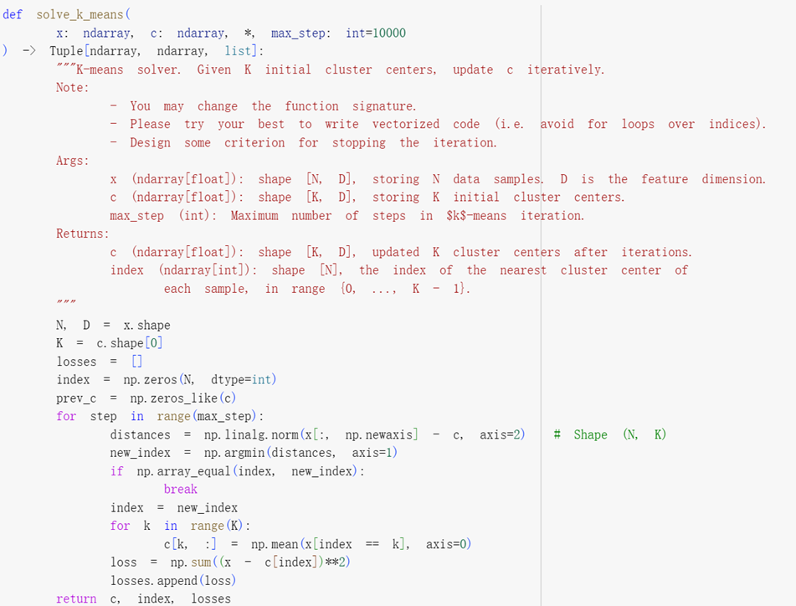

First assign the variables and then update accordingly. Also, keep track of the loss history for convenience.

Subtask2:

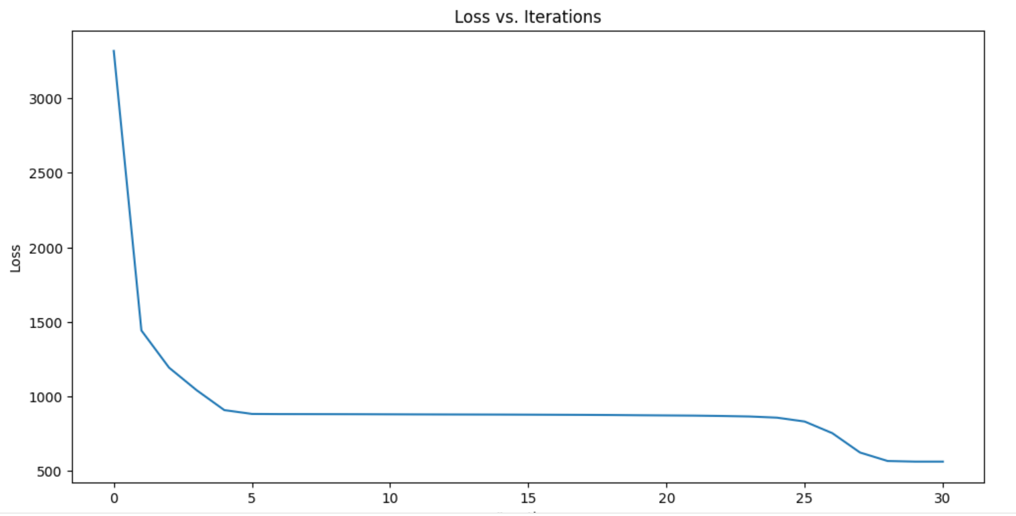

Subtask3:

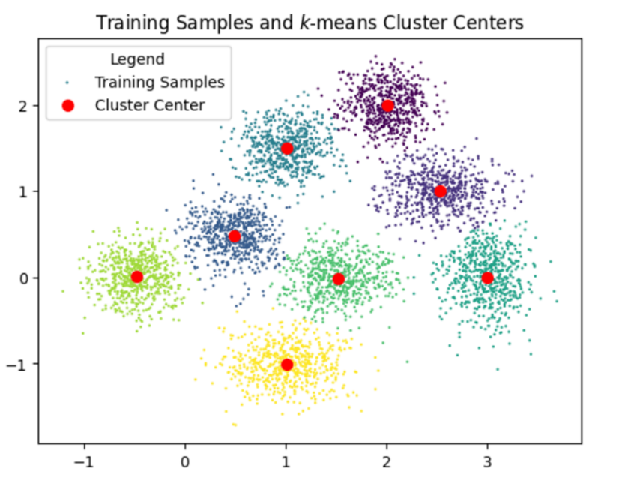

Subtask4:

It runs at least 10-15times until it converges to a global minimum.

It converges seldomly.

Task2:

Subtask1:

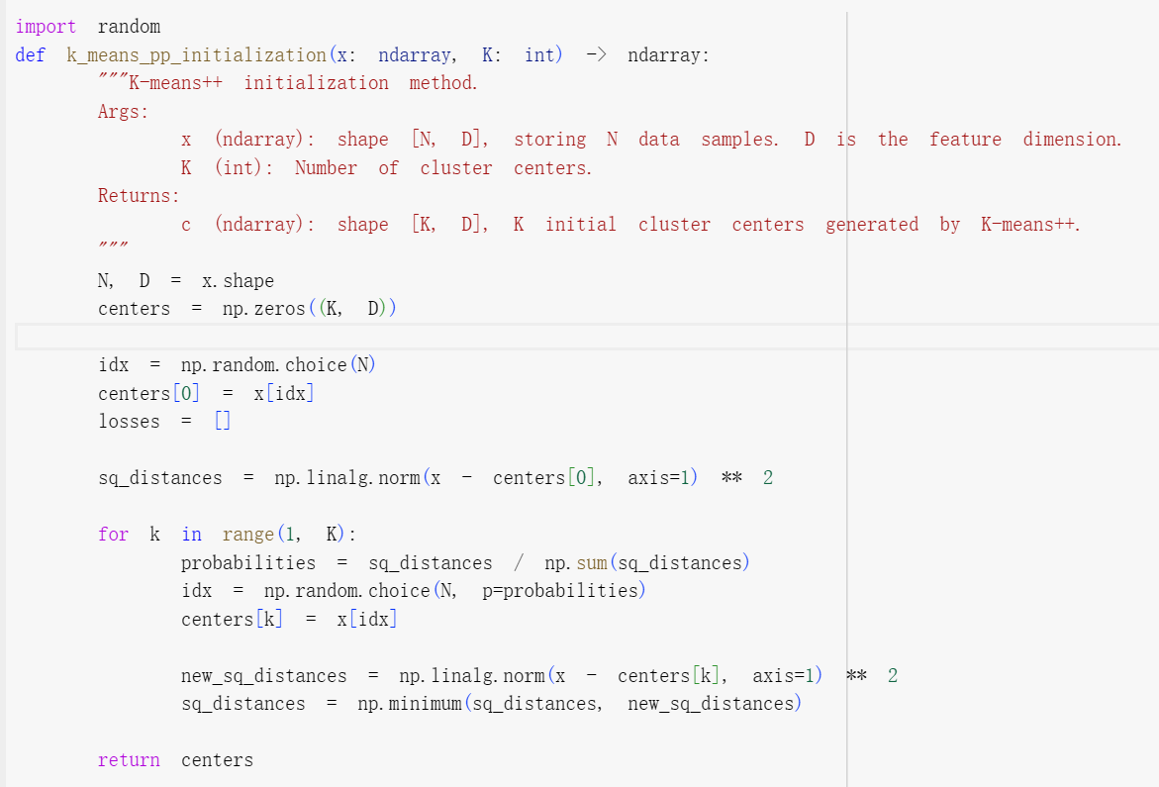

Randomly choose the first center, then choose the next center with a probability proportional to squared distance and update squared distances for each point.

Subtask2:

k -means++ initialization:

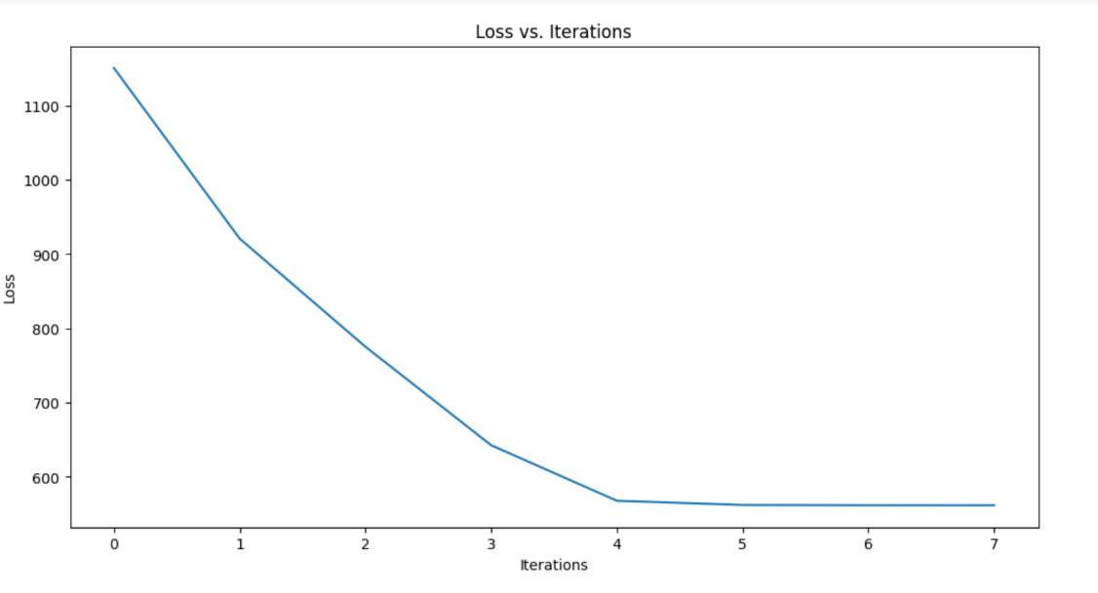

standard normal initialization:

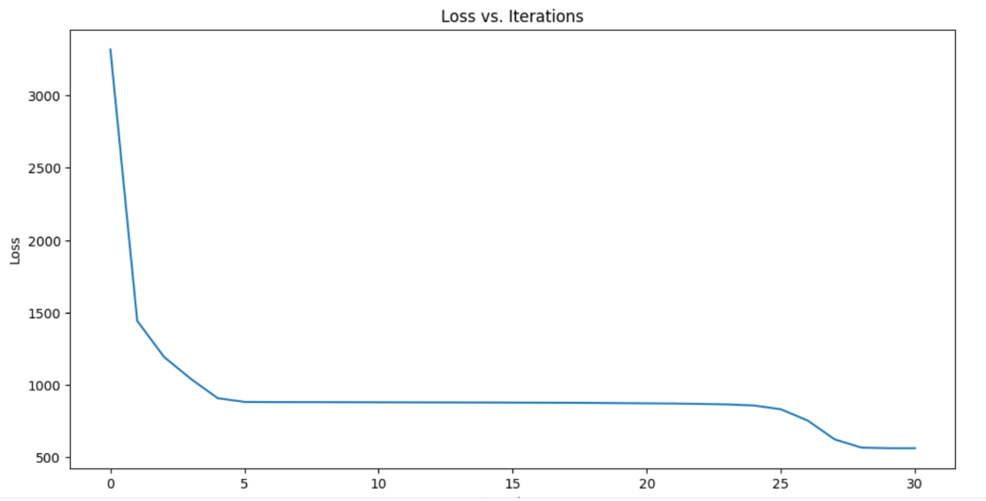

Subtask3:

k -means++ initialization converges more fastly.

Task3:

Subtask1:

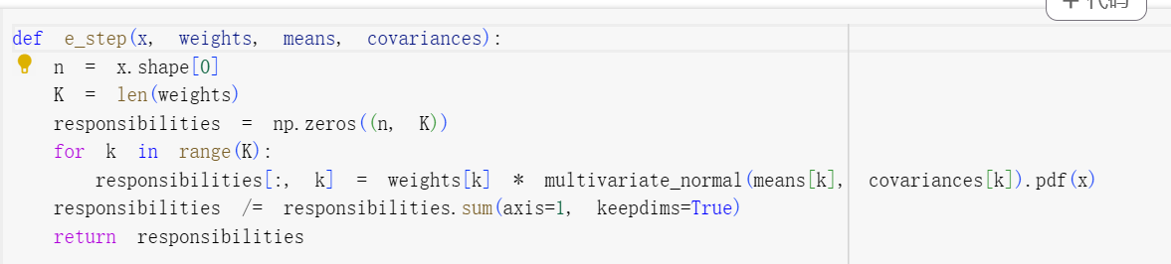

Compute responsibilities for each component of the GMM.

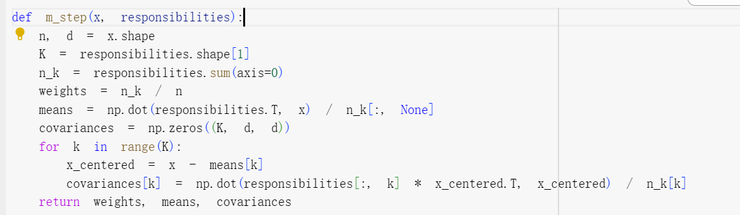

Update the parameters of the GMM

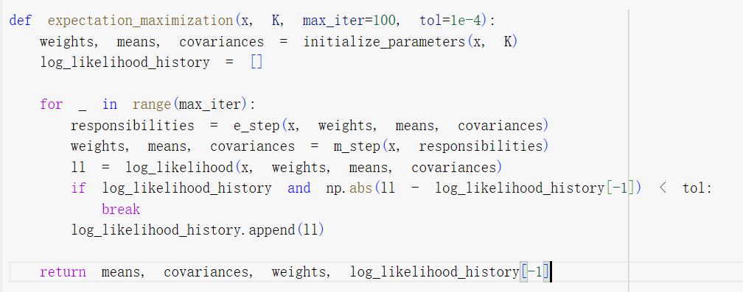

Run the EM algorithm to fit a Gaussian Mixture Model.

Subtask2:

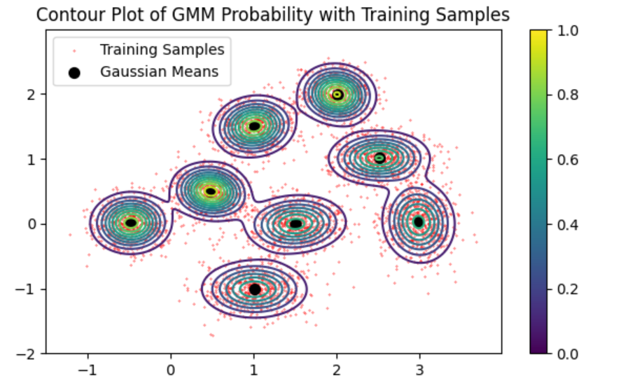

Subtask3:

