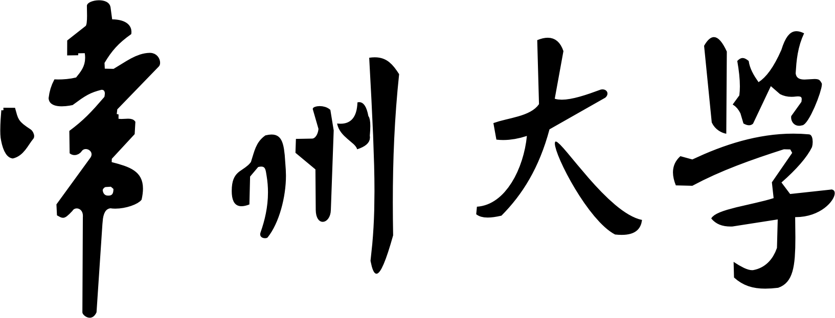

实 验 报 告

课程名称： nosql
实验名称： 选课系统的编写
学 生 姓 名： 丁浩 班 级 软件174 学 号 17484114
学 院（系）： 指 导 教 师：
实验时间： 2019 年 11 月 15 日 实验成绩：

实验三 选课系统后台逻辑的重新搭建

- 实验步骤
前端功能的重写，使用ajax实现异步请求，前后端非礼
<%@ page language="java" contentType="text/html; charset=UTF-8"
pageEncoding="UTF-8"%>
<%@ taglib uri="http://java.sun.com/jsp/jstl/core" prefix="c" %>
<%@ taglib uri="http://java.sun.com/jsp/jstl/fmt" prefix="fmt"%>
<!DOCTYPE html PUBLIC "-//W3C//DTD HTML 4.01 Transitional//EN" "http://www.w3.org/TR/html4/loose.dtd">
<html>
<head>
<meta http-equiv="Content-Type" content="text/html; charset=UTF-8">
<title>查询课程列表</title>
<meta name="viewport" content="width=device-width, initial-scale=1">
<link rel="stylesheet" href="https://cdn.staticfile.org/twitter-bootstrap/4.3.1/css/bootstrap.min.css">
<script src="https://cdn.staticfile.org/jquery/3.2.1/jquery.min.js"></script>
<script src="https://cdn.staticfile.org/popper.js/1.15.0/umd/popper.min.js"></script>
<script src="https://cdn.staticfile.org/twitter-bootstrap/4.3.1/js/bootstrap.min.js"></script>
<script type="text/javascript">
function true_click(kcxh,kcmc,xxrs,xh,xq){
var se=confirm("请确认选课!");
if (se==true)
{
AJAX(kcxh,kcmc,xxrs,xh,xq);
return true;
}
else
{
alert("取消成功!可刷新界面更新选课人次信息!");
return false;
}

}
function tk_click(kcxh,kcmc,xh,xq){
var se=confirm("请确认退课!");
if (se==true)
{
AJAXTK(kcxh,kcmc,xh,xq);
return true;
}
else
{
alert("取消成功!可刷新界面更新选课人次信息!");
return false;
}

}
function AJAX(kcxh,kcmc,xxrs,xh,xq){
var xuanke={
"kcxh":kcxh,
"kcmc":kcmc,
"xh":xh,
"xq":xq
};
$.ajax({
url:"${pageContext.request.contextPath }/select.action",
type:'post',
contentType:'application/json;charset=UTF-8',
dataType:'json',
data:JSON.stringify(xuanke),
success:return_alert
});
function return_alert(mes){
alert(mes.message)
}
}
function AJAXTK(kcxh,xh,xq){
alert(kcxh);
alert(xh);
alert(xq);
var tuike={
"kcxh":kcxh,
"xh":xh,
"xq":xq
};
$.ajax({
url:"${pageContext.request.contextPath }/tuike.action",
type:'post',
contentType:'application/json;charset=UTF-8',
dataType:'json',
data:JSON.stringify(tuike),
success:return_alert
});
function return_alert(mes){
alert(mes.message)
}
}
</script>
</head>
<body>
<div class="container">
<br>
<table class="table table-bordered" style="width: 50%;">
<thead>
<tr class="table-info">
<th class="text-center">姓名</th>
<th class="text-center">班级</th>
<th id="xh" class="text-center">学号</th>
<th id="xq" class="text-center">学期</th>
</tr>
</thead>
<tbody>
<tr>
<th class="text-center">${xm}</th>
<th class="text-center">${bj}</th>
<th class="text-center">${xh}</th>
<th class="text-center">${xq}</th>
</tr>
</tbody>

</table>
<br><br>
<table class="table table-bordered table-hover" style="width: 50%;">
<thead>
<tr class="table-info">
<th class="text-center">已修课程</th>
<th class="text-center">课程成绩</th>
</tr>
</thead>
<tbody>
<c:forEach items="${befclass}" var="bef" varStatus="s">
<tr>
<th class="text-center">${bef.lbmc}</th>
<th class="text-center">${bef.kscj}</th>
</c:forEach>
</tbody>
</table>
<br><br>

<table class="table table-bordered table-hover" style="width: 50%;">
<thead>
<tr class="table-info">
<th class="text-center">本次已选</th>
<th class="text-center">退课</th>
</tr>
</thead>
<tbody>
<c:forEach items="${NowClass}" var="now" varStatus="s">
<form name="reselect">
<tr class="a1">
<th class="text-center">${now.kcmc}/${now.kcxh}</th>
<td class="text-center"><input type="button" class="btn btn-info" value="点击退课" onclick="return tk_click('${now.kcxh}','${xh}','${xq}')"></td>
</tr>
</form>
</c:forEach>
</tbody>
</table>
<br><br>
<table class="table table-bordered table-condensed table-hover table-striped" style="width: 100%;">
<thead>
<tr class="table-info">
<th class="text-center">课程名称</th>
<th class="text-center">课程教师</th>
<th class="text-center">课程类别</th>
<th class="text-center">课程教室</th>
<th class="text-center">课程时间</th>
<th class="text-center">可选人数</th>
<th class="text-center">确认选课</th>
</tr>
</thead>
<tbody>
<c:forEach items="${classes}" var="classes" varStatus="s">
<form method="post">
<tr class="a1">
<td class="text-center">${classes.vjwkcdm.kcmc}/${classes.kcxh}</td>
<td class="text-center">${classes.jsmc}</td>
<td class="text-center">${classes.vjwlbdh.lbmc}/${classes.lbdh}</td>
<td class="text-center">${classes.jse}</td>
<td class="text-center">周${classes.zc}//${classes.jc1}-${classes.jc2}节//${classes.zc1}-${classes.zc2}</td>
<td id="xxrs" class="text-center">${classes.xxrs}</td>
<td class="text-center"><input type="button" name="xuanke" class="btn btn-info" value="选课" onclick="return true_click('${classes.kcxh}','${classes.vjwkcdm.kcmc}','${classes.xxrs}','${xh}','${xq}')" ></td>
</tr>
</form>
</c:forEach>
</tbody>
</table>
</div>

</body>
</html>

