**Incorporating MultiHot Embedding into ResNet and FT-T models**

1. Read our paper (attached), understand the mechanism of the MultiHot embedding
2. Go through the code of the paper at:

<https://github.com/qzl408011458/MultiHot_Embedding/blob/main/train_task1.py>

this code is for task 1 on the paper (California housing prediction). You may focus on the implementation of MultiHot Embedding (def process_t). When you understand the mechanism of MultiHot Embedding and the code of task 1 (train_task1.py), please let me know, we may discuss for the next step.

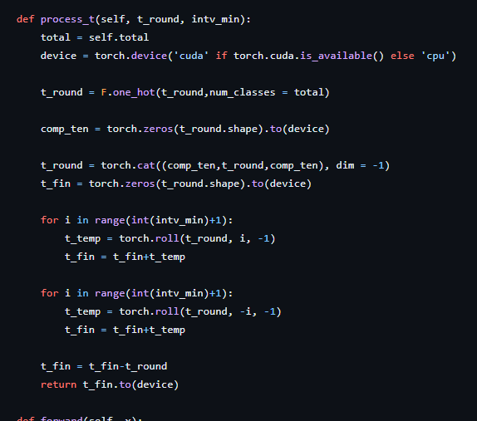

1. Incorporating the MultiHot Embedding into the experiment of FT-T and ResNet. Reproducing the implementation in Section 4.3 of the Revisiting… paper, get the results of FT-T and ResNet models (no need to reproduce the results of other models). Then, incorporating the MultiHot Embedding into FT-T and ResNet (for the continuous feature representation), get the new results.

