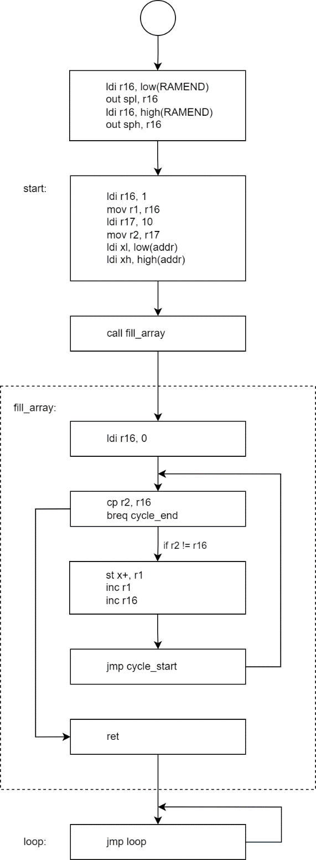.dseg

addr: .byte 1

.cseg

start:

ldi r16, 1

mov r1, r16

ldi r17, 10

mov r2, r17

ldi xl, low(addr)

ldi xh, high(addr)

call fill_array

loop:

jmp loop

; r1 - initial value, r2 - length, x - start address

; affect: r1, r16, x

fill_array:

ldi r16, 0

cycle_start:

cp r2, r16

breq cycle_end

st x+, r1

inc r1

inc r16

jmp cycle_start

cycle_end:

ret