Database Design Assignment

Name: Tzu-Ching Chuang

1. Projects Management

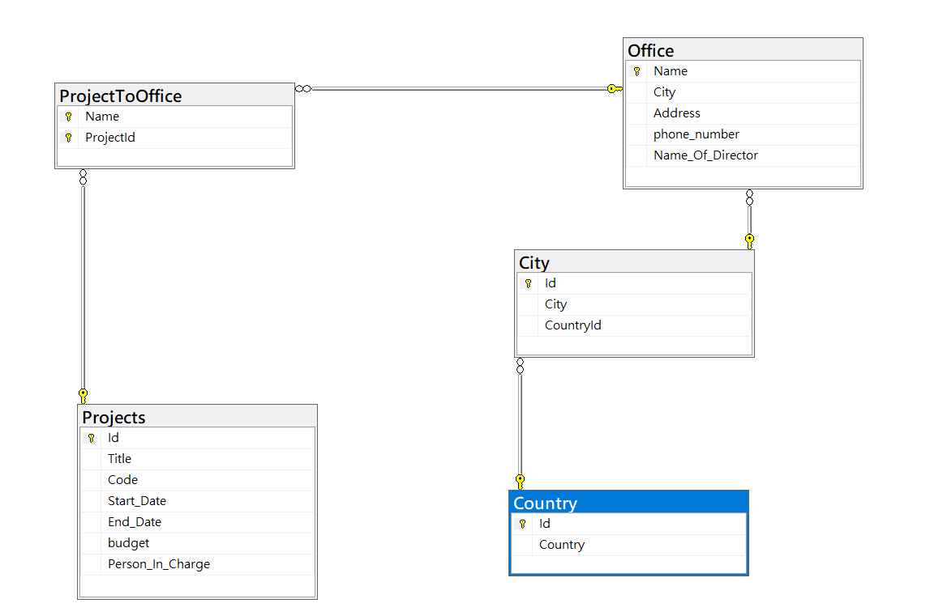

SQL Code

CREATE TABLE Country

(

[Id] INT NOT NULL IDENTITY(1,1),

Country NVARCHAR(10) NOT NULL,

PRIMARY KEY (Id)

);

CREATE TABLE City

(

[Id] INT NOT NULL IDENTITY(1,1),

[Name] NVARCHAR(20) NOT NULL,

[CountryId] INT NOT NULL,

PRIMARY KEY([Id]),

FOREIGN KEY (CountryId) REFERENCES Country(Id)

);

CREATE TABLE Office

(

[Name] [nvarchar](20) NOT NULL,

[City] [int] NOT NULL,

[Address] [nvarchar](30) NULL,

[phone_number] [nvarchar](15) NULL,

[Name_Of_Director] [nvarchar](20) NULL,

PRIMARY KEY ([Name]),

FOREIGN KEY (City) REFERENCES City(Id)

);

CREATE TABLE Projects

(

[Id] [int] IDENTITY(1,1) NOT NULL,

[Title] [nvarchar](10) NULL,

[Code] [nvarchar](50) NULL,

[Start_Date] [datetime] NULL,

[End_Date] [datetime] NULL,

[budget] [decimal](18, 2) NULL,

[Person_In_Charge] [nvarchar](20) NULL,

PRIMARY KEY (Id)

);

CREATE TABLE ProjectToOffice

(

[Name] [nvarchar](20) NOT NULL,

[ProjectId] [int] NOT NULL,

PRIMARY KEY ([Name],[ProjectId]),

FOREIGN KEY ([Name]) REFERENCES Office([Name]),

FOREIGN KEY ([ProjectId]) REFERENCES Projects(Id)

);

CREATE VIEW Actions

AS

SELECT po.ProjectId, c.City, COUNT(*) AS [Number Of Inhabitants]

FROM ProjectToOffice AS po ,Office AS o ,City AS c

WHERE po.Name = o.Name AND o.City = c.Id

GROUP BY po.ProjectId, c.CityS

1. Lending Company

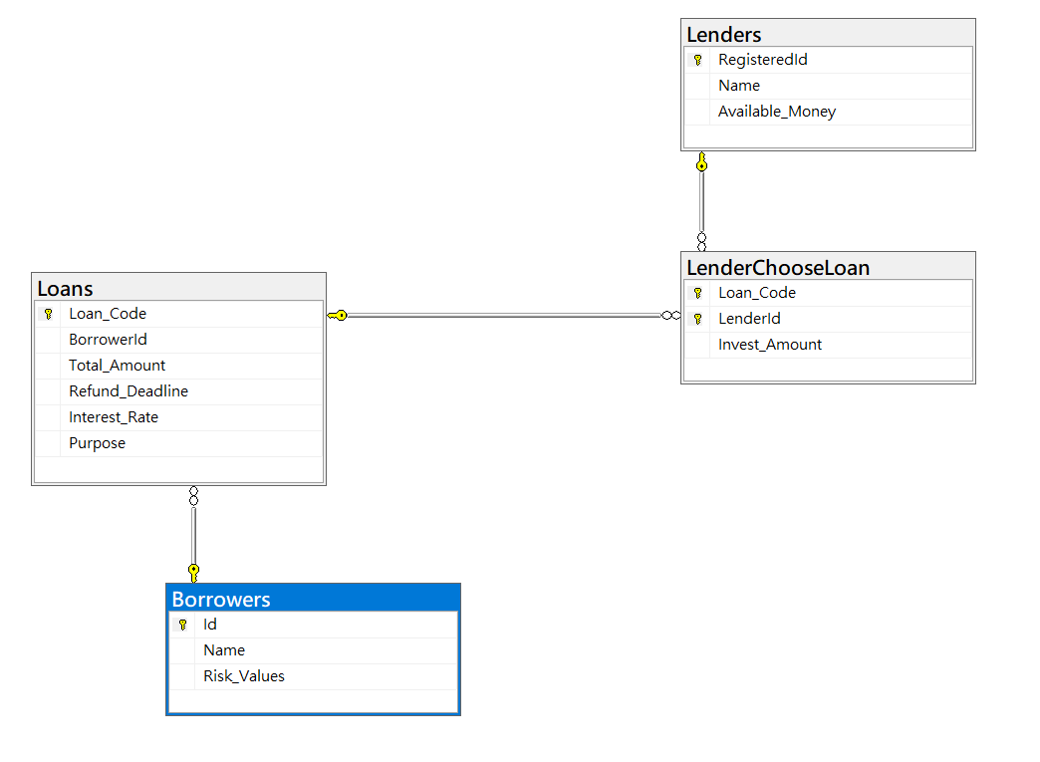

SQL

CREATE TABLE Lenders

(

RegisteredId INT NOT NULL IDENTITY(1,1),

[Name] NVARCHAR(20) NOT NULL,

[Available_Money] DECIMAL(18,2) NOT NULL,

PRIMARY KEY (RegisteredId)

);

CREATE TABLE Borrowers

(

Id INT NOT NULL IDENTITY(1,1),

[Name] NVARCHAR(20) NOT NULL,

Risk_Values DECIMAL(18,2) NOT NULL,

PRIMARY KEY (Id)

);

CREATE TABLE Loans

(

Loan_Code INT NOT NULL IDENTITY,

BorrowerId INT NOT NULL,

Total_Amount DECIMAL(18,2) NOT NULL,

Refund_Deadline DATETIME,

Interest_Rate DECIMAL(18,2),

Purpose TEXT,

PRIMARY KEY (Loan_Code),

FOREIGN KEY (BorrowerId) REFERENCES Borrowers(Id)

);

CREATE TABLE LenderChooseLoan

(

Loan_Code INT NOT NULL,

LenderId INT NOT NULL,

Invest_Amount DECIMAL(18,2),

PRIMARY KEY (Loan_Code, LenderId),

FOREIGN KEY (Loan_Code) REFERENCES Loans(Loan_Code),

FOREIGN KEY (LenderId) REFERENCES Lenders(RegisteredId)

);

1. Maintain menu of restaurant

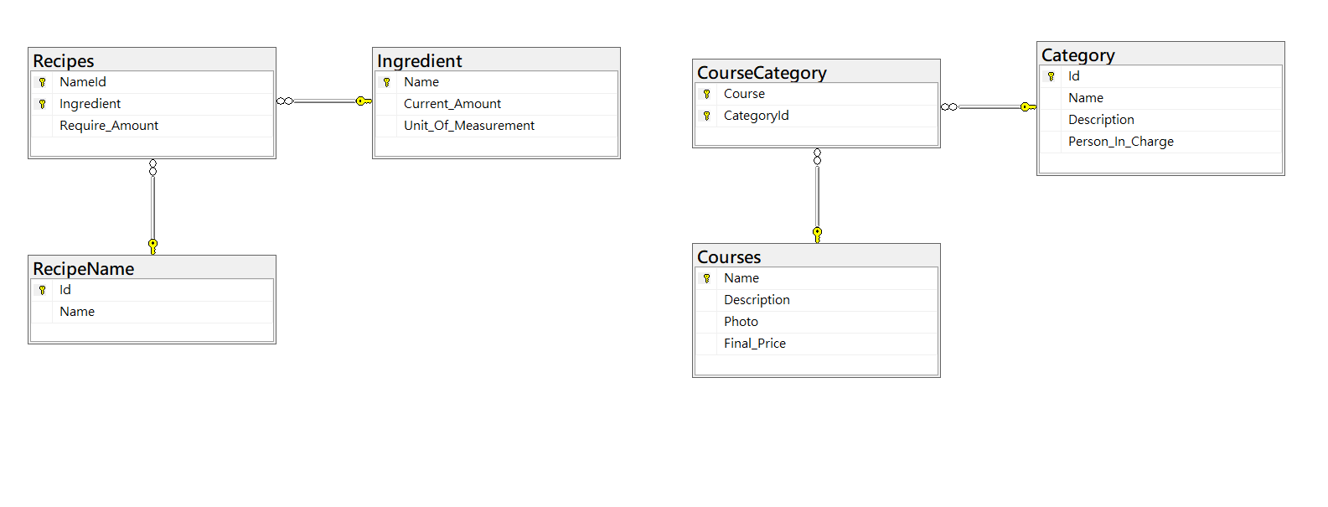

CREATE TABLE Courses

(

[Name] NVARCHAR(20) NOT NULL,

[Description] Text NOT NULL,

Photo IMAGE,

Final_Price DECIMAL(18,2)

PRIMARY KEY ([Name])

);

CREATE TABLE Category

(

Id INT NOT NULL IDENTITY(1,1),

[Name] NVARCHAR(10),

[Description] TEXT,

Person_In_Charge NVARCHAR(20)

PRIMARY KEY (Id)

);

CREATE TABLE CourseCategory

(

Course NVARCHAR(20) NOT NULL,

CategoryId INT NOT NULL,

PRIMARY KEY (Course, CategoryId),

FOREIGN KEY (CategoryId) REFERENCES Category(Id),

FOREIGN KEY (Course) REFERENCES Courses([Name])

);

CREATE TABLE Ingredient

(

[Name] NVARCHAR(20) NOT NULL,

Current_Amount INT,

Unit_Of_Measurement NVARCHAR(10),

PRIMARY KEY ([Name])

);

CREATE TABLE RecipeName

(

Id INT NOT NULL IDENTITY(1,1),

[Name] NVARCHAR(20),

PRIMARY KEY (Id)

);

CREATE TABLE Recipes

(

NameId INT NOT NULL,

Ingredient NVARCHAR(20) NOT NULL,

Require_Amount INT,

PRIMARY KEY (NameId,Ingredient),

FOREIGN KEY (Ingredient) REFERENCES Ingredient([Name]),

FOREIGN KEY (NameId) REFERENCES RecipeName(Id)

);