**Week -6 & 7**

1. Write a Java program to create a package “NumberConversion”. Write 3 classes in the package. Class 1 will have methods to convert a number to binary form and from binary to number form. Class 2 will have methods to convert a number to octal form and from octal to number form. Class 3 will have methods to convert a number to hexadecimal form and from hexadecimal to number form. Write a Main class to implement these functions.
2. Write a Java program to find the roots of a quadratic equation using packages.
3. Write a Java program to implement the Stack and Queue operations. Create an interface called as DataStructure. Write Stack & Queue classes which will implement the DataStructure interface.

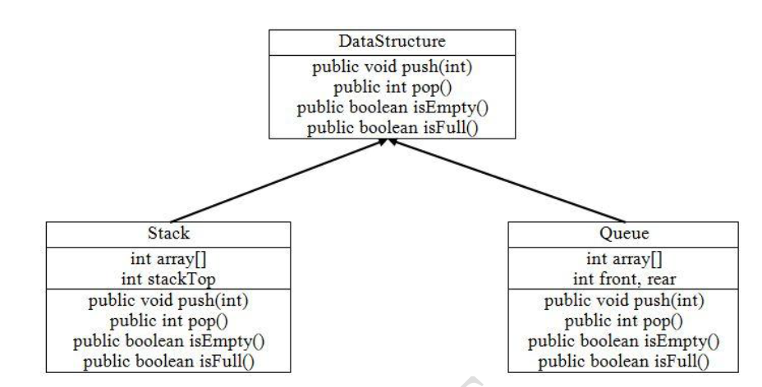

1. Write a Java program to simulate the ATM transactions. If the user tries to withdraw more than the 25K daily limit, throw “DailyTransactionLimitException”. If the user tries to withdraw more than the balance, throw “InsufficientAmountException”.
2. Write a Java program to demonstrate the Eligibility for the Semester End Exams. If the student has attendance less than 80% and/or CIE marks less than 20 then throw “NotEligibleException”. Attach initial exception as “LowAttendanceException” or “LowMarksException” using chained exception concept.
3. Create user defined exception which is raised when number of command line arguments less than 3.
4. Write a program to check if two given String is Anagram of each other. Your function should return true if two Strings are Anagram, false otherwise. A string is said to be an anagram if it contains the same characters and same length, but in a different order, e.g. army and Mary are anagrams.
5. Write a Java program to demonstrate the Eligibility for Elections. If the person enters his age less than 18, then throw “NotEligibleToVoteException”. If the person enters his age less than 1 or more than 120, then throw “InvalidAgeException”. If user enters valid age, then display message as “Eligible to Vote”.
6. Write a Java program to check the correctness of a vehicle number using packages. Write a class in the package VehicleNumberPlate to check the correctness of a vehicle Number. (Example: KA 01 AA 0011 → Correct Number KA 0W A2 00QQ → Incorrect Number.) Read the Vehicle Number as a String and check the correctness.