Week -5
- Write a java program for the given data:
super class: Animal methods: eat () ,sleep(), moves()
subclass: whale, Bat, Dog. Create class, objects and test it.
- Illustrate Constructor chaining and method overriding with the following details.
Superclass add : instance variables :a,b,add(),calci(int a,int b);
Subclass of add: sub instance variables :a,b,sub(),calci(int a,int b);
Subclass of sub : mul instance variables :a,b,mul (),calci(int a,int b);
Subclass of mul:div instance variables :a,b,div (),calci(int a,int b);
- Illustrate with a program Dynamic method Dispatch
- Illustrate with a program the uses of final keyword.
- Program to illustrate method overriding in which super class prints the messge "hello oops" and subclass prints "hello java".
- Illustrate the order of invoking constructors.
- Implement the following using interfaces.

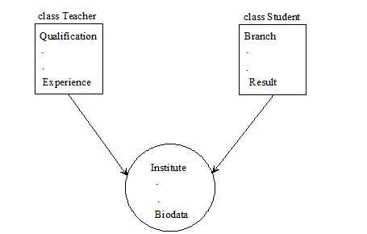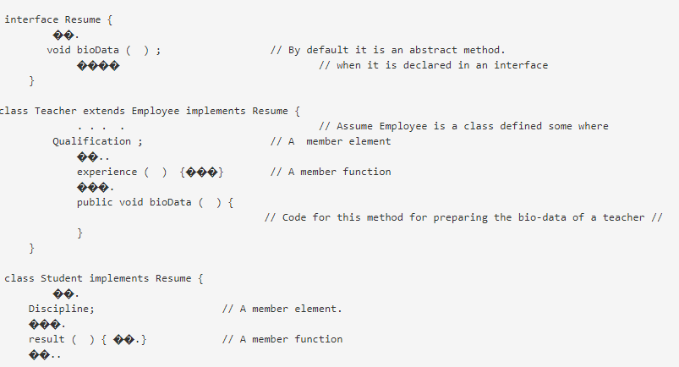

8.

