**Binomial**

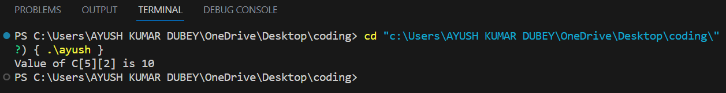

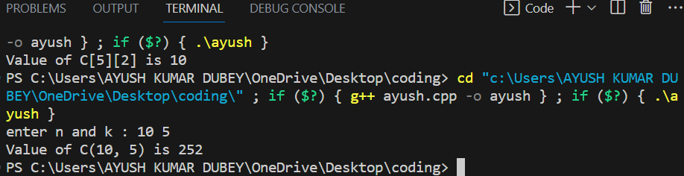

**Dijkstra**

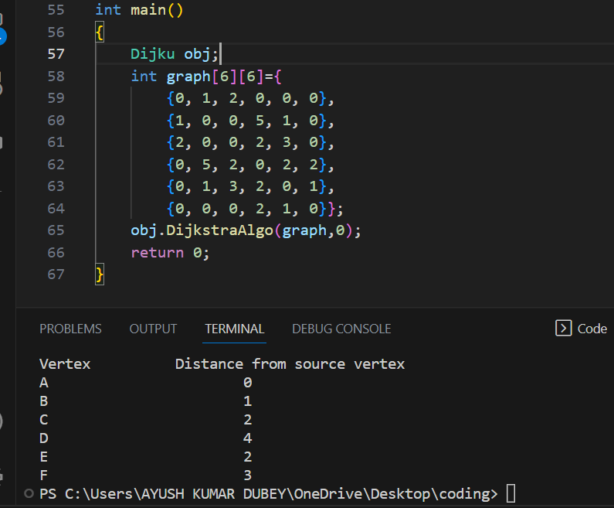

**Floyd Warshal**

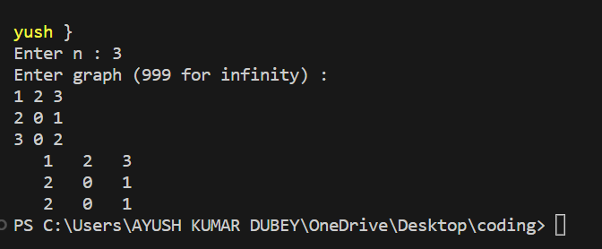

**Heap Sort**

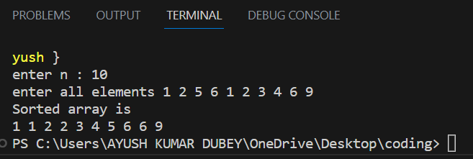

**Prims**

**BFS**

**DFS**

**Horspool**

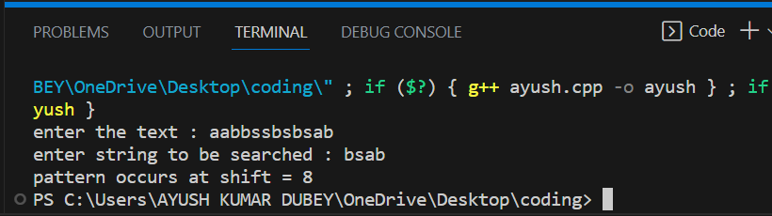

**Knapsack**

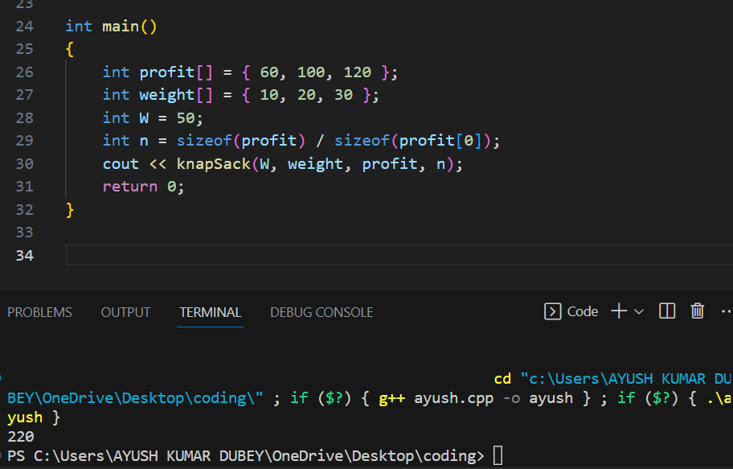

**N-Queen**

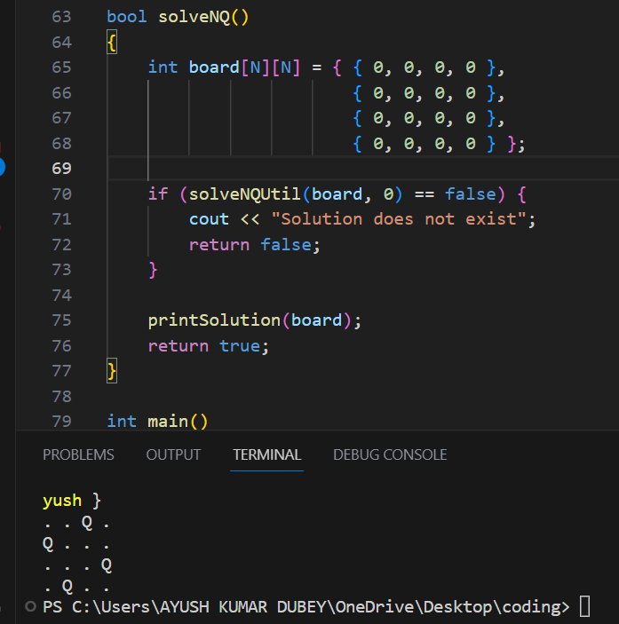

**Kruskals**

**Sum of Subsets**

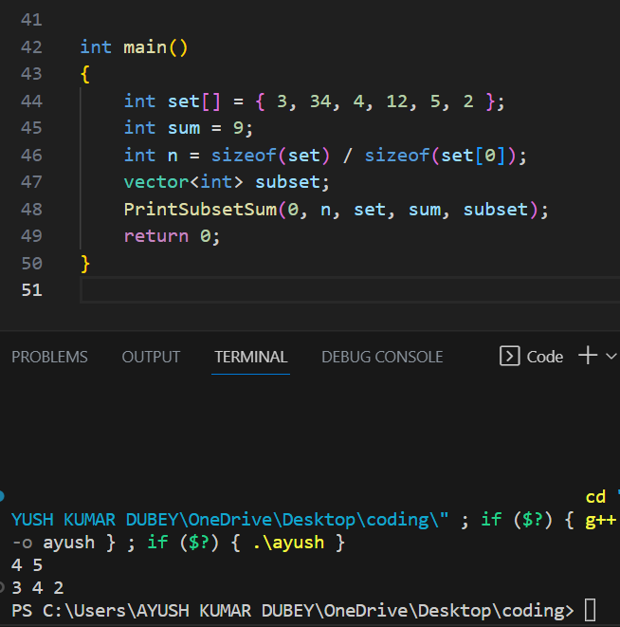

**Topological Sort DFS**

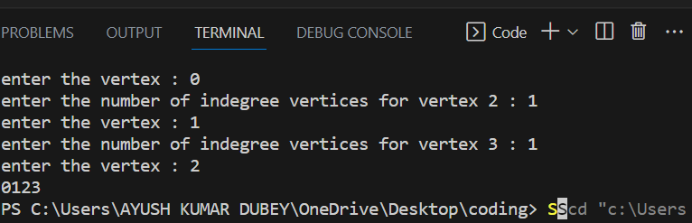

**Topological Sort Source Removal**

