**Book Review System**

**Mini-Project Report of**

**Object Oriented Programming through Java**

***Submitted by***

**Vidhi Damani (B068)**

***In partial fulfillment for the award of the degree of***

**MBA Tech.**

**COMPUTER ENGINEERING**

**At**



**MUKESH PATEL SCHOOL OF TECHNOLOGY MANAGEMENT & ENGINEERING**

NMIMS (Deemed –to-be University)

JVPD Scheme Bhaktivedanta Swami Marg,

Ville Parle (W), Mumbai-400 056.

**2023-2024**

**Table of Contents**

|  |  |  |
| --- | --- | --- |
| **Sr. No.** | **Title** | **Page No.** |
|  |  |  |
| 1 | Problem Statement and Scope | 3 |
| 2 | Project Synopsis | 4 |
| 3 | Implementation (Source Code) | 5 |
| 4 | Results | 60 |
| 5 | Conclusion | 68 |

# Problem Statement and Scope

**Problem Statement:**

Develop a book review system/app to allow users to share and discover book reviews. The system should provide a platform for users to rate and review books. The goal is to create a user-friendly and interactive platform that promotes reading and sharing of literary experiences.

**Scope:**

- **User Registration and Authentication:** Users can create accounts and log in to the system.

- **Book Catalog:** A database of books with details such as title, author, genre, and synopsis.

- **User Profile:** Users can view and edit their profiles, including adding a profile picture and personal information.

- **Book Reviews:** Users can rate and write reviews for books.

- **Search:** Users can search for books by title, author, genre, or keyword.

- **Accessibility:** The system should be accessible and easy to use.

- **Data Security:** Ensure user data is protected and comply with data protection regulations.

# Synopsis

Key Features:

1. User Registration and Authentication:

* Users can create accounts securely and log in to the system to access features.
* Robust authentication mechanisms ensure the security of user accounts.

1. Book Catalog:

* A meticulously curated database of books containing details such as title, author, genre, and synopsis.
* Regular updates and additions to the catalog to ensure a wide range of titles.

1. User Profile:

* Users can personalize their profiles, including adding a profile picture and relevant personal information.
* Profile management features allow users to edit and update their information as needed.

1. Book Reviews:

* Users can rate books and write detailed reviews, sharing their thoughts and experiences.
* A user-friendly interface for submitting reviews and ratings, encouraging active participation.

1. Search Functionality:

* Comprehensive search capabilities enable users to find books by title, author, genre, or keyword.
* Advanced search filters provide refined results tailored to user preferences.

1. Accessibility:

* The platform is designed with accessibility in mind, ensuring usability for individuals of all abilities.
* Features such as keyboard navigation and screen reader compatibility enhance accessibility.

1. Data Security:

* Stringent data protection measures are implemented to safeguard user information.
* Compliance with relevant data protection regulations to maintain user trust and confidentiality.

The primary goal of the "Book Review Hub" is to create a user-friendly and interactive platform that promotes reading and the sharing of literary experiences. By providing a seamless and enriching experience for users, the platform aims to cultivate a thriving community of book lovers, fostering discussions, recommendations, and a deeper appreciation for literature.

# Results

**Login:**

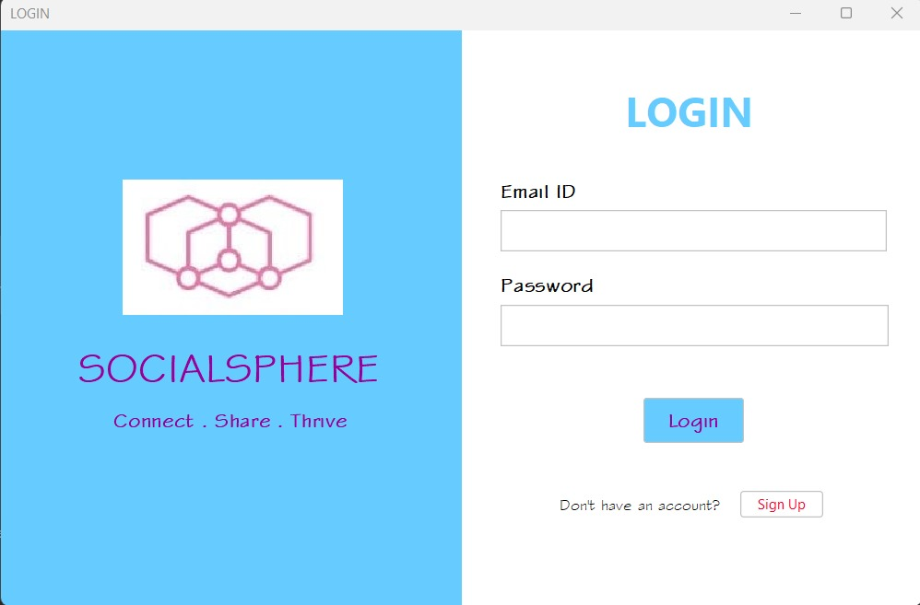

**Sign up:**

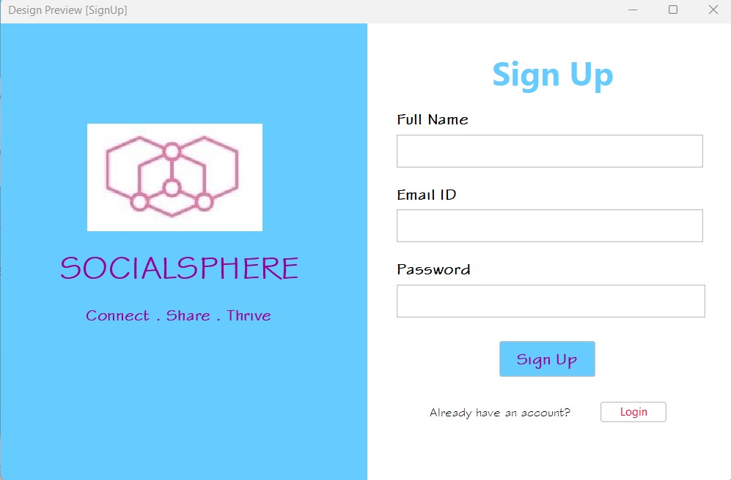

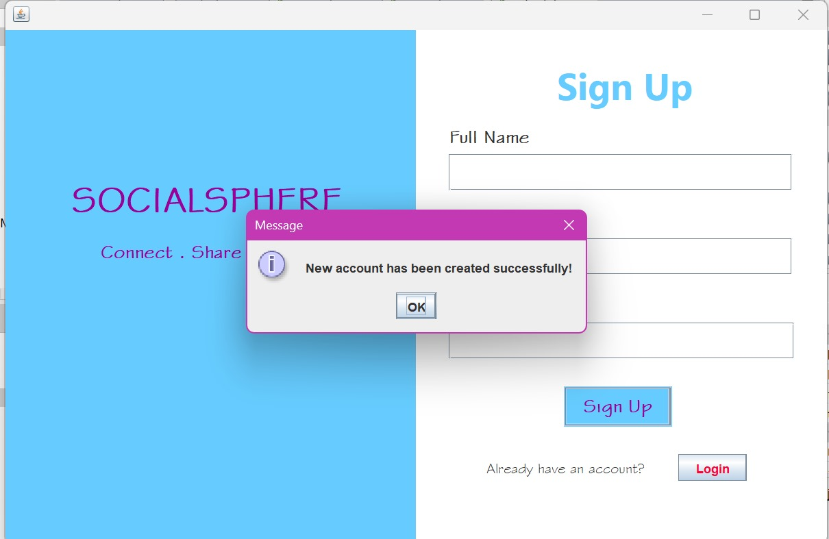

**Home Page:**

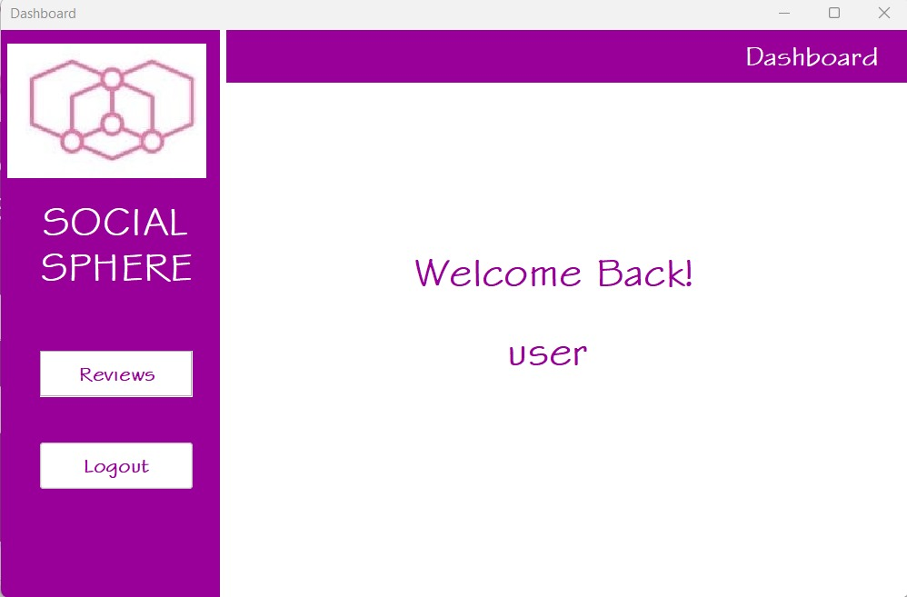

**Review Page:**

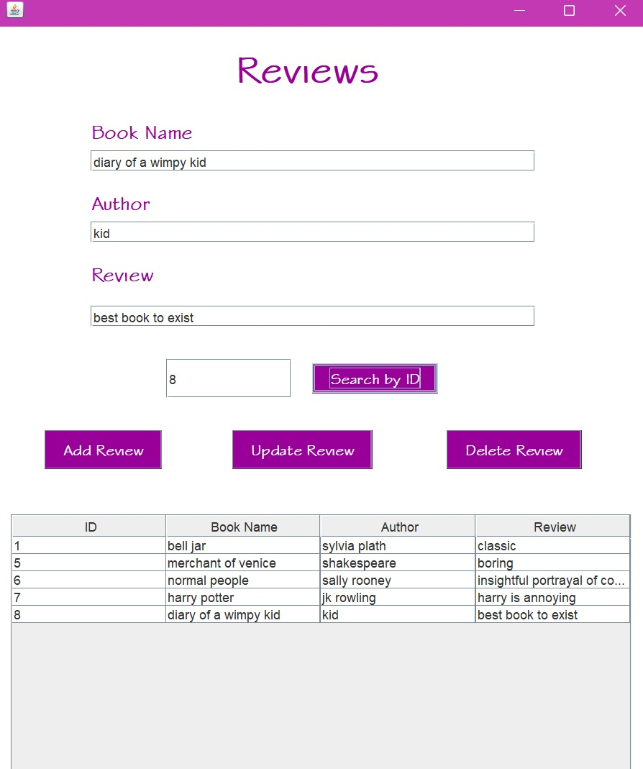

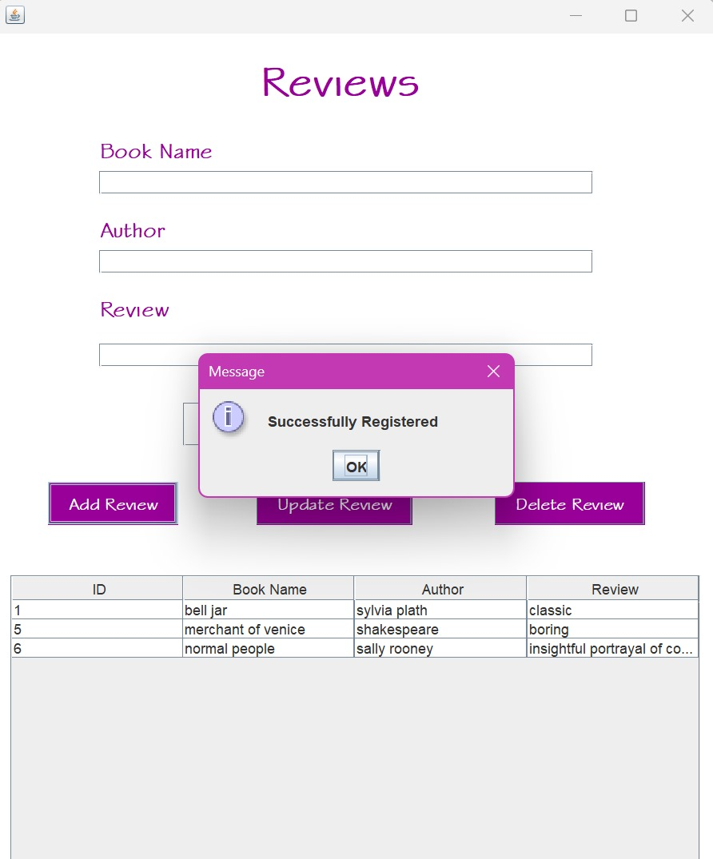

**Database for Accounts:**

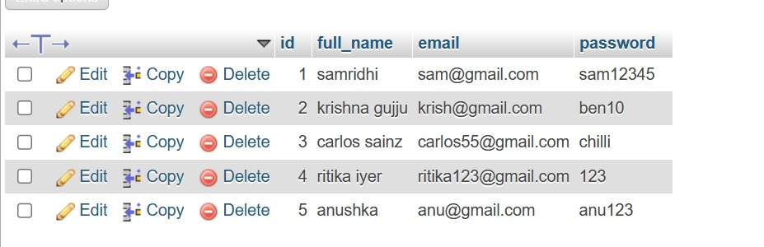

**Database for Reviews:**

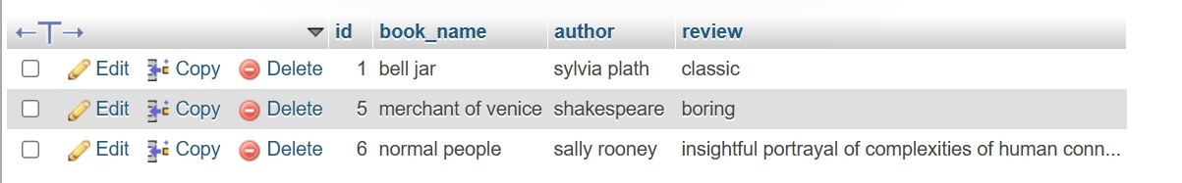

**Error pop ops:**

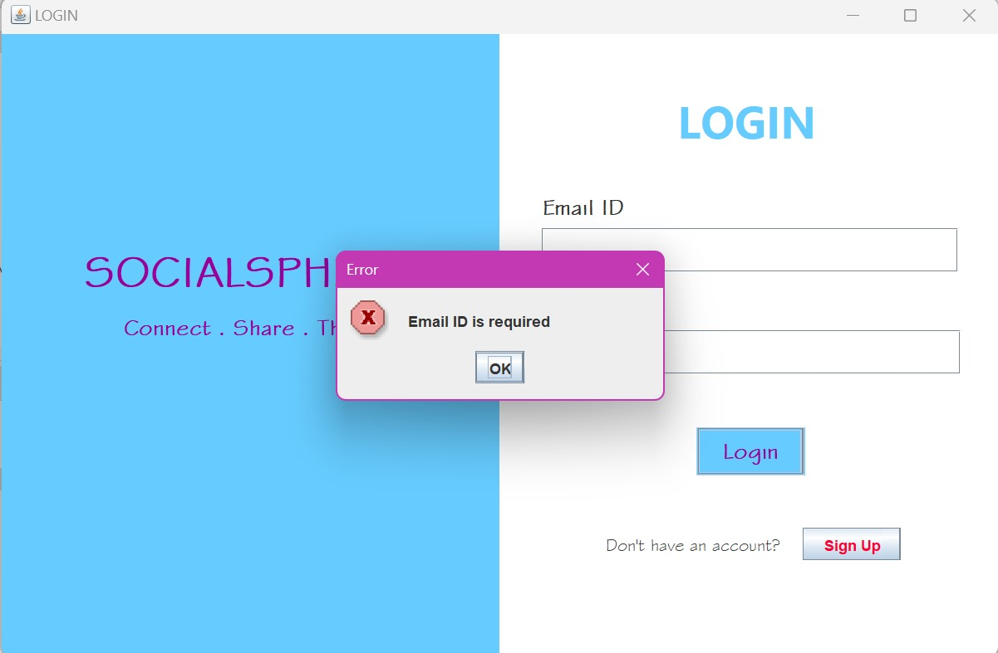

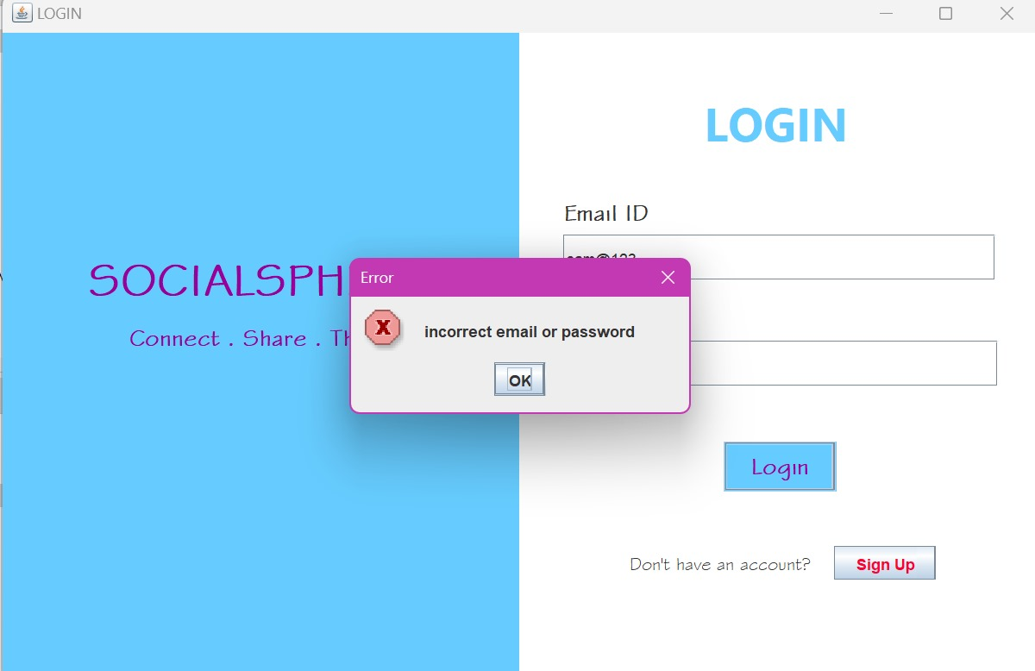

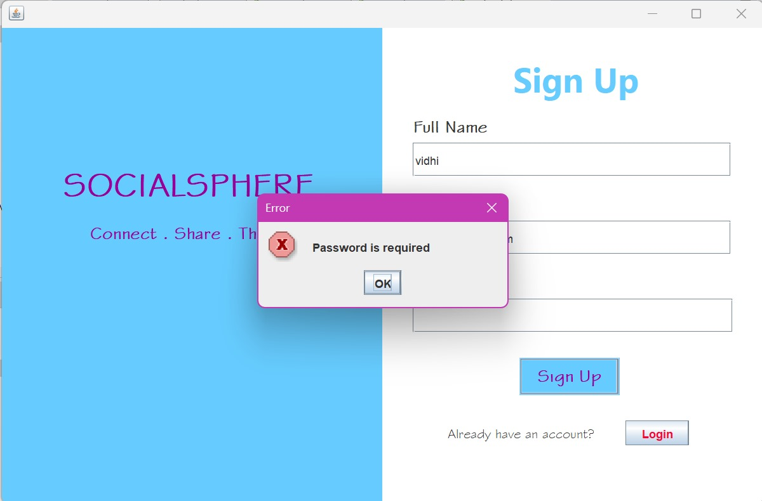

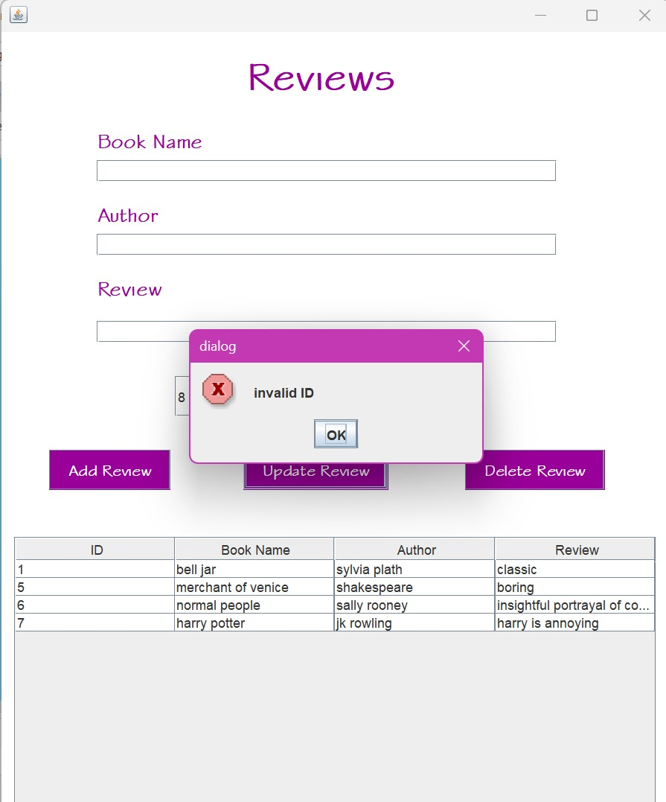

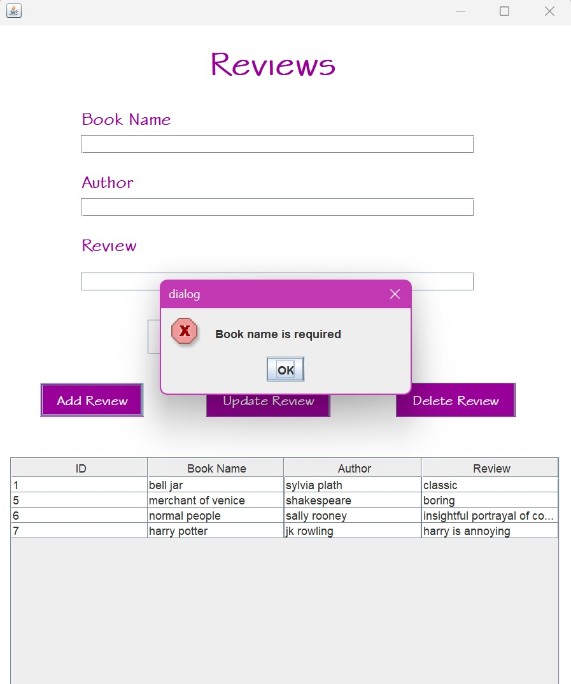

# Implementation (Source Code)

# Login page

package loginandsignup;

import java.sql.Connection;

import java.sql.DriverManager;

import java.sql.Statement;

import javax.swing.JFrame;

import javax.swing.JOptionPane;

import static javax.swing.JOptionPane.showMessageDialog;

/**

*

* @author vidhi

*/

public class Login extends javax.swing.JFrame {

/**

* Creates new form Login

*/

public Login() {

initComponents();

}

/**

* This method is called from within the constructor to initialize the form.

* WARNING: Do NOT modify this code. The content of this method is always

* regenerated by the Form Editor.

*/

@SuppressWarnings("unchecked")

// <editor-fold defaultstate="collapsed" desc="Generated Code">

private void initComponents() {

jPanel1 = new javax.swing.JPanel();

jPanel2 = new javax.swing.JPanel();

jLabel1 = new javax.swing.JLabel();

jLabel2 = new javax.swing.JLabel();

jLabel3 = new javax.swing.JLabel();

jLabel4 = new javax.swing.JLabel();

jLabel5 = new javax.swing.JLabel();

email = new javax.swing.JTextField();

jLabel6 = new javax.swing.JLabel();

password = new javax.swing.JPasswordField();

LoginBtn = new javax.swing.JButton();

jLabel7 = new javax.swing.JLabel();

jButton2 = new javax.swing.JButton();

setDefaultCloseOperation(javax.swing.WindowConstants.EXIT_ON_CLOSE);

setTitle("LOGIN");

jPanel1.setBackground(new java.awt.Color(255, 255, 255));

jPanel1.setPreferredSize(new java.awt.Dimension(800, 500));

jPanel2.setBackground(new java.awt.Color(102, 204, 255));

jPanel2.setPreferredSize(new java.awt.Dimension(400, 500));

jLabel1.setIcon(new javax.swing.ImageIcon("C:\\Users\\vidhi\\Desktop\\oopj\\icon_2.jpg")); // NOI18N

jLabel1.setText("jLabel1");

jLabel2.setFont(new java.awt.Font("Stylus BT", 1, 36)); // NOI18N

jLabel2.setForeground(new java.awt.Color(153, 0, 153));

jLabel2.setText(" SOCIALSPHERE");

jLabel3.setFont(new java.awt.Font("Stylus BT", 1, 18)); // NOI18N

jLabel3.setForeground(new java.awt.Color(153, 0, 153));

jLabel3.setText("Connect . Share . Thrive");

javax.swing.GroupLayout jPanel2Layout = new javax.swing.GroupLayout(jPanel2);

jPanel2.setLayout(jPanel2Layout);

jPanel2Layout.setHorizontalGroup(

jPanel2Layout.createParallelGroup(javax.swing.GroupLayout.Alignment.LEADING)

.addGroup(jPanel2Layout.createSequentialGroup()

.addContainerGap(55, Short.MAX_VALUE)

.addGroup(jPanel2Layout.createParallelGroup(javax.swing.GroupLayout.Alignment.LEADING)

.addGroup(javax.swing.GroupLayout.Alignment.TRAILING, jPanel2Layout.createSequentialGroup()

.addComponent(jLabel1, javax.swing.GroupLayout.PREFERRED_SIZE, 191, javax.swing.GroupLayout.PREFERRED_SIZE)

.addGap(103, 103, 103))

.addGroup(javax.swing.GroupLayout.Alignment.TRAILING, jPanel2Layout.createSequentialGroup()

.addComponent(jLabel2, javax.swing.GroupLayout.PREFERRED_SIZE, 299, javax.swing.GroupLayout.PREFERRED_SIZE)

.addGap(46, 46, 46))))

.addGroup(jPanel2Layout.createSequentialGroup()

.addGap(98, 98, 98)

.addComponent(jLabel3)

.addGap(0, 0, Short.MAX_VALUE))

);

jPanel2Layout.setVerticalGroup(

jPanel2Layout.createParallelGroup(javax.swing.GroupLayout.Alignment.LEADING)

.addGroup(jPanel2Layout.createSequentialGroup()

.addGap(129, 129, 129)

.addComponent(jLabel1)

.addGap(24, 24, 24)

.addComponent(jLabel2)

.addPreferredGap(javax.swing.LayoutStyle.ComponentPlacement.UNRELATED)

.addComponent(jLabel3)

.addContainerGap(151, Short.MAX_VALUE))

);

jLabel4.setFont(new java.awt.Font("Segoe UI", 1, 36)); // NOI18N

jLabel4.setForeground(new java.awt.Color(102, 204, 255));

jLabel4.setText("LOGIN");

jLabel5.setFont(new java.awt.Font("Stylus BT", 1, 18)); // NOI18N

jLabel5.setText("Email ID");

jLabel6.setFont(new java.awt.Font("Stylus BT", 1, 18)); // NOI18N

jLabel6.setText("Password");

LoginBtn.setBackground(new java.awt.Color(102, 204, 255));

LoginBtn.setFont(new java.awt.Font("Stylus BT", 1, 18)); // NOI18N

LoginBtn.setForeground(new java.awt.Color(153, 0, 153));

LoginBtn.setText("Login");

LoginBtn.setOpaque(true);

LoginBtn.addActionListener(new java.awt.event.ActionListener() {

public void actionPerformed(java.awt.event.ActionEvent evt) {

LoginBtnActionPerformed(evt);

}

});

jLabel7.setFont(new java.awt.Font("Stylus BT", 0, 14)); // NOI18N

jLabel7.setText("Don't have an account?");

jButton2.setForeground(new java.awt.Color(255, 0, 51));

jButton2.setText("Sign Up");

jButton2.addActionListener(new java.awt.event.ActionListener() {

public void actionPerformed(java.awt.event.ActionEvent evt) {

jButton2ActionPerformed(evt);

}

});

javax.swing.GroupLayout jPanel1Layout = new javax.swing.GroupLayout(jPanel1);

jPanel1.setLayout(jPanel1Layout);

jPanel1Layout.setHorizontalGroup(

jPanel1Layout.createParallelGroup(javax.swing.GroupLayout.Alignment.LEADING)

.addGroup(jPanel1Layout.createSequentialGroup()

.addComponent(jPanel2, javax.swing.GroupLayout.PREFERRED_SIZE, javax.swing.GroupLayout.DEFAULT_SIZE, javax.swing.GroupLayout.PREFERRED_SIZE)

.addGroup(jPanel1Layout.createParallelGroup(javax.swing.GroupLayout.Alignment.LEADING)

.addGroup(jPanel1Layout.createSequentialGroup()

.addGroup(jPanel1Layout.createParallelGroup(javax.swing.GroupLayout.Alignment.LEADING)

.addGroup(jPanel1Layout.createSequentialGroup()

.addGap(142, 142, 142)

.addComponent(jLabel4))

.addGroup(jPanel1Layout.createSequentialGroup()

.addGap(34, 34, 34)

.addGroup(jPanel1Layout.createParallelGroup(javax.swing.GroupLayout.Alignment.LEADING)

.addComponent(jLabel5)

.addComponent(email, javax.swing.GroupLayout.PREFERRED_SIZE, 335, javax.swing.GroupLayout.PREFERRED_SIZE)

.addComponent(jLabel6)

.addComponent(password, javax.swing.GroupLayout.PREFERRED_SIZE, 337, javax.swing.GroupLayout.PREFERRED_SIZE)))

.addGroup(jPanel1Layout.createSequentialGroup()

.addGap(85, 85, 85)

.addComponent(jLabel7)

.addGap(18, 18, 18)

.addComponent(jButton2)))

.addContainerGap(29, Short.MAX_VALUE))

.addGroup(javax.swing.GroupLayout.Alignment.TRAILING, jPanel1Layout.createSequentialGroup()

.addPreferredGap(javax.swing.LayoutStyle.ComponentPlacement.RELATED, javax.swing.GroupLayout.DEFAULT_SIZE, Short.MAX_VALUE)

.addComponent(LoginBtn, javax.swing.GroupLayout.PREFERRED_SIZE, 87, javax.swing.GroupLayout.PREFERRED_SIZE)

.addGap(155, 155, 155))))

);

jPanel1Layout.setVerticalGroup(

jPanel1Layout.createParallelGroup(javax.swing.GroupLayout.Alignment.LEADING)

.addGroup(jPanel1Layout.createSequentialGroup()

.addComponent(jPanel2, javax.swing.GroupLayout.PREFERRED_SIZE, javax.swing.GroupLayout.DEFAULT_SIZE, javax.swing.GroupLayout.PREFERRED_SIZE)

.addGap(0, 0, Short.MAX_VALUE))

.addGroup(jPanel1Layout.createSequentialGroup()

.addGap(45, 45, 45)

.addComponent(jLabel4)

.addGap(35, 35, 35)

.addComponent(jLabel5)

.addPreferredGap(javax.swing.LayoutStyle.ComponentPlacement.RELATED)

.addComponent(email, javax.swing.GroupLayout.PREFERRED_SIZE, 36, javax.swing.GroupLayout.PREFERRED_SIZE)

.addGap(18, 18, 18)

.addComponent(jLabel6)

.addPreferredGap(javax.swing.LayoutStyle.ComponentPlacement.RELATED)

.addComponent(password, javax.swing.GroupLayout.PREFERRED_SIZE, 36, javax.swing.GroupLayout.PREFERRED_SIZE)

.addPreferredGap(javax.swing.LayoutStyle.ComponentPlacement.RELATED, javax.swing.GroupLayout.DEFAULT_SIZE, Short.MAX_VALUE)

.addComponent(LoginBtn, javax.swing.GroupLayout.PREFERRED_SIZE, 39, javax.swing.GroupLayout.PREFERRED_SIZE)

.addGap(42, 42, 42)

.addGroup(jPanel1Layout.createParallelGroup(javax.swing.GroupLayout.Alignment.BASELINE)

.addComponent(jLabel7)

.addComponent(jButton2))

.addGap(77, 77, 77))

);

javax.swing.GroupLayout layout = new javax.swing.GroupLayout(getContentPane());

getContentPane().setLayout(layout);

layout.setHorizontalGroup(

layout.createParallelGroup(javax.swing.GroupLayout.Alignment.LEADING)

.addGroup(layout.createSequentialGroup()

.addComponent(jPanel1, javax.swing.GroupLayout.PREFERRED_SIZE, javax.swing.GroupLayout.DEFAULT_SIZE, javax.swing.GroupLayout.PREFERRED_SIZE)

.addGap(0, 0, Short.MAX_VALUE))

);

layout.setVerticalGroup(

layout.createParallelGroup(javax.swing.GroupLayout.Alignment.LEADING)

.addGroup(layout.createSequentialGroup()

.addComponent(jPanel1, javax.swing.GroupLayout.PREFERRED_SIZE, javax.swing.GroupLayout.DEFAULT_SIZE, javax.swing.GroupLayout.PREFERRED_SIZE)

.addGap(0, 0, Short.MAX_VALUE))

);

pack();

}// </editor-fold>

private void jButton2ActionPerformed(java.awt.event.ActionEvent evt) {

// TODO add your handling code here:

SignUp SignUpFrame = new SignUp();

SignUpFrame.setVisible(true);

SignUpFrame.pack();

SignUpFrame.setLocationRelativeTo(null);

this.dispose();

}

private void LoginBtnActionPerformed(java.awt.event.ActionEvent evt) {

// TODO add your handling code here:

String Email, Password, query, passDb=null, fname=null;

String SUrl, SUser, SPass;

SUrl="jdbc:MySQL://localhost:3306/java_user_database";

SUser="root";

SPass="";

int notFound = 0;

try{

Class.forName("com.mysql.cj.jdbc.Driver");

Connection con = DriverManager.getConnection(SUrl, SUser, SPass);

Statement st = con.createStatement();

if("".equals(email.getText())){

JOptionPane.showMessageDialog(new JFrame(), "Email ID is required", "Error",

JOptionPane.ERROR_MESSAGE);

}else if("".equals(password.getText())){

JOptionPane.showMessageDialog(new JFrame(), "Password is required", "Error",

JOptionPane.ERROR_MESSAGE);

}else{

Email = email.getText();

Password = password.getText();

query = "SELECT * FROM user WHERE email='"+Email+"'";

java.sql.ResultSet rs = st.executeQuery(query);

while(rs.next()){

passDb = rs.getString("password");

fname = rs.getString("full_name");

notFound=1;

}

if(notFound == 1 && Password.equals(passDb)){

Home HomeFrame = new Home();

HomeFrame.setUser(fname);

HomeFrame.setVisible(true);

HomeFrame.pack();

HomeFrame.setLocationRelativeTo(null);

this.dispose();

}else{

JOptionPane.showMessageDialog(new JFrame(), "incorrect email or password", "Error",

JOptionPane.ERROR_MESSAGE);

}

st.execute(query);

password.setText("");

}

}catch(Exception e){

System.out.println("Error!"+e.getMessage());

}

}

/**

* @param args the command line arguments

*/

// Variables declaration - do not modify

private javax.swing.JButton LoginBtn;

private javax.swing.JTextField email;

private javax.swing.JButton jButton2;

private javax.swing.JLabel jLabel1;

private javax.swing.JLabel jLabel2;

private javax.swing.JLabel jLabel3;

private javax.swing.JLabel jLabel4;

private javax.swing.JLabel jLabel5;

private javax.swing.JLabel jLabel6;

private javax.swing.JLabel jLabel7;

private javax.swing.JPanel jPanel1;

private javax.swing.JPanel jPanel2;

private javax.swing.JPasswordField password;

// End of variables declaration

}

# Sign up page

package loginandsignup;

import java.sql.Connection;

import java.sql.DriverManager;

import java.sql.ResultSet;

import java.sql.Statement;

import javax.swing.JFrame;

import javax.swing.JOptionPane;

import static javax.swing.JOptionPane.showMessageDialog;

/**

*

* @author vidhi

*/

public class SignUp extends javax.swing.JFrame {

/**

* Creates new form SignUp

*/

public SignUp() {

initComponents();

}

/**

* This method is called from within the constructor to initialize the form.

* WARNING: Do NOT modify this code. The content of this method is always

* regenerated by the Form Editor.

*/

@SuppressWarnings("unchecked")

// <editor-fold defaultstate="collapsed" desc="Generated Code">

private void initComponents() {

jLabel1 = new javax.swing.JLabel();

jLabel5 = new javax.swing.JLabel();

jLabel7 = new javax.swing.JLabel();

jLabel11 = new javax.swing.JLabel();

jPanel1 = new javax.swing.JPanel();

jPanel2 = new javax.swing.JPanel();

jLabel2 = new javax.swing.JLabel();

jLabel3 = new javax.swing.JLabel();

jLabel4 = new javax.swing.JLabel();

jLabel6 = new javax.swing.JLabel();

jLabel8 = new javax.swing.JLabel();

fname = new javax.swing.JTextField();

emailAddress = new javax.swing.JTextField();

jLabel9 = new javax.swing.JLabel();

pass = new javax.swing.JPasswordField();

jLabel10 = new javax.swing.JLabel();

SignUpBtn = new javax.swing.JButton();

jLabel12 = new javax.swing.JLabel();

jButton2 = new javax.swing.JButton();

jLabel1.setText("jLabel1");

jLabel5.setFont(new java.awt.Font("Segoe UI", 1, 36)); // NOI18N

jLabel5.setForeground(new java.awt.Color(102, 204, 255));

jLabel5.setText("LOGIN");

jLabel7.setFont(new java.awt.Font("Stylus BT", 1, 18)); // NOI18N

jLabel7.setText("Email ID");

jLabel11.setFont(new java.awt.Font("Stylus BT", 0, 14)); // NOI18N

jLabel11.setText("Don't have an account?");

setDefaultCloseOperation(javax.swing.WindowConstants.EXIT_ON_CLOSE);

jPanel1.setBackground(new java.awt.Color(255, 255, 255));

jPanel1.setPreferredSize(new java.awt.Dimension(800, 500));

jPanel2.setBackground(new java.awt.Color(102, 204, 255));

jPanel2.setPreferredSize(new java.awt.Dimension(400, 500));

jLabel2.setIcon(new javax.swing.ImageIcon("C:\\Users\\vidhi\\Desktop\\oopj\\icon_2.jpg")); // NOI18N

jLabel2.setText("jLabel1");

jLabel3.setFont(new java.awt.Font("Stylus BT", 1, 36)); // NOI18N

jLabel3.setForeground(new java.awt.Color(153, 0, 153));

jLabel3.setText(" SOCIALSPHERE");

jLabel4.setFont(new java.awt.Font("Stylus BT", 1, 18)); // NOI18N

jLabel4.setForeground(new java.awt.Color(153, 0, 153));

jLabel4.setText("Connect . Share . Thrive");

javax.swing.GroupLayout jPanel2Layout = new javax.swing.GroupLayout(jPanel2);

jPanel2.setLayout(jPanel2Layout);

jPanel2Layout.setHorizontalGroup(

jPanel2Layout.createParallelGroup(javax.swing.GroupLayout.Alignment.LEADING)

.addGroup(javax.swing.GroupLayout.Alignment.TRAILING, jPanel2Layout.createSequentialGroup()

.addGap(0, 53, Short.MAX_VALUE)

.addComponent(jLabel3, javax.swing.GroupLayout.PREFERRED_SIZE, 299, javax.swing.GroupLayout.PREFERRED_SIZE)

.addGap(48, 48, 48))

.addGroup(jPanel2Layout.createSequentialGroup()

.addGroup(jPanel2Layout.createParallelGroup(javax.swing.GroupLayout.Alignment.LEADING)

.addGroup(jPanel2Layout.createSequentialGroup()

.addGap(95, 95, 95)

.addComponent(jLabel2, javax.swing.GroupLayout.PREFERRED_SIZE, 191, javax.swing.GroupLayout.PREFERRED_SIZE))

.addGroup(jPanel2Layout.createSequentialGroup()

.addGap(93, 93, 93)

.addComponent(jLabel4)))

.addContainerGap(javax.swing.GroupLayout.DEFAULT_SIZE, Short.MAX_VALUE))

);

jPanel2Layout.setVerticalGroup(

jPanel2Layout.createParallelGroup(javax.swing.GroupLayout.Alignment.LEADING)

.addGroup(jPanel2Layout.createSequentialGroup()

.addGap(109, 109, 109)

.addComponent(jLabel2)

.addGap(18, 18, 18)

.addComponent(jLabel3)

.addGap(18, 18, 18)

.addComponent(jLabel4)

.addContainerGap(171, Short.MAX_VALUE))

);

jLabel6.setFont(new java.awt.Font("Segoe UI", 1, 36)); // NOI18N

jLabel6.setForeground(new java.awt.Color(102, 204, 255));

jLabel6.setText("Sign Up");

jLabel8.setFont(new java.awt.Font("Stylus BT", 1, 18)); // NOI18N

jLabel8.setText("Full Name");

jLabel9.setFont(new java.awt.Font("Stylus BT", 1, 18)); // NOI18N

jLabel9.setText("Password");

jLabel10.setFont(new java.awt.Font("Stylus BT", 1, 18)); // NOI18N

jLabel10.setText("Email ID");

SignUpBtn.setBackground(new java.awt.Color(102, 204, 255));

SignUpBtn.setFont(new java.awt.Font("Stylus BT", 1, 18)); // NOI18N

SignUpBtn.setForeground(new java.awt.Color(153, 0, 153));

SignUpBtn.setText("Sign Up");

SignUpBtn.setOpaque(true);

SignUpBtn.addActionListener(new java.awt.event.ActionListener() {

public void actionPerformed(java.awt.event.ActionEvent evt) {

SignUpBtnActionPerformed(evt);

}

});

jLabel12.setFont(new java.awt.Font("Stylus BT", 0, 14)); // NOI18N

jLabel12.setText("Already have an account?");

jButton2.setForeground(new java.awt.Color(255, 0, 51));

jButton2.setText("Login");

jButton2.addActionListener(new java.awt.event.ActionListener() {

public void actionPerformed(java.awt.event.ActionEvent evt) {

jButton2ActionPerformed(evt);

}

});

javax.swing.GroupLayout jPanel1Layout = new javax.swing.GroupLayout(jPanel1);

jPanel1.setLayout(jPanel1Layout);

jPanel1Layout.setHorizontalGroup(

jPanel1Layout.createParallelGroup(javax.swing.GroupLayout.Alignment.LEADING)

.addGroup(jPanel1Layout.createSequentialGroup()

.addComponent(jPanel2, javax.swing.GroupLayout.PREFERRED_SIZE, javax.swing.GroupLayout.DEFAULT_SIZE, javax.swing.GroupLayout.PREFERRED_SIZE)

.addGroup(jPanel1Layout.createParallelGroup(javax.swing.GroupLayout.Alignment.LEADING)

.addGroup(javax.swing.GroupLayout.Alignment.TRAILING, jPanel1Layout.createSequentialGroup()

.addPreferredGap(javax.swing.LayoutStyle.ComponentPlacement.RELATED, javax.swing.GroupLayout.DEFAULT_SIZE, Short.MAX_VALUE)

.addComponent(jLabel6)

.addGap(131, 131, 131))

.addGroup(jPanel1Layout.createSequentialGroup()

.addGroup(jPanel1Layout.createParallelGroup(javax.swing.GroupLayout.Alignment.LEADING)

.addGroup(jPanel1Layout.createSequentialGroup()

.addGap(32, 32, 32)

.addGroup(jPanel1Layout.createParallelGroup(javax.swing.GroupLayout.Alignment.LEADING)

.addComponent(jLabel8)

.addComponent(emailAddress, javax.swing.GroupLayout.PREFERRED_SIZE, 335, javax.swing.GroupLayout.PREFERRED_SIZE)

.addComponent(fname, javax.swing.GroupLayout.PREFERRED_SIZE, 335, javax.swing.GroupLayout.PREFERRED_SIZE)

.addComponent(pass, javax.swing.GroupLayout.PREFERRED_SIZE, 337, javax.swing.GroupLayout.PREFERRED_SIZE)

.addComponent(jLabel10)

.addGroup(jPanel1Layout.createSequentialGroup()

.addGap(36, 36, 36)

.addComponent(jLabel12)

.addGap(33, 33, 33)

.addComponent(jButton2))

.addComponent(jLabel9)))

.addGroup(jPanel1Layout.createSequentialGroup()

.addGap(144, 144, 144)

.addComponent(SignUpBtn, javax.swing.GroupLayout.PREFERRED_SIZE, 105, javax.swing.GroupLayout.PREFERRED_SIZE)))

.addContainerGap(31, Short.MAX_VALUE))))

);

jPanel1Layout.setVerticalGroup(

jPanel1Layout.createParallelGroup(javax.swing.GroupLayout.Alignment.LEADING)

.addGroup(jPanel1Layout.createSequentialGroup()

.addComponent(jPanel2, javax.swing.GroupLayout.PREFERRED_SIZE, javax.swing.GroupLayout.DEFAULT_SIZE, javax.swing.GroupLayout.PREFERRED_SIZE)

.addGap(0, 0, Short.MAX_VALUE))

.addGroup(jPanel1Layout.createSequentialGroup()

.addGap(29, 29, 29)

.addComponent(jLabel6)

.addGap(16, 16, 16)

.addComponent(jLabel8)

.addPreferredGap(javax.swing.LayoutStyle.ComponentPlacement.RELATED)

.addComponent(fname, javax.swing.GroupLayout.PREFERRED_SIZE, 36, javax.swing.GroupLayout.PREFERRED_SIZE)

.addGap(18, 18, 18)

.addComponent(jLabel10)

.addPreferredGap(javax.swing.LayoutStyle.ComponentPlacement.RELATED)

.addComponent(emailAddress, javax.swing.GroupLayout.PREFERRED_SIZE, 36, javax.swing.GroupLayout.PREFERRED_SIZE)

.addGap(18, 18, 18)

.addComponent(jLabel9)

.addPreferredGap(javax.swing.LayoutStyle.ComponentPlacement.RELATED)

.addComponent(pass, javax.swing.GroupLayout.PREFERRED_SIZE, 36, javax.swing.GroupLayout.PREFERRED_SIZE)

.addGap(26, 26, 26)

.addComponent(SignUpBtn, javax.swing.GroupLayout.PREFERRED_SIZE, 39, javax.swing.GroupLayout.PREFERRED_SIZE)

.addGap(27, 27, 27)

.addGroup(jPanel1Layout.createParallelGroup(javax.swing.GroupLayout.Alignment.BASELINE)

.addComponent(jLabel12)

.addComponent(jButton2))

.addContainerGap(javax.swing.GroupLayout.DEFAULT_SIZE, Short.MAX_VALUE))

);

javax.swing.GroupLayout layout = new javax.swing.GroupLayout(getContentPane());

getContentPane().setLayout(layout);

layout.setHorizontalGroup(

layout.createParallelGroup(javax.swing.GroupLayout.Alignment.LEADING)

.addGroup(layout.createSequentialGroup()

.addComponent(jPanel1, javax.swing.GroupLayout.PREFERRED_SIZE, javax.swing.GroupLayout.DEFAULT_SIZE, javax.swing.GroupLayout.PREFERRED_SIZE)

.addGap(0, 0, Short.MAX_VALUE))

);

layout.setVerticalGroup(

layout.createParallelGroup(javax.swing.GroupLayout.Alignment.LEADING)

.addGroup(layout.createSequentialGroup()

.addComponent(jPanel1, javax.swing.GroupLayout.PREFERRED_SIZE, javax.swing.GroupLayout.DEFAULT_SIZE, javax.swing.GroupLayout.PREFERRED_SIZE)

.addGap(0, 0, Short.MAX_VALUE))

);

pack();

}// </editor-fold>

private void jButton2ActionPerformed(java.awt.event.ActionEvent evt) {

// TODO add your handling code here:

Login LoginFrame = new Login();

LoginFrame.setVisible(true);

LoginFrame.pack();

LoginFrame.setLocationRelativeTo(null);

this.dispose();

}

private void SignUpBtnActionPerformed(java.awt.event.ActionEvent evt) {

// TODO add your handling code here:

String fullName, email, Password, query;

String SUrl, SUser, SPass;

SUrl="jdbc:MySQL://localhost:3306/java_user_database";

SUser="root";

SPass="";

try{

Class.forName("com.mysql.cj.jdbc.Driver");

Connection con = DriverManager.getConnection(SUrl, SUser, SPass);

Statement st = con.createStatement();

if("".equals(fname.getText())){

JOptionPane.showMessageDialog(new JFrame(), "Full Name is required", "Error",

JOptionPane.ERROR_MESSAGE);

}else if("".equals(emailAddress.getText())){

JOptionPane.showMessageDialog(new JFrame(), "Email ID is required", "Error",

JOptionPane.ERROR_MESSAGE);

}else if("".equals(pass.getText())){

JOptionPane.showMessageDialog(new JFrame(), "Password is required", "Error",

JOptionPane.ERROR_MESSAGE);

}else{

fullName = fname.getText();

email = emailAddress.getText();

Password = pass.getText();

System.out.println(Password);

query = "INSERT into user(full_name, email, password)" + "VALUES('"+fullName+"', '"+email+"', '"+Password+"')";

st.execute(query);

fname.setText("");

emailAddress.setText("");

pass.setText("");

showMessageDialog(null, "New account has been created successfully! ");

}

}catch(Exception e){

System.out.println("Error!"+e.getMessage());

}

}

/**

* @param args the command line arguments

*/

public static void main(String args[]) {

/* Set the Nimbus look and feel */

//<editor-fold defaultstate="collapsed" desc=" Look and feel setting code (optional) ">

/* If Nimbus (introduced in Java SE 6) is not available, stay with the default look and feel.

* For details see http://download.oracle.com/javase/tutorial/uiswing/lookandfeel/plaf.html

*/

try {

for (javax.swing.UIManager.LookAndFeelInfo info : javax.swing.UIManager.getInstalledLookAndFeels()) {

if ("Nimbus".equals(info.getName())) {

javax.swing.UIManager.setLookAndFeel(info.getClassName());

break;

}

}

} catch (ClassNotFoundException ex) {

java.util.logging.Logger.getLogger(SignUp.class.getName()).log(java.util.logging.Level.SEVERE, null, ex);

} catch (InstantiationException ex) {

java.util.logging.Logger.getLogger(SignUp.class.getName()).log(java.util.logging.Level.SEVERE, null, ex);

} catch (IllegalAccessException ex) {

java.util.logging.Logger.getLogger(SignUp.class.getName()).log(java.util.logging.Level.SEVERE, null, ex);

} catch (javax.swing.UnsupportedLookAndFeelException ex) {

java.util.logging.Logger.getLogger(SignUp.class.getName()).log(java.util.logging.Level.SEVERE, null, ex);

}

//</editor-fold>

/* Create and display the form */

java.awt.EventQueue.invokeLater(new Runnable() {

public void run() {

new SignUp().setVisible(true);

}

});

}

// Variables declaration - do not modify

private javax.swing.JButton SignUpBtn;

private javax.swing.JTextField emailAddress;

private javax.swing.JTextField fname;

private javax.swing.JButton jButton2;

private javax.swing.JLabel jLabel1;

private javax.swing.JLabel jLabel10;

private javax.swing.JLabel jLabel11;

private javax.swing.JLabel jLabel12;

private javax.swing.JLabel jLabel2;

private javax.swing.JLabel jLabel3;

private javax.swing.JLabel jLabel4;

private javax.swing.JLabel jLabel5;

private javax.swing.JLabel jLabel6;

private javax.swing.JLabel jLabel7;

private javax.swing.JLabel jLabel8;

private javax.swing.JLabel jLabel9;

private javax.swing.JPanel jPanel1;

private javax.swing.JPanel jPanel2;

private javax.swing.JPasswordField pass;

// End of variables declaration

}

# Home page

package loginandsignup;

/**

*

* @author vidhi

*/

public class Home extends javax.swing.JFrame {

/**

* Creates new form Home

*/

public Home() {

initComponents();

}

/**

* This method is called from within the constructor to initialize the form.

* WARNING: Do NOT modify this code. The content of this method is always

* regenerated by the Form Editor.

*/

@SuppressWarnings("unchecked")

// <editor-fold defaultstate="collapsed" desc="Generated Code">

private void initComponents() {

jPanel5 = new javax.swing.JPanel();

jPanel1 = new javax.swing.JPanel();

jPanel3 = new javax.swing.JPanel();

jPanel2 = new javax.swing.JPanel();

jLabel2 = new javax.swing.JLabel();

user = new javax.swing.JLabel();

jLabel5 = new javax.swing.JLabel();

user1 = new javax.swing.JLabel();

user2 = new javax.swing.JLabel();

user3 = new javax.swing.JLabel();

jPanel4 = new javax.swing.JPanel();

jLabel3 = new javax.swing.JLabel();

jLabel1 = new javax.swing.JLabel();

jButton2 = new javax.swing.JButton();

LogoutBtn = new javax.swing.JButton();

jLabel4 = new javax.swing.JLabel();

jLabel6 = new javax.swing.JLabel();

javax.swing.GroupLayout jPanel5Layout = new javax.swing.GroupLayout(jPanel5);

jPanel5.setLayout(jPanel5Layout);

jPanel5Layout.setHorizontalGroup(

jPanel5Layout.createParallelGroup(javax.swing.GroupLayout.Alignment.LEADING)

.addGap(0, 100, Short.MAX_VALUE)

);

jPanel5Layout.setVerticalGroup(

jPanel5Layout.createParallelGroup(javax.swing.GroupLayout.Alignment.LEADING)

.addGap(0, 100, Short.MAX_VALUE)

);

setDefaultCloseOperation(javax.swing.WindowConstants.EXIT_ON_CLOSE);

setTitle("Dashboard");

jPanel1.setBackground(new java.awt.Color(255, 255, 255));

jPanel1.setPreferredSize(new java.awt.Dimension(800, 500));

jPanel3.setBackground(new java.awt.Color(255, 255, 255));

jPanel2.setBackground(new java.awt.Color(153, 0, 153));

jPanel2.setPreferredSize(new java.awt.Dimension(555, 42));

jLabel2.setFont(new java.awt.Font("Stylus BT", 1, 24)); // NOI18N

jLabel2.setForeground(new java.awt.Color(255, 255, 255));

jLabel2.setText("Dashboard");

javax.swing.GroupLayout jPanel2Layout = new javax.swing.GroupLayout(jPanel2);

jPanel2.setLayout(jPanel2Layout);

jPanel2Layout.setHorizontalGroup(

jPanel2Layout.createParallelGroup(javax.swing.GroupLayout.Alignment.LEADING)

.addGroup(javax.swing.GroupLayout.Alignment.TRAILING, jPanel2Layout.createSequentialGroup()

.addContainerGap(456, Short.MAX_VALUE)

.addComponent(jLabel2)

.addGap(29, 29, 29))

);

jPanel2Layout.setVerticalGroup(

jPanel2Layout.createParallelGroup(javax.swing.GroupLayout.Alignment.LEADING)

.addComponent(jLabel2, javax.swing.GroupLayout.Alignment.TRAILING, javax.swing.GroupLayout.DEFAULT_SIZE, 46, Short.MAX_VALUE)

);

user.setFont(new java.awt.Font("Stylus BT", 1, 36)); // NOI18N

user.setForeground(new java.awt.Color(153, 0, 153));

user.setText("user");

jLabel5.setFont(new java.awt.Font("Stylus BT", 1, 36)); // NOI18N

jLabel5.setForeground(new java.awt.Color(153, 0, 153));

jLabel5.setText("Welcome Back!");

javax.swing.GroupLayout jPanel3Layout = new javax.swing.GroupLayout(jPanel3);

jPanel3.setLayout(jPanel3Layout);

jPanel3Layout.setHorizontalGroup(

jPanel3Layout.createParallelGroup(javax.swing.GroupLayout.Alignment.LEADING)

.addGroup(jPanel3Layout.createSequentialGroup()

.addGroup(jPanel3Layout.createParallelGroup(javax.swing.GroupLayout.Alignment.LEADING)

.addComponent(jPanel2, javax.swing.GroupLayout.PREFERRED_SIZE, 603, javax.swing.GroupLayout.PREFERRED_SIZE)

.addGroup(jPanel3Layout.createSequentialGroup()

.addGap(165, 165, 165)

.addComponent(jLabel5))

.addGroup(jPanel3Layout.createSequentialGroup()

.addGap(247, 247, 247)

.addComponent(user)))

.addContainerGap(817, Short.MAX_VALUE))

);

jPanel3Layout.setVerticalGroup(

jPanel3Layout.createParallelGroup(javax.swing.GroupLayout.Alignment.LEADING)

.addGroup(jPanel3Layout.createSequentialGroup()

.addComponent(jPanel2, javax.swing.GroupLayout.PREFERRED_SIZE, 46, javax.swing.GroupLayout.PREFERRED_SIZE)

.addGap(145, 145, 145)

.addComponent(jLabel5)

.addGap(26, 26, 26)

.addComponent(user)

.addContainerGap(javax.swing.GroupLayout.DEFAULT_SIZE, Short.MAX_VALUE))

);

user1.setFont(new java.awt.Font("Stylus BT", 1, 36)); // NOI18N

user1.setForeground(new java.awt.Color(153, 0, 153));

user1.setText("Vidhi");

user2.setFont(new java.awt.Font("Stylus BT", 1, 36)); // NOI18N

user2.setForeground(new java.awt.Color(153, 0, 153));

user2.setText("Vidhi");

user3.setFont(new java.awt.Font("Stylus BT", 1, 36)); // NOI18N

user3.setForeground(new java.awt.Color(153, 0, 153));

user3.setText("Vidhi");

jPanel4.setBackground(new java.awt.Color(153, 0, 153));

jLabel1.setIcon(new javax.swing.ImageIcon("C:\\Users\\vidhi\\Desktop\\oopj\\icon_2.jpg")); // NOI18N

jLabel1.setText("jLabel1");

jButton2.setFont(new java.awt.Font("Stylus BT", 1, 18)); // NOI18N

jButton2.setForeground(new java.awt.Color(153, 0, 153));

jButton2.setText("Reviews");

jButton2.setBorder(javax.swing.BorderFactory.createEtchedBorder());

jButton2.addActionListener(new java.awt.event.ActionListener() {

public void actionPerformed(java.awt.event.ActionEvent evt) {

jButton2ActionPerformed(evt);

}

});

LogoutBtn.setFont(new java.awt.Font("Stylus BT", 1, 18)); // NOI18N

LogoutBtn.setForeground(new java.awt.Color(153, 0, 153));

LogoutBtn.setText("Logout");

LogoutBtn.addActionListener(new java.awt.event.ActionListener() {

public void actionPerformed(java.awt.event.ActionEvent evt) {

LogoutBtnActionPerformed(evt);

}

});

jLabel4.setFont(new java.awt.Font("Stylus BT", 1, 36)); // NOI18N

jLabel4.setForeground(new java.awt.Color(255, 255, 255));

jLabel4.setText("SPHERE");

jLabel6.setFont(new java.awt.Font("Stylus BT", 1, 36)); // NOI18N

jLabel6.setForeground(new java.awt.Color(255, 255, 255));

jLabel6.setText("SOCIAL");

javax.swing.GroupLayout jPanel4Layout = new javax.swing.GroupLayout(jPanel4);

jPanel4.setLayout(jPanel4Layout);

jPanel4Layout.setHorizontalGroup(

jPanel4Layout.createParallelGroup(javax.swing.GroupLayout.Alignment.LEADING)

.addGroup(jPanel4Layout.createSequentialGroup()

.addGroup(jPanel4Layout.createParallelGroup(javax.swing.GroupLayout.Alignment.LEADING)

.addGroup(jPanel4Layout.createSequentialGroup()

.addContainerGap()

.addGroup(jPanel4Layout.createParallelGroup(javax.swing.GroupLayout.Alignment.LEADING)

.addComponent(jLabel3, javax.swing.GroupLayout.PREFERRED_SIZE, 181, javax.swing.GroupLayout.PREFERRED_SIZE)

.addComponent(jLabel1, javax.swing.GroupLayout.PREFERRED_SIZE, 175, javax.swing.GroupLayout.PREFERRED_SIZE)))

.addGroup(jPanel4Layout.createSequentialGroup()

.addGap(35, 35, 35)

.addGroup(jPanel4Layout.createParallelGroup(javax.swing.GroupLayout.Alignment.LEADING, false)

.addComponent(jLabel4, javax.swing.GroupLayout.DEFAULT_SIZE, javax.swing.GroupLayout.DEFAULT_SIZE, Short.MAX_VALUE)

.addComponent(jButton2, javax.swing.GroupLayout.DEFAULT_SIZE, javax.swing.GroupLayout.DEFAULT_SIZE, Short.MAX_VALUE)

.addComponent(LogoutBtn, javax.swing.GroupLayout.DEFAULT_SIZE, javax.swing.GroupLayout.DEFAULT_SIZE, Short.MAX_VALUE))))

.addContainerGap(javax.swing.GroupLayout.DEFAULT_SIZE, Short.MAX_VALUE))

.addGroup(jPanel4Layout.createParallelGroup(javax.swing.GroupLayout.Alignment.LEADING)

.addGroup(javax.swing.GroupLayout.Alignment.TRAILING, jPanel4Layout.createSequentialGroup()

.addContainerGap(37, Short.MAX_VALUE)

.addComponent(jLabel6)

.addGap(28, 28, 28)))

);

jPanel4Layout.setVerticalGroup(

jPanel4Layout.createParallelGroup(javax.swing.GroupLayout.Alignment.LEADING)

.addGroup(jPanel4Layout.createSequentialGroup()

.addContainerGap()

.addComponent(jLabel3)

.addPreferredGap(javax.swing.LayoutStyle.ComponentPlacement.RELATED)

.addComponent(jLabel1)

.addGap(56, 56, 56)

.addComponent(jLabel4)

.addGap(52, 52, 52)

.addComponent(jButton2, javax.swing.GroupLayout.PREFERRED_SIZE, 41, javax.swing.GroupLayout.PREFERRED_SIZE)

.addGap(40, 40, 40)

.addComponent(LogoutBtn, javax.swing.GroupLayout.PREFERRED_SIZE, 41, javax.swing.GroupLayout.PREFERRED_SIZE)

.addContainerGap(96, Short.MAX_VALUE))

.addGroup(jPanel4Layout.createParallelGroup(javax.swing.GroupLayout.Alignment.LEADING)

.addGroup(jPanel4Layout.createSequentialGroup()

.addGap(146, 146, 146)

.addComponent(jLabel6)

.addContainerGap(310, Short.MAX_VALUE)))

);

javax.swing.GroupLayout jPanel1Layout = new javax.swing.GroupLayout(jPanel1);

jPanel1.setLayout(jPanel1Layout);

jPanel1Layout.setHorizontalGroup(

jPanel1Layout.createParallelGroup(javax.swing.GroupLayout.Alignment.LEADING)

.addGroup(javax.swing.GroupLayout.Alignment.TRAILING, jPanel1Layout.createSequentialGroup()

.addComponent(jPanel4, javax.swing.GroupLayout.PREFERRED_SIZE, javax.swing.GroupLayout.DEFAULT_SIZE, javax.swing.GroupLayout.PREFERRED_SIZE)

.addPreferredGap(javax.swing.LayoutStyle.ComponentPlacement.RELATED, javax.swing.GroupLayout.DEFAULT_SIZE, Short.MAX_VALUE)

.addComponent(jPanel3, javax.swing.GroupLayout.PREFERRED_SIZE, javax.swing.GroupLayout.DEFAULT_SIZE, javax.swing.GroupLayout.PREFERRED_SIZE)

.addContainerGap())

.addGroup(jPanel1Layout.createParallelGroup(javax.swing.GroupLayout.Alignment.LEADING)

.addGroup(javax.swing.GroupLayout.Alignment.TRAILING, jPanel1Layout.createSequentialGroup()

.addContainerGap(1084, Short.MAX_VALUE)

.addComponent(user1)

.addGap(122, 122, 122)))

.addGroup(jPanel1Layout.createParallelGroup(javax.swing.GroupLayout.Alignment.LEADING)

.addGroup(javax.swing.GroupLayout.Alignment.TRAILING, jPanel1Layout.createSequentialGroup()

.addContainerGap(1094, Short.MAX_VALUE)

.addComponent(user2)

.addGap(112, 112, 112)))

.addGroup(jPanel1Layout.createParallelGroup(javax.swing.GroupLayout.Alignment.LEADING)

.addGroup(javax.swing.GroupLayout.Alignment.TRAILING, jPanel1Layout.createSequentialGroup()

.addContainerGap(1104, Short.MAX_VALUE)

.addComponent(user3)

.addGap(102, 102, 102)))

);

jPanel1Layout.setVerticalGroup(

jPanel1Layout.createParallelGroup(javax.swing.GroupLayout.Alignment.LEADING)

.addComponent(jPanel3, javax.swing.GroupLayout.DEFAULT_SIZE, javax.swing.GroupLayout.DEFAULT_SIZE, Short.MAX_VALUE)

.addComponent(jPanel4, javax.swing.GroupLayout.DEFAULT_SIZE, javax.swing.GroupLayout.DEFAULT_SIZE, Short.MAX_VALUE)

.addGroup(jPanel1Layout.createParallelGroup(javax.swing.GroupLayout.Alignment.LEADING)

.addGroup(jPanel1Layout.createSequentialGroup()

.addGap(136, 136, 136)

.addComponent(user1)

.addContainerGap(321, Short.MAX_VALUE)))

.addGroup(jPanel1Layout.createParallelGroup(javax.swing.GroupLayout.Alignment.LEADING)

.addGroup(jPanel1Layout.createSequentialGroup()

.addGap(146, 146, 146)

.addComponent(user2)

.addContainerGap(311, Short.MAX_VALUE)))

.addGroup(jPanel1Layout.createParallelGroup(javax.swing.GroupLayout.Alignment.LEADING)

.addGroup(jPanel1Layout.createSequentialGroup()

.addGap(156, 156, 156)

.addComponent(user3)

.addContainerGap(301, Short.MAX_VALUE)))

);

javax.swing.GroupLayout layout = new javax.swing.GroupLayout(getContentPane());

getContentPane().setLayout(layout);

layout.setHorizontalGroup(

layout.createParallelGroup(javax.swing.GroupLayout.Alignment.LEADING)

.addGroup(javax.swing.GroupLayout.Alignment.TRAILING, layout.createSequentialGroup()

.addComponent(jPanel1, javax.swing.GroupLayout.PREFERRED_SIZE, javax.swing.GroupLayout.DEFAULT_SIZE, javax.swing.GroupLayout.PREFERRED_SIZE)

.addGap(0, 0, Short.MAX_VALUE))

);

layout.setVerticalGroup(

layout.createParallelGroup(javax.swing.GroupLayout.Alignment.LEADING)

.addGroup(javax.swing.GroupLayout.Alignment.TRAILING, layout.createSequentialGroup()

.addComponent(jPanel1, javax.swing.GroupLayout.PREFERRED_SIZE, javax.swing.GroupLayout.DEFAULT_SIZE, javax.swing.GroupLayout.PREFERRED_SIZE)

.addGap(0, 0, Short.MAX_VALUE))

);

pack();

}// </editor-fold>

private void LogoutBtnActionPerformed(java.awt.event.ActionEvent evt) {

// TODO add your handling code here:

Login LoginFrame = new Login();

LoginFrame.setVisible(true);

LoginFrame.pack();

LoginFrame.setLocationRelativeTo(null);

this.dispose();

}

private void jButton2ActionPerformed(java.awt.event.ActionEvent evt) {

Review ReviewFrame = new Review();

ReviewFrame.setVisible(true);

ReviewFrame.pack();

ReviewFrame.setLocationRelativeTo(null);

this.dispose();

}

public void setUser(String name){

user.setText(name);

}

/**

* @param args the command line arguments

*/

public static void main(String args[]) {

/* Set the Nimbus look and feel */

//<editor-fold defaultstate="collapsed" desc=" Look and feel setting code (optional) ">

/* If Nimbus (introduced in Java SE 6) is not available, stay with the default look and feel.

* For details see http://download.oracle.com/javase/tutorial/uiswing/lookandfeel/plaf.html

*/

try {

for (javax.swing.UIManager.LookAndFeelInfo info : javax.swing.UIManager.getInstalledLookAndFeels()) {

if ("Nimbus".equals(info.getName())) {

javax.swing.UIManager.setLookAndFeel(info.getClassName());

break;

}

}

} catch (ClassNotFoundException ex) {

java.util.logging.Logger.getLogger(Home.class.getName()).log(java.util.logging.Level.SEVERE, null, ex);

} catch (InstantiationException ex) {

java.util.logging.Logger.getLogger(Home.class.getName()).log(java.util.logging.Level.SEVERE, null, ex);

} catch (IllegalAccessException ex) {

java.util.logging.Logger.getLogger(Home.class.getName()).log(java.util.logging.Level.SEVERE, null, ex);

} catch (javax.swing.UnsupportedLookAndFeelException ex) {

java.util.logging.Logger.getLogger(Home.class.getName()).log(java.util.logging.Level.SEVERE, null, ex);

}

//</editor-fold>

/* Create and display the form */

java.awt.EventQueue.invokeLater(new Runnable() {

public void run() {

new Home().setVisible(true);

}

});

}

// Variables declaration - do not modify

private javax.swing.JButton LogoutBtn;

private javax.swing.JButton jButton2;

private javax.swing.JLabel jLabel1;

private javax.swing.JLabel jLabel2;

private javax.swing.JLabel jLabel3;

private javax.swing.JLabel jLabel4;

private javax.swing.JLabel jLabel5;

private javax.swing.JLabel jLabel6;

private javax.swing.JPanel jPanel1;

private javax.swing.JPanel jPanel2;

private javax.swing.JPanel jPanel3;

private javax.swing.JPanel jPanel4;

private javax.swing.JPanel jPanel5;

private javax.swing.JLabel user;

private javax.swing.JLabel user1;

private javax.swing.JLabel user2;

private javax.swing.JLabel user3;

// End of variables declaration

}

# Review page

package loginandsignup;

import java.sql.Connection;

import java.sql.DriverManager;

import java.sql.ResultSet;

import java.sql.Statement;

import javax.swing.JFrame;

import javax.swing.JTable;

import javax.swing.table.DefaultTableModel;

import javax.swing.JOptionPane;

import static javax.swing.JOptionPane.showMessageDialog;

/**

*

* @author samieee

*/

public class Review extends javax.swing.JFrame {

public Review() {

initComponents();

loadData();

}

// <editor-fold defaultstate="collapsed" desc="Generated Code">

private void initComponents() {

jSeparator1 = new javax.swing.JSeparator();

update1 = new javax.swing.JButton();

jPanel1 = new javax.swing.JPanel();

jLabel1 = new javax.swing.JLabel();

jLabel2 = new javax.swing.JLabel();

bookname = new javax.swing.JTextField();

jLabel3 = new javax.swing.JLabel();

review = new javax.swing.JTextField();

jLabel4 = new javax.swing.JLabel();

author = new javax.swing.JTextField();

add = new javax.swing.JButton();

jScrollPane1 = new javax.swing.JScrollPane();

table = new javax.swing.JTable();

update = new javax.swing.JButton();

searchData = new javax.swing.JTextField();

searchBtn = new javax.swing.JButton();

delete = new javax.swing.JButton();

clear = new javax.swing.JButton();

back = new javax.swing.JButton();

update1.setBackground(new java.awt.Color(153, 0, 153));

update1.setFont(new java.awt.Font("Stylus BT", 1, 14)); // NOI18N

update1.setForeground(new java.awt.Color(255, 255, 255));

update1.setText("Update Review");

update1.addActionListener(new java.awt.event.ActionListener() {

public void actionPerformed(java.awt.event.ActionEvent evt) {

update1ActionPerformed(evt);

}

});

setDefaultCloseOperation(javax.swing.WindowConstants.EXIT_ON_CLOSE);

setBackground(new java.awt.Color(153, 0, 153));

jPanel1.setBackground(new java.awt.Color(255, 255, 255));

jPanel1.setPreferredSize(new java.awt.Dimension(600, 800));

jLabel1.setBackground(new java.awt.Color(255, 255, 255));

jLabel1.setFont(new java.awt.Font("Stylus BT", 1, 36)); // NOI18N

jLabel1.setForeground(new java.awt.Color(153, 0, 153));

jLabel1.setText("Reviews");

jLabel2.setFont(new java.awt.Font("Stylus BT", 1, 18)); // NOI18N

jLabel2.setForeground(new java.awt.Color(153, 0, 153));

jLabel2.setText("Book Name");

jLabel3.setFont(new java.awt.Font("Stylus BT", 1, 18)); // NOI18N

jLabel3.setForeground(new java.awt.Color(153, 0, 153));

jLabel3.setText("Author");

jLabel4.setFont(new java.awt.Font("Stylus BT", 1, 18)); // NOI18N

jLabel4.setForeground(new java.awt.Color(153, 0, 153));

jLabel4.setText("Review");

add.setBackground(new java.awt.Color(153, 0, 153));

add.setFont(new java.awt.Font("Stylus BT", 1, 14)); // NOI18N

add.setForeground(new java.awt.Color(255, 255, 255));

add.setText("Add Review");

add.addActionListener(new java.awt.event.ActionListener() {

public void actionPerformed(java.awt.event.ActionEvent evt) {

addActionPerformed(evt);

}

});

table.setFont(new java.awt.Font("Segoe UI", 0, 14)); // NOI18N

table.setModel(new javax.swing.table.DefaultTableModel(

new Object [][] {

{null, null, null, null},

{null, null, null, null},

{null, null, null, null},

{null, null, null, null}

},

new String [] {

"ID", "Book Name", "Author", "Review "

}

) {

Class[] types = new Class [] {

java.lang.Integer.class, java.lang.String.class, java.lang.String.class, java.lang.String.class

};

public Class getColumnClass(int columnIndex) {

return types [columnIndex];

}

});

table.setGridColor(new java.awt.Color(255, 255, 255));

table.setSelectionBackground(new java.awt.Color(255, 255, 255));

table.setSelectionForeground(new java.awt.Color(153, 0, 153));

jScrollPane1.setViewportView(table);

update.setBackground(new java.awt.Color(153, 0, 153));

update.setFont(new java.awt.Font("Stylus BT", 1, 14)); // NOI18N

update.setForeground(new java.awt.Color(255, 255, 255));

update.setText("Update Review");

update.addActionListener(new java.awt.event.ActionListener() {

public void actionPerformed(java.awt.event.ActionEvent evt) {

updateActionPerformed(evt);

}

});

searchBtn.setBackground(new java.awt.Color(153, 0, 153));

searchBtn.setFont(new java.awt.Font("Stylus BT", 1, 14)); // NOI18N

searchBtn.setForeground(new java.awt.Color(255, 255, 255));

searchBtn.setText("Search by ID");

searchBtn.addActionListener(new java.awt.event.ActionListener() {

public void actionPerformed(java.awt.event.ActionEvent evt) {

searchBtnActionPerformed(evt);

}

});

delete.setBackground(new java.awt.Color(153, 0, 153));

delete.setFont(new java.awt.Font("Stylus BT", 1, 14)); // NOI18N

delete.setForeground(new java.awt.Color(255, 255, 255));

delete.setText("Delete Review");

delete.addActionListener(new java.awt.event.ActionListener() {

public void actionPerformed(java.awt.event.ActionEvent evt) {

deleteActionPerformed(evt);

}

});

clear.setBackground(new java.awt.Color(153, 0, 153));

clear.setFont(new java.awt.Font("Stylus BT", 1, 14)); // NOI18N

clear.setForeground(new java.awt.Color(255, 255, 255));

clear.setText("Clear");

clear.addActionListener(new java.awt.event.ActionListener() {

public void actionPerformed(java.awt.event.ActionEvent evt) {

clearActionPerformed(evt);

}

});

back.setBackground(new java.awt.Color(153, 0, 153));

back.setFont(new java.awt.Font("Stylus BT", 1, 14)); // NOI18N

back.setForeground(new java.awt.Color(255, 255, 255));

back.setText("Back");

back.addActionListener(new java.awt.event.ActionListener() {

public void actionPerformed(java.awt.event.ActionEvent evt) {

backActionPerformed(evt);

}

});

javax.swing.GroupLayout jPanel1Layout = new javax.swing.GroupLayout(jPanel1);

jPanel1.setLayout(jPanel1Layout);

jPanel1Layout.setHorizontalGroup(

jPanel1Layout.createParallelGroup(javax.swing.GroupLayout.Alignment.LEADING)

.addGroup(jPanel1Layout.createSequentialGroup()

.addGroup(jPanel1Layout.createParallelGroup(javax.swing.GroupLayout.Alignment.LEADING)

.addGroup(jPanel1Layout.createSequentialGroup()

.addContainerGap()

.addComponent(jScrollPane1))

.addGroup(jPanel1Layout.createSequentialGroup()

.addGap(86, 86, 86)

.addGroup(jPanel1Layout.createParallelGroup(javax.swing.GroupLayout.Alignment.LEADING)

.addComponent(author, javax.swing.GroupLayout.PREFERRED_SIZE, 413, javax.swing.GroupLayout.PREFERRED_SIZE)

.addComponent(jLabel4)

.addComponent(review, javax.swing.GroupLayout.PREFERRED_SIZE, 413, javax.swing.GroupLayout.PREFERRED_SIZE)

.addComponent(jLabel2)

.addComponent(jLabel3)

.addComponent(bookname, javax.swing.GroupLayout.PREFERRED_SIZE, 413, javax.swing.GroupLayout.PREFERRED_SIZE))

.addGap(0, 0, Short.MAX_VALUE)))

.addContainerGap())

.addGroup(jPanel1Layout.createSequentialGroup()

.addContainerGap(javax.swing.GroupLayout.DEFAULT_SIZE, Short.MAX_VALUE)

.addComponent(searchData, javax.swing.GroupLayout.PREFERRED_SIZE, 117, javax.swing.GroupLayout.PREFERRED_SIZE)

.addGap(18, 18, 18)

.addComponent(searchBtn)

.addGap(59, 59, 59)

.addComponent(clear)

.addGap(114, 114, 114))

.addGroup(jPanel1Layout.createSequentialGroup()

.addGap(220, 220, 220)

.addComponent(jLabel1)

.addContainerGap(javax.swing.GroupLayout.DEFAULT_SIZE, Short.MAX_VALUE))

.addGroup(jPanel1Layout.createSequentialGroup()

.addGap(18, 18, 18)

.addComponent(add)

.addGap(42, 42, 42)

.addComponent(update)

.addGap(38, 38, 38)

.addComponent(delete)

.addGap(31, 31, 31)

.addComponent(back)

.addGap(0, 37, Short.MAX_VALUE))

);

jPanel1Layout.setVerticalGroup(

jPanel1Layout.createParallelGroup(javax.swing.GroupLayout.Alignment.LEADING)

.addGroup(jPanel1Layout.createSequentialGroup()

.addGap(18, 18, 18)

.addComponent(jLabel1)

.addGap(25, 25, 25)

.addComponent(jLabel2)

.addPreferredGap(javax.swing.LayoutStyle.ComponentPlacement.RELATED)

.addComponent(bookname, javax.swing.GroupLayout.PREFERRED_SIZE, javax.swing.GroupLayout.DEFAULT_SIZE, javax.swing.GroupLayout.PREFERRED_SIZE)

.addGap(18, 18, 18)

.addComponent(jLabel3)

.addPreferredGap(javax.swing.LayoutStyle.ComponentPlacement.RELATED)

.addComponent(author, javax.swing.GroupLayout.PREFERRED_SIZE, javax.swing.GroupLayout.DEFAULT_SIZE, javax.swing.GroupLayout.PREFERRED_SIZE)

.addGap(18, 18, 18)

.addComponent(jLabel4)

.addGroup(jPanel1Layout.createParallelGroup(javax.swing.GroupLayout.Alignment.LEADING)

.addGroup(jPanel1Layout.createSequentialGroup()

.addGap(18, 18, 18)

.addComponent(review, javax.swing.GroupLayout.PREFERRED_SIZE, javax.swing.GroupLayout.DEFAULT_SIZE, javax.swing.GroupLayout.PREFERRED_SIZE)

.addPreferredGap(javax.swing.LayoutStyle.ComponentPlacement.RELATED, 103, Short.MAX_VALUE)

.addGroup(jPanel1Layout.createParallelGroup(javax.swing.GroupLayout.Alignment.BASELINE)

.addComponent(add, javax.swing.GroupLayout.PREFERRED_SIZE, 36, javax.swing.GroupLayout.PREFERRED_SIZE)

.addComponent(update, javax.swing.GroupLayout.PREFERRED_SIZE, 36, javax.swing.GroupLayout.PREFERRED_SIZE)

.addComponent(delete, javax.swing.GroupLayout.PREFERRED_SIZE, 36, javax.swing.GroupLayout.PREFERRED_SIZE)

.addComponent(back, javax.swing.GroupLayout.PREFERRED_SIZE, 36, javax.swing.GroupLayout.PREFERRED_SIZE))

.addGap(30, 30, 30)

.addComponent(jScrollPane1, javax.swing.GroupLayout.PREFERRED_SIZE, 300, javax.swing.GroupLayout.PREFERRED_SIZE)

.addGap(75, 75, 75))

.addGroup(jPanel1Layout.createSequentialGroup()

.addGap(77, 77, 77)

.addGroup(jPanel1Layout.createParallelGroup(javax.swing.GroupLayout.Alignment.BASELINE)

.addComponent(searchData, javax.swing.GroupLayout.PREFERRED_SIZE, 37, javax.swing.GroupLayout.PREFERRED_SIZE)

.addComponent(searchBtn)

.addComponent(clear, javax.swing.GroupLayout.PREFERRED_SIZE, 36, javax.swing.GroupLayout.PREFERRED_SIZE))

.addContainerGap(javax.swing.GroupLayout.DEFAULT_SIZE, Short.MAX_VALUE))))

);

javax.swing.GroupLayout layout = new javax.swing.GroupLayout(getContentPane());

getContentPane().setLayout(layout);

layout.setHorizontalGroup(

layout.createParallelGroup(javax.swing.GroupLayout.Alignment.LEADING)

.addGroup(javax.swing.GroupLayout.Alignment.TRAILING, layout.createSequentialGroup()

.addContainerGap(javax.swing.GroupLayout.DEFAULT_SIZE, Short.MAX_VALUE)

.addComponent(jPanel1, javax.swing.GroupLayout.PREFERRED_SIZE, javax.swing.GroupLayout.DEFAULT_SIZE, javax.swing.GroupLayout.PREFERRED_SIZE)

.addContainerGap())

);

layout.setVerticalGroup(

layout.createParallelGroup(javax.swing.GroupLayout.Alignment.LEADING)

.addGroup(layout.createSequentialGroup()

.addContainerGap()

.addComponent(jPanel1, javax.swing.GroupLayout.DEFAULT_SIZE, 829, Short.MAX_VALUE)

.addContainerGap())

);

pack();

}// </editor-fold>

public void loadData(){

try{

Class .forName("com.mysql.cj.jdbc.Driver");

String url = "jdbc:MySQL://localhost:3306/java_user_database";

String user = "root";

String pass = "";

Connection con = DriverManager.getConnection(url, user, pass);

Statement st = con.createStatement();

DefaultTableModel model = new DefaultTableModel(new String[]{"ID", "Book Name", "Author", "Review"}, 0);

table.setModel(model);

String sql = "SELECT * FROM review";

ResultSet rs = st.executeQuery(sql);

String i,b,a,r;

while(rs.next()){

i = rs.getString("id");

b = rs.getString("book_name");

a = rs.getString("author");

r = rs.getString("review");

model.addRow(new Object[]{i, b, a, r});

}

}catch(Exception e){

System.out.println("Error" + e.getMessage());

}

}

private void addActionPerformed(java.awt.event.ActionEvent evt) {

String bn, aut, rev,query;

//connect to database

try{

Class .forName("com.mysql.cj.jdbc.Driver");

String url = "jdbc:MySQL://localhost:3306/java_user_database";

String user = "root";

String pass = "";

Connection con = DriverManager.getConnection(url, user, pass);

Statement st = con.createStatement();

if("".equals(bookname.getText())){

JOptionPane.showMessageDialog(new JFrame(), "Book name is required", "dialog",

JOptionPane.ERROR_MESSAGE);

}else if("".equals(author.getText())){

JOptionPane.showMessageDialog(new JFrame(), "Author name is required", "dialog",

JOptionPane.ERROR_MESSAGE);

}else if("".equals(review.getText())){

JOptionPane.showMessageDialog(new JFrame(), "Review is required", "dialog",

JOptionPane.ERROR_MESSAGE);

}else{

bn = bookname.getText();

aut = author.getText();

rev = review.getText();

query = "INSERT INTO review (book_name, author, review)" +

" VALUES ('"+bn+"','"+aut+"','"+rev+"')";

st.executeUpdate(query);

bookname.setText("");

author.setText("");

review.setText("");

showMessageDialog(null, "Successfully Registered");

loadData();

con.close();

}

}catch(Exception e){

System.out.println("Error" + e.getMessage());

}

}

private void updateActionPerformed(java.awt.event.ActionEvent evt) {

String ID;

int notFound = 0;

String bn, aut = null, rev;

try{

Class .forName("com.mysql.cj.jdbc.Driver");

String url = "jdbc:MySQL://localhost:3306/java_user_database";

String user = "root";

String pass = "";

Connection con = DriverManager.getConnection(url, user, pass);

Statement st = con.createStatement();

ID = searchData.getText();

if("".equals(ID)){

JOptionPane.showMessageDialog(new JFrame(), "ID is required", "dialog",

JOptionPane.ERROR_MESSAGE);

}else{

String sql = "SELECT * FROM review WHERE id="+ID;

ResultSet rs = st.executeQuery(sql);

while(rs.next()){

notFound=1;

bn = bookname.getText();

aut = author.getText();

rev = review.getText();

String sql2 = "UPDATE review SET book_name='"+bn+"', author='"+aut+"', review='"+rev+"' WHERE id="+ID;

st.executeUpdate(sql2);

loadData();

con.close();

}

if(notFound==0){

JOptionPane.showMessageDialog(new JFrame(), "invalid ID", "dialog",

JOptionPane.ERROR_MESSAGE);

}

}

}catch(Exception e){

System.out.println("Error" + e.getMessage());

}

}

private void searchBtnActionPerformed(java.awt.event.ActionEvent evt) {

// TODO add your handling code here:

String ID;

int notFound = 0;

try{

Class .forName("com.mysql.cj.jdbc.Driver");

String url = "jdbc:MySQL://localhost:3306/java_user_database";

String user = "root";

String pass = "";

Connection con = DriverManager.getConnection(url, user, pass);

Statement st = con.createStatement();

ID = searchData.getText();

if("".equals(ID)){

JOptionPane.showMessageDialog(new JFrame(), "ID is required", "dialog",

JOptionPane.ERROR_MESSAGE);

}else{

String sql = "SELECT * FROM review WHERE id="+ID;

ResultSet rs = st.executeQuery(sql);

while(rs.next()){

bookname.setText(rs.getString("book_name"));

author.setText(rs.getString("author"));

review.setText(rs.getString("review"));

notFound=1;

}

if(notFound==0){

JOptionPane.showMessageDialog(new JFrame(), "invalid ID", "dialog",

JOptionPane.ERROR_MESSAGE);

}

}

}catch(Exception e){

System.out.println("Error" + e.getMessage());

}

}

private void update1ActionPerformed(java.awt.event.ActionEvent evt) {

// TODO add your handling code here:

}

private void deleteActionPerformed(java.awt.event.ActionEvent evt) {

// TODO add your handling code here:

// TODO add your handling code here:

String ID;

int notFound = 0;

try{

Class .forName("com.mysql.cj.jdbc.Driver");

String url = "jdbc:MySQL://localhost:3306/java_user_database";

String user = "root";

String pass = "";

Connection con = DriverManager.getConnection(url, user, pass);

Statement st = con.createStatement();

ID = searchData.getText();

if("".equals(ID)){

JOptionPane.showMessageDialog(new JFrame(), "ID is required", "dialog",

JOptionPane.ERROR_MESSAGE);

}else{

String sql = "SELECT * FROM review WHERE id="+ID;

ResultSet rs = st.executeQuery(sql);

while(rs.next()){

notFound=1;

String sql2 = "DELETE FROM review WHERE id="+ID;

st.executeUpdate(sql2);

loadData();

con.close();

}

if(notFound==0){

JOptionPane.showMessageDialog(new JFrame(), "invalid ID", "dialog",

JOptionPane.ERROR_MESSAGE);

}

}

}catch(Exception e){

System.out.println("Error" + e.getMessage());

}

}

private void clearActionPerformed(java.awt.event.ActionEvent evt) {

// TODO add your handling code here:

bookname.setText("");

author.setText("");

review.setText("");

}

private void backActionPerformed(java.awt.event.ActionEvent evt) {

// TODO add your handling code here:

Home HomeFrame = new Home();

HomeFrame.setVisible(true);

HomeFrame.pack();

HomeFrame.setLocationRelativeTo(null);

this.dispose();

}

/**

* @param args the command line arguments

*/

public static void main(String args[]) {

/* Set the Nimbus look and feel */

//<editor-fold defaultstate="collapsed" desc=" Look and feel setting code (optional) ">

/* If Nimbus (introduced in Java SE 6) is not available, stay with the default look and feel.

* For details see http://download.oracle.com/javase/tutorial/uiswing/lookandfeel/plaf.html

*/

try {

for (javax.swing.UIManager.LookAndFeelInfo info : javax.swing.UIManager.getInstalledLookAndFeels()) {

if ("Nimbus".equals(info.getName())) {

javax.swing.UIManager.setLookAndFeel(info.getClassName());

break;

}

}

} catch (ClassNotFoundException ex) {

java.util.logging.Logger.getLogger(Review.class.getName()).log(java.util.logging.Level.SEVERE, null, ex);

} catch (InstantiationException ex) {

java.util.logging.Logger.getLogger(Review.class.getName()).log(java.util.logging.Level.SEVERE, null, ex);

} catch (IllegalAccessException ex) {

java.util.logging.Logger.getLogger(Review.class.getName()).log(java.util.logging.Level.SEVERE, null, ex);

} catch (javax.swing.UnsupportedLookAndFeelException ex) {

java.util.logging.Logger.getLogger(Review.class.getName()).log(java.util.logging.Level.SEVERE, null, ex);

}

//</editor-fold>

/* Create and display the form */

java.awt.EventQueue.invokeLater(new Runnable() {

public void run() {

Review x = new Review();

x.loadData();

x.setVisible(true);

}

});

}

// Variables declaration - do not modify

private javax.swing.JButton add;

private javax.swing.JTextField author;

private javax.swing.JButton back;

private javax.swing.JTextField bookname;

private javax.swing.JButton clear;

private javax.swing.JButton delete;

private javax.swing.JLabel jLabel1;

private javax.swing.JLabel jLabel2;

private javax.swing.JLabel jLabel3;

private javax.swing.JLabel jLabel4;

private javax.swing.JPanel jPanel1;

private javax.swing.JScrollPane jScrollPane1;

private javax.swing.JSeparator jSeparator1;

private javax.swing.JTextField review;

private javax.swing.JButton searchBtn;

private javax.swing.JTextField searchData;

private javax.swing.JTable table;

private javax.swing.JButton update;

private javax.swing.JButton update1;

// End of variables declaration

}

# LoginAndSignUp.java

package loginandsignup;

public class LoginAndSignUp {

public static void main(String[] args) {

// TODO code application logic here

Login LoginFrame = new Login();

LoginFrame.setVisible(true);

LoginFrame.pack();

LoginFrame.setLocationRelativeTo(null);

}

}

# ResultSet.java

package loginandsignup;

/**

*

* @author vidhi

*/

class ResultSet {

}

**Conclusion:**

In conclusion, the development of a book review system/app presents an exciting opportunity to create a vibrant community centered around literature. By incorporating features such as user registration and authentication, a comprehensive book catalog, user profiles, book reviews, search functionality, accessibility, and robust data security measures, the system aims to offer a seamless and enriching experience for book enthusiasts.

Through this platform, users can connect with like-minded readers, discover new books, share their literary experiences, and contribute to a growing repository of reviews. By fostering engagement and interaction, the system endeavors to promote a culture of reading and facilitate meaningful discussions about literature.

Overall, the book review system/app holds immense potential to foster a dynamic and inclusive online space dedicated to the celebration of books and reading. By embracing innovation and user-centric design principles, we aspire to create a platform that not only meets but exceeds the expectations of our users, inspiring a lifelong love for literature.