Software requirement specification

_{For}

Home Application

Prepared by : Ho Khanh Vu – SE 05427

Organization: FPT Education

Date created: 23/06/2021

Revision History
Date | Description | Verson
23/06/2021 |  | 1.0
26/07/2021 | Fix Preview | 1.1

Table of Contents
Revision History 2
I. Common 4
1. Font 4
2. Screen Resolution 4
II. Home Screen Layout 5
III. Status Bar 6
1. Overall 6
2. Back Button 6
IV. Widget 7
1. Overlay 7
2. Navigation Widget 8
3. Climate Widget 9
4. Media Widget 10
V. Application Menu Button 11
1. Overall 11
2. Application Icon 12

I. Introduction

1. Purpose
Describe functions and non-functions requirements for Home Application. This document provides information for project team members, helping implementation and correction of the application.

2. Project scope
Define requirements for Home Application.

3. Audience
FUNiX, Developer, Tester

4. Abbreviation
- SRS: Software Requirement Specification
- Fig: Figure

II. Use case diagram
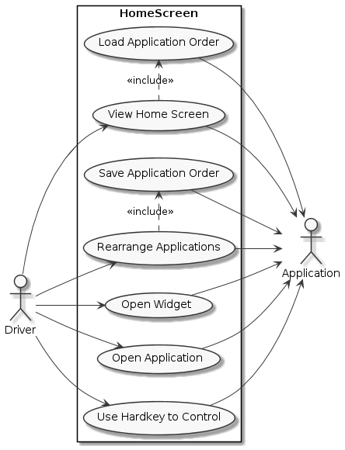

III. Specific requirements

1. SRS List
SRS | Actor | Description/Purpose
Home_SRS_01 | User | Application Layout
Home_SRS_02 | User | Home screen interaction
Home_SRS_03 | User | Status Bar detail
Home_SRS_04 | User | Widget detail
Home_SRS_05 | User | Applications detail
Home_SRS_06 | User | Control use hard keys

2. Software Requirement Specification

2.1 HOME_SRS_01

Actor | Driver
Purpose: | Application Layout
Functional Requirements
ID | Description
Home_SRS_01.1 | Home screen layout is divided into 3 sections: Status Bar, Application, Widget  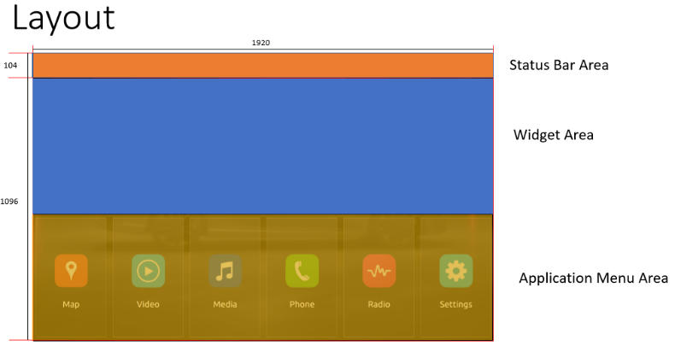  Fig 2: Application Menu
Home_SRS_01.2 | Status Bar: Display date time
Home_SRS_01.3 | Widgets: Display widget information (media, climate, map).
Home_SRS_01.4 | Application Menu: Display list of applications.
Home_SRS_01.5 | Focus: Only one widget or application can be focused at a time
Home_SRS_01.6 | Size: Base is 1920 x 1200 (px). Scale by screen ratio

2.2 HOME_SRS_02
Actor(s): | User
Purpose: | Home screen interaction
Functional Requirements
ID | Description
Home_SRS_02.1 | Display list applications stored in .xml file.
Home_SRS_02.2 | List applications that could be scroll over if there are more than six applications.
Home_SRS_02.3 | Application detail contain title and icon.
Home_SRS_02.4 | Applications list show when Home Application is opened.
Home_SRS_02.5 | Applications list could be rearranged and store in .xml file
Home_SRS_02.6 | Open application menu when clicked or triggered by hard key.
Home_SRS_02.7 | Application / Widget button have 3 status: normal, focused, pressed
Non-Functional Requirements
ID | Description
Home_SRS_02.8 | List application must have no more than 2 seconds after Home Application is opened.
Home_SRS_02.9 | Applications on List Application must be stored in a .xml file that user could be adjusting easily by drag and drop.

2.3 HOME_SRS_03

Actor(s): | User
Purpose: | Status Bar detail
Functional Requirements
ID | Description
Home_SRS_03.1 | Display current time and current date
Home_SRS_03.2 | Display time with format “hh:mm”, example: 19:04
Home_SRS_03.3 | Display date with format “MMM. dd”, example: Jun. 23)
Home_STS_03.4 | If not in Home screen, show Back button.
Non-Functional Requirements
ID | Description
Home_SRS_03.4 | Use date time that system provided
Home_SRS_03.5 | Datetime update immediately when every minute passed.

2.4 HOME_SRS_04

Actor(s): | User
Purpose: | Widget component detail
Functional Requirements
ID | Description
Home_SRS_04.1 | Contain widgets: Map, Climate, Media Player
Home_SRS_04.2 | Map Widget display current vehicle position on google map.
Home_SRS_04.3 | Climate Widget display current conditioner information.  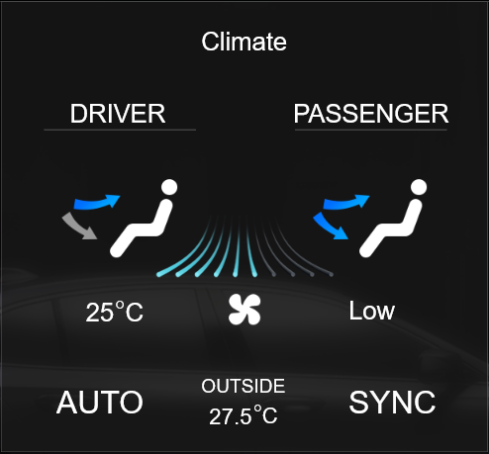  Fig 3: Climate widget  Subcomponents:  - Title : display widget name  - Driver wind flow mode: display current wind flow mode on driver position. 3 mode: Foot, Head, Foort & Head  - Passenger wind flow mode: display current wind flow mode on passenger position. 3 mode: Foot, Head, Foort & Head  - Wind direction : display win direction mode.  - Wind level : display fan and current level of win (maximum 10 level). 10 levels.  - Inside temperature: display current temperature inside vehicle.  - Auto: When turned on, setting of climate application will be automatic configured. 2 mode: ON and OFF  - Sync: When turned on, passenger flow mode with be synchronized with driver. 2 mode: ON and OFF  - Outside temperature: display current outside temperature.
Home_SRS_04.4 | Media Player Widget display current media player.  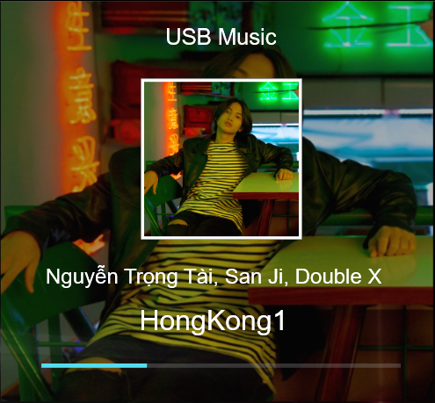  Fig 4: Media Player  Subcomponents:  - Title : display widget name  - Thumbnail Image: display thumbnail art  - Author, Singer: display singer and author of music  - Song name: display name of the song.  - Progress bar: display current progress of the song
Home_SRS_04.5 | Information on Climate Widget get from Climate Application.
Home_SRS_04.6 | Information on Map Widget get from Map Application.
Home_SRS_04.7 | Information on Media Widget get from Media Application.
Home_SRS_04.8 | Information on Widgets update in real time.
Home_SRS_04.9 | Widget have 3 status: Normal, Focused, Pressed.

2.5 HOME_SRS_05

Actor(s): | User
Purpose: | Applications detail
Functional Requirements
ID | Description
Home_SRS_05.1 | List all application in .xml file
Home_SRS_05.2 | Application display with icon, title
Home_SRS_05.3 | Application could be open and close
Home_SRS_05.4 | Application menu could be scroll over if there are more than 6 applications
Home_SRS_05.5 | Rearrange by press and hold application.
Home_SRS_05.6 | Order of applications should be saved.
Home_SRS_05.7 | Focus at 1st application at the first start.
Non-Functional Requirements
ID | Description
Home_SRS_05.8 | Application order should be intact even when app closed.

2.6 HOME_SRS_06

Actor(s): | User
Purpose: | Control using Hard Keys
Functional Requirements
ID | Description
Home_SRS_06.1 | Use hard keys could be used to control the screen.

