Software Design Specification

_{For}

Home Application

Prepared by : Ho Khanh Vu – SE 05427

Organization: FPT Education

Date created: 15/08/2021

Revision History
Date | Description | Verson
15/08/2021 |  | 1.0

Table of Contents
Revision History 2
I. Introduction 4
1. Purpose 4
2. Definitions, Acronyms and Abbreviations 4
3. Intended Audience and Reading Suggestions 4
4. Project Scope 4
II. UI Design 4
III. UX Design 4
IV. Architecture Design 5
V. Class Diagram 6
VI. Flow Chart 7
1. Starting Home Application 7
2. Load List Application 8
3. Open Application / Widget 9
4. Communicate with Climate Simulator 10
5. Scroll Application List 11
6. Rearrange Application order 12

I. Introduction

1. Purpose
This document will outline in detail the software architecture and design for the Home Application. This document will provide several views of the tool's design in order to facilitate communication and understanding of the app. It intends to capture and convey the significant architectural and design decisions that have been made for the Home Application.

2. Definitions, Acronyms and Abbreviations
SDS: Software Design Specification.
UI Design: User Interface Design
UX Design: User Experience Design

3. Intended Audience and Reading Suggestions
FUNiX, Developer, Tester

4. Project Scope
This document defines architecture and design for developing Home application.

II. UI Design
Attachment

III. UX Design
Attachment

IV. Architecture Design

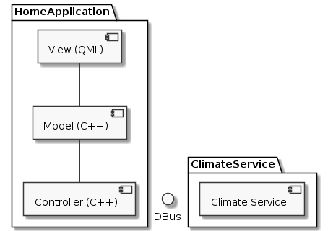
Component | Descriptions
View (QML) | The place where application controls screens, components that are built from QML and resources of building screens.
Model | The place where is built interface for state management of interface from C++. It is where the data for building state of screen is shown.
Controller | Controls, executes the program and takes responsibility for connecting the third-party services (in this case, it is climate services).

The architecture built for the application is based on Model View architecture.
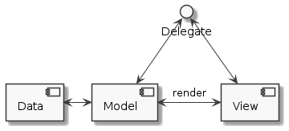

Data: Xml stores application information in system.

Model: Class stores application list that is read from ".xml" file

View: QML displays application list.

V. Class Diagram
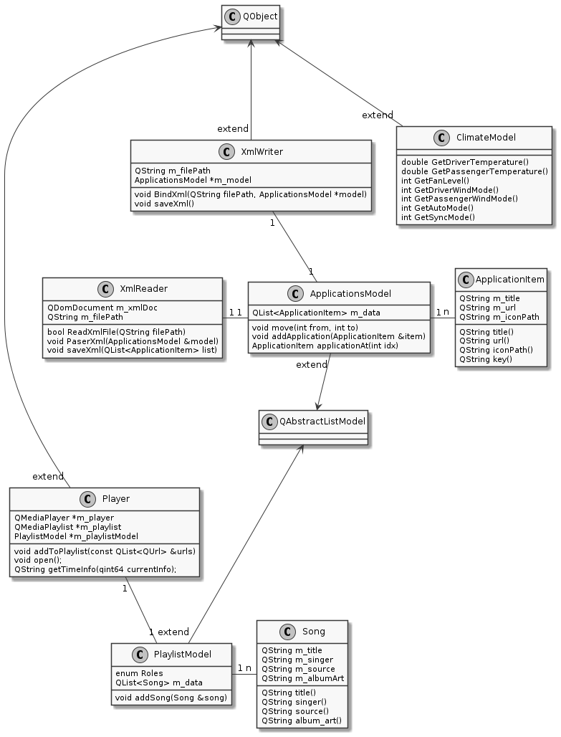

VI. Flow Chart

1. Starting Home Application
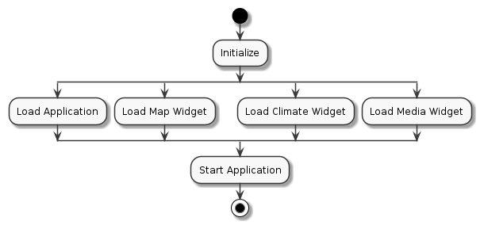
Order | Description
1 | Initialize Home application
2.1 | Load Applications from XML
2.2 | Load Map Widget
2.3 | Load Climate Widget
2.4 | Load Media Widget
3 | Start Application

2. Load List Application
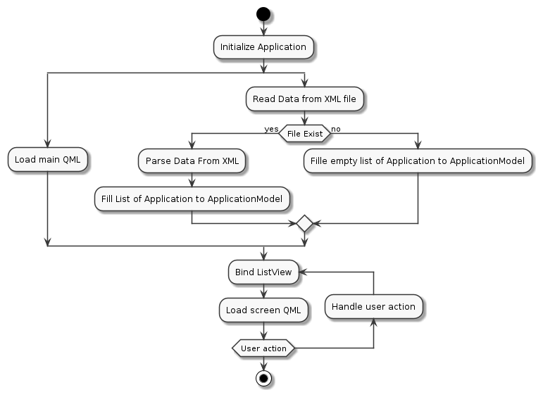
Order | Description
1 | Initialize Home Application
2.1 | Load Main QML
2.2 | Read applications from XML file
3.1 | If XML file does not exist, go to 5
3.2 | If XML file does exist, parse data
4 | Fill list parsed applications to application model
5 | Bind application model to list view
6 | Load Screen QML
7 | Waiting for User Action
8 | Handle user action, go to 5

3. Open Application / Widget
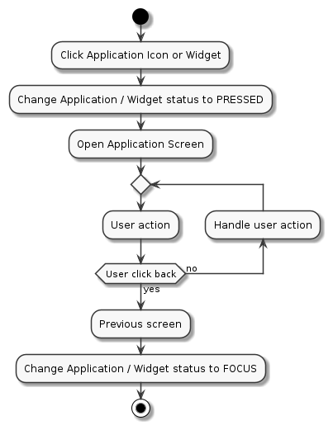
Order | Description
1 | Click on application / widget icon
2 | Change application / widget status to PRESSED
3 | Open application screen
4 | Wait for user action
5.1 | If user does not click back button, handle action and go to 4
5.2 | If user click back button, go to 6
6 | Go to previous Screen
7 | Change application / widget status to FOCUS

4. Communicate with Climate Simulator
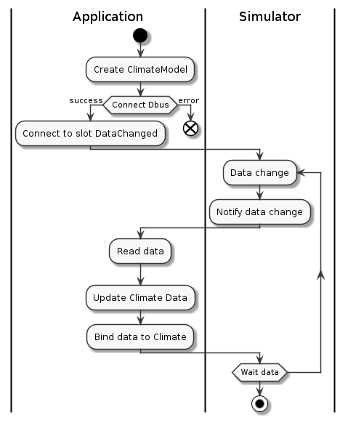
Order | Description
1 | Create climate model
2.1 | If connect to Dbus error, end
2.2 | If connect to Dbus success, go to 3
3 | Connect to slot DataChanged
4 | Climate data change
5 | Climate notify data changed using Dbus
6 | Home application read data
7 | Update climate data
8 | Bind data to climate
9 | Waiting to data, if data changed go to 4

5. Scroll Application List
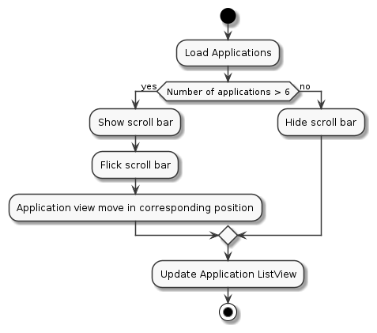
Order | Description
1 | Load application
2.1 | If Number of application less or equal 6, go to 3
2.2 | If Number of application more than 6, go to 4
3 | Hide scroll bar, go to 6
4 | Show scroll bar
5 | Application view move into corresponding position
6 | Update application ListView

6. Rearrange Application order
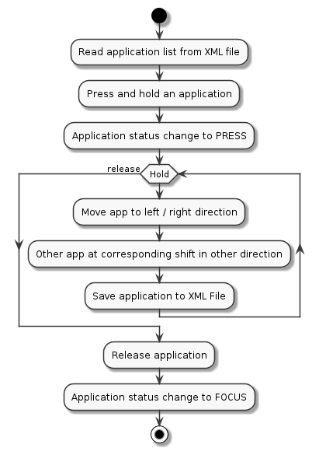

Order | Description
1 | Read application list from XML
2 | Press and hold on application icon
3 | Application status change to PRESS
4.1 | If keep holding, go to 5
4.2 | If release, go to 8
5 | Move app to left / right direction
6 | Other app at corresponding move to opposite direction
7 | Save application to XML, go to 4
8 | Release application
9 | Application status change to FOCUS

