UI Design Guideline

_{For}

Home Application

Prepared by : Ho Khanh Vu – SE 05427

Organization: FPT Education

Date created: 08/07/2021

Revision History
Date | Description | Verson
08/07/2021 |  | 1.0
15/08/2021 | Fix Preview | 1.1

Table of Contents
Revision History 2
I. Common 4
1. Font 4
2. Screen Resolution 4
II. Home Screen Layout 5
III. Status Bar 6
1. Overall 6
2. Back Button 6
IV. Widget 7
1. Overlay 7
2. Navigation Widget 8
3. Climate Widget 9
4. Media Widget 10
V. Application Menu Button 11
1. Overall 11
2. Application Icon 12

I. Common

1. Font
- Using font: Arial
- Font size unit: px

2. Screen Resolution
- Width: 1920px
- Heigh: 1200px
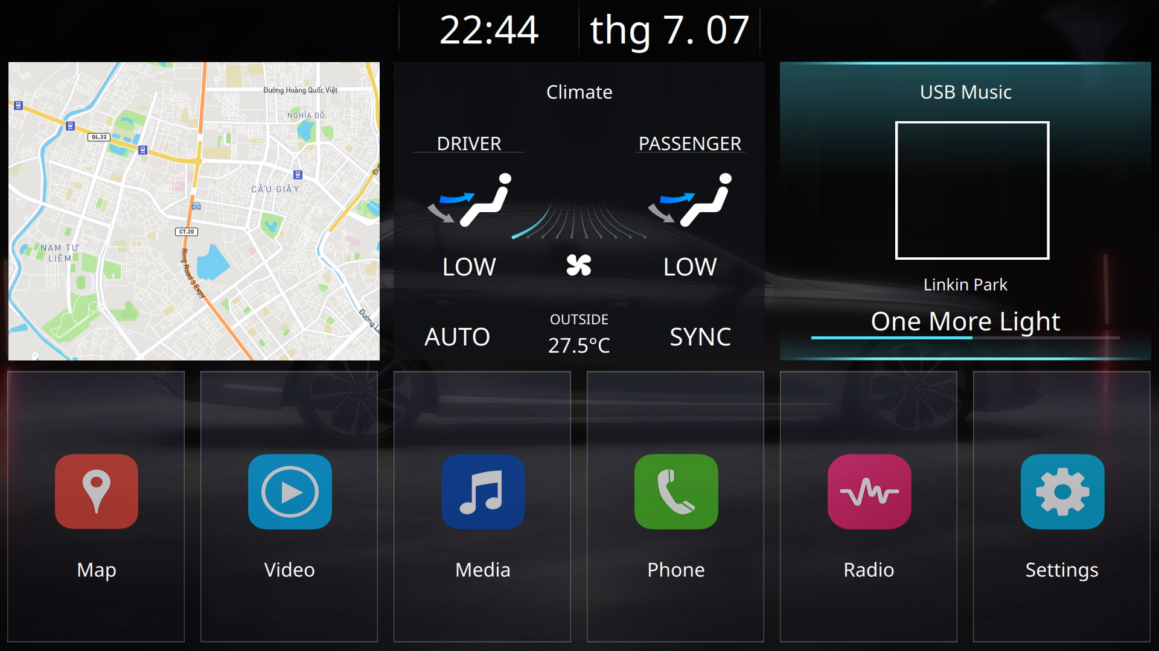
Fig 1: Home Application layout

II. Home Screen Layout
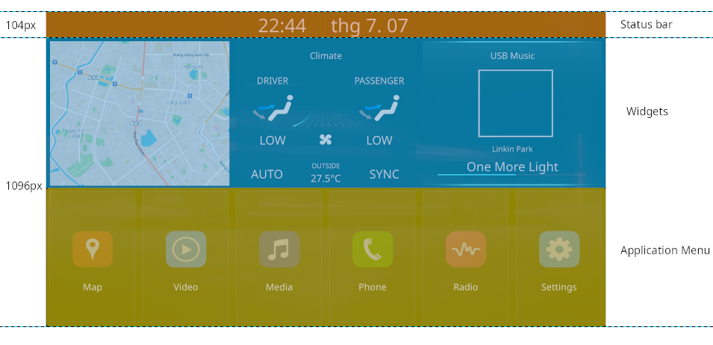
Fig 2: Home Screen Layout
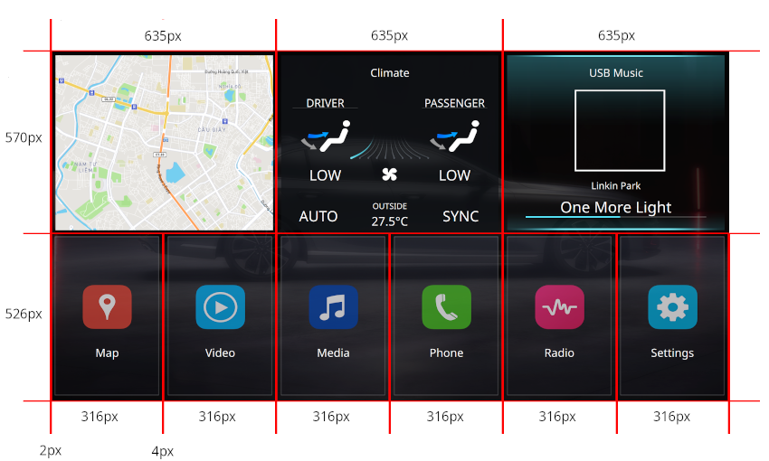
Fig 3: Widget and Application Menu Layout

III. Status Bar

1. Overall
- Font size: 72px
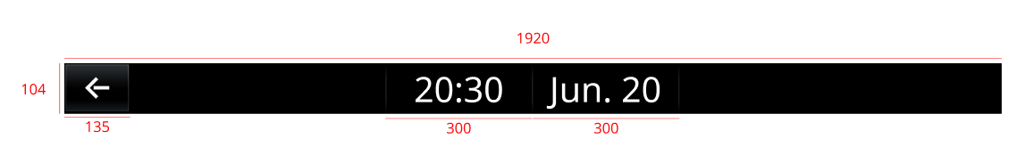

2. Back Button

Image |  | 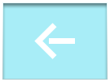 | 
State | Normal | Pressed | Focus
Description | Normal state, not selected or pressed | When press by touchpad or mouse | When use hardkey to select
Folder | StatusBar | StatusBar | StatusBar
Source | btn_home_menu_xxx_n.png | btn_home_menu_xxx_p.png | btn_home_menu_xxx_f.png

IV. Widget

1. Overlay
Image |  |  | 
State | Normal | Focus | Pressed
Description | Normal state, not selected or pressed | When use hardkey to select | When press by touchpad or mouse
Folder |  | HomeScreen | HomeScreen
Source |  | bg_widget_f.png | bg_widget_p.png

2. Navigation Widget
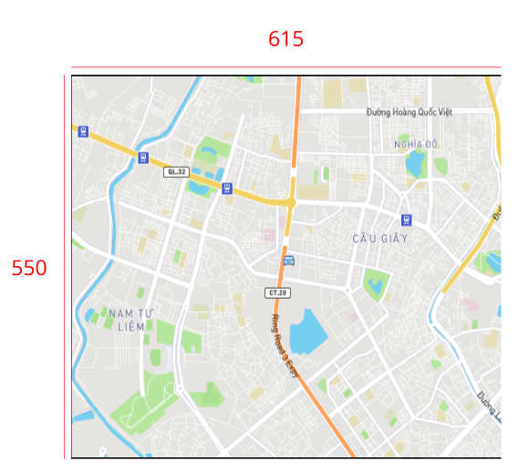  A
  Order | Size(px) | Folder | Image Source
  A | 16x16 | Map | car_icon.png

3. Climate Widget
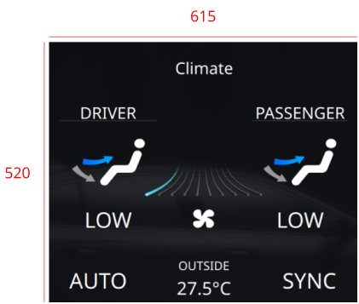  1  1  1  2  2  2  2  3  4  A  B  C  D  A  B | Label  Icon
  Order | Font size(px) | Color
  1 | 34 | #FFFFFF
  2 | 46 | #FFFFFF
  3 | 26 | #FFFFFF
  4 | 38 | #FFFFFF
  Order | Image Size (px) | Folder | Image Source
  A | 70x50 | Climate | widget_climate_arrow_0n_x.png
  B | 110x120 | Climate | widget_climate_arrow_seat.png
  C | 290x100 | Climate | widget_climate_wind_level_nn  .png
  D | 290x100 | Climate | widget_climate_wind_level_bg  .png
  E | 60x60 | Climate | widget_climate_ico_wind.png

4. Media Widget

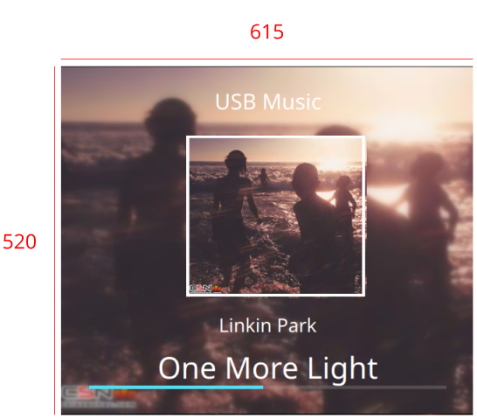  1  2  3  A  B  C  D  E | Label  Icon
  Order | Font size(px) | Color
  1 | 34 | #FFFFFF
  2 | 30 | #FFFFFF
  3 | 48 | #FFFFFF
  Order | Image Size(px) | Folder | Image source
  A | 615x550 | App/Media/Image | album_art_xxx.png
  B | 258x258 | App/Media/Image | widget_media_album_bg.png
  C | 258x258 | App/Media/Image | album_art_xxx.png
  D | 511x6 | App/Media/Image | widget_media_pg_s.png
  E | 511x6 | App/Media/Image | widget_media_pg_n.png

V. Application Menu Button

1. Overall
Image | 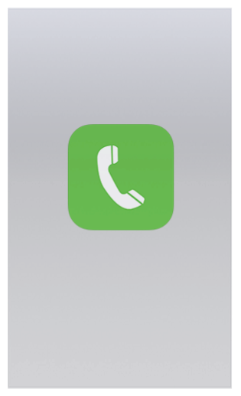 | 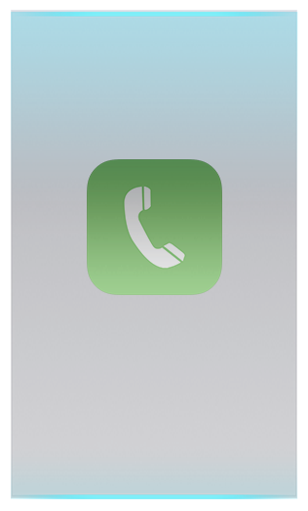 | 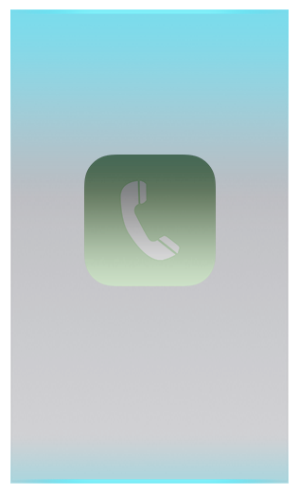
State | Normal | Focus | Pressed
Description | Normal state, not selected or pressed | When use hardkey to select | When press by touchpad or mouse
Folder | HomeScreen | HomeScreen | HomeScreen
Source | btn_xxx_n.png | btn_xxx_f.png | btn_xxx_p.png

2. Application Icon
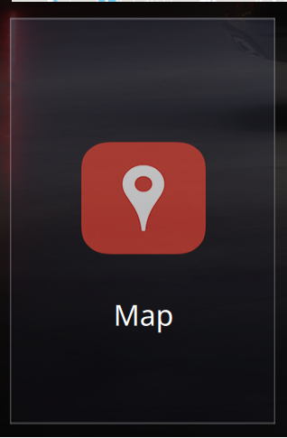  1  A | Label  Image
  Order | Font size(px) | Color
  1 | 36 | #FFFFFF
  Order | Size (px) | Folder | Image Source
  A | 316x604 | HomeScreen | btn_home_menu_xxx_n/p/f/d.png

