UX Design Guideline

_{For}

Home Application

Prepared by : Ho Khanh Vu – SE 05427

Organization: FPT Education

Date created: 25/06/2021

Revision History
Date | Description | Verson
25/06/2021 |  | 1.0
16/08/2021 | Fix Preview | 1.1

Table of Contents
Revision History 2
I. Common 4
1. Hardkey Map 4
II. Screen Specification 4
1. Overall 4
2. Status Bar 4
3. Widget 5
4. Application 6
Feature: 6
5. Application Screen 7
III. Flow specification 8
1. Open / Close Widget or Applications 8
2. Scroll Application menu 9
3. Rearrange Applications 10
4. Climate Widget Interaction 10


I. Common

1. Hardkey Map
Key | Hard Key | Keyboard | Action
Home | ⌂ | Home | Go to main screen
Enter | OK | Return | Open current focusing application
Up | ⏶ | Up | Go to previous area
Down | ⏷ | Down | Go to next area
Left | ⏴ | Left | Focus to previous item
Right | ⏵ | Right | Focus to next item
Back | ← | Backspace | Back to previous screen
Vol Up | + | Page Up | Increase volume
Vol Down | - | Page Down | Decrease volume
Mute | 🔇 | End | Mute / Unmute
Phone | ☎ | P | Open Dial
Radio | Rad | R | Open Radio
Navi | Nav | N | Open Navigation
Media | Media | M | Open Media Player

II. Screen Specification

1. Overall

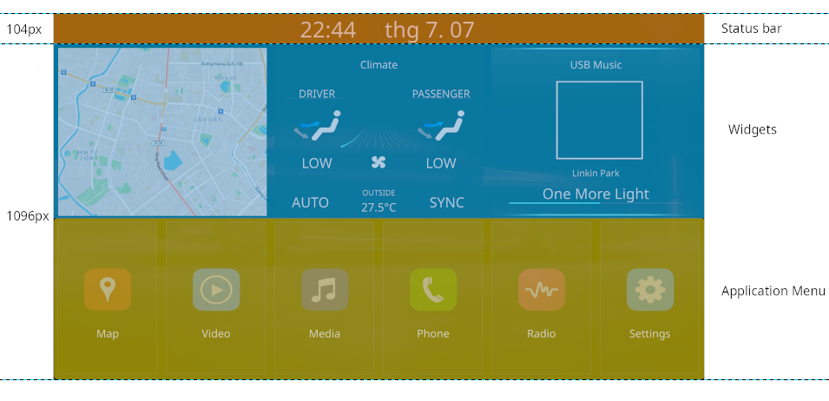
2. Status Bar
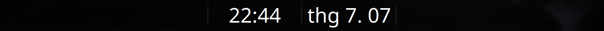
1
2
3
Order | Type | Label | Condition | Action
1 | Button | BACK | Not in Home Screen | Back to previous screen
2 | Text | Current time  (hh:mm 24h)
3 | Text | Current date (MMM. dd)

3. Widget
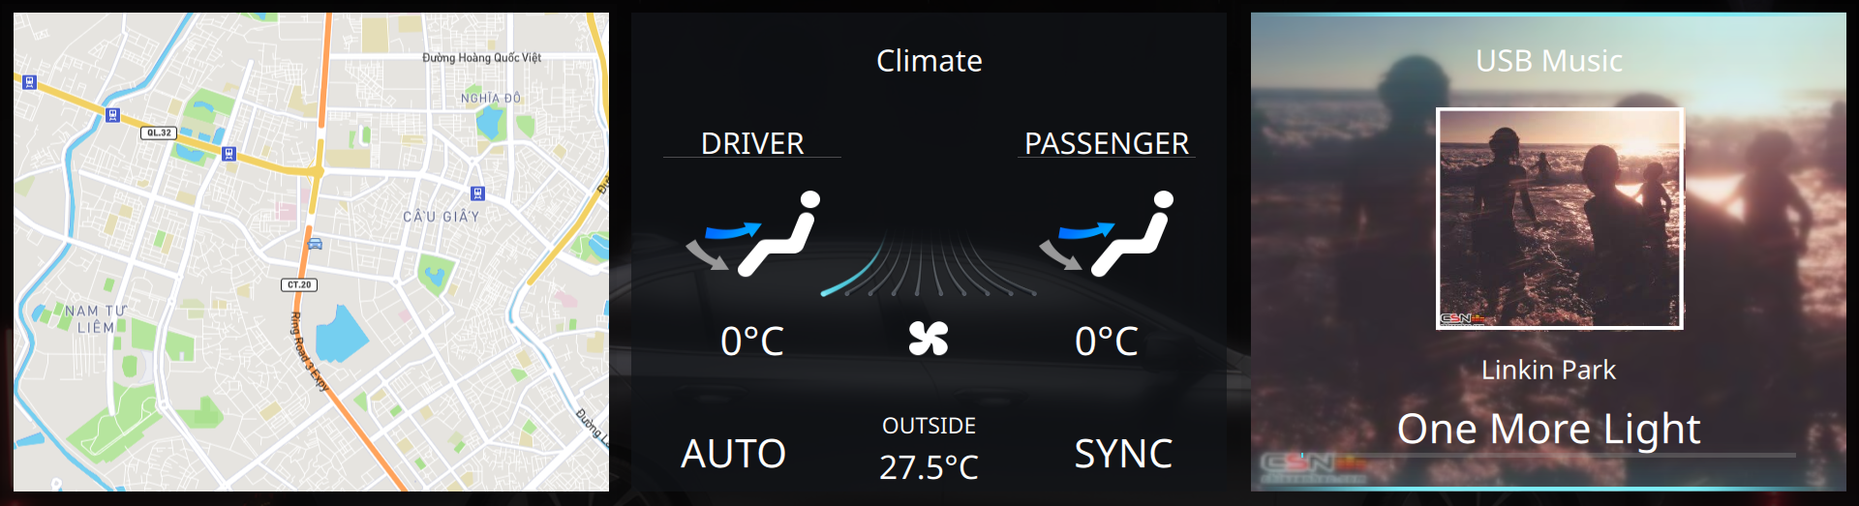
1
2
3
Order | Type | Label | Description | Action
1 | Button | Map | Map Widget | Go to navigation screen
2 | Button | Climate | Climate Widget | Go to climate screen
3 | Button | USB Music | Media Widget | Go to media player screen

4. Application
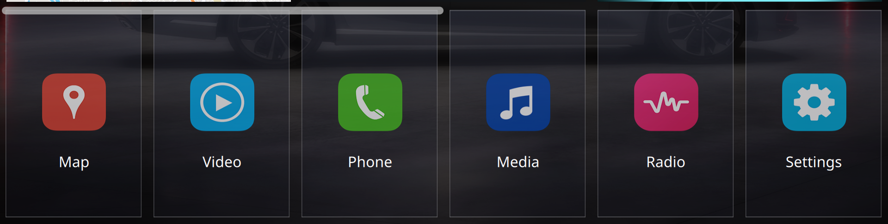
1
2
2
2
2
2
2

Order | Type | Label | Condition | Action
1 | Scroll |  | Number of applications more than 6 | Scroll ListView of applications
2 | Button | Application Name ( Map, Video, Phone, … ) |  | Open Application

Feature:
Order | Name | Description
1 | State Changing | Button have 3 state  Normal: Default state  Pressed: On Pressed on Application Icon  Focus: When focus using hard-key
2 | Re-order Application | Applications can be re-order by drag and drop

5. Application Screen
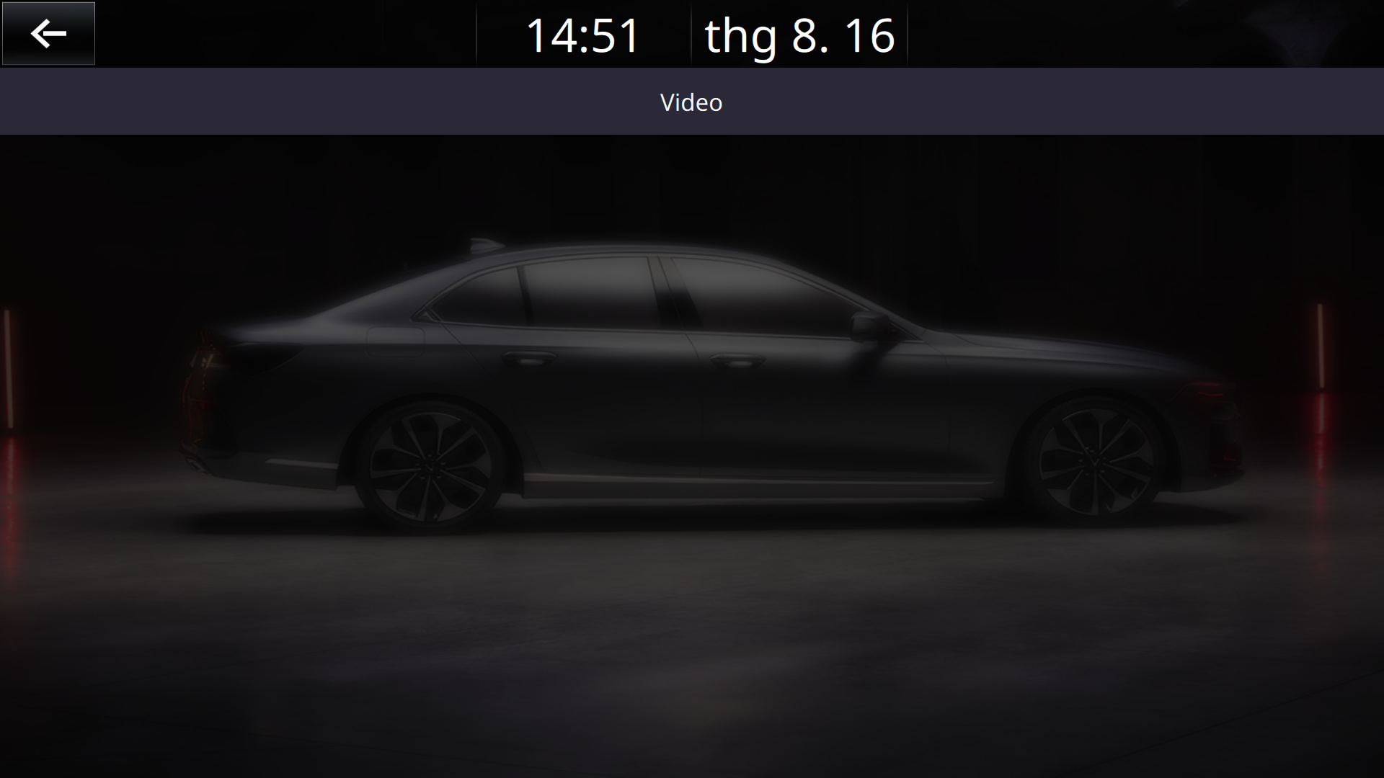
1
2
Order | Type | Description | Condition | Action
1 | Text | Application name | When in application screen
2 | Screen | Application screen

III. Flow specification

1. Open / Close Widget or Applications
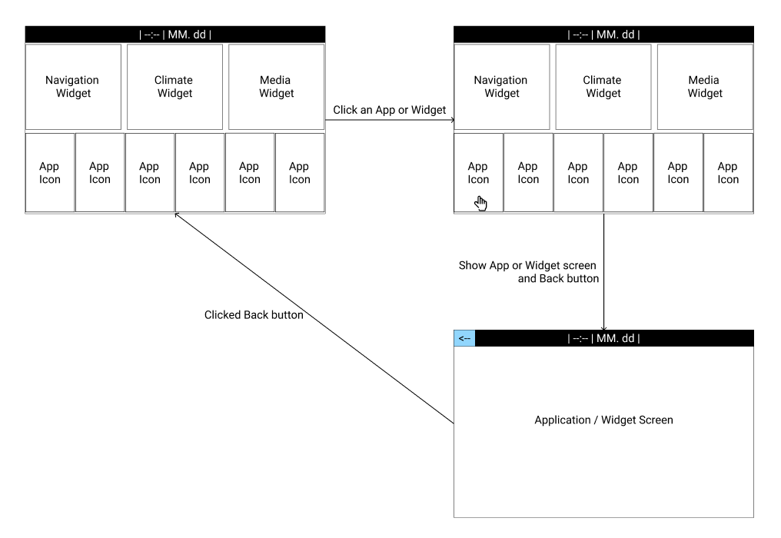

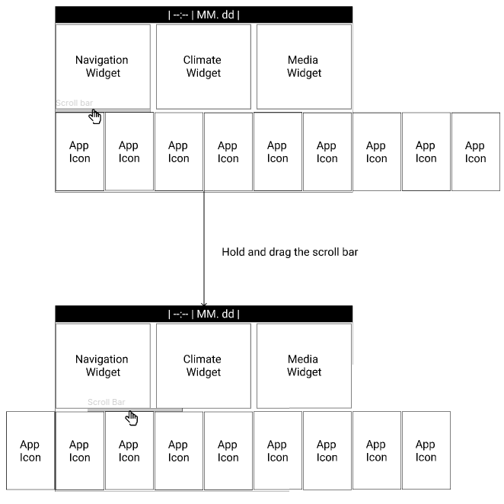
2. Scroll Application menu

3. Rearrange Applications
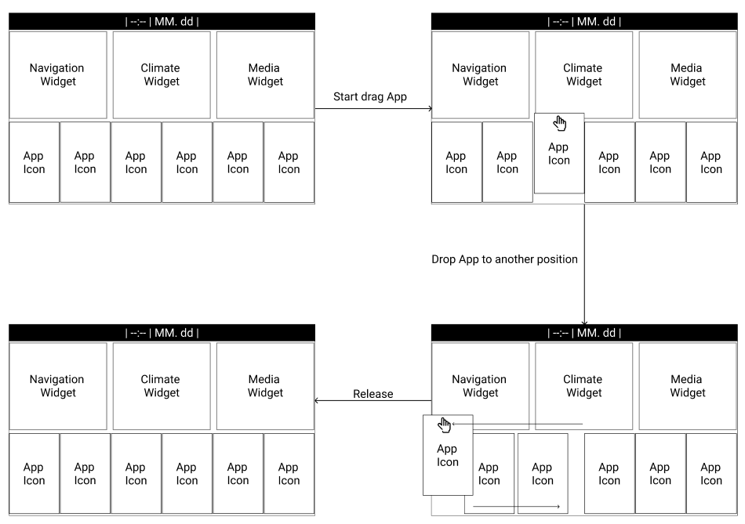

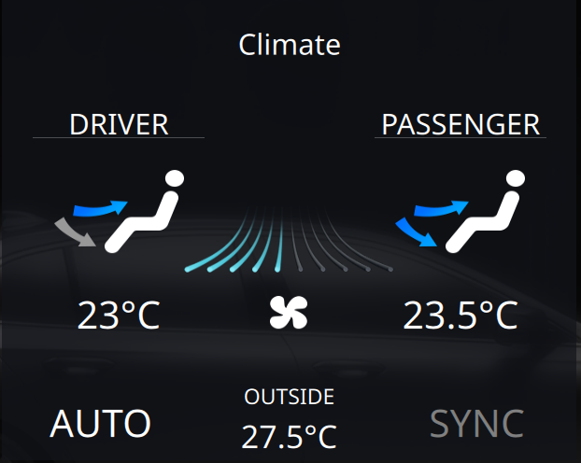
4. Climate Widget Interaction
1  2  4  5  3  6  7  Dbus | 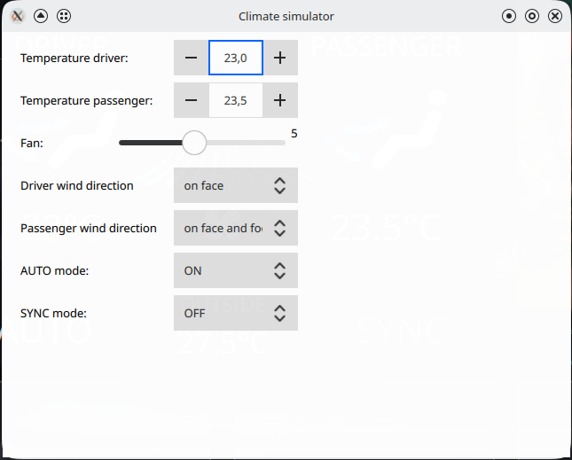  1  2  3  4  5  6  7

