Software Requirement Specification

for

Home Application

|  |  |  |
| --- | --- | --- |
|  | Prepared by: Ho Khanh Vu –FX01999  Hanoi, 23/06/2021 | |
|  | |  |

Table of Content

s

1. Introduction 1

1.1 Purpose 1

1.2 Project Scope Error! Bookmark not defined.

1.3 Audience 1

1.4 Abbreviation Error! Bookmark not defined.

2. Use Case Diagram 2

3. Specific Requirements 3

3.1 SRS List 3

3.2 Software Requirements Specification 3

3.2.1 Home_SRS_01 3

3.2.2 Home_SRS_02 4

3.2.3 Home_SRS_03 4

3.2.4 Home_SRS_04 5

3.2.5 Home_SRS_05 6

3.2.6 Home_SRS_06 7

# Revision History

|  |  |  |  |
| --- | --- | --- | --- |
| **Name** | **Date** | **Reason For Changes** | **Version** |
| Home Application Software Requirement Specification | 23/06/2021 | First release | V1.0.0 |
|  |  |  |  |
|  |  |  |  |
|  |  |  |  |

# **Introduction**

## Purpose

Describe functions and non-functions requirements for Home Application. This document provides information for project team members, helping implementation and correction of the application.

## Project Scope

Define requirements for Home Application.

## Audience

FUNiX, Developer, Tester

* 1. Abbreviation
* SRS: Software Requirement Specification
* Fig: Figure

# **Use Case Diagram**

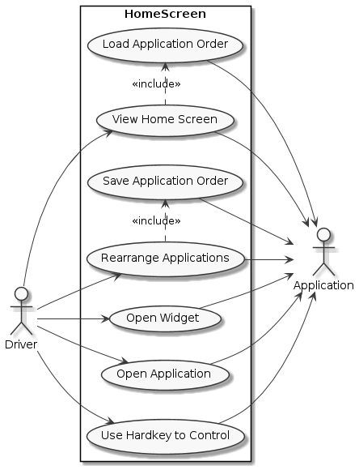

*Fig 1: Use Case Diagram*

# **Specific Requirements**

## SRS List

|  |  |  |
| --- | --- | --- |
| **SRS** | **Actor** | **Description/Purpose** |
| Home_SRS_01 | User | Application Layout |
| Home_SRS_02 | User | Home screen interaction |
| Home_SRS_03 | User | Status Bar detail |
| Home_SRS_04 | User | Widget detail |
| Home_SRS_05 | User | Applications detail |
| Home_SRS_06 | User | Control use hard keys |

## Software Requirements Specification

### Home_SRS_01

|  |  |  |
| --- | --- | --- |
| Actor | Driver | |
| Purpose: | Application Layout | |
| **Functional Requirements** | | |
| **ID** | | **Description** |
| Home_SRS_01.1 | | Home screen layout is divided into 3 sections: Status Bar, Widgets,  *Fig 2: Application Menu* |
| Home_SRS_01.2 | | Status Bar: Display current datetime. |
| Home_SRS_01.3 | | Widgets: Display widget information (media, climate, map). |
| Home_SRS_01.4 | | Application Menu: Display applications in a List View. |

### Home_SRS_02

|  |  |  |
| --- | --- | --- |
| Actor(s): | User | |
| Purpose: | Home screen interaction | |
| **Functional Requirements** | | |
| **ID** | | **Description** |
| Home_SRS_02.1 | | Display applications that stored in .xml file. |
| Home_SRS_02.2 | | List applications that could be scroll over. |
| Home_SRS_02.3 | | Show detail of applications that contain title, icon. |
| Home_SRS_02.4 | | List of application immediate show up when Home Application is opened. |
| Home_SRS_02.5 | | Display most 6 applications at a time on List Application. |
| **Non-Functional Requirements** | | |
| **ID** | | **Description** |
| Home_SRS_02.5 | | List application must have no more than 2 seconds after Home Application is opened. |
| Home_SRS_02.6 | | Applications on List Application must be stored in a .xml file that user could be adjusting easily. |
|  | |  |

### Home_SRS_03

|  |  |  |
| --- | --- | --- |
| Actor(s): | User | |
| Purpose: | Status Bar detail | |
| **Functional Requirements** | | |
| **ID** | | **Description** |
| Home_SRS_03.1 | | Status Bar component display current date and time. |
| Home_SRS_03.2 | | Display time with format “hh:mm”, example: 19:04 |
| Home_SRS_03.3 | | Display date with format “MMM. dd”, example: Jun. 23) |
| **Non-Functional Requirements** | | |
| **ID** | | **Description** |
| Home_SRS_03.4 | | Use date time that system provided |
| Home_SRS_03.5 | | Datetime update immediately when every minute passed. |

### Home_SRS_04

|  |  |  |
| --- | --- | --- |
| Actor(s): | User | |
| Purpose: | Widget component detail | |
| **Functional Requirements** | | |
| **ID** | | **Description** |
| Home_SRS_04.1 | | Display 3 components: Map, Climate, Media Player |
| Home_SRS_04.2 | | Map Widget display current vehicle position on google map. |
| Home_SRS_04.3 | | Climate Widget display current temperature both inside and outside, current wind flow mode and wind direction.    *Fig 3: Climate widget*  **Subcomponent***:*   * Title (Top Center): display widget name * Driver wind flow mode (Middle Left): display current wind flow mode on driver position. * Passenger wind flow mode (Middle Right): display current wind flow mode on passenger position. * Wind direction (Inside passenger and driver wind flow mode component): display win direction mode * Wind level (Middle center): display fan and current level of win (maximum 10 level) * Inside temperature (Bellow driver wind flow mode): display current temperature inside vehicle. * Auto: * Sync: * Outside temperature (Bottom Center): display current outside temperature. |
| Home_SRS_04.4 | | Media Player Widget display current playing music.    *Fig 4: Media Player*  **Subcomponents***:*   * Title (Top Center): display widget name * Thumbnail Image (Middle Center): display thumbnail art * Author, Singer (Below thumbnail image): display singer and author of music * Song name (Below author, singer): display name of the song. * Progress bar (Bottom Center): display current progress of the song |
| **Non-Functional Requirements** | | |
| **ID** | | **Description** |
| Home_SRS_04.7 | | Connect to Climate system using D-bus |
| Home_SRS_04.8 | | Position of the vehicle must display with maximum accurate minimum error. |

### Home_SRS_05

|  |  |  |
| --- | --- | --- |
| Actor(s): | User | |
| Purpose: | Applications Widget detail | |
| **Functional Requirements** | | |
| **ID** | | **Description** |
| Home_SRS_05.1 | | Applications menu display all applications that installed on system. |
| Home_SRS_05.2 | | Application display with icon, title |
| Home_SRS_05.3 | | Application could be open and close |
| Home_SRS_05.4 | | Application menu could be scroll over. |
| Home_SRS_05.5 | | Display up to maximum 6 applications at a time. |
| Home_SRS_05.6 | | Rearrange by press and hold application. |
| Home_SRS_05.7 | | Order of applications should be saved. |
| Home_SRS_05.7 | | Focus at 1st application at the first start. |
| **Non-Functional Requirements** | | |
| **ID** | | **Description** |
| Home_SRS_05.8 | | Application order should be intact even when app closed. |

### Home_SRS_06

|  |  |  |
| --- | --- | --- |
| Actor(s): | User | |
| Purpose: | Control using Hard Keys | |
| **Functional Requirements** | | |
| **ID** | | **Description** |
| Home_SRS_06.1 | | Hard keys could be used to control the screen.   * : Go to home application. * OK: Submit current focused action. * ⏶: Focus to previous component * ⏷: Focus to next component. * ⏴: Focus to previous item in component. * ⏵: Focus to next item in component. * ←: Close current app, back to previous screen. * +: Increate volume. * -: Decrease volume. * : Mute volume. * : Open dial menu or accept current phone call. * Radio: Open radio application * Nav: Open navigation map * Media: Open media player |