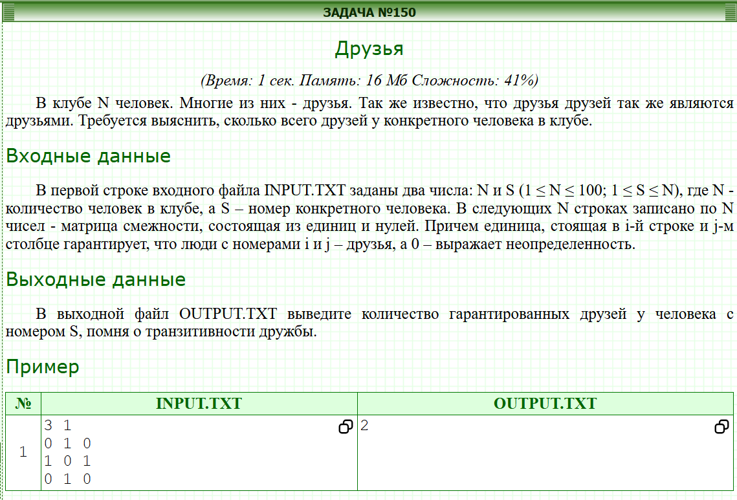
#include <bits/stdc++.h>
using namespace std;

vector<vector<int> > arr;
bool visited[111];
int cnt = 0;
int n, s, x;
void dfs(int u){
if(visited[u]) return ;
cnt++;
visited[u] = true;
for(int v: arr[u]){
dfs(v);
}
}

int main()
{
cin >> n >> s;
arr.resize(n + 1);
for(int i = 1; i <= n; i++){
for(int j = 1; j <= n; j++){
cin >> x;
if(x) arr[i].push_back(j);
}
}
dfs(s);
cout << cnt - 1;
}

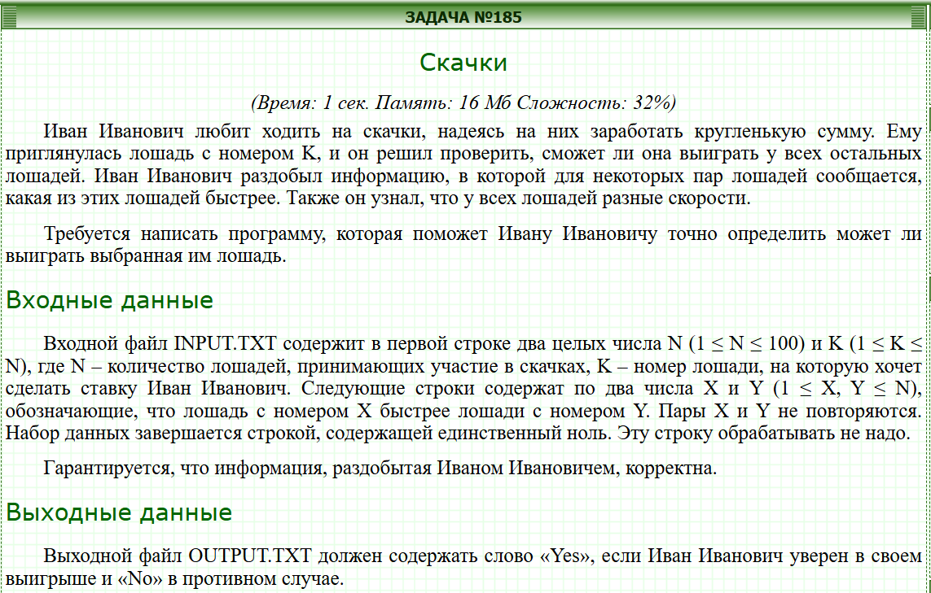
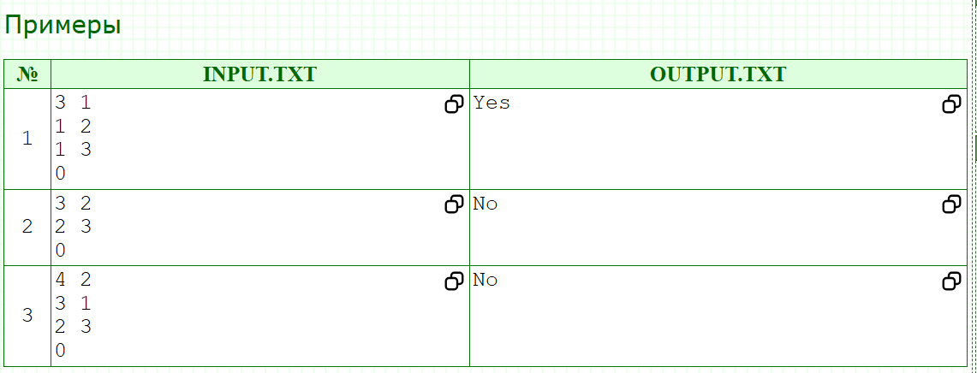
#include <iostream>
#include <vector>

using namespace std;

vector<int>adj[101];
bool visited[101];
int res = 0;

void dfs(int k){
visited[k] = true;
res++;
for(int v: adj[k]){
if(!visited[v]){
dfs(v);
}
}
}

int main() {
ios_base::sync_with_stdio(false);
cin.tie(NULL);

int n, k, x, y;
cin >> n >> k;
while(cin >> x && x){
cin >> y;
adj[x].push_back(y);
}
dfs(k);
if(res == n){
cout << "Yes";
} else {
cout << "No";
}
}

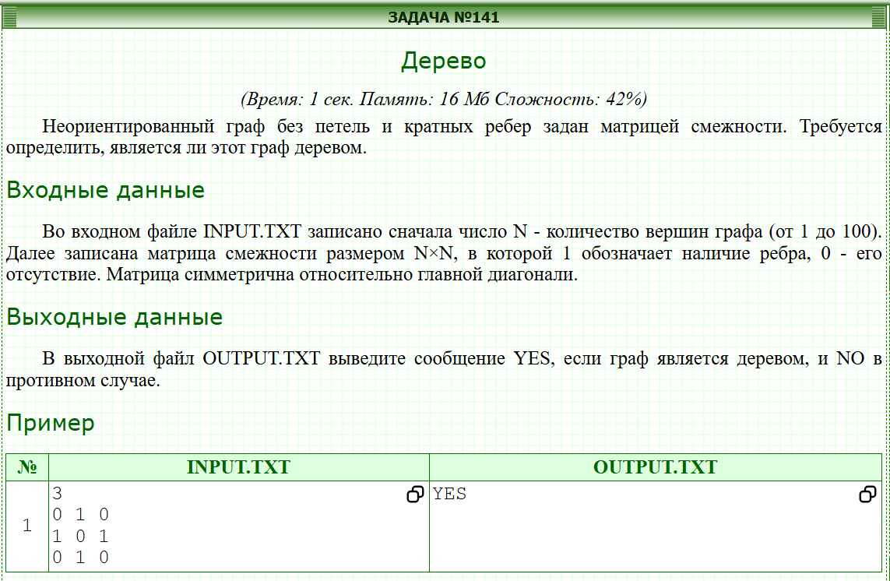
#include <iostream>
#include <vector>

using namespace std;

int n;
int adj[101][101];
bool visited[101];
int visited_count = 0;

// Grafning barcha qismlariga kirishni tekshirish uchun DFS
void dfs(int u) {
visited[u] = true;
visited_count++;
for (int v = 0; v < n; v++) {
// Agar u va v o'rtasida qirra bo'lsa va v hali borilmagan bo'lsa
if (adj[u][v] == 1 && !visited[v]) {
dfs(v);
}
}
}

int main() {
// Kiritish va chiqarishni tezlashtirish
ios_base::sync_with_stdio(false);
cin.tie(NULL);

if (!(cin >> n)) return 0;

int edge_count = 0;
for (int i = 0; i < n; i++) {
for (int j = 0; j < n; j++) {
cin >> adj[i][j];
if (adj[i][j] == 1) {
edge_count++;
}
}
}

// Har bir qirra matritsada 2 marta (i,j va j,i) keladi
edge_count /= 2;

// Daraxt sharti: E = N - 1
if (edge_count != n - 1) {
cout << "NO" << endl;
return 0;
}

// Bog'langanlikni tekshirish (0-tugundan boshlab)
dfs(0);

// Agar barcha tugunlarga borilgan bo'lsa va E = N - 1 bo'lsa - bu daraxt
if (visited_count == n) {
cout << "YES" << endl;
} else {
cout << "NO" << endl;
}

return 0;
}


#include <bits/stdc++.h>

using namespace std;

vector<int>people[101];
int chairs[101];

void dfs(int i, int chair){
if(chairs[i] != 0){
if(chairs[i] != chair){
cout << "NO"; exit(0);
}
return ;
}

chairs[i] = chair;
for(int enemy: people[i]){
dfs(enemy, 3-chair);
}
}

int main()
{
int n, m, x, y;
cin >> n >> m;
for(int i = 0; i < m; i++){
cin >> x >> y;
people[x].push_back(y);
people[y].push_back(x);
}
for(int i = 1; i <= n; i++){
if(chairs[i] == 0){
dfs(i, 1);
}
}
cout << "YES";
}

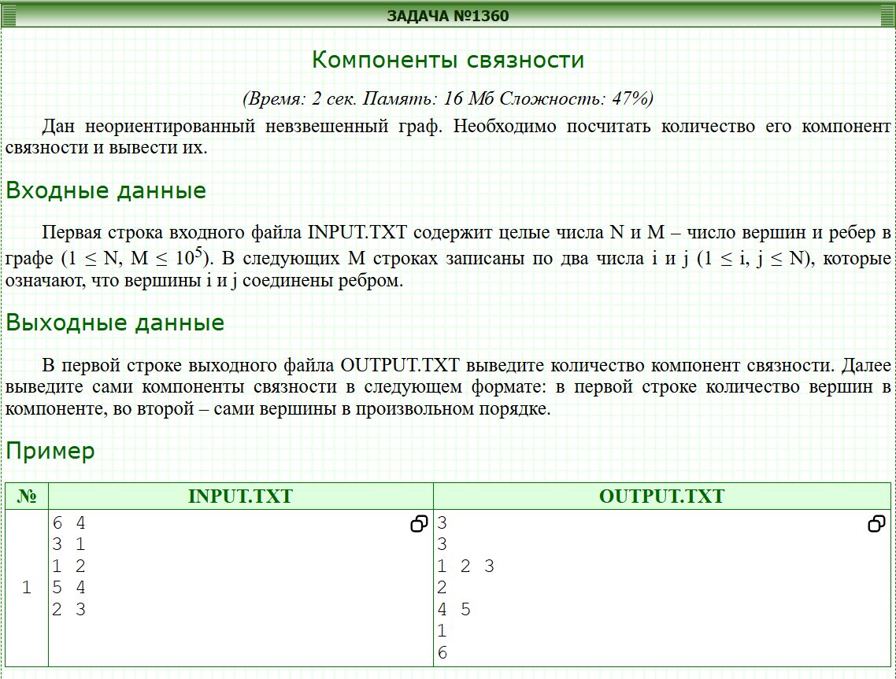
#include <stdio.h>
#include <vector>
using namespace std;

int n, m, d;
vector<int> a[100100];
vector<int> ans[100100];
bool used[100100];

void rec(int k){
ans[d].push_back(k);
used[k] = 1;
for(int i = 0; i < a[k].size(); i ++){
if(!used[a[k][i]]){
rec(a[k][i]);
}
}
}

int main()
{
scanf("%d %d", &n, &m);

for(int i = 0; i < m; i ++){
int u, v;
scanf("%d %d", &u, &v);
a[u].push_back(v);
a[v].push_back(u);
}

for(int i = 1; i <= n; i ++){
if(!used[i]){
d ++;
rec(i);
}
}

printf("%d", d);
for(int i = 1; i <= d; i ++){
printf("\n%d\n", ans[i].size());
for(int j = 0; j < ans[i].size(); j ++){
printf("%d ", ans[i][j]);
}
// puts("\n");
}
}

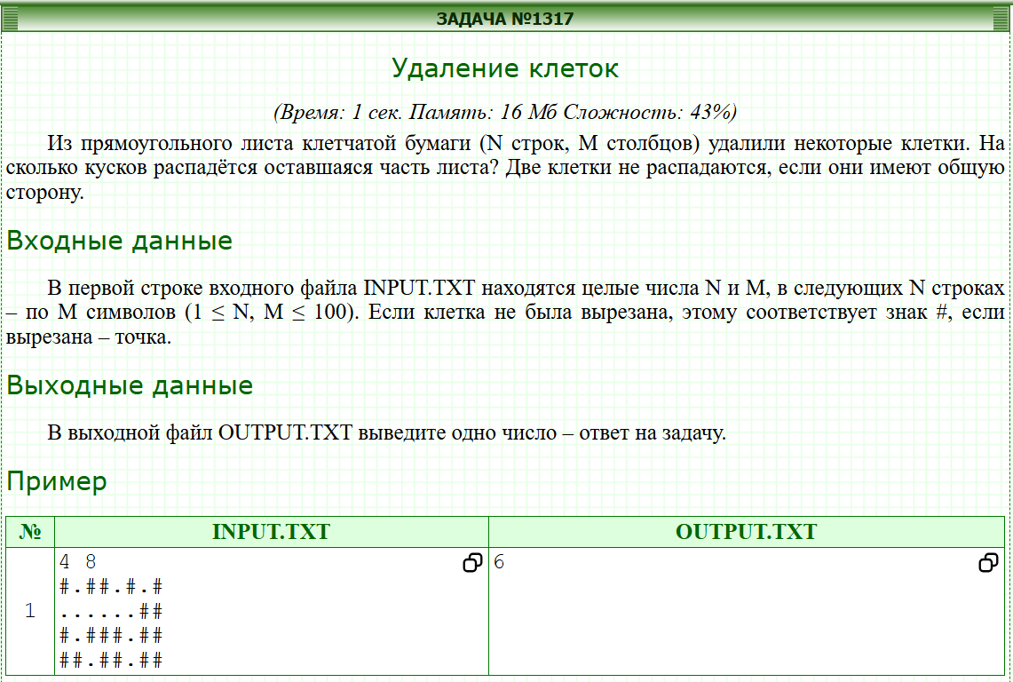
#include <iostream>

using namespace std;
int n, m, res;
int a[111][111];

void rec(int i, int j){
a[i][j] = 0;
if(a[i - 1][j] == 1) rec(i - 1, j);
if(a[i + 1][j] == 1) rec(i + 1, j);
if(a[i][j - 1] == 1) rec(i, j - 1);
if(a[i][j + 1] == 1) rec(i, j + 1);
}

int main(){
cin >> n >> m;
for(int i = 1; i <= n; ++ i){
for(int j = 1; j <= m; ++ j){
char x;
cin >> x;
if(x == '#') a[i][j] = 1;
}
}
for(int i = 1; i <= n; ++ i){
for(int j = 1; j <= m; ++ j){
if(a[i][j]){
rec(i, j);
res ++;
}
}
}
cout << res;
return 0;
}

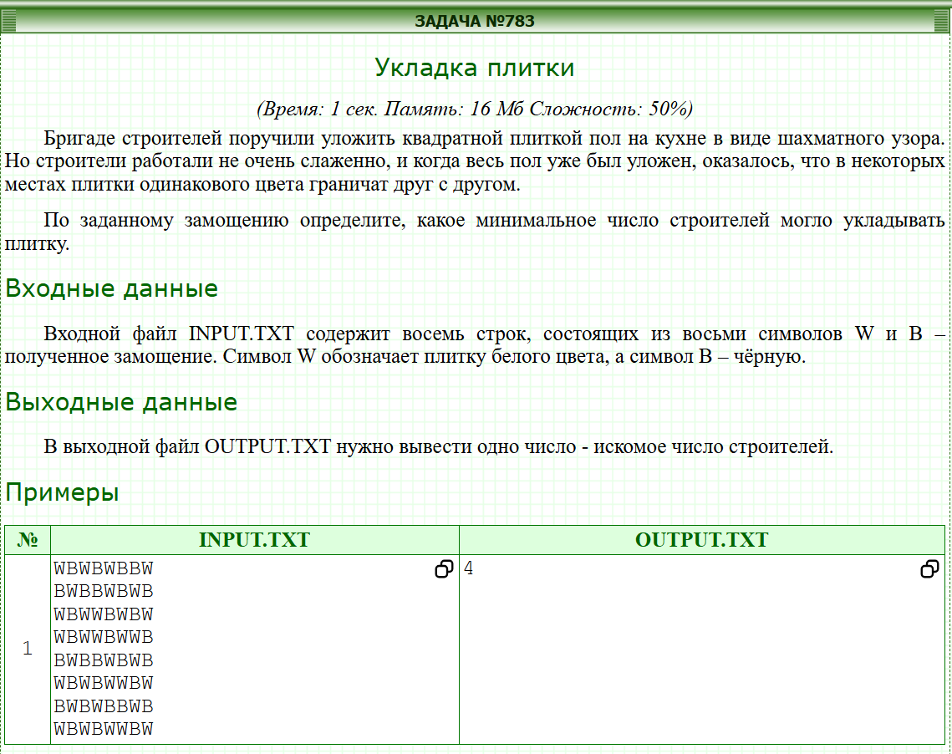
#include <stdio.h>
#include <algorithm>
#include <string.h>

const int n = 8;
char arr[n][n];
int db[n][n];
int ans = 0;
void dfs(int r, int c){
if(db[r][c]!=-1) return ;
db[r][c] = ans;
int dr[] = { 0 , 1 , 0 , -1};
int dc[] = { 1 , 0 , -1 , 0};
for(int i=0,R,C; i<4; i++){
R = r + dr[i];
C = c + dc[i];
if(R>=0 && R<n && C>=0 && C<n){
if(db[R][C]==-1 && arr[r][c]!=arr[R][C]) dfs(R,C);
}
}
}

int main(){
memset(db, -1, sizeof db);
for(int i=0; i<n; i++) gets(arr[i]);

for(int i=0; i<n; i++){
for(int j=0; j<n; j++){
if(db[i][j]==-1){
dfs(i,j);
ans++;
}

}
}
printf("%d",ans);
return 0;
}

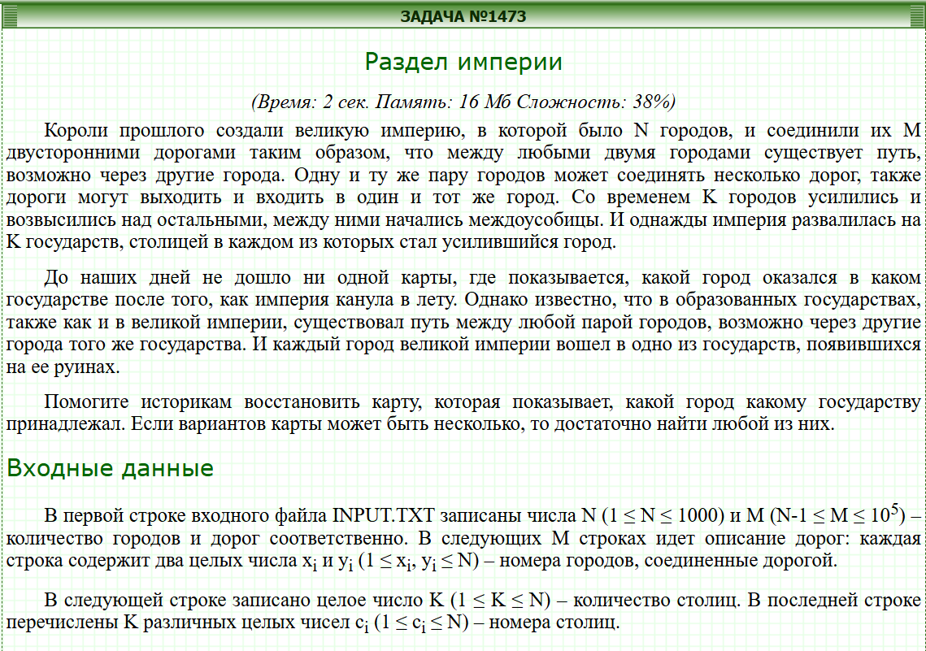
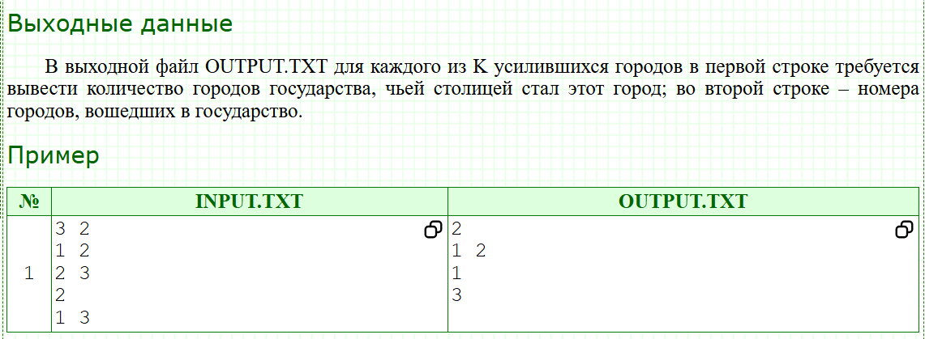
#include <stdio.h>
#include <vector>
#include <iostream>
#include <map>
#include <algorithm>
#include <string.h>
using namespace std;
vector<int> graf[100001];
vector<int> group;
vector<int> w[100001];
bool used[100001];
vector<int>::iterator it;
int lb;
void dfs(int x,int lb){
it = find(group.begin(),group.end(),x);
if(it!=group.end()){
//group[distance(group.begin(),it)-1] = -1;
}else{
if(!used[x]){
used[x]=true;
w[lb].push_back(x);
for(int i=0; i<graf[x].size();i++){
if(!used[graf[x][i]]){
dfs(graf[x][i],lb);
}
}
}
}
}
int main(){
int n,m;
scanf("%d%d",&n,&m);
for(int i=0,u,v; i<m; i++){
scanf("%d%d",&u,&v);
graf[u].push_back(v);
graf[v].push_back(u);
}
int k;
scanf("%d",&k);
for(int i=0,x; i<k; i++){
scanf("%d",&x);
group.push_back(x) ;
}
for(int i=0,x; i<k; i++){
x = group[i];
group[i]=-1;
dfs(x,lb);
lb++;
}

for(int i=0; i<lb;i++){
sort(w[i].begin(),w[i].end());
cout<<w[i].size()<<endl;
for(int j=0; j<w[i].size();j++){
printf("%d ",w[i][j]);
}
cout<<endl;
}
}

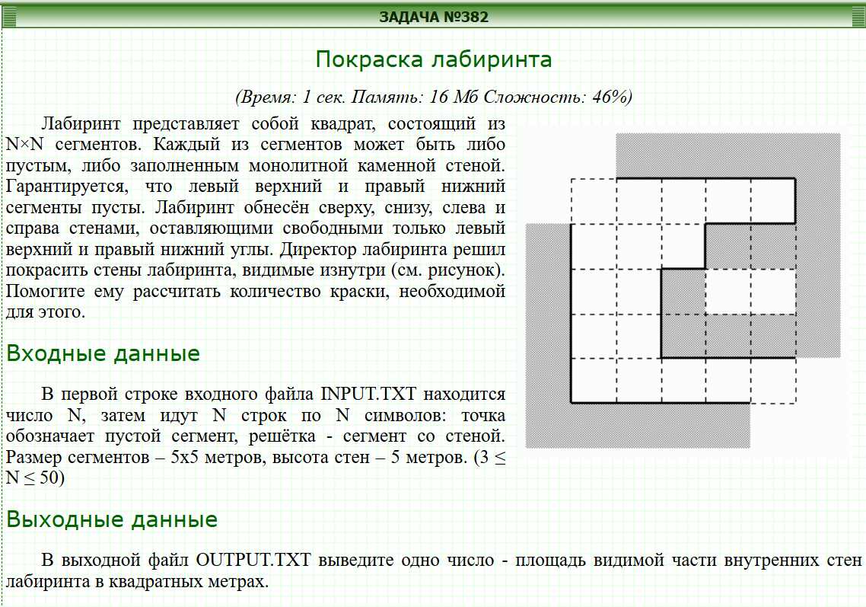
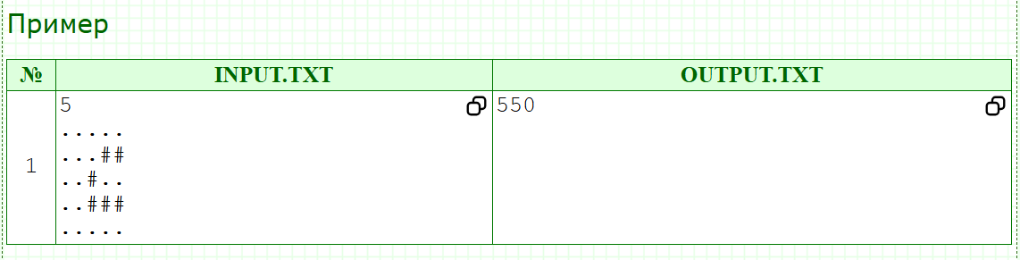
#include <stdio.h>
#include <vector>
#include <iostream>
#include <map>
#include <algorithm>
#include <string.h>
using namespace std;
char arr[100][100];
int db[100][100];
int ans,n;
void dfs(int r,int c){
if(db[r][c]==2) return;
db[r][c]=2;
int dr[] = {1,-1,0,0};
int dc[] = {0,0,1,-1};
for(int i=0,R,C; i<4; i++){
R = r + dr[i];
C = c + dc[i];
if(R>=0 && R<=n+1 && C>=0 && C<=n+1 && db[R][C]==-1) {
ans++;
//cout<<R<<" "<<C<<endl;
}
}
for(int i=0,R,C; i<4; i++){
R = r + dr[i];
C = c + dc[i];
if(R>=0 && R<=n+1 && C>=0 && C<=n+1 && db[R][C]==0) {
dfs(R,C);
}
}
}
int main(){
memset(db,-1,sizeof(db));

scanf("%d\n",&n);

for(int i=0; i<n; i++) gets(arr[i]);
for(int i=0; i<n; i++){
for(int j=0; j<n; j++){
if(arr[i][j]=='.') db[i+1][j+1] = 0;
}
}
int dr[] = {0,1,0,n+1,n,n+1};
int dc[] = {0,0,1,n+1,n+1,n};
for(int i=0; i<6; i++){
db[dr[i]][dc[i]] = 2;
}

dfs(1,1);
// for(int i=0; i<=n+1; i++){
// for(int j=0; j<=n+1; j++){
// printf("%3d ",db[i][j]);
// }
// cout<<endl;
// }
dfs(n,n);
// for(int i=0; i<=n+1; i++){
// for(int j=0; j<=n+1; j++){
// printf("%3d ",db[i][j]);
// }
// cout<<endl;
// }
cout<<ans*25;
}

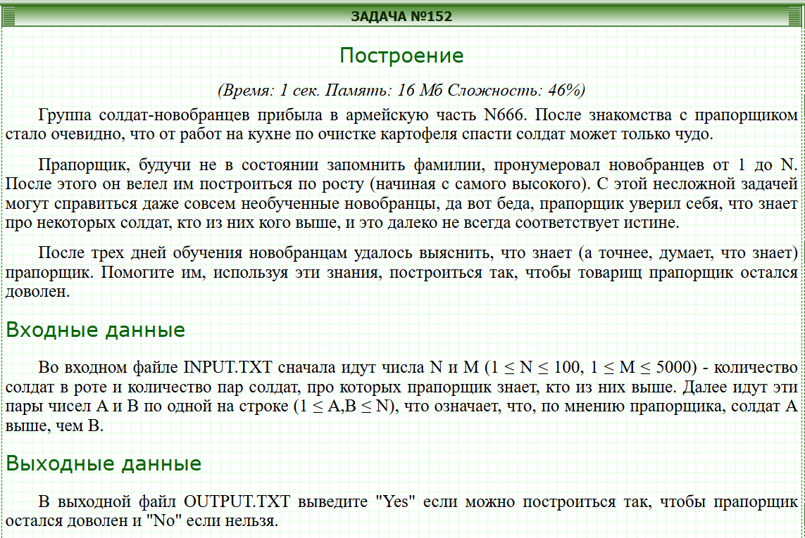
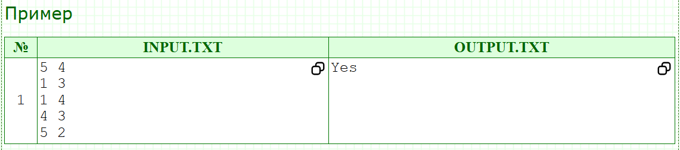
#include <stdio.h>
#include <vector>
#include <set>
#include <iostream>
#include <algorithm>
#include <string.h>
using namespace std;
vector<vector<int> > way;
vector<int> color;
const int NEW = 0;
const int DURING = 1;
const int VISITED = 2;
bool ans = false;
void dfs(int u){
if(color[u]==DURING){
ans = true;
return;
}
if(color[u]==VISITED){
return;
}
color[u] = DURING;
for(int i=0,v; i<way[u].size(); i++){
v = way[u][i];
dfs(v);
}
color[u] = VISITED;
}
int main(){
int n,m;
scanf("%d %d",&n,&m);
way.resize(n+1);
color.resize(n+1);
for(int i=0,u,v; i<m; i++){
scanf("%d %d",&u,&v);
way[u].push_back(v);
}
for(int i=1; i<=n; i++){
if(color[i]==NEW){
dfs(i);
}
}
if(!ans) printf("Yes");
else printf("No");
}

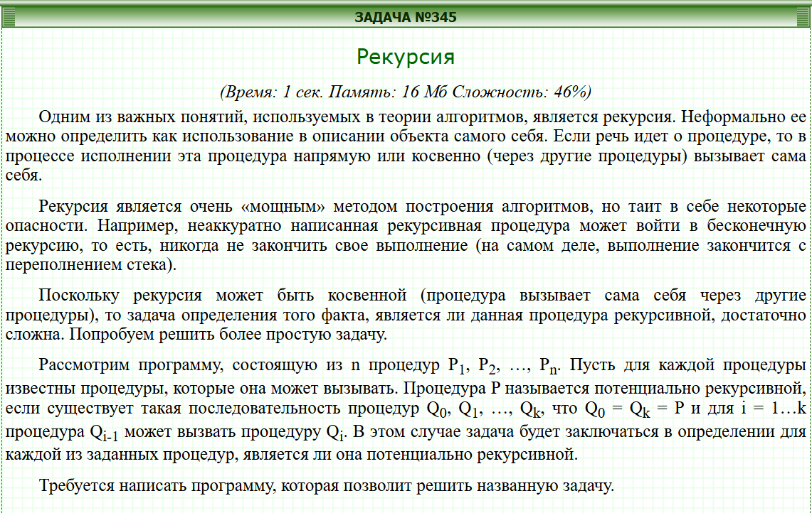
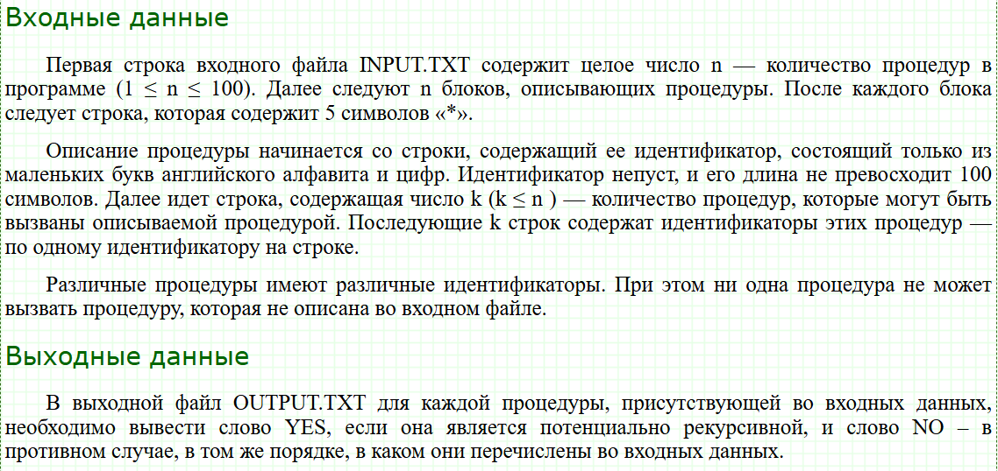
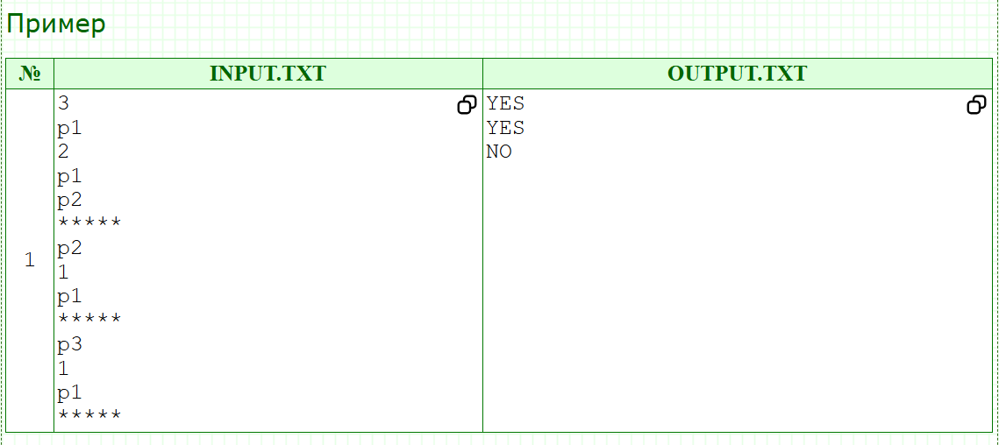
#include <stdio.h>
#include <vector>
#include <set>
#include <map>
#include <algorithm>
#include <string.h>
#include <iostream>
using namespace std;
map<string,int> p;
vector<vector<int> > arr; //stringlarni intga utkazilgan varianti;
vector<bool> used; //foydalanilganligi;
vector<bool> color; //rangi
vector<int> fin; // qidirish kerak bolgan qiymatlar
bool test = false; //yakuniy javob
vector<bool>ans;
void dfs(int x){
used[x] = true;
for(int i=0; i<arr[x].size(); i++){
if(color[arr[x][i]]){
test = true;
return;
}
if(!used[arr[x][i]]){
dfs(arr[x][i]);

}
}
}
int main(){
string buf,buf1;
int n,t,temp=0;
scanf("%d\n",&n);
ans.resize(n);
fin.resize(n);
arr.resize(n);
used.resize(n);
color.resize(n);
for(int i=0; i<n; i++){
cin>>buf;
if(p.find(buf)==p.end()){
p[buf] = temp++;
}
scanf("%d\n",&t);
for(int j=0; j<t; j++){
cin>>buf1;
if(p.find(buf1)==p.end()){
p[buf1] = temp++;
}
arr[p[buf]].push_back(p[buf1]);
}
fin[i] = p[buf];
cin>>buf;

}
for(int i=0; i<n; i++){
color[fin[i]] = true;
dfs(fin[i]);
used.assign(used.size(),false);
color[fin[i]] = false;
ans[i] = test;
test = false;
// memset()
}
for(int i=0; i<n; i++){
if(ans[i]) cout<<"YES\n";
else cout<<"NO\n";
}
return 0;
}

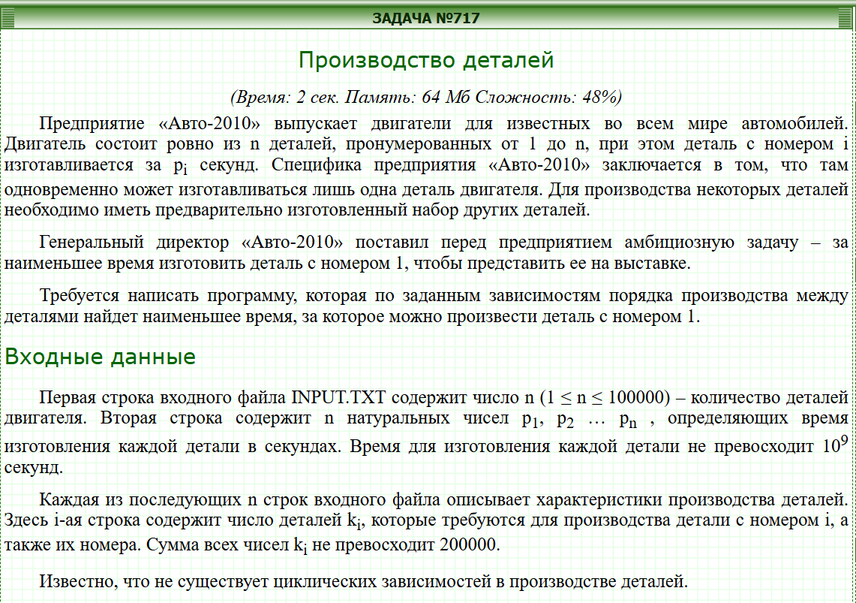
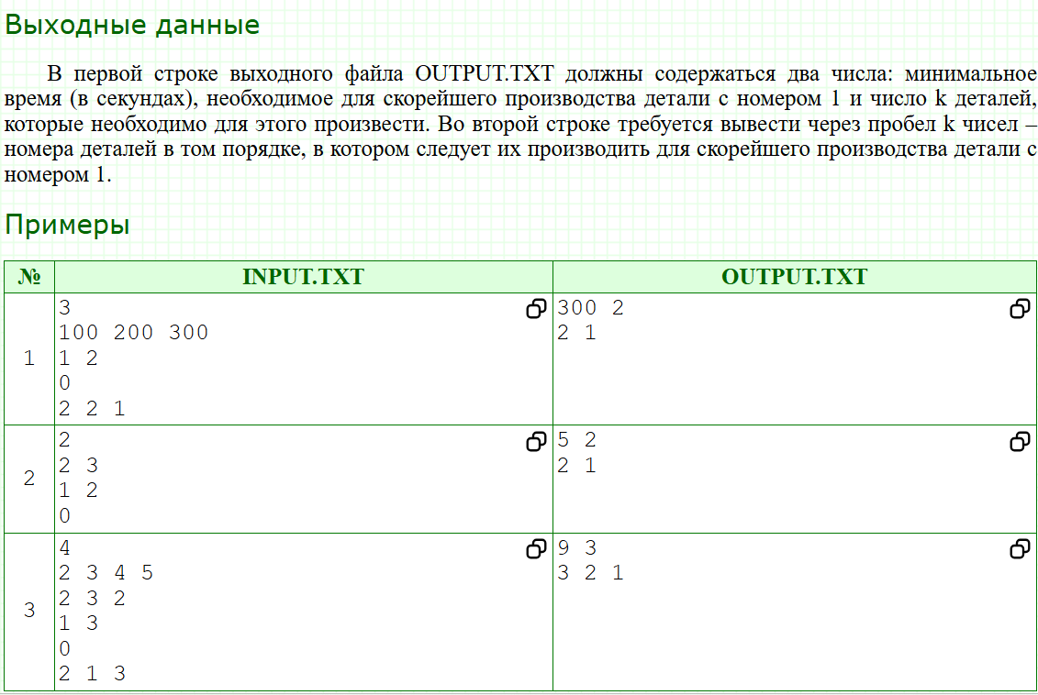
#include <stdio.h>
#include <vector>
#include <set>
#include <map>
#include <algorithm>
#include <string.h>
//using namespace std;
int n;
std::vector<int>time;
std::vector<std::vector<int> >detal;
std::vector<int> coun;
std::vector<bool>used;
long long t;
void dfs(int x){
used[x] = true;
t += time[x];
for(int i : detal[x]){
if(!used[i]) dfs(i);
}
coun.push_back(x);
}
int main(){
scanf("%d",&n);
time.resize(n+1);
detal.resize(n+1);
used.resize(n+1);
for(int i=1; i<=n; i++){
scanf("%d",&time[i]);
}
for(int i=1,s; i<=n; i++){
scanf("%d",&s);
for(int j=0,t; j<s; j++){
scanf("%d",&t);
detal[i].push_back(t);
}
}
dfs(1);
printf("%lld %d\n",t,coun.size());
for(auto i:coun){
printf("%d ",i);
}
return 0;
}

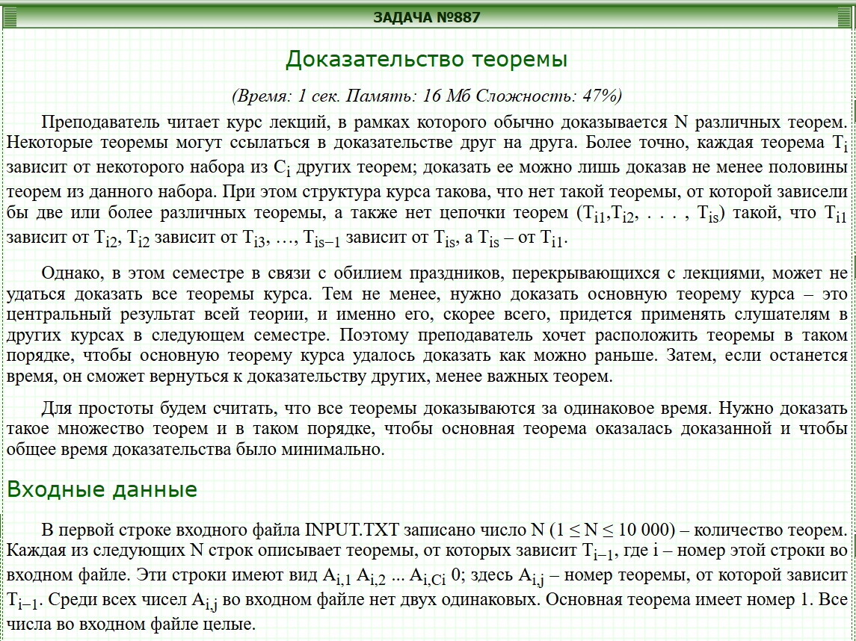
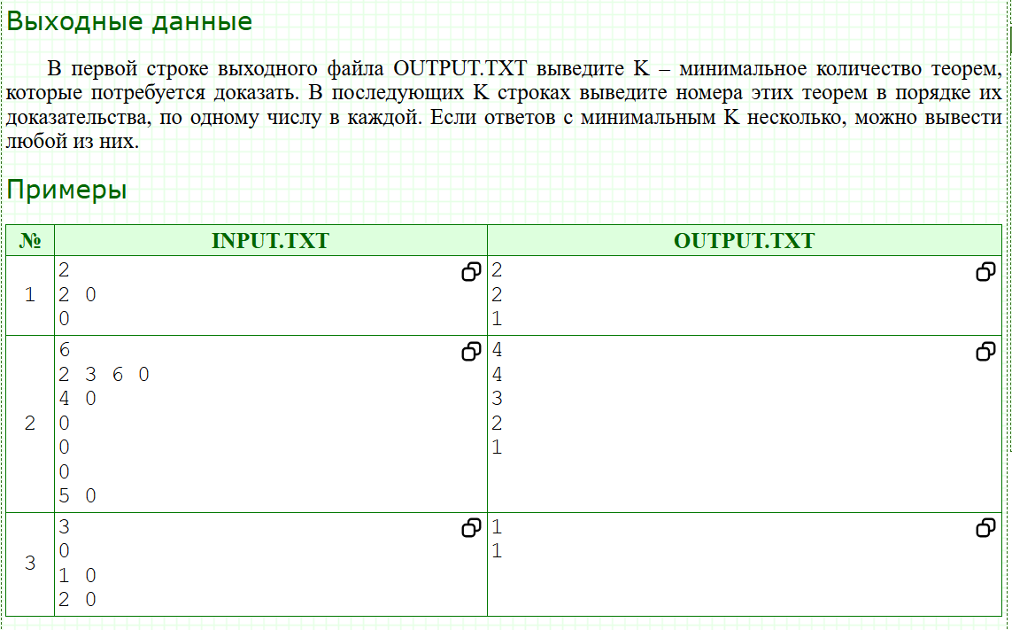
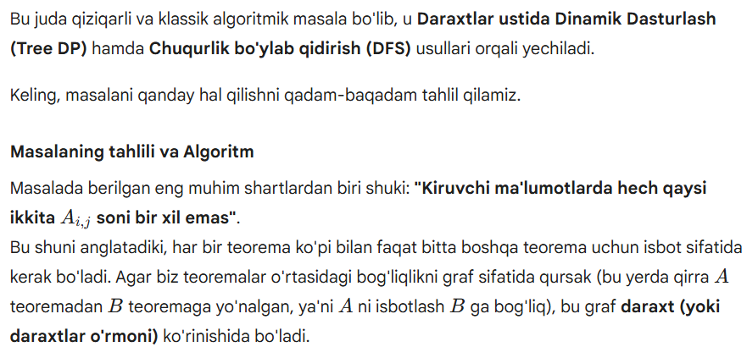
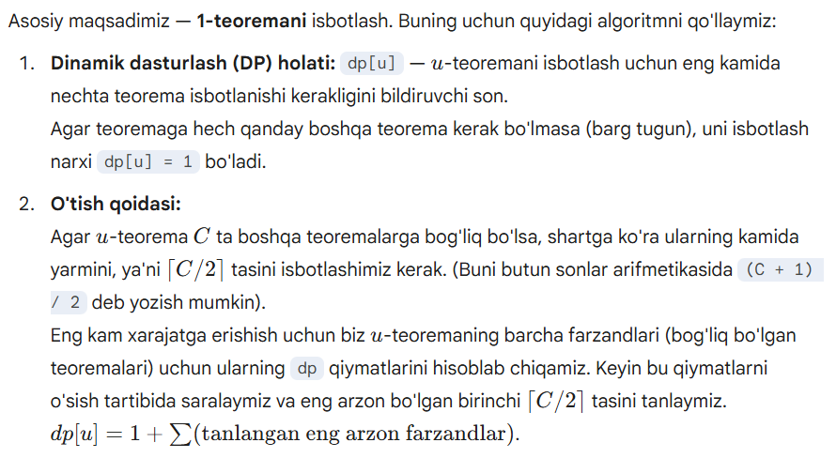
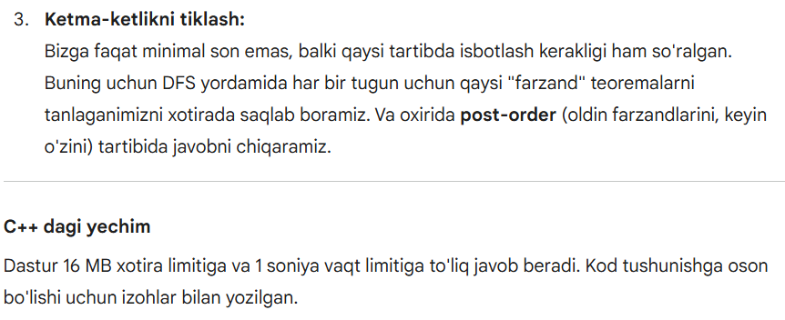
#include <iostream>
#include <vector>
#include <algorithm>

using namespace std;

const int MAXN = 10005;

// Har bir teorema qaysi teoremalarga bog'liqligini saqlovchi ro'yxat
vector<int> adj[MAXN];

// Har bir teorema uchun tanlangan eng optimal "farzand" teoremalar
vector<int> chosen[MAXN];

// dp[i] - i-teoremani isbotlash uchun jami qancha teorema isbotlash kerakligi
int dp[MAXN];

// Chuqurlik bo'ylab qidirish (DFS) va Dinamik Dasturlash
void dfs(int u) {
// Agar teorema hech narsaga bog'liq bo'lmasa
if (adj[u].empty()) {
dp[u] = 1;
return;
}

// Farzandlarning dp qiymatlarini va ularning raqamlarini saqlash
vector<pair<int, int>> children_dp;
for (int v : adj[u]) {
dfs(v); // Oldin farzandni hisoblaymiz
children_dp.push_back({dp[v], v});
}

// Eng kam teorema talab qiladiganlarini tanlash uchun saralaymiz
sort(children_dp.begin(), children_dp.end());

// Qancha teorema kerak? (Kamida yarmi: ceil(C/2))
int req = (adj[u].size() + 1) / 2;

dp[u] = 1; // O'zini isbotlash uchun 1 qadam
for (int i = 0; i < req; ++i) {
dp[u] += children_dp[i].first; // Narxni qo'shamiz
chosen[u].push_back(children_dp[i].second); // Qaysi birini tanlaganimizni saqlaymiz
}
}

// Javobni chop etish uchun (Post-order traversal)
// Teoremani isbotlashdan oldin, u bog'liq bo'lgan teoremalarni chiqarish kerak
void print_order(int u) {
for (int v : chosen[u]) {
print_order(v);
}
cout << u << "\n";
}

int main() {
// Kiritish va chiqarishni tezlashtirish
ios_base::sync_with_stdio(false);
cin.tie(NULL);

int N;
if (!(cin >> N)) return 0;

// Kirituvchi ma'lumotlarni o'qish
for (int i = 1; i <= N; ++i) {
int dep;
while (cin >> dep && dep != 0) {
adj[i].push_back(dep);
}
}

// 1-teorema (Asosiy teorema) uchun DFS ni boshlaymiz
dfs(1);

// Minimal teoremalar sonini chiqaramiz
cout << dp[1] << "\n";

// Qaysi tartibda isbotlash kerakligini chiqaramiz
print_order(1);

return 0;
}

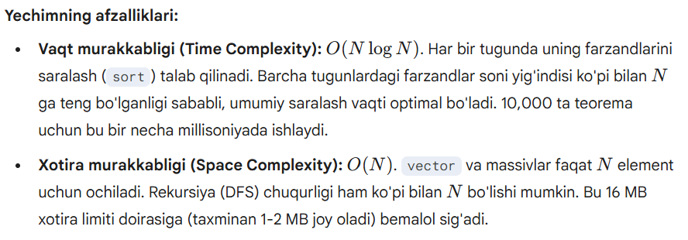

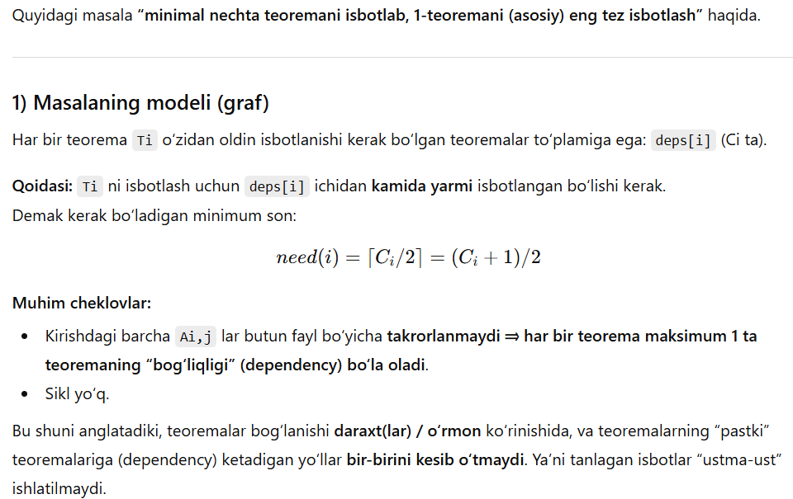
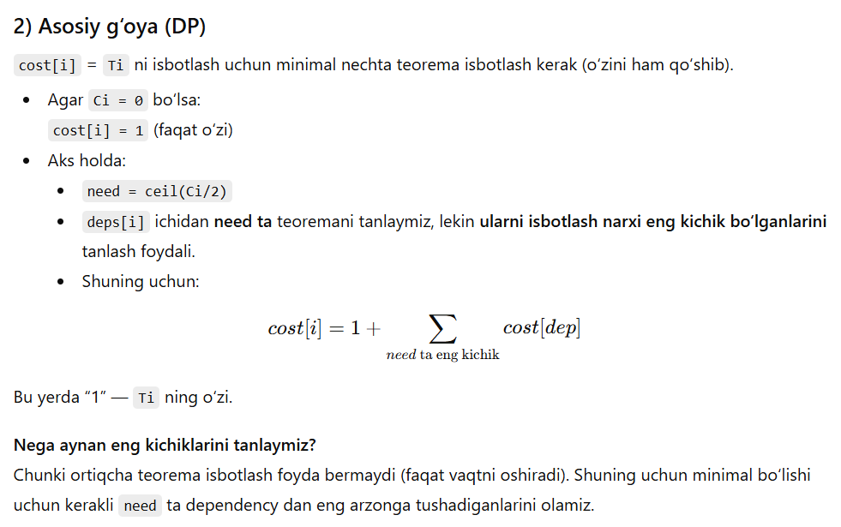
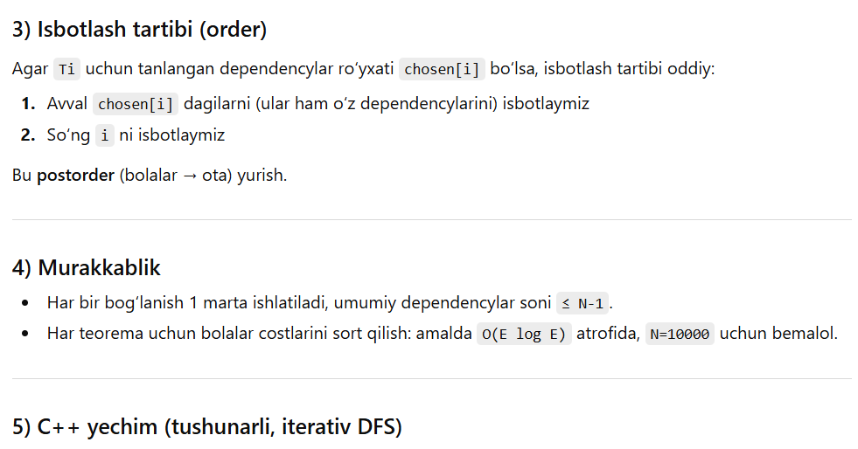
#include <bits/stdc++.h>
using namespace std;

int main() {
ios::sync_with_stdio(false);
cin.tie(nullptr);

int N;
cin >> N;

vector<vector<int>> deps(N + 1);
for (int i = 1; i <= N; i++) {
int x;
while (cin >> x && x != 0) {
deps[i].push_back(x);
}
}

// cost[i] - minimal number of theorems to prove theorem i (including itself)
vector<int> cost(N + 1, -1);

// chosen[i] - which dependencies we actually choose to prove for theorem i
vector<vector<int>> chosen(N + 1);

// --- Compute cost[] bottom-up with iterative postorder from node 1 ---
// Because graph is acyclic, we can do DFS stack (node, state)
// state=0 -> go down, state=1 -> compute
vector<pair<int,int>> st;
st.push_back({1, 0});

// We may need to compute costs for nodes reachable from 1 through deps (full subtree).
while (!st.empty()) {
auto [v, state] = st.back();
st.pop_back();

if (state == 0) {
if (cost[v] != -1) continue; // already computed
st.push_back({v, 1});
for (int u : deps[v]) {
if (cost[u] == -1) st.push_back({u, 0});
}
} else {
// compute cost[v]
int c = (int)deps[v].size();
if (c == 0) {
cost[v] = 1;
chosen[v].clear();
continue;
}

int need = (c + 1) / 2; // ceil(c/2)

// collect (cost[dep], dep)
vector<pair<int,int>> arr;
arr.reserve(c);
for (int u : deps[v]) {
arr.push_back({cost[u], u});
}
nth_element(arr.begin(), arr.begin() + need, arr.end());
// after nth_element, first need elements are the smallest (unordered)

// take the smallest 'need' elements
chosen[v].clear();
int sum = 0;
for (int i = 0; i < need; i++) {
sum += arr[i].first;
chosen[v].push_back(arr[i].second);
}
cost[v] = 1 + sum;
}
}

// --- Build proof order (postorder) only along chosen edges ---
vector<int> order;
vector<pair<int,int>> st2;
st2.push_back({1, 0});
vector<char> vis(N + 1, 0);

while (!st2.empty()) {
auto [v, state] = st2.back();
st2.pop_back();

if (state == 0) {
if (vis[v]) continue;
vis[v] = 1;
st2.push_back({v, 1});
for (int u : chosen[v]) {
if (!vis[u]) st2.push_back({u, 0});
}
} else {
order.push_back(v);
}
}

cout << order.size() << "\n";
for (int x : order) cout << x << "\n";

return 0;
}

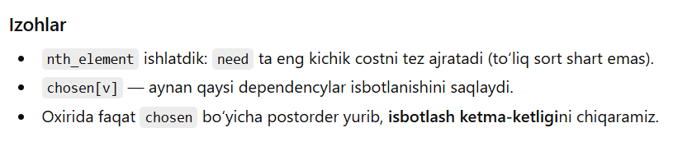

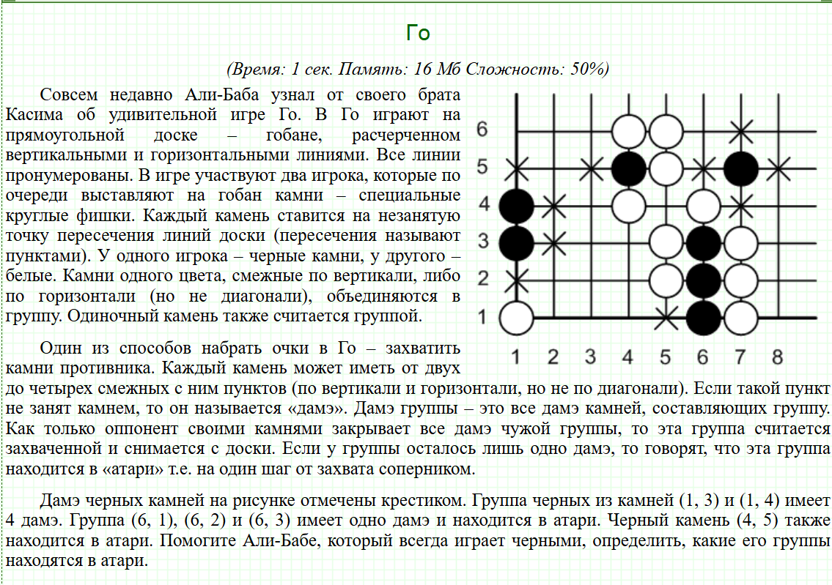
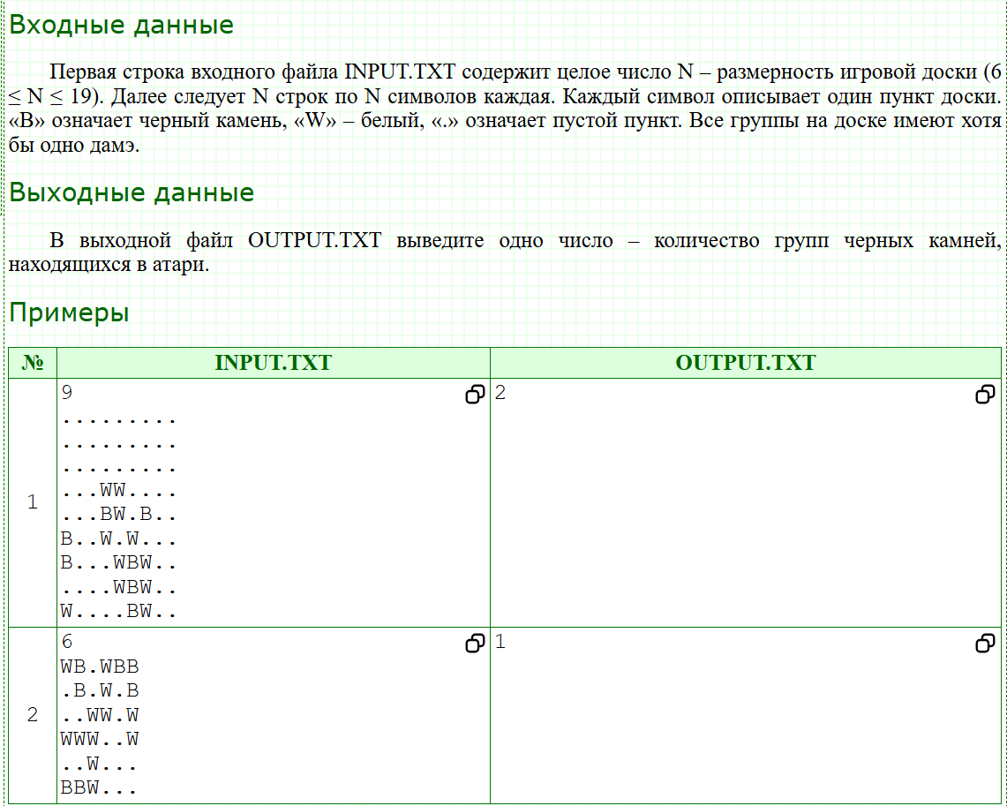
#include <bits/stdc++.h>
using namespace std;
char a[22][22];
int color[22][22];
int n;
int dx[] = {1,-1,0,0};
int dy[] = {0,0,1,-1};
int dfs(int x, int y, int rang){
a[x][y] = 'W';
int c = 0;
int result = 0;
for(int i = 0, X, Y; i < 4; i ++){
X = x + dx[i];
Y = y + dy[i];
if(0 <= X && X < n && 0 <= Y && Y < n){
if(a[X][Y] == '.' && color[X][Y] != rang){
c ++;
color[X][Y] = rang;
}
if(a[X][Y] == 'B'){
result += dfs(X, Y, rang);
}
}
}
result += c;
return result;
}
int main(){
scanf("%d\n", &n);
for(int i = 0; i < n; i ++) gets(a[i]);
int result = 0, rang = 0;
for(int i = 0; i < n; i ++){
for(int j = 0; j < n; j ++){
if(a[i][j] == 'B'){
result += dfs(i, j, ++rang) == 1;
}
}
}
printf("%d", result);
return 0;
}

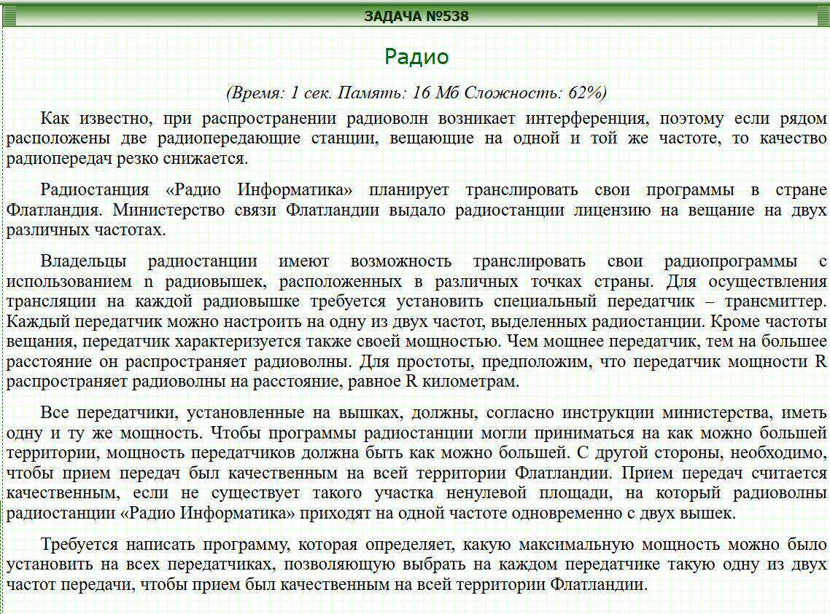
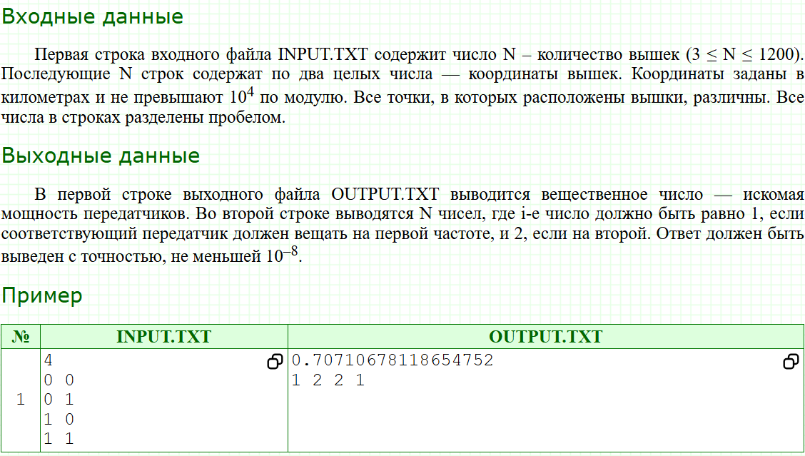
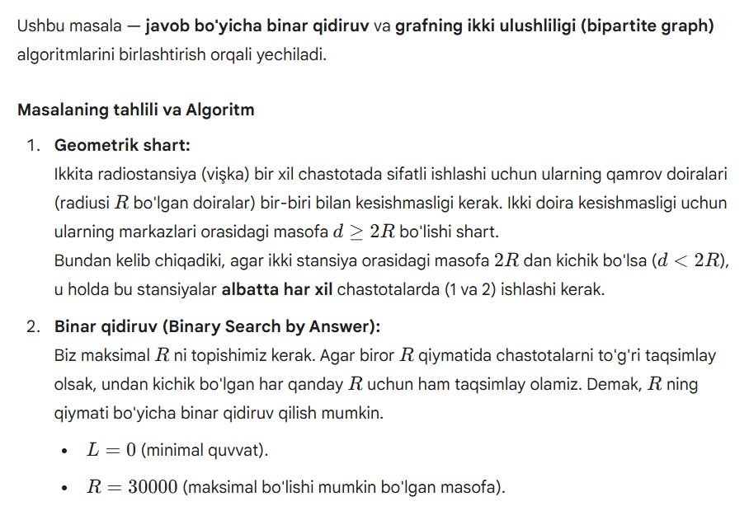
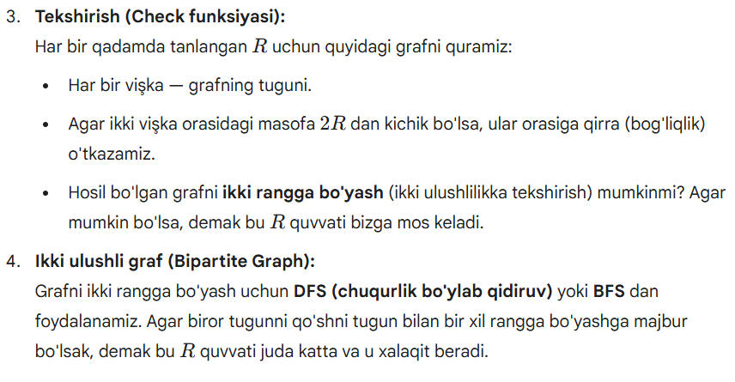
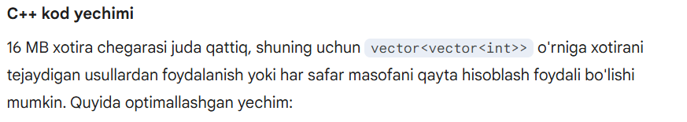
#include <iostream>
#include <vector>
#include <cmath>
#include <iomanip>
#include <algorithm>

using namespace std;

struct Point {
double x, y;
};

int n;
Point p[1205];
int color[1205];
vector<int> adj[1205];

// Grafni ikki rangga bo'yash (DFS)
bool isBipartite(int u, int c) {
color[u] = c;
for (int v : adj[u]) {
if (color[v] == 0) {
if (!isBipartite(v, 3 - c)) return false;
} else if (color[v] == c) {
return false;
}
}
return true;
}

// Berilgan R quvvatda yechim borligini tekshirish
bool check(double R) {
for (int i = 0; i < n; i++) {
adj[i].clear();
color[i] = 0;
}

double dist_threshold = 4.0 * R * R; // (2R)^2

for (int i = 0; i < n; i++) {
for (int j = i + 1; j < n; j++) {
double dx = p[i].x - p[j].x;
double dy = p[i].y - p[j].y;
if (dx * dx + dy * dy < dist_threshold) {
adj[i].push_back(j);
adj[j].push_back(i);
}
}
}

for (int i = 0; i < n; i++) {
if (color[i] == 0) {
if (!isBipartite(i, 1)) return false;
}
}
return true;
}

int main() {
ios::sync_with_stdio(false);
cin.tie(NULL);

if (!(cin >> n)) return 0;
for (int i = 0; i < n; i++) {
cin >> p[i].x >> p[i].y;
}

double low = 0, high = 30000;
// 10^-8 aniqlik uchun 100 ta iteratsiya yetarli
for (int iter = 0; iter < 100; iter++) {
double mid = (low + high) / 2.0;
if (check(mid)) {
low = mid;
} else {
high = mid;
}
}

// Eng oxirgi to'g'ri chiqqan R uchun ranglarni (chastotalarni) qayta hisoblaymiz
check(low);

cout << fixed << setprecision(10) << low << "\n";
for (int i = 0; i < n; i++) {
cout << (color[i] == 0 ? 1 : color[i]) << (i == n - 1 ? "" : " ");
}
cout << endl;

return 0;
}
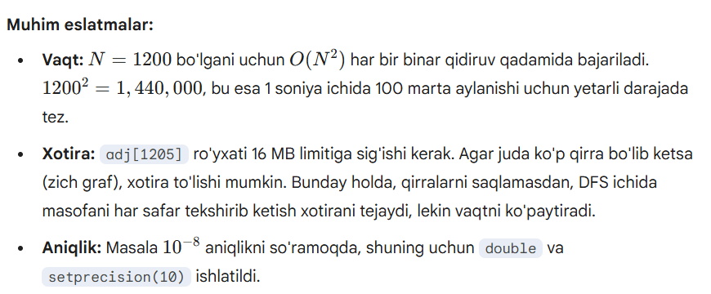
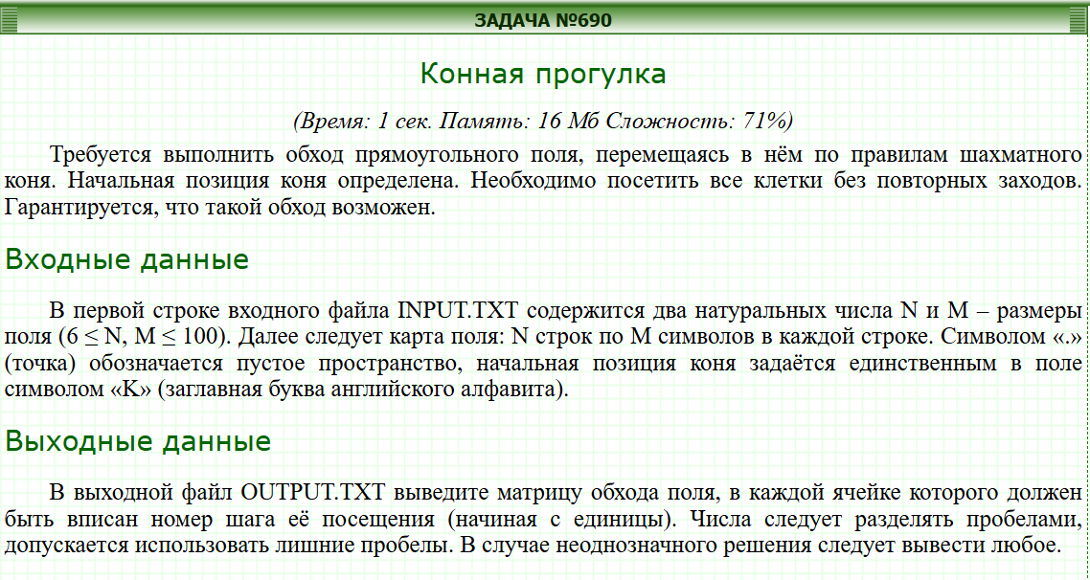
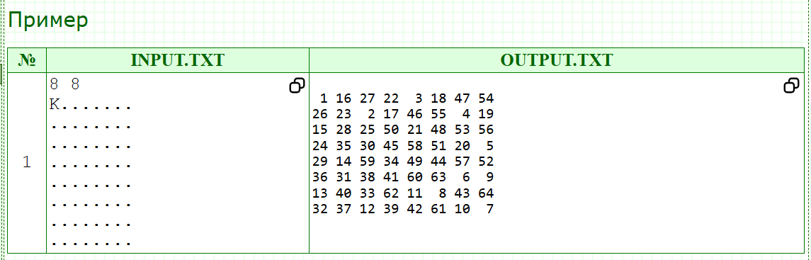
#include <bits/stdc++.h>
using namespace std;

static const int dx[8] = { 2, 2, 1, 1,-1,-1,-2,-2};
static const int dy[8] = { 1,-1, 2,-2, 2,-2, 1,-1};

inline bool inside(int x, int y, int N, int M){
return (x>=0 && x<N && y>=0 && y<M);
}

int main(){
ios::sync_with_stdio(false);
cin.tie(nullptr);

int N, M;
cin >> N >> M;
vector<string> g(N);
for(int i=0;i<N;i++) cin >> g[i];

int sx=-1, sy=-1;
for(int i=0;i<N;i++)
for(int j=0;j<M;j++)
if(g[i][j]=='K'){ sx=i; sy=j; }

vector<vector<int>> ans(N, vector<int>(M, 0));
vector<vector<char>> used(N, vector<char>(M, 0));

// Tasodifiy tie-break uchun
mt19937 rng((uint32_t)chrono::steady_clock::now().time_since_epoch().count());

auto solve_once = [&](bool random_tie)->bool{
for(int i=0;i<N;i++){
fill(ans[i].begin(), ans[i].end(), 0);
fill(used[i].begin(), used[i].end(), 0);
}

int x = sx, y = sy;
used[x][y] = 1;
ans[x][y] = 1;

for(int step = 2; step <= N*M; step++){
// Keyingi yurishni tanlaymiz: eng kichik "degree"
int bestNx = -1, bestNy = -1;
int bestDeg = INT_MAX;

// (ixtiyoriy) teng bo'lsa random tanlash
int bestCnt = 0;

for(int k=0;k<8;k++){
int nx = x + dx[k], ny = y + dy[k];
if(!inside(nx,ny,N,M) || used[nx][ny]) continue;

// degree(nx,ny): undan keyin nechta bo'sh qo'shni bor
int deg = 0;
for(int t=0;t<8;t++){
int tx = nx + dx[t], ty = ny + dy[t];
if(inside(tx,ty,N,M) && !used[tx][ty]) deg++;
}

if(deg < bestDeg){
bestDeg = deg;
bestNx = nx; bestNy = ny;
bestCnt = 1;
}else if(deg == bestDeg){
if(random_tie){
// Reservoir sampling: tenglar orasidan tasodifiy biri
bestCnt++;
uniform_int_distribution<int> dist(1, bestCnt);
if(dist(rng) == 1){
bestNx = nx; bestNy = ny;
}
}
}
}

if(bestNx == -1) return false; // tiqilib qoldi

x = bestNx; y = bestNy;
used[x][y] = 1;
ans[x][y] = step;
}
return true;
};

bool ok = false;

// Avval deterministik urinib ko'ramiz
ok = solve_once(false);

// Agar tiqilib qolsa, bir nechta random restart (odatda juda tez topadi)
for(int it=0; !ok && it<80; it++){
ok = solve_once(true);
}

// Shart bo'yicha yechim borligi kafolatlangan, shuning uchun ok odatda true bo'ladi.
// Chiqish
for(int i=0;i<N;i++){
for(int j=0;j<M;j++){
cout << ans[i][j] << (j+1==M?'\n':' ');
}
}
return 0;
}

