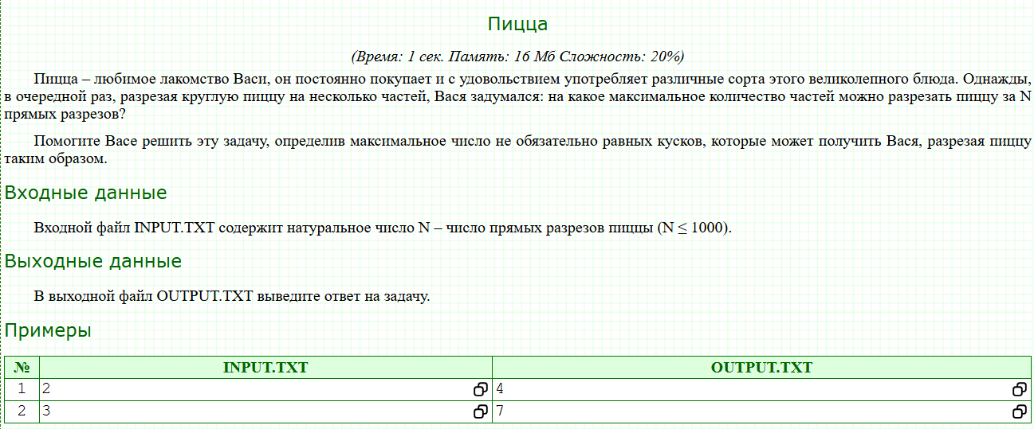

#include <bits/stdc++.h>
using namespace std;
using ll = long long;
int main()
{
int n;
cin >> n;
cout << n * (n + 1) / 2 + 1;
}

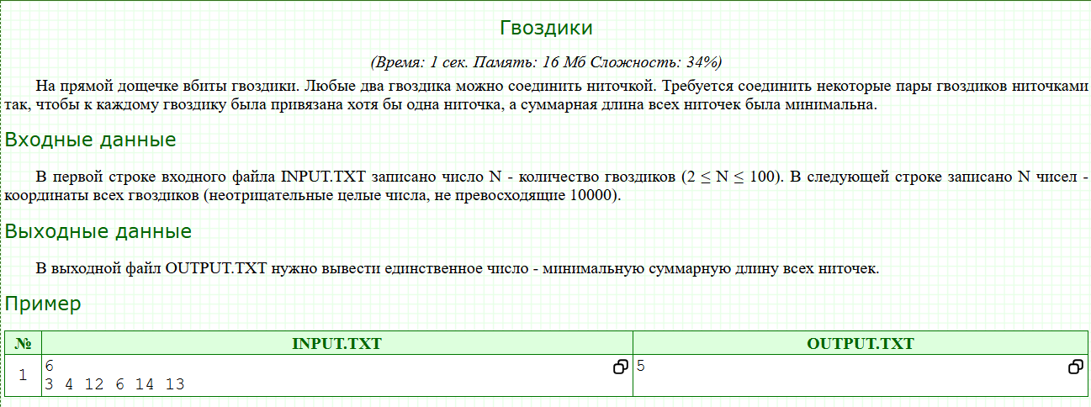

#include <iostream>
#include <algorithm>

using namespace std;

int n;
int a[111];
int dp[111];

int main(){
cin >> n;
for(int i = 0; i < n; ++ i){
cin >> a[i];
}
sort(a, a + n);
dp[1] = a[1] - a[0];
dp[2] = a[2] - a[0];

for(int i = 3; i < n; ++ i){
dp[i] = min(dp[i - 1], dp[i - 2]) + a[i] - a[i - 1];
}
cout << dp[n - 1];
return 0;
}

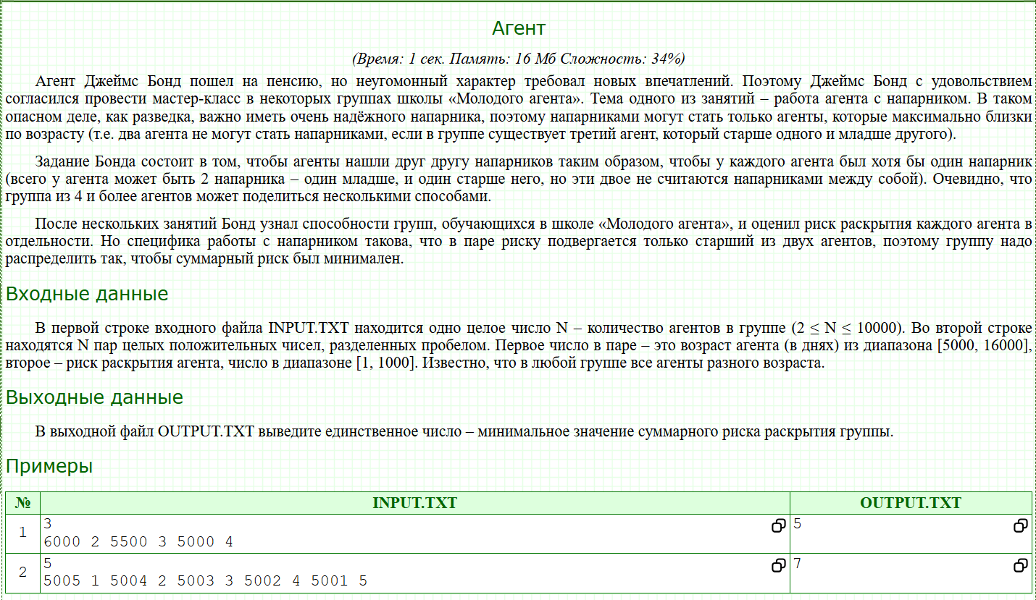
#include <bits/stdc++.h>
using namespace std;

int main() {
ios::sync_with_stdio(false);
cin.tie(nullptr);

int N;
if (!(cin >> N)) return 0;
vector<pair<int,int>> a(N); // {age, risk}
for (int i = 0; i < N; ++i) cin >> a[i].first >> a[i].second;

// 1) Yosh bo'yicha saralash (oshish tartibida)
sort(a.begin(), a.end());

// 2) Faqat risklar ketma-ketligini olib qo'yamiz (saralangan yoshga mos)
vector<int> risk(N+1);
for (int i = 1; i <= N; ++i) risk[i] = a[i-1].second;

const long long INF = (1LL<<60);
// dp[i][c]: 1..i agentlar ko'rib chiqilgan, c=0 -> i qoplanmagan, c=1 -> i qoplangan
vector<array<long long,2>> dp(N+1, {INF, INF});
dp[1][0] = 0; // hali hech qanday qirra tanlanmagan, 1-agent qoplanmagan

for (int i = 1; i <= N-1; ++i) {
// 1) Qirrani olish (i, i+1) — xarajat risk[i+1]
// Bu i va i+1 ni qoplaydi; keyingi holatda (i+1) qoplangan bo'ladi
dp[i+1][1] = min(dp[i+1][1], dp[i][0] + risk[i+1]);
dp[i+1][1] = min(dp[i+1][1], dp[i][1] + risk[i+1]);

// 2) Qirrani olmaslik — faqat i allaqachon qoplangan bo'lsa ruxsat
dp[i+1][0] = min(dp[i+1][0], dp[i][1]);
}

// Oxirgi agent ham qoplangan bo'lishi kerak
cout << dp[N][1] << "\n";
return 0;
}

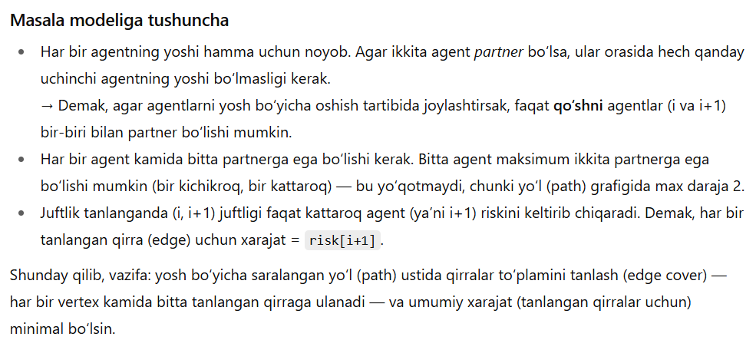

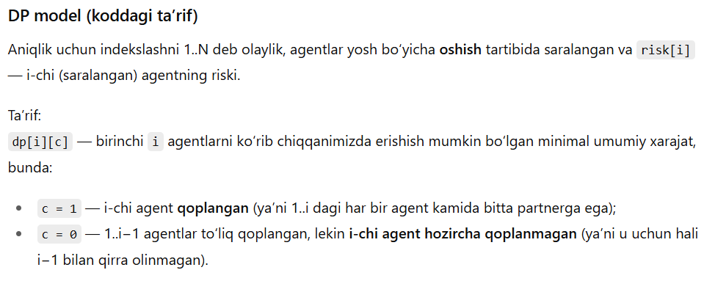
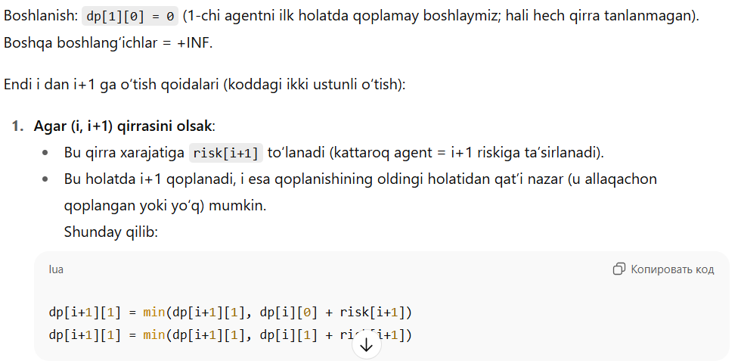
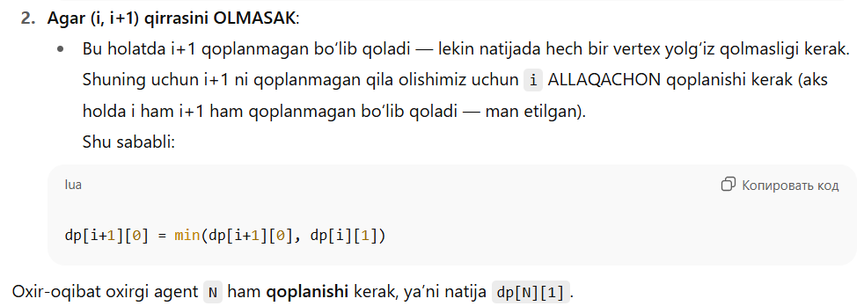
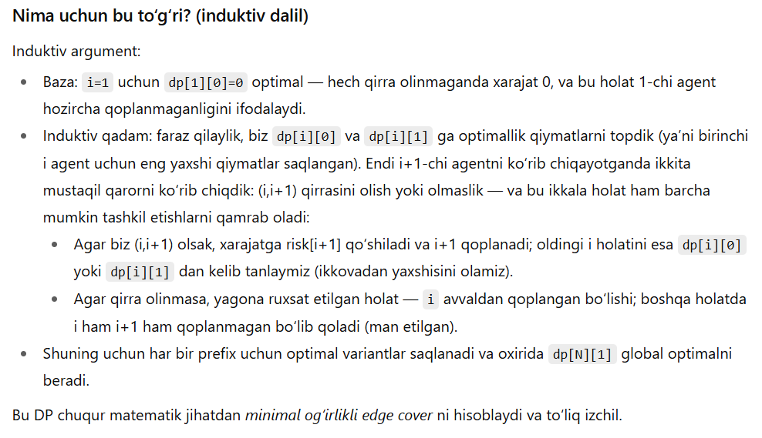
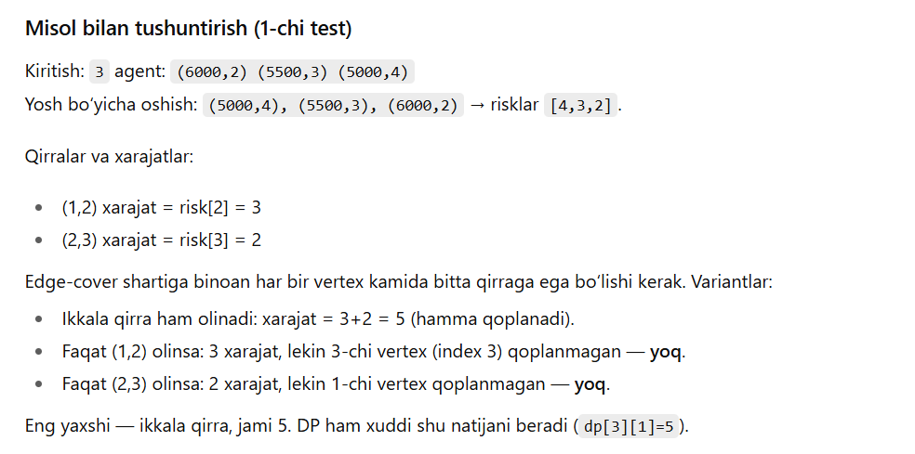
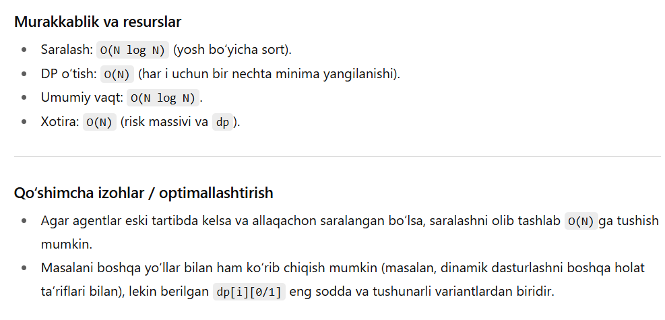

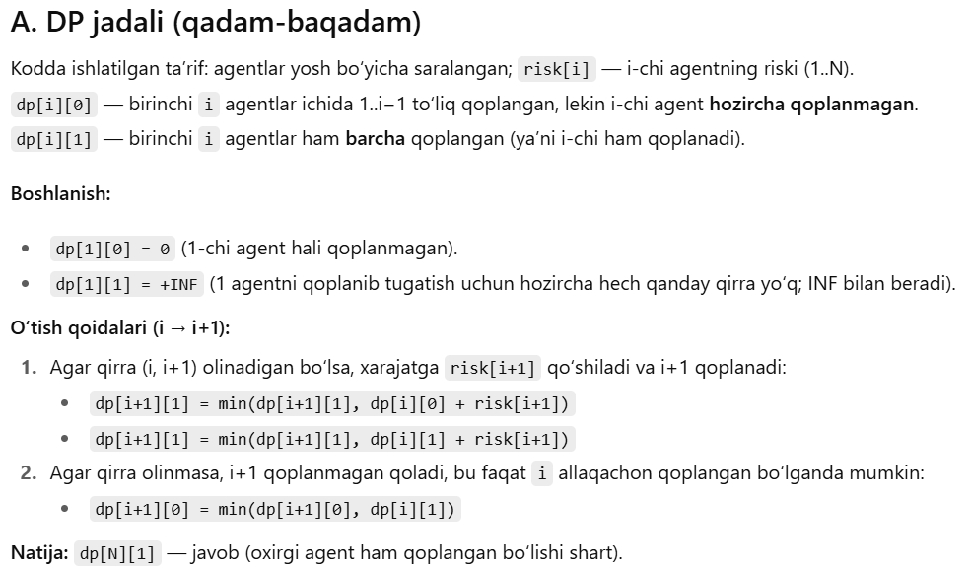
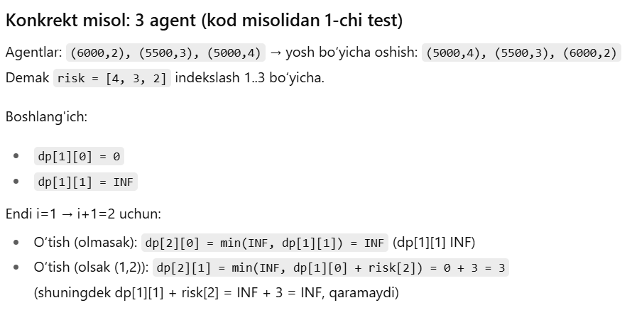
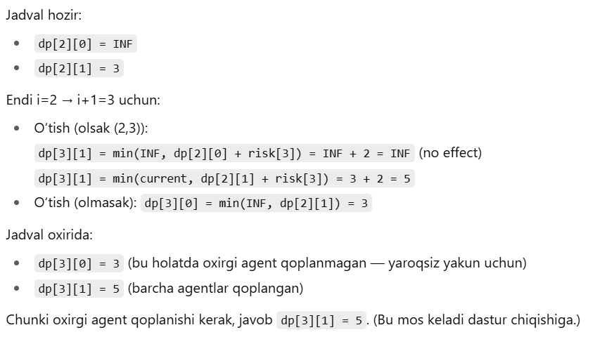
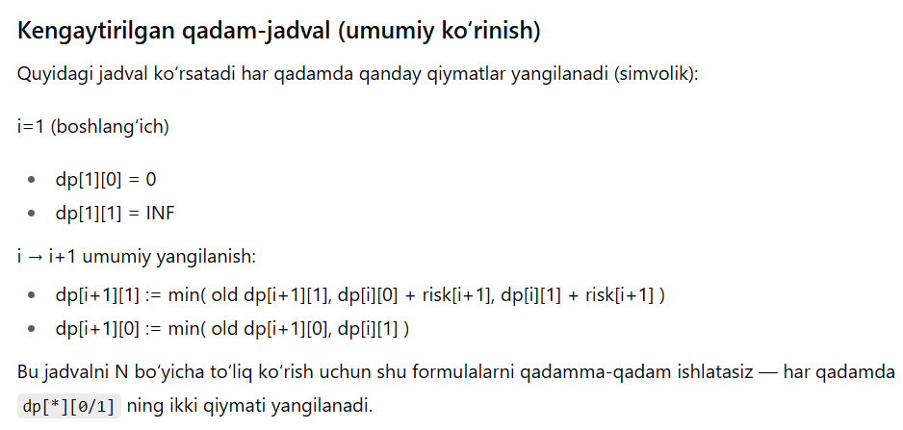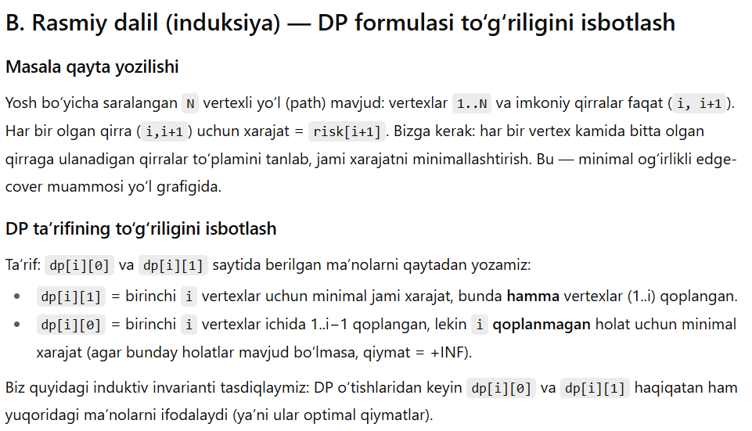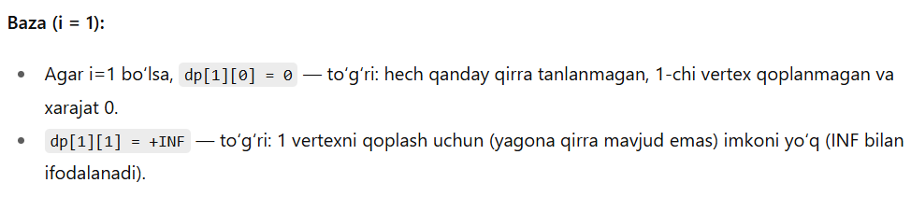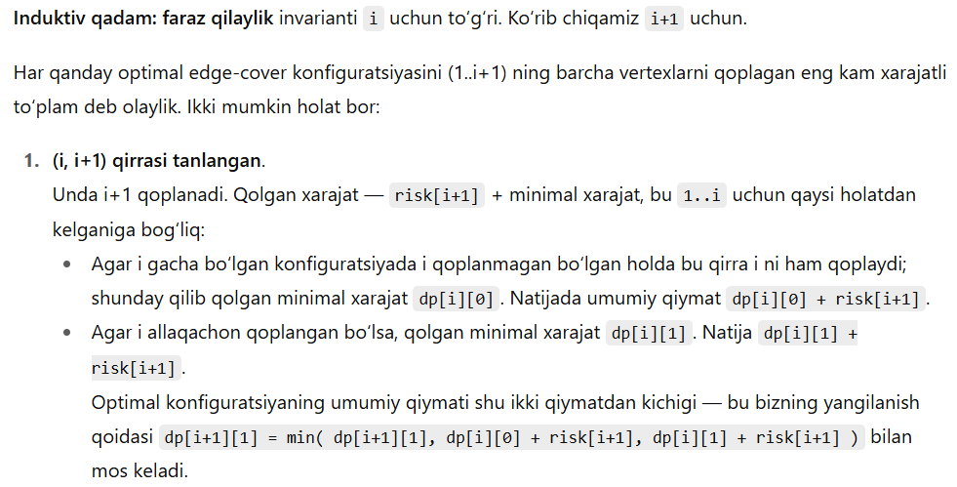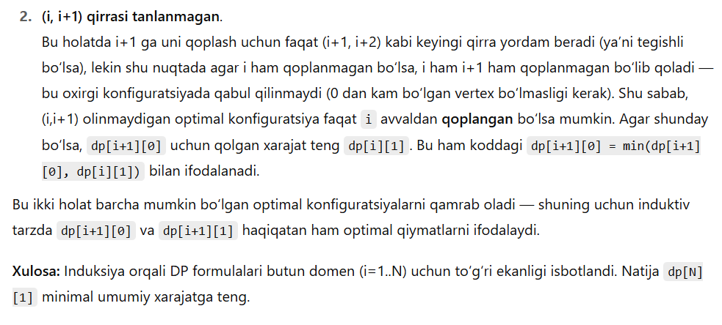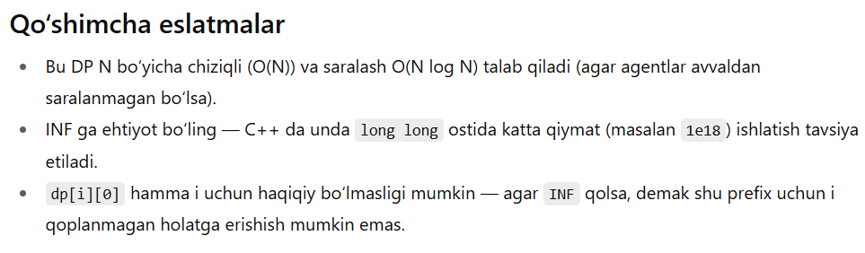

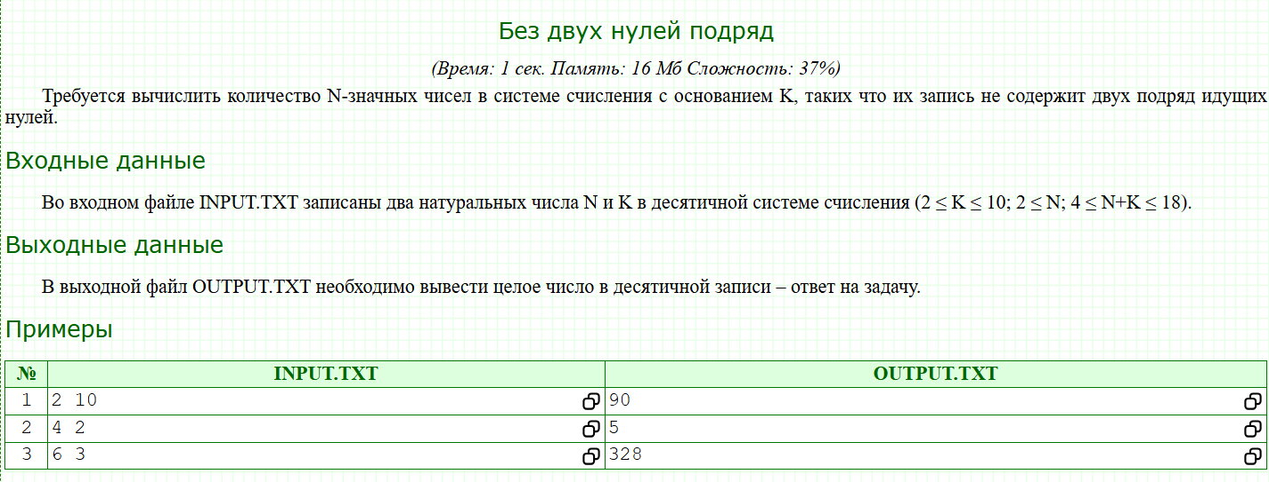
#include <bits/stdc++.h>

using namespace std;

typedef long long LL;

int cnt[20];

int main()
{
int n, base;
cin >> n >> base;
cnt[1] = base - 1;
cnt[2] = (base - 1) * base;
for(int i = 3; i <= n; i++){
cnt[i] = (base - 1) * (cnt[i - 1] + cnt[i - 2]);
}
cout << cnt[n];
}

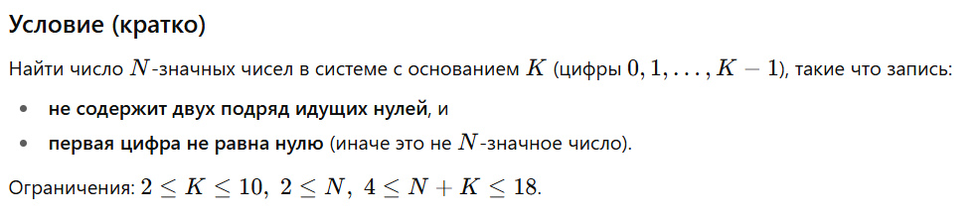
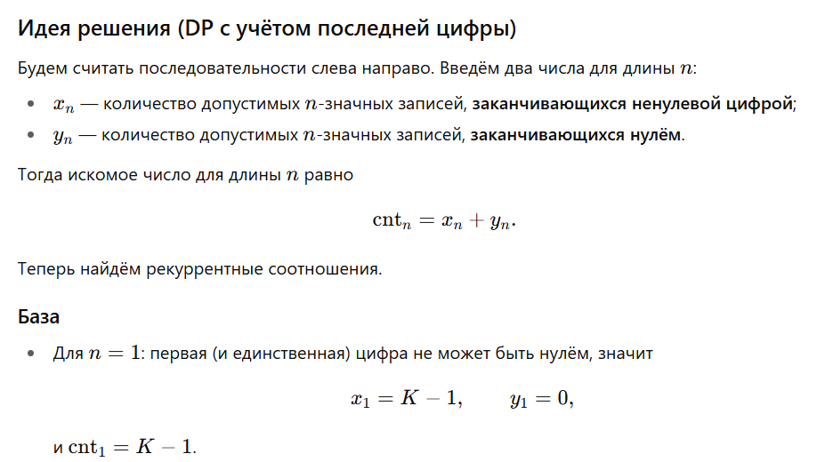

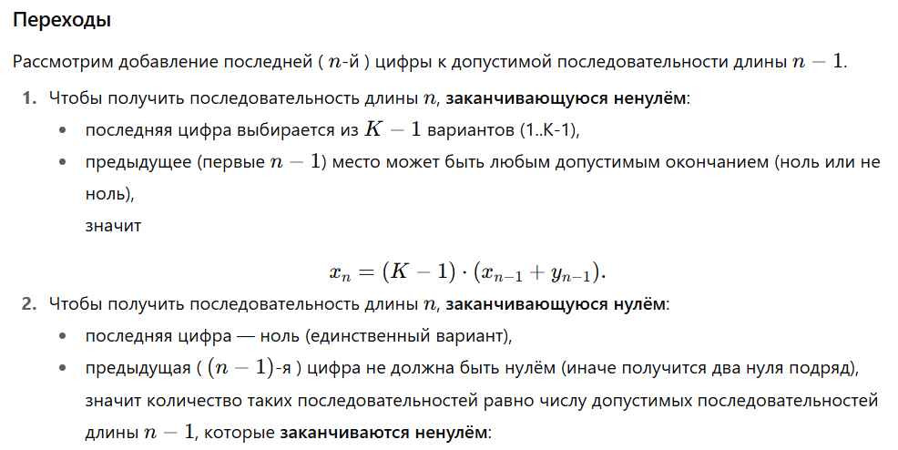
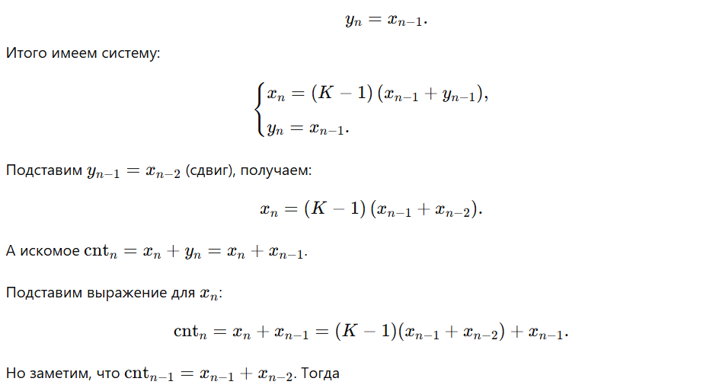
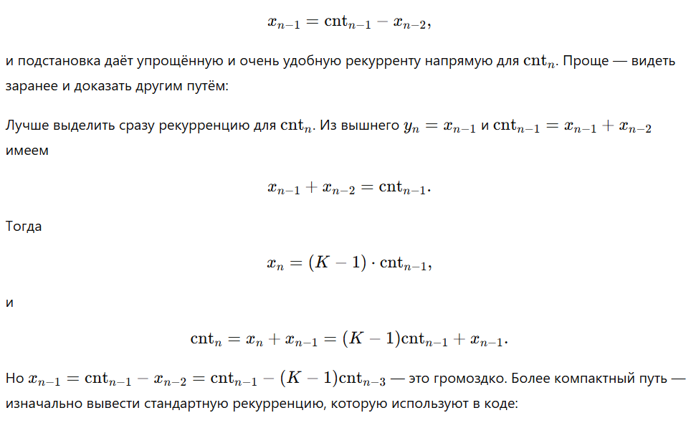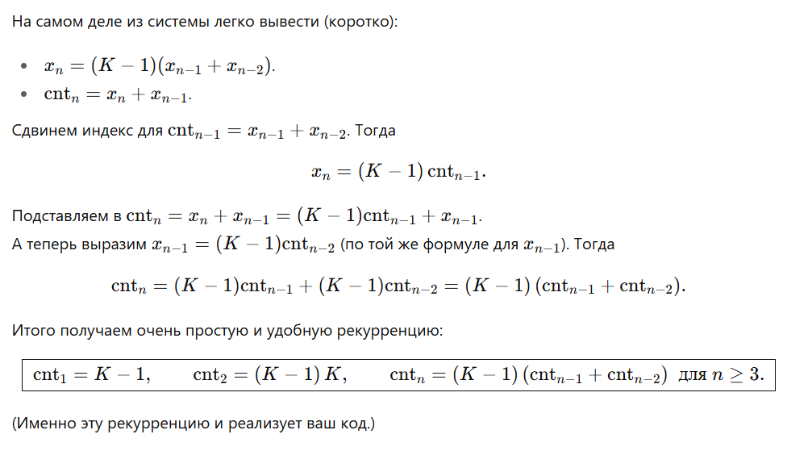
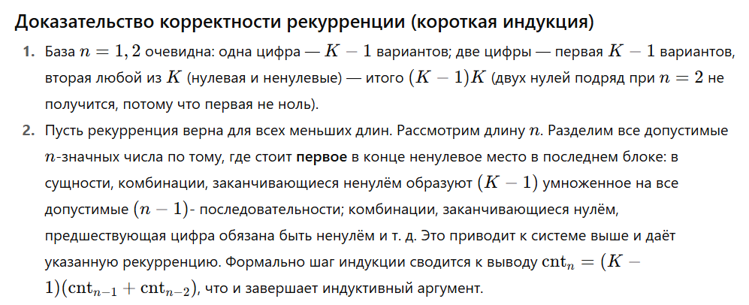
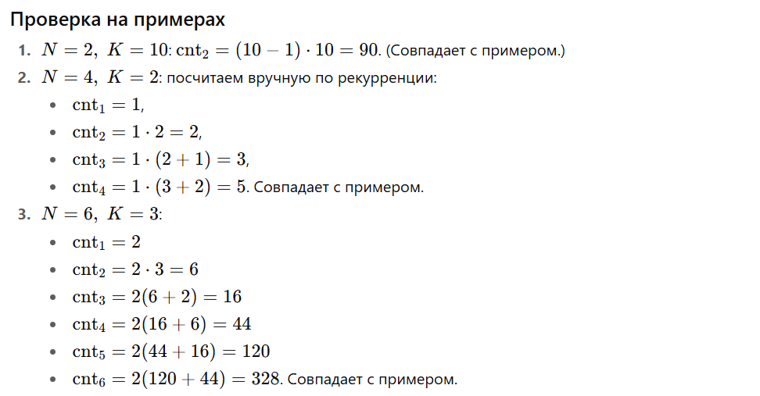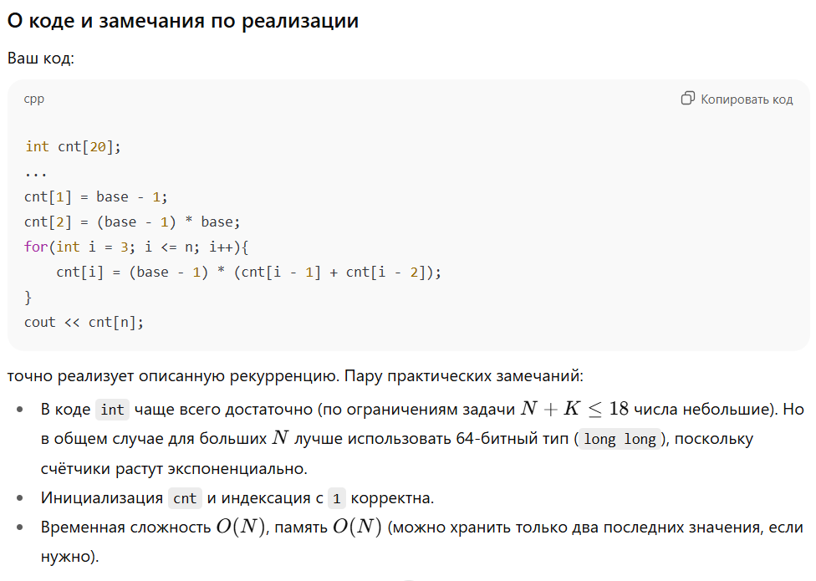
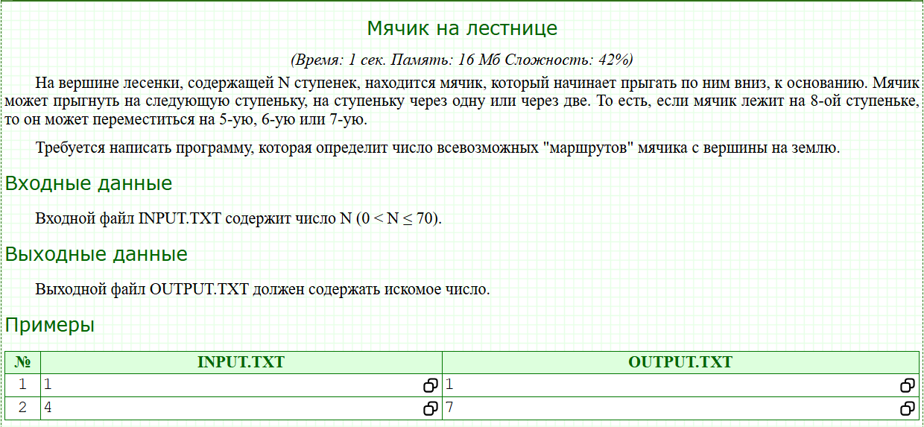
#include <bits/stdc++.h>

using namespace std;

typedef long long LL;

LL cnt[70];

int main()
{
int n;
cin >> n;
cnt[0] = 1;
for(int i = 1; i <= n; i++){
for(int j = max(0, i - 3); j < i; j++){
cnt[i] += cnt[j];
}
}
cout << cnt[n];
}

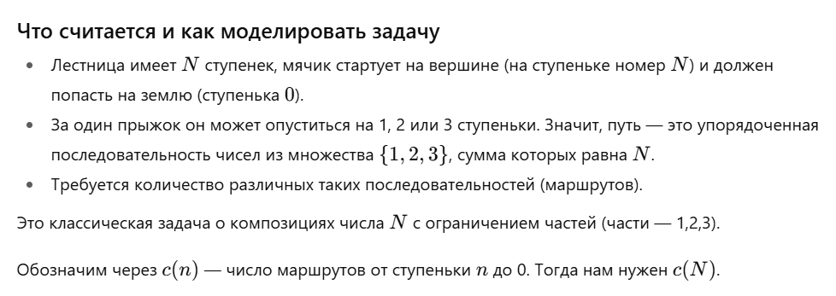
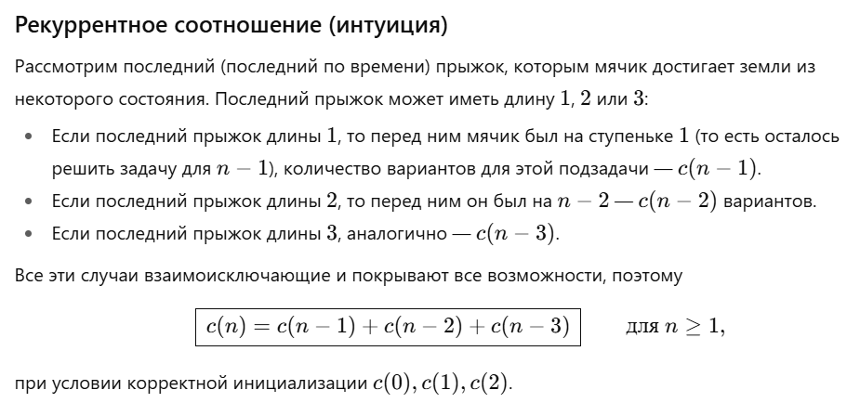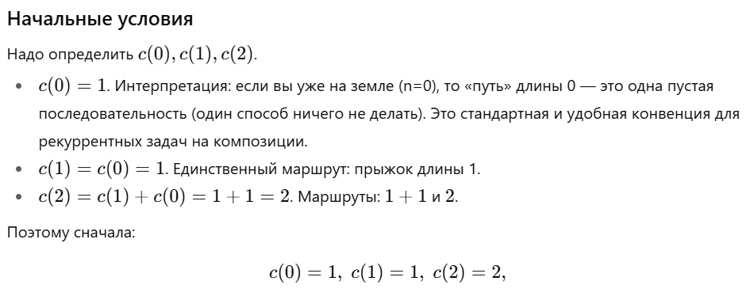
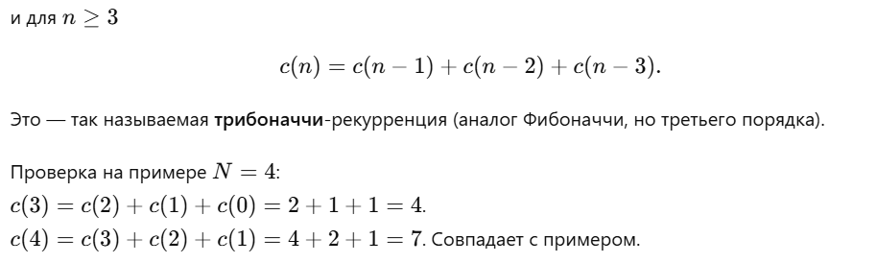
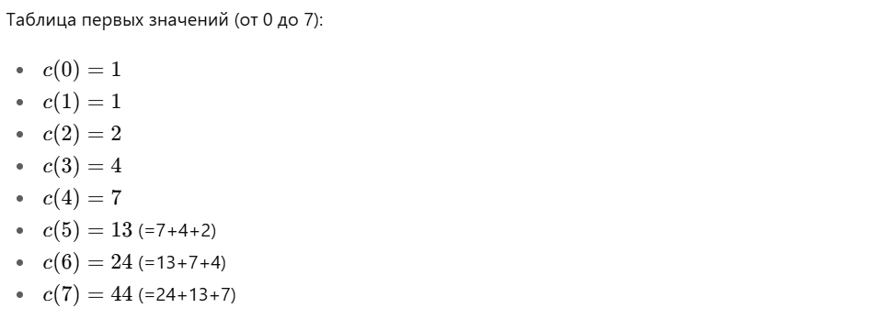
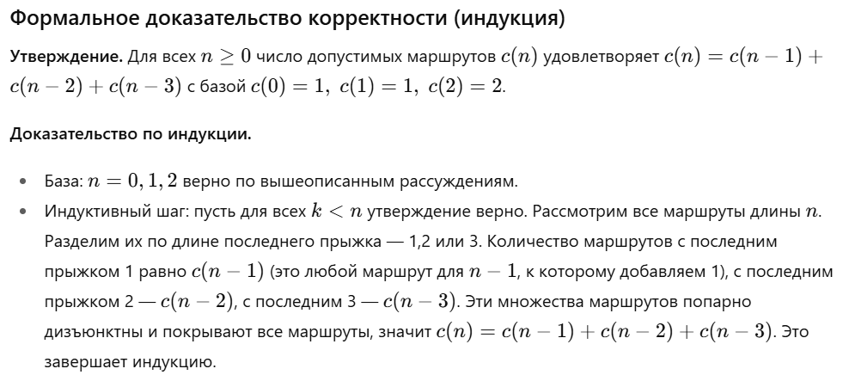
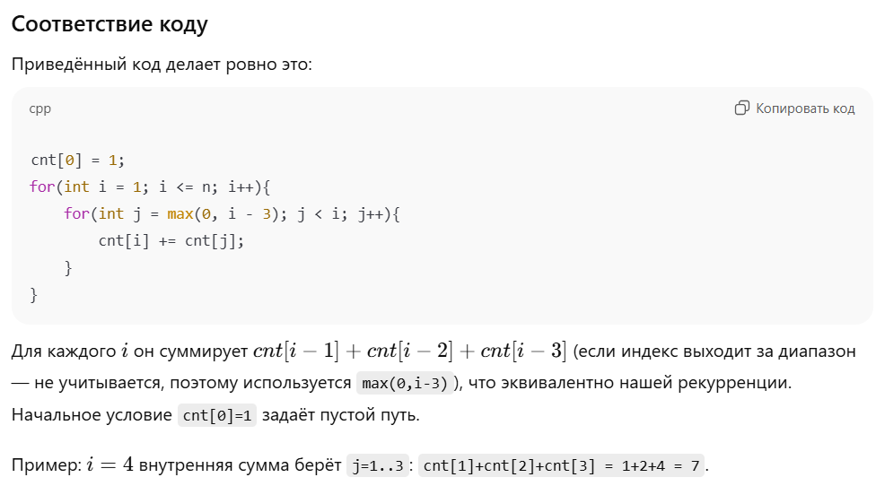
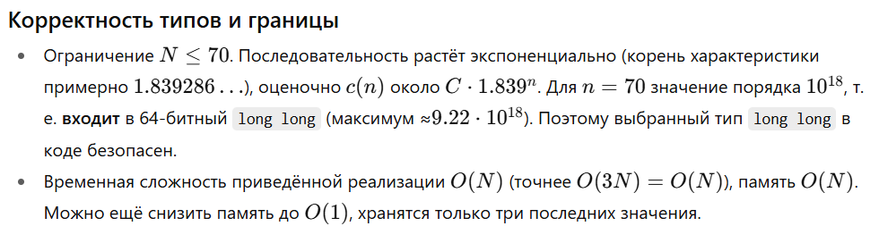
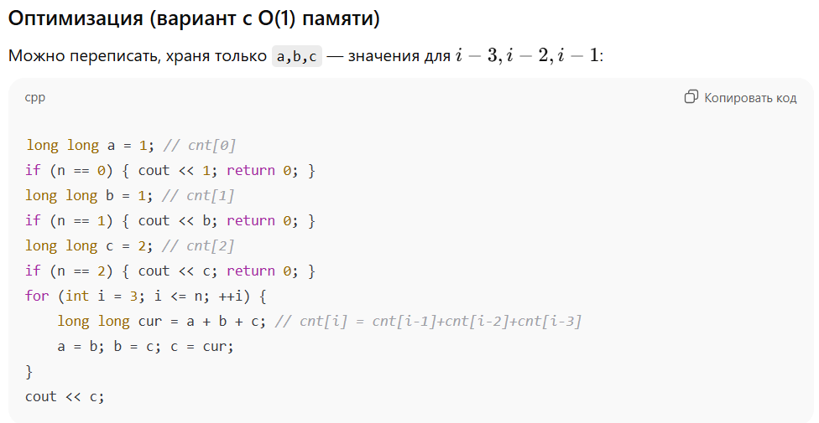
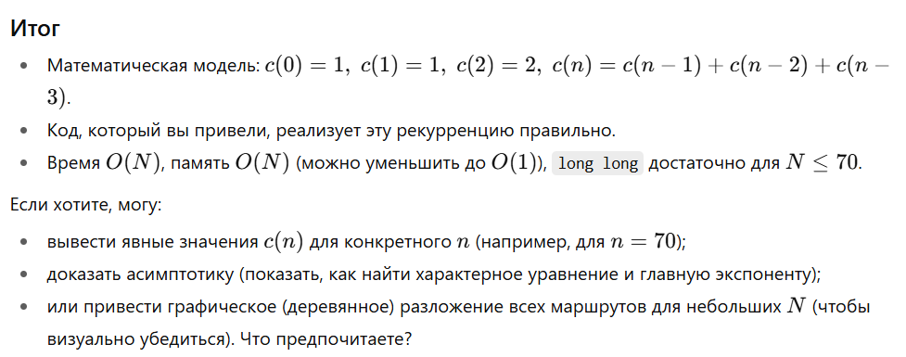

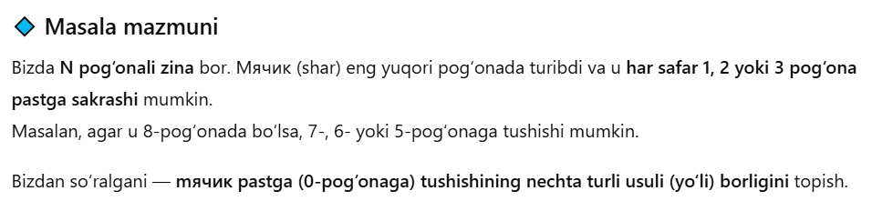
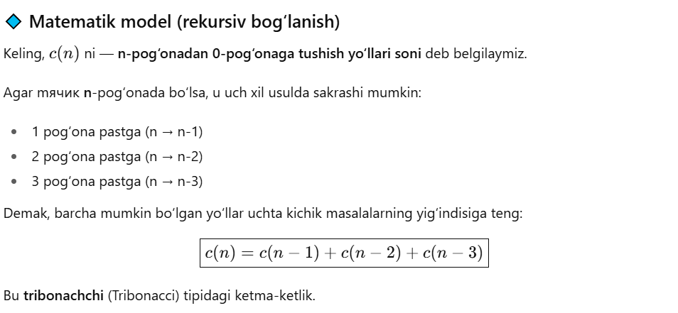
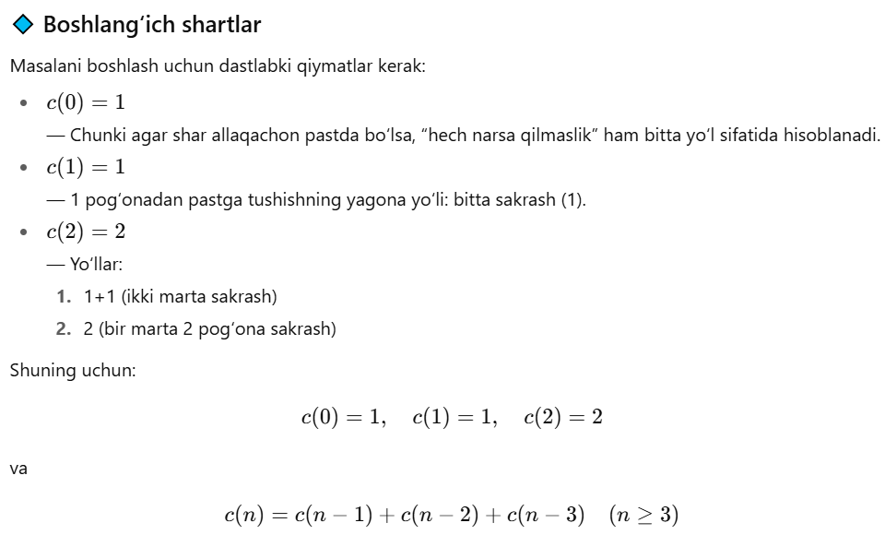
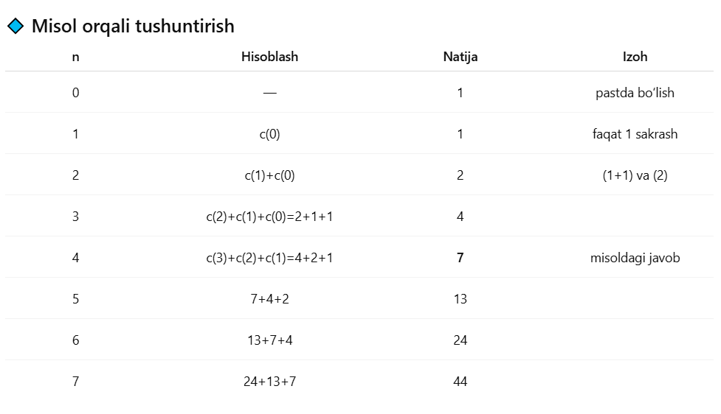
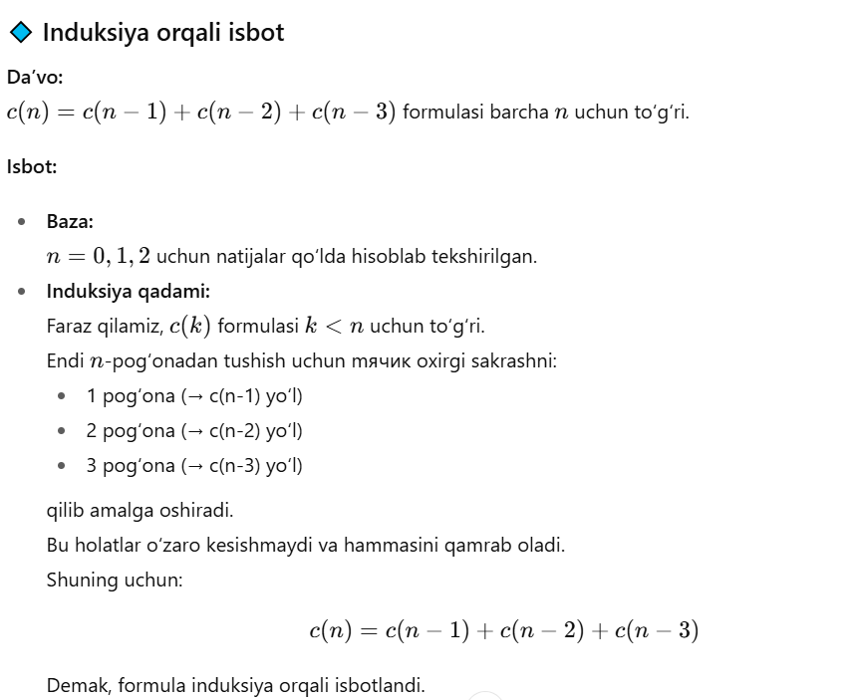
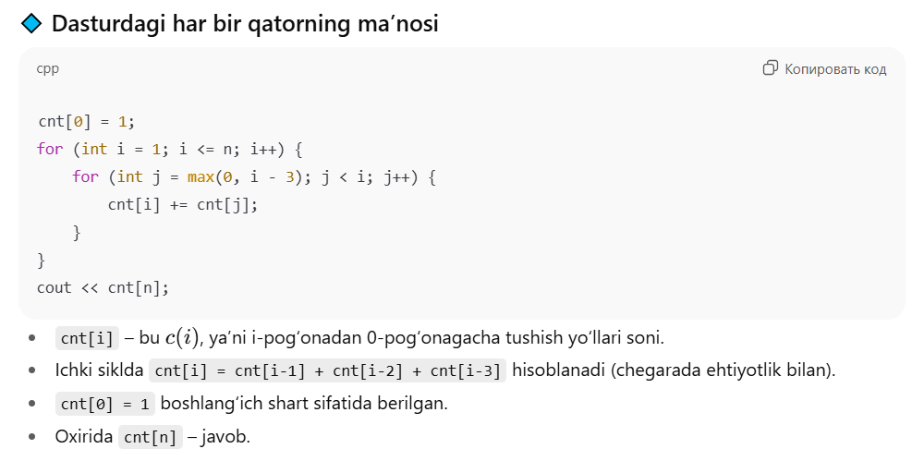
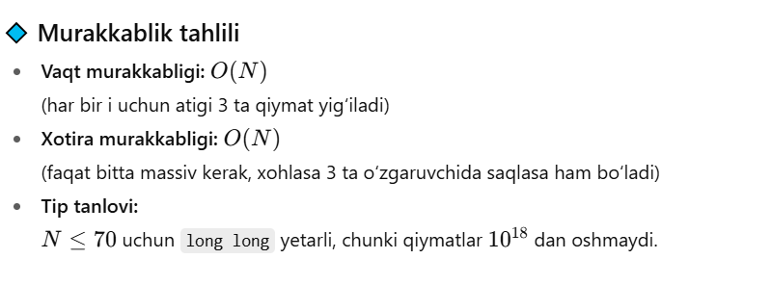
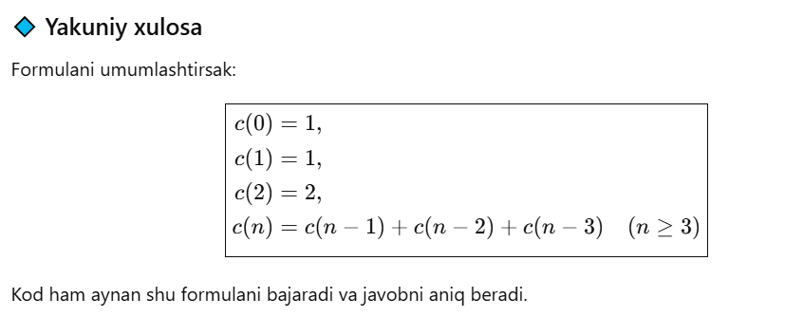

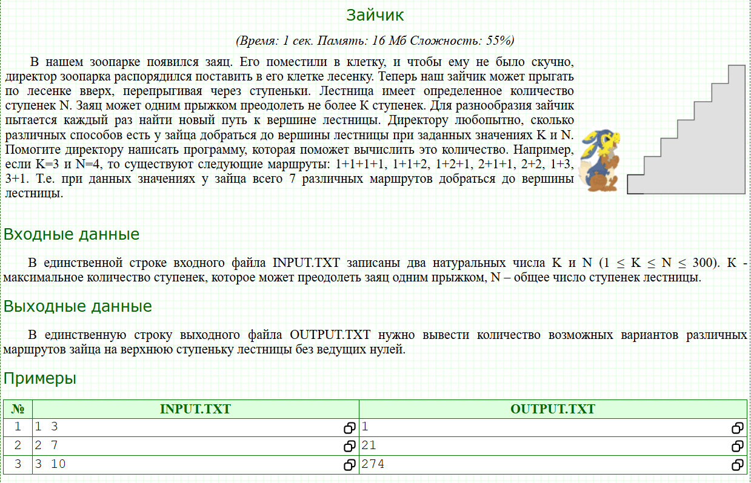
k, n = map(int, input().split())
a = [1, 1]
for i in range(2, n + 1):
a.append(sum(a[len(a) - min(k, len(a)):]))
print(a[n])

