Slide 1. Title slide
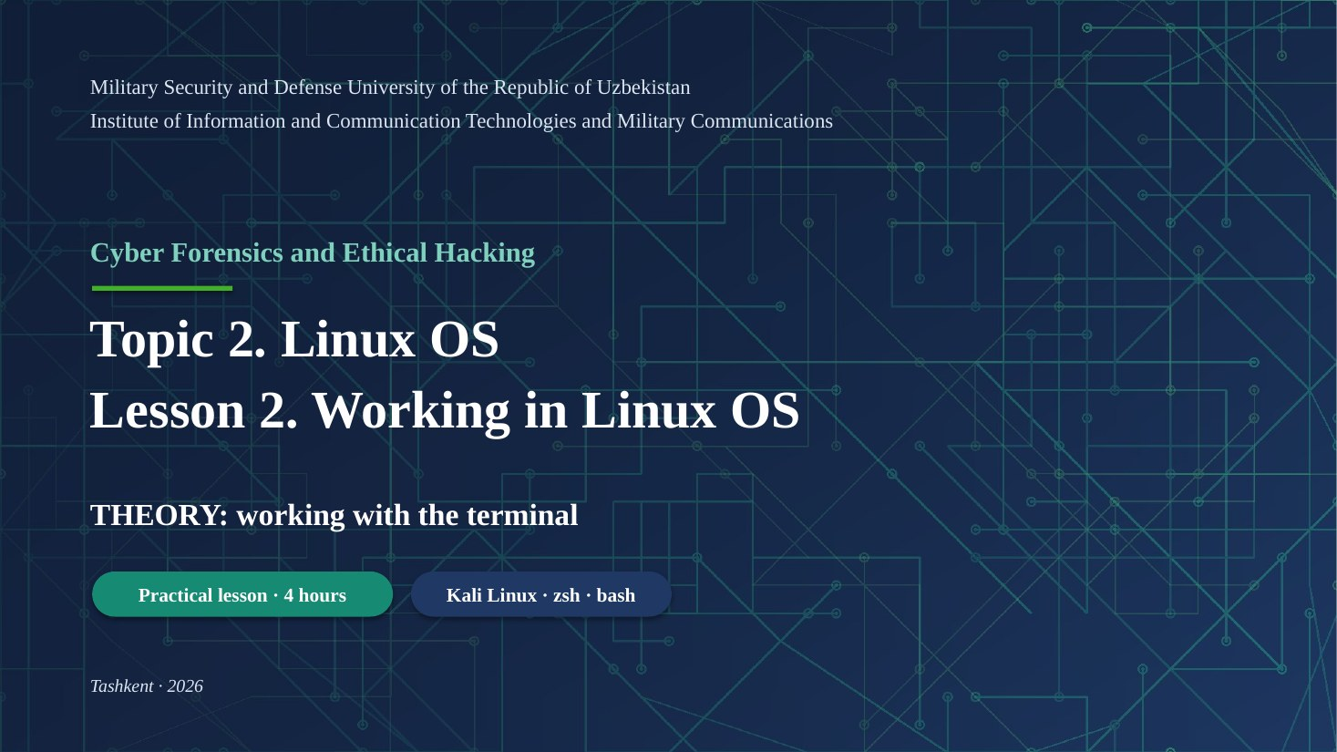
Good morning, everyone. Today we continue Topic 2, the Linux operating system. This is Lesson 2: working in Linux.
In the first part of the lesson, I will explain the theory about the terminal. It takes about twenty minutes. After that, you will do thirteen practical tasks on your Kali Linux virtual machine.
Please ask me questions at any time. If something is not clear, it is better to ask now.
Key words: theory – nazariya; practical – amaliy; virtual machine – virtual mashina

Slide 2. 1.1 Terminal, console, shell
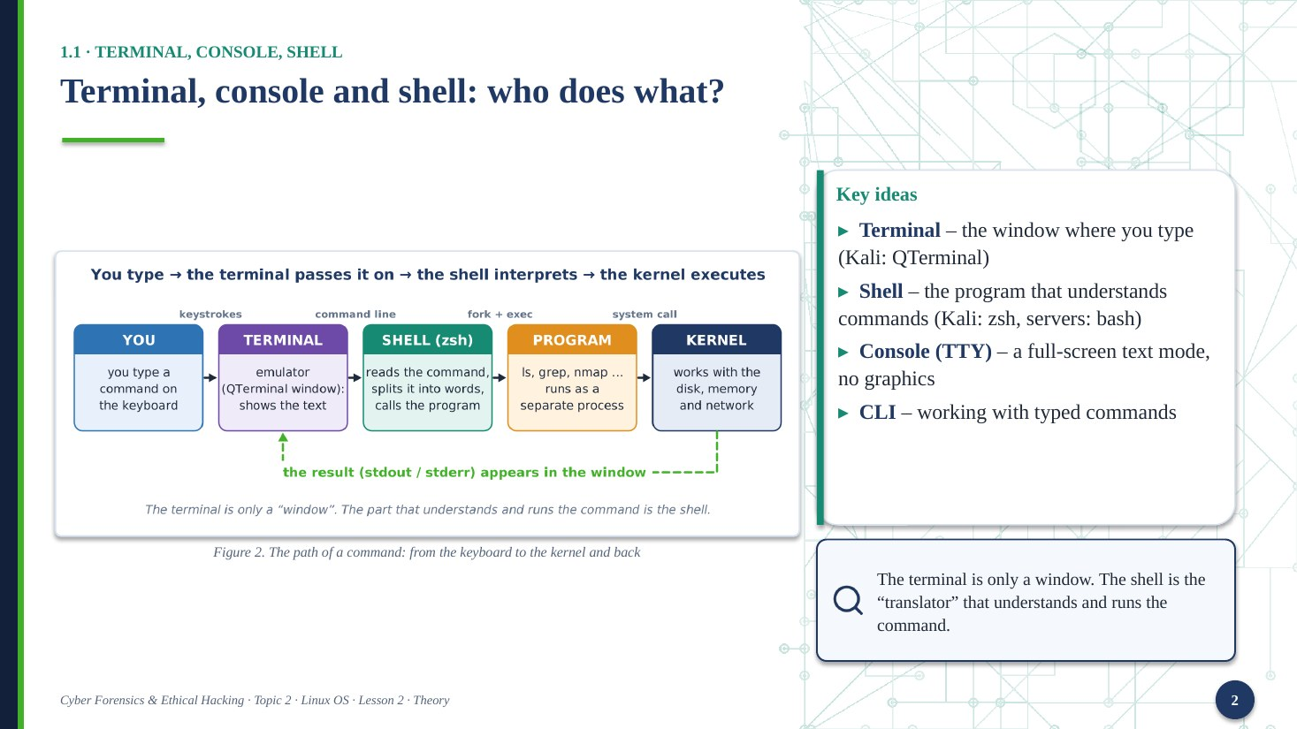
First, four words that people often mix up. The terminal is the window where you type. The shell is the program that reads your command and understands it. In Kali, the shell is zsh. On servers, it is usually bash.
The console, or TTY, is a full-screen text mode. It has no graphics. And CLI means the command-line way of working.
Look at the picture. You type a command. The terminal passes it to the shell. The shell starts the program. The kernel does the real work. Then the result comes back to your screen the same way.
Remember this: the terminal is only a window. The shell is the translator.
Key words: terminal – terminal oynasi; shell – qobiq, buyruq tarjimoni; console (TTY) – konsol; kernel – yadro

Slide 3. 1.1 Terminal, console, shell
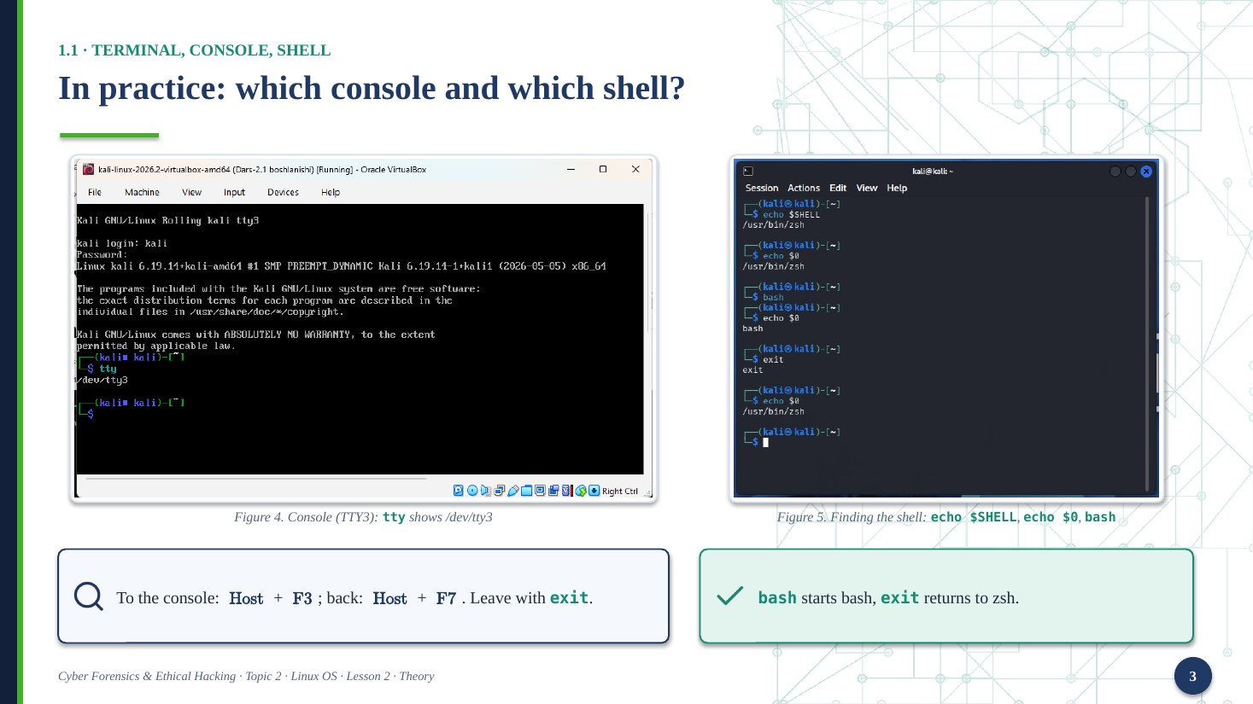
Here are two screenshots from our lab. On the left, I switched to a text console with Host plus F3. I logged in as user kali, and then I typed the command tty. The answer is slash dev slash tty3. This means I am working in virtual console number three.
On the right, I am in the normal terminal. I typed echo dollar SHELL, and the answer is zsh. Then I typed echo dollar zero. It shows the shell that is running right now.
Then I typed bash, and the shell changed to bash. I typed exit, and I came back to zsh.
To return from the console to the graphical screen, press Host plus F7.
Key words: log in – tizimga kirish; graphical screen – grafik ekran; running – ishlayotgan

Slide 4. 1.2 The prompt
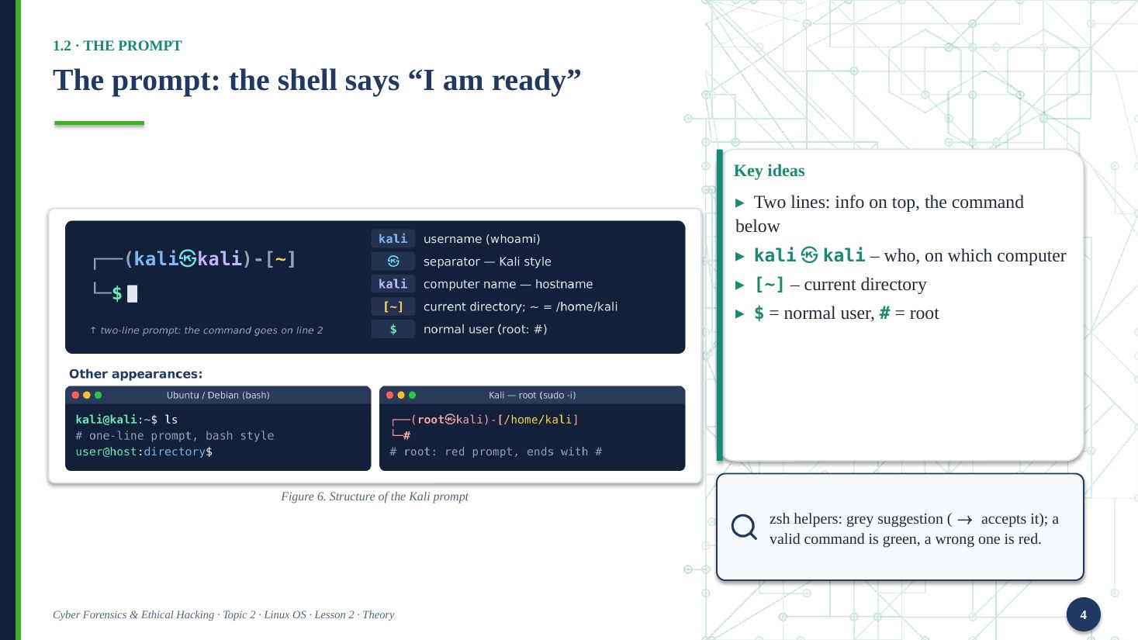
The prompt is a sign from the shell. It says: I am ready, type your command.
In Kali, the prompt has two lines. The first line shows information. The word before the at-sign is the user name. The word after it is the computer name. Then you see the current directory in square brackets. The tilde sign means your home directory.
The last symbol is very important. A dollar sign means a normal user. A hash sign means root, the administrator. Be careful when you see the hash.
Kali zsh also helps you. It shows a grey suggestion from your history. Press the right arrow to accept it. A correct command is green. A wrong command is red.
Key words: prompt – taklif satri; current directory – joriy katalog; root – administrator; suggestion – taklif

Slide 5. 1.3 Command syntax
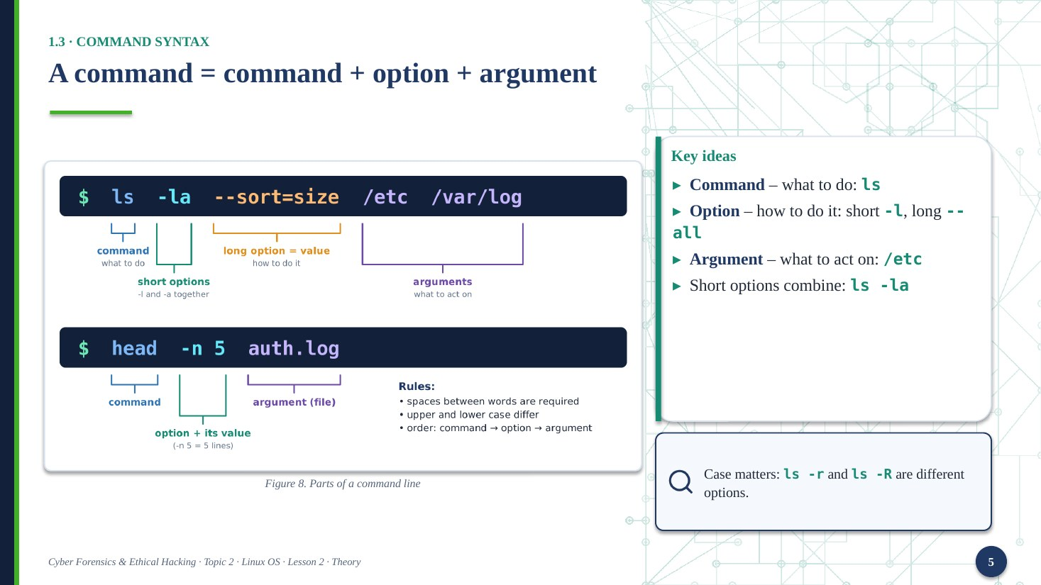
Every command has the same structure. First, the command: what to do. For example, ls. Second, the option: how to do it. A short option has one dash and one letter, like dash l. A long option has two dashes and a word, like dash dash all. Third, the argument: what to work on. For example, the directory slash etc.
You can combine short options. So ls dash l dash a is the same as ls dash l a.
Please remember: capital and small letters are different. Ls dash small r and ls dash capital R are two different options.
Key words: command – buyruq; option – kalit (opsiya); argument – argument; short / long – qisqa / uzun

Slide 6. 1.3 Command syntax
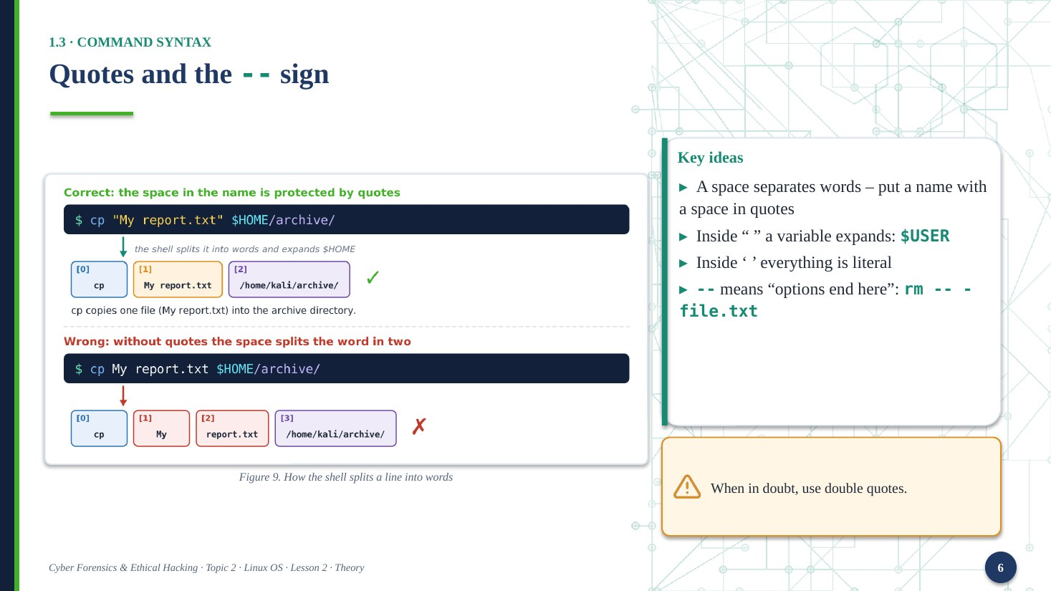
Now, quotes. The shell splits every line into words. The separator is a space. So if a file name has a space, the shell sees two names. The solution is simple: put the name in quotes.
With double quotes, the shell replaces a variable with its value. For example, dollar USER becomes kali. With single quotes, everything stays as it is.
One more useful sign: double dash. It means: options end here. After it, everything is a normal argument. For example, imagine a file called dash file dot txt. The command rm dash file dot txt gives an error. But rm, double dash, dash file dot txt works.
If you are not sure, use double quotes.
Key words: quotes – qo‘shtirnoq; variable – o‘zgaruvchi; space – bo‘sh joy; error – xato

Slide 7. 1.4 Command types and PATH
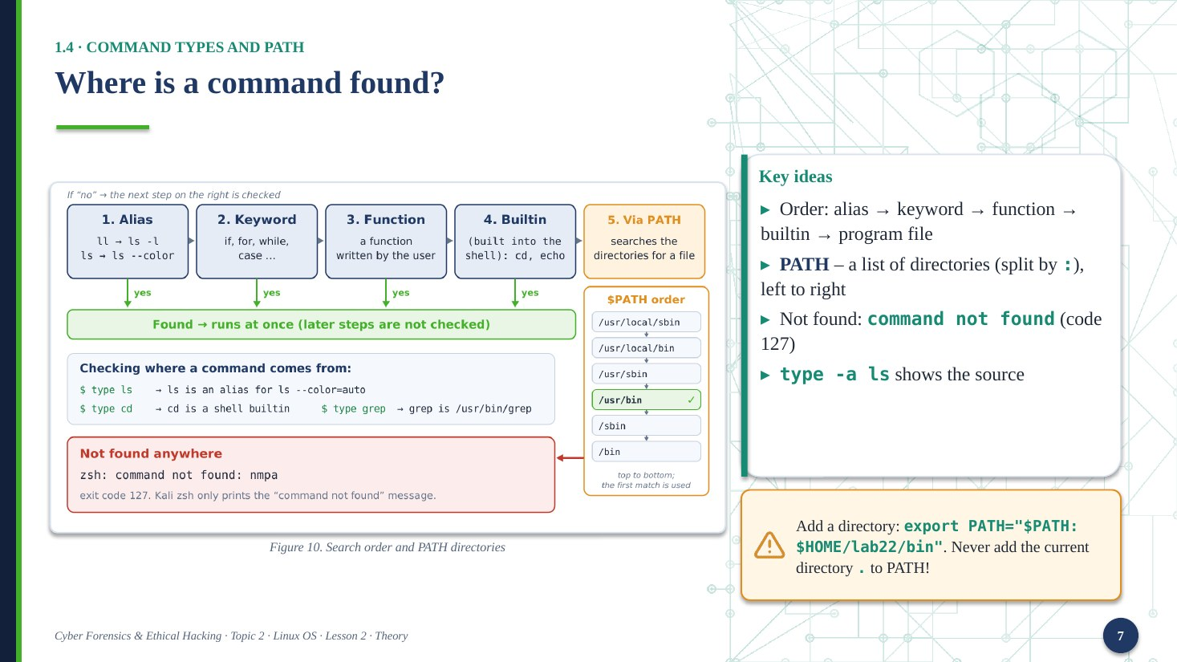
When you type ls, the shell must find this command. It looks in a strict order. First an alias, then a keyword, then a function, then a builtin command, and last a program file on the disk.
PATH is a variable. It is not a file. It is a list of directories, separated by a colon. The shell checks them from left to right and runs the first match.
If the shell finds nothing, you see: command not found. The exit code is 127.
You can add your own directory to PATH with the export command. But never add the current directory, the dot. A bad person could put a fake ls there. The command type dash a shows where a command comes from.
Key words: alias – qisqartma; builtin – ichki buyruq; directory – katalog; match – mos kelish

Slide 8. 1.5 Getting help
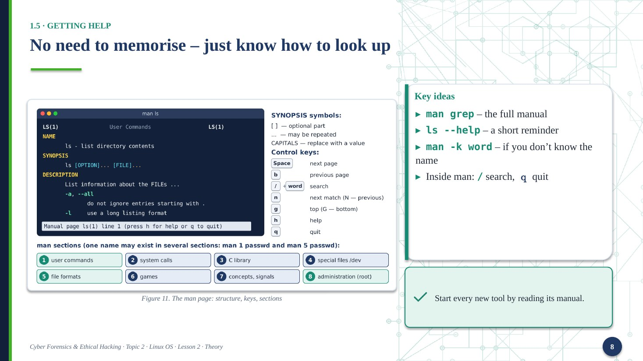
Linux has hundreds of commands. Nobody remembers all of them. The important skill is to find information quickly.
You have three main tools. First, man, the full manual. For example, man grep. Second, the help option: ls dash dash help shows a short reminder. Third, man dash k and a word. Use it when you do not know the name of the command.
Inside man, press slash to search, n for the next match, and q to quit.
My advice: when you meet a new tool, start by reading its manual.
Key words: manual – qo‘llanma; search – qidirish; quit – chiqish; reminder – eslatma

Slide 9. 1.6 Working fast
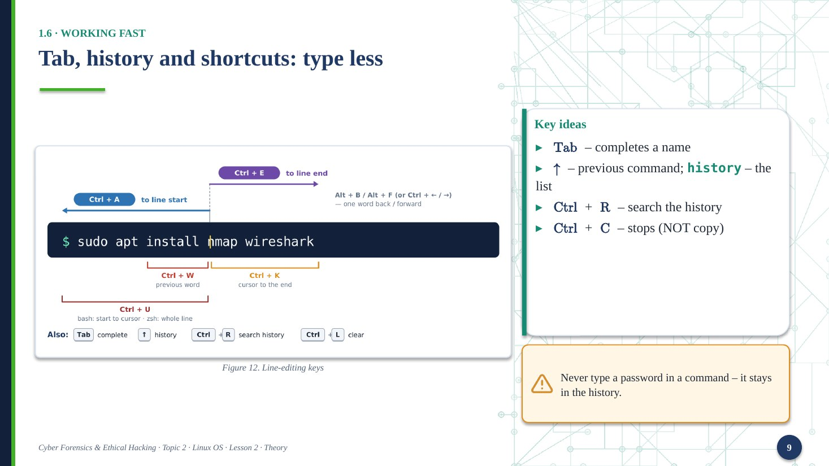
Professionals do not type a lot. They type little. Press Tab, and the shell completes the name for you. Press the up arrow, and you get your previous command. Press Control and R to search in your history.
A very important key is Control and C. In the terminal it does not copy. It stops the running command.
One warning. The history is saved in a file. So never type a password inside a command. It stays there in clear text. In forensics, this history file is one of the first things we check.
Key words: history – buyruqlar tarixi; complete – to‘ldirish; shortcut – tezkor tugma; password – parol

Slide 10. 1.7 Streams and redirection
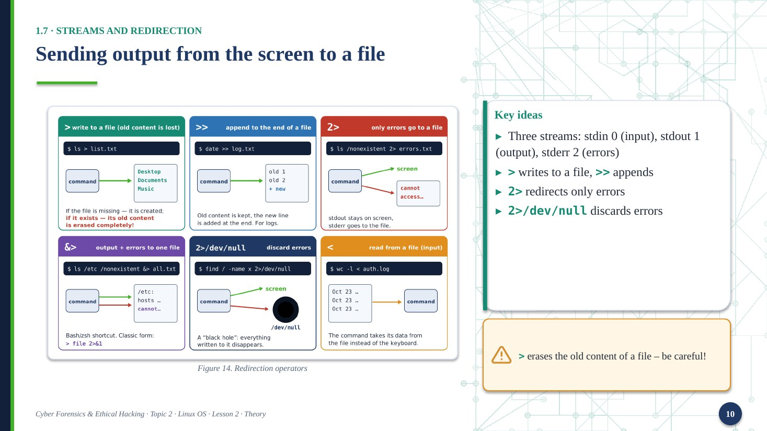
Every program has three standard streams. Stdin, number zero, is the input. Stdout, number one, is the normal output. Stderr, number two, is for error messages. On the screen, output and errors look the same, but they are separate streams.
Redirection means sending a stream to a file. The greater-than sign writes the output to a file. Be careful: it erases the old content. Two greater-than signs add text to the end of a file. The sign two and greater-than sends only errors. And two greater-than, slash dev slash null, throws errors away.
Please remember: one greater-than sign can destroy a file.
Key words: stream – oqim; redirection – yo‘naltirish; output – chiqish, natija; append – oxiriga qo‘shish

Slide 11. 1.8 Pipe and filters
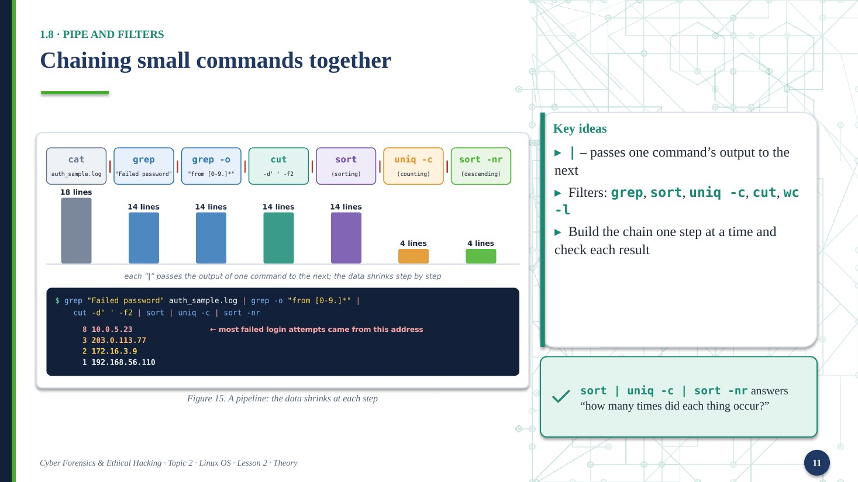
The vertical bar is called a pipe. It takes the output of one command and gives it to the next command. So we can connect small commands into a chain.
These are the main filters. Grep selects lines. Sort puts them in order. Uniq with dash c counts repeated lines. Cut takes a column. And wc dash l counts lines.
Look at the picture. We start with a log file. At each step, the data becomes smaller. At the end, we see which address tried to log in most often.
A good habit: build the chain step by step. Check the result after every step.
Key words: pipe – konveyer; filter – filtr; log file – jurnal fayli; chain – zanjir

Slide 12. 1.9 Combining commands
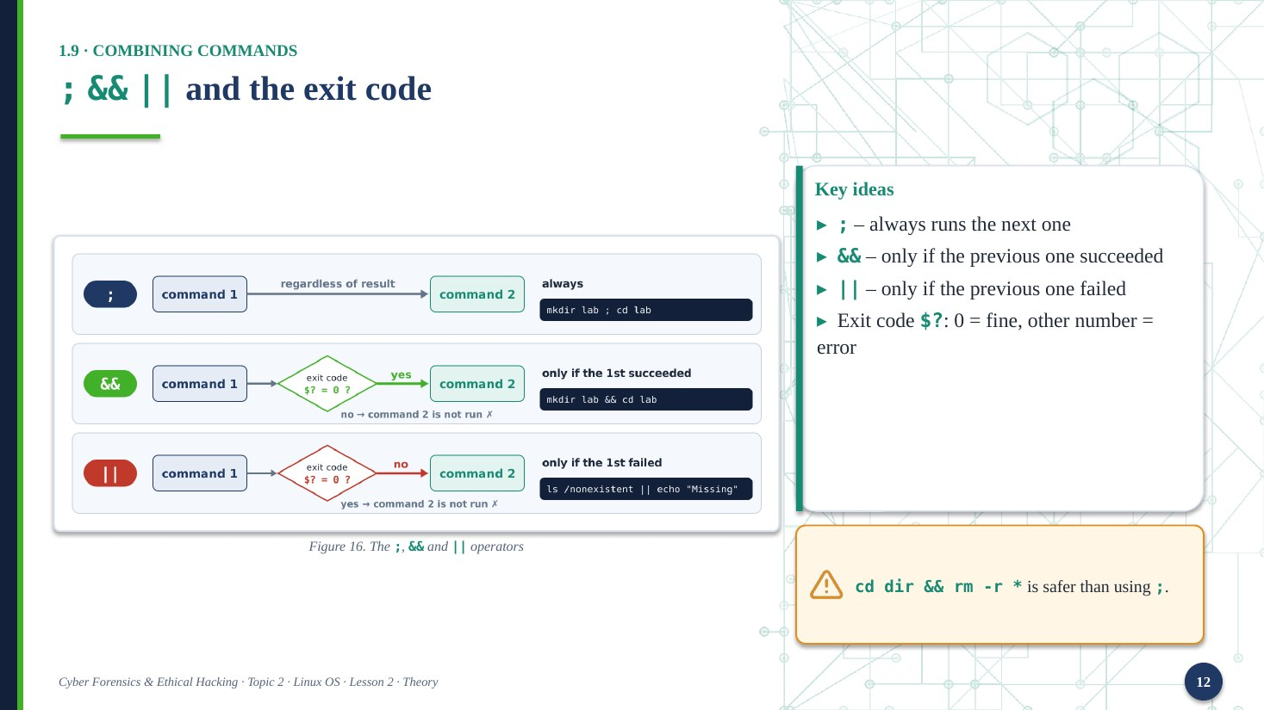
When a command finishes, it returns a number. This is the exit code. Zero means success. Any other number means an error. You can see the last code with dollar question mark.
Now three operators. The semicolon always runs the next command. Double ampersand runs the next command only if the first one succeeded. Double bar runs the next command only if the first one failed.
Some codes you should know. Zero is success. One is a general error. One hundred twenty-seven means command not found. One hundred thirty means you stopped it with Control and C.
For example, cd directory and-and rm is safer than using a semicolon.
Key words: exit code – chiqish kodi; success – muvaffaqiyat; failure – muvaffaqiyatsizlik; operator – operator

Slide 13. 1.10 Variables, aliases, config
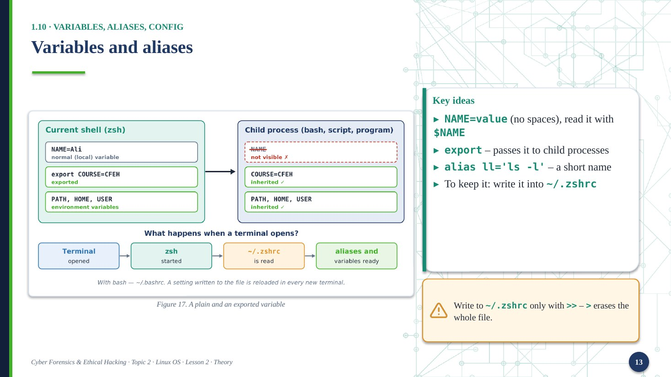
A variable stores a value under a name. You write the name, an equals sign, and the value. There must be no spaces around the equals sign. To read it, put a dollar sign before the name.
A normal variable lives only in the current shell. If you use export, child processes also get it. These are environment variables, like PATH, HOME and USER.
An alias is a short name for a long command. For example, ll for ls dash l.
These things disappear when you close the terminal. To keep them, write them into the file tilde slash dot zshrc. Always use two greater-than signs there, and make a backup copy first.
Key words: variable – o‘zgaruvchi; environment – muhit; alias – qisqa nom; backup – zaxira nusxa

Slide 14. 1.11 Processes and signals
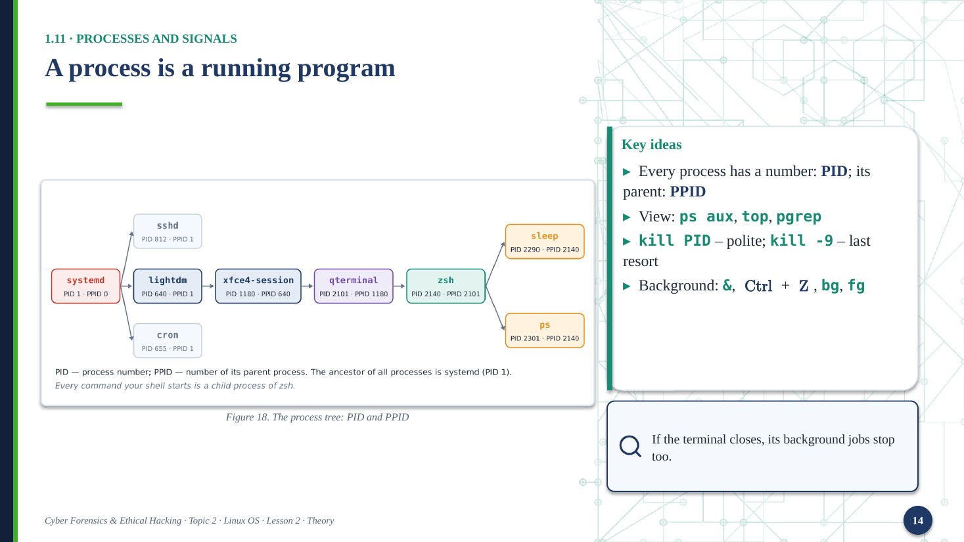
A process is a running program. Every process has a number, the PID. It also knows its parent, the PPID. At the top of the tree is systemd, with PID one.
To see processes, use ps aux, top, or pgrep. To stop a process, use kill and the PID. This sends a polite signal, SIGTERM: please finish your work. Kill dash nine sends SIGKILL. It ends the process at once, and the program cannot save anything. So use it only as a last resort.
You can also run a command in the background with the ampersand sign. Or press Control and Z to pause it. Then use bg or fg to continue it in the background or the foreground.
Key words: process – jarayon; signal – signal; parent – ota jarayon; background – fon rejimi

Slide 15. 1.12 Packages: apt and dpkg
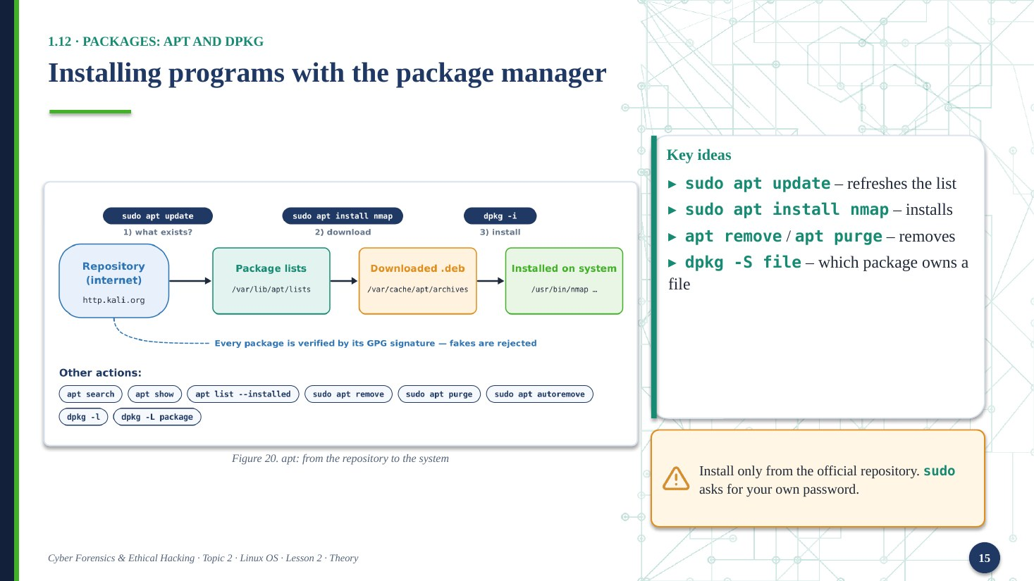
On Linux, we do not download installers from the internet. We use a package manager. In Kali it is apt. Programs are stored in a repository, and every package has a digital signature.
First, run sudo apt update to refresh the list. Then sudo apt install and the name of the program. To remove a program, use apt remove. Apt purge also deletes its settings.
Dpkg works at a lower level. For example, dpkg dash S and a file name tells you which package owns that file.
Sudo runs one command as root. It asks for your own password. You do not see the letters when you type it. This is normal.
Key words: package – paket; repository – repozitoriy; install / remove – o‘rnatish / o‘chirish; signature – imzo

Slide 16. 1.13 Services: systemd
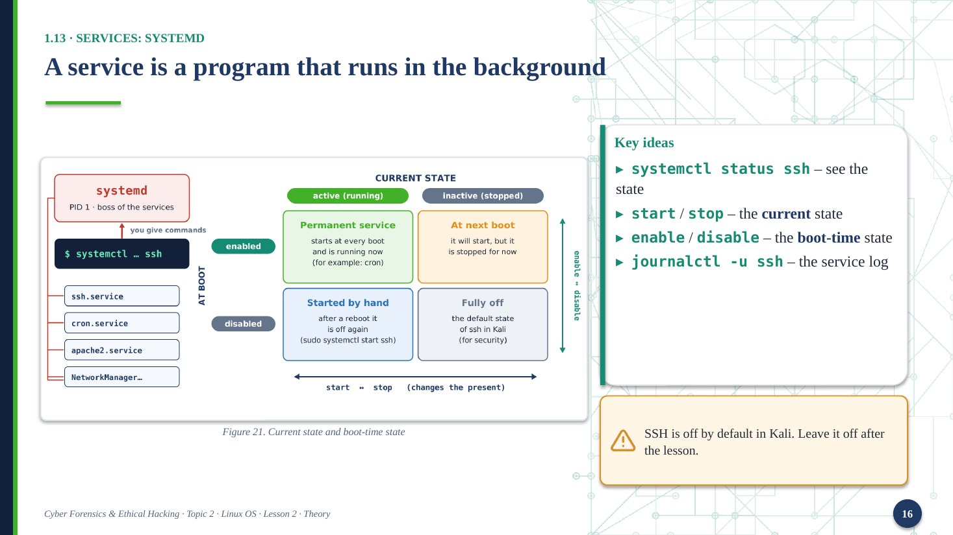
A service is a program that works in the background all the time. For example, an SSH server. In modern Linux, systemd manages the services, and we control them with the command systemctl.
A service has two separate states. The first is the current state: active or inactive. You change it with start and stop. The second is the boot state: enabled or disabled. You change it with enable and disable. So a service can be running now, but not start after a reboot.
To read the log of a service, use journalctl dash u and the service name.
In Kali, SSH is off by default. This is for security. Please leave it off after our lesson.
Key words: service – servis; state – holat; boot – yuklanish; log – jurnal

Slide 17. 1.14 Bash script
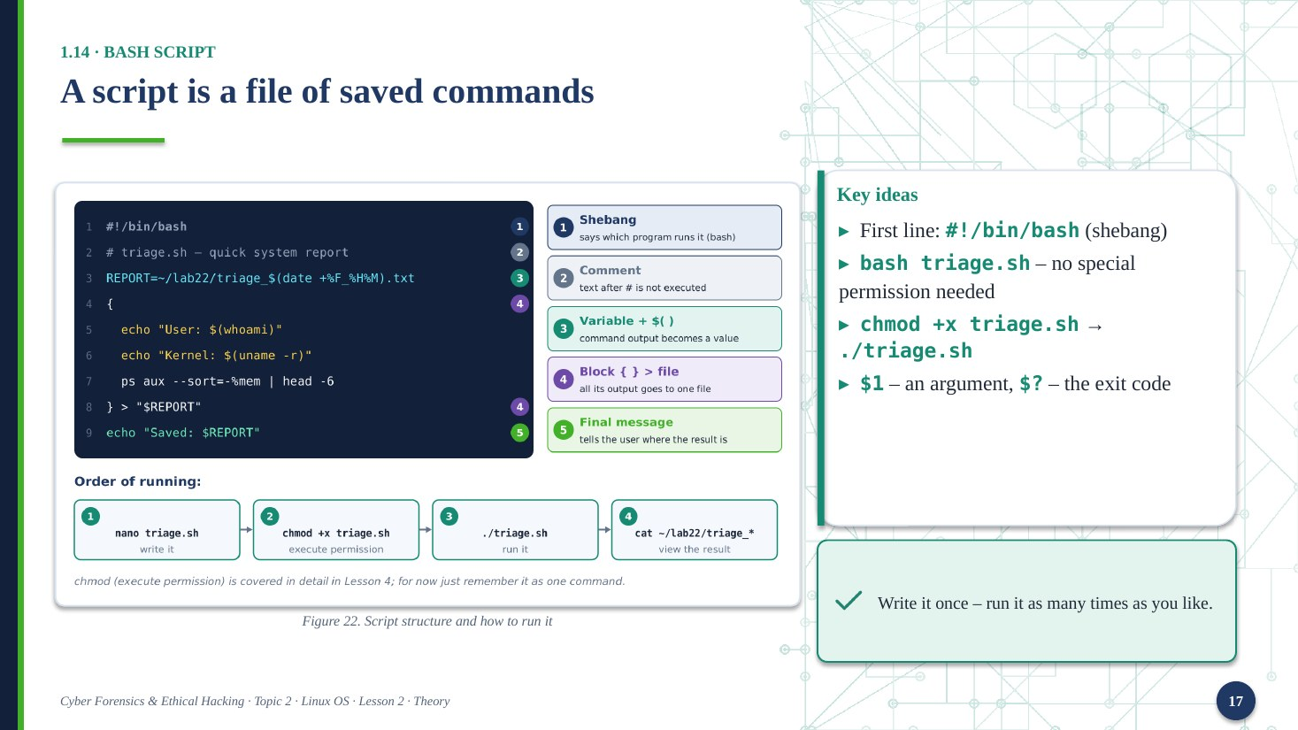
A script is a text file with commands. You write it once, and you can run it many times.
The first line is the shebang: hash, exclamation mark, slash bin slash bash. It tells the system which program must run the file. Lines that begin with a hash sign are comments.
There are two ways to run a script. First: bash and the file name. You do not need any special permission. Second: use chmod plus x to give execute permission, and then run dot slash and the file name.
Inside a script, dollar one is the first argument, and dollar question mark is the last exit code. In the practice, we will write a script that makes a quick system report.
Key words: script – skript; comment – izoh; permission – ruxsat (huquq); report – hisobot

Slide 18. Closing slide
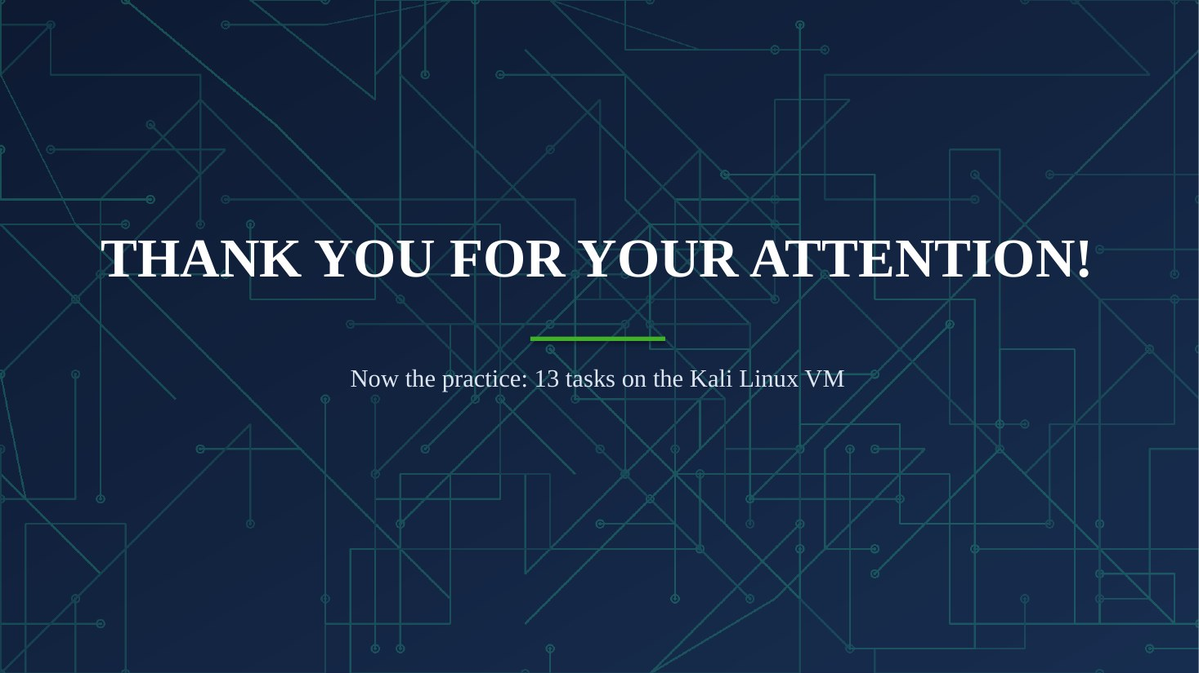
That is all for the theory. Let me repeat the main idea. The terminal is the window, and the shell understands the commands. Everything else, like pipes, variables, processes and services, helps us control the system from the keyboard.
Thank you for your attention. Now let us start the practical part. Open your Kali Linux virtual machine, take a snapshot, and begin with Task 1.
Key words: snapshot – snapshot (holat nusxasi); task – topshiriq; practical part – amaliy qism

