UNIVERSITY OF MILITARY SECURITY AND DEFENSE OF THE REPUBLIC OF UZBEKISTAN
INSTITUTE OF INFORMATION AND COMMUNICATION TECHNOLOGIES AND MILITARY COMMUNICATIONS
DEPARTMENT OF CYBERSECURITY
STUDY GUIDE AND PRACTICAL WORKBOOK
Course: "Cyber Forensics and Ethical Hacking"
TOPIC 2. LINUX OS
LESSON 3 (PRACTICAL, 4 HOURS)
Working in Linux OS:
RECON ACTIONS AND NETWORK TOOLS
Short theory and a workbook that every cadet completes independently
Tashkent – 2026

INTRODUCTION: ABOUT THE LESSON
Table 1. Lesson passport
Item | Information
Course | Cyber Forensics and Ethical Hacking
Topic | Topic 2. Linux OS
Lesson | Lesson 3. Working in Linux OS
Type and duration | Practical lesson · 4 hours (160 minutes)
Study questions | 1. Recon actions in Linux OS.  2. Nmap, Netcat, Traceroute, whois, dig.
Laboratory | Kali Linux (attacker machine) and Metasploitable (target) in VirtualBox, on one Host-only network
Prior knowledge | Lesson 2.2: terminal, pipe (|), redirection (>), grep, apt

Goal
To introduce the cadet to recon (gathering information about a target), the first stage of a cybersecurity assessment, and to teach how to collect information about the lab target with whois, dig, traceroute, nmap and nc.

Expected result - by the end of the lesson the cadet:
• distinguishes passive from active recon;
• finds information about a domain and an IP address with whois and dig;
• sees the path of a packet with traceroute;
• finds open ports, services and their versions on the target with nmap;
• connects to a port with nc and sees how a service introduces itself;
• saves the results to a file and writes a short report.

Table 2. Lesson time plan (2 pairs × 80 minutes = 160 minutes)
Part | Content | Time
PAIR 1 |  | 80 min.
I. Introduction | Attendance, safety rules, starting the virtual machines, preparation | 10 min.
II. Main part | Theory explanation (Part I) | 20 min.
 | Tasks 1–2: whois, dig, traceroute | 40 min.
III. Final part | Checking results, answering questions | 10 min.
PAIR 2 |  | 80 min.
I. Introduction | Recalling the previous pair, checking the virtual machines | 10 min.
II. Main part | Tasks 3–6: nmap, netcat, final report | 60 min.
III. Final part | Cleaning up the lab, control questions, homework | 10 min.

The most important rule
• Scanning is done only on your own lab target (Metasploitable).
• Scanning another computer or network without the owner’s written permission may be a crime.
• Metasploitable is a deliberately vulnerable system: never connect it to the internet or to a shared network.

How to work with this guide
• Part I - short theory. Read the relevant section before the task.
• Part II - the workbook. In each task: steps → place for a screenshot → fill in the table → conclusion.
• Do not type the $ sign in code blocks. Gray text after # is a comment.
• The IP addresses in the examples may differ on your machine - that is normal.

PART I. THEORY (BRIEFLY)
A security assessment always starts with information gathering: what the target is, where it is, and which services are running. This stage is called recon (reconnaissance). Today we study the five main tools of this stage.

1.1. Recon: passive and active
Passive recon gathers information without touching the target itself (whois, dig): the request goes to public databases or to a DNS server, not to the target. Active recon sends packets to the target and watches the reply (traceroute, nmap, nc): the target can see these attempts in its logs. That is why an assessment goes first with passive and then with active methods.
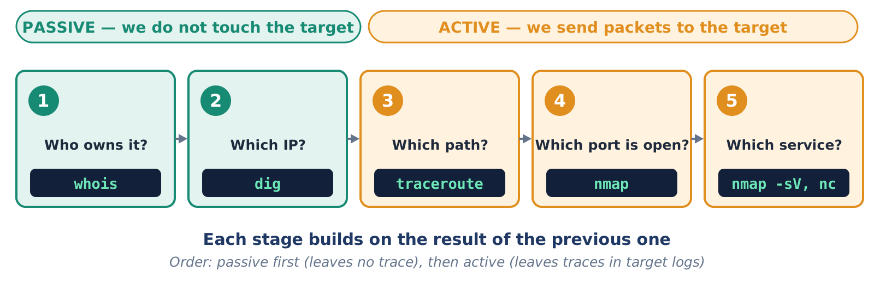
Figure 1. Recon stages and their tools
Table 3. Five tools - five questions
Tool | Question it answers | Type
whois | Who owns the domain or IP address? | Passive
dig | Which IP address does the domain have? Which are its mail and name servers? | Passive
traceroute | Which path does a packet take to the target? | Active
nmap | Which hosts are up? Which ports are open? Which service and version? | Active
nc (netcat) | How does a service introduce itself when we connect to its port? | Active

1.2. whois and DNS: dig
whois shows the organization that registered a domain, the registration date and the name servers. For an IP address it shows which provider or organization owns it. Many domains hide personal data (“REDACTED FOR PRIVACY”) - this is normal.
DNS is the system that turns a domain name into an IP address - “the phone book of the internet”. dig asks a DNS server for records. The record type says what kind of information you want.
Table 4. Main DNS records
Record | Meaning | Example
A | IPv4 address of the domain | dig +short example.com A
AAAA | IPv6 address of the domain | dig +short example.com AAAA
NS | Name servers responsible for the domain | dig +short example.com NS
MX | Mail servers | dig +short gmail.com MX
TXT | Text record (mail protection, verification) | dig +short example.com TXT
PTR | Reverse lookup: name from an IP address | dig -x 8.8.8.8 +short

1.3. traceroute: the path of a packet
Every IP packet has a TTL (Time To Live) field. Each router decreases the TTL by 1 before forwarding the packet; when the TTL reaches 0, the router drops the packet and sends back a “time exceeded” message (ICMP Time Exceeded). traceroute uses this: it sends packets with TTL=1, then TTL=2, then TTL=3 … and records which router answered each time.
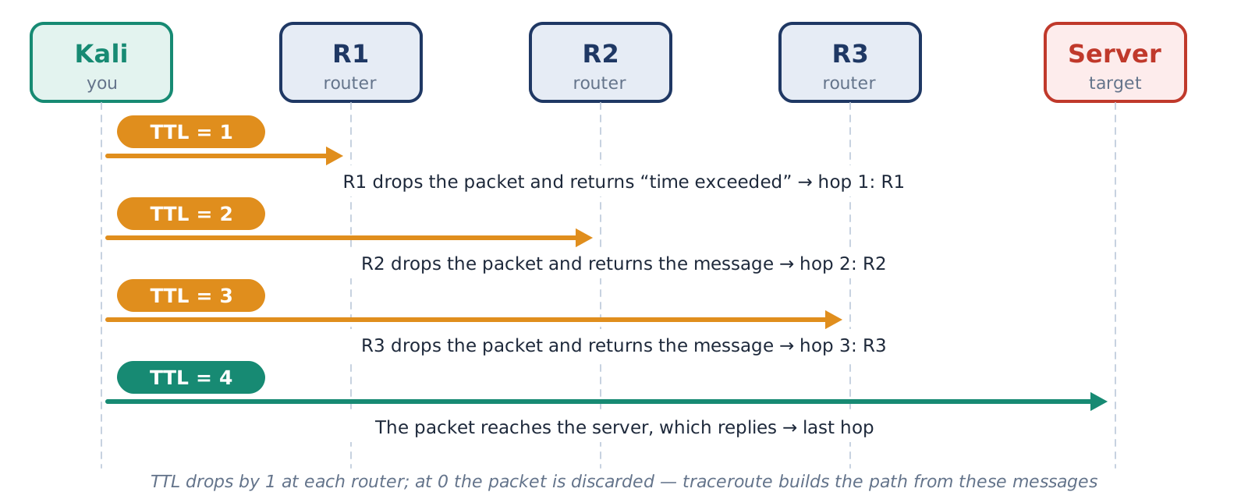
Figure 2. How traceroute finds the path using TTL
• * * * - no reply from this hop (the router does not answer or a firewall blocks it). It does not mean the path is broken.
• The number of hops and the routers may differ from time to time - this is normal.
• A target on the same network is usually one hop away.

1.4. nmap: scanning ports and services
nmap (Network Mapper) is the most popular scanning tool. A port is the “door” of a service on a computer (numbered 0 to 65535). For example, a web server waits on port 80 and SSH on port 22. Nmap tries to connect to a port and determines its state.
Table 5. Port states
State | Meaning
open | The port is open: a service is running and accepting connections
closed | The port is closed: the computer answers, but no service is there
filtered | No reply: a firewall blocks the packets, so nmap cannot determine the state

Table 6. Most common ports
Port | Service | Port | Service
21 | FTP - file transfer | 80 | HTTP - website
22 | SSH - secure remote access | 443 | HTTPS - protected website
23 | Telnet - old remote access | 445 | SMB - Windows file sharing
25 | SMTP - sending mail | 3306 | MySQL - database
53 | DNS | 3389 | RDP - Windows remote desktop

Table 7. Main nmap options
Option | What it does
-sn | Finds only live hosts, does not scan ports
-p 21,80 / -p- | Scans the listed ports / all 65535 ports
-F | Fast scan: the 100 most popular ports
-sV | Detects service name and version
-O | Guesses the operating system (needs sudo)
--open | Shows only open ports in the output
-oN file | Saves the result to a text file
-Pn | Does not check the host with ping (if ping is blocked)

If no options are given, nmap checks the 1000 most popular ports.

1.5. netcat (nc): connecting to a port by hand
nc (netcat) opens a simple TCP or UDP connection. It is called the “Swiss army knife of networking” because one tool does several jobs: checking a port, getting a service banner, and setting up communication between two computers. A banner is the introductory text a service sends when you connect; it usually contains its name and version (for example, 220 (vsFTPd 2.3.4)).
Table 8. Main nc options
Option | What it does
-z | Only checks whether the port is open, sends no data
-v | Prints verbose output
-n | Does not look up names (no DNS) - faster
-w 3 | Waits 3 seconds for a reply, then stops
-l | Waits for a connection (listens)
-p 4444 | Sets the port number

About nc in Kali
• Kali may have several versions of nc. Check the version with nc -h.
• The listen command is nc -lvnp 4444. If -p gives an error, write nc -lvn 4444.
• If it is missing: sudo apt install netcat-traditional.

PART II. PRACTICAL WORKBOOK

Preparation: setting up the lab
1. Start the Kali Linux and Metasploitable virtual machines in VirtualBox. Both must be on the same Host-only network.
2. In Kali take a snapshot named “Lesson-2.3 start” (Machine → Take Snapshot).
3. Open a terminal in Kali and check your address: ip -br a. In the example, Kali’s address is 192.168.56.102.
4. In Metasploitable (login msfadmin, password msfadmin) type ip a to find its address. In the example it is 192.168.56.101.
5. In Kali, store the target address in a variable and check connectivity:
$ export TARGET=192.168.56.101 # write your own target’s address
$ ping -c 3 $TARGET # send 3 packets
$ mkdir -p ~/lab23 && cd ~/lab23
Important
• If you do not know the Metasploitable address, type nmap -sn 192.168.56.0/24 in Kali (studied in Task 3) - the live hosts will be listed.
• whois, dig and traceroute need the internet: the NAT adapter of the Kali machine must also be enabled.
• If the terminal is closed, the TARGET variable is lost - type it again.

Task 1. whois and dig: information about a domain
Goal: Find public information about a domain and an IP address. · Time: 20 minutes · Theory: 1.2
1. View the domain owner and registration information:
$ whois example.com | head -20
$ whois example.com | grep -i -E "registrar|creation|name server"
$ whois 8.8.8.8 | grep -i -E "orgname|netname" # who owns the IP
2. Query DNS records:
$ dig example.com # full output
$ dig +short example.com A # IP address only
$ dig +short example.com NS # name servers
$ dig +short gmail.com MX # mail servers
$ dig -x 8.8.8.8 +short # name from IP
$ dig @8.8.8.8 example.com +short # ask server 8.8.8.8
3. In the output of dig example.com find the ANSWER SECTION - the A record is there.
▢ Screenshot 1. whois and dig results
(paste your own result screenshot here)

Table 9. Answer table
Question | Your answer
What is the IP address (A record) of example.com?
Which is one of the name servers of example.com?
Which is one of the mail servers of gmail.com?
Which organization owns the address 8.8.8.8?

Possible situations and errors
• whois: command not found - sudo apt install whois.
• connection timed out; no servers could be reached or Temporary failure in name resolution - no internet; check the NAT adapter in Kali.
• status: NXDOMAIN - no such domain exists (the name is misspelled).
• Empty output - there is no record of that type (for example, a domain may have no AAAA).
• REDACTED FOR PRIVACY - the owner’s data is hidden, this is normal.

Conclusion – Task 1
Meaning: whois shows registration information and dig shows DNS records. Neither touches the target (passive recon).
Where and when it is needed: At the start of an assessment, to identify an organization’s domains, servers and mail infrastructure. Knowing which IP addresses belong to the organization defines the scope of later scanning.

Task 2. traceroute: viewing the path of a packet
Goal: Find which routers a packet passes through on its way to the target. · Time: 20 minutes · Theory: 1.3
1. View the path to a domain on the internet:
$ traceroute -n example.com # -n: faster
$ traceroute -n -m 10 example.com # at most 10 hops
$ sudo traceroute -n -I example.com # using ICMP
2. See how TTL works yourself:
$ ping -c 2 -t 1 example.com # TTL=1: 1st router
$ ping -c 2 -t 2 example.com # TTL=2: 2nd router
3. View the path to the lab target:
$ traceroute -n $TARGET # same network: one hop
▢ Screenshot 2. Results of traceroute -n example.com and ping -t 1
(paste your own result screenshot here)

Table 10. Answer table
Question | Your answer
How many hops to example.com?
What is the address of the router at hop 1?
At which hops did * * * appear (if any)?
How many hops to $TARGET?

Possible situations and errors
• traceroute: command not found - sudo apt install traceroute.
• * * * - no reply from this hop; if later hops appear, the path works.
• All hops show * * * - a firewall blocks the path or there is no internet.
• !H, !N, !X marks - host or network unreachable, or rejected by a firewall.
• Time to live exceeded in the ping -t 1 output - this is the correct result, not an error.

Conclusion – Task 2
Meaning: traceroute sends packets with TTL=1, 2, 3 … and identifies each router on the path.
Where and when it is needed: Used to find where a network is broken, to understand which network a target sits in, and to guess where a firewall is.

Task 3. nmap: live hosts and open ports
Goal: Find the hosts on the network and the open ports on the target. · Time: 20 minutes · Theory: 1.4
1. Find live hosts on the network (first learn your own network with ip -br a):
$ nmap -sn 192.168.56.0/24 # /24 - 256 addresses are checked
2. Scan the ports on the target:
$ nmap $TARGET # 1000 most popular ports
$ nmap -p 21,22,80 $TARGET # only 3 ports
$ nmap -F $TARGET # fast scan
$ nmap -p- --open $TARGET # 65535 ports (1-3 min.)
▢ Screenshot 3. Results of nmap -sn and nmap $TARGET
(paste your own result screenshot here)

Table 11. Answer table
Question | Your answer
How many live hosts did nmap -sn find?
How many ports were open in the normal scan?
How many ports were open in the -p- --open scan?
Write 3 familiar ports and their services

Possible situations and errors
• Host seems down - the host is off or ping is blocked; add the -Pn option.
• All 1000 scanned ports are in ignored states - all ports are filtered: a firewall is present.
• You requested a scan type which requires root privileges - put sudo before the command.
• Failed to resolve - the name or address is misspelled; check with echo $TARGET.
• If the scan takes too long - stop it with Ctrl + C and shorten it with -F or -p.
• A line MAC Address ... (Oracle VirtualBox) in the output is normal: it is shown only for hosts on the same network.

Conclusion – Task 3
Meaning: nmap -sn finds live hosts and plain nmap finds open ports. Every open port is a running service, that is, a door through which the target can be reached.
Where and when it is needed: The main step of an assessment: you cannot defend an organization’s network without knowing which hosts and which ports are open.

Task 4. nmap: service, version and OS
Goal: Detect the service and version on open ports and save the result. · Time: 15 minutes · Theory: 1.4
$ nmap -sV $TARGET # service, version
$ nmap -sV -p 21,22,80 $TARGET # only 3 ports
$ sudo nmap -O $TARGET # OS guess
$ nmap -sV --open -oN ~/lab23/nmap_sv.txt $TARGET # save to file
$ grep -E "^[0-9]+/tcp +open" ~/lab23/nmap_sv.txt # open ports only
▢ Screenshot 4. nmap -sV result (PORT, STATE, SERVICE, VERSION columns)
(paste your own result screenshot here)

Table 12. Answer table: write at least 3 open ports
Port | Service | Version | Note
21
22
80

Possible situations and errors
• -O gives an approximate answer such as Running: Linux 2.6.X. An exact result is not guaranteed.
• OSScan results may be unreliable - nmap could not detect the OS reliably, this is normal.
• The VERSION column is empty or tcpwrapped - the service did not give its version.
• If -sV takes too long, reduce the ports with -p.

For cyber forensics
• A service with an old version (for example, an FTP or SSH released years ago) may have known vulnerabilities. That is why the version is always written in the report.
• Every nmap scan leaves traces in the target’s logs: a forensic examiner uses these traces to find out that scanning took place.

Conclusion – Task 4
Meaning: -sV detects the service name and version, -O detects the operating system, and -oN saves the result to a file.
Where and when it is needed: The version is used to look for vulnerabilities in the next stage. Saving the result to a file is needed for reporting and for later comparison.

Task 5. netcat: connecting to a port by hand
Goal: Check a port with nc, get a banner and set up simple communication. · Time: 15 minutes · Theory: 1.5
1. Check whether ports are open:
$ nc -zv $TARGET 21 22 80 23 # check four ports
$ nc -zv $TARGET 20-30 2>&1 | grep -E "succeeded|open" # range; 2>&1
2. Get the service banner:
$ nc -nv $TARGET 21 # FTP banner; QUIT
$ nc -nv $TARGET 22 # SSH banner; Ctrl+C
$ printf 'HEAD / HTTP/1.0\r\n\r\n' | nc -n -w 3 $TARGET 80 # web server
3. Set up communication between two terminals. In the first terminal, listen:
$ nc -lvnp 4444 # terminal 1: listens
4. Open a second terminal (new tab), connect and type some text:
$ nc -nv 127.0.0.1 4444 # terminal 2: connects
Hello # appears in terminal 1
5. Stop both terminals with Ctrl + C .
▢ Screenshot 5. Port checks, FTP/SSH banners and the two-terminal connection
(paste your own result screenshot here)

Table 13. Answer table
Port | Service | Text in the banner
21 | FTP
22 | SSH
80 | HTTP | Server: line

Possible situations and errors
• Connection refused - the port is closed (closed).
• The connection hangs and prints nothing - the port is filtered: a firewall blocks it. Exit with Ctrl + C .
• Address already in use - port 4444 is busy; choose another port (for example, 5555).
• invalid option -- 'p' - a different nc version: type nc -lvn 4444.
• nc: command not found - sudo apt install netcat-traditional.

Conclusion – Task 5
Meaning: With nc you can check a port and read the banner the service itself sends. The banner reveals the service name and version.
Where and when it is needed: Used to verify an nmap -sV result by hand, to see what runs on an unknown port, and to test network connectivity.

Task 6. Final: a short recon report
Goal: Combine what was learned in the lesson into a report about the target. · Time: 10 minutes · Theory: 1.1–1.5
1. Create the report file (we use { } and > from Lesson 2.2):
$ cd ~/lab23
$ { echo "RECON REPORT: $(date)"; echo "Target: $TARGET"; echo; nmap -sV --open $TARGET; } > report.txt
$ cat report.txt
2. Print the number and the list of open ports:
$ grep -cE "^[0-9]+/tcp +open" report.txt # count
$ grep -E "^[0-9]+/tcp +open" report.txt | tr -s ' ' | cut -d' ' -f1,3 # port and service
3. Write the 3 services you consider most noteworthy in the table and briefly give the reason:
Table 14. Report table
Port and service | Version | Why it is noteworthy

▢ Screenshot 6. Contents of report.txt and the list of open ports
(paste your own result screenshot here)

Possible situations and errors
• grep -c result is 0 - the target address is wrong or the scan stopped; check with cat report.txt.
• report.txt is empty - the } before > report.txt is missing or the braces are not closed.
• If $TARGET is empty, nmap gives an error: type export TARGET=... again.

Conclusion – Task 6
Meaning: When the results of the tools are collected in one file, the assessment becomes a report: target, time, open ports and versions.
Where and when it is needed: In a real assessment the report is handed to the client. In forensics, a result saved with a timestamp serves as evidence of the system’s state.

Restoring the lab to its previous state
1. Check that no nc processes are left running: pgrep -a nc; if any remain - pkill nc.
2. Save a copy of the report (if needed), then delete the directory: rm -r ~/lab23.
3. Remove the variable: unset TARGET.
4. The easiest way is to restore the “Lesson-2.3 start” snapshot in VirtualBox (Restore).
5. Shut down Metasploitable: it is a vulnerable system, do not leave it running when not in use.

PART III. ADDITIONAL INFORMATION

3.1. Common errors
Table 15. Error reference
Message | Cause | Solution
command not found | The tool is not installed | sudo apt install whois traceroute
Host seems down | The target is off or ping is blocked | Check with ping; add -Pn
requires root privileges | The scan type needs privileges | Put sudo before the command
Connection refused | The port is closed | Check the port number
No output | The port is filtered or the target is not answering | Ctrl + C ; try -w 3 or -Pn
The scan is very slow | All ports or -sV were selected | Shorten with -F or -p

3.2. Scanning leaves traces in the target’s logs
• Active recon (nmap, nc, traceroute) is visible in the target’s logs and firewall records. Passive recon (whois, dig) is not directly visible to the target.
• If a forensic examiner sees many port attempts from one address in a short time in a log, they treat it as a sign of scanning.
• That is why it is important to scan only authorized targets and to record what was done, with times.

CONTROL QUESTIONS
1. What is recon? What is the difference between passive and active recon? Give an example.
2. What are whois and dig used for? Why are they passive recon?
3. What do the DNS A, NS and MX records mean?
4. How does traceroute work? What is TTL?
5. How do the open, closed and filtered states differ in nmap?
6. What do the -sn, -F, -p-, -sV and -O options do?
7. What is a banner? How can it be obtained with nc, and why is it important?
8. Why must only authorized targets be scanned?

APPENDIX. QUICK REFERENCE
Table 16. Lesson commands on one page
Tool | Main commands
whois | whois domain, whois IP
dig | dig domain, dig +short domain A|NS|MX|TXT, dig -x IP +short, dig @server domain
traceroute | traceroute -n domain, traceroute -n -m 10 domain, sudo traceroute -n -I domain
nmap | nmap -sn network/24, nmap IP, nmap -p 21,80 IP, nmap -F IP, nmap -p- --open IP, nmap -sV IP, sudo nmap -O IP, nmap -oN file IP
nc | nc -zv IP port, nc -nv IP port, nc -lvnp port, nc -nv 127.0.0.1 port

REFERENCES AND SOURCES
1. Nishanov I.I., Xusenov M.J. Cyber Forensics and Ethical Hacking: Textbook. – Tashkent, 2024. – 390 p.
2. Nishanov I.I., Xusenov M.J. Cyber Forensics and Ethical Hacking: Study guide. – Tashkent, 2024. – 268 p.
3. Lyon G. Nmap Network Scanning: The Official Nmap Project Guide to Network Discovery and Security Scanning. – Sunnyvale: Insecure.Com LLC, 2009.
4. OccupyTheWeb. Linux Basics for Hackers. – San Francisco: No Starch Press, 2018. – 248 p.
5. Nmap Reference Guide. https://nmap.org/book/man.html
6. Kali Linux official documentation. https://www.kali.org/docs/
7. Linux man pages. https://man7.org/linux/man-pages/

