MILITARY SECURITY AND DEFENCE UNIVERSITY OF THE REPUBLIC OF UZBEKISTAN
INSTITUTE OF INFORMATION AND COMMUNICATION TECHNOLOGIES AND MILITARY COMMUNICATIONS
DEPARTMENT OF CYBERSECURITY
INDEPENDENT STUDY ASSIGNMENT
“Cyber Forensics and Ethical Hacking” course
5th semester
Task 1. Analysis of Windows OS services
(Deadline: 28.10.2026)

Tashkent — 2026

1. What this task is about
In the Windows operating system many services run in the background — for example, printing, updates, antivirus. Each service runs under a certain account, through a certain file, and at a certain privilege level. If a service is misconfigured, it can become a way into the system. A cybersecurity specialist must therefore be able to read services, see the weak point in them, and make the right decision.
In this task you will: examine the Windows services given in your variant, assess their security, do hands-on practice on a special “test service”, and write a reasoned conclusion for each service. The work is done on a Windows virtual machine; its volume is 8 hours.
The overall order of work is as follows — the parts are done in exactly this sequence:
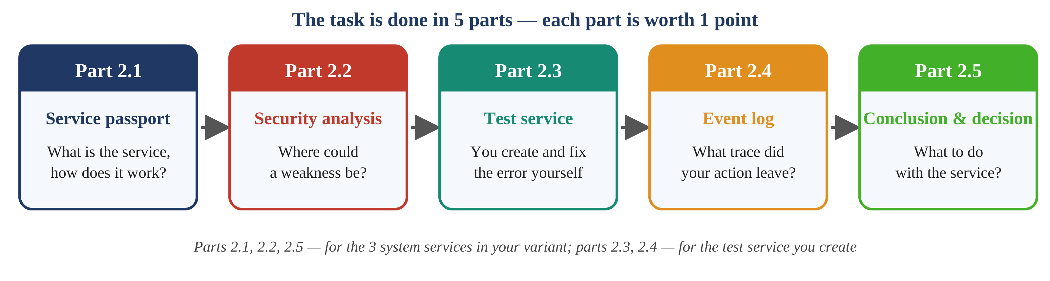
Figure 1. The five parts of the task and the order of work

1.1. How to find your variant
Your variant number is your roll number in the register. If your number is greater than 15, divide it by 15 and take the remainder: student 16 — variant 1, student 17 — variant 2; if the remainder is 0 — variant 15. Find your variant in the table in Section 3. It gives you 3 system services and 1 test service.

1.2. Before you start
Safety precautions — read carefully
• Do the work on a Windows virtual machine. Before you start, take a snapshot — if something goes wrong, you can roll back.
• On the real system services perform read-only actions: do not stop, delete or change their settings. You only inspect them.
• Change and delete actions are performed only on the test service you create yourself (Part 2.3).

cmd and PowerShell — which one
• Commands that start with sc are run in Command Prompt (cmd) with Administrator rights: press Win , type cmd, right-click it and choose “Run as administrator”.
• Search and analysis commands such as Get-CimInstance, Get-Acl are run in PowerShell (also open it as Administrator).
• Note: in PowerShell sc is an alias for another command, so sc commands work only in cmd.

1.3. Assessment
The task is graded on a 5-point scale. Each part in Section 2 that is fully completed and explained during the defence earns 1 point (5 parts, 5 points). For a part to count, it must be done for all three system services in your variant.
The report is submitted as a Word or PDF file (format in Section 4) and defended orally (questions in Section 5).

2. Task parts
The following 5 parts are done in order. Each part first shows what you do, then why it is needed, then the steps, and finally what goes into the report.

2.1. Service passport (1 point)
What you do: for each system service in your variant (3 of them) determine its main attributes and fill in the table below.
Why it is needed: before assessing a service you must identify it — through which file, under which account, in which mode it runs. This “passport” is the basis for the following parts.
Steps: for each service run the commands below (replace name with the service name, e.g. EventLog) and fill in the “Value” column. Take a screenshot of each command result.
Attribute | How to determine it | Value (you fill in)
Service name | sc query name
Display name and description | services.msc → double-click the service
Executable (BINARY_PATH_NAME) | sc qc name
Start type (START_TYPE) | sc qc name
Account (SERVICE_START_NAME) | sc qc name
Dependencies (DEPENDENCIES) | sc qc name
Current state and PID | sc queryex name
Which process it runs in | tasklist /svc /fi "services eq name"
The service’s purpose (2 sentences, your own words) | Based on the description and your observation

Tip: what svchost.exe is
Many services turn out to have svchost.exe as their file. This is a “host” that runs several services together in one process. You find which service runs in which process through the PID number in the tasklist /svc command.

2.2. Security analysis (1 point)
What you do: check each service against 6 questions from a security point of view.
Why it is needed: how much risk a service poses depends on its privilege, the location of its file, and its exposure to the network. First, two key concepts.
First concept — the service account
Each service runs under a certain account. The account sets the service’s privilege level in the system:
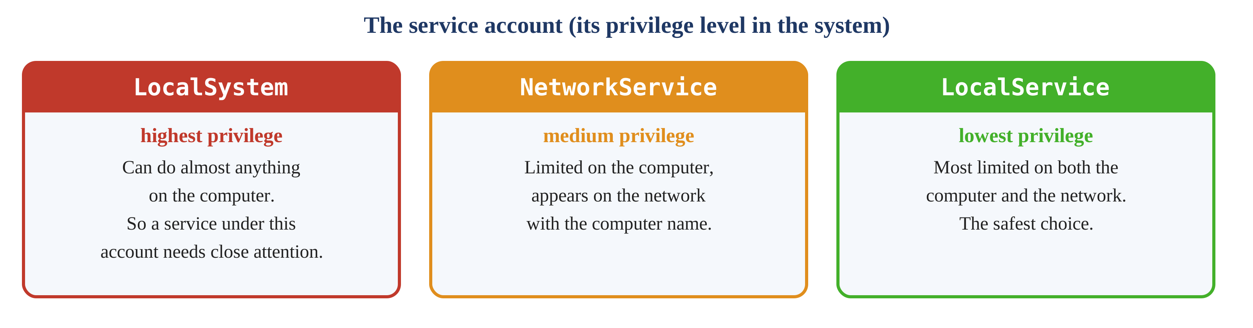
Figure 2. The three main service accounts and their privilege levels
Second concept — the unquoted path
If the path to the service file contains a space but the path is not enclosed in quotation marks, Windows searches for the file in several stages. This misconfiguration is called an “unquoted service path”:
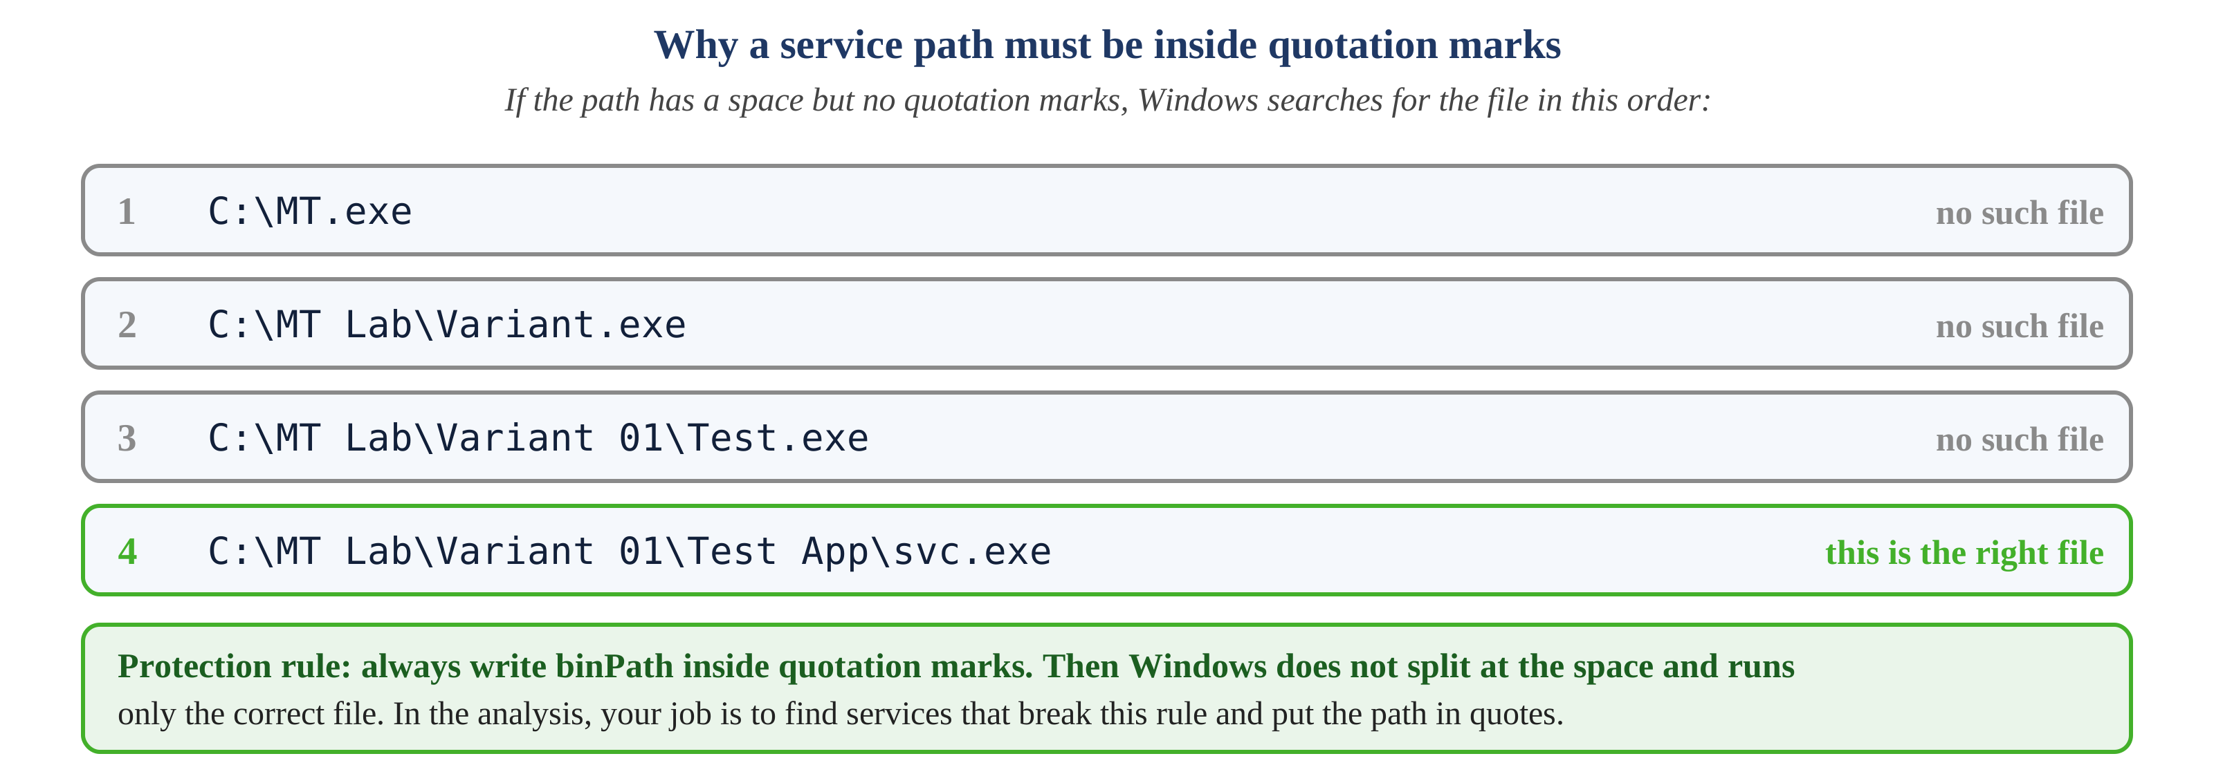
Figure 3. How Windows reads an unquoted path and the rule for correct configuration
Now — the analysis questions
Answer the following 6 questions for each service. Add the command result (screenshot) and a 1–2 sentence note to each answer.
1) Account. Which account does the service run under (see Figure 2)? Is that privilege level necessary for its job, or would a lower-privilege account be enough?
2) File permissions. Can an ordinary user (the Users group) modify the service file and the folder it is in? Answer: safe or needs attention — with the reason.
3) Path. Is the service path inside quotation marks or not (see Figure 3)? Is there a space?
4) Network. Does the service listen on any network port or not? Is a connection from outside possible?
5) Known risk. Find at least one known vulnerability (CVE number) or MITRE ATT&CK technique related to the service and describe it in 2–3 sentences. Give the source link.
6) Protection. Write 2–3 concrete measures that reduce the risk.
Commands that help the analysis (PowerShell; replace EventLog with your own service):
Get-CimInstance Win32_Service -Filter "Name='EventLog'" |
Select-Object Name, StartName, PathName, StartMode, State

icacls "C:\Windows\System32\svchost.exe" # file permissions (for question 1)
tasklist /svc /fi "services eq EventLog" # PID and process
netstat -ano | findstr <PID> # which port this PID uses (question 4)

Tip: for services inside svchost
The real code of a service whose file is svchost.exe lives in a separate library (DLL). You find it in the ServiceDll value under HKLM\SYSTEM\CurrentControlSet\Services\<name>\Parameters, and you check question 2 (file permissions) for exactly that DLL file.

2.3. Hands-on work on the test service (1 point)
What you do: you create one “test service” yourself, find the unquoted-path error in it, fix it, and finally delete it.
Why it is needed: you examine the “unquoted path” concept from Part 2.2 with your own hands, safely, without touching a real service. The test service’s name, account and start type are in the table in Section 3. Replace NN with your variant number (e.g. 01, 07, 15).
1) Create the test service. A space after the = sign is required. obj= value: for LocalSystem use LocalSystem; for LocalService use "NT AUTHORITY\LocalService"; for NetworkService use "NT AUTHORITY\NetworkService".
sc create MT_Test_NN binPath= "C:\MT Lab\Variant NN\Test App\svc.exe" start= <demand or auto> obj= <account> DisplayName= "MT Test Service NN"

2) Show the configuration: sc qc MT_Test_NN. Note that the path in the BINARY_PATH_NAME line is unquoted. Take a screenshot.
3) In PowerShell, search for unquoted paths that contain a space:
Get-CimInstance Win32_Service |
Where-Object { $_.PathName -notlike '"*' -and $_.PathName -like '* *' } |
Select-Object Name, PathName

MT_Test_NN should appear in the list. If other services also appear, read their paths carefully: in entries like svchost.exe -k ... the space comes after the file (in the parameters) and poses no risk. Separate out the entries that are genuinely risky (the space is in the file name itself).
4) Windows splits an unquoted path at the spaces and, adding .exe to each fragment, checks them one by one (Figure 3). For your path, write the 4 file names it checks, in order. Do not create the files — only list them.
5) Fix the path by enclosing it in quotation marks, then repeat the search from step 3 — MT_Test_NN should no longer appear.
sc config MT_Test_NN binPath= "\"C:\MT Lab\Variant NN\Test App\svc.exe\""

6) Try to start it: sc start MT_Test_NN. It fails because the file does not exist — write the error code and its meaning.
7) Change the start type: sc config MT_Test_NN start= disabled, then try sc start again. How does the error code differ from before?
8) When finished, delete it: sc delete MT_Test_NN and confirm it is gone with sc query MT_Test_NN. (The log entries remain after deletion — you will need them in Part 2.4.)

2.4. Event log (1 point)
What you do: find what trace your actions from Part 2.3 left in the Windows log.
Why it is needed: every service action is written to the log. In cyber forensics it is exactly these traces that reveal what happened on the system. Condition: this part is done after Part 2.3.
1) Win + R → eventvwr.msc → Windows Logs → System. Using “Filter Current Log” on the right, select Service Control Manager in the Event sources field.
2) Event 7045 (“A service was installed in the system”) — written when MT_Test_NN was created. Copy the Service Name, Service File Name, Service Type, Start Type and Account fields into the report.
3) Event 7040 — when the start type was changed (step 7 of Part 2.3). Write the old and new values.
4) Event 7000 — when the service failed to start (file not found). Write the error text.
5) For one of the system services in your variant, find event 7036 (state changed: running/stopped) and write the last entry. If there is none, state the reason.
6) In 2–3 sentences, explain why event 7045 is an important trace for determining what was installed on the system.

2.5. Conclusion and decision (1 point)
What you do: reach a final decision for each system service and justify it.
Why it is needed: analysis is not an end in itself — in the end you must make a practical decision on “what to do with this service”. The decision is written separately for two environments, because one service may be unneeded on a workstation but required on a server.
Possible decisions: Keep · set to Manual · Disable · restrict (firewall, lower-privilege account, tightened permissions). Use the analysis from Part 2.2 as the basis. Before disabling a service, check the services that depend on it (the “Dependencies” from Part 2.1).
Service | On a workstation | On a server | Reasoning (2–3 sentences)

3. Table of variants
Find your variant by your number. Each variant has 3 system services (for Parts 2.1, 2.2, 2.5) and 1 test service (for Parts 2.3, 2.4). The services are arranged by importance: the earlier variants have the most essential services, the later ones the less used.
Var. | Service 1 | Service 2 | Service 3 | Test service: name · account · type
01 | EventLog (Windows Event Log) | Dnscache (DNS Client) | WinRM (Windows Remote Management) | MT_Test_01 · LocalSystem · start= demand
02 | WinDefend (Microsoft Defender Antivirus Service) | W32Time (Windows Time) | Spooler (Print Spooler) | MT_Test_02 · LocalService · start= auto
03 | LanmanServer (Server) | BITS (Background Intelligent Transfer Service) | RemoteRegistry (Remote Registry) | MT_Test_03 · NetworkService · start= demand
04 | Winmgmt (Windows Management Instrumentation) | wuauserv (Windows Update) | SSDPSRV (SSDP Discovery) | MT_Test_04 · LocalSystem · start= auto
05 | Schedule (Task Scheduler) | TermService (Remote Desktop Services) | Themes (Themes) | MT_Test_05 · LocalService · start= demand
06 | Dnscache (DNS Client) | WinRM (Windows Remote Management) | EventLog (Windows Event Log) | MT_Test_06 · NetworkService · start= auto
07 | W32Time (Windows Time) | Spooler (Print Spooler) | WinDefend (Microsoft Defender Antivirus Service) | MT_Test_07 · LocalSystem · start= demand
08 | BITS (Background Intelligent Transfer Service) | RemoteRegistry (Remote Registry) | LanmanServer (Server) | MT_Test_08 · LocalService · start= auto
09 | wuauserv (Windows Update) | SSDPSRV (SSDP Discovery) | Winmgmt (Windows Management Instrumentation) | MT_Test_09 · NetworkService · start= demand
10 | TermService (Remote Desktop Services) | Themes (Themes) | Schedule (Task Scheduler) | MT_Test_10 · LocalSystem · start= auto
11 | WinRM (Windows Remote Management) | EventLog (Windows Event Log) | Dnscache (DNS Client) | MT_Test_11 · LocalService · start= demand
12 | Spooler (Print Spooler) | WinDefend (Microsoft Defender Antivirus Service) | W32Time (Windows Time) | MT_Test_12 · NetworkService · start= auto
13 | RemoteRegistry (Remote Registry) | LanmanServer (Server) | BITS (Background Intelligent Transfer Service) | MT_Test_13 · LocalSystem · start= demand
14 | SSDPSRV (SSDP Discovery) | Winmgmt (Windows Management Instrumentation) | wuauserv (Windows Update) | MT_Test_14 · LocalService · start= auto
15 | Themes (Themes) | Schedule (Task Scheduler) | TermService (Remote Desktop Services) | MT_Test_15 · NetworkService · start= demand

4. How to prepare the report
- On the title page: surname, first name, group, variant number.
- At the start of the report put the output of the hostname and whoami commands (to show the work was done on your own VM).
- Arrange the sections in the order of the parts: 2.1, 2.2, 2.3, 2.4, 2.5.
- For each command give the result as both a screenshot and text; the command itself must be visible in the screenshot.
- Write the answers in your own words. If identical text or results are found with another student, the work will not be accepted.

5. Defence questions
The following questions are asked at the defence. Be ready for them:
- How do the LocalSystem, LocalService and NetworkService accounts differ in privilege?
- What is an unquoted service path and why does it need attention?
- When several services run inside svchost.exe, how do you determine which service is in which process?
- What does event 7045 indicate and why is it important?
- What must be checked before disabling a service?

