MILITARY SECURITY AND DEFENSE UNIVERSITY OF THE REPUBLIC OF UZBEKISTAN
INSTITUTE OF INFORMATION AND COMMUNICATION TECHNOLOGIES AND MILITARY COMMUNICATIONS

“CYBERSECURITY” DEPARTMENT

STUDY GUIDE

“Cyber Forensics and Ethical Hacking” course

TOPIC 1
WINDOWS OS SECURITY

Tashkent — 2026
“Cyber Forensics and Ethical Hacking” course
TOPIC 1
WINDOWS OS SECURITY
This guide explains all four lessons of the “Windows OS Security” topic (Lesson 1 – lecture, Lesson 2 – seminar, Lessons 3 and 4 – practicals) without requiring any prior knowledge. Each section consists of: (1) a theoretical explanation, (2) a diagram or table that makes it easier to understand, (3) its practical significance, and (4) review questions at the end. A cadet who reads the guide to the end will understand the main security mechanisms of the Windows operating system (services, UAC, AppLocker, SmartScreen, Defender, Firewall, user and security policies) and will be able to configure them in practice.
General structure of the topic
• Lesson 1 (Lecture, 2 hours): Characteristics and functions of services and how to start them;
• Lesson 2 (Seminar, 2 hours): The UAC, AppLocker, SmartScreen, Defender and Firewall security systems;
• Lesson 3 (Practical, 4 hours): Configuring the UAC, AppLocker and SmartScreen security systems in practice;
• Lesson 4 (Practical, 4 hours): Configuring security settings and user security.
Why does this topic matter? In cybersecurity, almost every attack and defense action happens at the operating-system level. Once an intruder gets into a system, the first things they run into are its services and security mechanisms — UAC, Defender, Firewall; conversely, the defender (Blue Team) and the forensic investigator detect the attack precisely through the logs and settings of these same mechanisms. That is why this topic is the foundation for all the following topics (virology, network monitoring, ethical hacking).
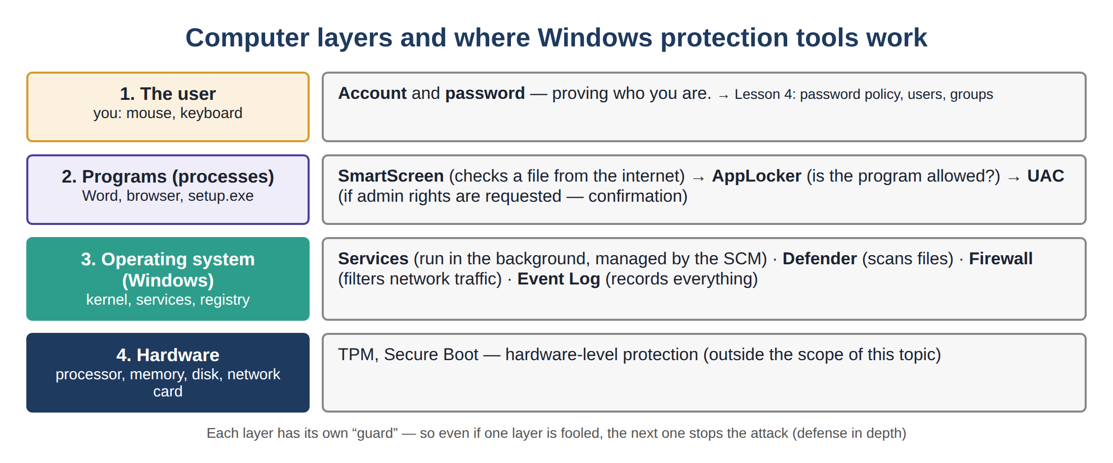
Figure 1. Computer layers and where Windows protection tools sit
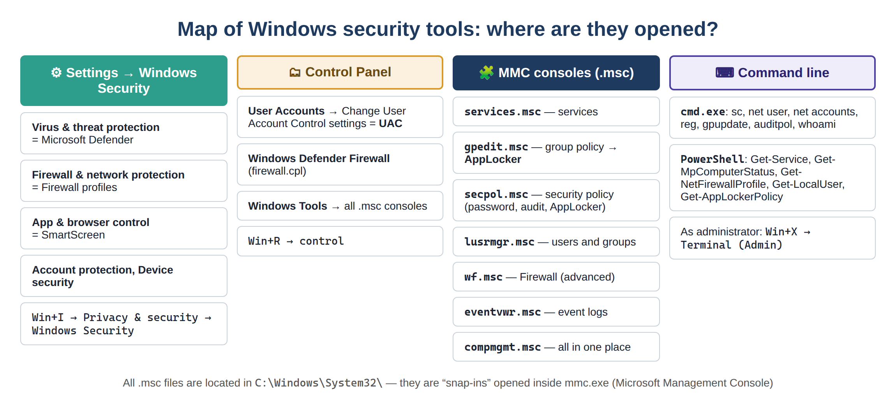
Figure 2. Map of Windows security tools: where each one is opened
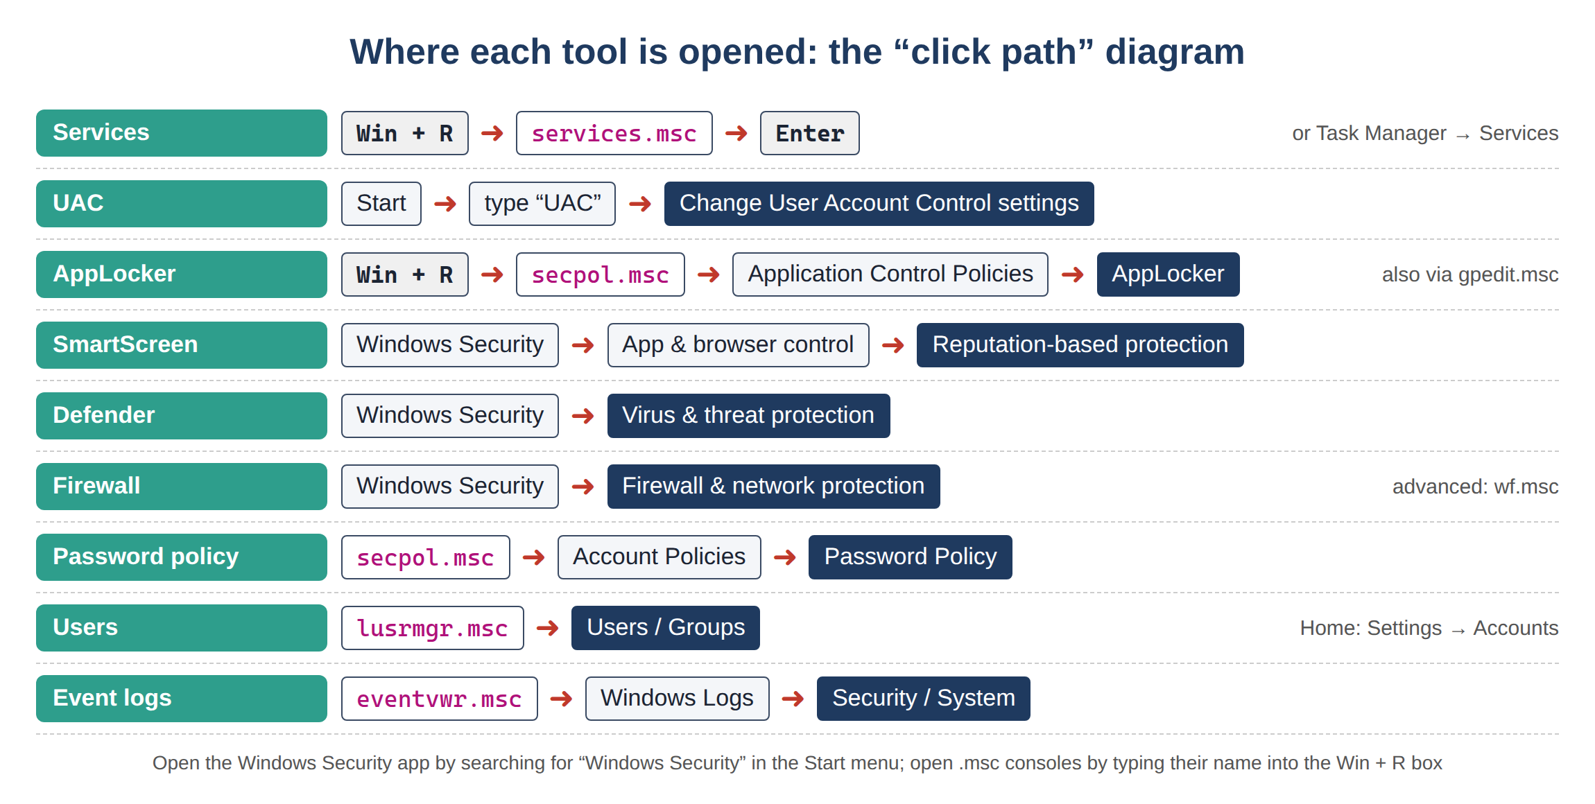
Figure 3. The click path to open each tool (diagram)
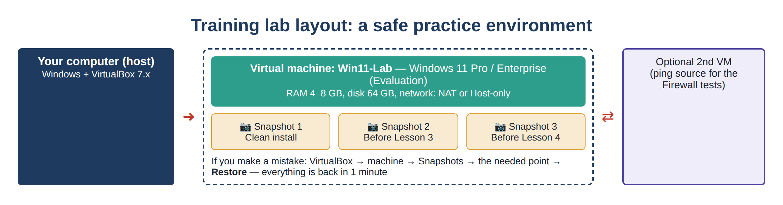
Figure 4. Training lab layout: virtual machine and snapshots

Contents
Lesson 0. Before you begin: key concepts and preparation
Lesson 1. Windows OS Services (Lecture)
Question 1. Characteristics and functions of services
Question 2. Starting services
Lesson 2. Windows OS Services (Seminar)
Question 1. The UAC, AppLocker and SmartScreen security systems
Question 2. The Defender and Firewall security systems
Lesson 3. Windows OS Services (Practical)
Question 1. Configuring User Account Control (UAC) in practice
Question 2. Configuring AppLocker and SmartScreen in practice
Lesson 4. Windows OS Services (Practical)
Question 1. Configuring security settings (Local Security Policy)
Question 2. Configuring user security
Conclusion
Glossary
References and sources

Lesson 0. Before you begin: key concepts and preparation
This section is the “zero step” before the main topic begins. A student who reads it will know where to find each tool used in the following lessons, how to open it, and where in Windows it lives. So later, when names such as services.msc, AppLocker, SmartScreen appear, the question “where did this come from?” will not arise.
0.1. Which editions does Windows come in, and why does it matter?
Windows comes in several editions (edition), and they differ in their capabilities. Most importantly, some of the tools in this topic exist only in the higher editions. For example, AppLocker and gpedit.msc (Local Group Policy Editor) do not exist at all in the Home edition. That is why you need to know your Windows edition before doing the practical lessons.
To check the edition: press Win + R , type winver and press Enter — the window that opens shows the Windows edition (for example “Windows 11 Pro”).
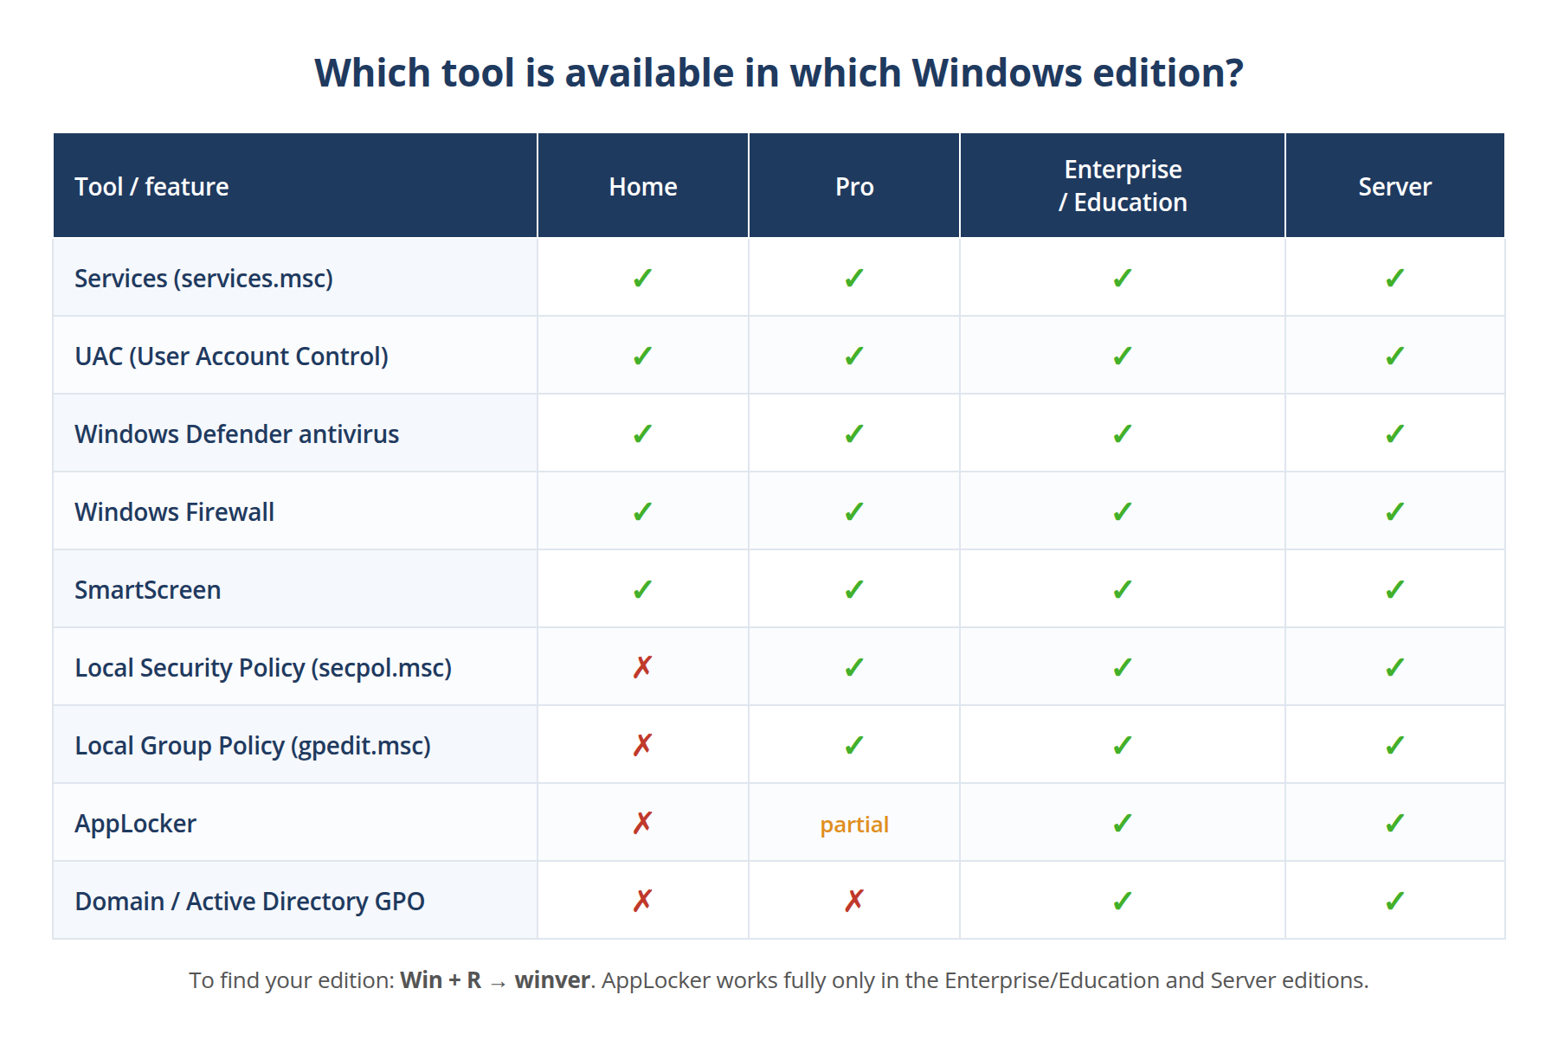
Figure 5. Which security tool is available in which Windows edition
Recommendation for the lab
To complete this topic in full, Windows 11 Pro or Enterprise is recommended (in a virtual machine). The Home edition has no secpol.msc, gpedit.msc or AppLocker, so some tasks in Lessons 3 and 4 cannot be done on it.
0.2. The five “doors” for configuring Windows
In Windows, a single setting can often be reached in several ways. These ways fall into five main groups — once you know them, you can find any tool:
- MMC consoles (.msc files): “deep” settings such as services, security policy and logs. To open: Win + R → for example services.msc.
- The Settings app: modern, simplified settings (user accounts, updates). To open: Win + I .
- Control Panel: the classic control panel (Firewall, User Accounts). To open: Win + R → control.
- The Windows Security app: all protection tools in one place (Defender, Firewall status, SmartScreen). To open: search the Start menu for Windows Security.
- Command line (PowerShell / cmd): for automation and quick actions (sc, net user, gpupdate).
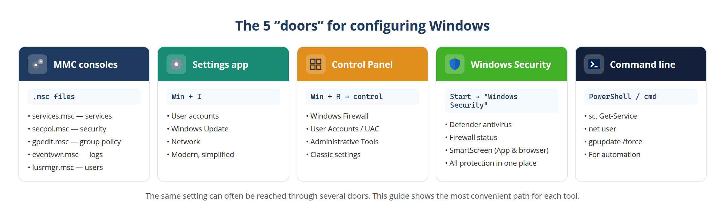
Figure 6. The five main ways (“doors”) to configure Windows
0.3. What are MMC and “.msc”? Why do all consoles look the same?
In the following lessons, names such as services.msc, secpol.msc, gpedit.msc, eventvwr.msc, lusrmgr.msc come up often. All of them are built on one common base — MMC (Microsoft Management Console). MMC is an empty “frame” into which a module called a snap-in is loaded. Each .msc file is a ready-made console prepared with exactly one snap-in.
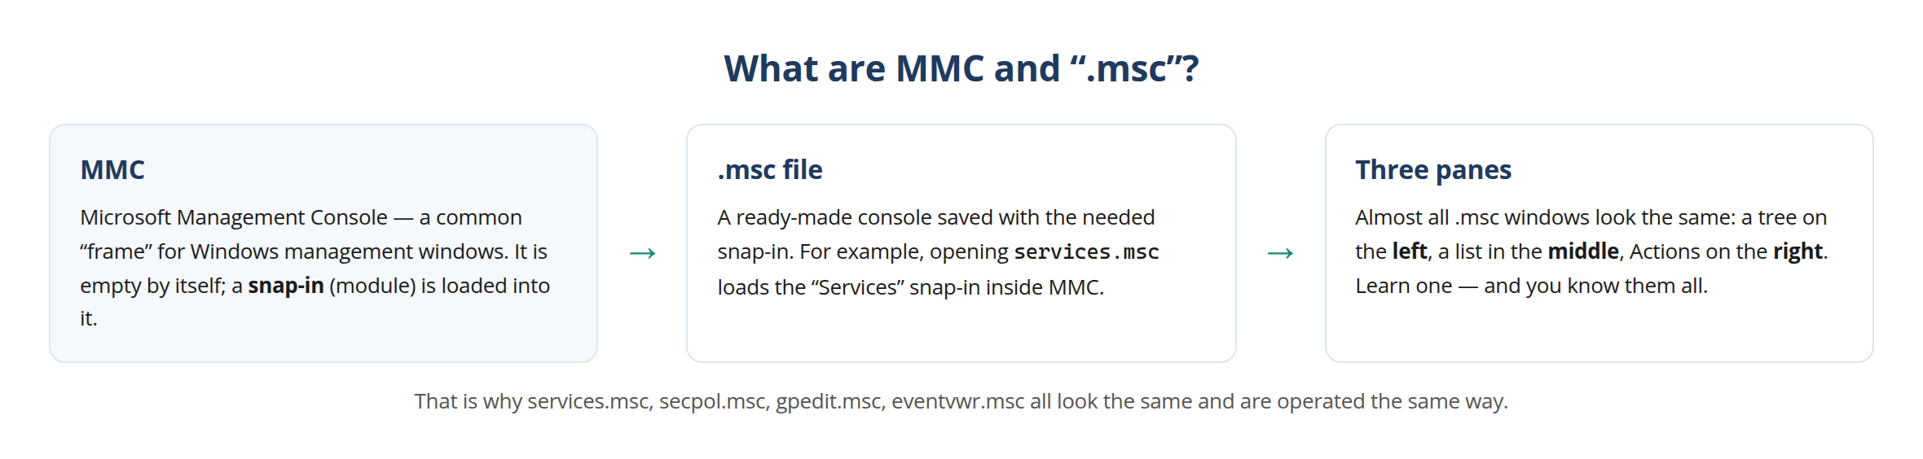
Figure 7. MMC, the “.msc” file and the three-pane layout
Almost all .msc windows have the same three-pane layout: on the left — the tree of sections, in the middle — the contents of the selected section, on the right — the actions (Actions). Once you learn one, the others look familiar too.
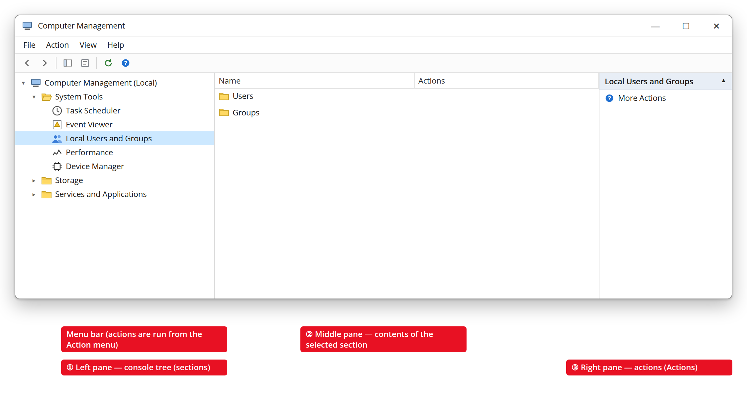
Figure 8. The three panes of an MMC console (Computer Management example)
0.4. The Run box and Start search — the two keys that open everything
90% of the tools in this guide are opened in one of two ways. The first is the Run box. Pressing Win + R opens a small window; you type the name of a program or console into it and press Enter.
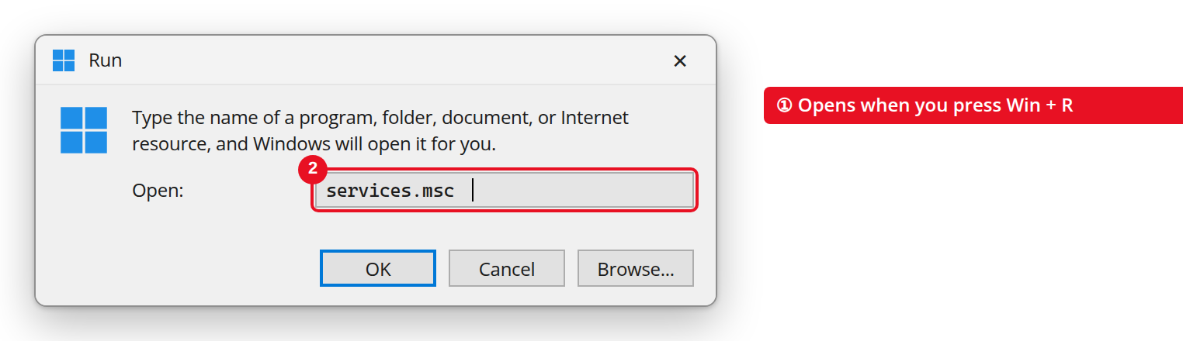
Figure 9. The Run box (Win + R) — the console name is typed into it
The second is Start menu search. Press the Win key and start typing the name of what you are looking for; Windows shows the matching result. This is especially handy when you do not know the exact console name (for example “User Account Control”).
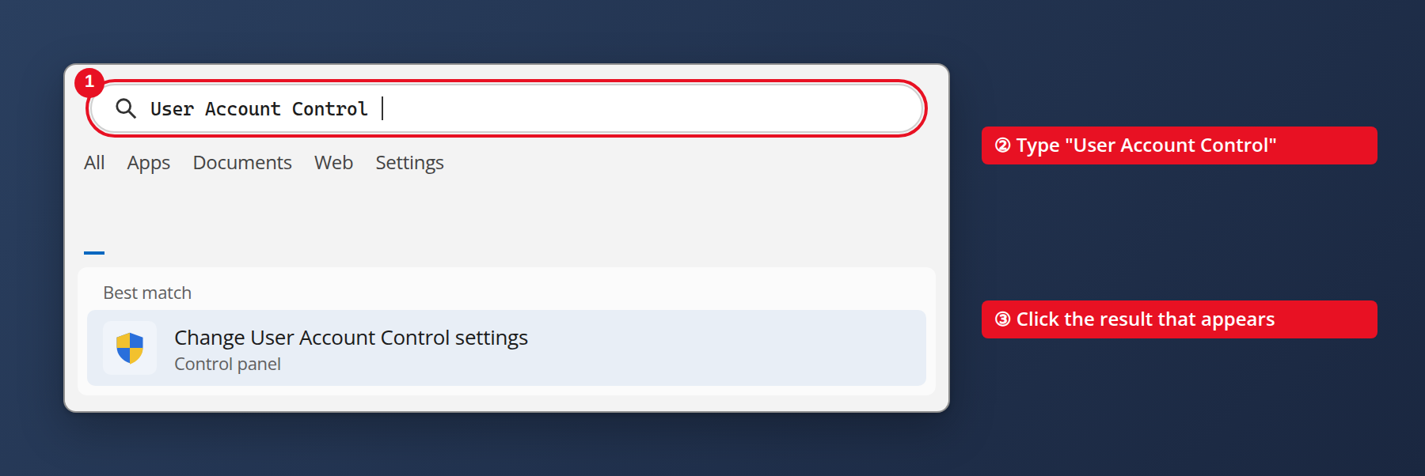
Figure 10. Finding a setting through Start menu search
0.5. Opening with administrator rights (Run as administrator)
Most security settings require administrator rights. If you open them with ordinary rights, the settings appear “greyed out” (cannot be changed) or an error appears. So open PowerShell or any other tool via right-click → “Run as administrator”. A UAC confirmation window will then appear — this is normal.
Remember
If you see “Access is denied” or the buttons are greyed out, the cause is usually the same: the tool was opened without administrator rights. Close it and open it again as administrator.
0.6. Getting to know the Windows Security, Control Panel and Settings apps
These three apps are the places you will open most often in the following lessons. It is useful to look at them in advance.
Windows Security — the Defender antivirus, Firewall status and SmartScreen live in this app. Open it by searching the Start menu for Windows Security.
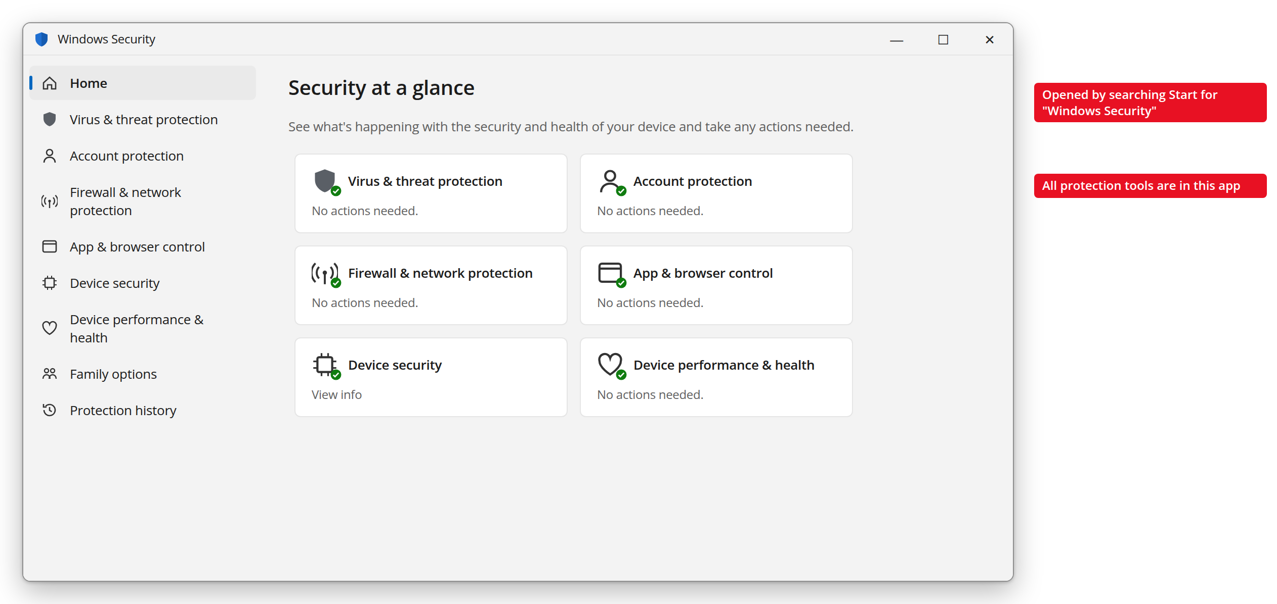
Figure 11. The home screen of the Windows Security app
Control Panel — the classic control panel. Windows Firewall and User Accounts (UAC) are opened from here. Win + R → control.
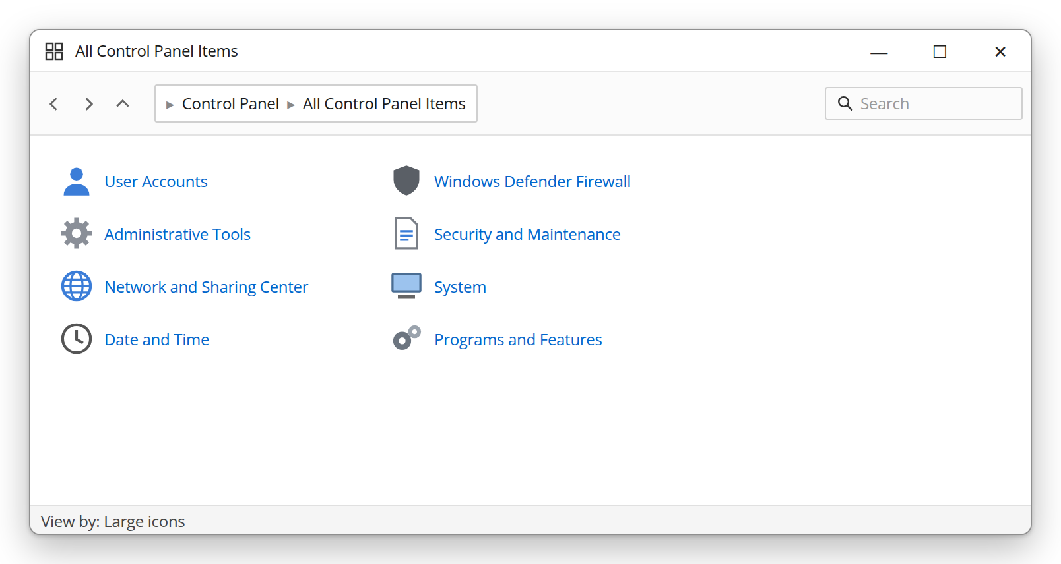
Figure 12. Control Panel (all items, large icons view)
Settings — the modern settings app. User accounts and updates are here. Win + I .
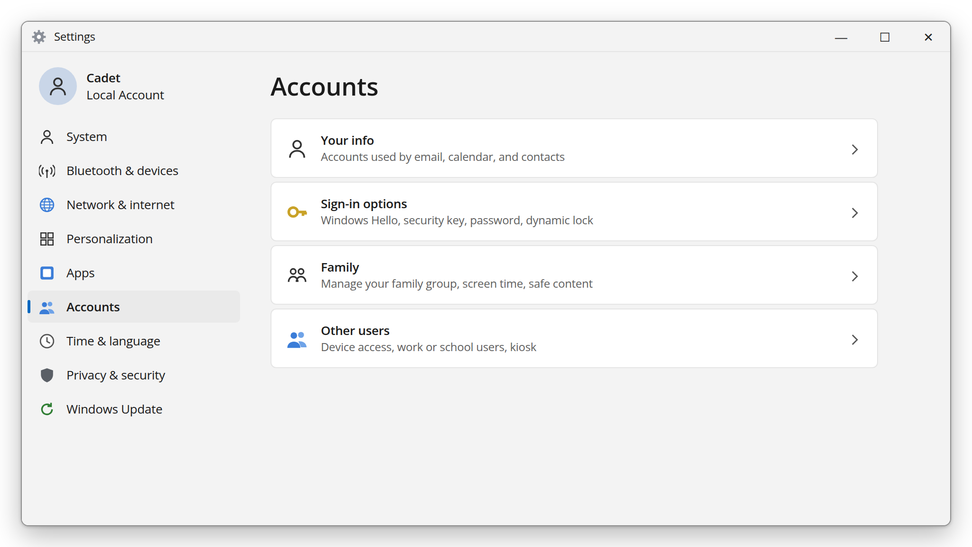
Figure 13. The Windows 11 Settings app (Accounts section)
Lesson 0 summary
Now you know: Windows editions differ; settings are reached through five doors; .msc consoles all work the same way; Win + R and Start search are the main keys; security settings require administrator rights. With this knowledge, the following lessons are much easier to master.

Lesson 1. Windows OS Services (Lecture)
Topic: Windows OS Security Lesson type: Lecture Duration: 2 hours

Learning questions
- Characteristics and functions of services
- Starting services

Question 1. Characteristics and functions of services
1.1. What is a Windows service?
Every computer runs two kinds of programs: the first are ordinary programs you open with the mouse and whose window you see on screen (for example Word, a browser). The second are programs you do not see, which have no window on screen but constantly run in the background. This second kind is called a service.
A service differs from an ordinary program in three main ways:
- It runs without a user: a service can run even when nobody has logged in — for example, if you turn on the computer and do not sign in to any account, dozens of services are still running in the background.
- It starts automatically: it starts as soon as Windows boots, without the user doing anything.
- It runs under special system accounts: whereas an ordinary program runs in the name of your account, a service usually runs under special, highly privileged accounts such as SYSTEM, LocalService or NetworkService.
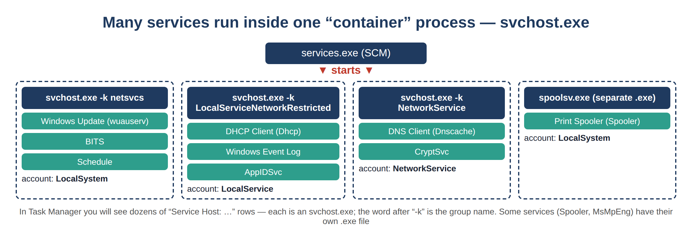
Figure 14. Services and svchost.exe processes
1.2. Why does this matter for cybersecurity?
This is the most important point of the whole topic and must be understood well. Services deserve special attention from a security point of view for three reasons:
- High privilege. Many services run at the SYSTEM level — the highest privilege level in Windows, with even more rights than an administrator. If an attacker takes control of such a service, they can take full control of the entire computer through it.
- A persistence tool. Once malware gets into a computer, it wants to keep running even after the computer restarts. The most reliable way to do that is to register itself as a new service, because services start automatically when Windows boots.
- A privilege escalation path. If a service is misconfigured (for example, if an ordinary user can also write to its file), a low-privileged attacker can climb all the way up to SYSTEM level through that weakness. The best known of these cases is the “unquoted service path” vulnerability, which is officially listed in the MITRE ATT&CK knowledge base as technique T1574.009.
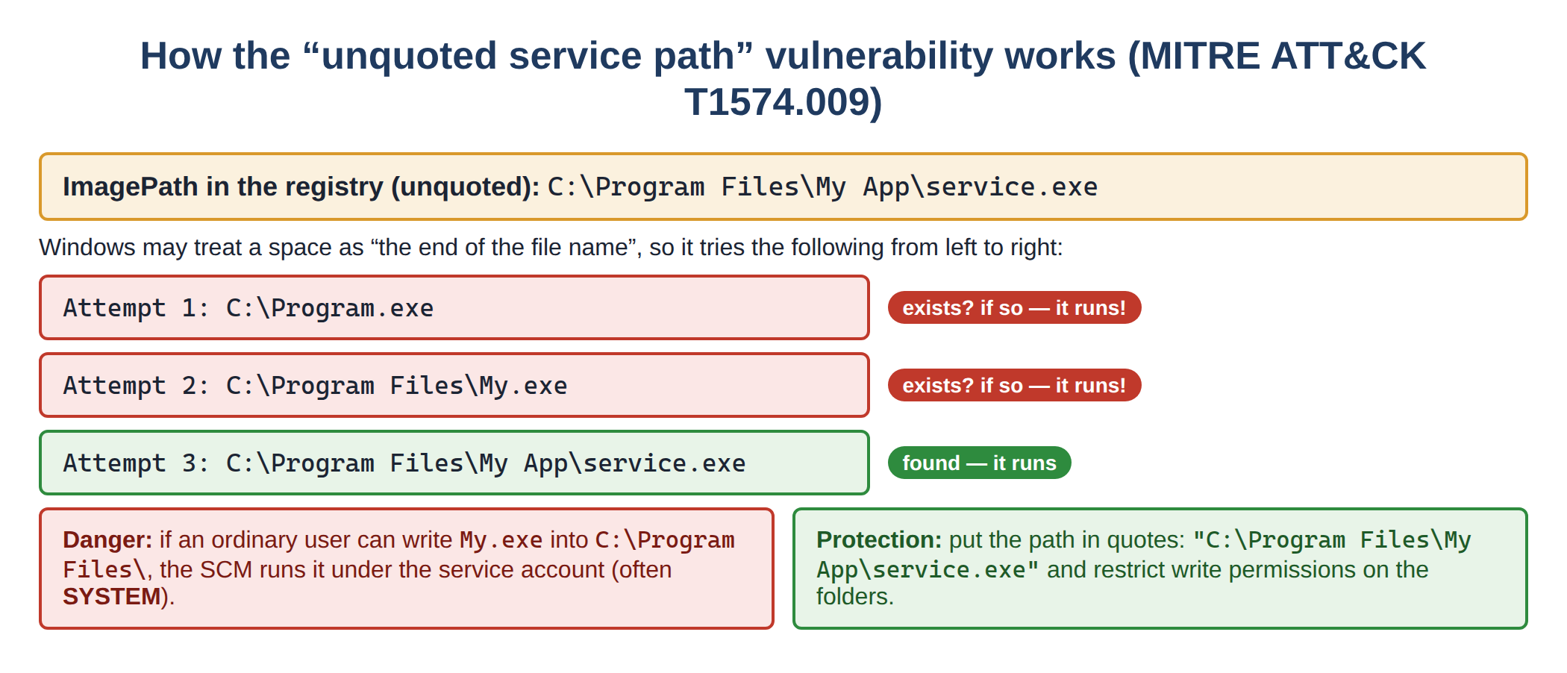
Figure 15. How the “unquoted service path” vulnerability works (diagram)
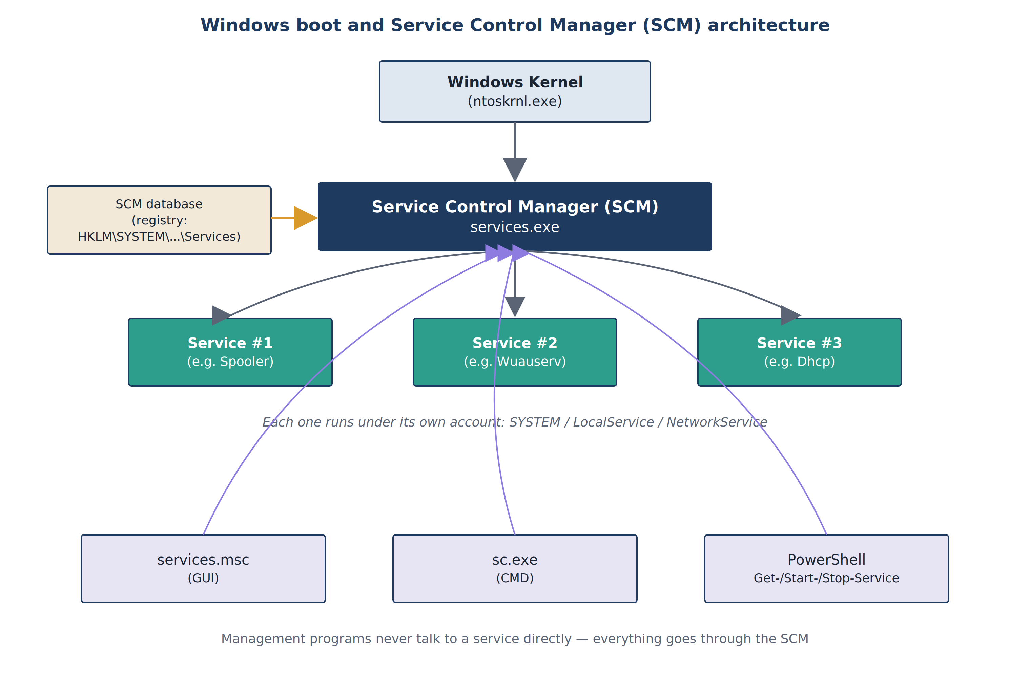
Figure 16. Windows boot and the Service Control Manager (SCM) architecture
1.3. Service Control Manager (SCM) — the “supervisor” of all services
Windows has hundreds of services, and it is impossible to control each of them individually. That is why there is a special central component — the Service Control Manager (SCM). It runs as the services.exe file and starts automatically as soon as Windows boots. The SCM performs the following tasks:
- It keeps the database of all installed services and driver services (this data is stored in the Windows registry, specifically under the HKLM\SYSTEM\CurrentControlSet\Services key).
- It starts each service at system boot or on request.
- It continuously tracks the state (running/stopped) of the running services.
- For each service it defines who has the right to access it (the security descriptor).
Note that no management program (services.msc, sc.exe, PowerShell) talks to a service directly — everything goes through the SCM. Thanks to this centralized architecture, Windows services can be managed securely even remotely.
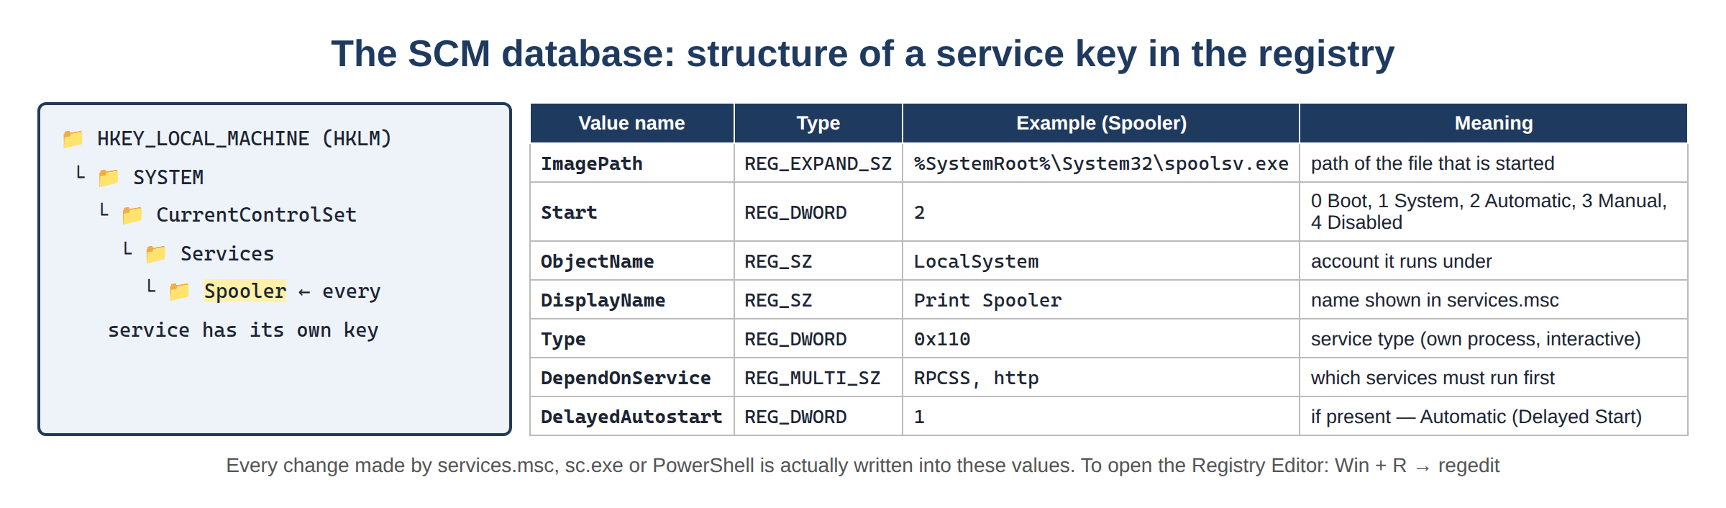
Figure 17. Structure of a service key in the registry (HKLM\SYSTEM\CurrentControlSet\Services)
What does the registry key mentioned above actually look like? To see it, open Win + R → regedit (with administrator rights) and go to the HKLM\SYSTEM\CurrentControlSet\Services key. Each service is stored here as a separate key.
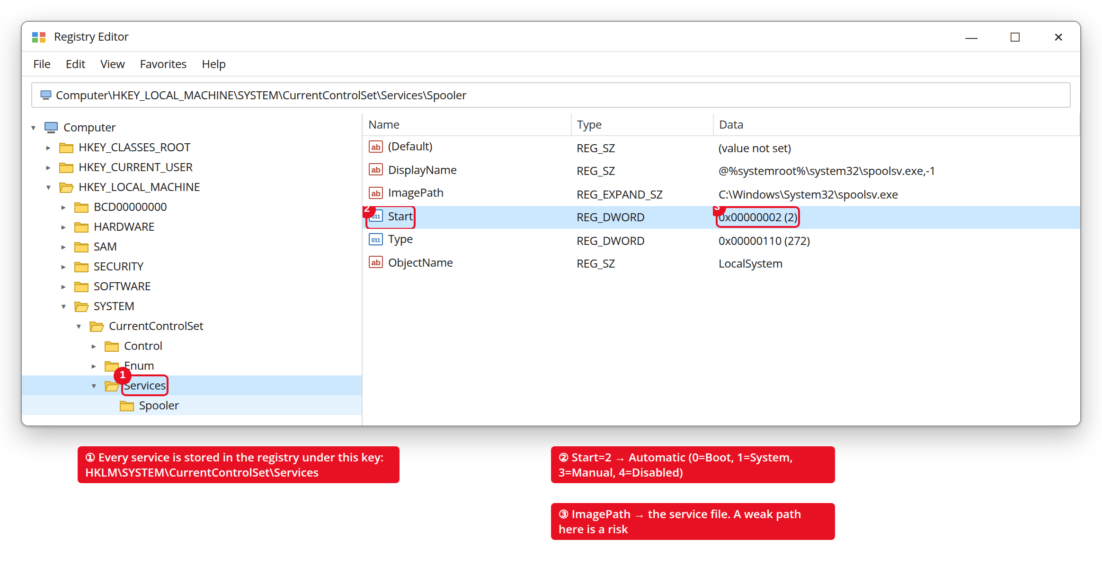
Figure 18. regedit — a service key and its values (annotated)
The Start value here corresponds to the Startup type: 2 = Automatic, 3 = Manual, 4 = Disabled (0 and 1 are for driver services). ImagePath is the path to the service file — if exactly this path is written incorrectly, the unquoted service path vulnerability arises.
1.4. The service life cycle (Service States)
During its life, every service goes through several states. Understanding them is important for diagnostics and troubleshooting: for example, if a service stays in the “START PENDING” state for a long time, that indicates a problem.
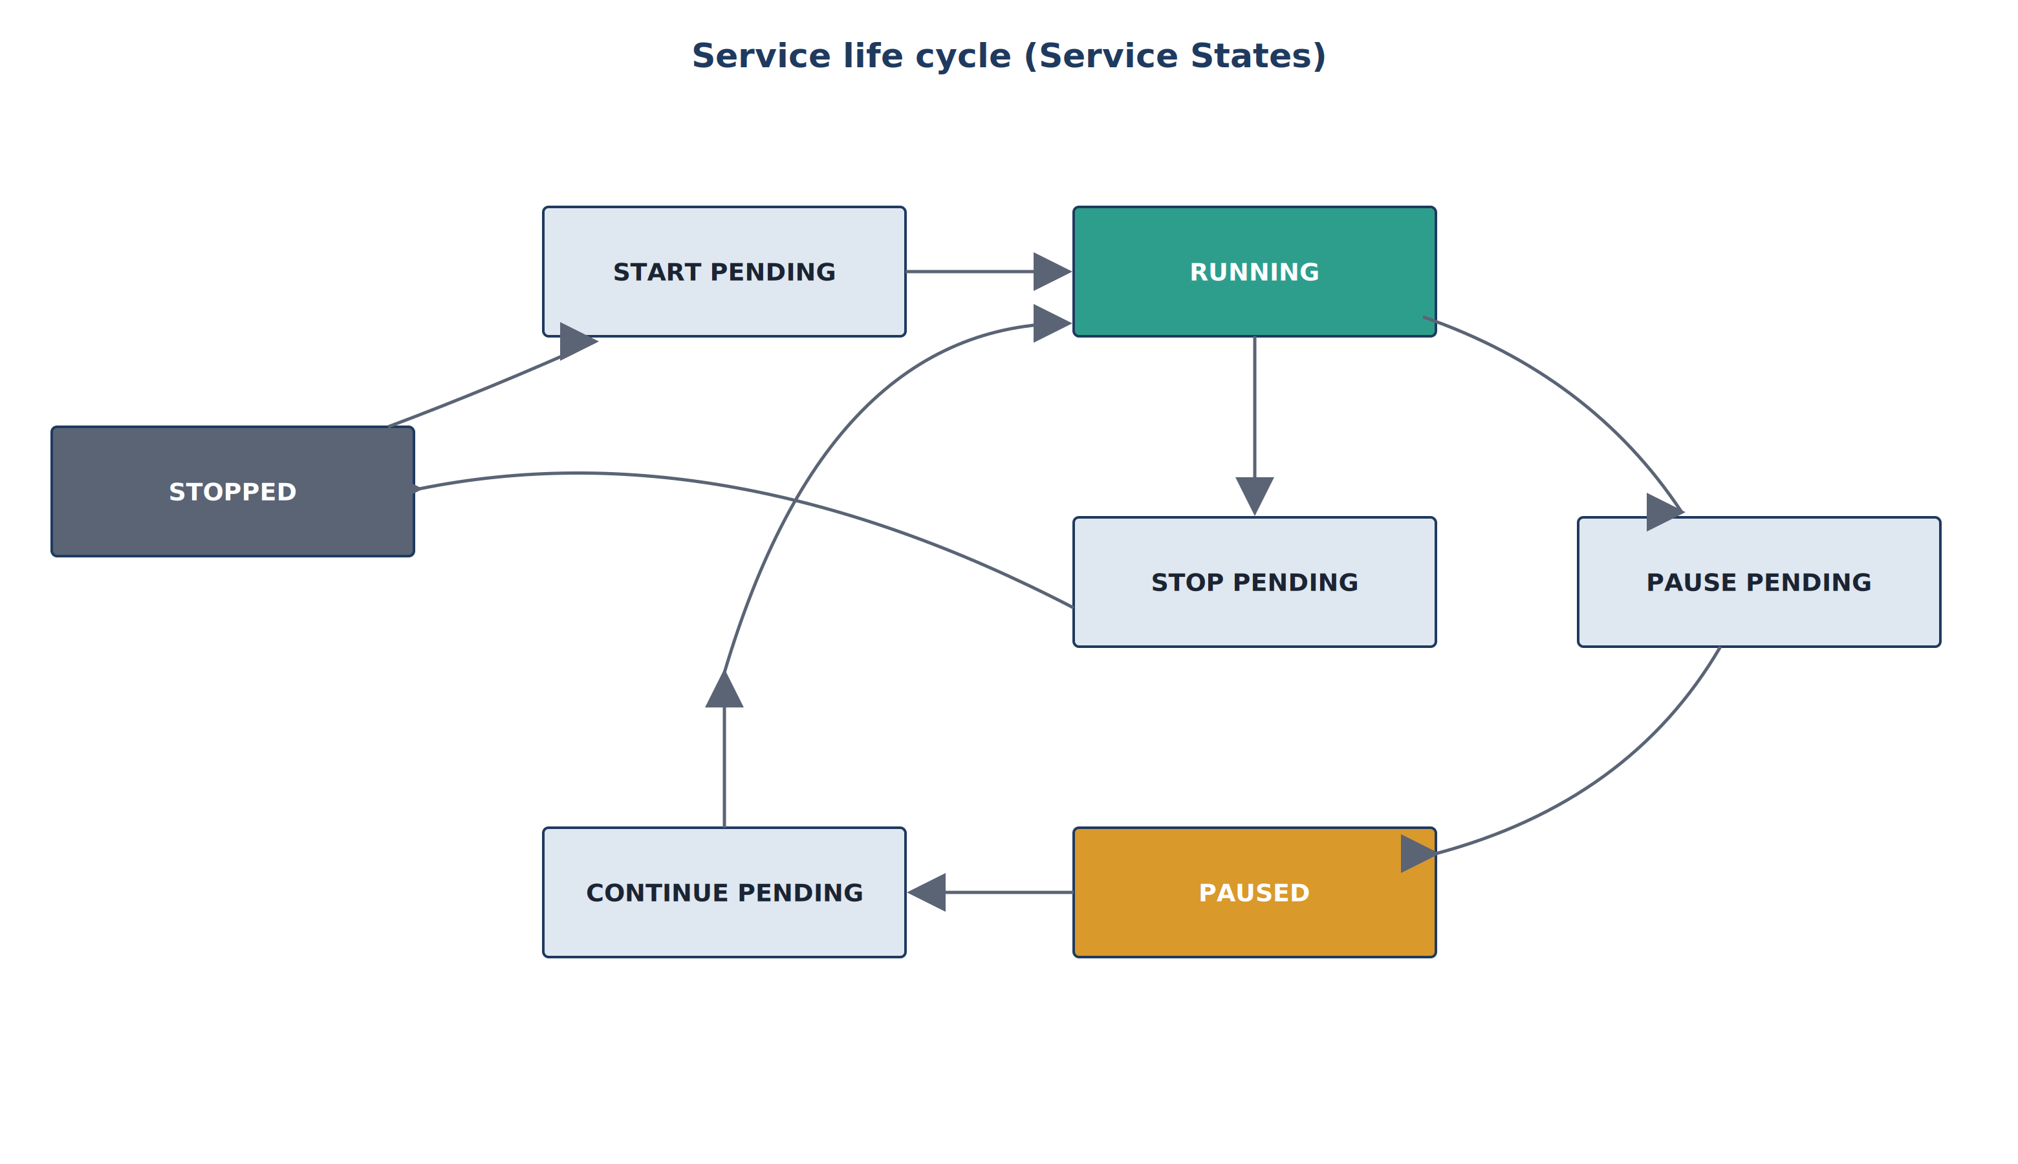
Figure 19. The service life cycle (Service States)
State | Meaning
Stopped | The service is fully stopped and not running.
Start Pending | The service is in the process of starting (not fully started yet).
Running | The service is fully running.
Pause Pending | The service is in the process of being paused.
Paused | The service is temporarily suspended but stays in memory and can resume quickly.
Continue Pending | The service is in the process of resuming from pause.
Stop Pending | The service is in the process of stopping.
1.5. Startup types (Startup Type)
For each service it is specified separately when it should start. This setting is called the “startup type” and it is very important from a security point of view: switching unused services to “Disabled” is one of the simplest ways to reduce the attack surface.
Type | Meaning | When it is used
Automatic | Starts immediately at system boot, before everything else. | For important services that are always needed (for example networking, Windows Update).
Automatic (Delayed Start) | Starts a little later, after the system has finished booting. | For services that are needed but not immediately — speeds up the boot.
Manual | Starts only when another program or the user requests it. | For rarely used services (for example Print Spooler, if the printer is rarely used).
Disabled | Does not start at all, even when requested. | For unused services that may be dangerous from a security point of view.
1.6. Which account does a service run under?
Every service runs “in the name of” a particular user account and has that account’s rights. Windows has three special built-in accounts for services:
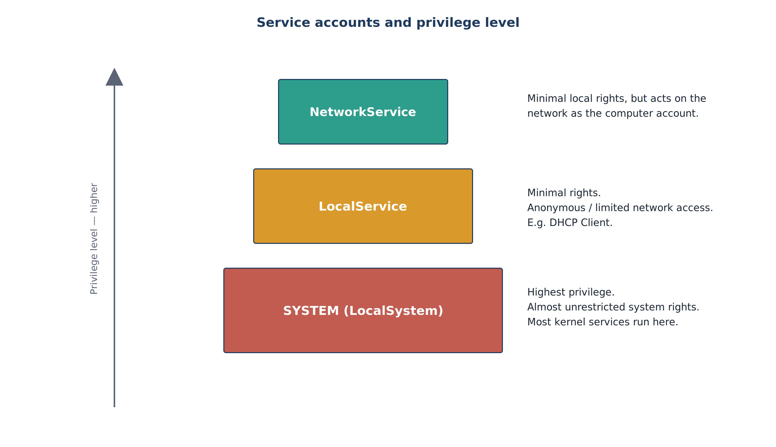
Figure 20. Service accounts and their privilege level
Account | Privilege level | Network access | Example
SYSTEM (LocalSystem) | Highest — almost unrestricted | As the computer account | Many kernel and system services
LocalService | Minimal, local only | Anonymous / very limited | Low-privilege services such as DHCP Client
NetworkService | Minimal locally, but active on the network | As the computer account | Some network-facing services
Keep in mind from a security point of view
• A service running with SYSTEM rights is the most “valuable prize” for an attacker, because capturing it means controlling the whole system.
• Always follow the “least privilege” principle: the fewer rights a service is given, the higher the security.

Question 2. Starting services
There are three main tools for managing Windows services: the graphical interface (services.msc), the command-line tool (sc.exe) and PowerShell. As we saw above, all three talk to the Service Control Manager in the background.
2.1. Through the GUI — services.msc
- To open it: press the Win + R keys, type services.msc in the window that opens and press Enter.
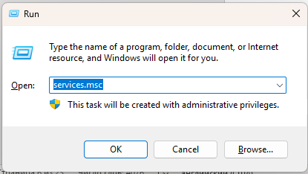
- The window that opens shows the list of all services, their status (Running / Stopped), their startup type, and in the “Log On” column which account each one runs under.
A closer look at the services.msc window — what do the columns mean?
The thing that raises the most questions for beginners is the columns in the services.msc window. Below are the real window and the meaning of each column.
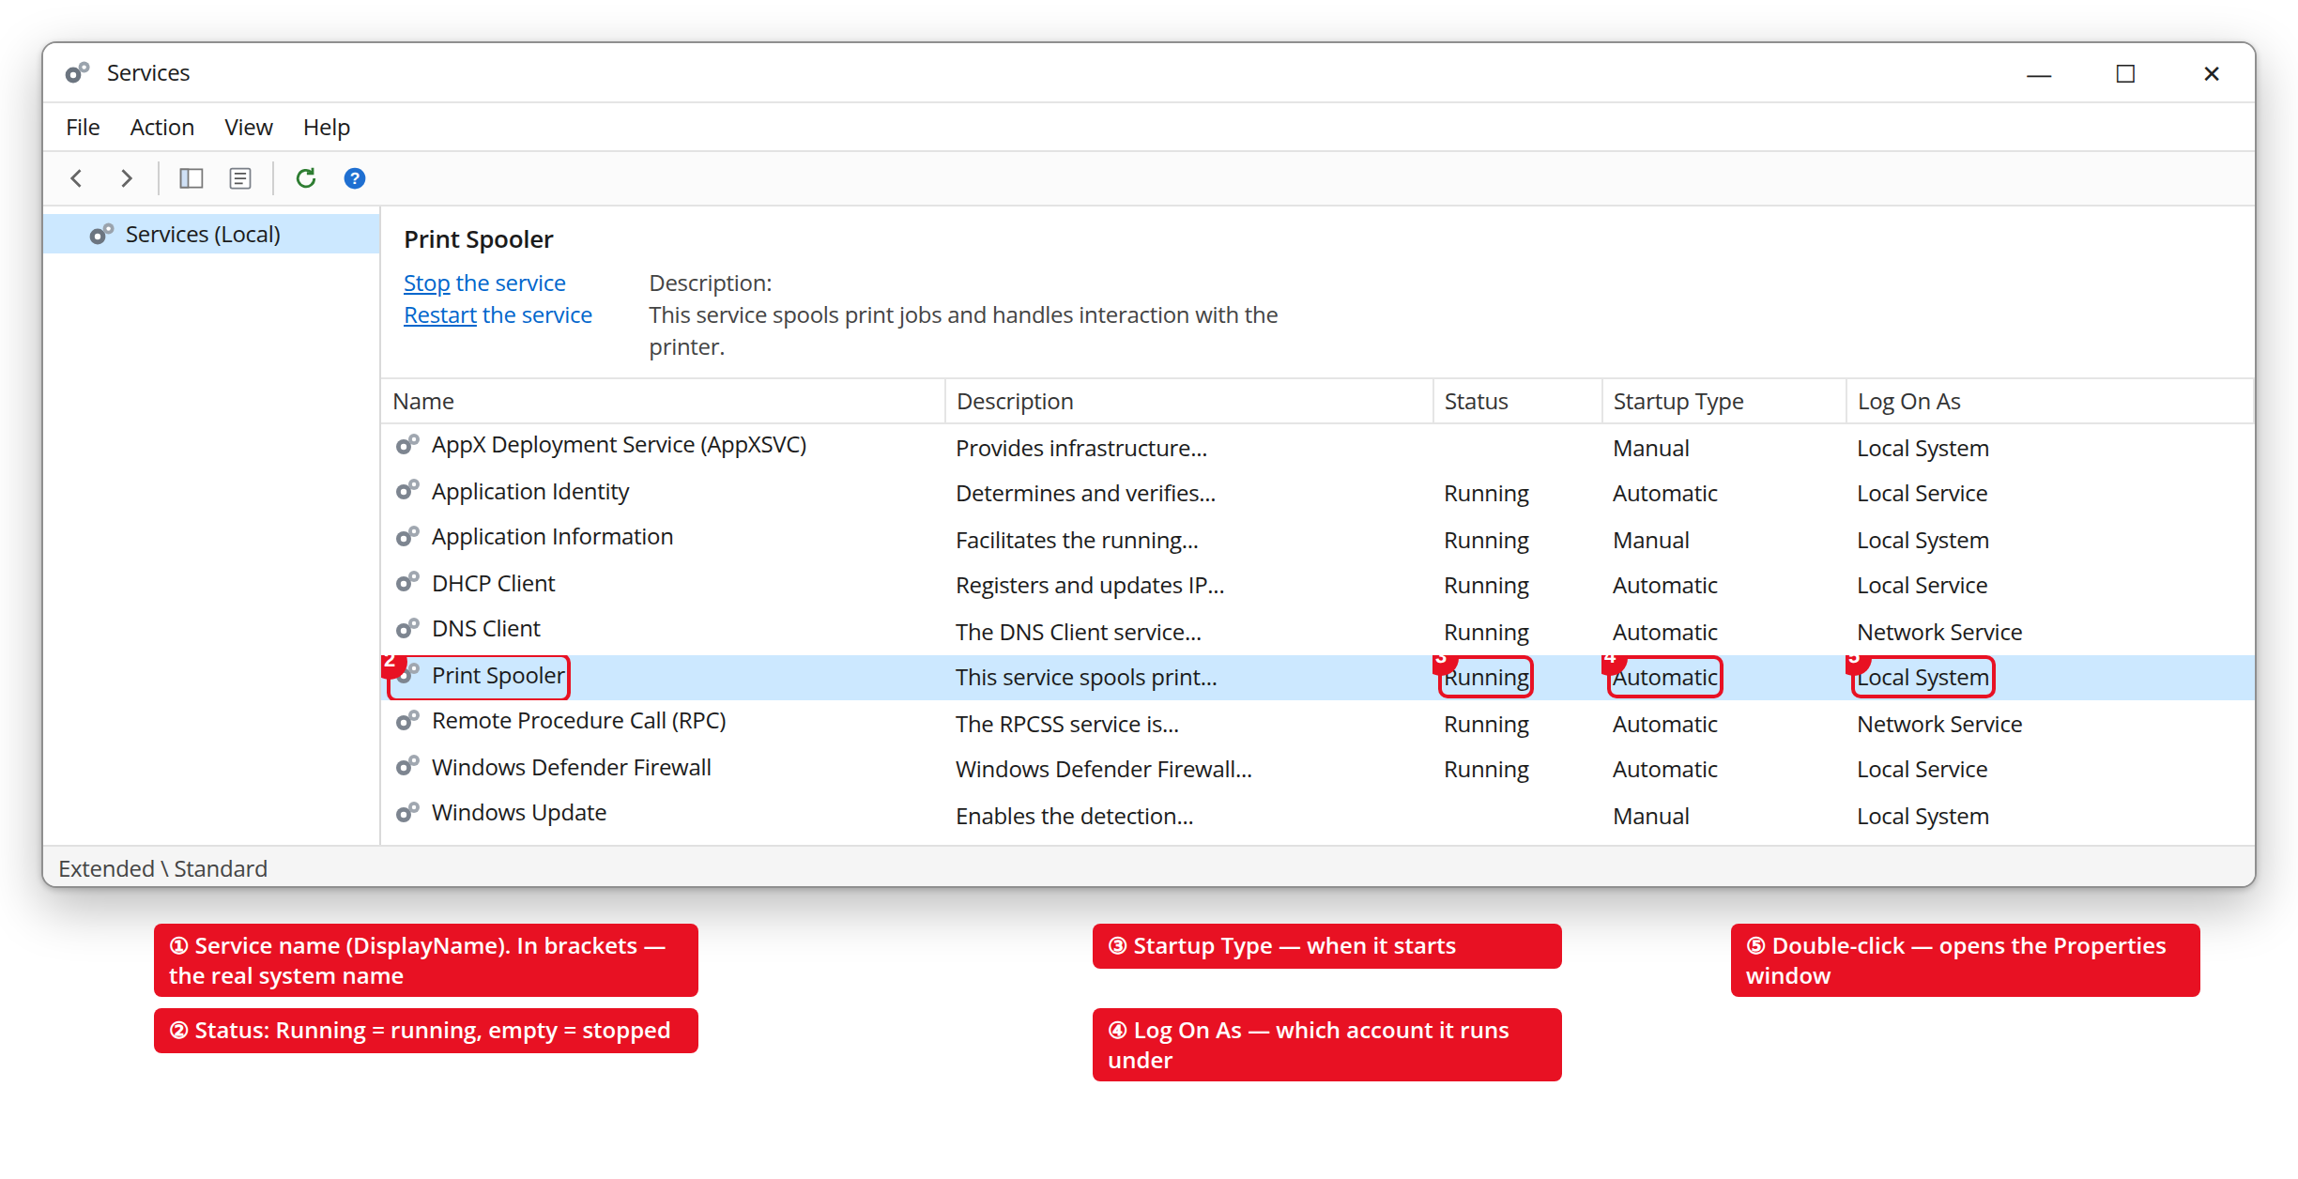
Figure 21. The services.msc window and the meaning of its columns (annotated)
Column | What it means
Name | The visible name of the service (DisplayName). In brackets — the internal system name (for example Spooler).
Description | A short description of what the service does.
Status | Running = it is running; empty or Stopped = it is stopped.
Startup Type | When it starts: Automatic, Automatic (Delayed), Manual, Disabled.
Log On As | Which account the service runs under (Local System, Local Service, Network Service).
At the bottom of the list there are the Standard and Extended tabs. In Extended mode, an extra description of the selected service and the “Stop / Restart” links appear on the left.
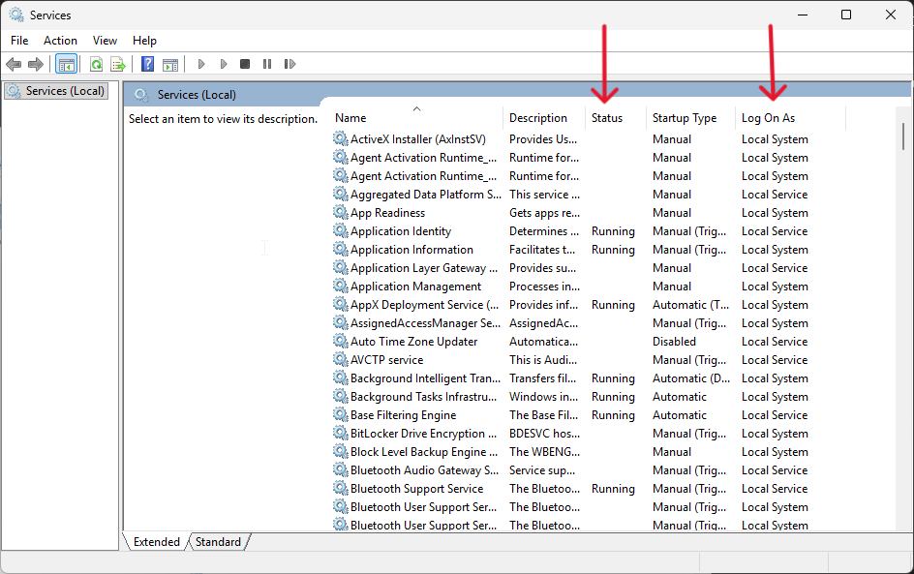
- By double-clicking a service (or right-click → Properties) you can change its Startup type, and stop or start the service.
The service Properties window — this is where you configure it
Double-clicking a service opens the Properties window. The most important tab is General: this is exactly where the Startup type is changed and the service is Start / Stop-ped.
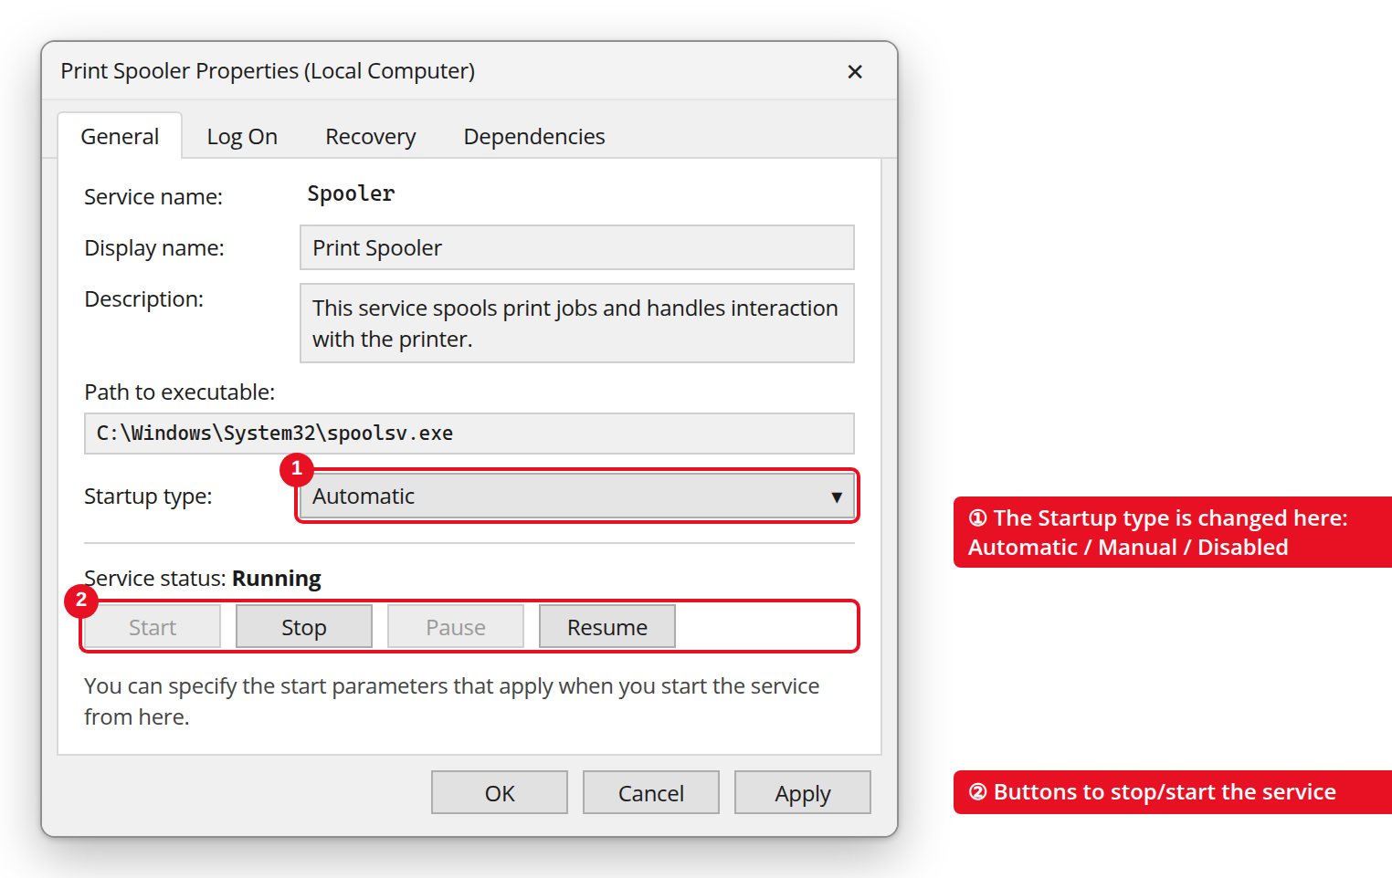
Figure 22. Service Properties → General tab (annotated)
The second important tab is Log On: here you see which account the service runs under. Local System account is the highest privilege; “This account” lets you switch it to another account.
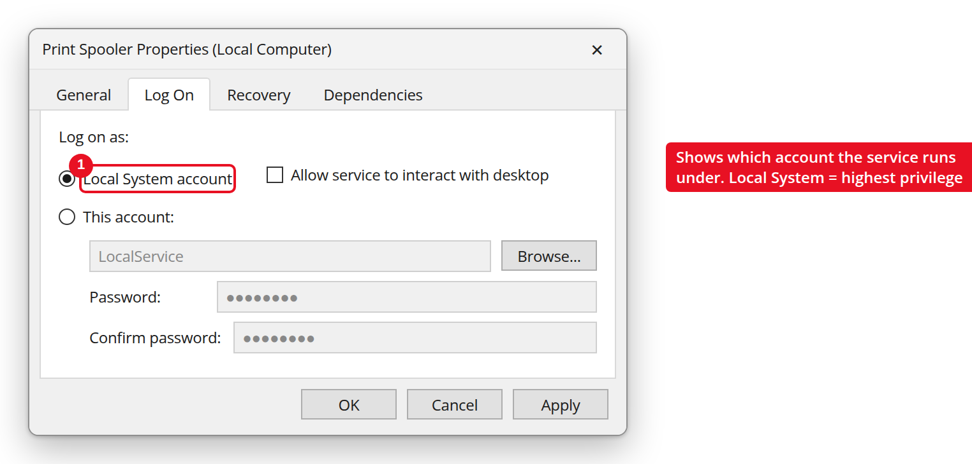
Figure 23. Service Properties → Log On tab
Besides services.msc, there is another quick way to view services: Task Manager ( Ctrl + Shift + Esc ) → the Services tab. The PID (process ID) is also shown here.
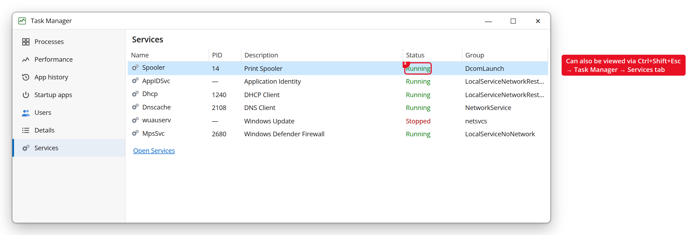
Figure 24. Task Manager → Services tab
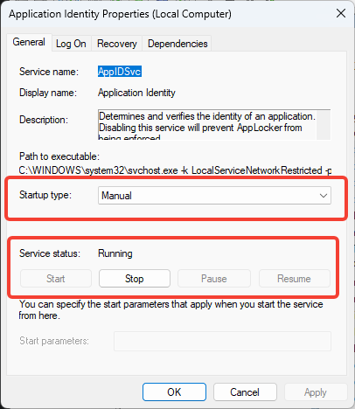 | 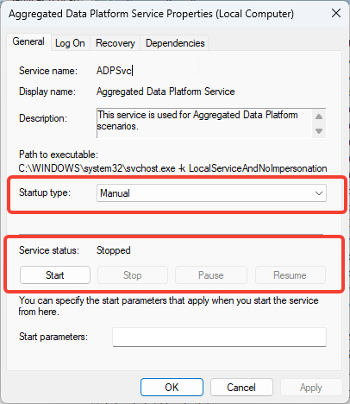

2.2. From the command line — sc.exe
sc (Service Control) is the classic Windows tool for managing services from the command line. The most frequently used commands:
Command | What it does | Standard user | Administrator
sc query <servicename> | Shows the current state of the service | Works | Works
sc start <servicename> | Starts the service | Does not work | Works
sc stop <servicename> | Stops the service | Does not work | Works
sc config <servicename> start= disabled | Changes the startup type to “Disabled” | Does not work | Works
sc qc <servicename> | Shows the service configuration (including the file path) — important in security audits | Works | Works

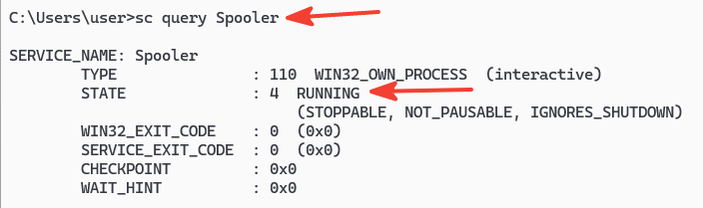 | 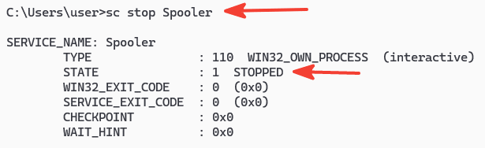
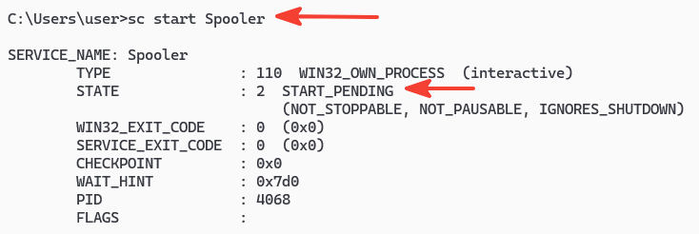 | 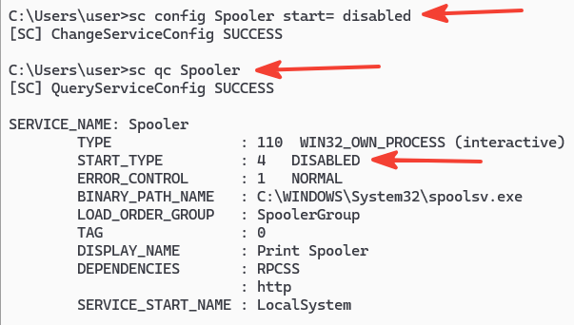
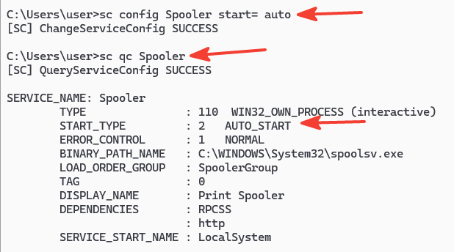
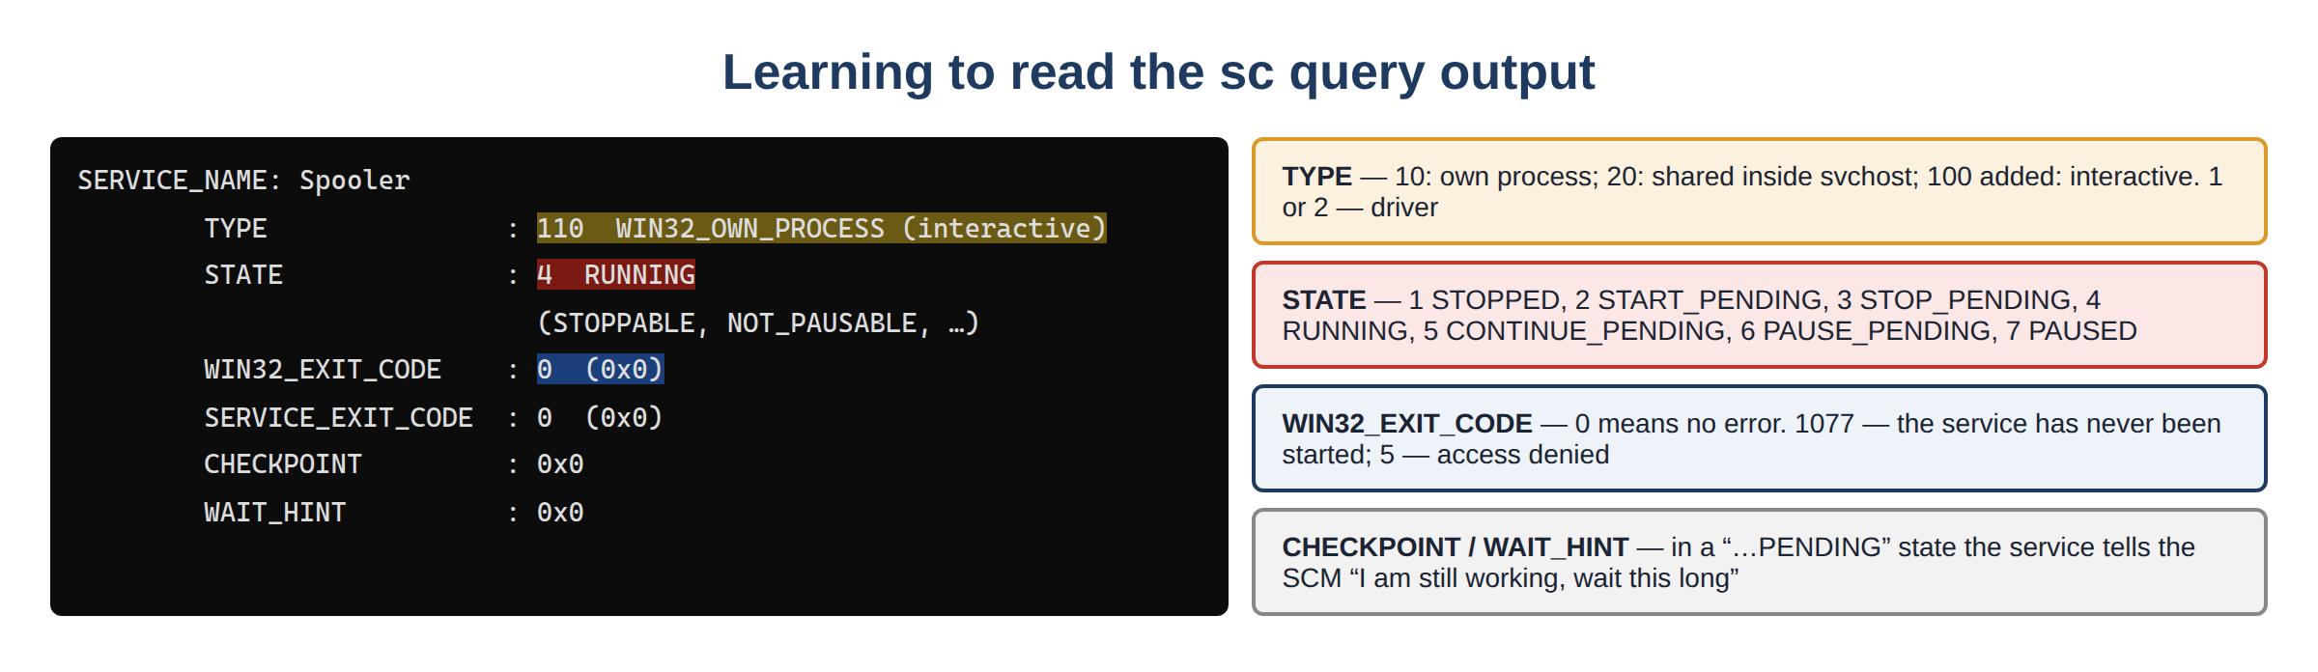
Figure 25. Meaning of the fields in the sc query output
Below are the real outputs of the sc commands above. sc qc shows the full service configuration:
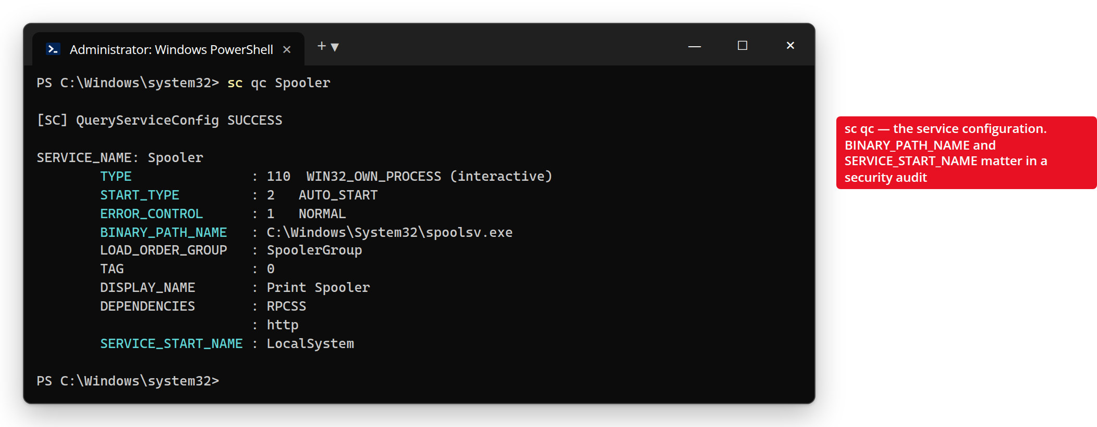
Figure 26. sc qc output — BINARY_PATH_NAME and SERVICE_START_NAME (annotated)
sc query shows the current state (STATE) of the service:
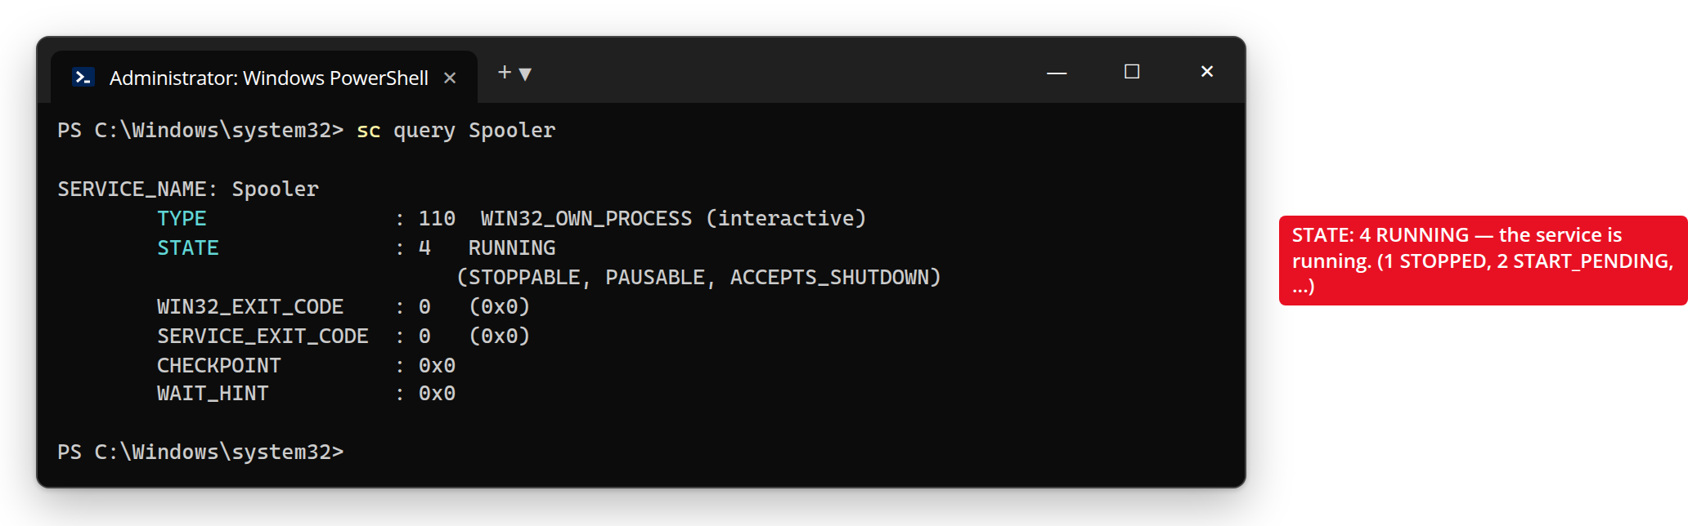
Figure 27. sc query output — meaning of the STATE field
2.3. With PowerShell
PowerShell is the modern tool and the most convenient one for automation. The main commands (cmdlets):
Cmdlet | What it does
Get-Service | Shows the list of all services
Get-Service -Name "Spooler" | Shows the state of one specific service
Start-Service -Name "Spooler" | Starts the service
Stop-Service -Name "Spooler" | Stops the service
Set-Service -Name "Spooler" -StartupType Disabled | Changes the startup type
And this is how the PowerShell command Get-Service works — a filter has been added to show only running services:
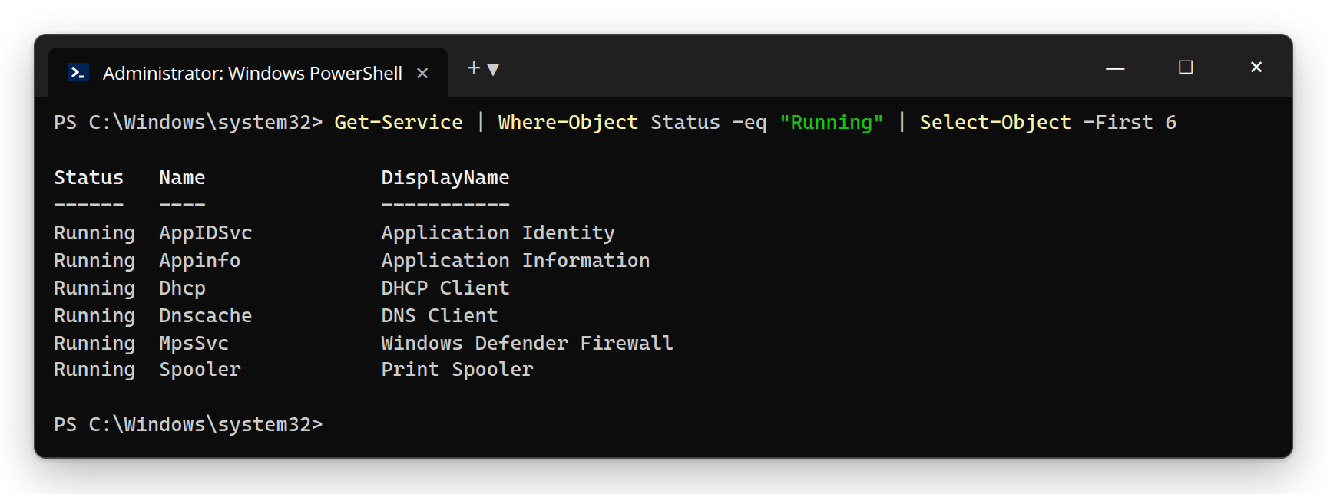
Figure 28. PowerShell — viewing running services with Get-Service
2.4. How is this knowledge used in practice?
From the point of view of cyber forensics and ethical hacking, this knowledge is applied in two directions:
- Defense (Blue Team): identifying unnecessary, unused services and switching them to “Disabled” reduces the attack surface. For example, if the computer has no printer, it is recommended to disable the Print Spooler service.
- Attack and analysis (Red Team / Forensics): after getting into a system, an intruder often creates a new service and uses it to establish persistence. That is why checking sc query or the registry Services key is one of the first steps in a forensic analysis.

Additional important information
Below are several important system services you will often meet in practice, and what they do — you will need to know them in the following lessons (especially for security settings):
Service name | What it does
Windows Update (wuauserv) | Downloads and installs security and other updates for the system
Print Spooler (spooler) | Queues and manages print requests
DHCP Client (dhcp) | Lets the computer obtain an IP address from the network automatically
DNS Client (dnscache) | Caches requests that translate domain names into IP addresses
Remote Procedure Call (RpcSs) | A core service required by many system components
Windows Defender Antivirus Service | Provides real-time protection against malware
Windows Firewall (MpsSvc) | Controls network traffic and applies security rules
Frequently asked questions — Lesson 1
Q: I want to stop a service, but the “Stop” button is greyed out. Why?
A: Most likely services.msc was opened without administrator rights, or the service depends on another service (dependency). Open the console again as administrator.
Q: How do I find out the service name (for example Spooler)?
A: Double-click the service in services.msc — the “Service name” on the General tab is exactly this internal name. Commands (sc, Get-Service) use this name, not the DisplayName.
Q: Which services are safe to disable?
A: Only those you are sure you do not need (for example Print Spooler if there is no printer). Never disable core services such as RpcSs or DcomLaunch — the system may stop working.
Q: Is the SYSTEM account even more powerful than administrator?
A: Yes. SYSTEM is the highest local privilege, running in the name of the operating system itself. That is why capturing a service with SYSTEM rights is the most valuable target for an attacker.

Review questions — Lesson 1
- How does a Windows service differ from an ordinary program?
- Explain the difference between the SYSTEM, LocalService and NetworkService accounts.
- What tasks does the Service Control Manager (SCM) perform and where is it located?
- List the four startup types and explain when each is used.
- Why can privilege escalation happen through a misconfigured service?
- What is the difference between the sc query and sc config commands?
- Why is checking services important in a forensic analysis?

Lesson 2. Windows OS Services (Seminar)
Topic: Windows OS Security Lesson type: Seminar Duration: 2 hours

Learning questions
- The User Account Control, AppLocker and SmartScreen security systems
- The Defender and Firewall security systems

Question 1. The UAC, AppLocker and SmartScreen security systems
1.1. User Account Control (UAC)
In older Windows versions (for example Windows XP), users often worked with administrator rights all the time. This was very dangerous: if such a user accidentally launched malware, that program immediately had full administrator rights as well. UAC (User Account Control) is the mechanism introduced in Windows Vista to solve exactly this problem.
The main idea of UAC is simple: even if you are working under an administrator account, the system makes you do your everyday work with “reduced” (standard) rights. If a program or action requires administrator rights (for example installing a program or changing system settings), a special request — a confirmation window — appears on the screen, and the action is performed only if the user says “Yes”.
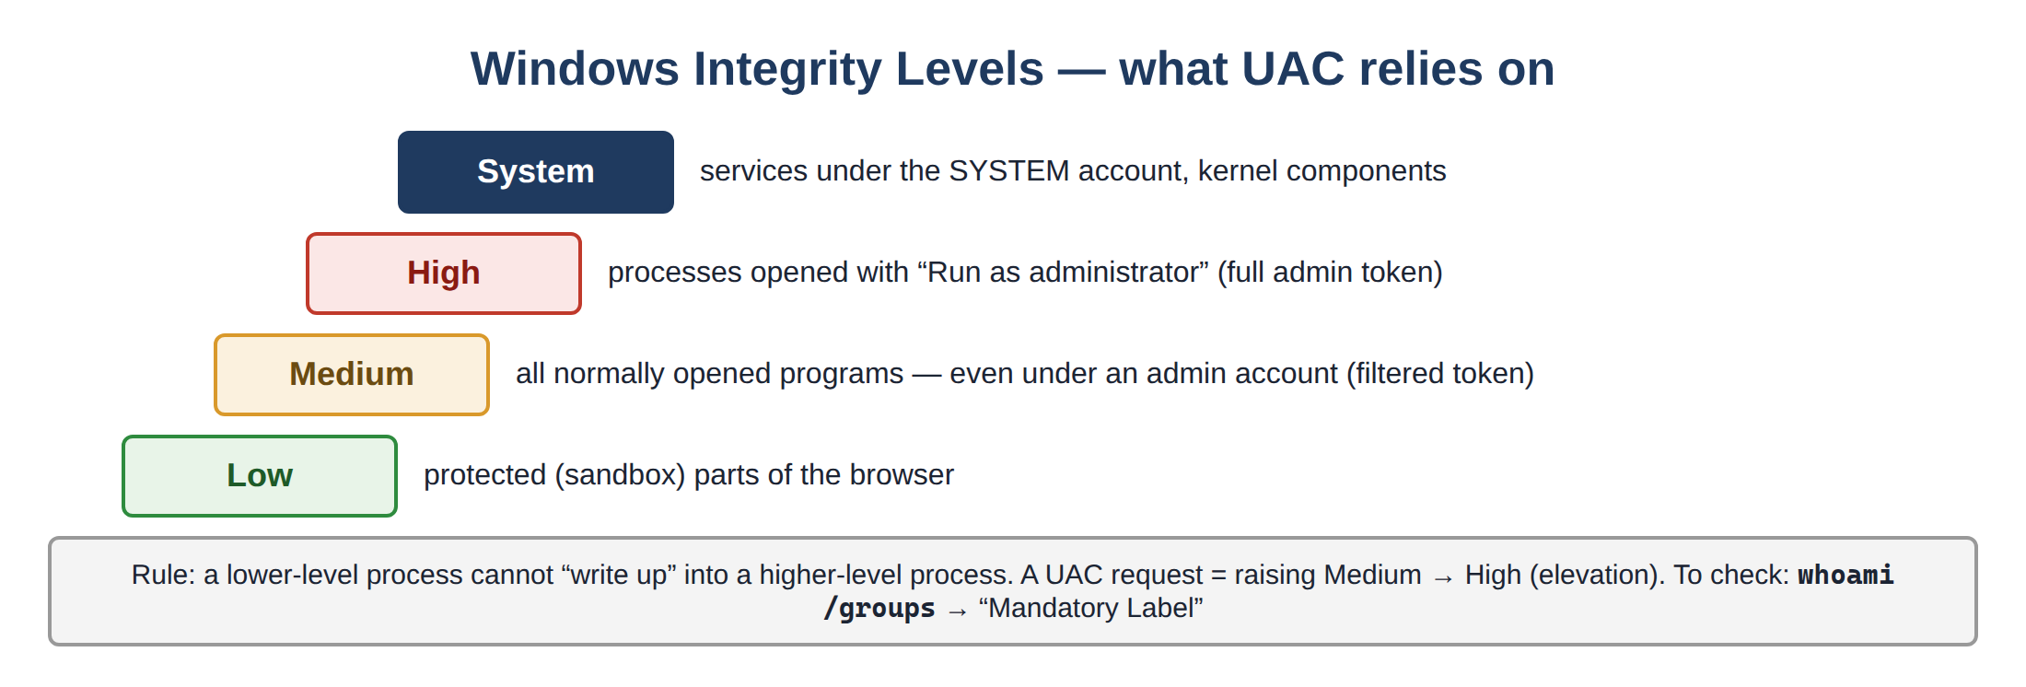
Figure 29. Windows Integrity Levels
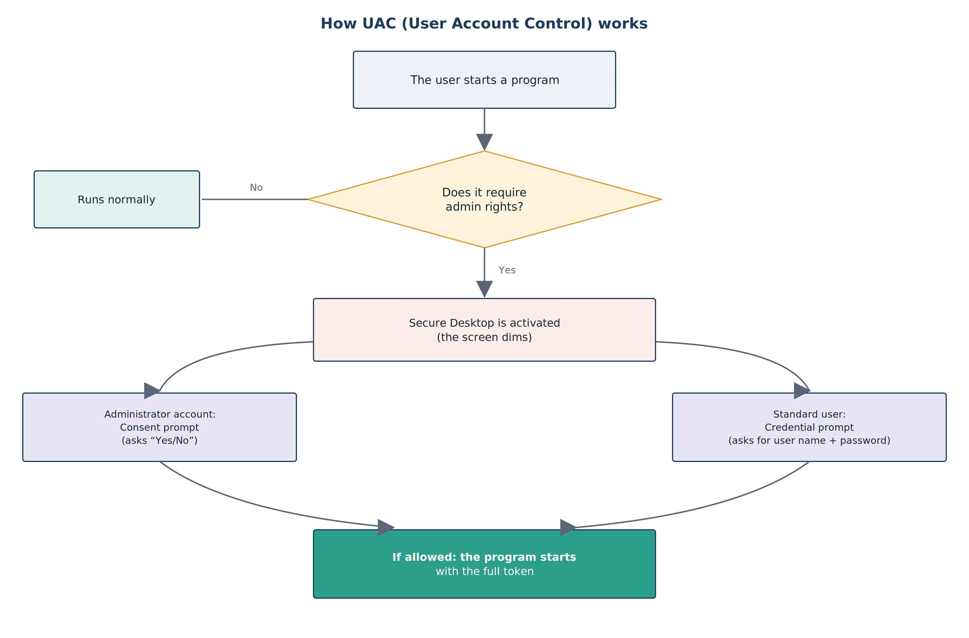
Figure 30. How UAC (User Account Control) works
Note: the confirmation window is shown in a special “Secure Desktop” mode (that is why the screen dims a little) — this security measure prevents malware from automatically clicking a fake “Yes” button. The type of confirmation requested depends on the type of user:
- For an administrator — the Consent prompt: simply clicking “Yes” or “No” is enough.
- For a standard user — the Credential prompt: to continue, an administrator’s user name and password must be entered.
What does the UAC confirmation window look like in practice? Three cases are shown below. The first is a signed, trusted program (for example one of Microsoft’s own tools): the “Verified publisher” line is green.
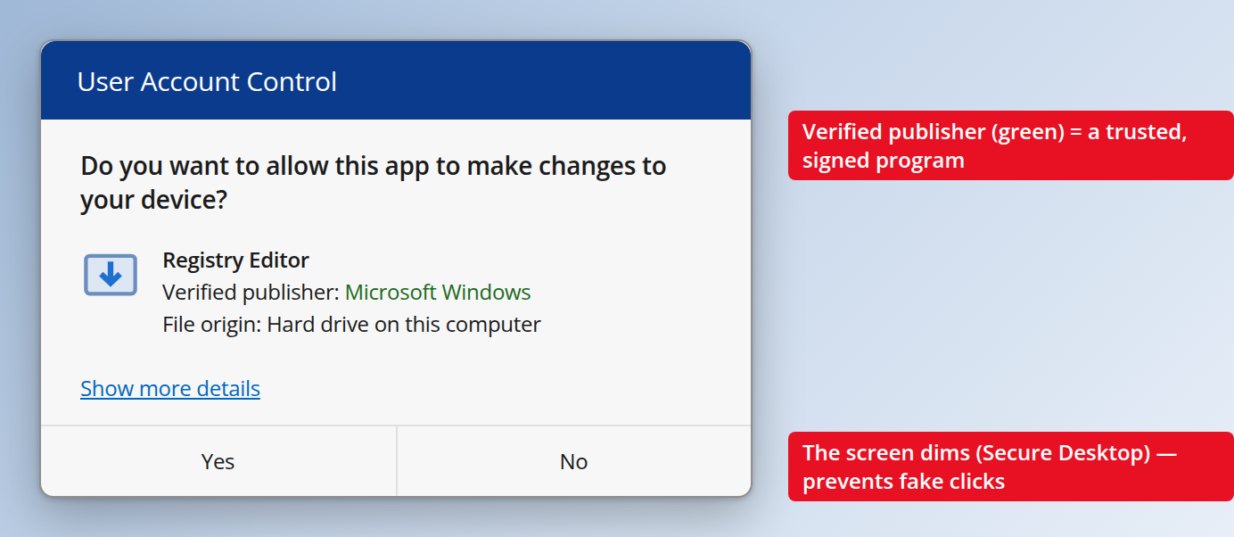
Figure 31. UAC Consent prompt — a signed program (Verified publisher in green)
The second is an unsigned, unknown program. “Unknown publisher” is shown in red. This is a serious warning sign: in this situation it is better to click “No”.
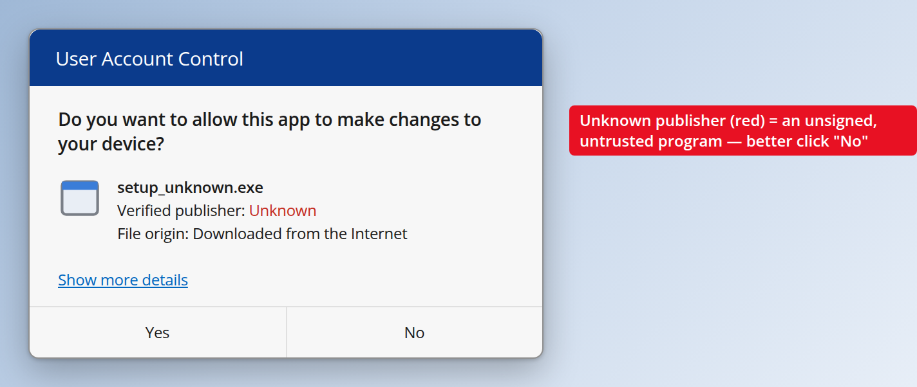
Figure 32. UAC — an unsigned program (Unknown publisher in red)
The third is for a standard (ordinary) user. Here, instead of a simple “Yes/No”, a Credential prompt appears: to continue, an administrator’s user name and password must be entered.
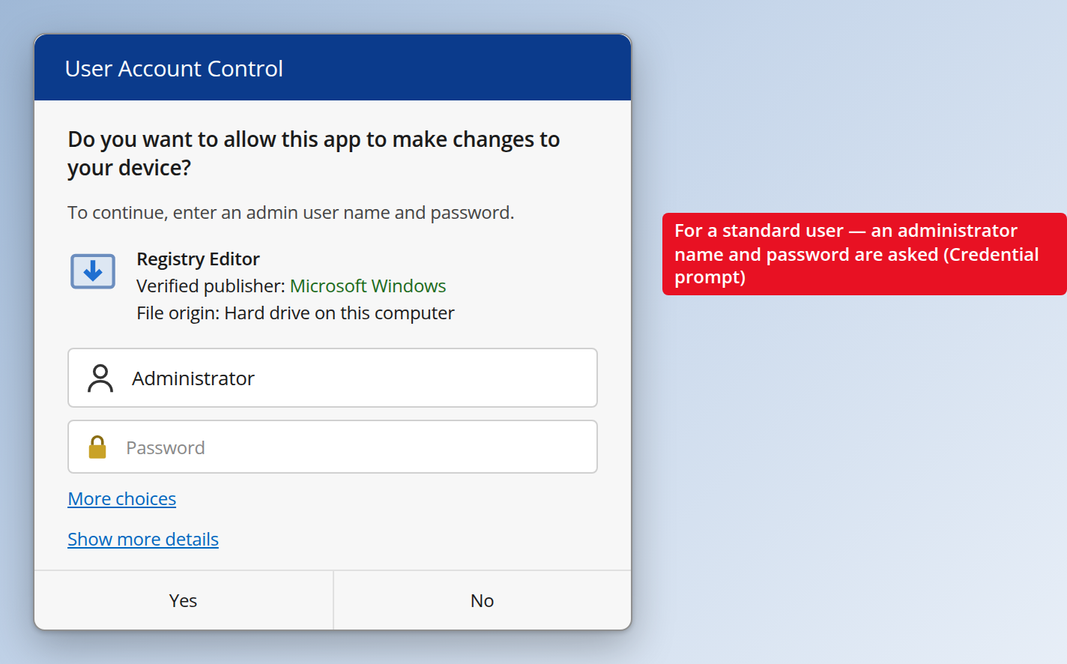
Figure 33. UAC Credential prompt — a standard user is asked for an admin password
How is this done? When you sign in with an administrator account, Windows gives you two “tokens” (sets of rights):
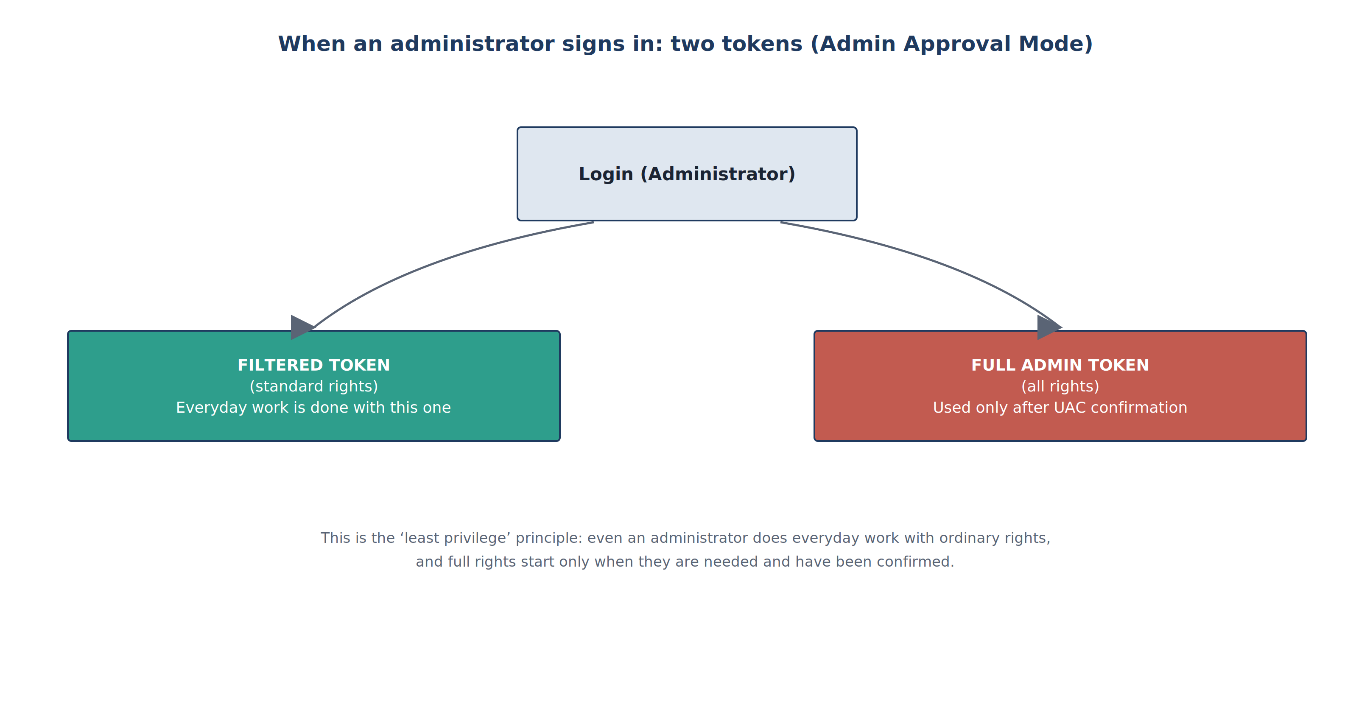
Figure 34. The two tokens created when an administrator signs in (Admin Approval Mode)
This is the practical form of the “least privilege” principle: even an administrator does everyday work with ordinary rights, and full rights are activated only at the moment they are needed and confirmed.
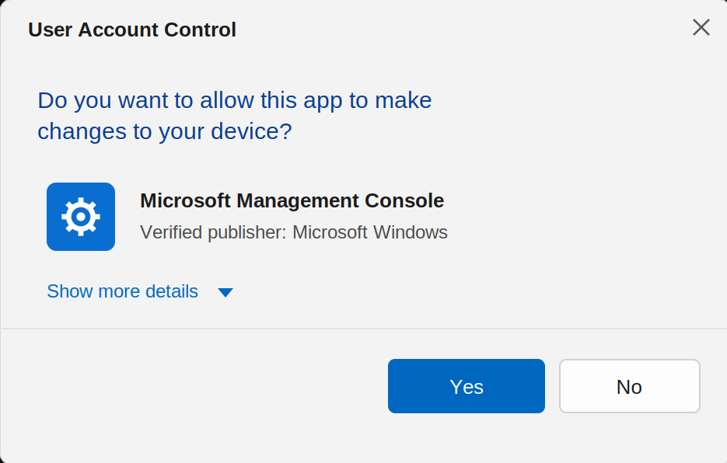
Figure 35. The UAC confirmation window (Consent prompt) — in Secure Desktop mode
In the window above, Windows shows the program’s name, its publisher (Verified publisher) and its signature status. If this line says “Unknown publisher” in red, that is a serious warning sign: an unsigned, untrusted program is asking for administrator rights. In that situation it is safer to click “No”.
UAC levels (UAC slider)
Now let us show exactly where the UAC slider is opened. Win + R → control → User Accounts → “Change User Account Control settings” (or search the Start menu directly for “User Account Control”). The window that opens looks like this:
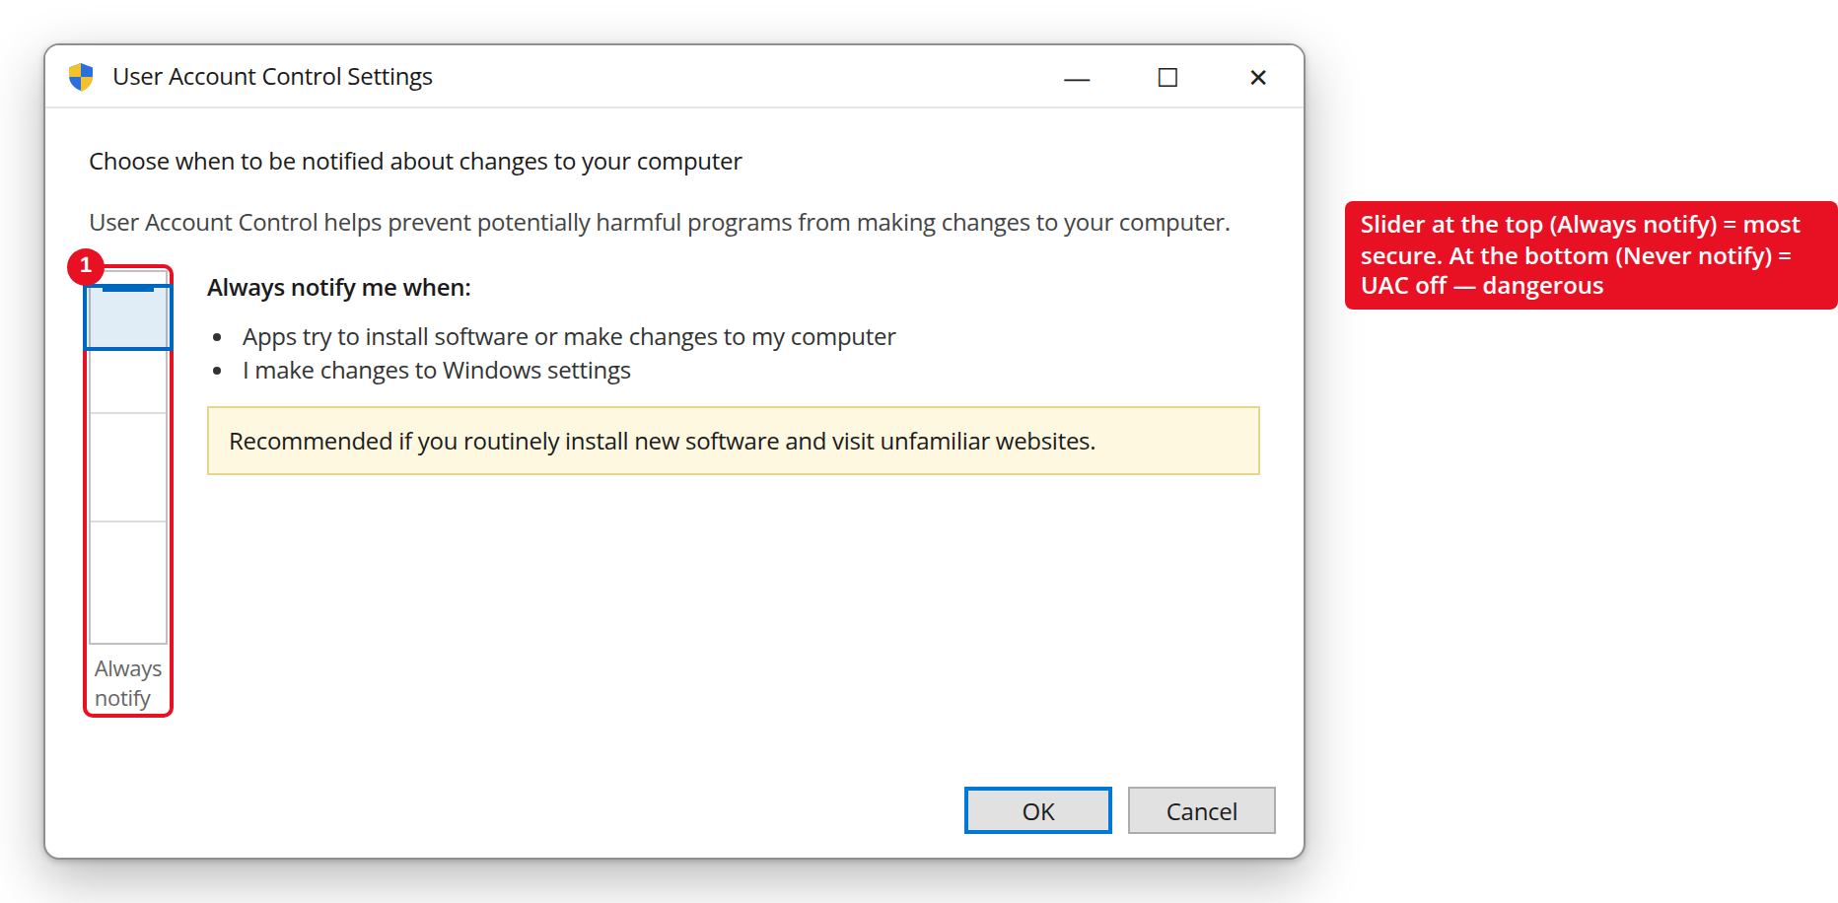
Figure 36. The UAC settings window — slider at the highest level (Always notify)
In Control Panel (Control Panel → User Accounts → Change User Account Control settings) you can set four sensitivity levels for UAC:
Level | Description
Always notify | Highest security: warns about every change (even in Windows settings) and uses the Secure Desktop.
Notify only when apps try to make changes (default) | Warns only when programs try to make changes; does not ask for Windows settings. The level recommended for most users.
Notify only when apps try (do not dim the desktop) | Same as above, but the Secure Desktop is not used — security is somewhat lower.
Never notify | UAC is turned off completely — not recommended, it lowers security significantly.
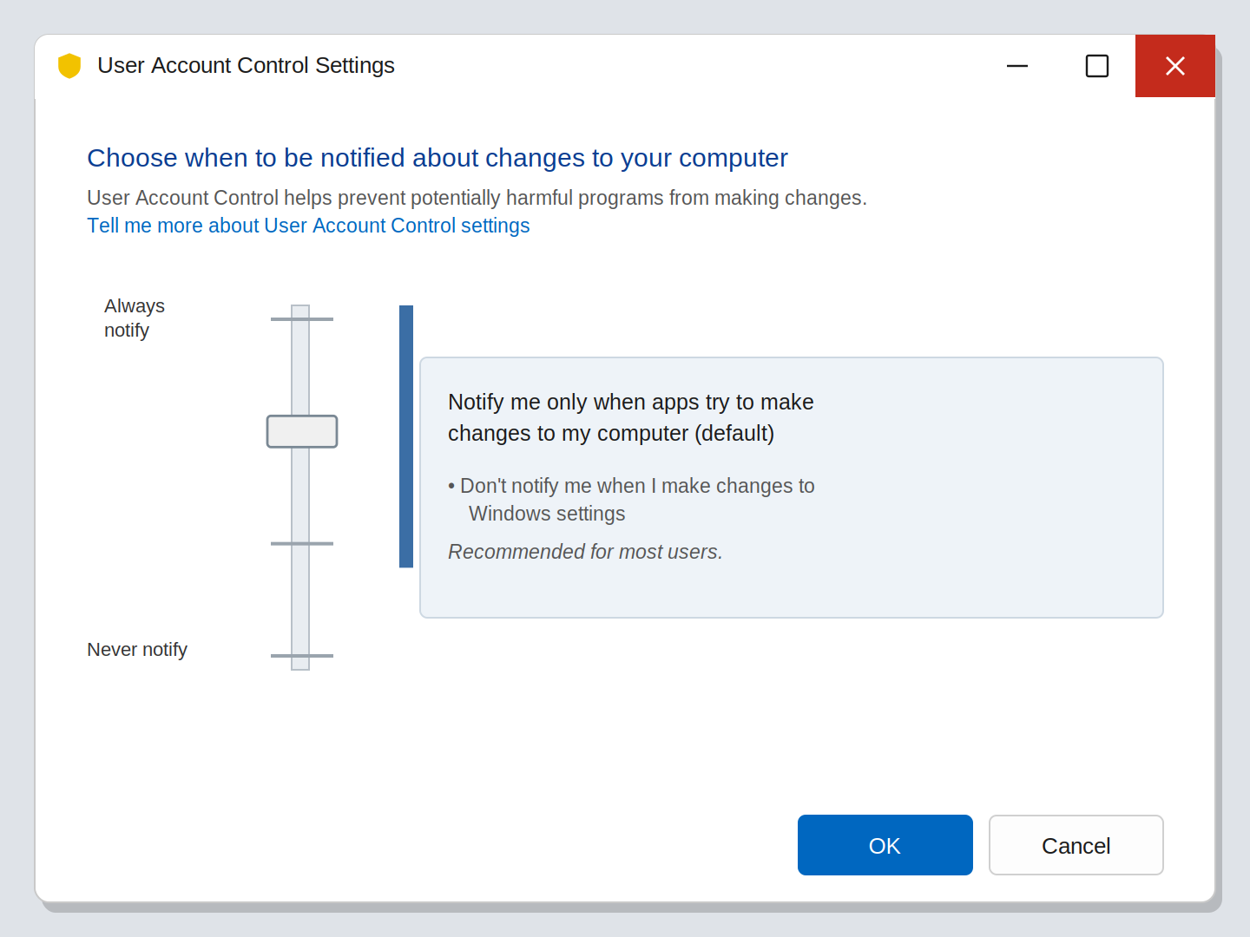
Figure 37. The UAC level settings window (User Account Control Settings)
In practice this slider is the most frequently used setting. By default it sits at the second (default) level. In environments with high security requirements — for example military or government networks — it is recommended to move the slider to the highest level, Always notify. The lowest level, Never notify, turns UAC off completely and should never be used.
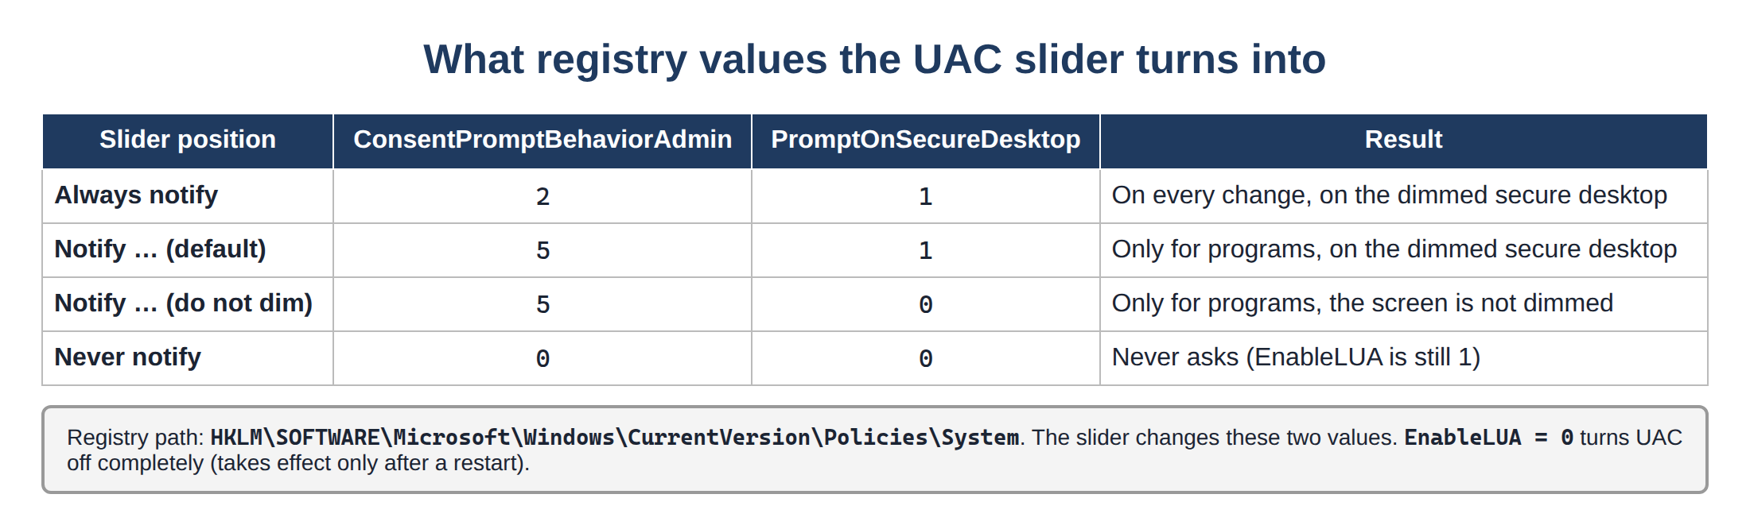
Figure 38. UAC slider positions and their registry values
1.2. AppLocker
While UAC controls who can do what, AppLocker controls which programs are allowed to run at all. In other words, AppLocker is an “allowed programs list” (whitelist) mechanism: the administrator defines in advance which programs, scripts or installers may run, and everything else is blocked automatically.
This is especially important in corporate and military organizations: if an employee accidentally or deliberately tries to run malware from an unknown source (for example from a USB flash drive), AppLocker stops it automatically — even if the user says “Yes”.
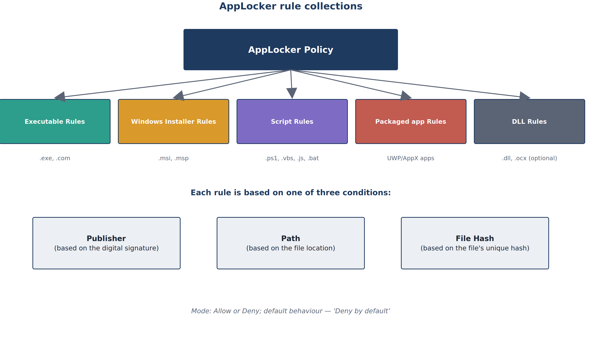
Figure 39. AppLocker rule collections and conditions
AppLocker is divided into five rule collections — Executable (.exe/.com), Windows Installer (.msi/.msp), Script (.ps1/.vbs/.js/.bat), Packaged app (UWP apps) and DLL. Each rule can be based on one of three conditions:
- Publisher: allows a program based on its digital signature (its vendor) — the most flexible method, because the rule keeps working even when the program is updated.
- Path: allows a program based on the location of the file (for example, only programs inside C:\Program Files are allowed).
- File Hash: allows a program based on the unique digital “fingerprint” of that exact file — the strictest method, but the rule must be rewritten whenever the program is updated.
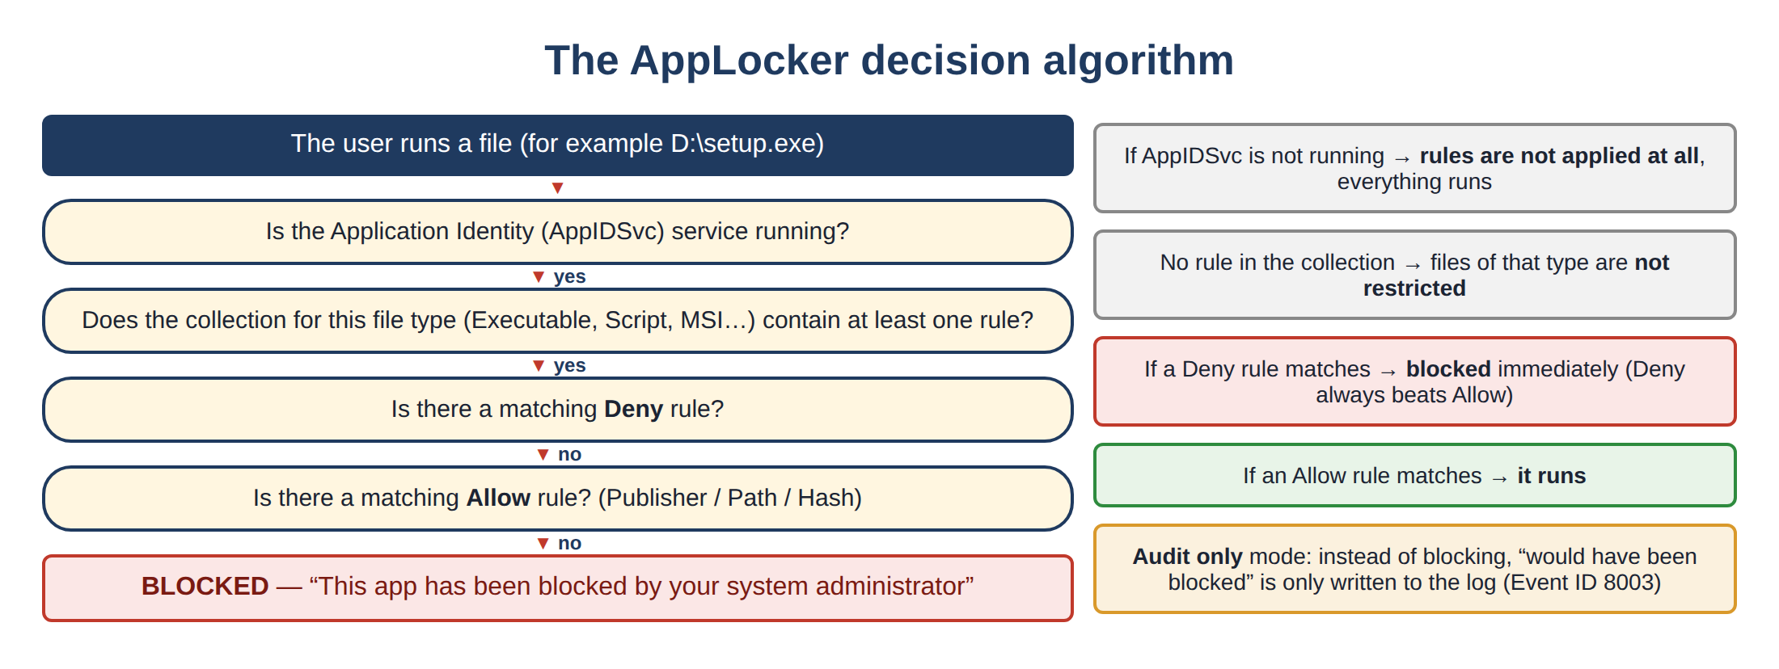
Figure 40. The AppLocker decision algorithm
Important note
• For AppLocker to work, the “Application Identity” (AppIDSvc) service must be running — this ties directly to the service concept learned in Lesson 1.
• AppLocker works fully only in the Windows Enterprise/Education/Server editions; it is limited in the Home and Pro editions.
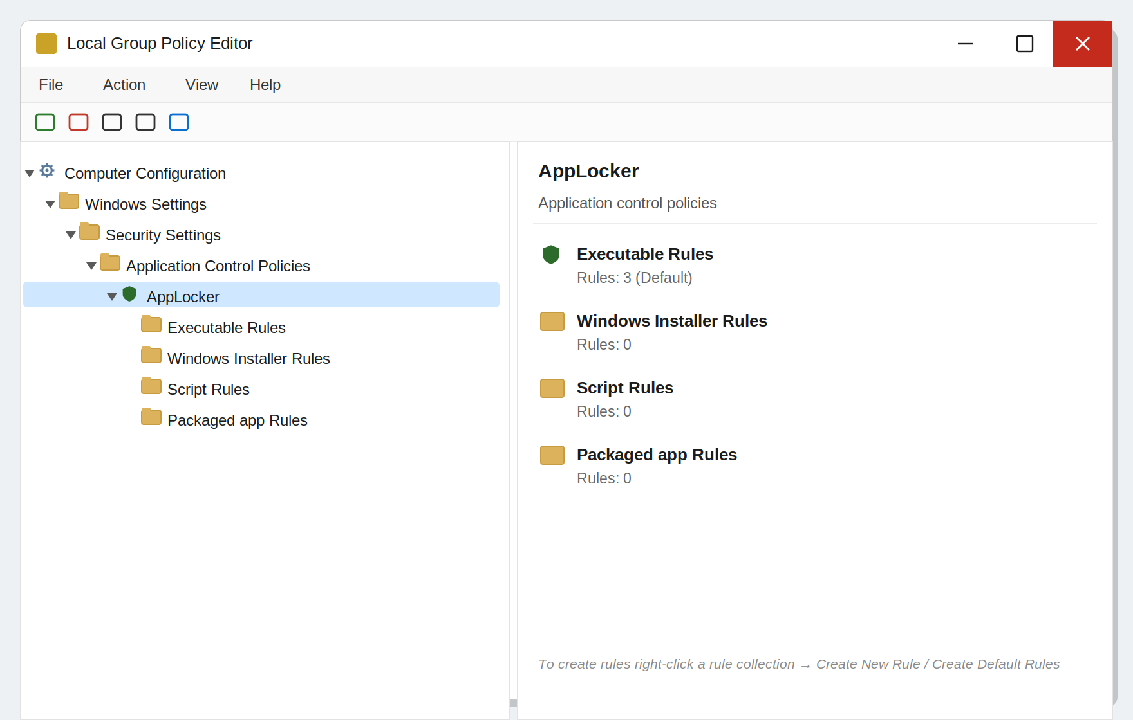
Figure 41. AppLocker rules in the Local Group Policy Editor (gpedit.msc)
Where exactly is AppLocker located? You will find it inside secpol.msc (Local Security Policy): Application Control Policies → AppLocker. (On domain computers it is managed centrally through Group Policy — gpedit.msc.)
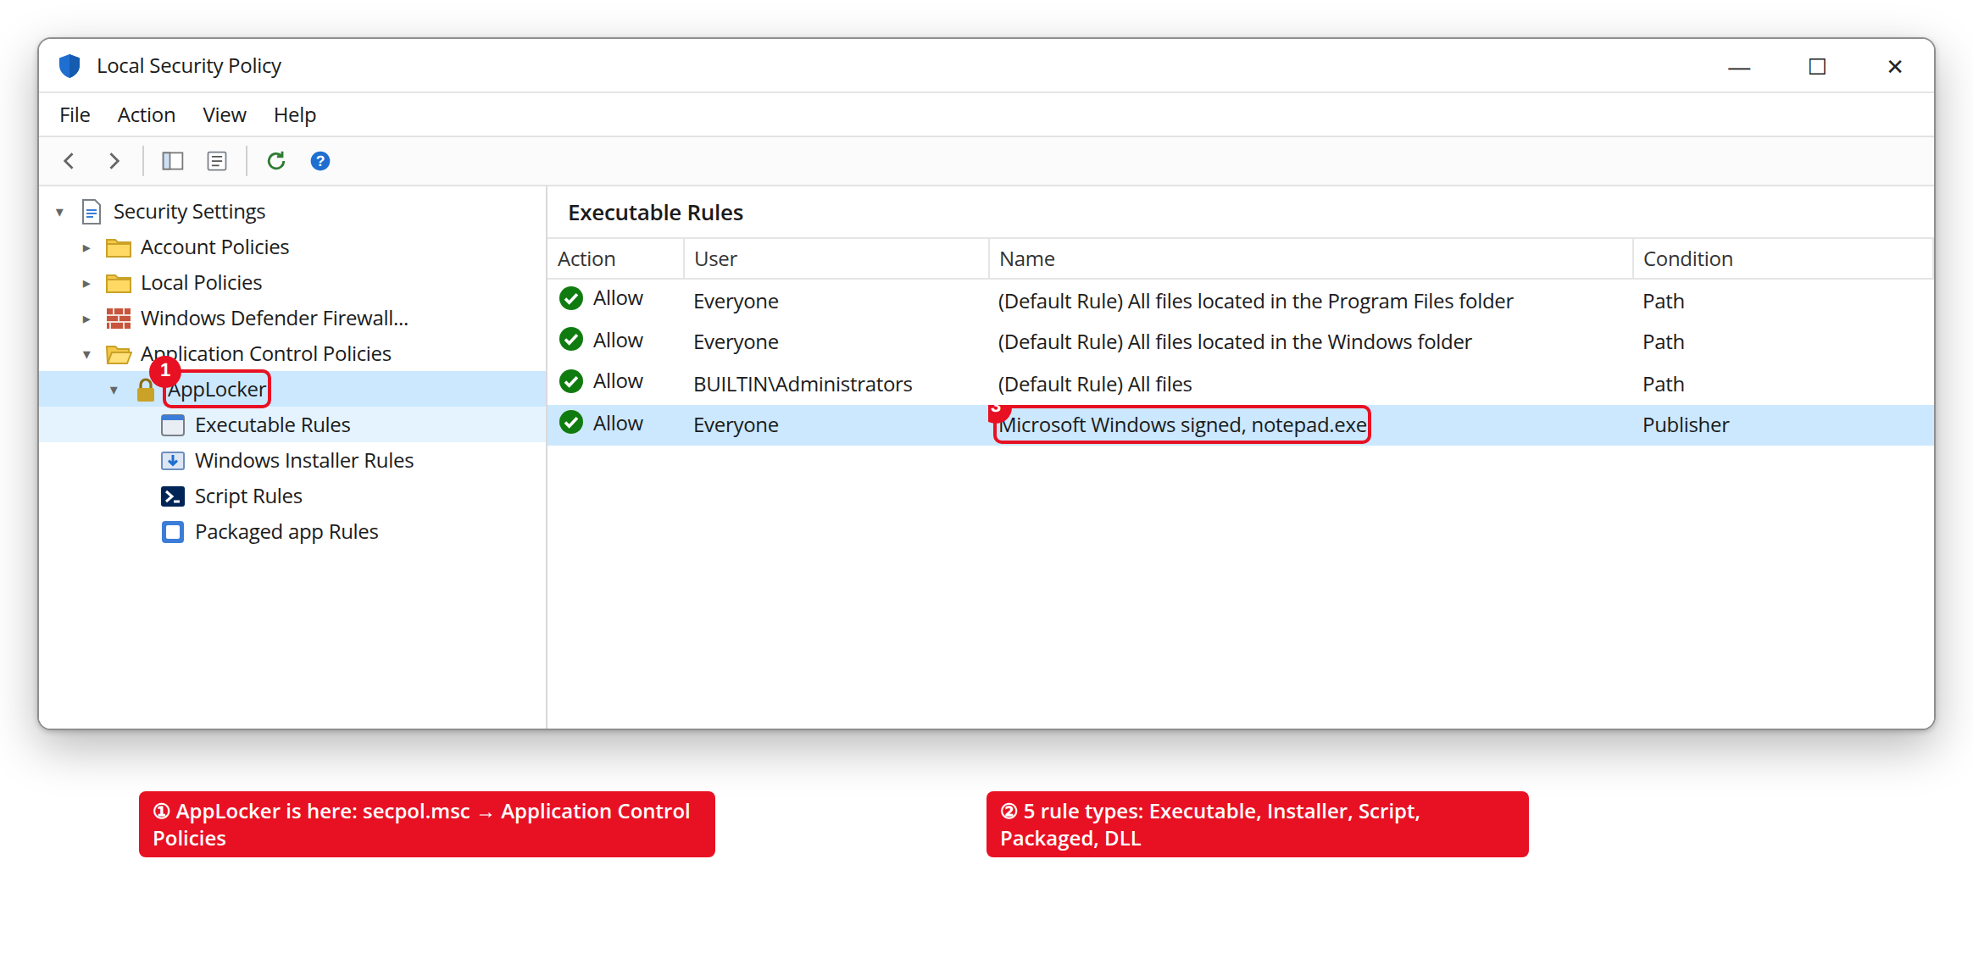
Figure 42. AppLocker inside secpol.msc (Application Control Policies)
When you create a new rule (right-click → “Create New Rule”), a wizard opens. At its “Conditions” step, one of the three conditions described above is chosen:
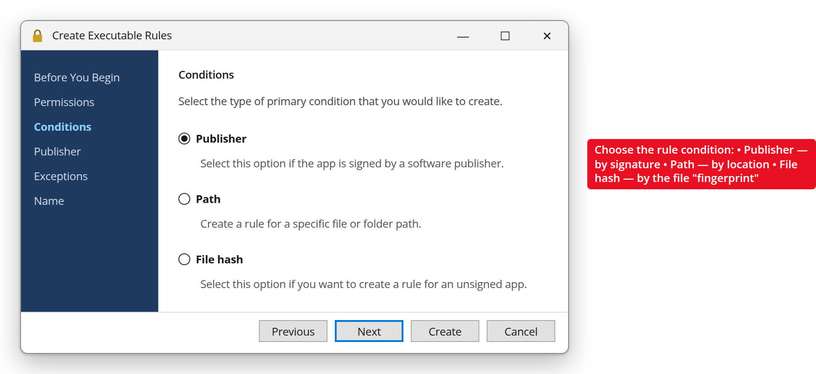
Figure 43. The AppLocker rule creation wizard — the condition selection step
When someone tries to run a program that is not covered by a rule, the following window appears — the program is blocked, even if the user is an administrator:
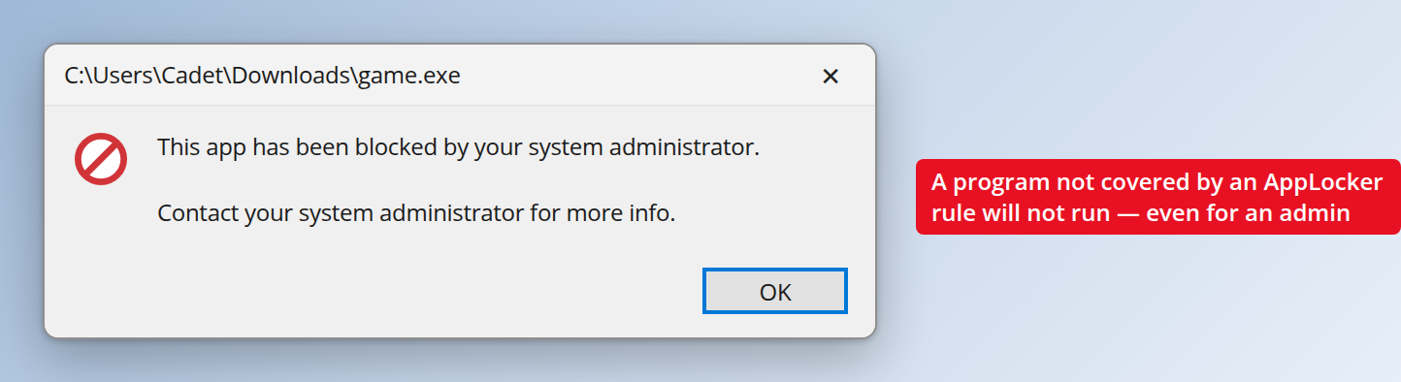
Figure 44. The window of a program blocked by AppLocker
Practical example: if the organization creates a Path rule that allows programs to run only from the C:\Program Files and C:\Windows folders, any .exe file the user tries to run from the Downloads folder or a USB flash drive is blocked automatically — even if the user is an administrator.
1.3. Windows SmartScreen
While AppLocker controls programs on the local system, SmartScreen checks how dangerous files downloaded from the internet and the websites being visited are. SmartScreen uses Microsoft’s large cloud database, which holds information about the “reputation” of millions of files and sites.
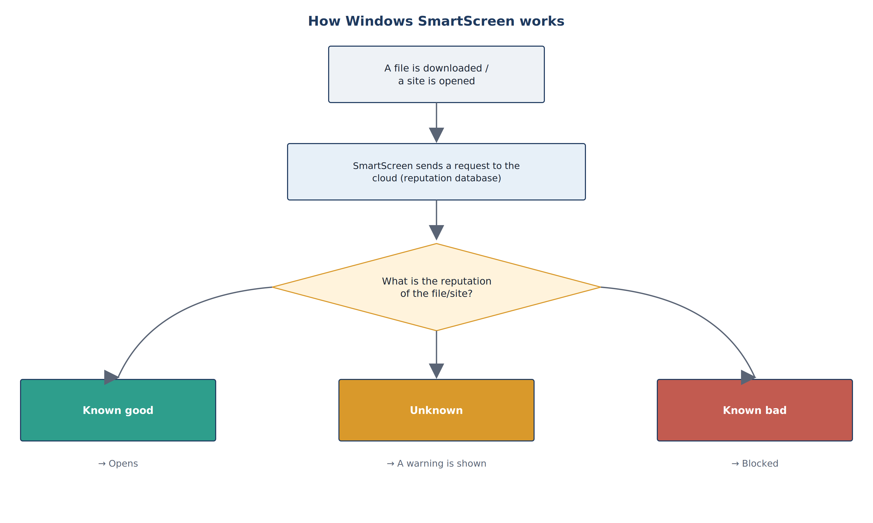
Figure 45. How Windows SmartScreen works
If a file or site is new (nobody has opened it yet) or has a low reputation, SmartScreen shows a warning such as “Unknown publisher” or “Do you want to continue the download?”. This is very effective protection against phishing (fraud) sites and newly spreading malware, because it can catch threats for which no traditional antivirus signature exists yet.
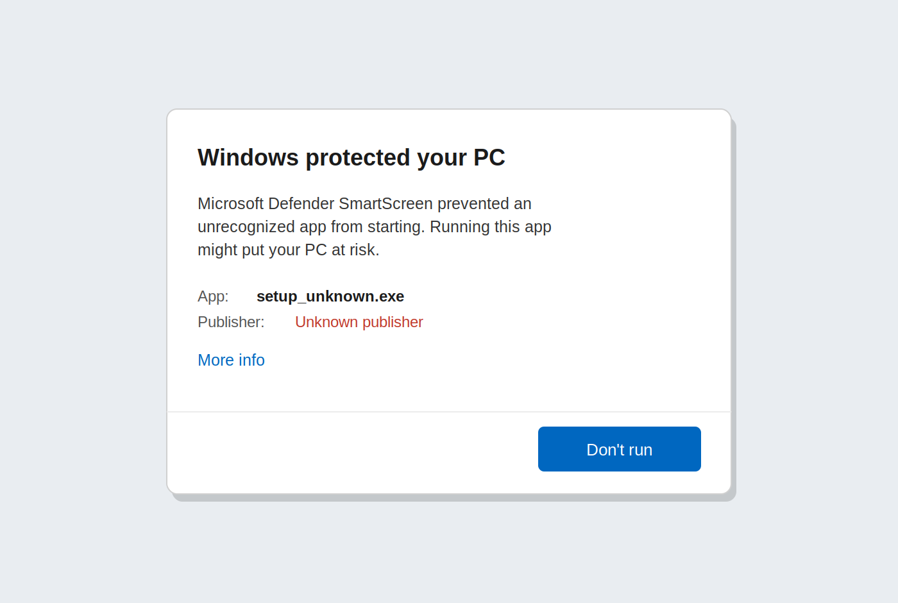
Figure 46. The Windows SmartScreen warning window
This is what a SmartScreen warning looks like in practice. Clicking “More info” reveals the program name and publisher; “Run anyway” lets you continue while taking responsibility yourself:
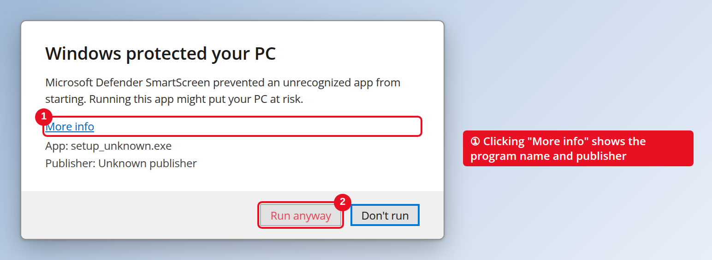
Figure 47. SmartScreen — the “Windows protected your PC” window (annotated)
Where are the SmartScreen settings? Windows Security → App & browser control → “Reputation-based protection settings”. Here it can be turned on or off (it is recommended to keep it always on):
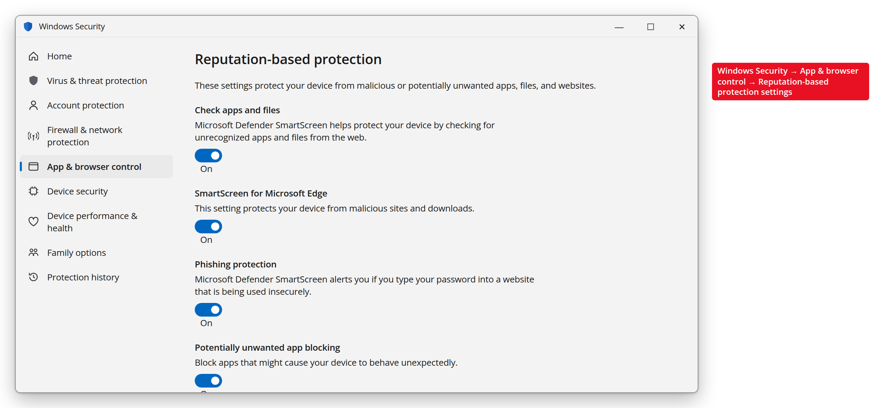
Figure 48. SmartScreen settings (Reputation-based protection)
For example, when you try to run an unsigned file setup_unknown.exe downloaded from the internet, SmartScreen shows the window above and blocks the file. The user can continue only through the “More info → Run anyway” link, taking responsibility on themselves — and this makes the user stop for a moment and think.
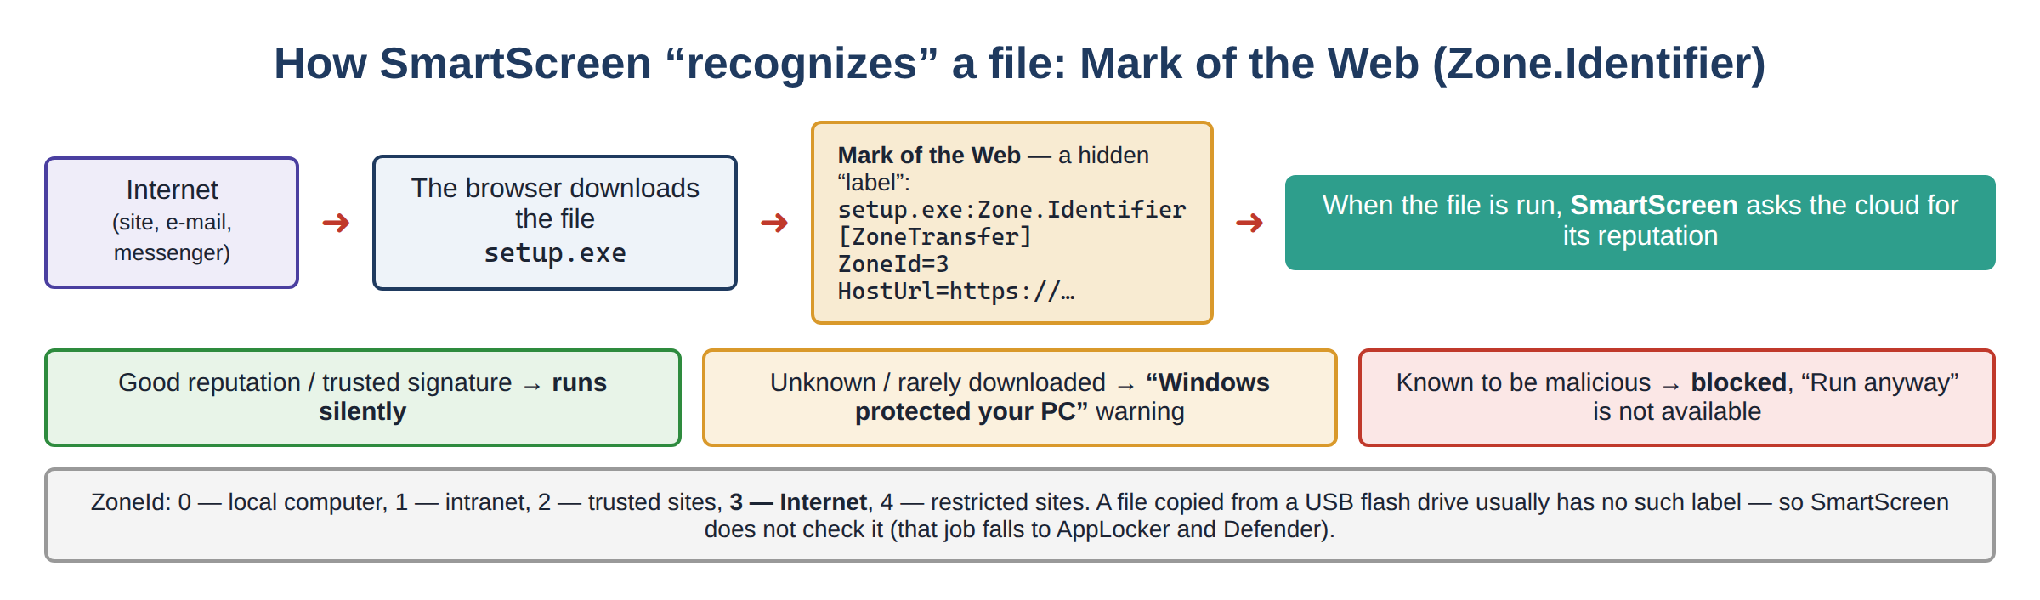
Figure 49. SmartScreen and the Mark of the Web (Zone.Identifier)

Question 2. The Defender and Firewall security systems
2.1. Windows Defender (Microsoft Defender Antivirus)
Windows Defender is the antivirus and antimalware solution created by Microsoft that comes built into Windows. While UAC, AppLocker and SmartScreen focus on “blocking in advance”, Defender focuses on actively scanning files that already exist or are running on the system and detecting malicious behavior.
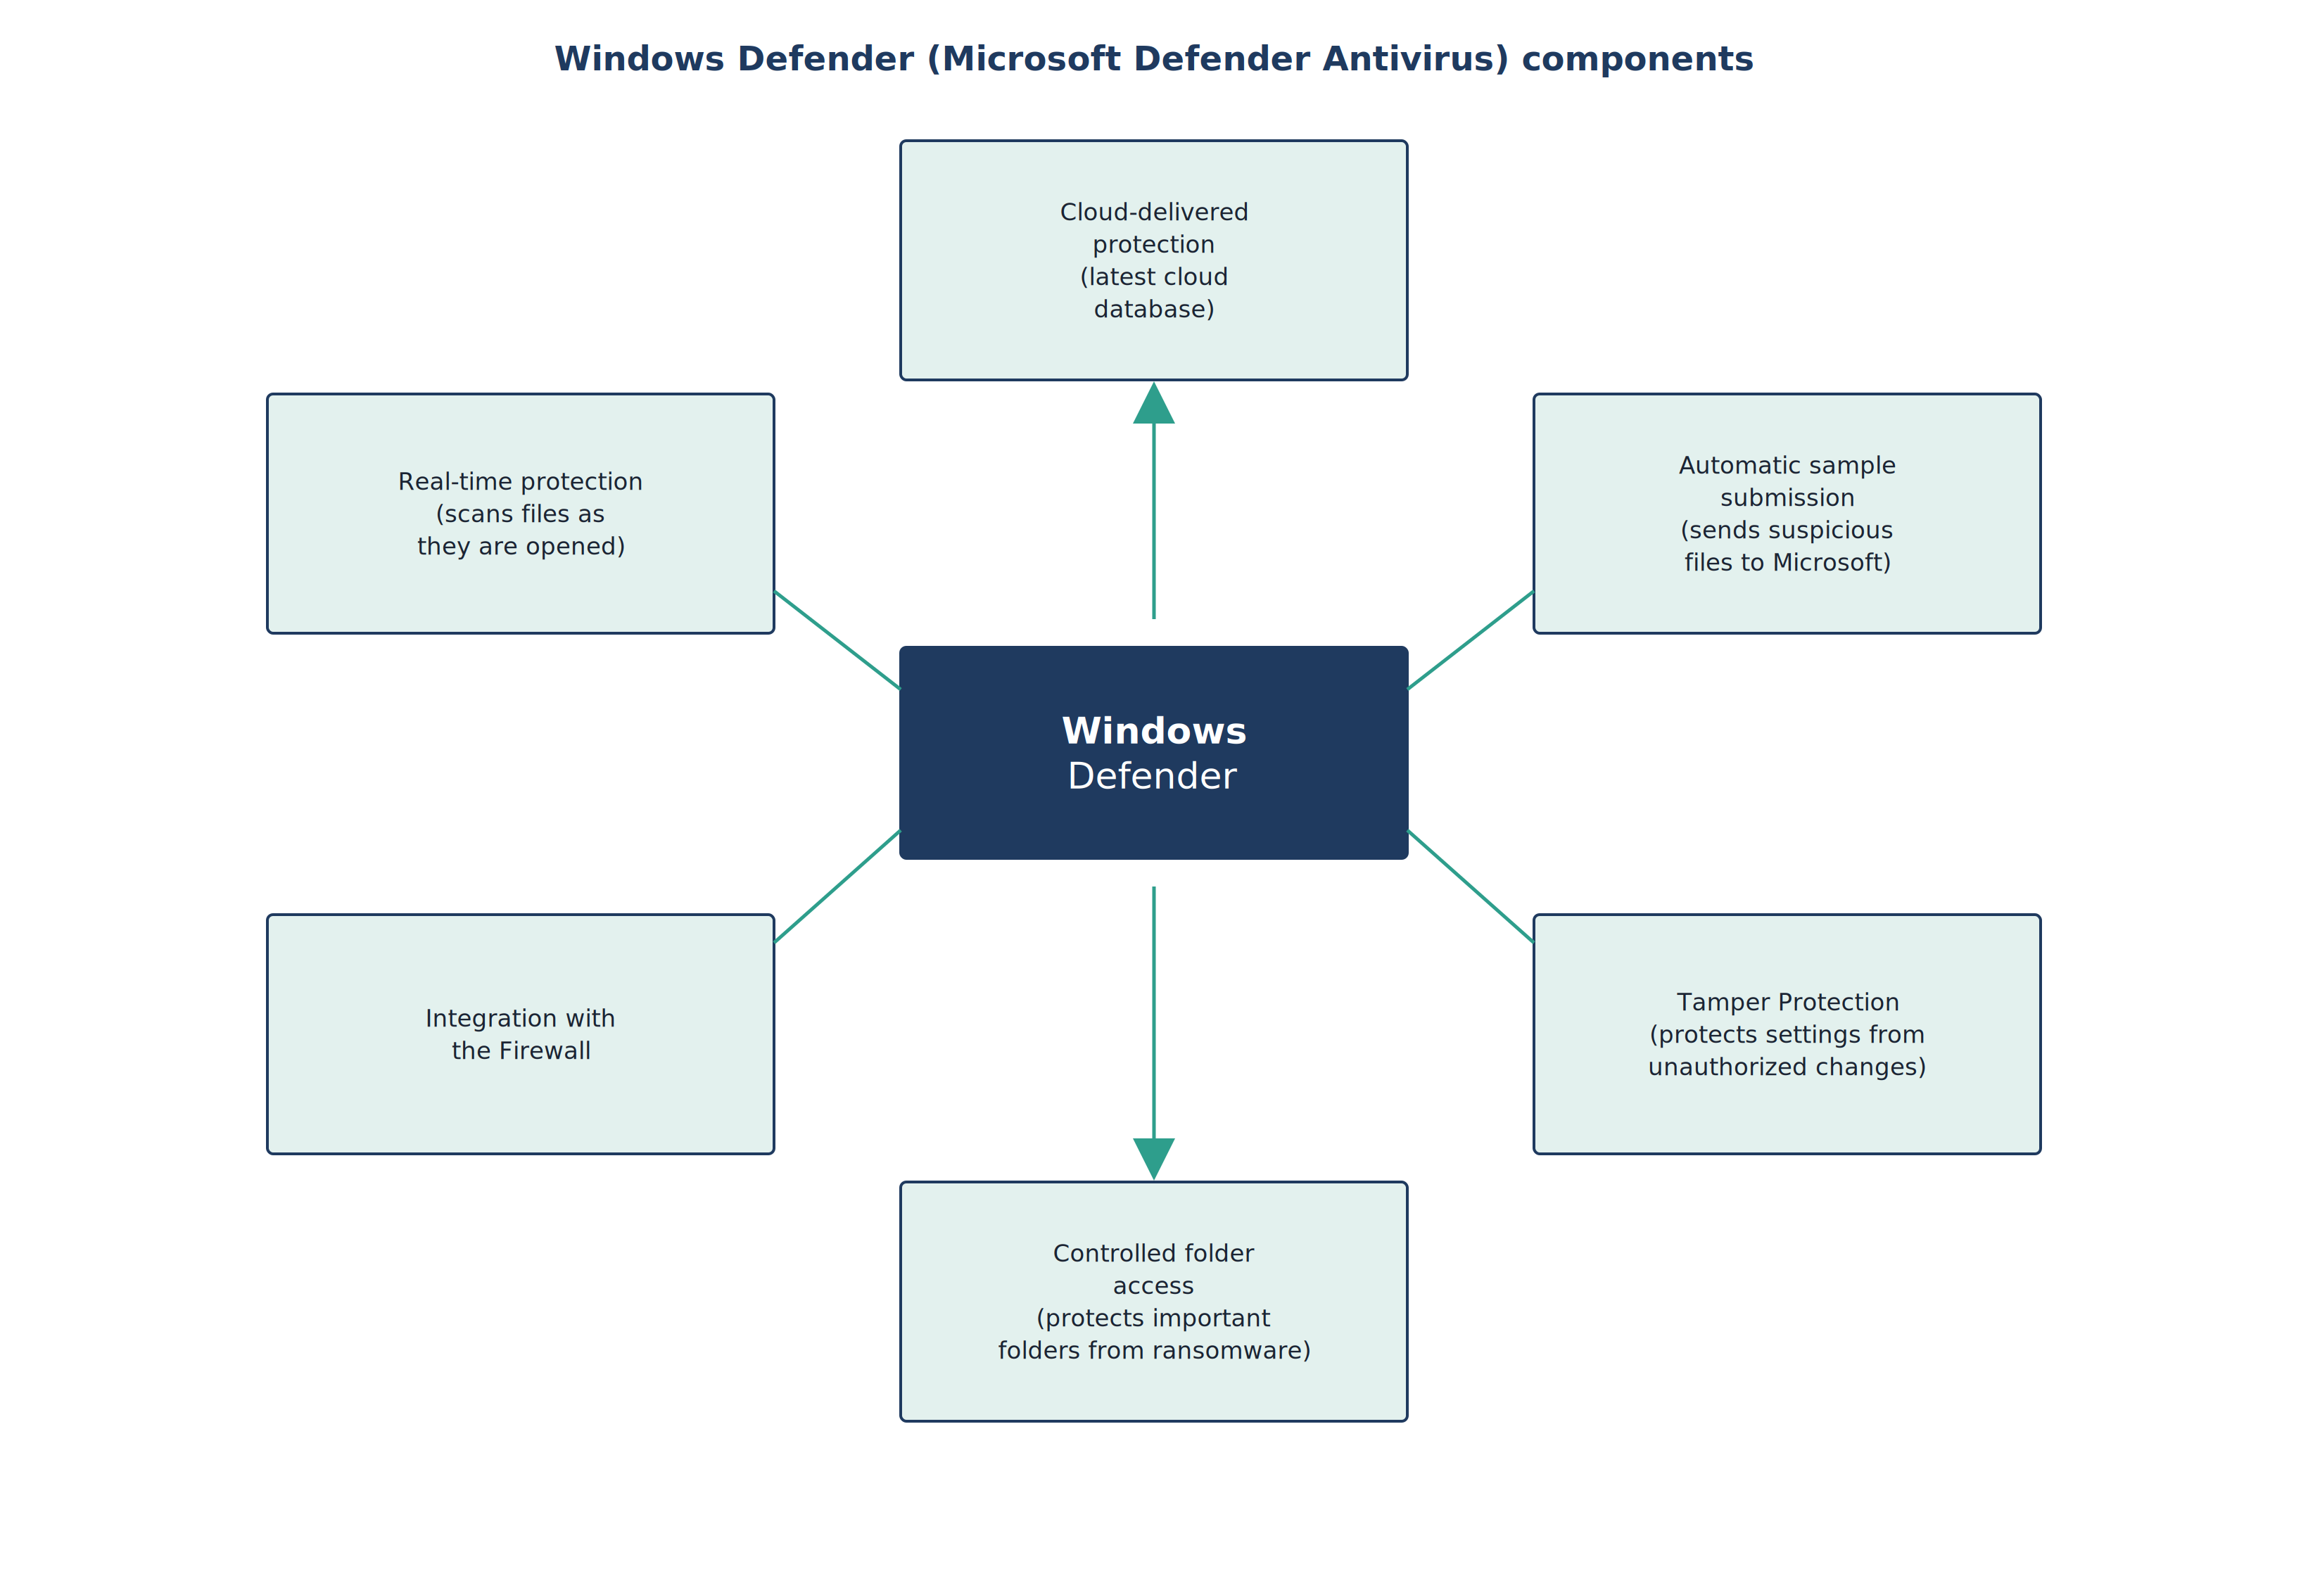
Figure 50. Windows Defender components
Component | What it does
Real-time protection | Checks every file immediately as it is opened, downloaded or run.
Cloud-delivered protection | Detects new threats that are not in the local database, using the latest database in the cloud.
Automatic sample submission | Automatically sends a sample of a suspicious but still unknown file to Microsoft for analysis.
Tamper Protection | Protects Defender’s settings from being changed or turned off by malware or an intruder.
Controlled folder access | Protects important folders (Documents, Pictures) from unauthorized changes (for example ransomware encryption).
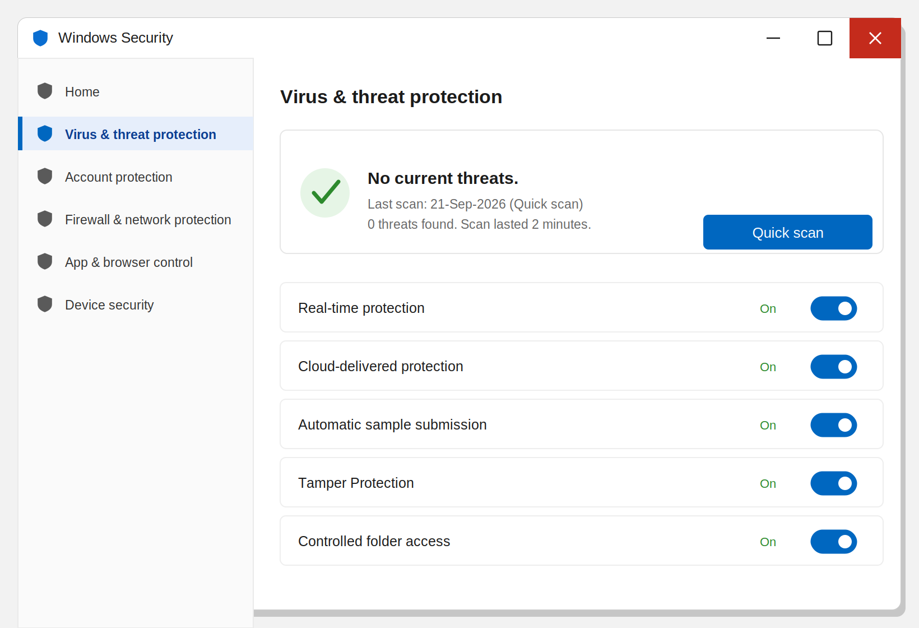
Figure 51. Windows Security — the “Virus & threat protection” section (Microsoft Defender)
2.2. Windows Firewall
Windows Firewall is the wall that controls traffic between the computer and the outside network (the internet or the local network). It checks traffic in two directions: Inbound (coming into the computer) and Outbound (leaving the computer). Each rule defines whether traffic for a particular port, program or protocol is allowed or blocked.
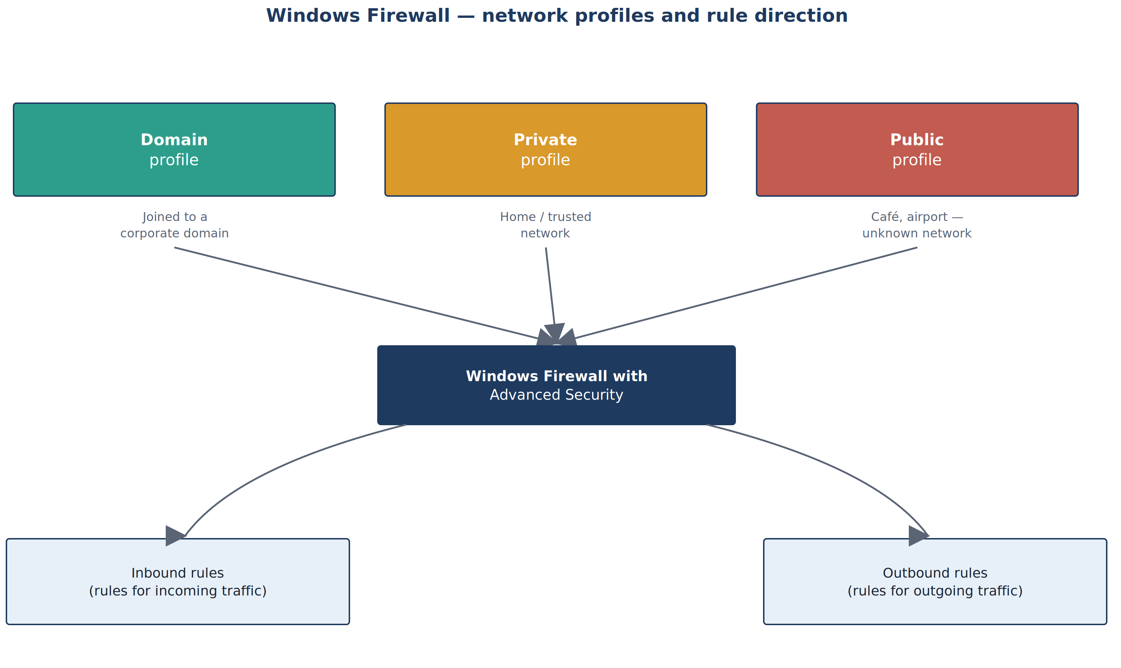
Figure 52. Windows Firewall network profiles and rule direction
An important feature of the firewall is that it applies a different profile depending on what type of network you are connected to, because the risk on a home network differs from open Wi-Fi in a café:
Profile | When it is applied | Typical security level
Domain | When the computer is joined to a corporate domain (Active Directory) | Medium — higher trust in the internal network
Private | When connected to a home or trusted private network | Medium
Public | On unfamiliar networks such as cafés, airports and hotels | Strictest — most incoming connections are blocked
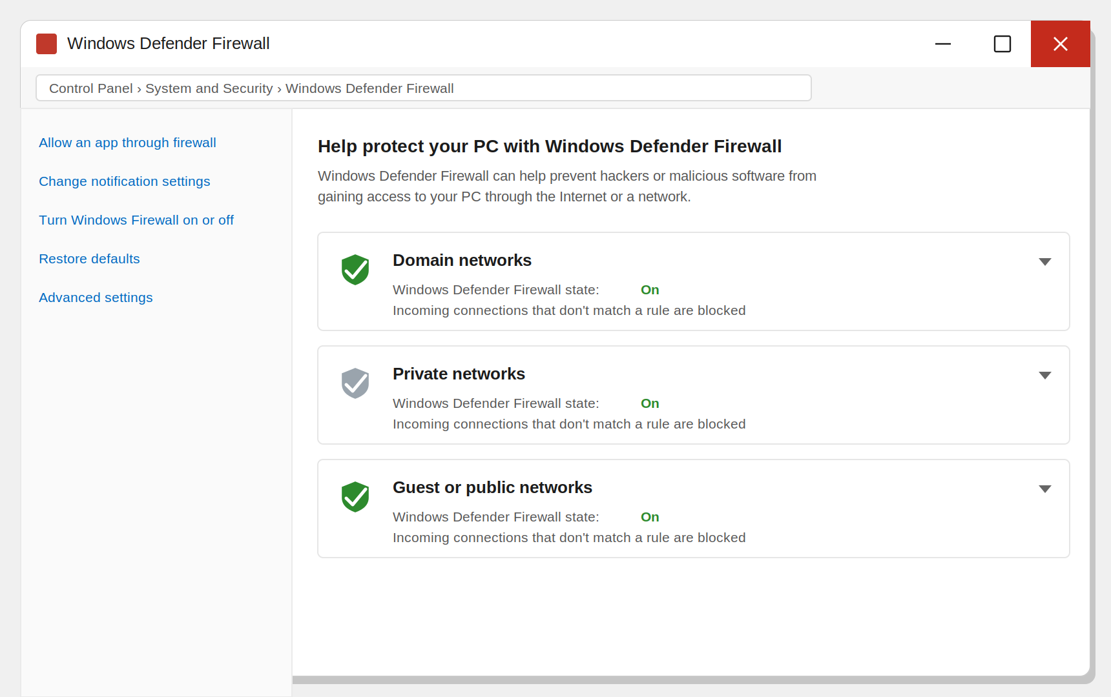
Figure 53. Windows Defender Firewall — network profiles (Control Panel)
Where is Windows Firewall opened? The simplest way is control → Windows Defender Firewall. This window shows the three profiles (Domain, Private, Public) and their status:
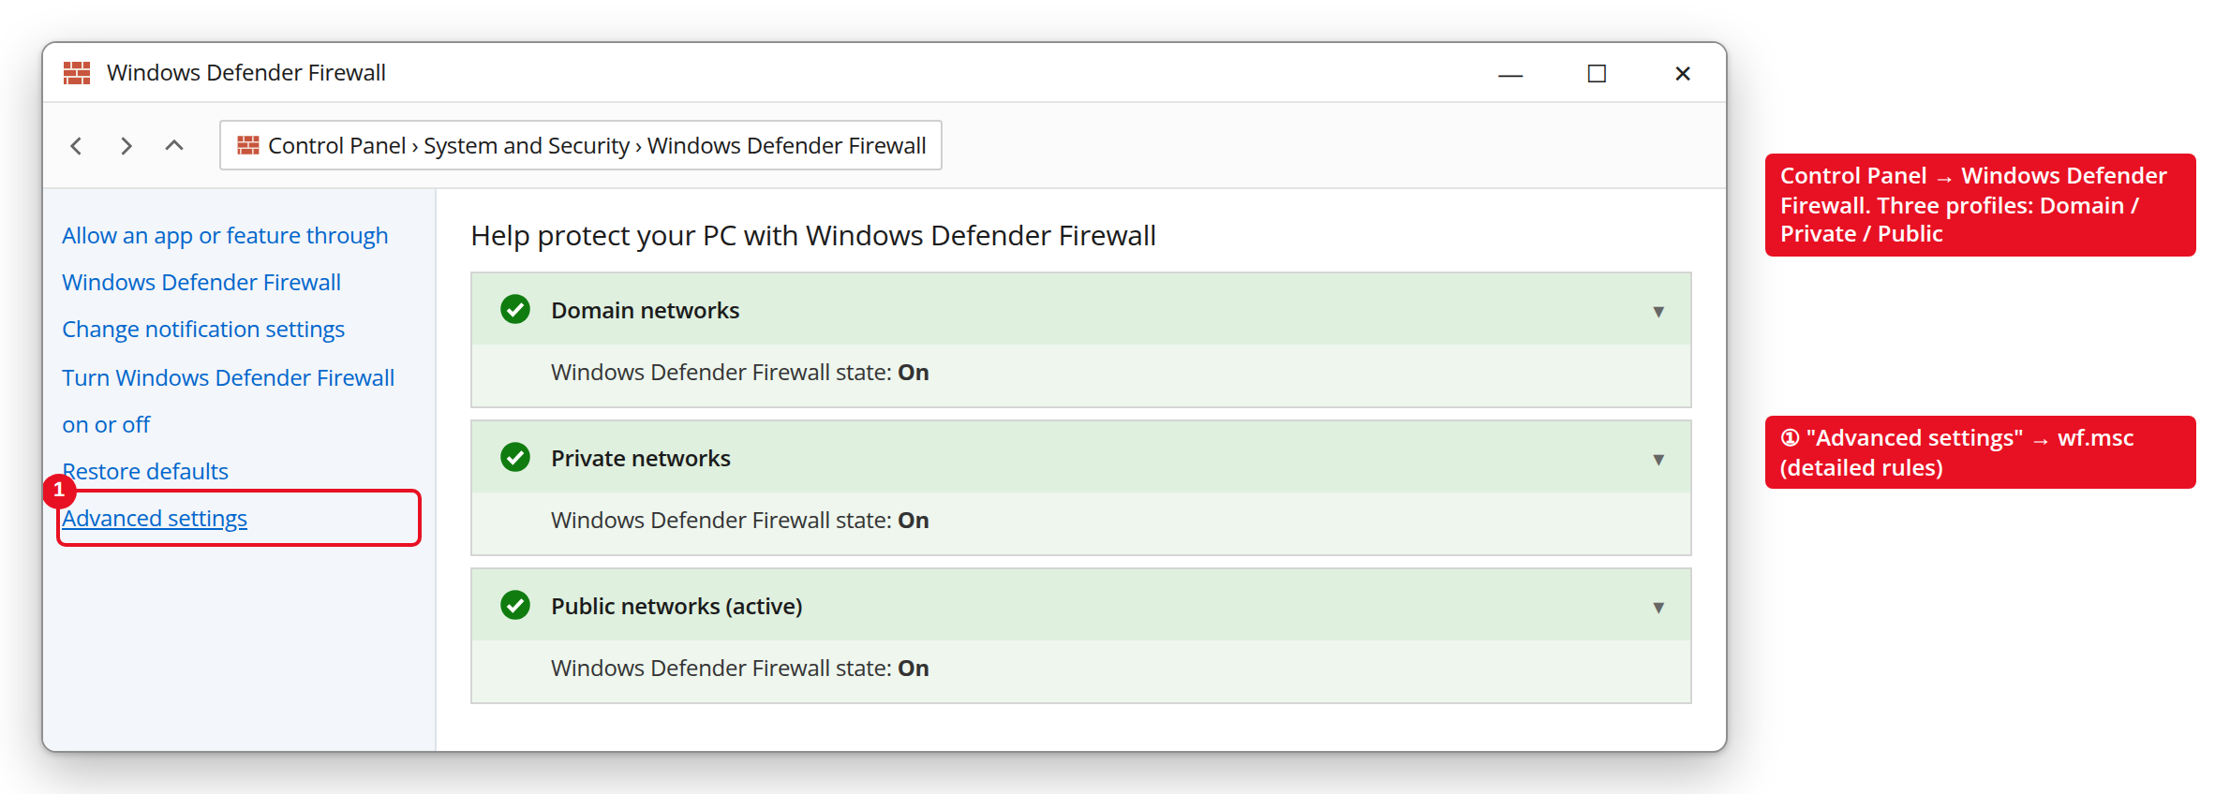
Figure 54. Windows Defender Firewall (Control Panel) — status of the three profiles
For detailed rules (allowing/blocking a specific port or program), wf.msc is opened through the “Advanced settings” link on the left. Here there are lists of Inbound and Outbound rules:
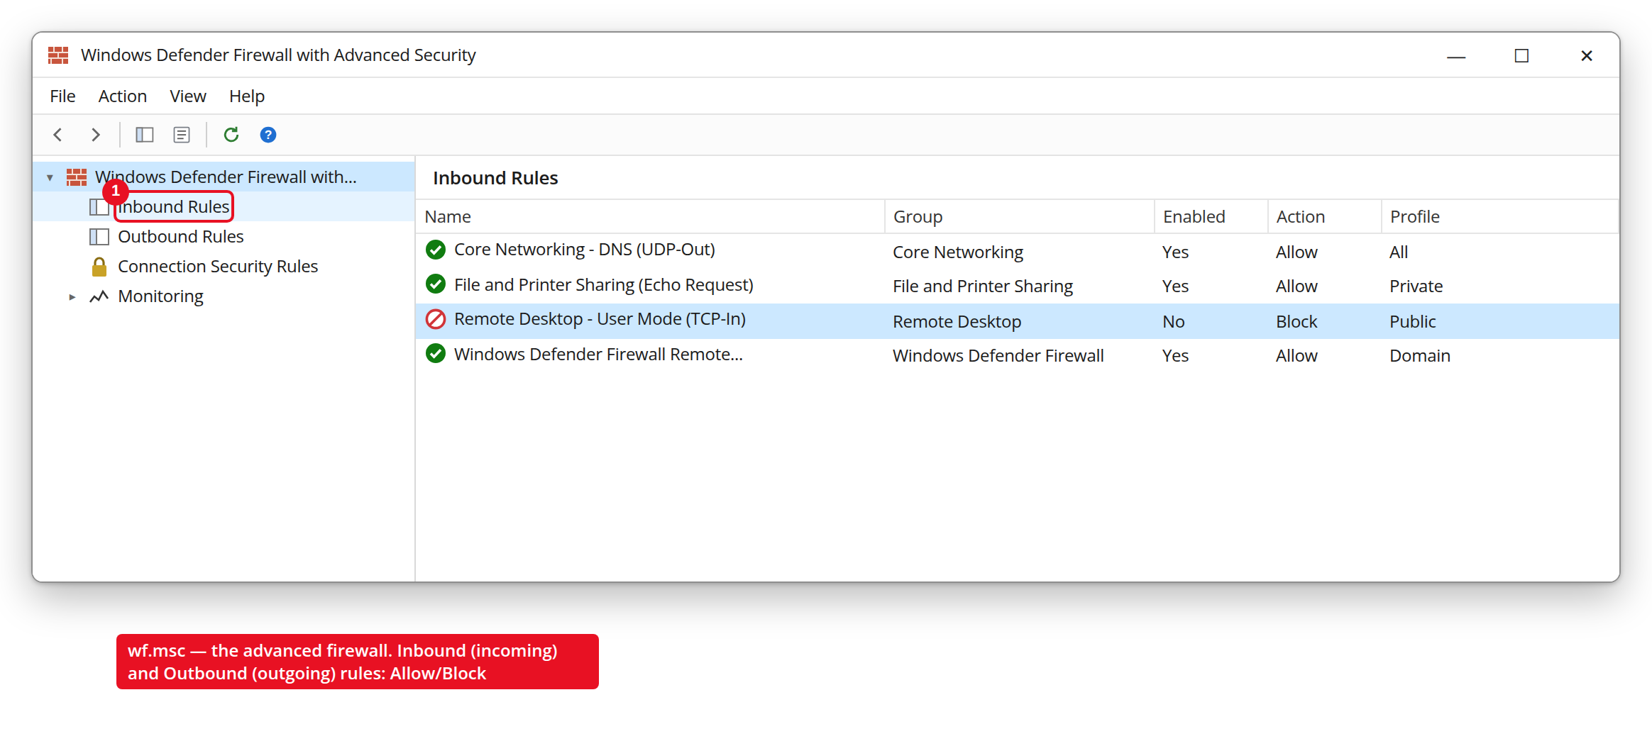
Figure 55. wf.msc — the advanced firewall, Inbound rules (Allow/Block)
A separate set of rules is kept for each profile. For example, when you connect to open Wi-Fi in a café, Windows applies the Public profile and blocks almost all incoming connections; on your trusted home network, the Private profile allows services such as file sharing.
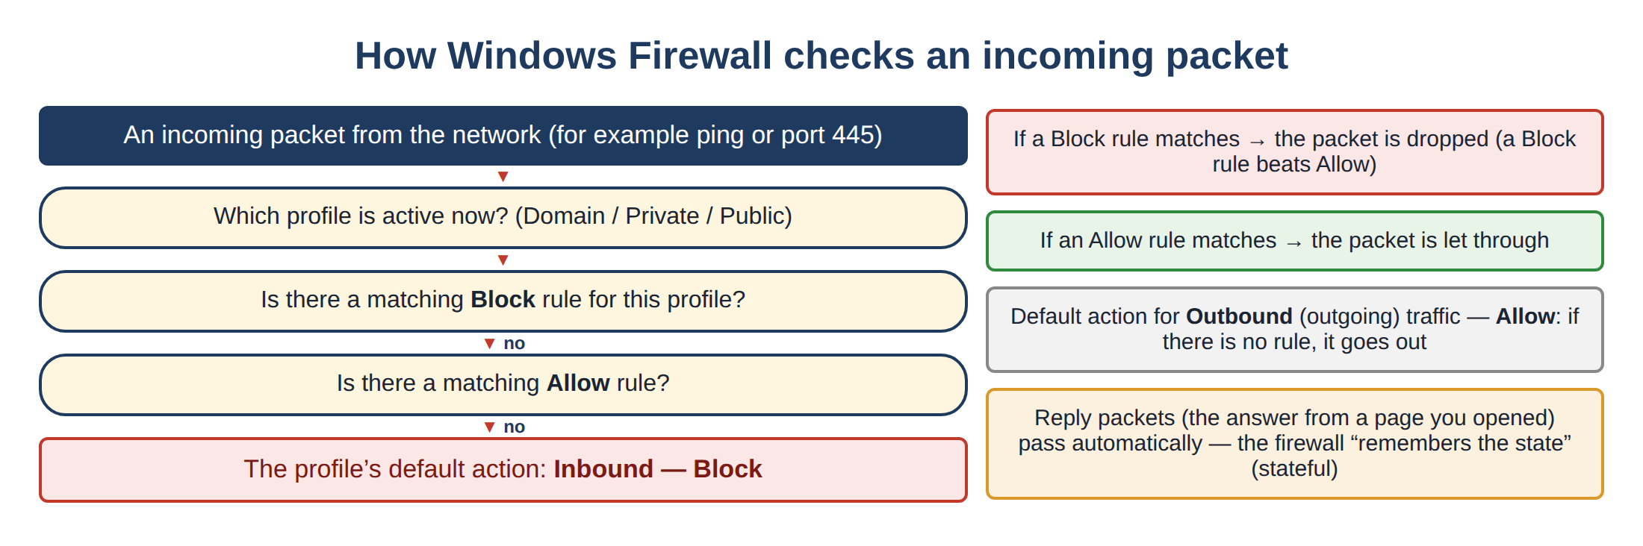
Figure 56. The Windows Firewall algorithm for checking an incoming packet

Additional important information — how all the tools work together
UAC, AppLocker, SmartScreen, Defender and Firewall are layers that work separately but together form the “defense in depth” principle. The essence of this principle: even if an attacker manages to bypass one layer, the next layer stops them.
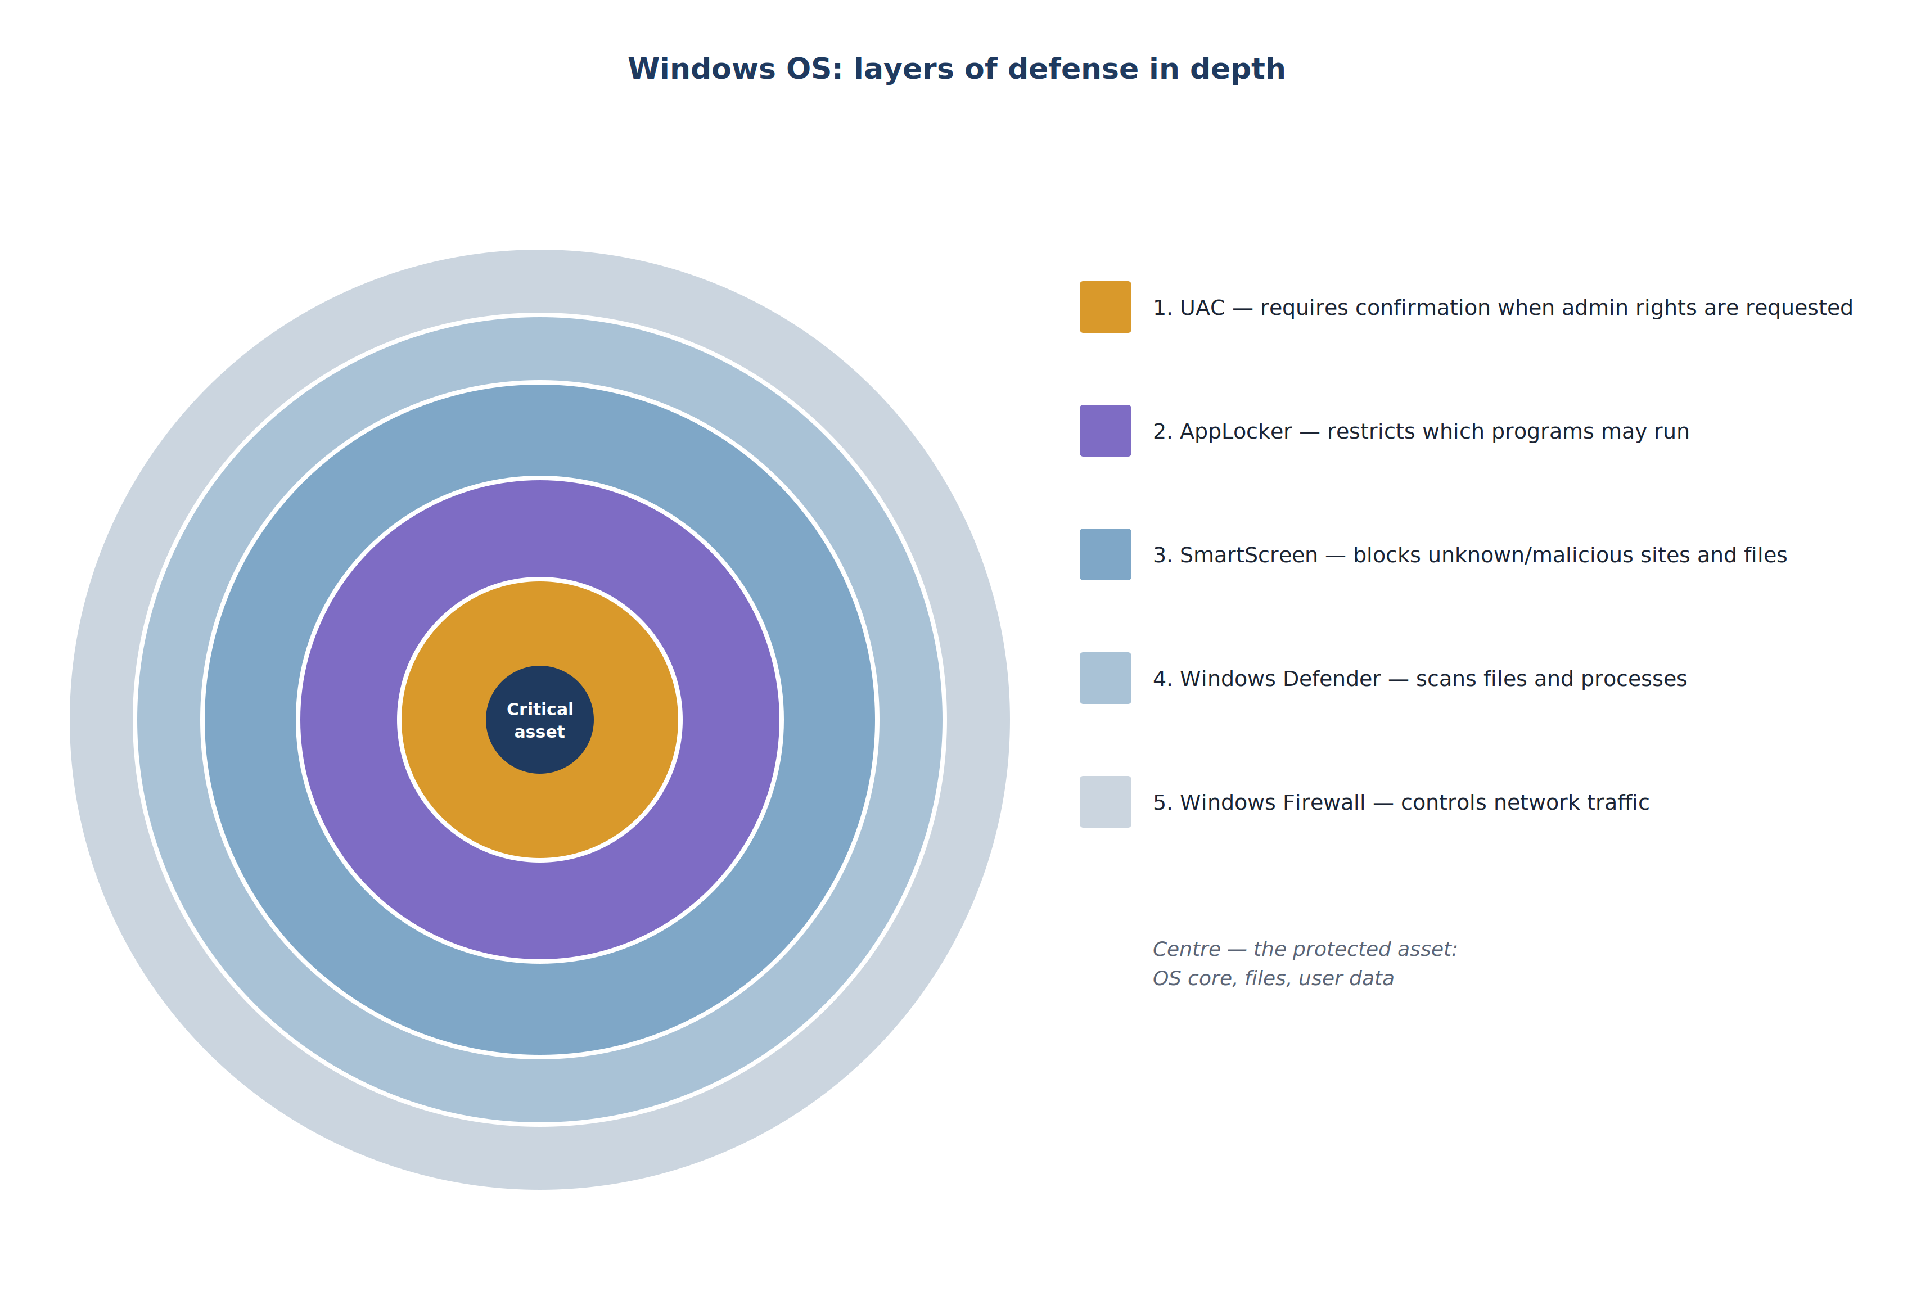
Figure 57. Windows OS: layers of defense in depth
Tool | What it mainly protects against
UAC | Admin rights being used without the user’s knowledge
AppLocker | Unauthorized/unknown programs running
SmartScreen | Malicious files downloaded from the internet and phishing sites
Windows Defender | Malicious code (viruses, trojans, ransomware) already present or running on the computer
Windows Firewall | Unauthorized connections coming in or going out over the network
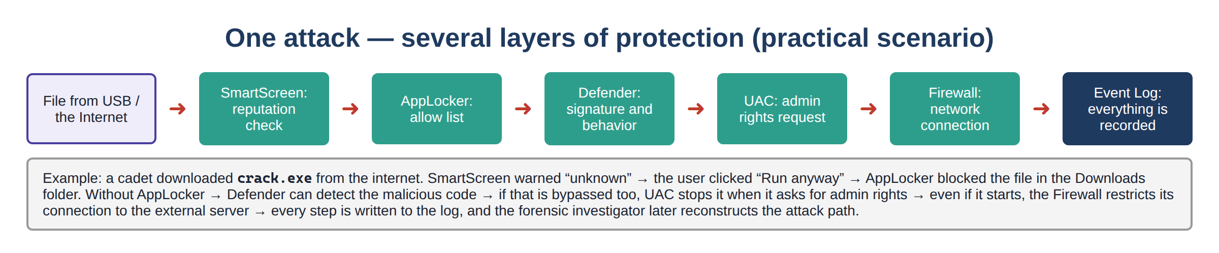
Figure 58. Several layers of protection against a single attack (scenario)
Frequently asked questions — Lesson 2
Q: I cannot find AppLocker — it is not in secpol.msc?
A: Your Windows edition may be Home. AppLocker works fully only in the Enterprise/Education and Server editions. Check your edition with winver.
Q: What is the difference between UAC and AppLocker? Don’t both of them stop programs?
A: UAC asks for confirmation before a program gets admin rights (if the user says “Yes”, it goes through). AppLocker, on the other hand, forbids the program from running at all (saying “Yes” does not help).
Q: Are SmartScreen and Defender the same thing?
A: No. SmartScreen checks new/unknown files and sites coming from the internet by their reputation (before they run). Defender is the antivirus that scans files already present on the system.
Q: How can I tell the difference between the Public and Private profiles?
A: When you connect to a new network, Windows asks “is this network private?”. If you say “No”, the Public (stricter) profile is applied; if you say “Yes”, the Private profile is applied.

Review questions — Lesson 2
- Why was UAC introduced and what problem does it solve?
- What is the difference between the Consent prompt and the Credential prompt?
- Why are the filtered token and the full admin token needed?
- Explain AppLocker’s three rule conditions (Publisher, Path, File Hash).
- Against which types of threats is SmartScreen especially effective?
- What does Windows Defender’s Controlled folder access component protect against?
- Explain the difference between the Domain, Private and Public firewall profiles.
- What does the “defense in depth” principle mean?

Lesson 3. Windows OS Services (Practical)
Topic: Windows OS Security Lesson type: Practical Duration: 4 hours

Learning questions
- User Account Control
- The AppLocker and SmartScreen security systems
Attention: This is a practical lesson dedicated to configuring, by hand, in a real (or virtual) Windows environment, the theory learned in Lesson 2. Every action must be done in a dedicated training lab or in a Windows virtual machine in VirtualBox/VMware — never try it on a work or personal computer.

Question 1. Configuring User Account Control (UAC) in practice
Practical task 1.1: Changing the UAC level
- In the Start menu search box, type “User Account Control” and open “Change User Account Control settings”.
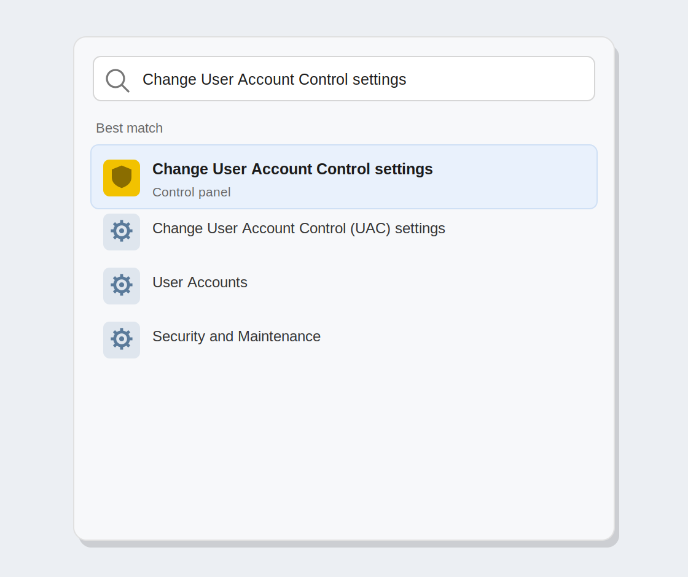
Figure 59. Searching for the UAC setting in the Start menu
- The window that opens shows a slider — it indicates the four levels.
- Move the slider to “Always notify” (the highest level) and click “OK”.
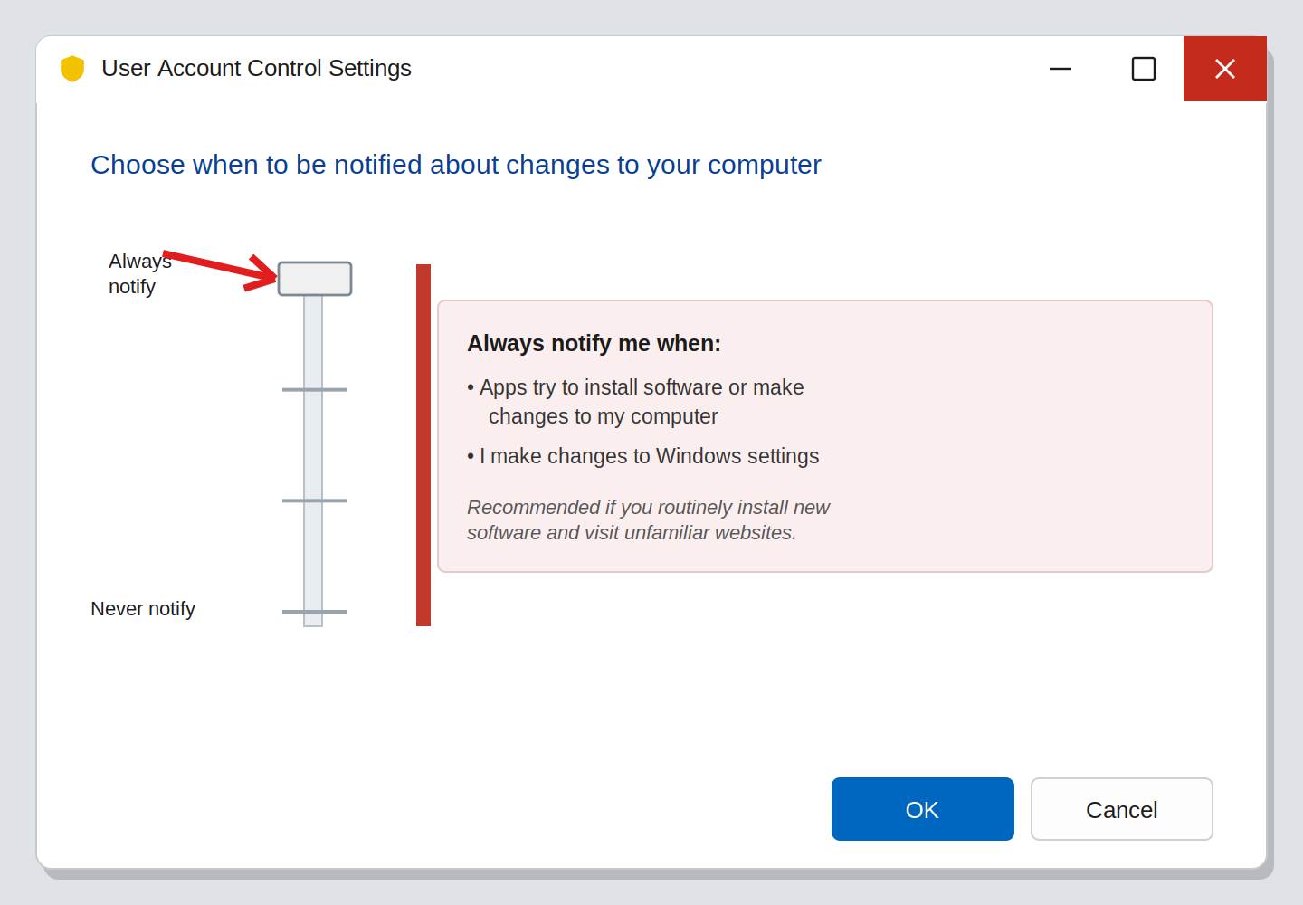
Figure 60. The UAC slider at the highest level, “Always notify”
- UAC itself asks for confirmation — answer “Yes”.
- Now try changing any system setting (for example, changing the date) — observe that now even Windows itself asks for confirmation.
- Return the slider to the default level (“Notify only when apps try to make changes”).
Practical task 1.2: Checking UAC from the command line
Open PowerShell with administrator rights and check the current UAC state with the following command:
Command | Result
Get-ItemProperty HKLM:\Software\Microsoft\Windows\CurrentVersion\Policies\System -Name EnableLUA | Shows whether UAC is enabled (1) or disabled (0)
Get-ItemProperty HKLM:\Software\Microsoft\Windows\CurrentVersion\Policies\System -Name ConsentPromptBehaviorAdmin | Shows the current UAC prompt behavior for administrators as a number (0–5)
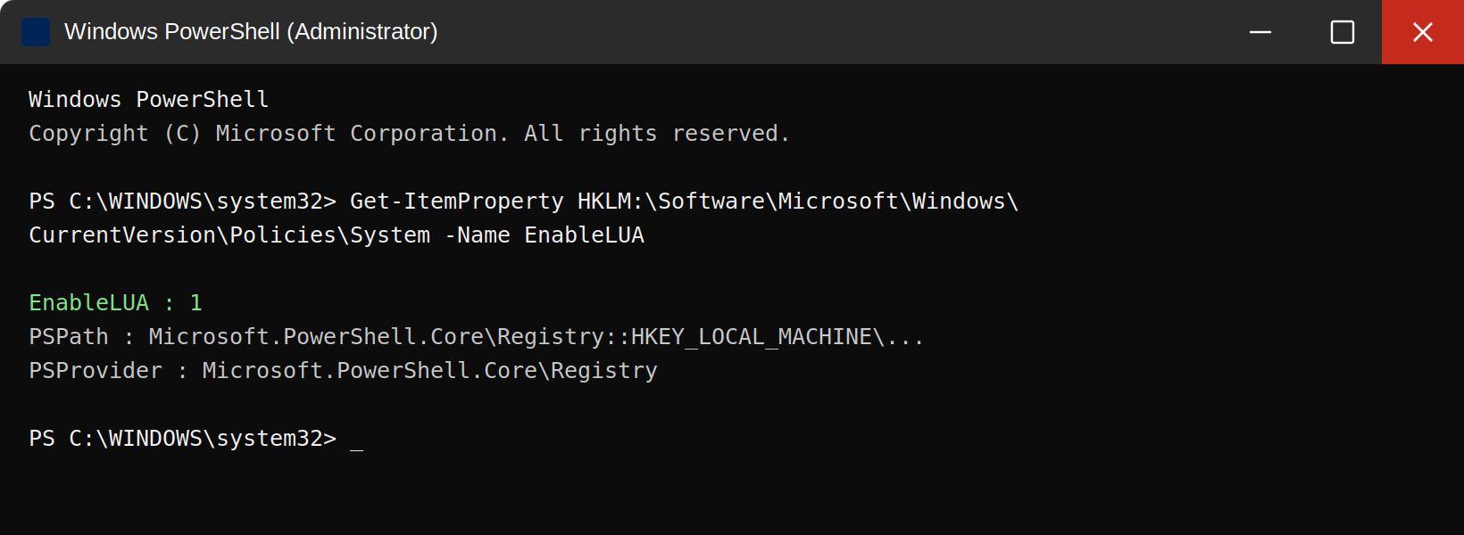
Figure 61. PowerShell — result of checking the UAC state (EnableLUA)
The full output of the command and its meaning are shown below. EnableLUA indicates whether UAC is enabled, and ConsentPromptBehaviorAdmin indicates the prompt type for administrators:
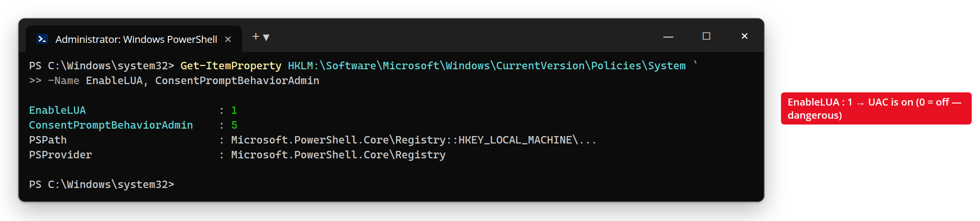
Figure 62. PowerShell — the EnableLUA and ConsentPromptBehaviorAdmin values
In the output, the value EnableLUA : 1 means UAC is enabled. If this value is 0, UAC is disabled — a serious security weakness that must be fixed immediately. The ConsentPromptBehaviorAdmin value sets the prompt type for administrators: 2 — always asks “Yes/No” on the Secure Desktop, 0 — asks nothing (dangerous), 5 — asks only for programs (default).
Note: these registry keys can be changed by hand, but changing them through the GUI is recommended, because a wrong value can make the system unstable.

Question 2. Configuring AppLocker and SmartScreen in practice
Practical task 2.1: Enabling AppLocker and creating a rule
- First, check that the required service is running: open services.msc, find the “Application Identity” service, set it to “Automatic” and start it (the knowledge from Lesson 1 is applied in practice here).
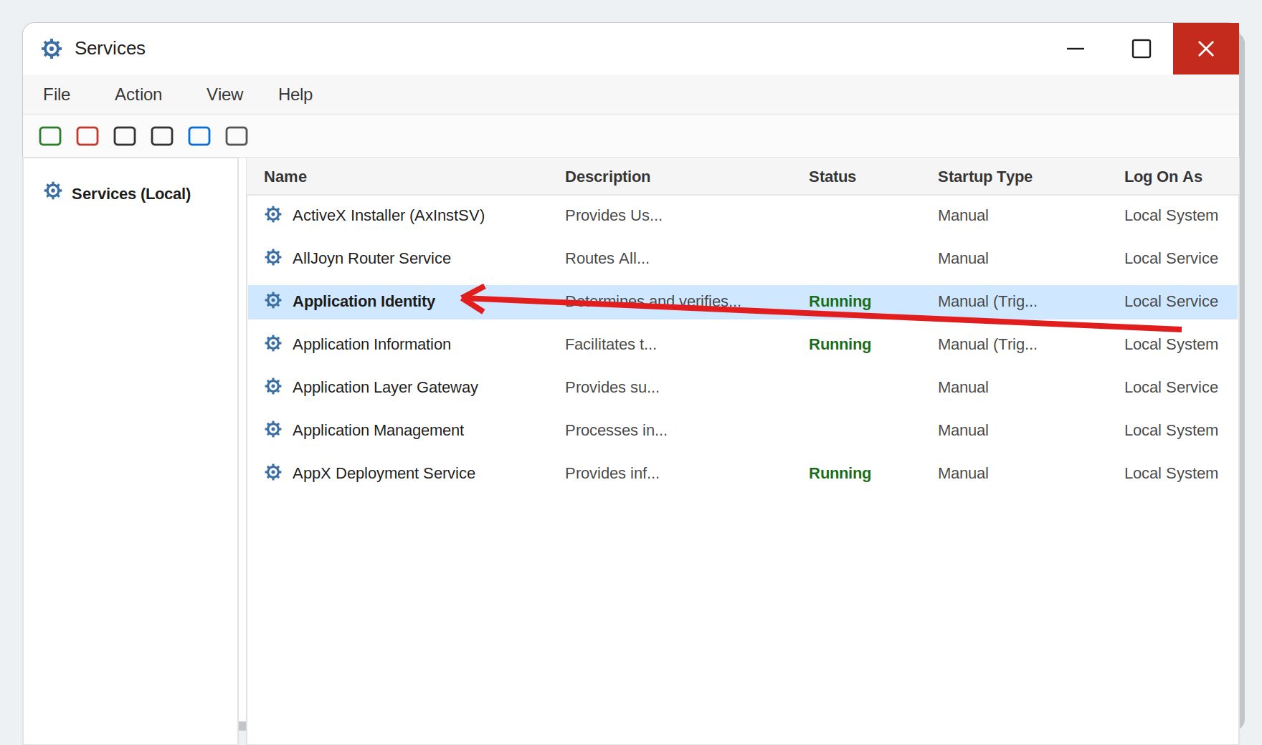
Figure 63. services.msc — the “Application Identity” (AppIDSvc) service
- Win + R → open the Local Group Policy Editor with the gpedit.msc command (available only in the Pro/Enterprise editions).
- Go through the following path: Computer Configuration → Windows Settings → Security Settings → Application Control Policies → AppLocker.
- Right-click “Executable Rules” and choose “Create Default Rules” — this automatically creates the default rules the system needs.
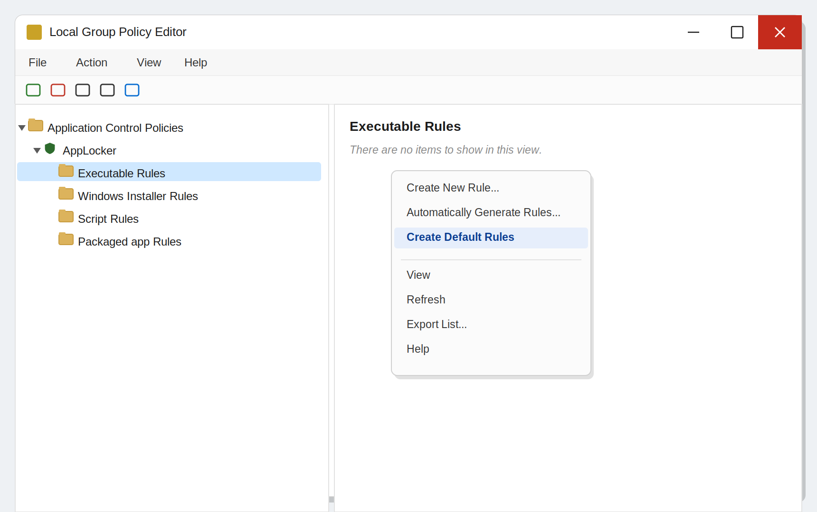
Figure 64. gpedit.msc — the “Create Default Rules” command (context menu)
- To add a new rule, right-click again → “Create New Rule” — answer the prompts, choose the “Publisher” condition and point to a signed program file (for example notepad.exe).
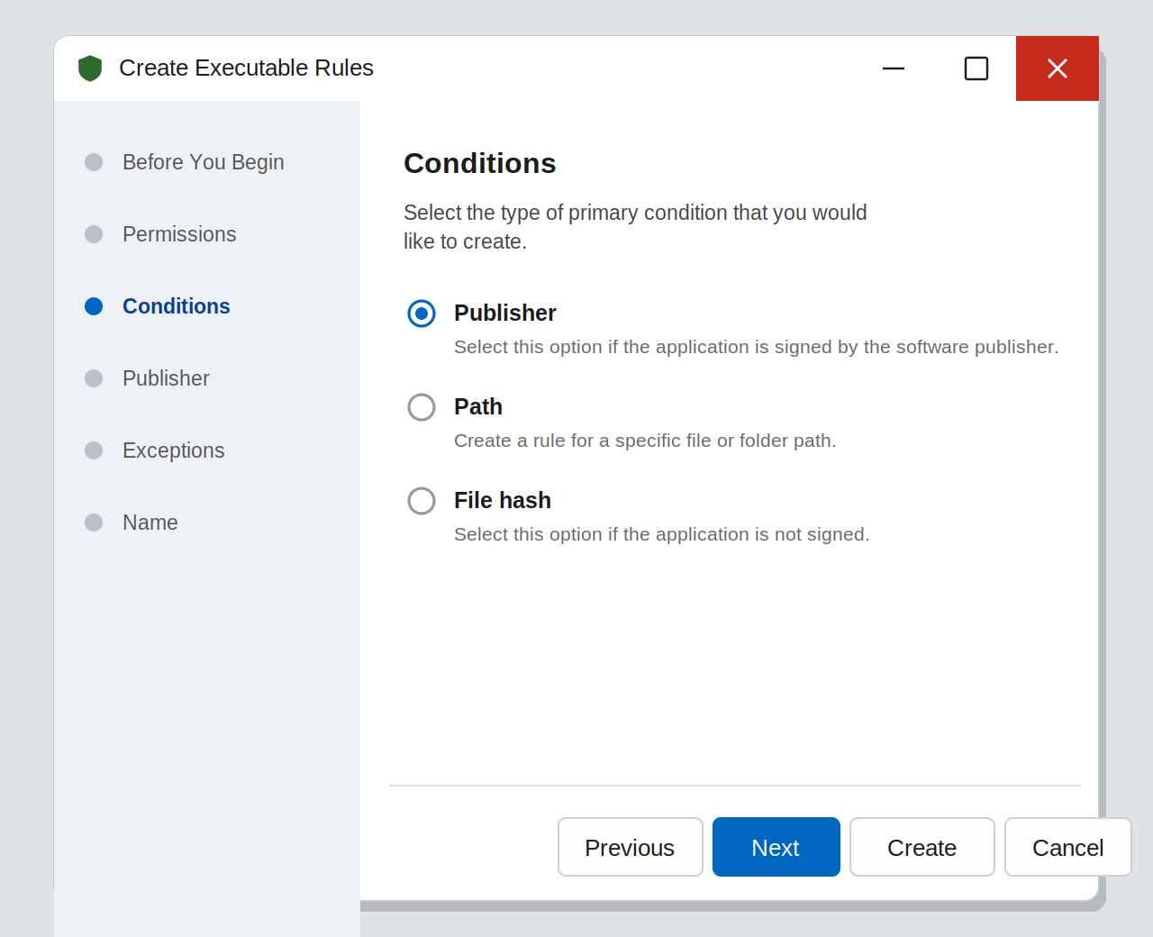
Figure 65. AppLocker — the new rule wizard (Publisher condition)
- Save the rule in “Allow” mode.
- To apply the AppLocker settings, run the gpupdate /force command in PowerShell.
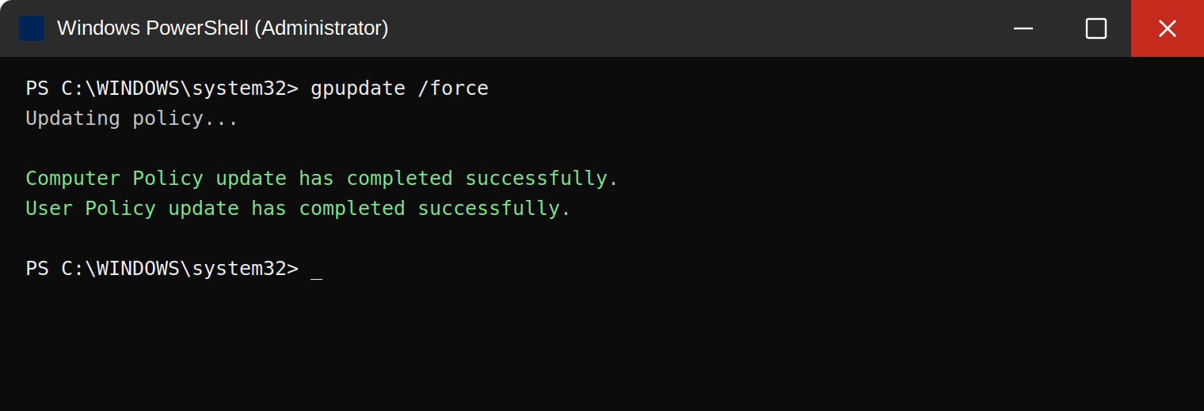
Figure 66. PowerShell — applying the policy with “gpupdate /force”
After creating the AppLocker rule, the gpupdate /force command is used to apply it immediately. A successful result looks like this:
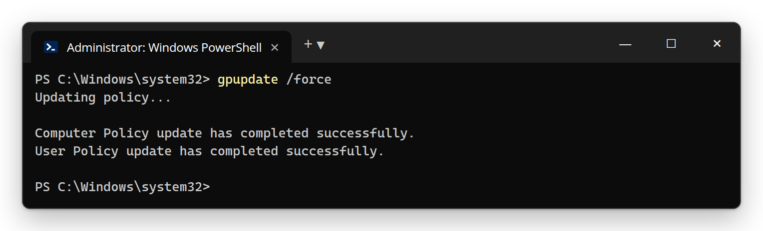
Figure 67. PowerShell — applying the policy with gpupdate /force
- Now try to run a program that is not covered by the rule — it should be blocked.
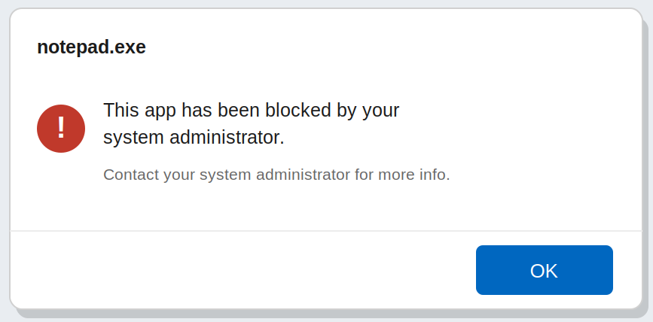
Figure 68. The window of a program blocked by AppLocker
Common mistakes
• AppLocker rules do not work — the cause is usually that the “Application Identity” service has not been started.
• With “Audit only” mode enabled, rules block nothing — this mode is intended only for monitoring; for real blocking, “Enforce Rules” must be selected.
• If the default rules (Create Default Rules) are not created, the system itself may stop working — always create the default rules first.
Practical task 2.2: Checking and configuring SmartScreen settings
- Open the “Windows Security” app → go to the “App & browser control” section.
- Click the “Reputation-based protection settings” link.
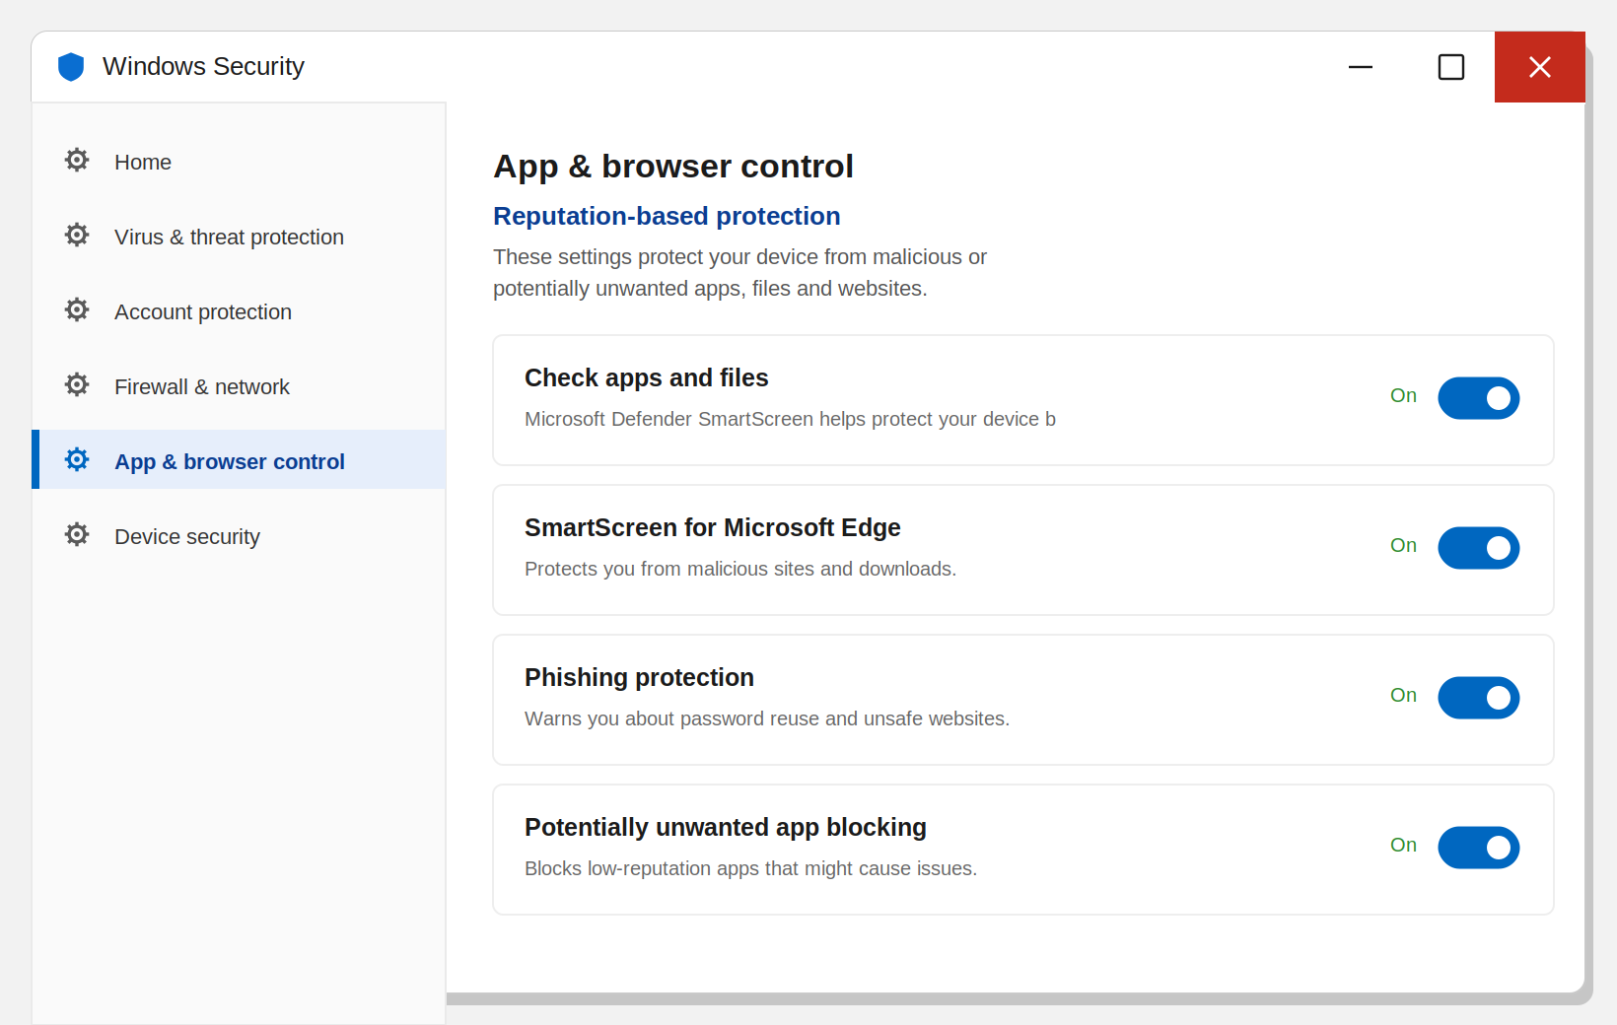
Figure 69. “App & browser control” — Reputation-based protection settings
- You will see three main settings: “Check apps and files”, “SmartScreen for Microsoft Edge” and “Phishing protection” — leave all of them “On”.
- With “Check apps and files” turned on, try downloading a file of unknown origin from the internet (for example from an untrusted test site) — observe that SmartScreen shows a warning window.
- Click the “More info” link in the warning window and study what additional information (publisher, reputation level) it shows.
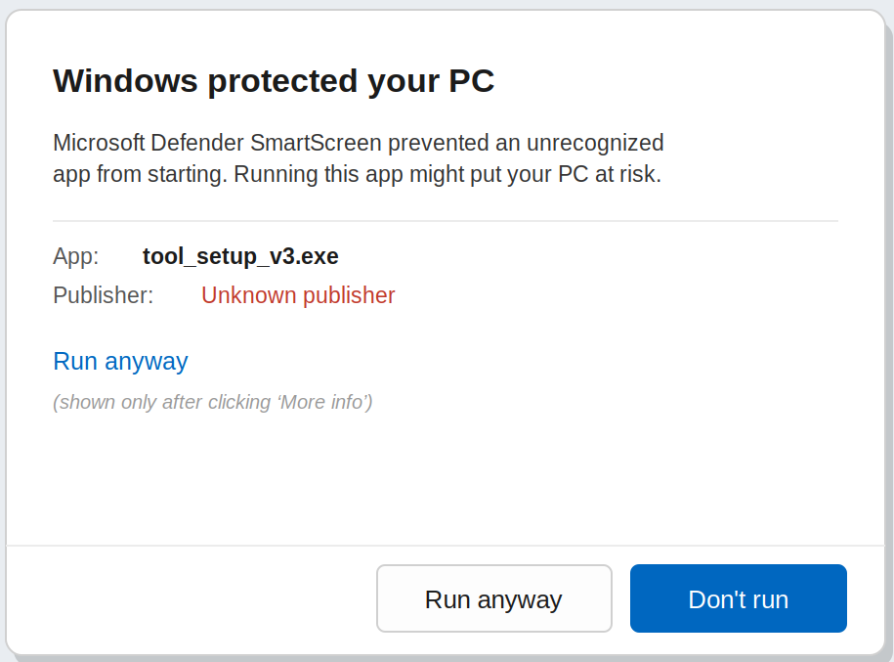
Figure 70. SmartScreen warning and “More info → Run anyway”

Practical lab assignment (final)
Complete the following assignment independently in a virtual machine and present the result in a report (with screenshots):
- Set the UAC level to “Always notify” and take a screenshot confirming it.
- Using AppLocker, create a Path rule that allows programs to run only from the C:\Windows and C:\Program Files folders.
- Try to run any .exe file located outside this rule and confirm with a screenshot that it was blocked.
- Using SmartScreen, download a file from an unknown source and take a screenshot of the warning window.
Frequently asked questions — Lesson 3
Q: I created an AppLocker rule, but the program still runs. Why?
A: One of three reasons: (1) the Application Identity (AppIDSvc) service is not running; (2) the mode is “Audit only” — switch it to “Enforce Rules”; (3) gpupdate /force was not run.
Q: I get an error saying secpol.msc or gpedit.msc was not found.
A: These tools do not exist in the Home edition. You need the Pro/Enterprise edition. Install the lab VM accordingly.
Q: Can I turn UAC off completely — its constant prompts annoy me?
A: No, that is not recommended. “Never notify” turns UAC off and lowers security significantly. At most leave it at the default level; in military/government environments “Always notify” is recommended.

Review questions — Lesson 3
- Which service must be running for AppLocker to work?
- What is the difference between the “Audit only” and “Enforce Rules” modes?
- Which command-line tool can be used to check the UAC level?
- What additional information can the user see when a SmartScreen warning appears?
- Why is it not recommended to add a custom rule without first creating the default AppLocker rules (Default Rules)?

Lesson 4. Windows OS Services (Practical)
Topic: Windows OS Security Lesson type: Practical Duration: 4 hours

Learning questions
- Configuring security settings
- Configuring user security

Question 1. Configuring security settings (Local Security Policy)
All of Windows’ important security settings (password requirements, audit rules, user rights) are gathered in one central place — the Local Security Policy (secpol.msc) tool. This tool is available in the Windows Pro/Enterprise editions, and on domain computers it can also be managed centrally through Group Policy (gpedit.msc / Active Directory GPO).
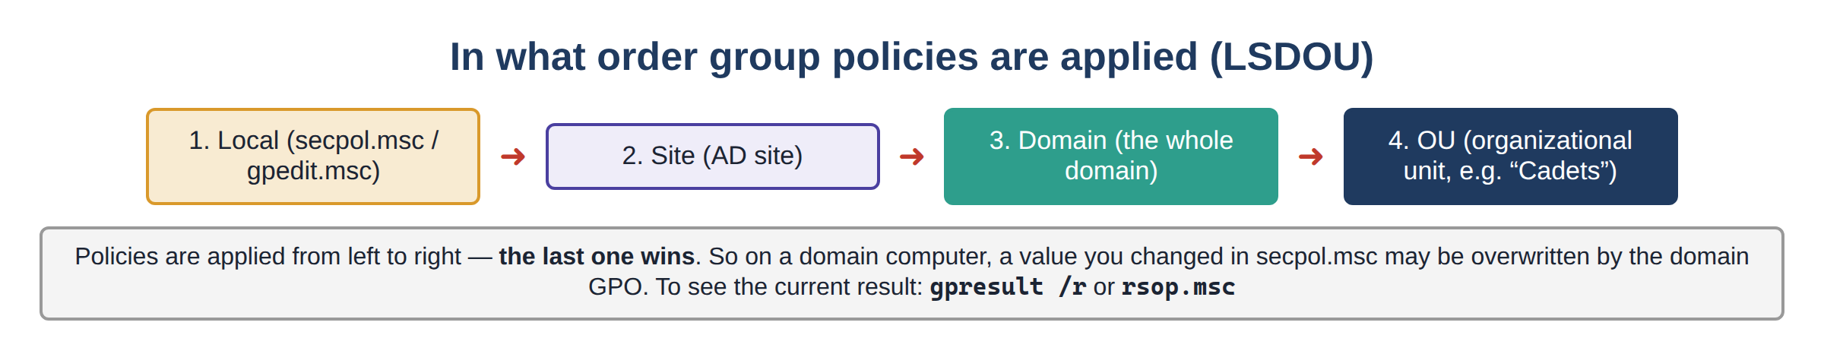
Figure 71. The order in which group policies are applied (LSDOU)
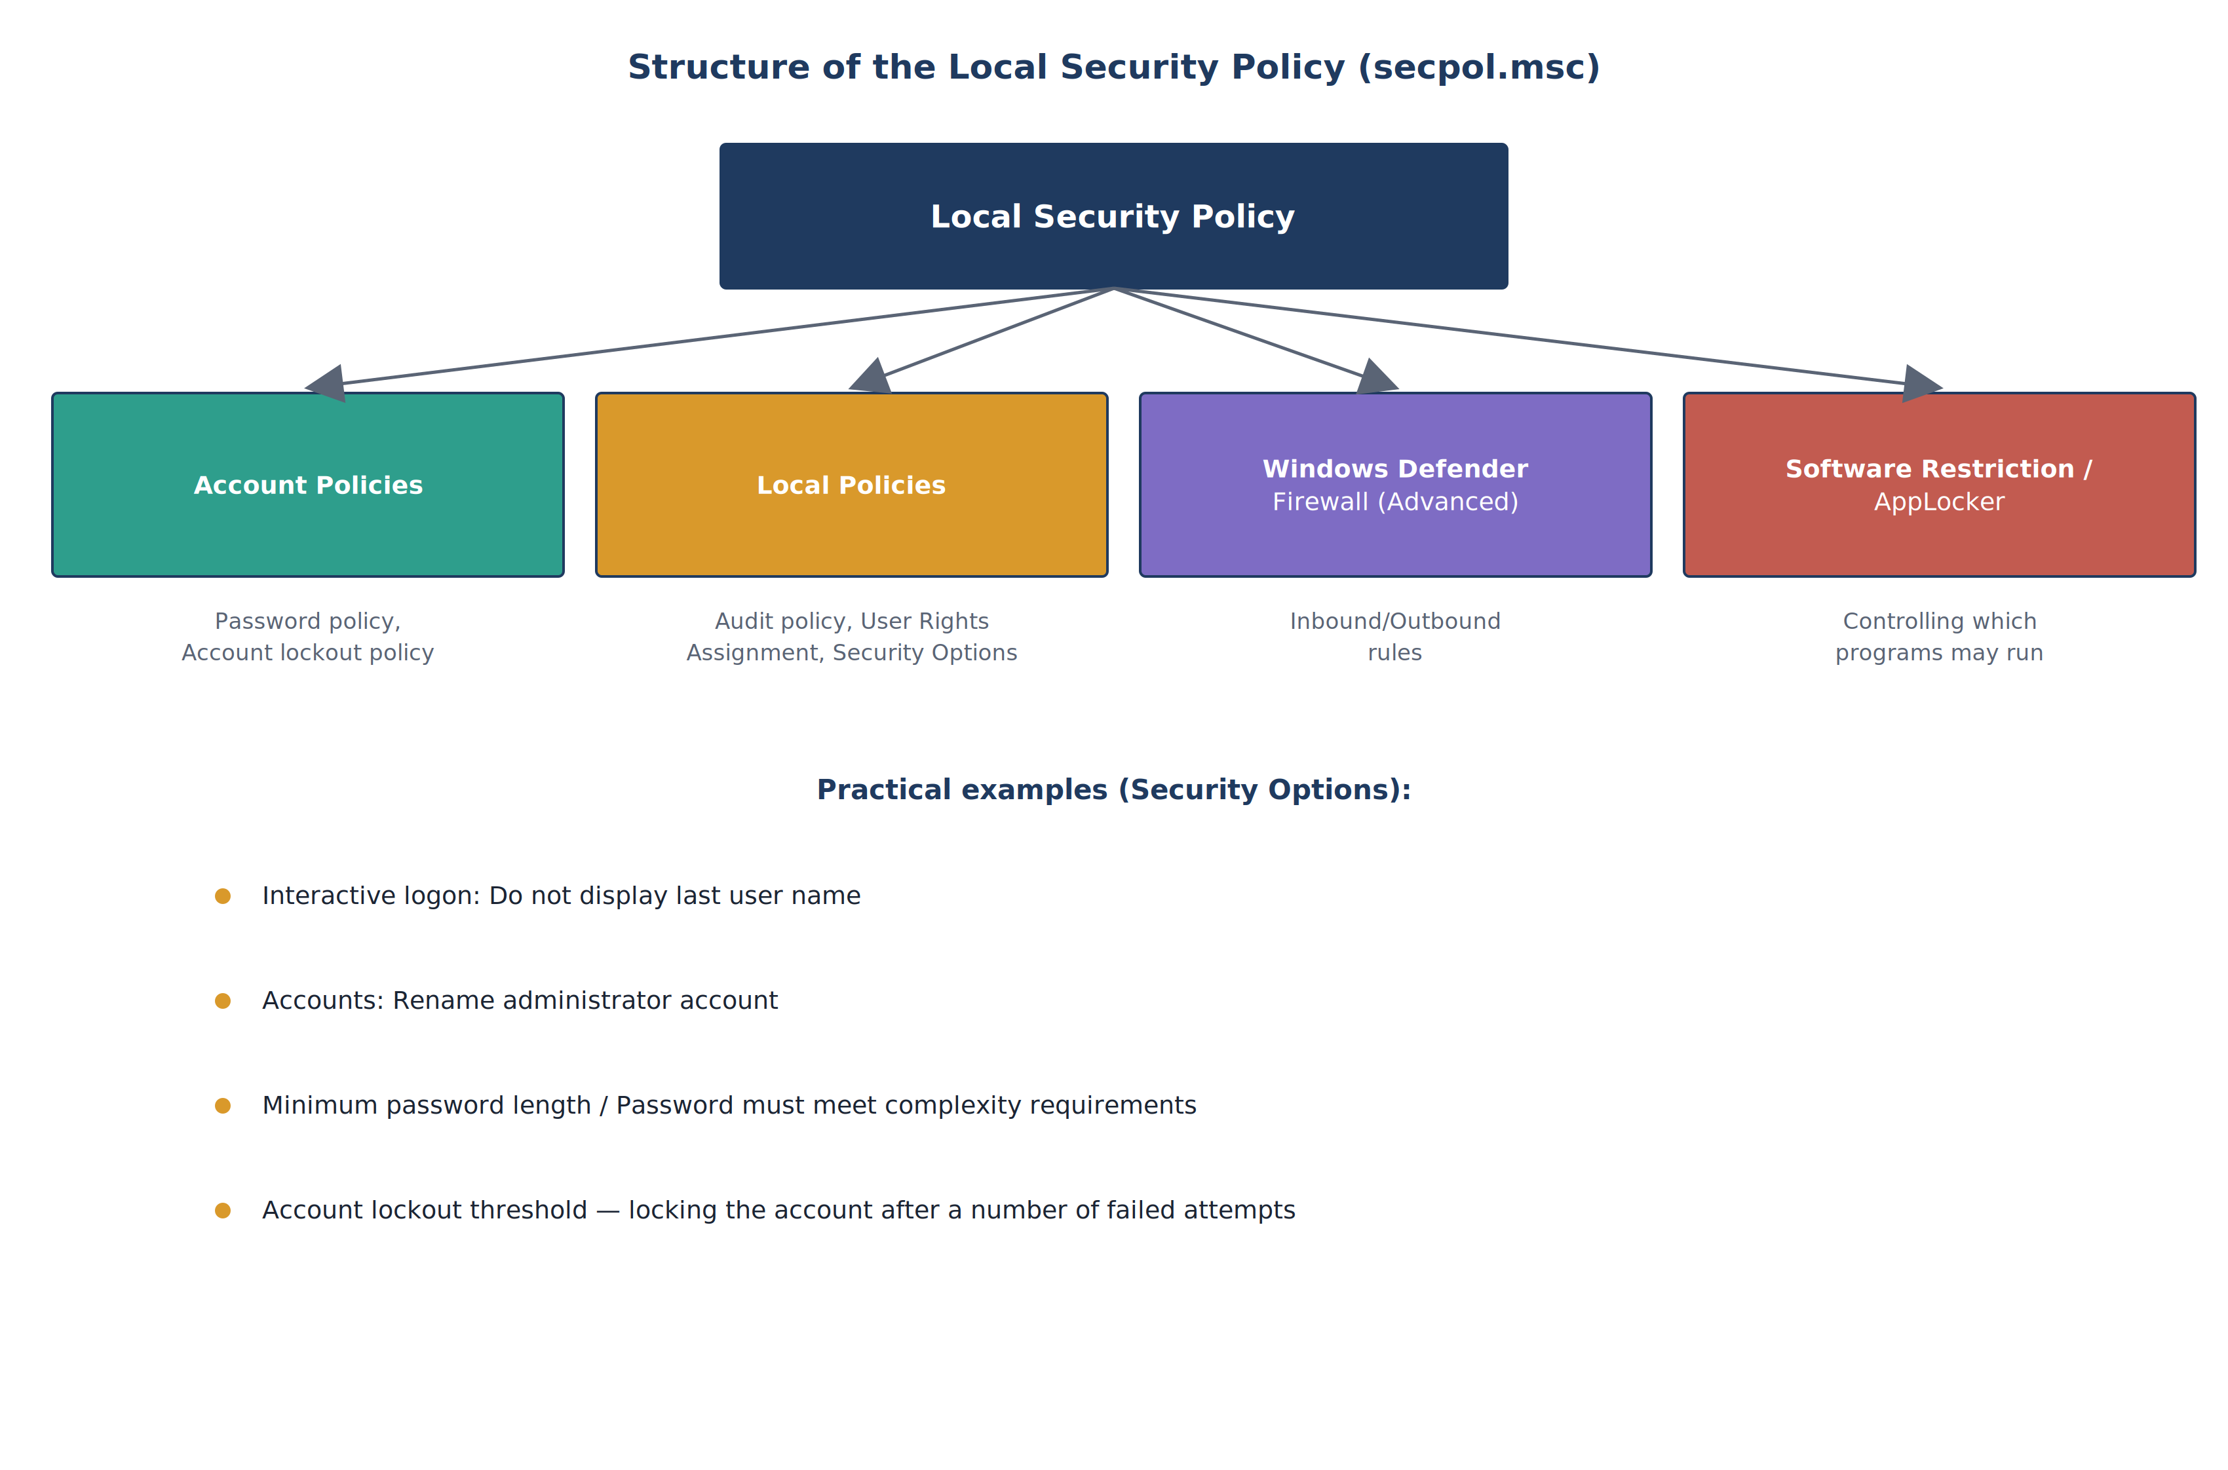
Figure 72. Structure of the Local Security Policy (secpol.msc)
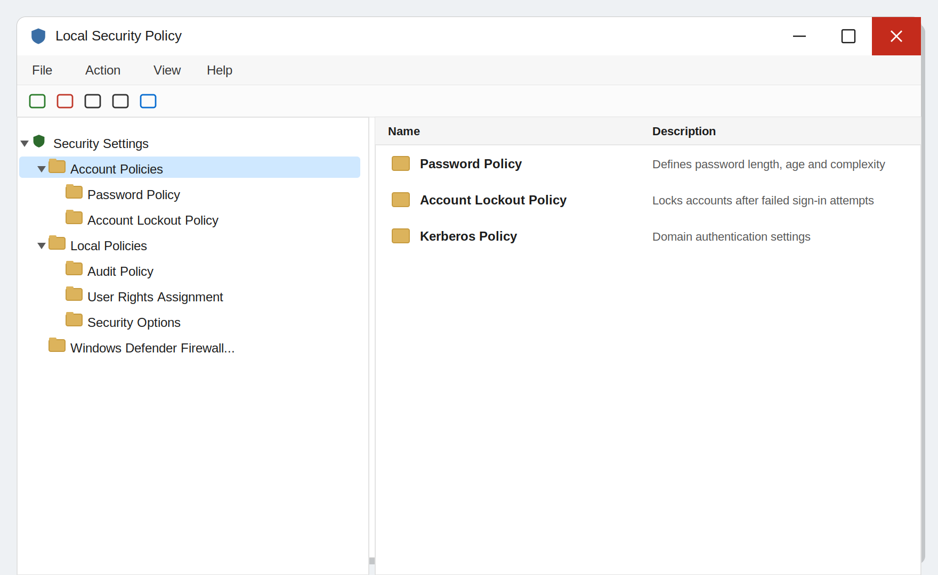
Figure 73. The Local Security Policy (secpol.msc) window
First, let us show exactly where these settings are opened. Win + R → secpol.msc → Account Policies → Password Policy. You change a value by double-clicking its row:
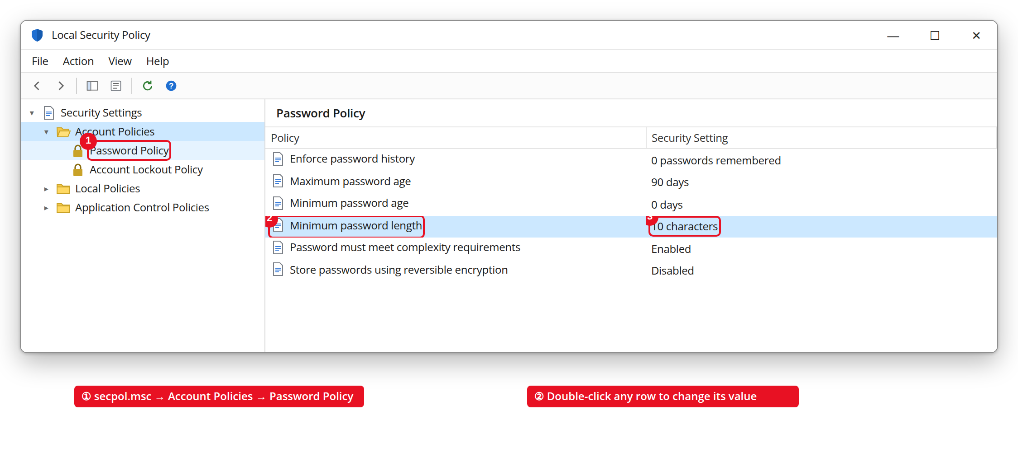
Figure 74. secpol.msc → Account Policies → Password Policy (annotated)
For example, double-clicking the “Minimum password length” row opens the following small window — this is where you enter the minimum number of characters:
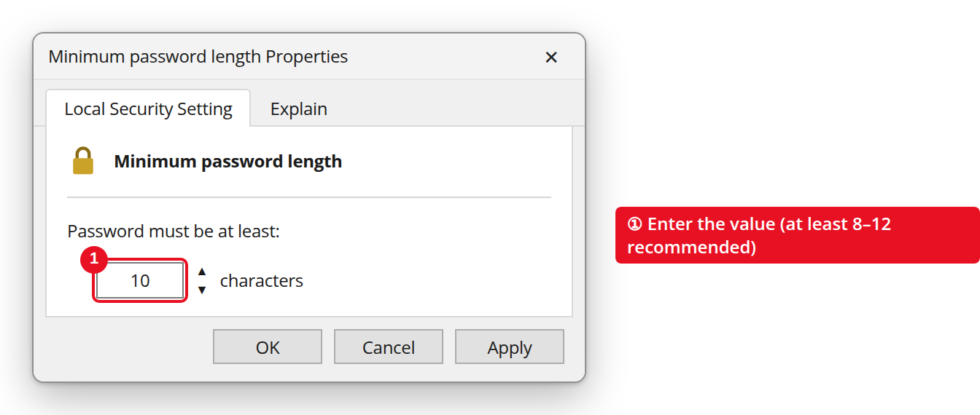
Figure 75. The “Minimum password length” properties window
1.1. Account Policies
This section defines the rules for passwords and account lockout. Recommended values for a secure system:
Setting | Recommended value | Purpose
Minimum password length | At least 8–12 characters | Prevents short, easily guessed passwords
Password must meet complexity requirements | Enabled | Requires upper/lower-case letters, digits and symbols in the password
Maximum password age | 60–90 days | Forces the password to be changed regularly
Account lockout threshold | 3–5 invalid attempts | Protects against password-guessing (brute-force) attacks
Account lockout duration | 15–30 minutes | Sets how long a locked account stays locked
Why does password policy matter?
• If a password is only 6 characters long, an automated guessing (brute-force) attack can find it within a few hours.
• Finding a 12-character password made of upper/lower-case letters, digits and symbols is practically impossible.
• Account lockout stops such attempts after 3–5 tries, making the attack completely useless.
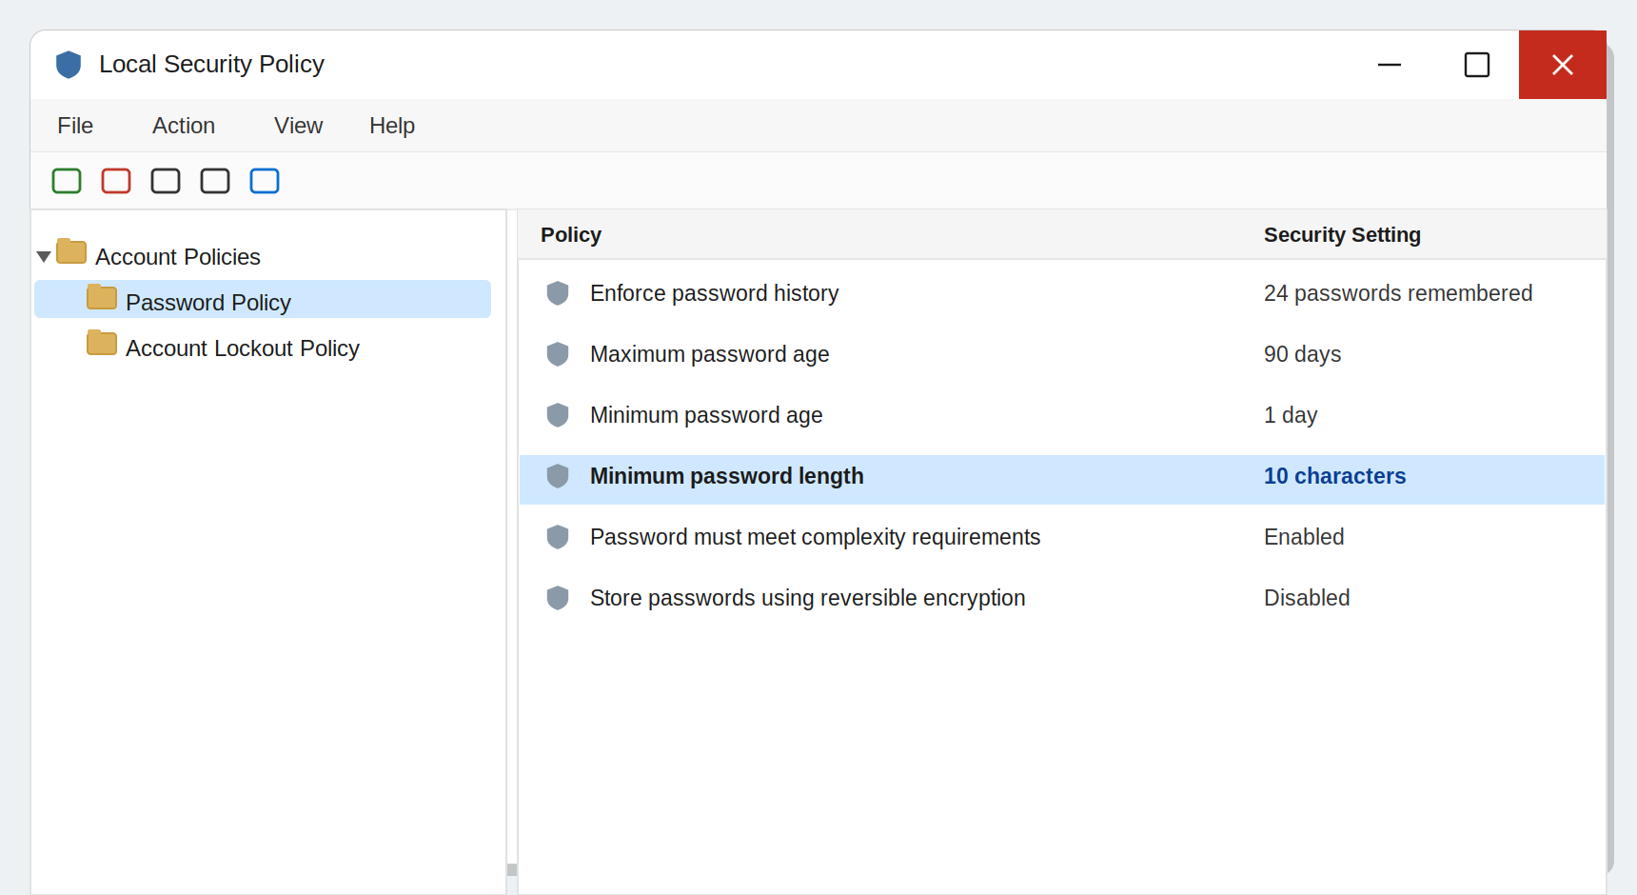
Figure 76. Account Policies → Password Policy settings (secpol.msc)
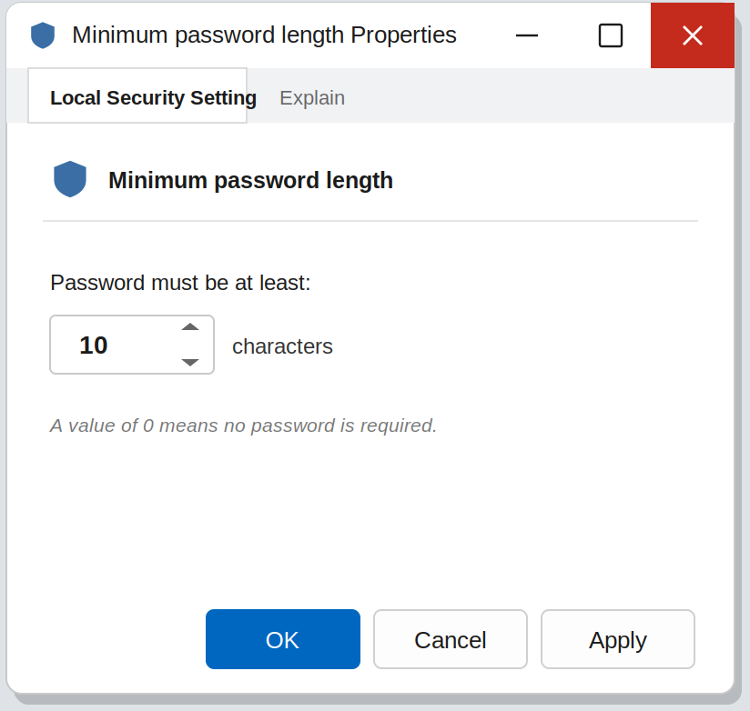
Figure 77. The “Minimum password length” properties window
1.2. Local Policies — Audit and Security Options
The Audit Policy defines which events on the system (login attempts, file access, changes to settings) are recorded in the Windows Event Log. This serves as the data source for cyber forensics and SIEM systems, which are studied in later topics. The Security Options section contains important settings such as:
- Interactive logon: Do not display last user name — hides the name of the last signed-in user on the login screen, which makes it harder for an attacker to guess an account name.
- Accounts: Rename administrator account — changing the default “Administrator” name, because this name is known to attackers in advance.
- Accounts: Guest account status — disabling the guest account, because it is often passwordless or weakly protected.
Where can you see the events recorded by the Audit Policy? — eventvwr.msc (Event Viewer) → Windows Logs → Security. Every login attempt is recorded here. For example Event ID 4625 — a failed login (a sign of a password-guessing attack):
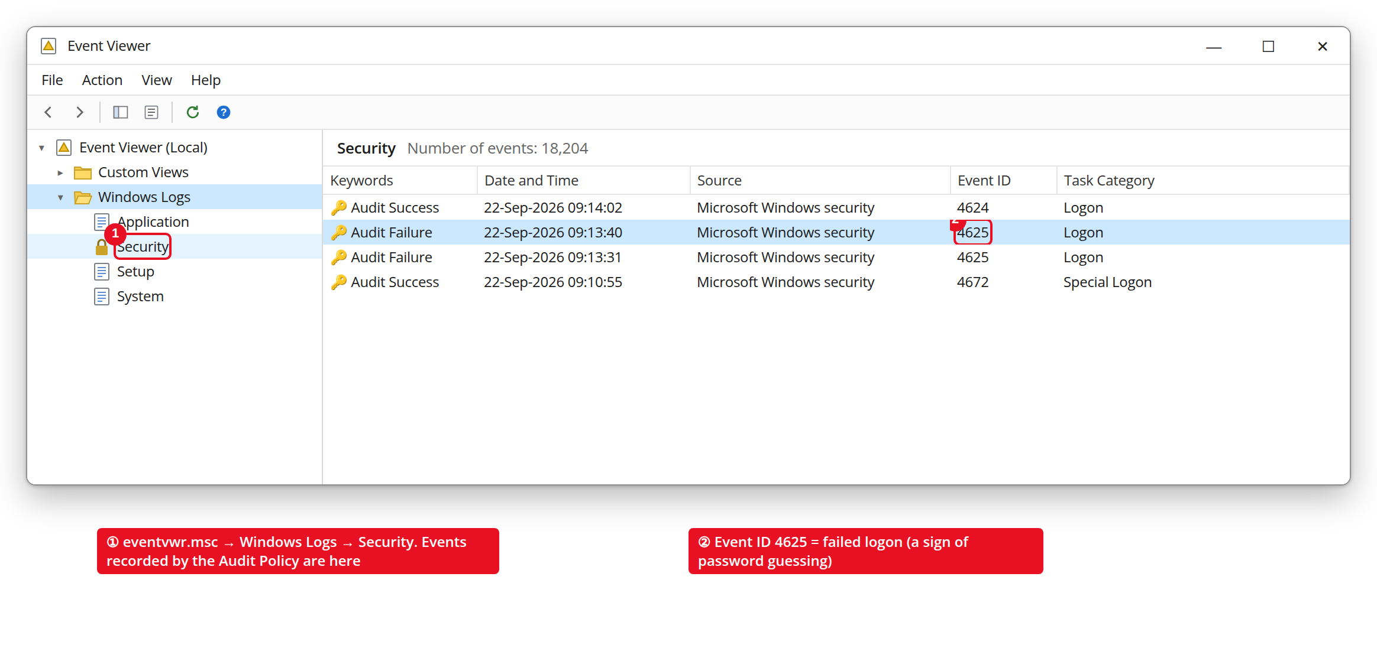
Figure 78. Event Viewer → Security log — logon events (annotated)
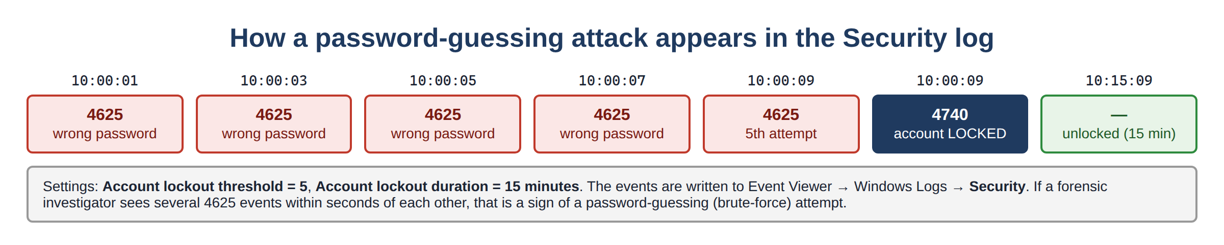
Figure 79. How a password-guessing attack appears in the Security log
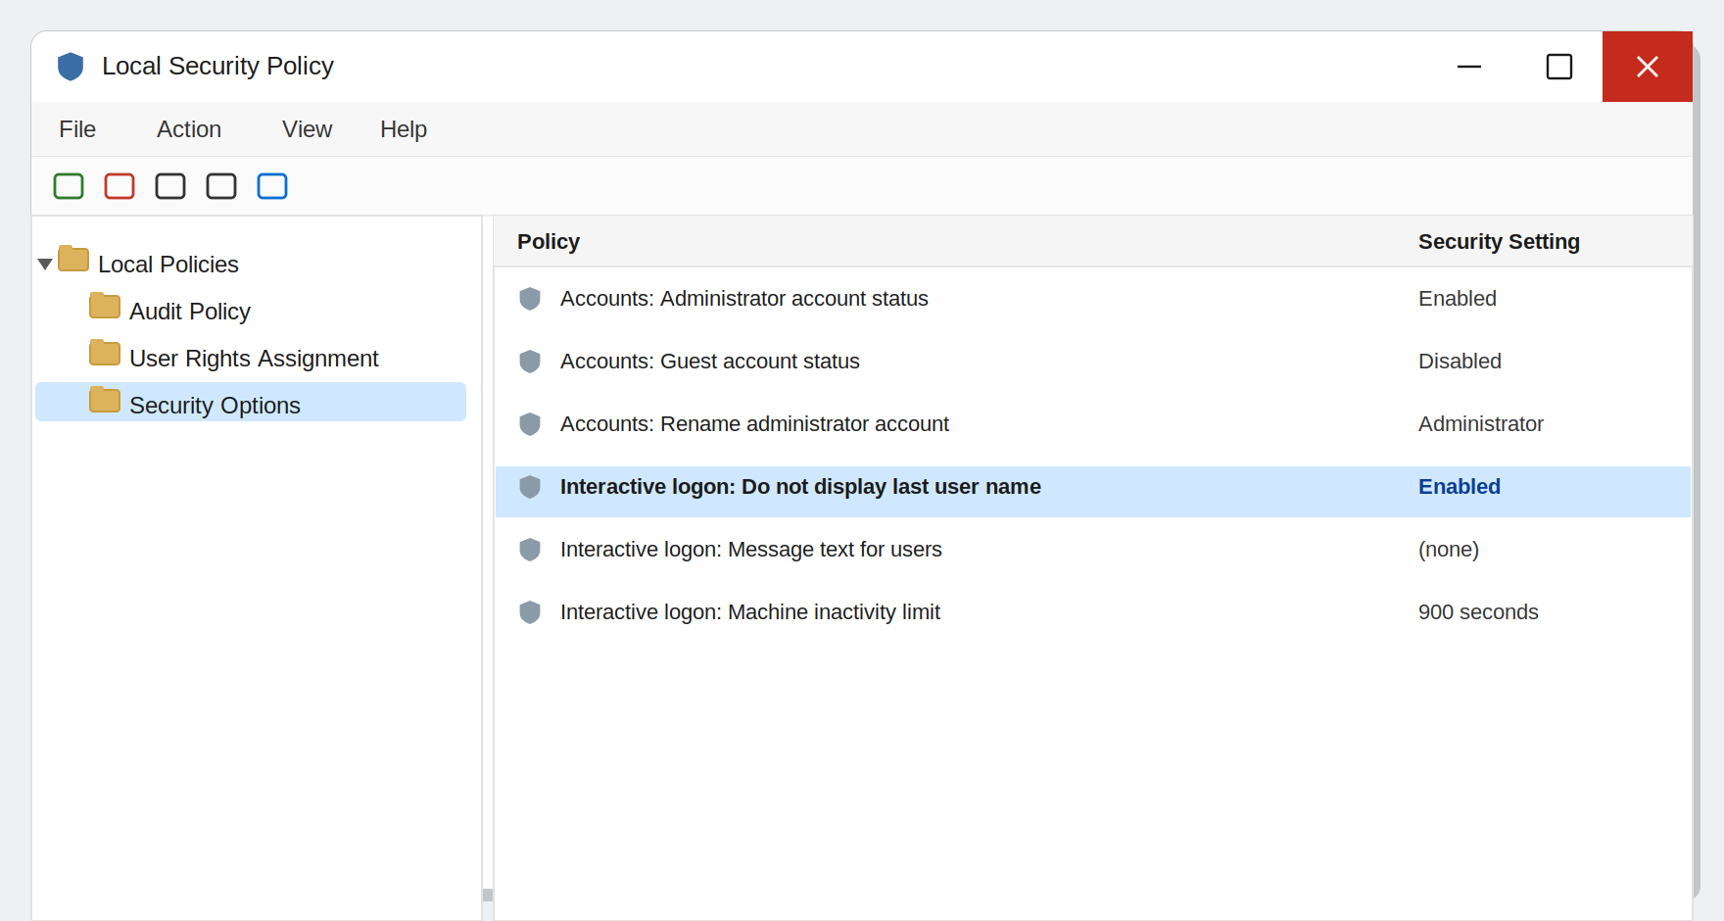
Figure 80. The Local Policies → Security Options list
1.3. Practical task: changing a security setting
- Win + R → run the secpol.msc command.
- Go to Account Policies → Password Policy.
- Change the “Minimum password length” value to 10.
- Go to Local Policies → Security Options.
- Find the “Interactive logon: Do not display last user name” setting and set it to “Enabled”.
- Save the changes, lock the computer (Win + L) and check the result — the user name should no longer appear on the login screen.
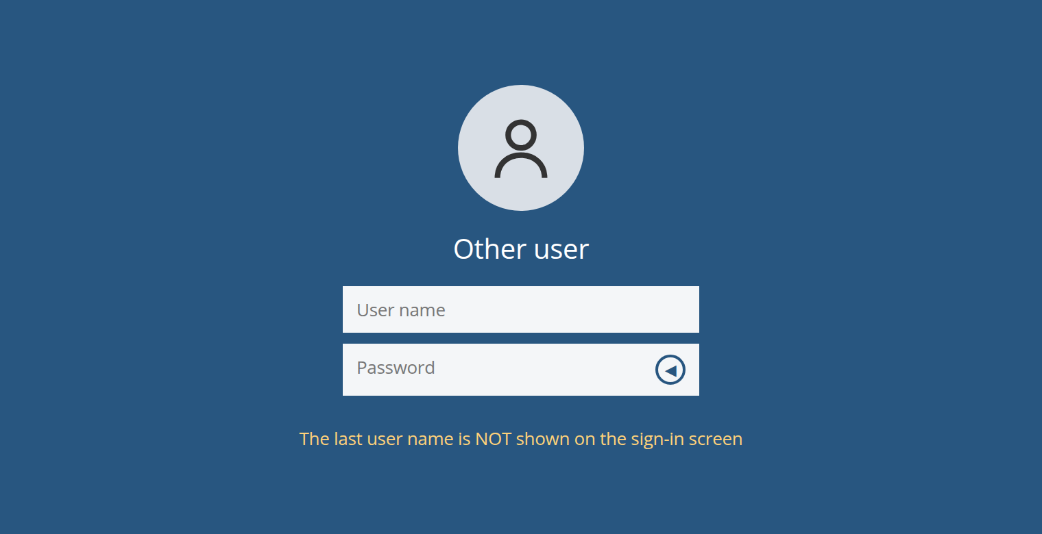
Figure 81. Result: the last user name is not shown on the sign-in screen

Question 2. Configuring user security
In Windows, a separate account is created for each person, and these accounts are combined into groups. Group membership determines what rights a user gets — this approach is called “role-based access control”.
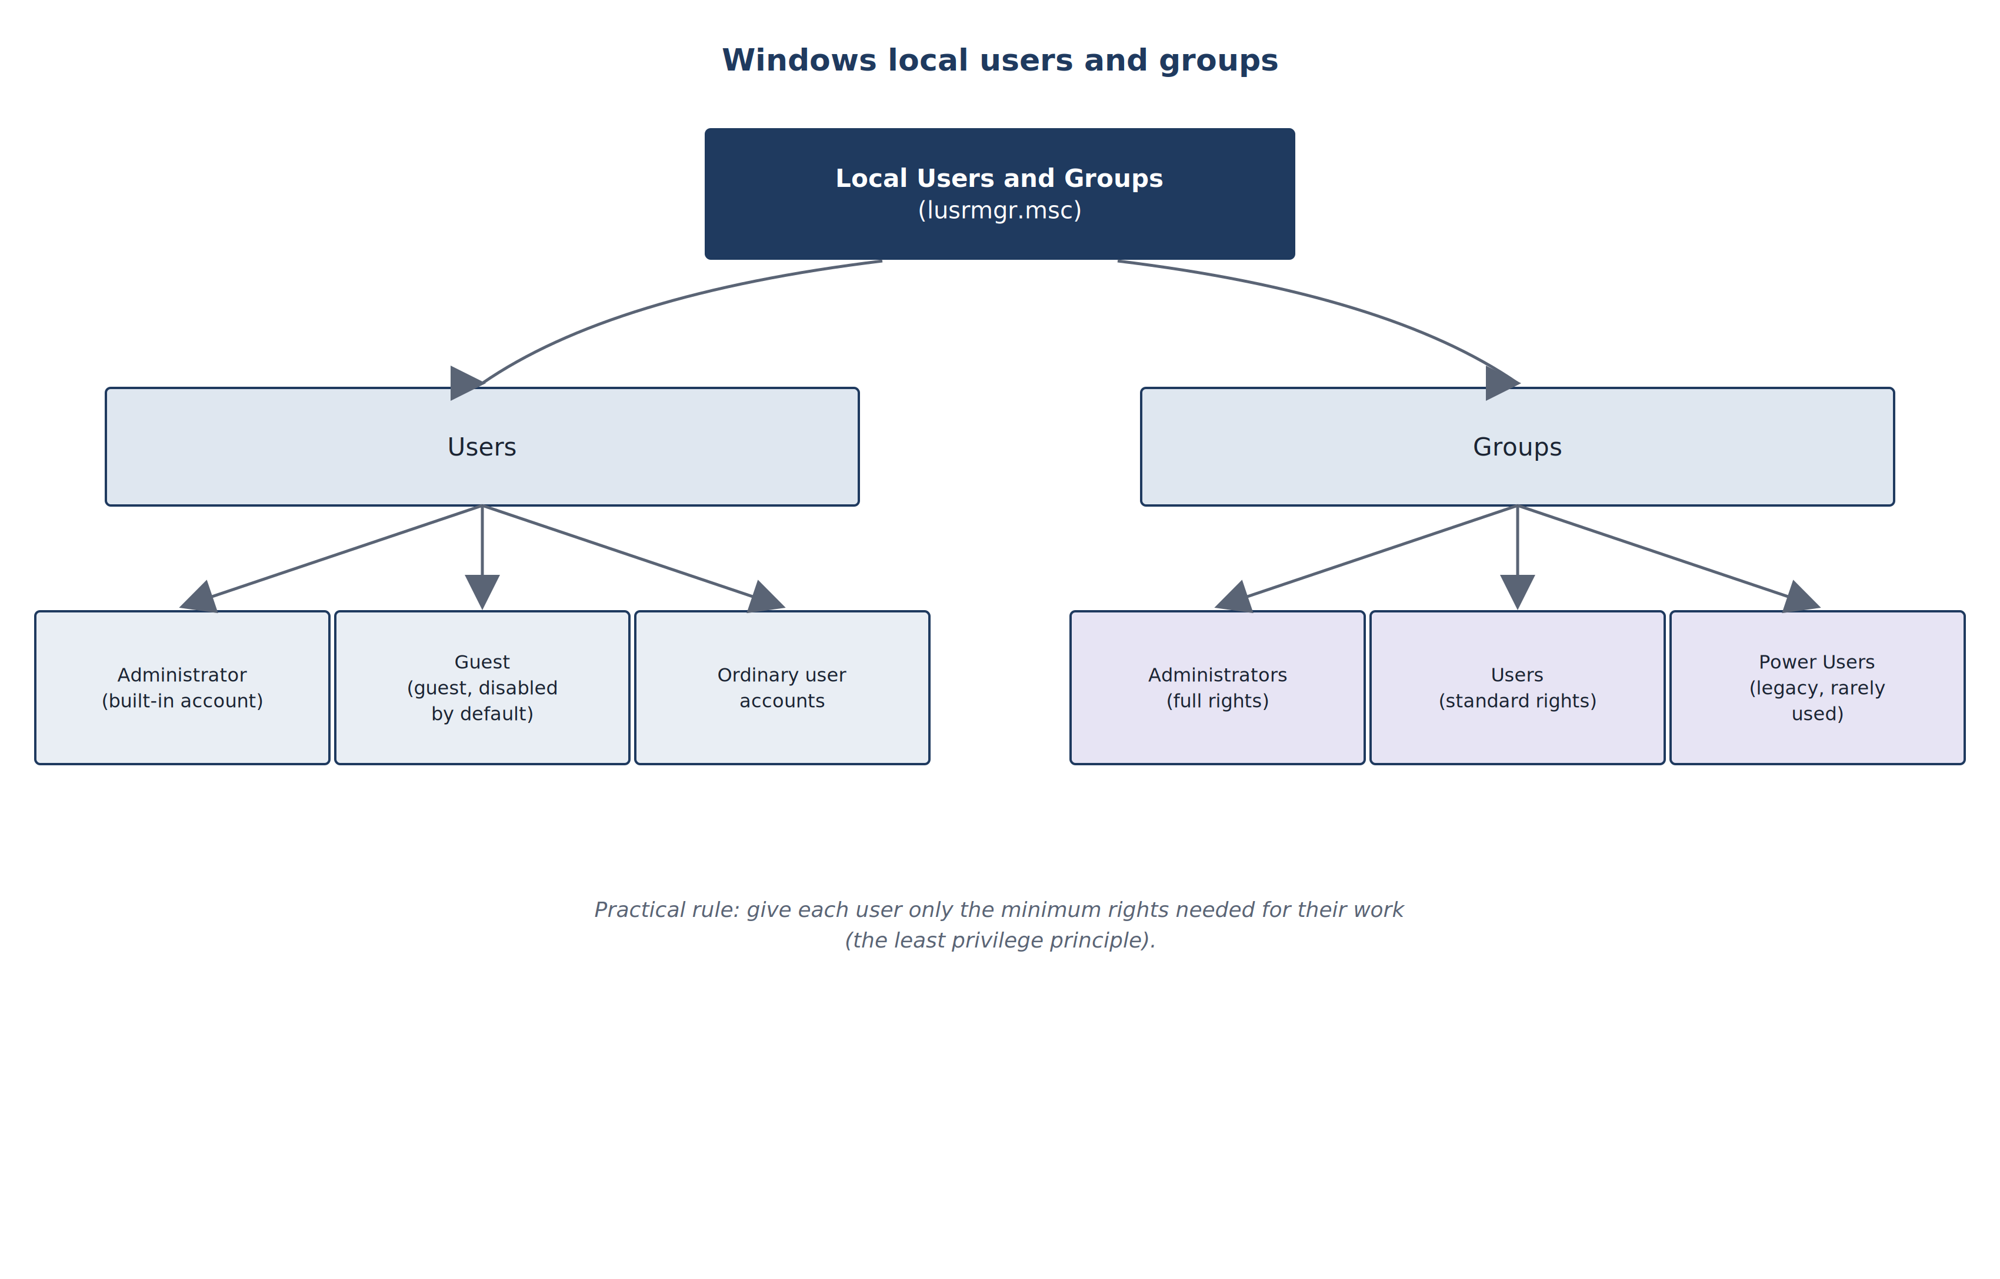
Figure 82. Windows local users and groups
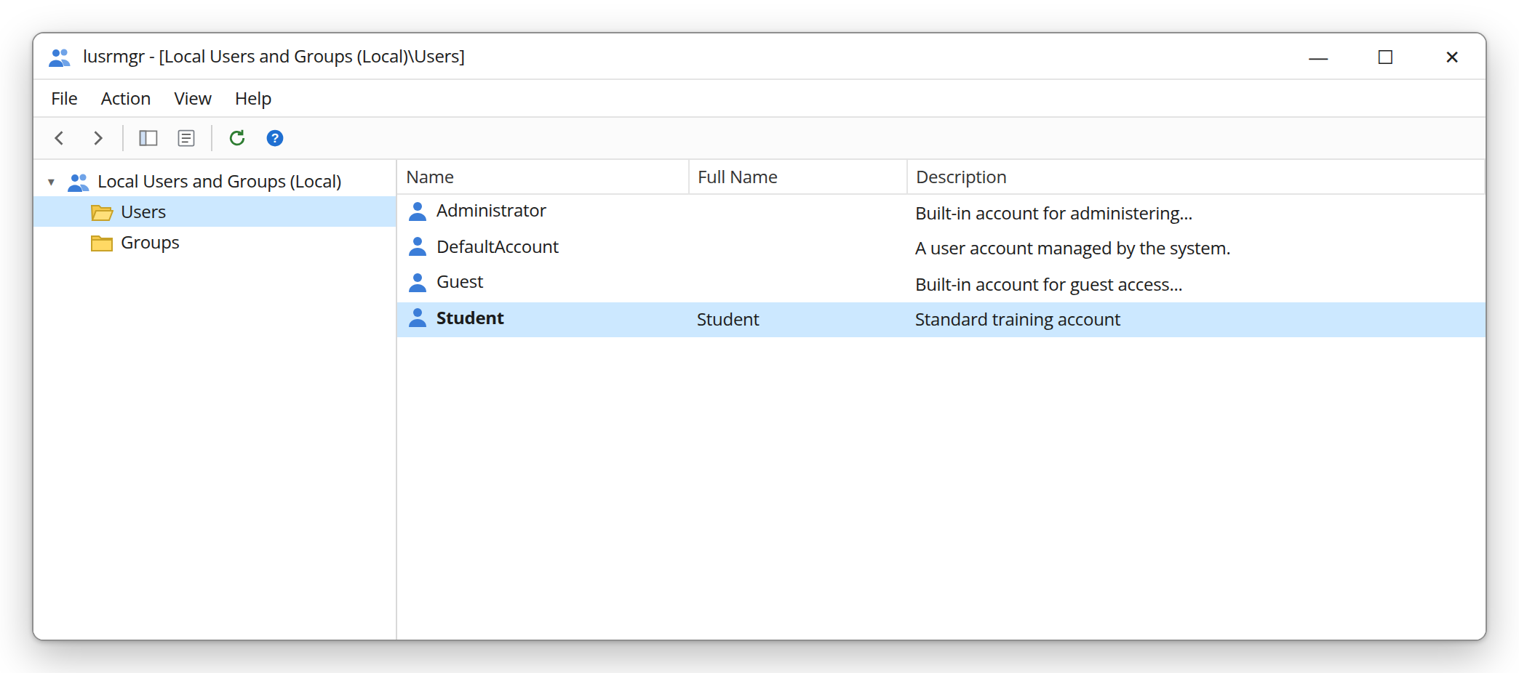
Figure 83. lusrmgr.msc — Local Users and Groups (user list)
Where are users and groups managed? — Win + R → lusrmgr.msc (Local Users and Groups). “Users” — accounts, “Groups” — groups:
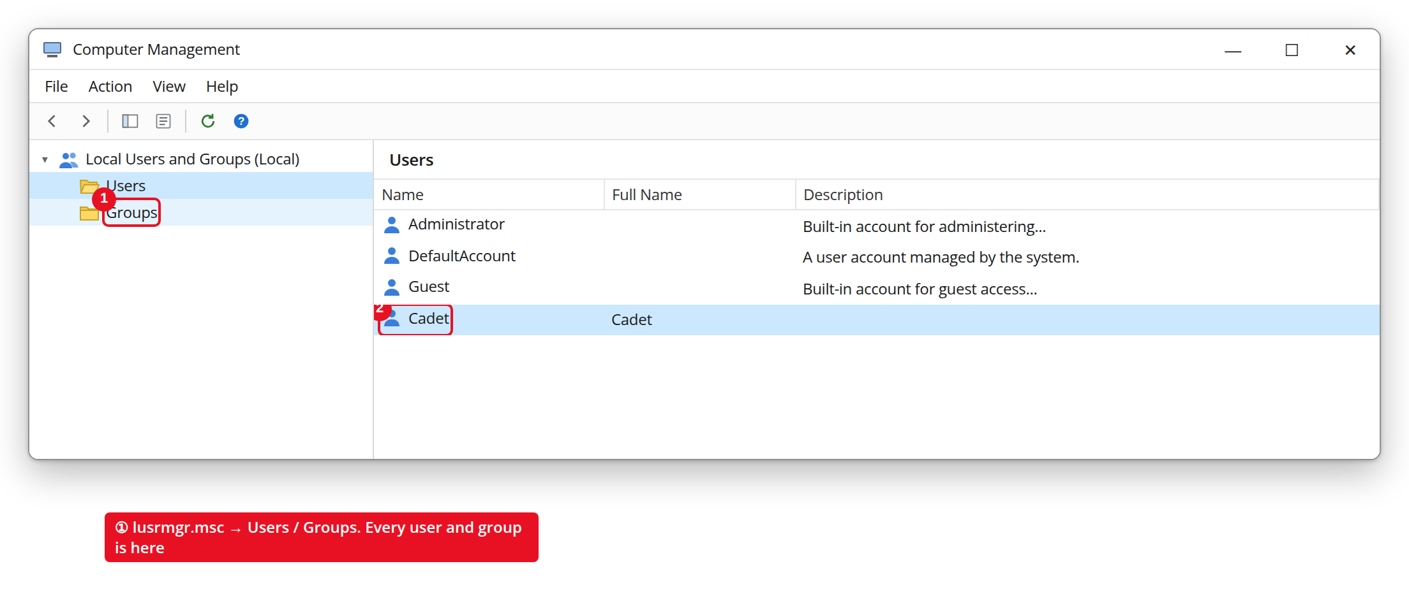
Figure 84. lusrmgr.msc — Local Users and Groups (users)
To create a new account through the GUI, right-click “Users” → “New User”. In the window that opens, only “User name” is required:
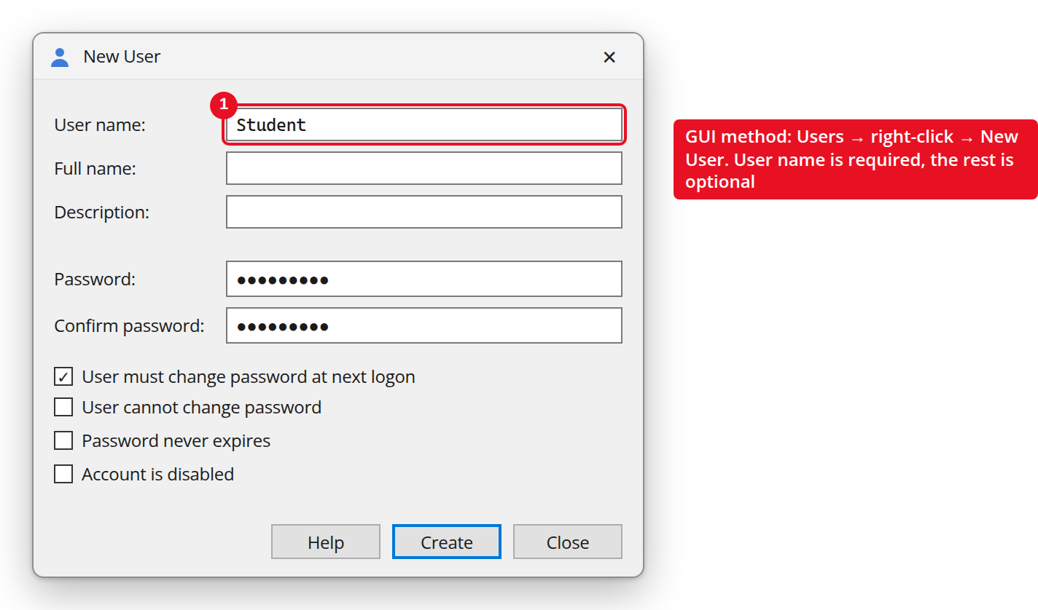
Figure 85. Creating a new account through the “New User” window
From the command line the same job is done as follows. Note: the new account has “Local Group Memberships: *Users” — that is, it received standard (limited) rights:
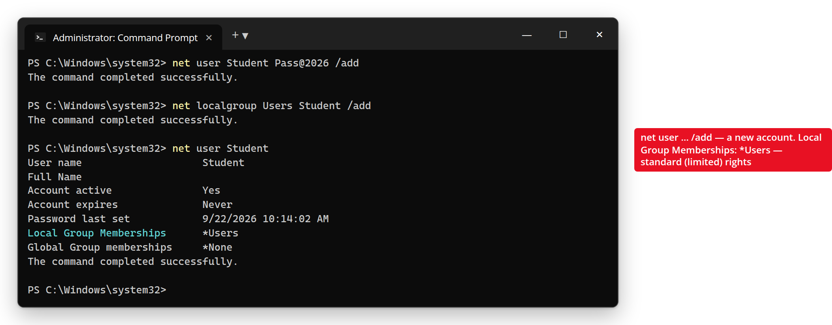
Figure 86. net user — creating and checking a new account
Group | Rights level | Recommendation
Administrators | Full — can change all system settings | Give only to people who perform administrator duties
Users | Standard — cannot install programs or change system settings | Recommended for everyday work accounts
Guests | Very limited, temporary | Keep disabled whenever possible
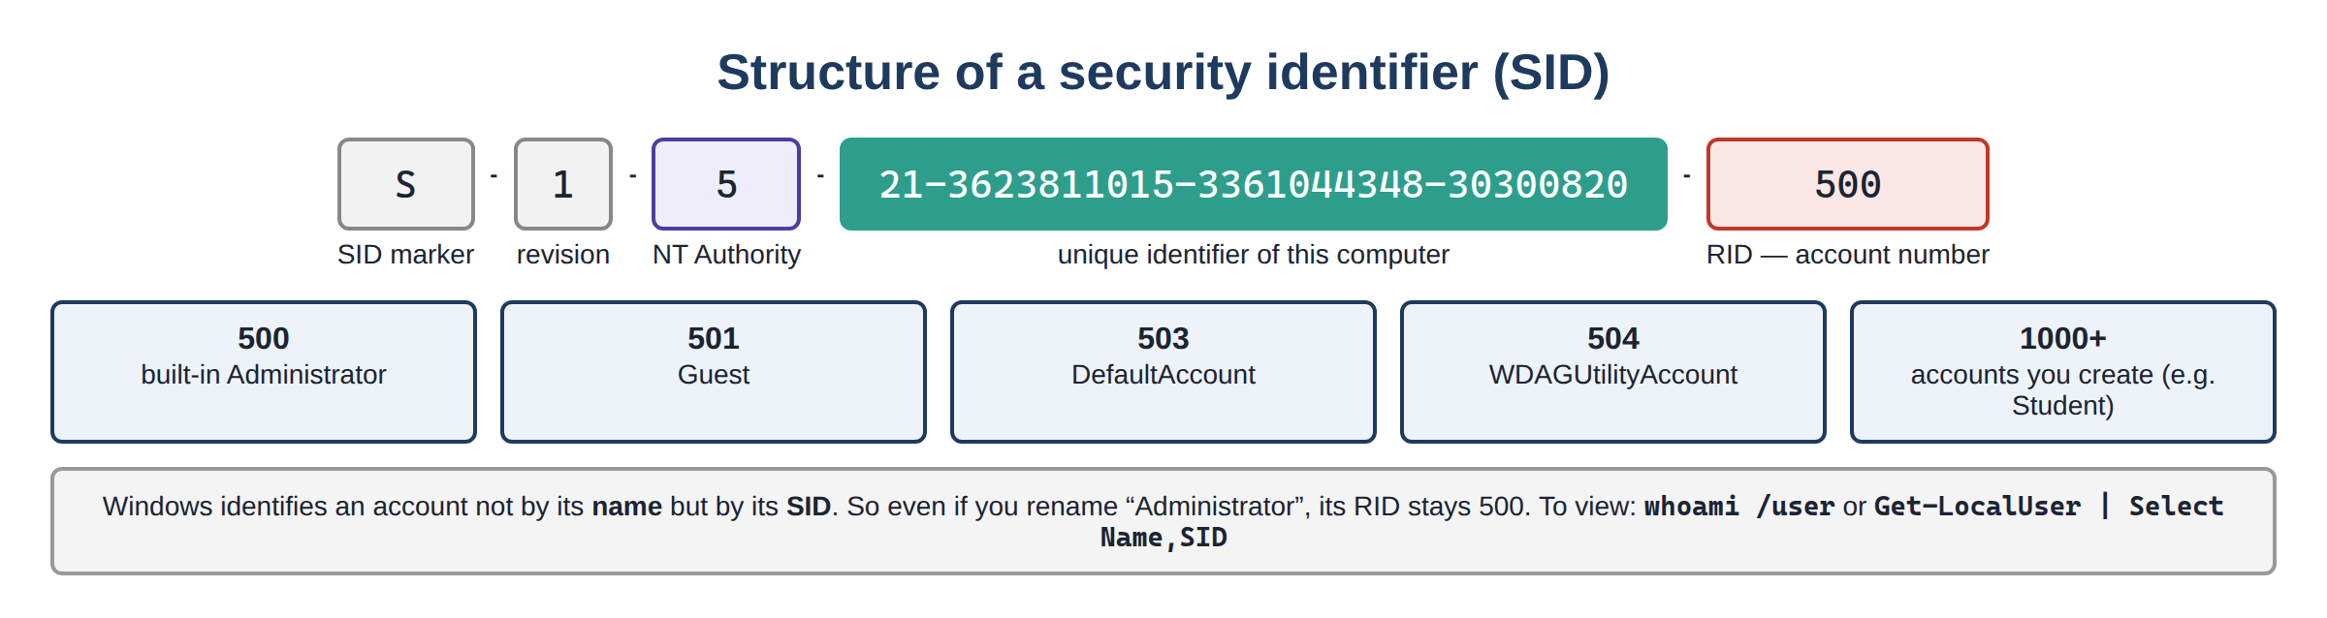
Figure 87. Structure of a security identifier (SID)
2.1. Practical task: creating a new limited user
This can be done through the GUI (Computer Management → Local Users and Groups) or from the command line. The command-line method:
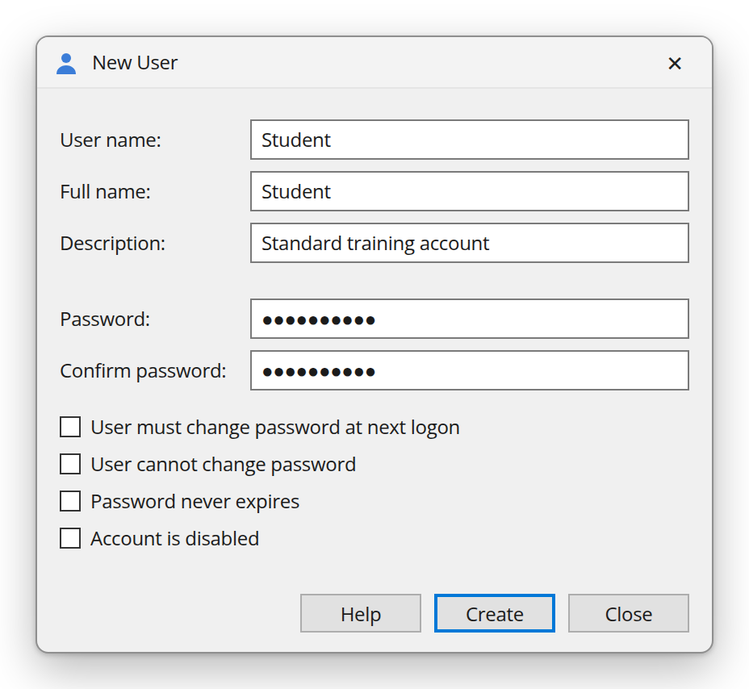
Figure 88. GUI method: creating an account through the “New User” window
Command | What it does
net user Student Pass@2026 /add | Creates a new account named “Student” with the given password
net localgroup Users Student /add | Adds the new account to the standard “Users” group (usually automatic)
net localgroup Administrators Student /delete | If the account is accidentally in the Administrators group, removes it
net user Student /active:yes | Activates the account
net user Student | Shows full information about the account (groups, last login, etc.)
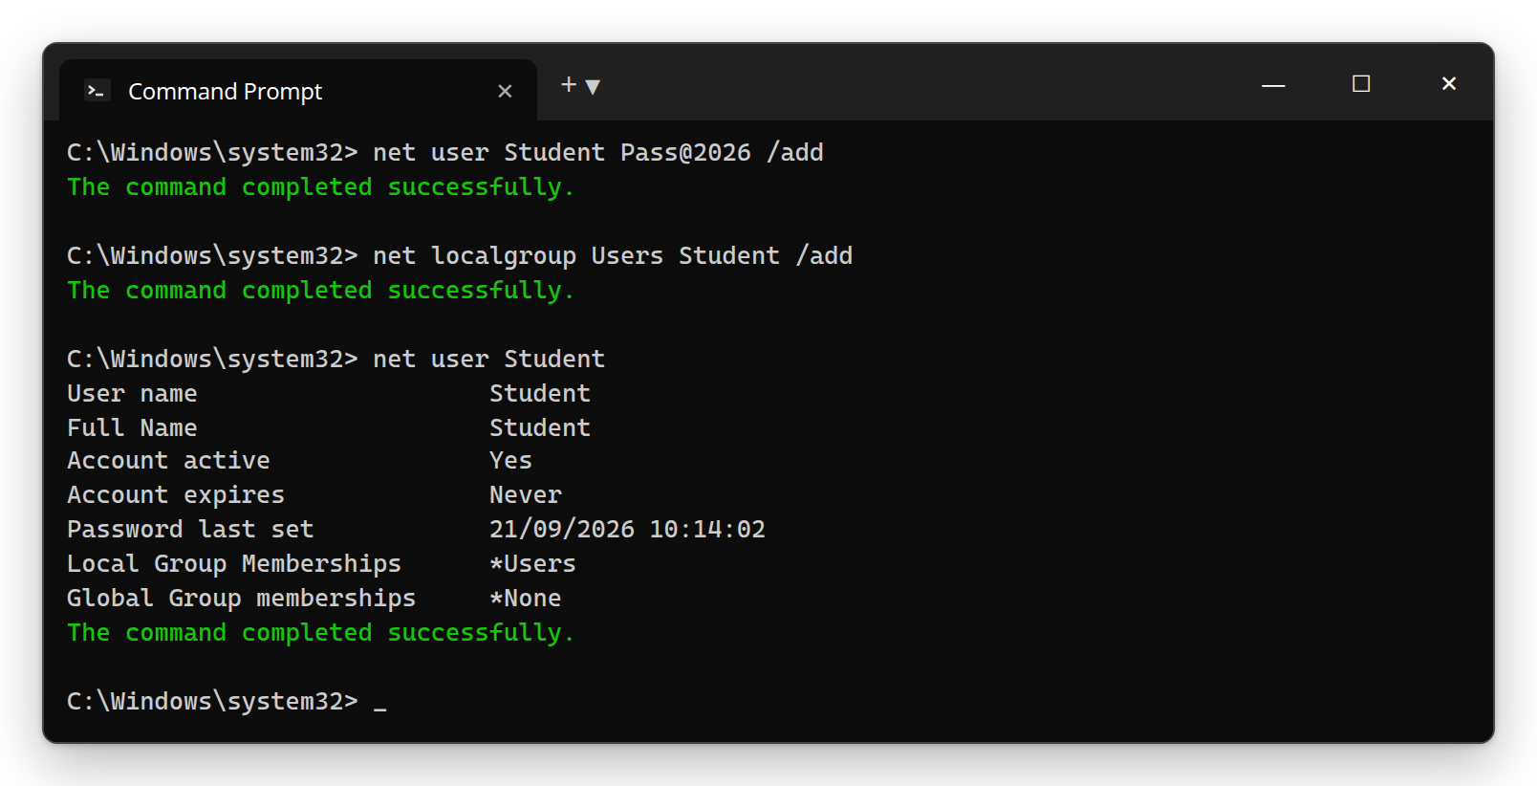
Figure 89. Command line — creating and checking an account with “net user”
- Create a new user account with standard rights using the net user command above.
- Sign in again with the new account (Sign out → choose the new account).
- Under this account, try to install a program or change a system setting — observe that the UAC Credential prompt (asking for a user name + password) appears.
- Return to the administrator account and delete the test account with the net user Student /delete command.
Final security recommendations (checklist)
• Always use a standard account (in the Users group) for everyday work; use the Administrator account only when necessary.
• Disable the Guest account and rename the default Administrator account.
• Never set UAC to “Never notify”.
• Always keep AppLocker, or at least SmartScreen, turned on.
• Make the password policy (length, complexity, age) mandatory and enable Account Lockout.
• Never turn off Windows Defender and the Firewall; even if a third-party antivirus is installed, keep checking their status.
Frequently asked questions — Lesson 4
Q: The password policy I changed in secpol.msc does not work?
A: A local policy can be overridden by the domain’s Group Policy (GPO) — in a domain, the GPO takes precedence. On a standalone (non-domain) computer, the change takes effect immediately.
Q: Why is it dangerous to do everyday work in an administrator account?
A: Because malware that is accidentally launched immediately gets full admin rights as well. Use a standard account in the “Users” group for everyday work.
Q: How do I delete the account I created for testing?
A: As administrator: net user Student /delete or in lusrmgr.msc right-click the account → Delete.
Q: What is “role-based access control” in plain words?
A: Giving rights not to each person separately, but to a group (role). When you add a user to the right group, they get all the rights of that group.

Review questions — Lesson 4
- What do the Account lockout threshold and Account lockout duration settings mean?
- Why does the “Do not display last user name” setting increase security?
- Explain the difference between the Administrators, Users and Guests groups.
- Explain what the net user and net localgroup commands do.
- Why is it recommended not to use an administrator account for everyday work?
- Explain the concept of “role-based access control” in your own words.

Conclusion
This topic examined, step by step, the main mechanisms that secure the Windows operating system: first the background processes — services — and their privilege system (Lesson 1), then the tools that control user actions and programs — UAC, AppLocker, SmartScreen, Defender, Firewall (Lesson 2), and then the practical application of this knowledge — setup and configuration (Lessons 3 and 4).
This knowledge is not only valuable on its own, but is also an essential foundation for the following topics of the course — virology, network monitoring systems (SIEM, IDS/IPS) and ethical hacking (Metasploit, privilege escalation). In particular, according to the roadmap in the roadmap.html file, this topic corresponds directly to “Stage 02: Operating systems — in depth”, and also lays the groundwork for “Stage 05: Security fundamentals” and “Stage 08: Defense (Blue Team)”.

Glossary
Below is a short explanation of all the important terms that appear in this topic. Technical terms are kept in their original English form, so you will recognize them in English sources in the future.
Term | Meaning
Service | A program that runs in the background with no window on screen. It can start automatically when Windows boots and run under a special system account.
Service Control Manager (SCM) | The central component that manages all services (services.exe). Every service command passes through it.
svchost.exe | A shared host process that runs several services together inside one process.
SYSTEM (LocalSystem) | The account with the highest local privilege in Windows — even more powerful than an administrator. Many system services run under this account.
LocalService / NetworkService | Low-privilege accounts for services. LocalService is anonymous on the network; NetworkService acts on the network as the computer account.
Startup type | The setting that defines when a service starts: Automatic, Automatic (Delayed), Manual, Disabled.
Persistence | The ability of malware to keep running after the computer restarts. Often achieved by registering itself as a new service.
Privilege escalation | A low-privileged attacker climbing to higher rights (for example SYSTEM) through a weakness in the system.
Unquoted service path | A vulnerability that arises when the path to a service file is unquoted and contains spaces (MITRE ATT&CK T1574.009).
Attack surface | The sum of all points an attacker could attack. Disabling unneeded services reduces it.
UAC (User Account Control) | A mechanism that asks for confirmation whenever an action requires admin rights. Present since Windows Vista.
Secure Desktop | The protected mode in which the UAC confirmation window is shown (the screen dims) — malware cannot click a fake button.
Consent prompt / Credential prompt | For an administrator — a simple “Yes/No” (Consent); for a standard user — an admin user name/password (Credential).
Integrity level | The trust level of processes (Low/Medium/High/System). UAC works based on these levels.
Filtered token / Full token | The two sets of rights given when an administrator signs in: a restricted (filtered) token for everyday work and a full token that is activated after confirmation.
Least privilege | The principle of giving each user/service only the minimum rights it needs.
AppLocker | An “allow list” (whitelist) mechanism that controls which programs may run. Full support only in the Enterprise/Education/Server editions.
Rule collection | The types of AppLocker rules: Executable, Windows Installer, Script, Packaged app, DLL.
Publisher / Path / File Hash | The three conditions an AppLocker rule can be based on: digital signature, file location, or the file’s “fingerprint”.
Application Identity (AppIDSvc) | The service that must be running for AppLocker to work.
SmartScreen | Protection that checks files and sites downloaded from the internet by their reputation.
Mark of the Web (Zone.Identifier) | A special mark added to a file downloaded from the internet — SmartScreen checks based on this mark.
Windows Defender | The antivirus/antimalware built into Windows. Actively scans files present on the system.
Real-time protection | The Defender component that checks every file immediately as it is opened or run.
Tamper Protection | A mechanism that protects Defender’s settings from being turned off by malware.
Controlled folder access | Protects important folders from unauthorized changes (for example ransomware).
Windows Firewall | The wall that controls incoming (Inbound) and outgoing (Outbound) network traffic of the computer.
Firewall profiles | Domain, Private, Public — sets of rules applied depending on the type of network.
Defense in depth | The principle of placing several layers of protection one after another: if one layer is breached, the next one stops the attack.
Local Security Policy (secpol.msc) | The console that gathers security settings such as password, audit and user-rights settings.
Group Policy (gpedit.msc / GPO) | A tool for managing settings centrally; in a domain it is applied through Active Directory GPOs.
LSDOU | The order in which group policies are applied: Local → Site → Domain → OU.
Account lockout | Temporarily locking an account after several wrong password attempts — protection against brute-force attacks.
Password complexity | A rule requiring upper/lower-case letters, digits and symbols in a password.
SID (Security Identifier) | The unique numeric identifier of every user and group in the system.
Role-based access control (RBAC) | The approach of giving rights to a group (role) rather than to an individual.
MMC / .msc | Microsoft Management Console — a common frame for management windows; .msc is a ready-made console file.
Audit Policy / Event ID | The policy that defines which events are written to the log; Event ID is the number of an event type (for example 4625 — a failed login).

References and sources
Official documentation (Microsoft)
- Service Control Manager — https://learn.microsoft.com/en-us/windows/win32/services/service-control-manager
- About Services (Win32 apps) — https://learn.microsoft.com/en-us/windows/win32/services/about-services
- Windows System Services Fundamentals — https://learn.microsoft.com/en-us/archive/technet-wiki/12229.windows-system-services-fundamentals
- Get-Service / Start-Service / Stop-Service / Set-Service (PowerShell) — https://learn.microsoft.com/en-us/powershell/module/microsoft.powershell.management/get-service
- How User Account Control works — https://learn.microsoft.com/en-us/windows/security/application-security/application-control/user-account-control/how-it-works
- AppLocker overview — https://learn.microsoft.com/en-us/windows/security/application-security/application-control/app-control-for-business/applocker/applocker-overview
- Microsoft Defender SmartScreen overview — https://learn.microsoft.com/en-us/windows/security/operating-system-security/virus-and-threat-protection/microsoft-defender-smartscreen/
- Microsoft Defender Antivirus in Windows overview — https://learn.microsoft.com/en-us/defender-endpoint/microsoft-defender-antivirus-windows
- Windows Defender Firewall with Advanced Security (Explore) — https://learn.microsoft.com/en-us/training/modules/manage-defender-windows-client/6-explore-windows-defender-firewall-advanced-security
Sources on security practice and attack techniques
- MITRE ATT&CK — T1574.009: Hijack Execution Flow: Path Interception by Unquoted Path — https://attack.mitre.org/techniques/T1574/009/
- HackTricks — Windows Local Privilege Escalation Checklist — https://hacktricks.wiki/en/windows-hardening/checklist-windows-privilege-escalation.html
Core literature recommended by the department
- Nishanov I.I., Xusenov M.J. — Cyber Forensics and Ethical Hacking: textbook. Tashkent, 2024. — 390 p.
- Brian W. Kernighan. Understanding the Digital World: What You Need to Know about Computers, the Internet, Privacy, and Security, 2nd Edition. 2022.

