Семинар Матрицы

# Матрицы в R

Способ задания матрицы №1

X <- matrix(data = 1:25, nrow = 5, ncol = 5, byrow = T)  
print(X)

## [,1] [,2] [,3] [,4] [,5]  
## [1,] 1 2 3 4 5  
## [2,] 6 7 8 9 10  
## [3,] 11 12 13 14 15  
## [4,] 16 17 18 19 20  
## [5,] 21 22 23 24 25

Способ задания матрицы №2

x <- c(1, 3, 5, 7, 9)  
y <- c(1, 2, 3, 4, 5)  
  
Y <- outer(X = x, Y = y, FUN = function(x, y) sin(x) + cos(y))  
plot(Y)

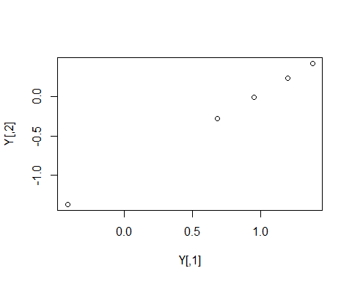

Способ задания матрицы №3

Z <- cbind(x, x, x, x, y, x, y, y)  
N <- rbind(x, x, x, x, y, x, y, y)  
print(colnames(Z))

## [1] "x" "x" "x" "x" "y" "x" "y" "y"

rownames(Z) <- letters[1:5]  
  
print(Z)

## x x x x y x y y  
## a 1 1 1 1 1 1 1 1  
## b 3 3 3 3 2 3 2 2  
## c 5 5 5 5 3 5 3 3  
## d 7 7 7 7 4 7 4 4  
## e 9 9 9 9 5 9 5 5

print(N)

## [,1] [,2] [,3] [,4] [,5]  
## x 1 3 5 7 9  
## x 1 3 5 7 9  
## x 1 3 5 7 9  
## x 1 3 5 7 9  
## y 1 2 3 4 5  
## x 1 3 5 7 9  
## y 1 2 3 4 5  
## y 1 2 3 4 5

## Индексация

Слайсинг

print(X[c(2, 4), -4])

## [,1] [,2] [,3] [,4]  
## [1,] 6 7 8 10  
## [2,] 16 17 18 20

print(X[1:3, 1:3])

## [,1] [,2] [,3]  
## [1,] 1 2 3  
## [2,] 6 7 8  
## [3,] 11 12 13

print(X[1:4, ])

## [,1] [,2] [,3] [,4] [,5]  
## [1,] 1 2 3 4 5  
## [2,] 6 7 8 9 10  
## [3,] 11 12 13 14 15  
## [4,] 16 17 18 19 20

cat("\n")

print(X[,2:3])

## [,1] [,2]  
## [1,] 2 3  
## [2,] 7 8  
## [3,] 12 13  
## [4,] 17 18  
## [5,] 22 23