Environment: Ubuntu 14.04, ROS indigo

0. install ROS

see Linux_setting file

1. assembly crazyfile instructions

https://wiki.bitcraze.io/projects:crazyflie2:userguide:assembly

2. install crazyflie_ros

you have to install ros before install it

cd ~/catkin_ws/src (or go to catkin ws src folder)
git clone https://github.com/whoenig/crazyflie_ros.git
cd ~/catkin_ws (or at your src folder)
catkin_make

3.Setting udev permissions (for crazy radio)

sudo groupadd plugdev
sudo usermod -a -G plugdev <user name> (e.g. jungwon)
sudo gedit /etc/udev/rules.d/99-crazyradio.rules

add the following:
SUBSYSTEM=="usb", ATTRS{idVendor}=="1915", ATTRS{idProduct}=="7777", MODE="0664", GROUP="plugdev"

To connect Crazyflie 2.0 via usb

sudo gedit /etc/udev/rules.d/99-crazyflie.rules

and add the following:
SUBSYSTEM=="usb", ATTRS{idVendor}=="0483", ATTRS{idProduct}=="5740", MODE="0664", GROUP="plugdev"

4. scan crazyflie 2.0

rosrun crazyflie_tools scan

result : //0/80/250K (in my case)

5.Demo

roslaunch crazyflie_demo teleop_xbox360.launch uri:=radio:<your scan result>

(e.g. roslaunch crazyflie_demo teleop_xbox360.launch uri:=radio://0/80/250K)

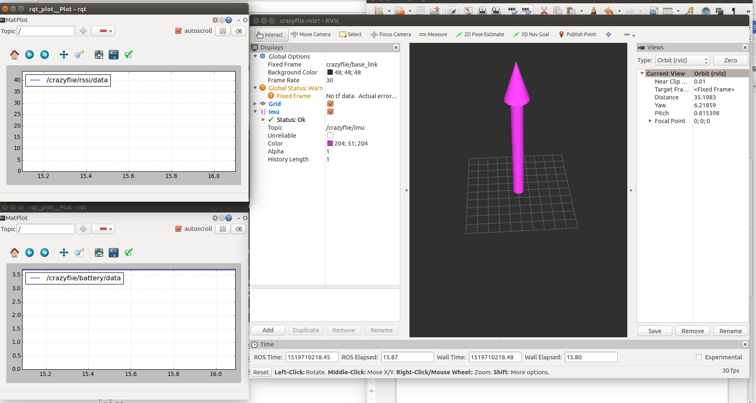

Others

1. python version install
https://github.com/bitcraze/crazyflie-clients-python

