**Assignment 2C:**Configuration of Router and FTP, HTTP, DNS and Mail Server

**Solution:** 1) Configuration of FTP (File Transfer Protocol) Server:

* 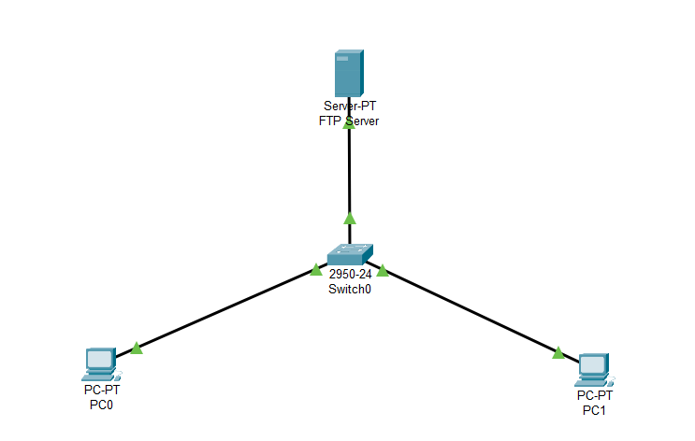We make a Star Topology network of 3 nodes consisting of one Server to host the FTP Service and two PCs. We interconnect them with a 24 pin Switch

* We assign IP Addresses to the three nodes of the network such that all of them belong to the same Network (having same network id, 192.168.4)

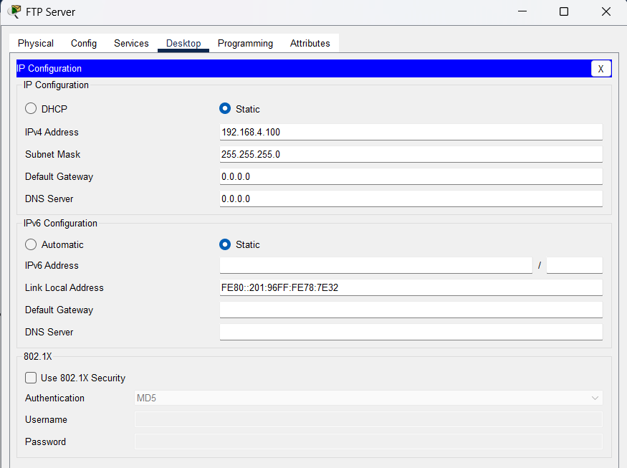

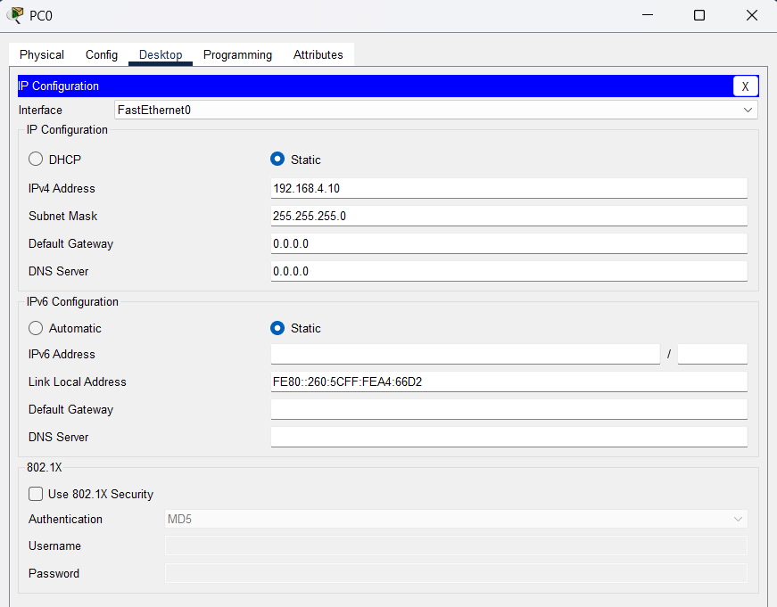

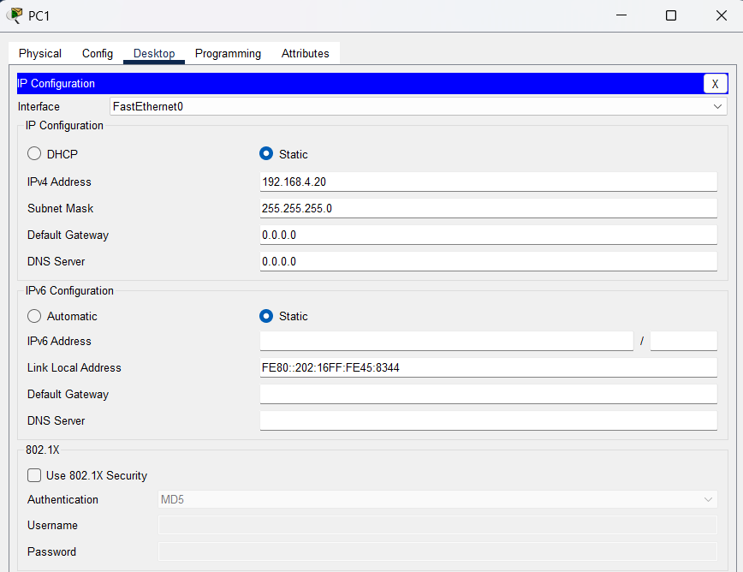

* We assign the IP Addresses 192.168.4.100, 192.168.4.10 and 192.168.4.20 to the Server, PC0 and PC1 respectively
* Then we configure the Server to enable the FTP Services from the Server’s Services Menu
* 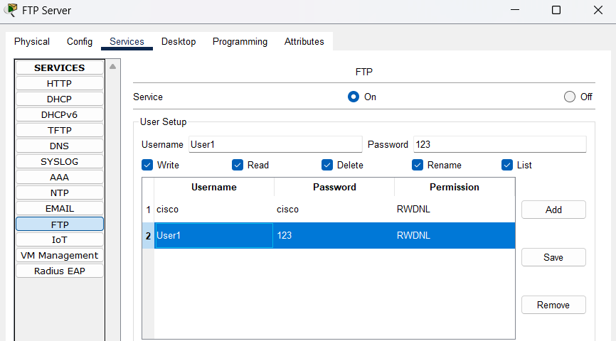We create a new user in the Server with Username as User1 and Password as 123, and give it all permissions to Write, Read, Delete, Rename and List (RWDNL) for FTP

* Then to test the FTP, we create a simple Text File in PC0 and save it as file1.txt

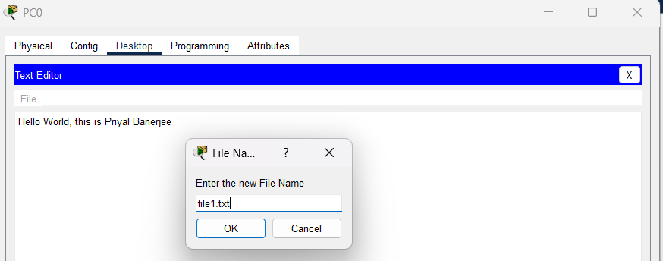

* Then we connect to the Server using FTP Protocol from PC0 (using the command “ftp 192.168.4.100”) using the username and password set previously. Then upload file1.txt from PC0 to the Server using the command “put file1.txt”

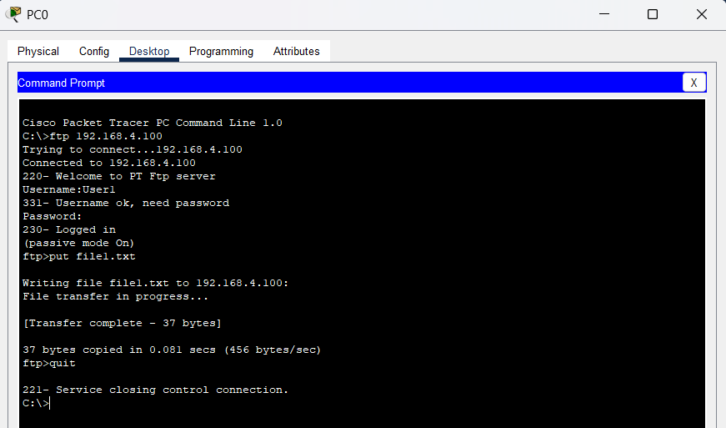

* 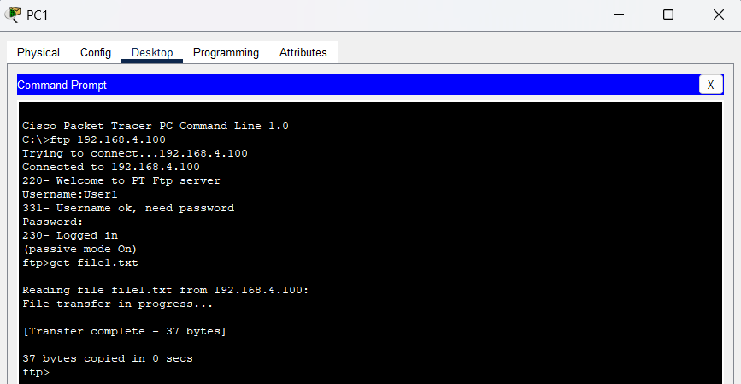Then we connect to the FTP Server from PC1, in the same way as we did from PC0 and download the file file1.txt in PC1 from the Server. We use the command “get file1.txt” to download the file

* 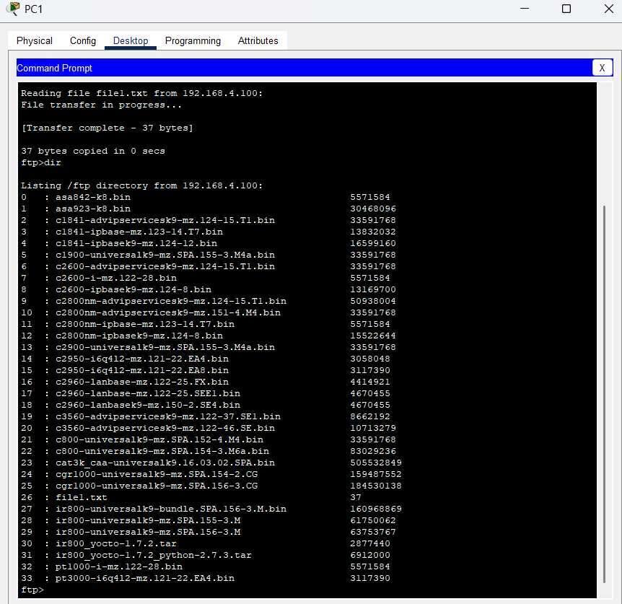And we can then see the file is downloaded into PC1. This is how we can transfer a file from one PC to another using an FTP Server

2) Configuration of DNS (Domain Name System) Server:

* 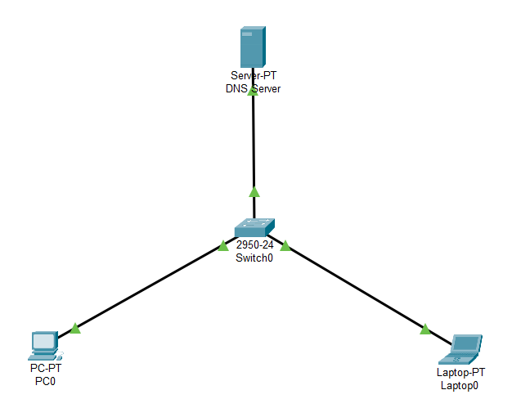We use the same Star Topology Network of one Server an two Workstations (one PC and one Laptop) interconnected with a 24 pin Switch for this
* 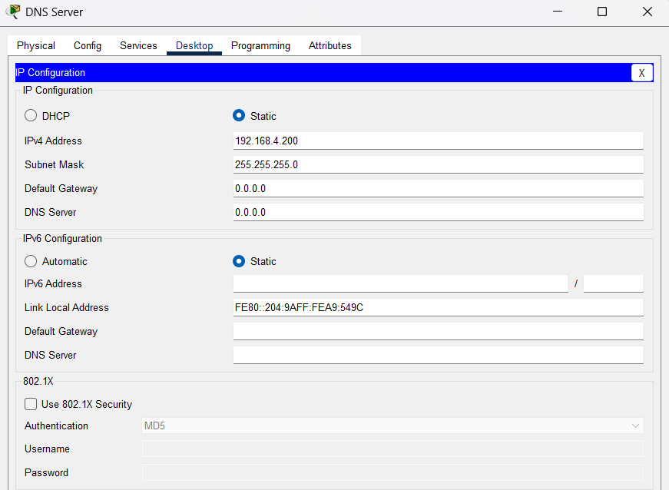Then we assign IP Address to the Server (192.168.4.200) and enable its DNS Service so that the Server can work as a DNS Server. We set a Domain Name called “User1” with the IP of the Server

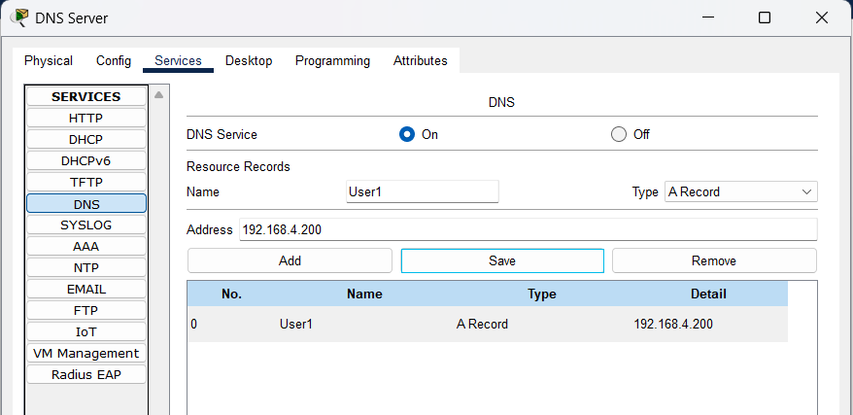

* Then we assign IP Addresses to the Workstations, ensuring that they are in the same network as that of the Server

PC0 🡪 192.168.4.10

Laptop0 🡪 192.168.4.20

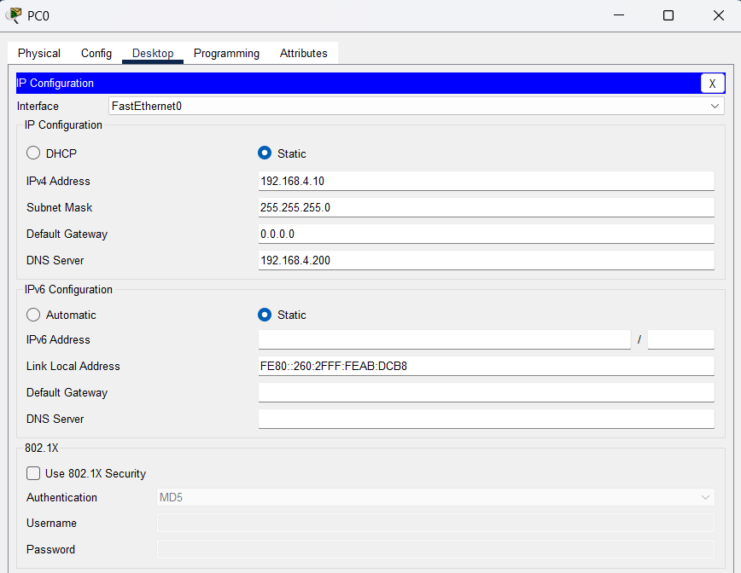We put the Server’s IP in the DNS Server field of both the workstations, so that they can connect to that DNS

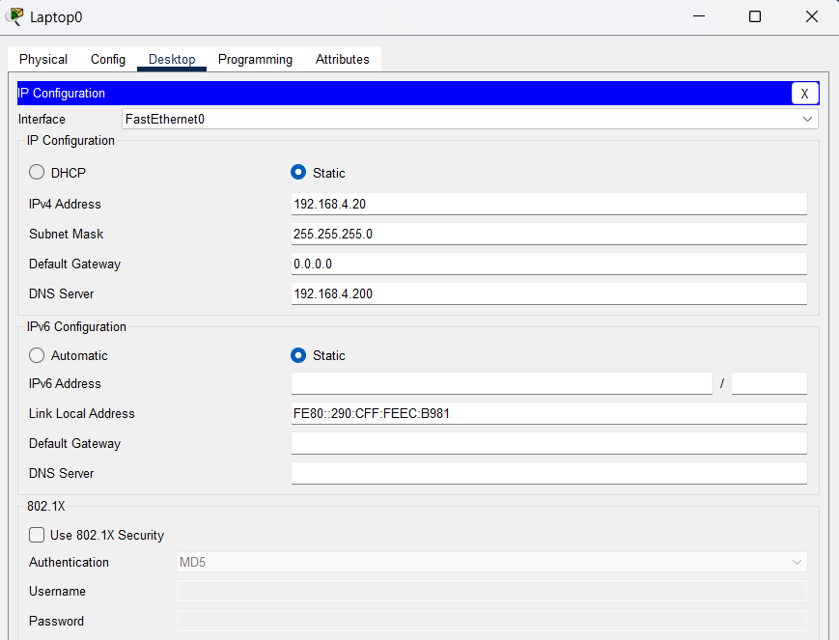

* 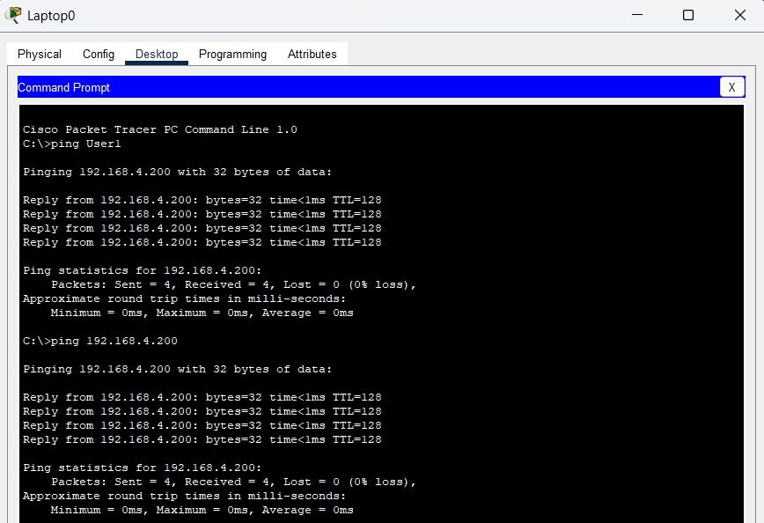Then we check the DNS Connectivity using the “ping” command from Laptop0

3) Configuration of HTTP (Hyper Text Transfer Protocol) Server:

* Configuring the same Star Topology Network for HTTP Services

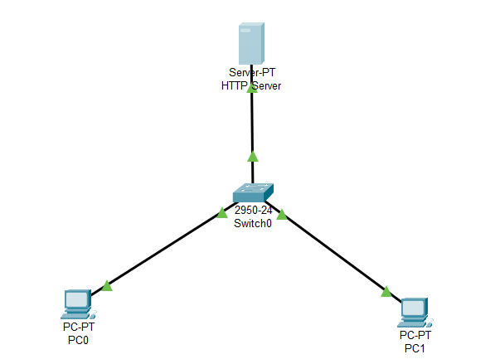

* 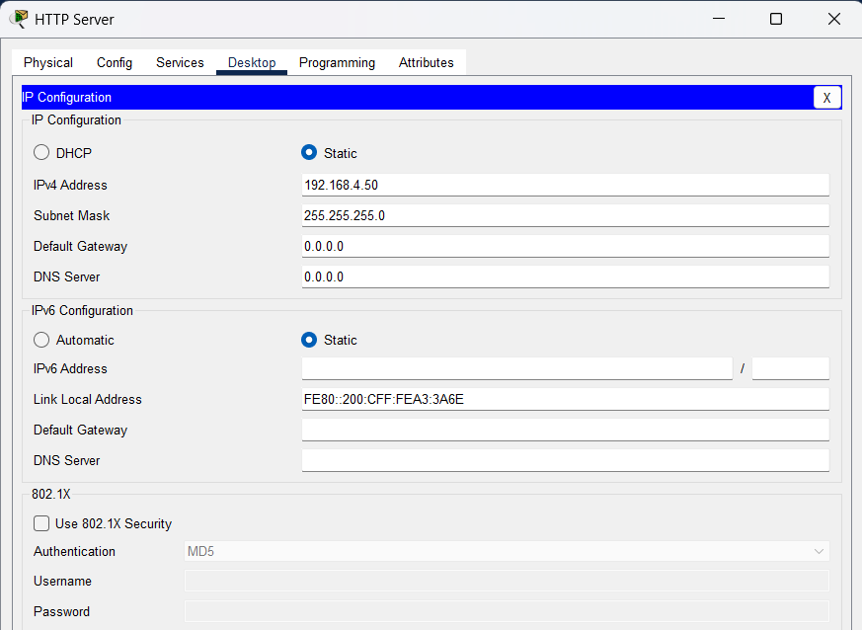Changing the IP Addresses of the Server, PC0 and PC1 within the same network

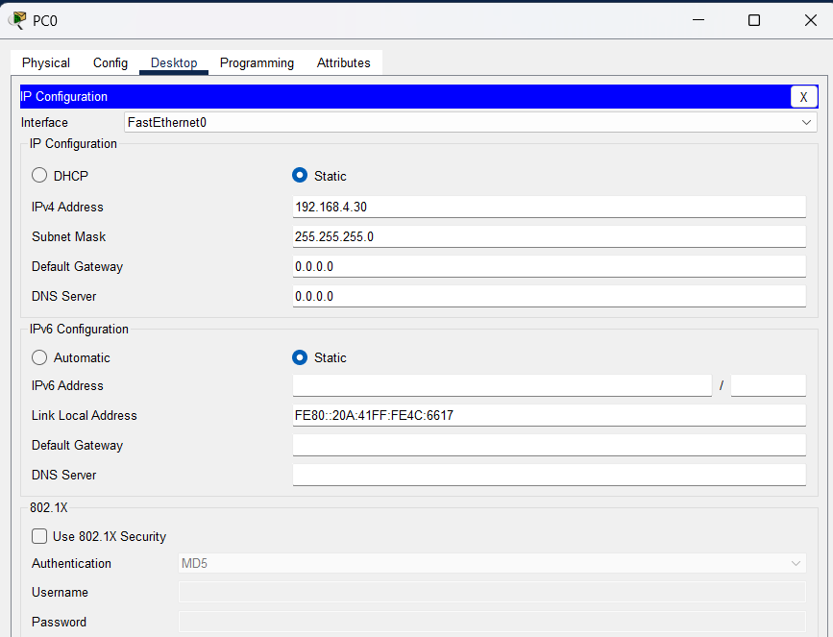

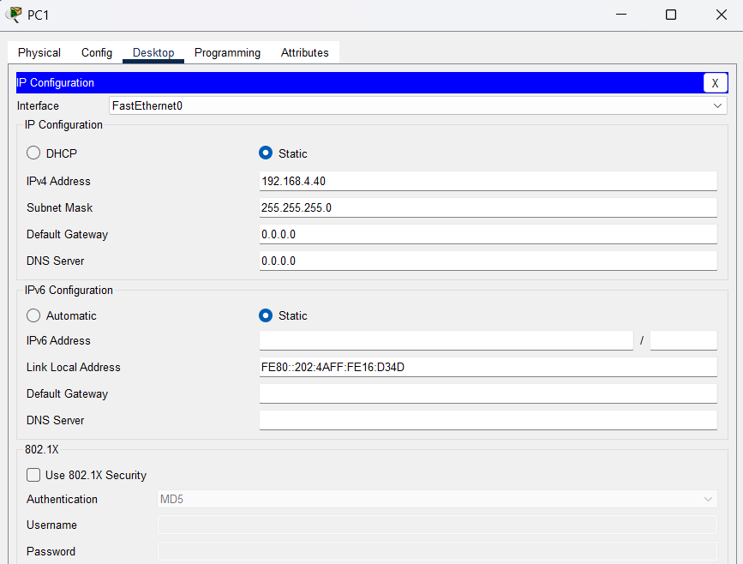

* 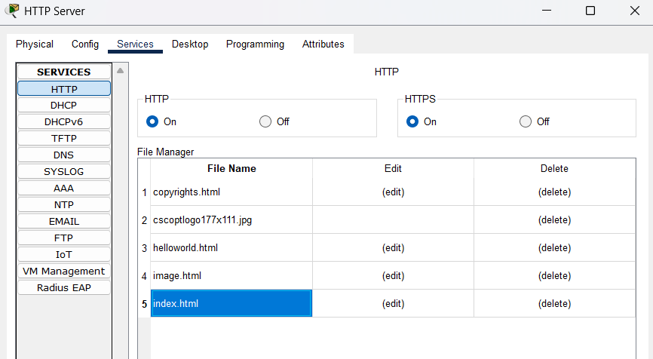Enabling the HTTP Service from the Server and configuring the index.html page of the Server
* 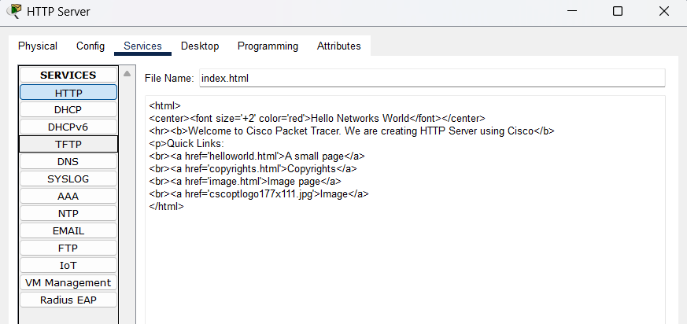0.0Configuring the index.html page to change the visuals, like bolding the texts, etc.
* 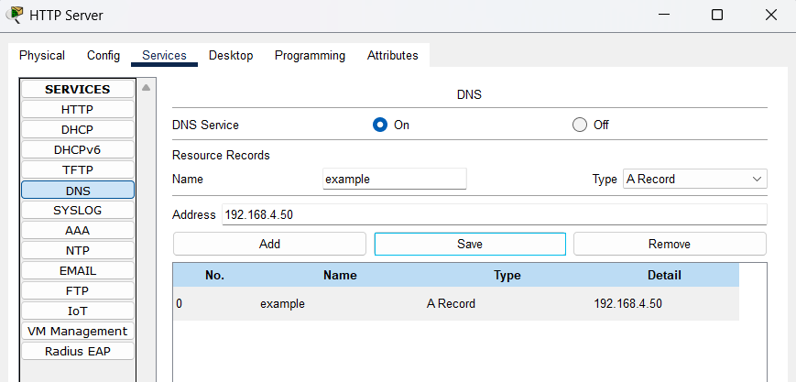Setting up a DNS Server in the same Server, so that the HTTP Service of the Server can be tested using the Web Browser of another device by writing the site name only, and not explicitly mentioning the Server IP Address
* Whenever the site name “example” would be written on the web browser, it will automatically get replaced by the Server IP
* Now, considering PC0 as the test PC, we connect it to the DNS Server to access the DNS Services

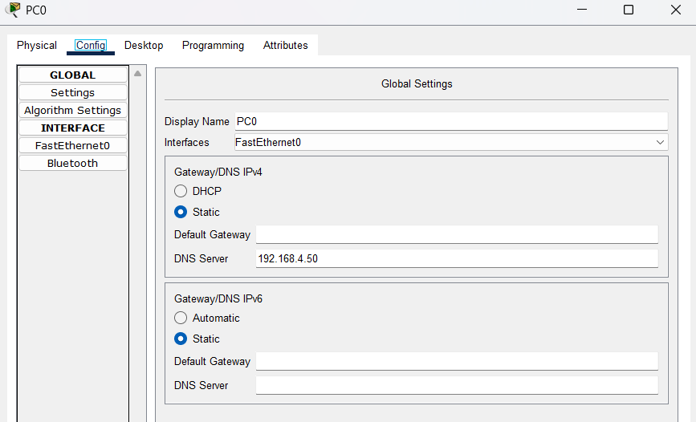

* 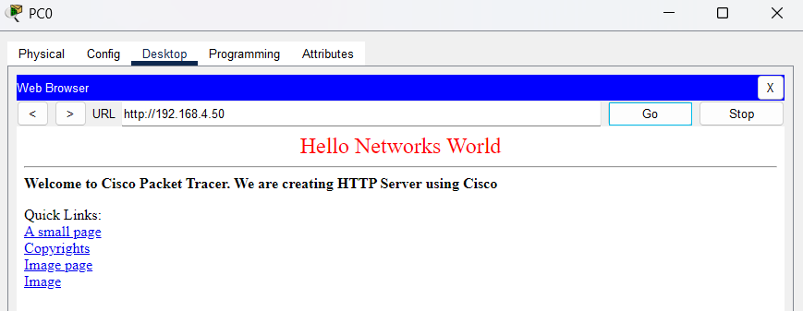Now we open the Web Browser of both PC0 and PC1, and try connecting to the index.html page of the Server using the Server’s HTTP Services. We use the DNS name “example” in PC0 and direct IP Address 192.168.4.50 in the Web Browser’s Search Engines and we observe the same result for both

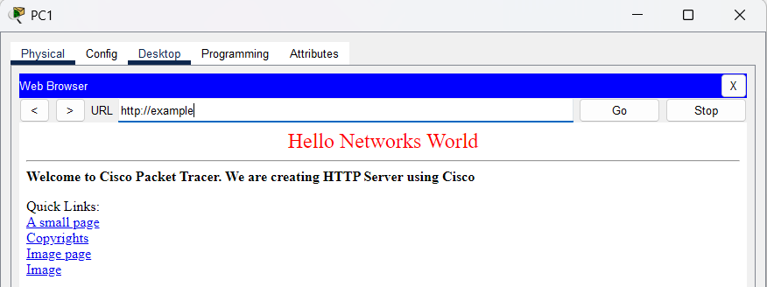

4) Configuration of Mail Server:

* 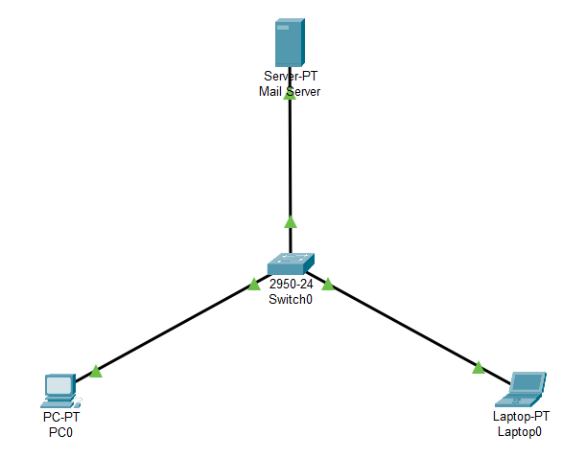Using the same Start Network, and assigning the IP Addresses to the workstations

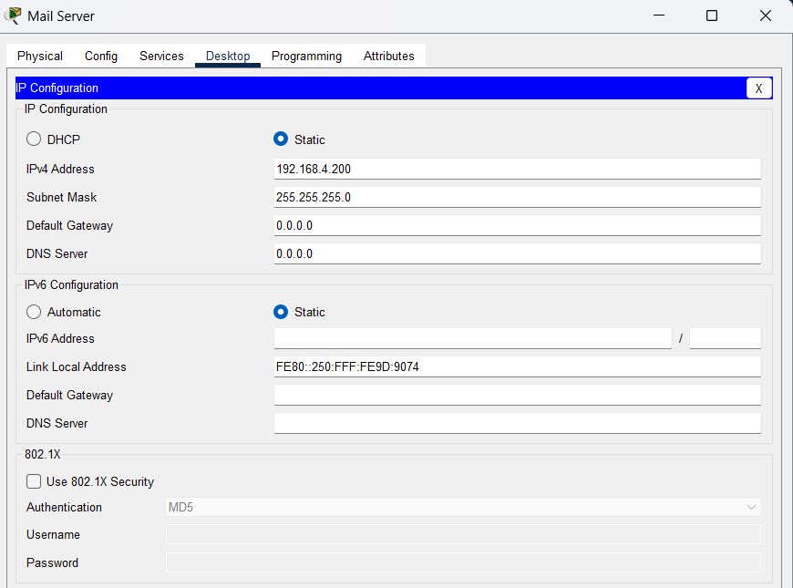

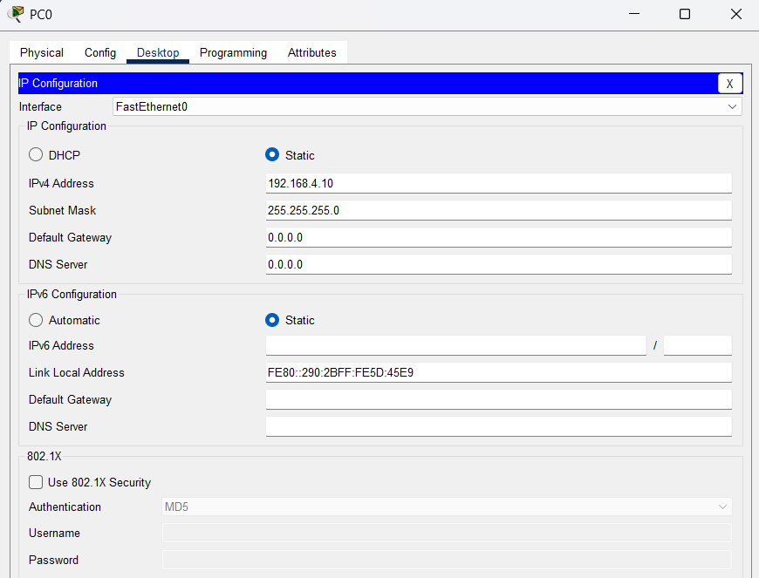

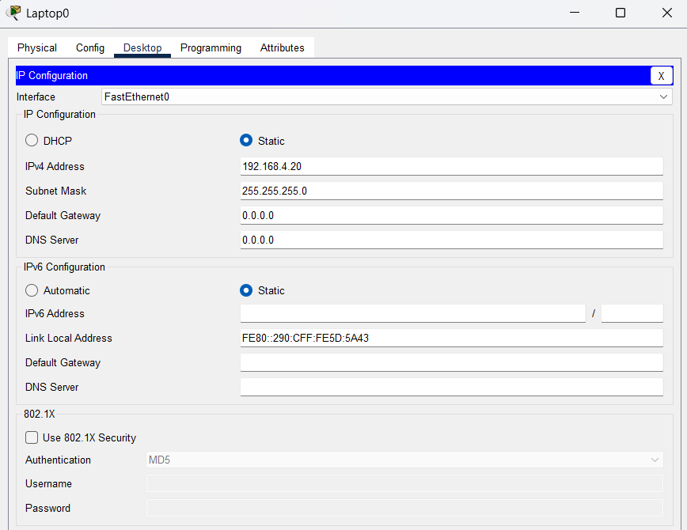

* Mail Server IP Address = 192.168.4.200

PC0 IP Address = 192.168.4.10

Laptop0 = 192.168.4.20

* Then we configure the Mail Server by turning on its Mail Services. And we create two users “User1” and “User2” in the Server

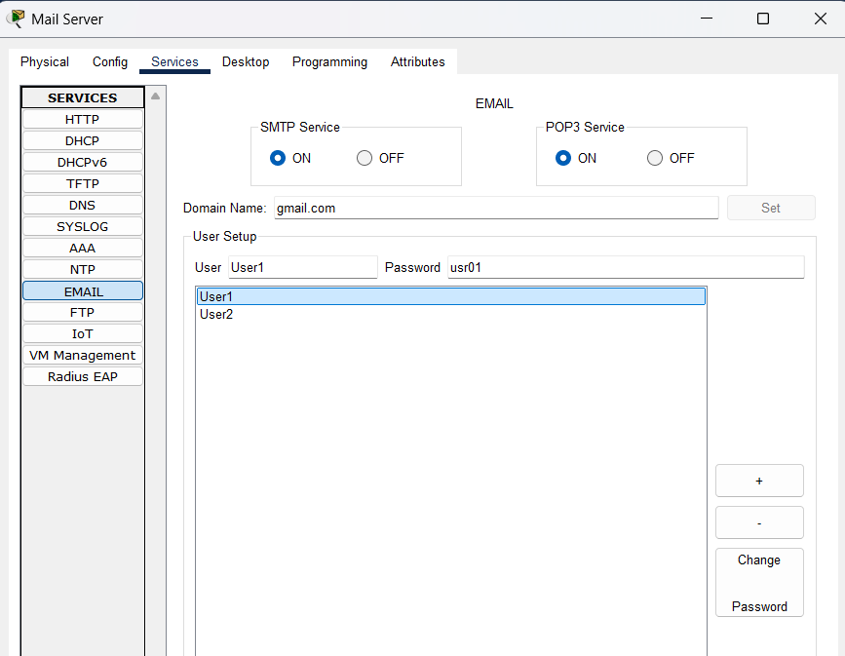

* Then we configure the Mail Settings from both PC0 and Laptop0, such that both the Machines can work as the “User1” and “User2” of the Mail Server respectively. Assigning the email addresses of the machines (users) and passwords along with setting the Mail Server IP

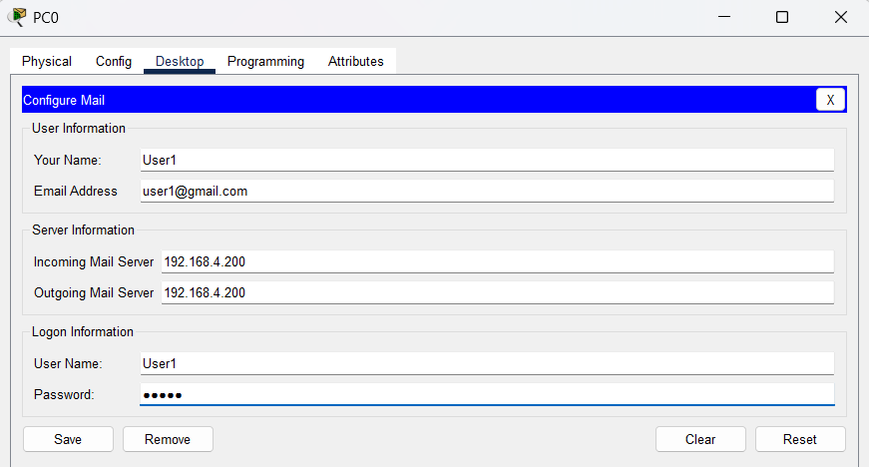

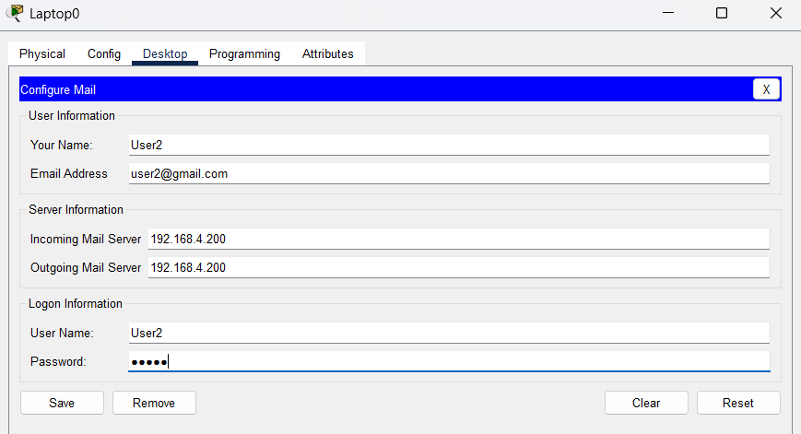

* 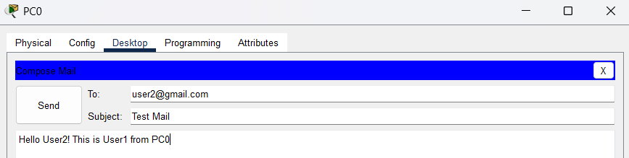Now to test the Mail Server connectivity, we compose an email in PC0 and send it to the email address of Laptop0, via the Mail Server
* 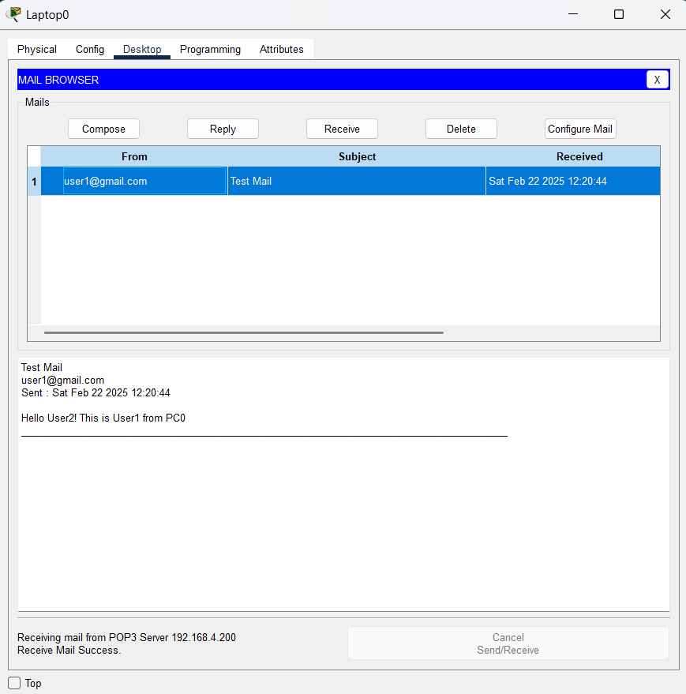The mail has been successfully received by Laptop0 from PC0
* Checking the Mail content from Laptop0

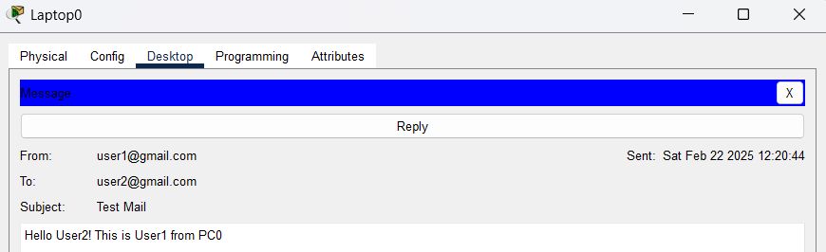

* Now composing a reply mail for PC0 from Laptop0 and sending it

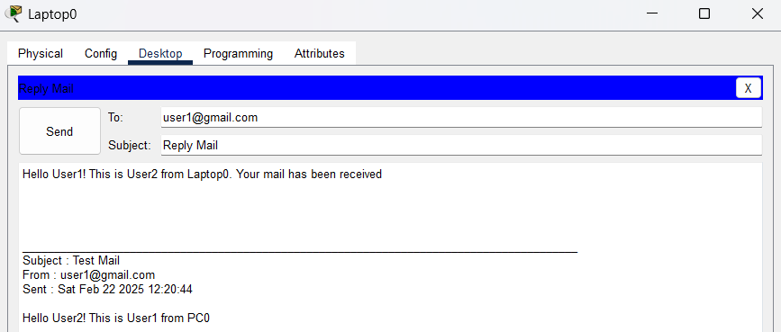

* The reply mail from Laptop0 has been successfully received by PC0

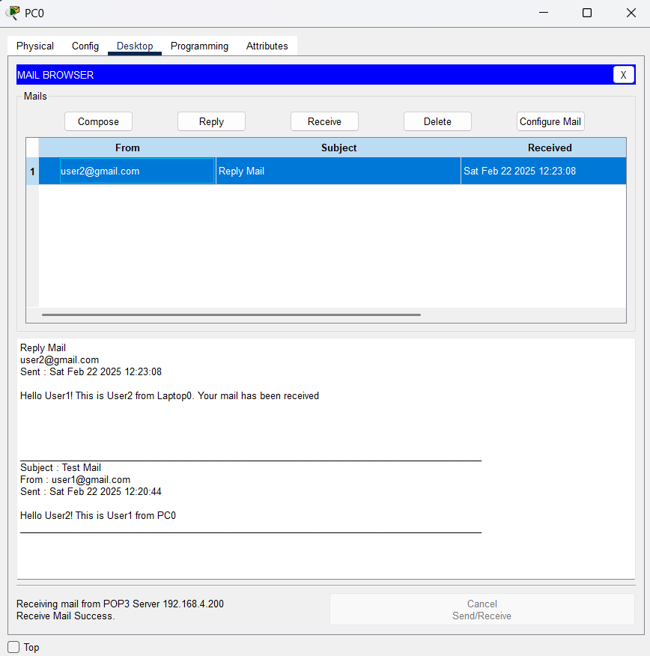

* Then we access the Mail from PC0

