Set up and start the program
- Set up (Window)
- python -m pip install --upgrade pip
- pip install -r requirements.txt
- Start up
- python -m dcas.run_server
- exit (ctrl + c)

Update-ver0.1_enhanced_security
The difference between ver0.2(intro-to-cs) -ver0.1(intro-to-cs1)
- intro-to-cs/dcas/api/server.py vs intro-to-cs1/dcas/api/server.py
  - ver0.1:
    - uses request.get_json(silent=True) instead of direct request.get_json()
    - validates content is a string
    - checks missing/invalid payloads before processing
    - catches RuntimeError while storing file bytes and returns 503
  - ver0.0:
    - simpler and less defensive
    - does not validate JSON input as carefully
    - omits some error handling
    - has an unused import flask
- intro-to-cs/dcas/storage/network.py vs intro-to-cs1/dcas/storage/network.py
  - ver0.1:
    - checks replication_factor < 1 and raises ValueError
    - _select_nodes_for_storage(chunk_hash) prioritizes nodes that do not already hold that chunk
    - keeps rollback on partial write failures
    - stores each chunk with validation and cleanup logic
  - ver0.0:
    - removes the early validation
    - _select_nodes_for_storage(count) is simpler and picks lightest nodes without chunk-aware selection
    - does not roll back partial writes
    - less robust replication behavior
- intro-to-cs/dcas/core/chunker.py vs intro-to-cs1/dcas/core/chunker.py
  - ver0.1:
    - handles empty-byte input explicitly:
      - returns a single empty chunk when data == b""
    - streaming chunker also handles empty file reads cleanly
  - ver0.0:
    - omits the explicit empty-data handling
    - simpler but less edge-case-safe
- intro-to-cs/dcas/tests/test_dcas.py (ver0.1) vs intro-to-cs1/dcas/tests/test_dcas.py (ver0.0)
  - Both look nearly identical in structure
  - The main difference is that intro-to-cs includes the more complete/robust behavior that the code supports; intro-to-cs1 may be a simplified version of the same test suite
- intro-to-cs/dcas/tests/test_web_app.py (ver0.1) vs intro-to-cs1/dcas/tests/test_web_app.py (ver0.0)
  - Similar overall
  - Likely same app flow, with minor behavioral differences due to API logic changes
- intro-to-cs/dcas/verifier/verifier.py (ver0.0) vs intro-to-cs1/dcas/verifier/verifier.py (ver0.0)
  - Likely same core verification logic
  - The set of differences mainly reflects the network/storage behavior differences above
- intro-to-cs/dcas_api_network (ver0.1) vs intro-to-cs1/dcas_api_network (ver0.0)
  - ver0.1:
    - node folders exist but metadata files are absent
  - ver0.0:
    - includes _metadata.json in node-000 and node-001
  - This means intro-to-cs1 contains generated runtime metadata/state not present in intro-to-cs
- Database
  - intro-to-cs/dcas_api_metadata.db (ver0.0)
  - intro-to-cs1/dcas_api_metadata.db (ver0.1)
  - These are different database files, indicating different stored metadata history/state
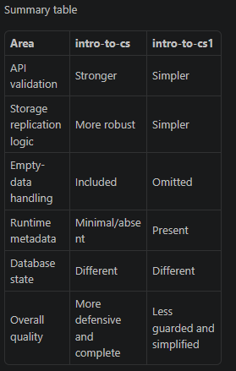
Update-ver0.2_sharing
- Creating shared storage data (sharing by link)

Update-ver0.3_sharing_extra
- Shared link now can access to another people storage

Update-ver0.3.1_sharing_extra_interface_review
- New interface
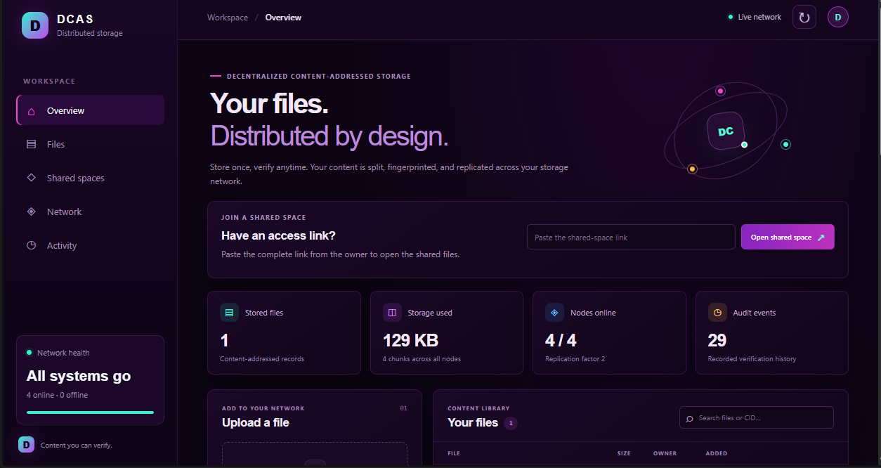

- Review
What the code does
The current uncommitted code change is only app.css: it applies the dark violet/neon theme. It doesn’t change how files are stored.
The DCAS app works like this:
- Start the web app. run_server.py starts Flask and defaults to four storage nodes.
- Store files. StorageNetwork.store_bytes splits files into chunks, hashes them, builds a Merkle tree, and distributes copies across nodes. The web dashboard shows files, network health, and activity.
- Create shared spaces. The owner chooses read-only or read/write access. Shared-space files are encrypted in the browser; recipients use a pasted link to view, verify, and download them. Read/write links also allow uploads. The routes and permission checks are in server.py; the browser workflow is in app.js.
Review notes
- Important encryption limitation: the server checks that an upload starts with a DCAS1 marker, but that doesn’t prove the bytes are actually encrypted. The normal browser interface encrypts them, but encryption isn’t enforced or verified by the server.
- Link permissions are transferable: anyone who gets a link inherits its permissions; there are no individual user accounts for shared spaces.
- Owner credentials are stored in browser local storage. This is suitable for the current demo, but not robust production key management.
- The storage network is currently a local simulation, not a connection to a public decentralized storage protocol

Update-ver0.3.2_sharing_extra_interface_review_part2_ehancedsecurity
Limitation need to fix
Overall
DCAS is a useful demo/prototype, but it is not ready to expose as a public service. The 77 Python tests pass, though the test run emits two non-fatal ResourceWarnings for CSS/JS test responses. I made no changes during this review.
Highest-priority limitations
- Publicly reachable controls can damage the service. The node fail/recover, simulated-corruption, and public-file deletion routes have no authentication checks: fail_node, recover_node, corrupt_chunk, and delete_file. Public uploads and space creation are also open. The launcher can bind beyond localhost, and uses Flask’s built-in development server: run_server.py.
- No resource-abuse controls. Upload handlers read entire files into memory, and the browser encrypts whole files in memory too: server.py, app.js. I found no upload-size cap or rate limiting. Open uploads and unlimited space creation can consume memory, disk, and database capacity.
- Encryption has important trust and migration limits. The new storage layer protects new shared uploads from storage-node operators, but the API receives the upload and holds the storage key. The browser’s separate share key is kept in local storage and included in the access link: app.js, app.js. DCAS1 is still only a marker; the server cannot prove a write-link holder encrypted content in the browser. Files from before this change are not migrated and may remain unencrypted on nodes: STORAGE_ENCRYPTION.md. Link revocation can block future access, but cannot erase copies already downloaded.
- “Decentralized” storage is simulated locally. StorageNetwork manages node directories on one host; there is no peer-to-peer protocol, independent node operators, consensus, or blockchain. Replication helps retrieval, but there’s no automatic repair/re-replication after data loss.
- The storage challenge is not a real proof of possession. challenge_node reads the chunk locally and computes both the expected and “node” responses in the verifier. That check doesn’t demonstrate that an independent remote node holds the data.
Other limitations
- Shared links are bearer capabilities: anyone who gets an active link can access its permissions. There are no individual accounts, link expiry, or identity-bound audit records.
- The owner’s credentials and encryption key have no account recovery. Losing browser storage or the storage key can make access or stored files unrecoverable.
- Filenames, sizes, and access patterns remain visible, as the UI notes in index.html.
- There is no shared-file deletion route; revoking a link does not remove stored content.
- The app requires HTTPS for browser encryption outside localhost, but the launcher itself does not configure TLS.
Recommended before any public deployment: restrict or authenticate destructive/admin routes, add upload quotas and rate limits, use a production server with HTTPS, and migrate or securely remove pre-change shared data.
Update-ver0.3.2.2_sharing_extra_interface_review_part2_ehancedsecurity_fix_2
Encryption has important trust and migration limits. (fixed)
- Secures Legacy Plaintext: It sweeps your database for older files that were uploaded before the encryption layer was implemented and encrypts them retroactively, ensuring all data across your network meets the new security standard.
- Prevents Link Breakage: By preserving the original CIDs and access links at the database level, the migration is completely invisible to users. Anyone clicking an old sharing link will still retrieve their file, even though the underlying storage format has changed.
- Executes Safely (Idempotent): Because it authenticates files that are already wrapped by the storage layer, the script is safe to run multiple times or resume after a crash. It knows which files have already been migrated and skips them, rather than double-encrypting them.
- Protects Against Data Loss: Halting the migration when an existing envelope fails authentication is a critical fail-safe. It prevents the script from deleting the original file or proceeding if the newly encrypted data appears corrupted or tampered with.
- Optimizes Storage Costs: By deleting the old, unencrypted chunks from the decentralized network once the encrypted version is secured, it acts as a garbage collector, preventing your storage payload (and associated decentralized storage fees) from doubling.
- To migrate your data (keep the old data and transfer it to the new version): stop the server and back up the metadata database, node directories, and storage key first. Then, from the project directory, run: python -m dcas.run_server --migrate-shared-storage --network-dir .\dcas_api_network --db .\dcas_api_metadata.db

The storage challenge is not a real proof of possession - > Educational RSA-based proof-of-data-possession (PDP)
This description is an assessment of a piece of software (likely a script or prototype) that demonstrates Proof of Data Possession (PDP)—a cryptographic technique used in cloud and decentralized storage to prove a server still holds a file without downloading the whole thing.
Here is a plain-English breakdown of each part of that statement:
1. "Educational, publicly verifiable RSA-PDP flow"
- PDP (Proof of Data Possession): A challenge-response protocol where a client asks a storage server, "Prove you still have my file," and the server sends back a tiny mathematical receipt proving it hasn't deleted or corrupted the data.
- RSA-based: It uses RSA cryptography (modular exponentiation with large prime numbers) to generate the cryptographic tags on the file blocks and verify the proof.
- Publicly verifiable: Anyone with the public key—not just the original file owner—can audit the storage server and verify that the data is still intact.
- Educational: The code is simplified to teach how the math works, skipping real-world complexities like network error handling, key rotation, or performance optimization.
2. "Nodes return an aggregate proof rather than the challenged sector bytes"
- When auditing a file, the verifier picks a random subset of file chunks ("sectors" or blocks).
- Instead of sending those actual data chunks back over the network (which wastes bandwidth), the storage node combines the chunks and their cryptographic signatures into a single, small mathematical value (an aggregate proof). The verifier checks this single value to confirm all the challenged chunks are intact at once.
3. "The core equations are internally consistent with that design"
- The underlying math is implemented properly. The formulas used to tag the file, generate the challenge, combine the proof, and verify the result match the academic specification for RSA-PDP.
4. "It is not a production-audited proof of retrievability"
- Not production-audited: Security experts haven't vetted the code for real-world vulnerabilities (like side-channel attacks, weak random number generation, or improper parameter sizes), so it shouldn't be used to protect real money or sensitive systems.
- PDP vs. Proof of Retrievability (PoR): PDP only proves the server currently possesses the data. PoR goes a step further by adding erasure coding (redundancy) so that even if a few sectors are slightly corrupted, the client can still mathematically recover the full original file.
5. "The aggregate response does not preserve data confidentiality"
- While the node doesn't send the raw file bytes directly, the mathematical proof it sends back is derived directly from the raw data. If the underlying file is small, predictable, or low-entropy, an eavesdropper intercepting the proof could potentially reverse-engineer or guess the contents of the file. In a real system, data must be encrypted before running PDP, or zero-knowledge techniques must be added to hide the data inside the proof.

