Set up and start the program
- Set up (Window)
- python -m pip install --upgrade pip
- pip install -r requirements.txt
- Start up
- python -m dcas.run_server
- exit (ctrl + c)

Update-ver0.1_enhanced_security
The difference between ver0.2(intro-to-cs) -ver0.1(intro-to-cs1)
- intro-to-cs/dcas/api/server.py vs intro-to-cs1/dcas/api/server.py
  - ver0.1:
    - uses request.get_json(silent=True) instead of direct request.get_json()
    - validates content is a string
    - checks missing/invalid payloads before processing
    - catches RuntimeError while storing file bytes and returns 503
  - ver0.0:
    - simpler and less defensive
    - does not validate JSON input as carefully
    - omits some error handling
    - has an unused import flask
- intro-to-cs/dcas/storage/network.py vs intro-to-cs1/dcas/storage/network.py
  - ver0.1:
    - checks replication_factor < 1 and raises ValueError
    - _select_nodes_for_storage(chunk_hash) prioritizes nodes that do not already hold that chunk
    - keeps rollback on partial write failures
    - stores each chunk with validation and cleanup logic
  - ver0.0:
    - removes the early validation
    - _select_nodes_for_storage(count) is simpler and picks lightest nodes without chunk-aware selection
    - does not roll back partial writes
    - less robust replication behavior
- intro-to-cs/dcas/core/chunker.py vs intro-to-cs1/dcas/core/chunker.py
  - ver0.1:
    - handles empty-byte input explicitly:
      - returns a single empty chunk when data == b""
    - streaming chunker also handles empty file reads cleanly
  - ver0.0:
    - omits the explicit empty-data handling
    - simpler but less edge-case-safe
- intro-to-cs/dcas/tests/test_dcas.py (ver0.1) vs intro-to-cs1/dcas/tests/test_dcas.py (ver0.0)
  - Both look nearly identical in structure
  - The main difference is that intro-to-cs includes the more complete/robust behavior that the code supports; intro-to-cs1 may be a simplified version of the same test suite
- intro-to-cs/dcas/tests/test_web_app.py (ver0.1) vs intro-to-cs1/dcas/tests/test_web_app.py (ver0.0)
  - Similar overall
  - Likely same app flow, with minor behavioral differences due to API logic changes
- intro-to-cs/dcas/verifier/verifier.py (ver0.0) vs intro-to-cs1/dcas/verifier/verifier.py (ver0.0)
  - Likely same core verification logic
  - The set of differences mainly reflects the network/storage behavior differences above
- intro-to-cs/dcas_api_network (ver0.1) vs intro-to-cs1/dcas_api_network (ver0.0)
  - ver0.1:
    - node folders exist but metadata files are absent
  - ver0.0:
    - includes _metadata.json in node-000 and node-001
  - This means intro-to-cs1 contains generated runtime metadata/state not present in intro-to-cs
- Database
  - intro-to-cs/dcas_api_metadata.db (ver0.0)
  - intro-to-cs1/dcas_api_metadata.db (ver0.1)
  - These are different database files, indicating different stored metadata history/state
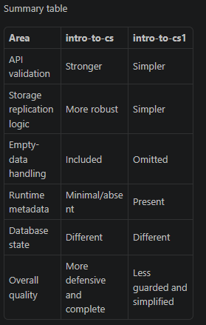
Update-ver0.2_sharing
- Creating shared storage data (sharing by link)

Update-ver0.3_sharing_extra
- Shared link now can access to another people storage

Update-ver0.3.1_sharing_extra_interface_review
- New interface
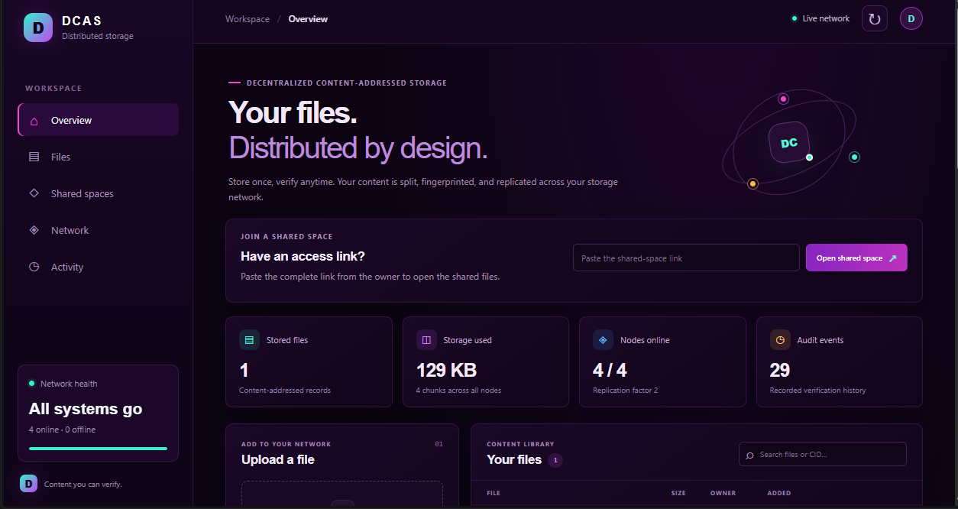

- Review
What the code does
The current uncommitted code change is only app.css: it applies the dark violet/neon theme. It doesn’t change how files are stored.
The DCAS app works like this:
- Start the web app. run_server.py starts Flask and defaults to four storage nodes.
- Store files. StorageNetwork.store_bytes splits files into chunks, hashes them, builds a Merkle tree, and distributes copies across nodes. The web dashboard shows files, network health, and activity.
- Create shared spaces. The owner chooses read-only or read/write access. Shared-space files are encrypted in the browser; recipients use a pasted link to view, verify, and download them. Read/write links also allow uploads. The routes and permission checks are in server.py; the browser workflow is in app.js.
Review notes
- Important encryption limitation: the server checks that an upload starts with a DCAS1 marker, but that doesn’t prove the bytes are actually encrypted. The normal browser interface encrypts them, but encryption isn’t enforced or verified by the server.
- Link permissions are transferable: anyone who gets a link inherits its permissions; there are no individual user accounts for shared spaces.
- Owner credentials are stored in browser local storage. This is suitable for the current demo, but not robust production key management.
- The storage network is currently a local simulation, not a connection to a public decentralized storage protocol

Update-ver0.3.2_sharing_extra_interface_review_part2_ehancedsecurity
Limitation need to fix
Overall
DCAS is a useful demo/prototype, but it is not ready to expose as a public service. The 77 Python tests pass, though the test run emits two non-fatal ResourceWarnings for CSS/JS test responses. I made no changes during this review.
Highest-priority limitations
- Publicly reachable controls can damage the service. The node fail/recover, simulated-corruption, and public-file deletion routes have no authentication checks: fail_node, recover_node, corrupt_chunk, and delete_file. Public uploads and space creation are also open. The launcher can bind beyond localhost, and uses Flask’s built-in development server: run_server.py.
- No resource-abuse controls. Upload handlers read entire files into memory, and the browser encrypts whole files in memory too: server.py, app.js. I found no upload-size cap or rate limiting. Open uploads and unlimited space creation can consume memory, disk, and database capacity.
- Encryption has important trust and migration limits. The new storage layer protects new shared uploads from storage-node operators, but the API receives the upload and holds the storage key. The browser’s separate share key is kept in local storage and included in the access link: app.js, app.js. DCAS1 is still only a marker; the server cannot prove a write-link holder encrypted content in the browser. Files from before this change are not migrated and may remain unencrypted on nodes: STORAGE_ENCRYPTION.md. Link revocation can block future access, but cannot erase copies already downloaded.
- “Decentralized” storage is simulated locally. StorageNetwork manages node directories on one host; there is no peer-to-peer protocol, independent node operators, consensus, or blockchain. Replication helps retrieval, but there’s no automatic repair/re-replication after data loss.
- The storage challenge is not a real proof of possession. challenge_node reads the chunk locally and computes both the expected and “node” responses in the verifier. That check doesn’t demonstrate that an independent remote node holds the data.
Other limitations
- Shared links are bearer capabilities: anyone who gets an active link can access its permissions. There are no individual accounts, link expiry, or identity-bound audit records.
- The owner’s credentials and encryption key have no account recovery. Losing browser storage or the storage key can make access or stored files unrecoverable.
- Filenames, sizes, and access patterns remain visible, as the UI notes in index.html.
- There is no shared-file deletion route; revoking a link does not remove stored content.
- The app requires HTTPS for browser encryption outside localhost, but the launcher itself does not configure TLS.
Recommended before any public deployment: restrict or authenticate destructive/admin routes, add upload quotas and rate limits, use a production server with HTTPS, and migrate or securely remove pre-change shared data.

