一、进度

程序主要部分已经结束，待解决有

1、待机变频器的灯语（现在暂时用LED常灭代替，和连接不到变频器相同）。

2、恰当的延时

二、测试项

1、初始化：

对T1、T2、T5默认条件输出；

|  |  |  |  |  |  |  |  |  |  |  |  |
| --- | --- | --- | --- | --- | --- | --- | --- | --- | --- | --- | --- |
| T1 | | | | T2 | | | | T5 | | | |
| 0001 | 1000 | 0001 | 1000 | 0001 | 1000 | 0001 | 1000 | 1011 | 1011 | 0011 | 1100 |

2、条件输出项：

当发现一个故障的情况下，根据图中逻辑对T1、T2按下表进行输出设置。

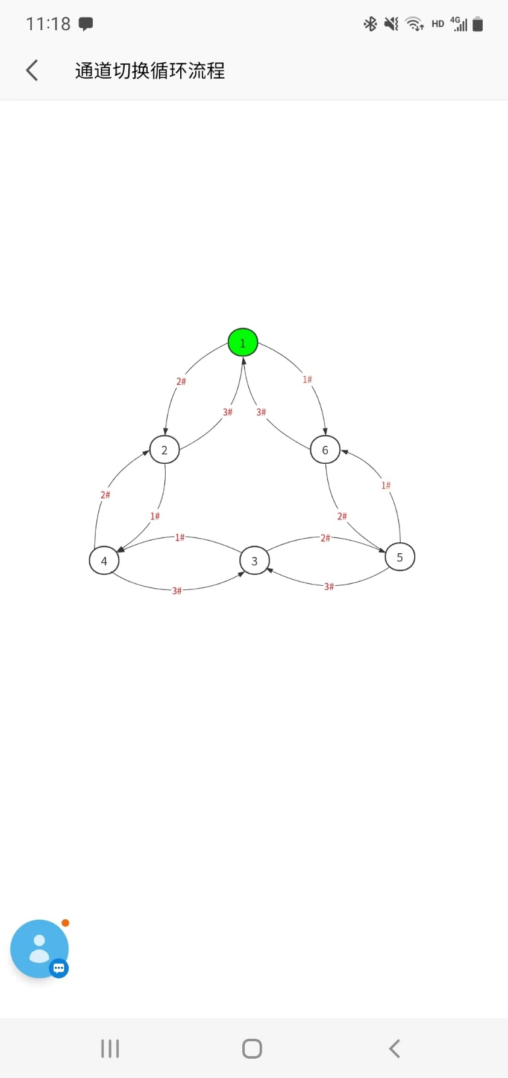

需要完成以下情况的验证：

Fault:1-故障 0-正常

LED:0x10绿 0x01红 0x11黄 0x00无色

|  |
| --- |
| / |
| 7e7e1b000300ffff01f00000000000000000000000010100000d0a |
|  |
| 7e7e1b000200ffff01f00000000000000000000000010100000d0a |
|  |
| 7e7e1b000100ffff01f00000000000000000000001010100000d0a |
|  |
| 7e7e1b000300ffff01f00000000000000000000000010100000d0a |
|  |
| 7e7e1b000200ffff01f00000000000000000000000000100000d0a |
|  |
| 7e7e1b000100ffff01f00000000000000000000000010100000d0a |

|  |  |  |  |  |  |  |  |  |  |  |  |
| --- | --- | --- | --- | --- | --- | --- | --- | --- | --- | --- | --- |
| T1 | | | | T2 | | | | T5 | | | |
| 0001 | 1000 | 0001 | 1000 | 0001 | 1000 | 0001 | 1000 | 1011 | 1011 | 0011 | 1100 |
| 0001 | 1000 | 0001 | 1000 | 0001 | 1000 | 0001 | 1000 | 1011 | 1011 | 0111 | 1100 |
| 0010 | 0100 | 0010 | 0100 | 0010 | 0100 | 0010 | 0100 | 1011 | 1000 | 1111 | 1100 |
| 0010 | 0100 | 0010 | 0100 | 0010 | 0100 | 0010 | 0100 | 1011 | 1001 | 1111 | 1100 |
| 0100 | 1000 | 0100 | 1000 | 0100 | 1000 | 0100 | 1000 | 1011 | 1110 | 0011 | 1100 |
| 0100 | 1000 | 0100 | 1000 | 0100 | 1000 | 0100 | 1000 | 1011 | 1110 | 0111 | 1100 |
| 0110 | 0000 | 1000 | 0100 | 0110 | 0000 | 1000 | 0100 | 1011 | 0010 | 1111 | 1100 |
| 0110 | 0000 | 1000 | 0100 | 0110 | 0000 | 1000 | 0100 | 1011 | 0110 | 1111 | 1100 |
| 1000 | 0100 | 0110 | 0000 | 1000 | 0100 | 0110 | 0000 | 1011 | 1100 | 1011 | 1100 |
| 1000 | 0100 | 0110 | 0000 | 1000 | 0100 | 0110 | 0000 | 1011 | 1101 | 1011 | 1100 |
| 1001 | 0000 | 1001 | 0000 | 1001 | 0000 | 1001 | 0000 | 1011 | 0011 | 1011 | 1100 |
| 1001 | 0000 | 1001 | 0000 | 1001 | 0000 | 1001 | 0000 | 1011 | 0111 | 1011 | 1100 |

一个以上的故障

T5按照下表赋值

1表示坏 2表示断线 0表示正常

ff表示故障之前此处数据

|  |  |  |  |  |  |  |  |
| --- | --- | --- | --- | --- | --- | --- | --- |
| 序号 | 1 | 2 | 3 | T5 | | | |
| 1 | 1 | 1 | 0 | 1011 | 0101 | ff11 | 1100 |
| 2 | 1 | 0 | 1 | 1011 | 01ff | 0111 | 1100 |
| 3 | 0 | 1 | 1 | 1011 | ff01 | 0111 | 1100 |
| 4 | 1 | 1 | 1 | 1011 | 0101 | 0111 | 1100 |
| 5 | 2 | 2 | 0 | 1011 | 0000 | ff11 | 1100 |
| 6 | 2 | 0 | 2 | 1011 | 00ff | 0011 | 1100 |
| 7 | 0 | 2 | 2 | 1011 | ff00 | 0011 | 1100 |
| 8 | 2 | 2 | 2 | 1011 | 0000 | 0011 | 1100 |
| 9 | 1 | 2 | 0 | 1011 | 0100 | Ff11 | 1100 |
| 10 | 1 | 0 | 2 | 1011 | 01ff | 0011 | 1100 |
| 11 | 2 | 1 | 0 | 1011 | 0001 | Ff11 | 1100 |
| 12 | 0 | 1 | 2 | 1011 | Ff01 | 0011 | 1100 |
| 13 | 2 | 0 | 1 | 1011 | 00ff | 0111 | 1100 |
| 14 | 0 | 2 | 1 | 1011 | Ff00 | 0111 | 1100 |
| 15 | 1 | 1 | 2 | 1011 | 0101 | 0011 | 1100 |
| 16 | 1 | 2 | 1 | 1011 | 0100 | 0111 | 1100 |
| 17 | 2 | 1 | 1 | 1011 | 0001 | 0111 | 1100 |
| 18 | 2 | 2 | 1 | 1011 | 0000 | 0111 | 1100 |
| 19 | 2 | 1 | 2 | 1011 | 0001 | 0011 | 1100 |
| 20 | 1 | 2 | 2 | 1011 | 0100 | 0011 | 1100 |
| 21 | 1 | 0 | 0 |  |  |  |  |
| 22 | 2 | 0 | 0 |  |  |  |  |
| 23 | 0 | 1 | 0 |  |  |  |  |
| 24 | 0 | 2 | 0 |  |  |  |  |
| 25 | 0 | 0 | 1 |  |  |  |  |
| 26 | 0 | 0 | 2 |  |  |  |  |

3、通信

间隔1秒，依次对1、2、3号端口进行查询，判断应答状态是否存在故障，形成输出条件

|  |  |  |  |  |
| --- | --- | --- | --- | --- |
|  |  | 1# | 2# | 3# |
| 1 | 7e7e001b0100ffff01f00000000000000000000001010100000d0a | 0 | / | / |
| 2 | 7e7e001b0100ffff01f00000000000000000000000010100000d0a | 1 |  |  |
| 3 | 7e7e001b0100ffff01f00000000000000000000001000100000d0a | 1 |  |  |
| 4 | 7e7e001b0100ffff01f00000000000000000000001010000000d0a | 1 |  |  |
| 5 | 7e7e001b0100ffff01f00000000000000000000000000100000d0a | 1 |  |  |
| 6 | 7e7e001b0100ffff01f00000000000000000000001000000000d0a | 1 |  |  |
| 7 | 7e7e001b0100ffff01f00000000000000000000000010000000d0a | 1 |  |  |
| 8 | 7e7e001b0100ffff01f00000000000000000000000000000000d0a | 1 |  |  |
| 9 | / | 2 |  |  |
| 10 | 7e7e001b0100ffff01f00000000000000000000001010100000d0a |  | 0 |  |
| 11 | 7e7e001b0100ffff01f00000000000000000000000010100000d0a |  | 1 |  |
| 12 | 7e7e001b0100ffff01f00000000000000000000001000100000d0a |  | 1 |  |
| 13 | 7e7e001b0100ffff01f00000000000000000000001010000000d0a |  | 1 |  |
| 14 | 7e7e001b0100ffff01f00000000000000000000000000100000d0a |  | 1 |  |
| 15 | 7e7e001b0100ffff01f00000000000000000000001000000000d0a |  | 1 |  |
| 16 | 7e7e001b0100ffff01f00000000000000000000000010000000d0a |  | 1 |  |
| 17 | 7e7e001b0100ffff01f00000000000000000000000000000000d0a |  | 1 |  |
| 18 | / |  | 2 |  |
| 19 | 7e7e001b0100ffff01f00000000000000000000001010100000d0a |  |  | 0 |
| 20 | 7e7e001b0100ffff01f00000000000000000000000010100000d0a |  |  | 1 |
| 21 | 7e7e001b0100ffff01f00000000000000000000001000100000d0a |  |  | 1 |
| 22 | 7e7e001b0100ffff01f00000000000000000000001010000000d0a |  |  | 1 |
| 23 | 7e7e001b0100ffff01f00000000000000000000000000100000d0a |  |  | 1 |
| 24 | 7e7e001b0100ffff01f00000000000000000000001000000000d0a |  |  | 1 |
| 25 | 7e7e001b0100ffff01f00000000000000000000000010000000d0a |  |  | 1 |
| 26 | 7e7e001b0100ffff01f00000000000000000000000000000000d0a |  |  | 1 |
| 27 | / |  |  | 2 |
|  |  |  |  |  |