初始店铺营业额

select name,total_turnover from merchant

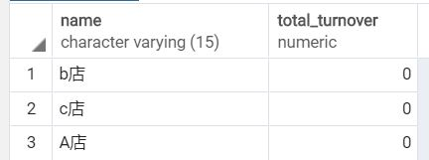

初始用户节省金额

select uname,total_discount from user1

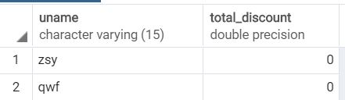

初始订单

select oid,usernmae,mid,price,state,amount,discount from morder

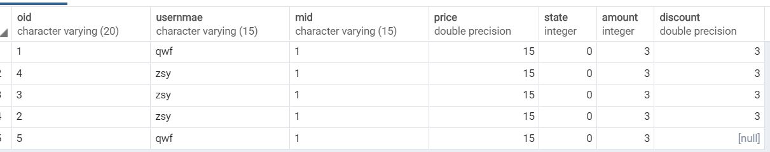

用户1插入一个订单

insert into user_order1 values('6','1','1','0','1','qwf',15,null,null,(select now()),null,'sunny'

,(select nowlocation from user1 where uid='1')

,'15287814721',1,3,6)

用户查询订单

select oid,usernmae,mid,price,state,amount,discount from user_order1

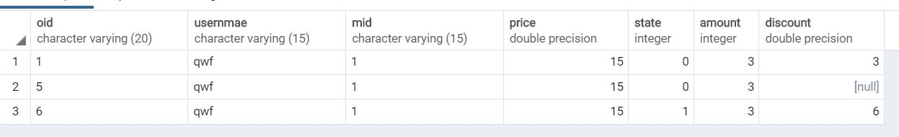

用户收货更新订单状态

update user_order1 set state=3 where oid='6'

更新后的用户订单，商家营业额，用户节省金额

