**Week 5 Quiz (Sequence Alignment Part I)**

**02-604: Fundamentals of Bioinformatics**

1. Consider the following adjacency list of a DAG:

a -> b: 5

a -> c: 6

a -> d: 5

b -> c: 2

b -> f: 4

c -> e: 4

c -> f: 3

c -> g: 5

d -> e: 4

d -> f: 5

e -> g: 2

f -> g: 1

What is the longest path in this graph? Give your answer as a sequence of nodes separated by spaces. (Note: a, b, c, d, e, f, g is a topological order for this graph.)

a b c e g

1. 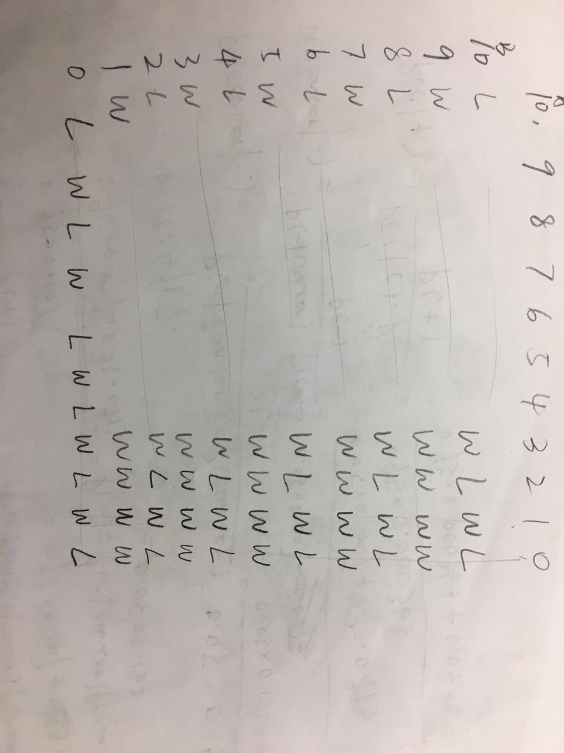Alice and Bob are bored and play a game. They have two piles of ten rocks. In each turn, a player can take one rock from a single pile, or one rock from both piles. The player who takes the last rock wins the game. Alice moves first. What should she do? Is there a strategy that can guarantee a win? (And what does this have to do with sequence alignment?)

In the table above, T[i, j] means the person can win(W) or lose(L) when facing the case where A pile has I rocks and B pile has j rocks. So that the person who starts from (10,10) will lose eventually.

This case is just like sequence alignment that when you align two sequences, you take one rock from both piles. If you don’t align them together, it’s like you only take one rock from one pile.

1. 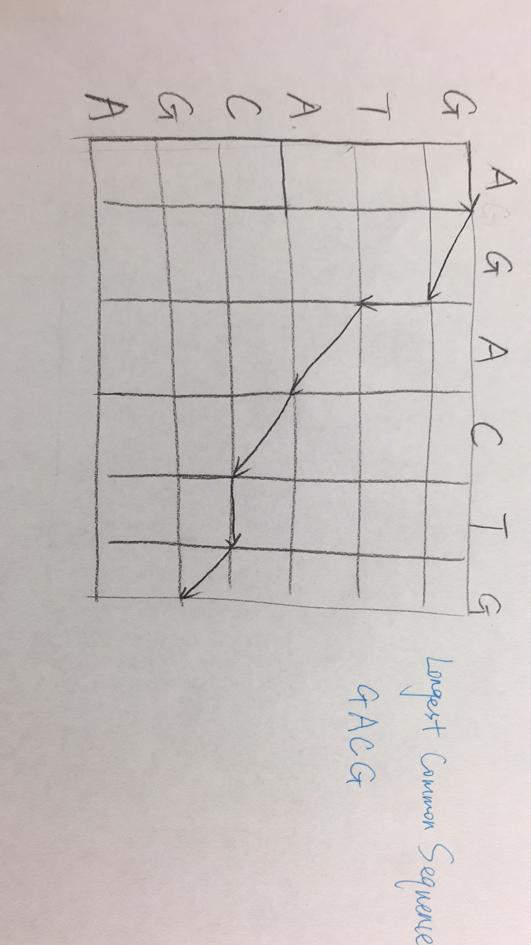There is a unique longest common subsequence of the strings AGACTG and GTACGA. What is it? (You must show your work with an alignment graph.)

GACG

1. Draw the path through the alignment graph corresponding to the following alignment.

TCGAC--ATT

CC---GAA-T

