Exercise 3.3: Inheritance
Lab Objectives

- Learn how to:
  - Extend your classes using inheritance
  - Override methods appropriately
  - Make use of polymorphism
  - Override equals(...) in your own inheritance hierarchies

Associated Reading:
Java Oracle Tutorials,
https://docs.oracle.com/javase/tutorial/java/concepts/inheritance.html
https://docs.oracle.com/javase/tutorial/java/IandI/subclasses.html

Extending classes using inheritance

In OO programming, there are two fundamental ways of reusing functionality of existing classes; the first is by composition/aggregation where a new class is made up of existing classes, the second is by inheritance, where a new class is based on an existing class, with modifications or extensions.

Inheritance allows code to be shared between classes and services to be provided that can be used by multiple classes. By organising related classes that share common behaviour into a hierarchy, designers can avoid duplication and reduce redundancy.

- In inheritance, we say that a one class extends another class. The subclass extends the superclass. "B extends A", "B inherits from A", "B is an A".

 | extends
  B
  A
- The subclass inherits all of the superclass’ fields and methods.
- The subclass can add more fields and methods. So it becomes more specialized.
- The subclass can override (i.e. redefine) the inherited methods, or leave them unchanged.
- In Java a class can only have one superclass, (but it can have many behaviours by implementing many interfaces - not yet covered).
- The first line of a subclass’ constructor is always a call to the superclass’ constructor (because the superclass’ fields must be initialized). If the programmer does not explicitly call the superclass’ constructor then its no-argument constructor is automatically called.
- Classes that might be extended should always have a no-argument constructor.
- super() is the code for calling the no-argument constructor of a superclass.
- super is a keyword that refers to the superclass object (as opposed to this, which refers to 'self'). It can be used to access the superclass’ methods, e.g. super.toString().
- A superclass’ private fields cannot be accessed directly by a subclass.
- protected fields can be accessed directly by subclasses, although it is not usually recommended using this scope.

Notes - The Inheritance association:
- Inheritance (Extending and specializing a class) “is-a”
- Illustrated in UML class diagrams using the following association symbol:

Person |  | Student |  | Inheritance (“is-a” or “extends”). A student “is a” person.

Please continue to the next page...
Question 1 Reopen your Eclipse workspace "CTEC2710_OO" then download the existing Java Project that can be extracted from the "Inheritance.zip" file, and imported into Eclipse. In Eclipse press Ctrl+F10 and select Package Presentation > Flat.

Earlier in the module you may recall implementing two types of Counter. A 'modulo' counter behaved in the same way as a standard counter except that its value stayed in the range 0 to (modulo-1). When the value of the counter reached 'modulo' it wrapped back to zero. For example, the seconds counter on a watch behaves like a modulo 60 counter.

The ModuloCounter 'is-a' Counter, and therefore can naturally be associated with it through inheritance so as to reuse common implementation. We could easily define additional variants of the Counter class, e.g.
  - StepCounter: increment and decrement by a step amount. E.g. count up and down in steps of 2.
  - OffsetCounter: The internal representation of the count value is the same as in Counter, but getCount returns the count+offset.
  - BoundedCounter: The counter value must always be in some given range min..max inclusive. There are additional methods isMin and isMax.

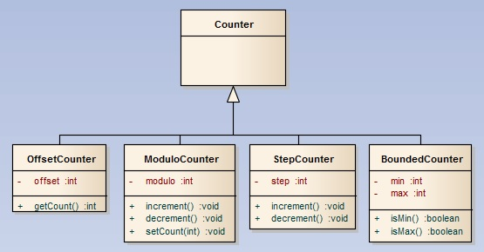

- In the lib.counters package, study the code within the classes you have been provided, especially paying attention to how the inheritance relationships have been defined. Additionally, look in the main package at the CountersDemo program and how different types of counter can be processed in a uniform way, i.e. polymorphism - that you have already seen when using interface types.
- Implement the StepCounter class ensuring it extends Counter and overrides the increment(), decrement() and toString() methods. It should define a default and custom constructor, as well as get/set methods for its step field.
- Add some more code to the CountersDemo program so that a StepCounter object is created and added to the ArrayList so that it is processed within the for-each loop.
Question 2 Continue working in the same project and open the lib.bankaccounts package.

The following UML specification shows how you can create an inheritance hierarchy for bank accounts:

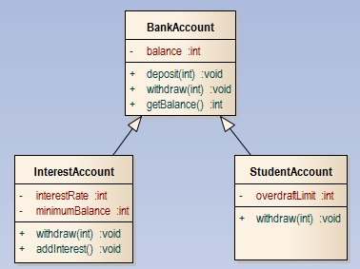

- Study the code within the BankAccount superclass and the InterestAccount subclass which extends it. In InterestAccount take note of how the constructors firstly call a parent constructor, the overridden withdraw(...) method and how there are get and set methods and a toString() that are not listed in the UML class diagram.
- Implement the StudentAccount subclass ensuring it extends BankAccount and overrides its withdraw(...) method, such that money is only withdrawn if the overdraftLimit is not exceeded. For example if the overdraft was set to 1000 then the balance should never go below -1000. You should also have a get and set method for the overdraft field and a toString() method. Hint: Look at InterestAccount to help guide you.
- Add some more code to the BankAccountDemo program (in the main package) so that a StudentAccount object is created and its methods called, then add at least one instance to the ArrayList so that it is processed within the for-each loop.
Notes - Polymorphism and inheritance:
- When multiple classes share common features, they may all extend the same superclass. They may then either inherit or override a particular method from the superclass. It is possible to process these objects with different behaviour in a uniform way - a technique called polymorphism (also relevant to interface types).
- This is because each object is guaranteed to either inherit or override the method. But how does the Java virtual machine know which method to invoke? This is achieved via dynamic method lookup, which finds the exact class type of the object instance and then either executes the overridden version of the method or that inherited by its superclass.

Please continue to the next page...

Notes - Using the super keyword:
- The super keyword is most obviously used to call the constructor of a superclass. It can also be used to invoke any method within a superclass. For example super.toString() will invoke the toString() method in a superclass.
- When you want to call a method of the superclass, that has been overridden in the subclass, it is necessary to use the super keyword, e.g. super.withdraw(amount), this is typically done when a subclass method overrides the superclass implementation by adding functionality, but then also invokes the original method as well. The functionality for the withdraw() method in InterestAccount can reuse that in BankAccount but also add more specialised behaviour.
- There are other occasions when it is optional to use the super keyword, for example InterestAccount does not override the deposit(...) method specified in BankAccount. When it needs to use it within the addInterest() method, either super.deposit(amount) or simply deposit(amount) would be acceptable. This is because public methods of the superclass are automatically inherited. In this circumstance, some developers like to use super, to make it explicitly clear that the method belongs to the superclass. The only issue that could arise here is if at a later stage, the deposit(...) method was overridden, each occasion where it was called within that class would need to be checked to ensure either the overridden version or that of the superclass was called as appropriate.
Notes - Inheritance and the toString() method:
- A toString() representation should consist of the class name and the names and values of the instance variables. If you want it to be usable by subclasses of your class, you should use the getClass().getName() methods rather than hardcoding the class name, e.g.
return this.getClass().getName() + ":[balance=" + balance + "]";
- In a subclass, which will also override toString(), the parent's toString() method should firstly be called, followed by the subclass instance variables, e.g.
return super.toString() + "[interestRate=" + interestRate + ", minimumBalance=" + minimumBalance + "]";
- The result is that the correct class name is output, matching that of the object for which the method is invoked, and the brackets are helpful in showing which variables belong to the superclass.
OUTPUT:
BankAccount:[balance=100]
InterestAccount:[balance=3000][interestRate=5, minimumBalance=1000]

Please turn over...

Question 3 Continue working in the same package as the previous question and develop an "IsaAccount" class that extends InterestAccount. An IsaAccount 'is-a' InterestAccount and therefore also 'is-a' BankAccount. It shares their features but adds its own specialized functionality, in that there is a depositRemaining. This instance variable is initialized with an amount and any deposits will result in it being reduced. It should never go below zero.

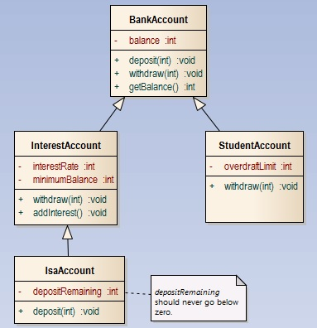

- Implement the IsaAccount class ensuring it extends InterestAccount and overrides the deposit(...) method (that it would automatically inherit from BankAccount), such that every deposit is deducted from the depositRemaining and is only carried out if the resultant value is zero or greater.
For example if depositRemaining was set to 1000 then 600 was deposited, it would reduce to 400. If a user then attempts to deposit 401, it should not be allowed as this would result in the limit being exceeded.
- Add some more methods getDepositRemaining(), resetDepositRemaining() that resets it to a sensible fixed amount (e.g. 5000) and a suitable toString().
- Add some more code to the BankAccountDemo program (in the main package) so that a StudentAccount object is created and its methods called, then add at least one instance to the ArrayList so that it is processed within the for-each loop. You can also experiment further with the different bank accounts if you wish.

Please turn over...

Question 4 For the classes you have developed during this lab exercise, you have not yet overridden the equals(...) method. In previous lab exercises, you have learnt how to override the equals(...) method to test objects for equality by using the instanceof operator. The principle is similar when doing so in your own inheritance hierarchy, with slight differences:

- Go to your BankAccount class and copy in the following equals(...) method:
@Override
public boolean equals(Object obj) {
if (obj == null || this.getClass() != obj.getClass())
return false;

BankAccount other = (BankAccount) obj;

return this.balance == other.balance;
}

Note above: The logic within the implementation of the method is a little different to what you have seen previously. Instead of using instanceof, the getClass() method is used (which ensures the types are exactly the same – see slides for more on this), with the null check being done separately. A downcast is then done before checking the balance.
- Now let's override the equals(...) method in a subclass. Go to your InterestAccount class and copy in the following code:
@Override
public boolean equals(Object obj) {
if (!super.equals(obj))
return false;

InterestAccount other = (InterestAccount) obj;

return this.interestRate == other.interestRate
&& this.minimumBalance == other.minimumBalance;
}

Note above: In your subclass, you firstly call equals(...) within the superclass, this will cause the class type and null checks to occur, as well as checking the instance variable(s) of the superclass, in this case balance. It is therefore not necessary to check the class type and object reference (for null) again in the subclass, as this is done by the superclass. Instead, simply cast the object into the subclass type (e.g. InterestAccount) and then check the instance variables of the subclass.
- Implement a copy of the equals(...) method within your StudentAccount class.
- Implement a copy of the equals(...) method within your IsaAccount class. Note: This method will call the equals method within its direct superclass, i.e. InterestAccount, which will in turn call that within BankAccount, such that all instance variables of the subclass and its superclasses are tested for equality.
- Test each of your equals(...) implementations work as expected in your BankAccountDemo program.

