User Manual for Java IUT

Index
User Manual for Java IUT 1
Index 1
1 Command Line Options 2
2 Tutorial 2
2.1 Install 3
2.1.1 Setting up the home folder 3
2.1.2 Setting up iutj executable 3
2.2 Modifying build.gradle file 4
2.3 Initializing 5
2.4 Preprocessing 6
2.5 Incremental Testing 7
2.6 Removing the project 8

Command Line Options
The command for Java Incremental Unit Testing tool is “iutj”. It has 5 command options, which are as follows.

Command Options | Argument | Description
-i <projectName> | projectName: name of the target project | Initialize configuration file and several settings.
-c <projectName> | projectName: name of the target project | Instrument source -> run test cases to cover methods -> update database.
-s <projectName> <oldVersionPath> <newVersionPath> | projectName: name of the target project  oldVersionPath: the absolute path of the old version  newVersionPath: the absolute path of the new version | Diff to find changed methods -> query for affected test cases -> run affected test cases.
-r <projectName> | projectName: name of the target project | Remove db file and other related files and setting of the project.
-h | N/A | Show help information

Tutorial
We use JsonPath (https://github.com/jayway/JsonPath) as sample project for iutj, just as before.
This tutorial is demoed with the listed environment:
- Linux - Ubuntu 14.04 LTS
- Java - 1.8.0_77
- Gradle - 2.14.1
- Sqlite - 3.8.2

Install
To install Java IUT, after unzipping the iutj.zip file, you have to take care of two things. The first is setting up a home folder which contains all the things that are needed for running iutj and stores specific folders for projects that uses iutj. The second is to add the location of the iutj executable to PATH for users to run iutj wherever they want.

Setting up the home folder
To set up the home folder, we need to copy the “point iut” folder to your $HOME path. It’s better to rename it to “.iut” to make it invisible as it need not to be visible.
Possible commands:
cp -r point\ iut $HOME/.iut

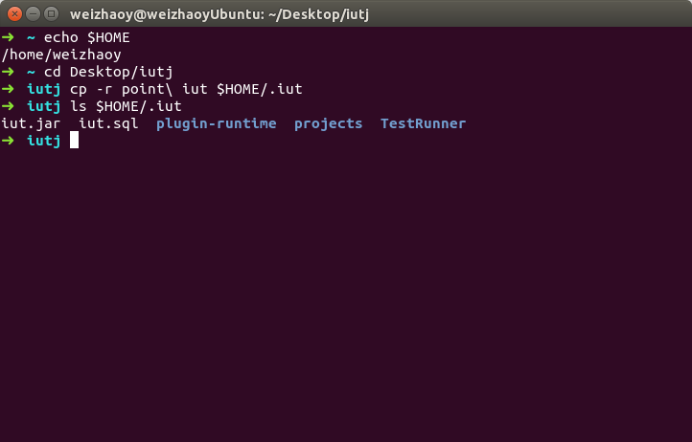

Setting up iutj executable
To set up the iutj executable file, we need to add its path to $PATH, or simply move the iutj file to one of the paths in $PATH, such as “/usr/local/bin”.
Possible commands:
sudo cp iutj /usr/local/bin/

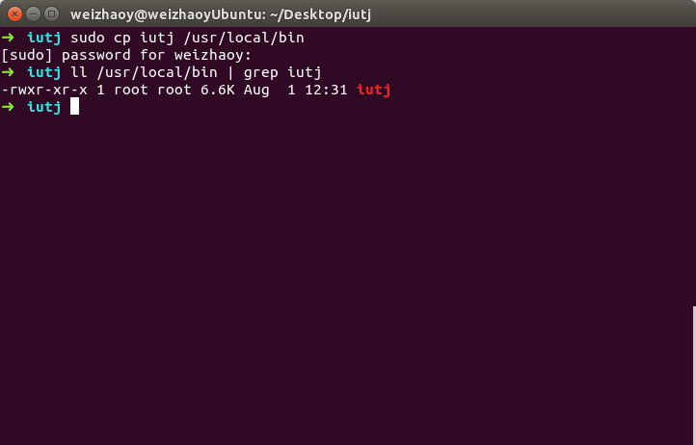

Modifying build.gradle file
We need to modify the “build.gradle” file of the project to enable our plugin to work.
Add the following settings into the “build.gradle” file:
buildscript {
dependencies {
classpath fileTree(dir: '<Your iut home>/plugin-runtime', include: '*.jar')
}
}

apply plugin: 'cn.edu.sjtu.iut'
Possible commands:
cd {your JsonPath directory}/json-path

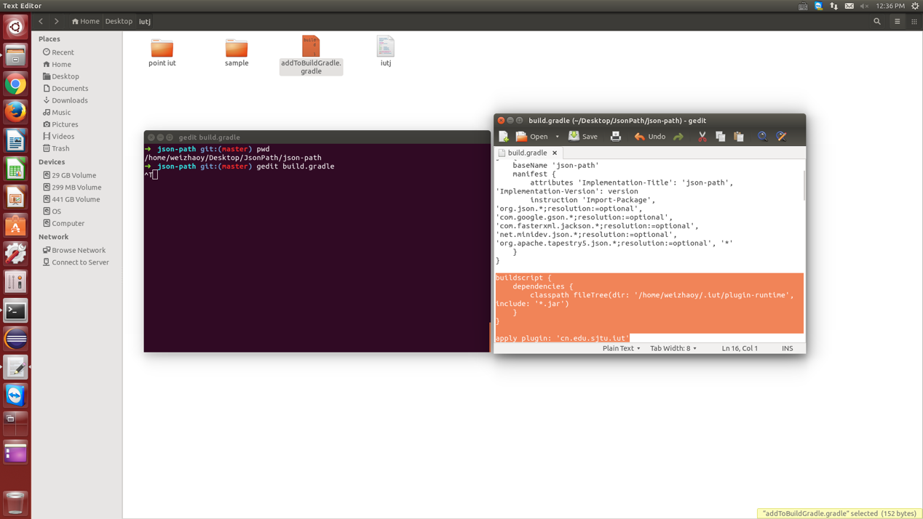

Initializing
To initialize a project for incremental testing, we need to change to the project directory, and run the command “–i” option with a specified project name.
Possible commands:
cd {your JsonPath directory}
iutj –i jsonpath

After that, iutj will create a configuration file called “iut.json”. Its contents are as follows. It’s preferred to check the file to see if the configurations generated are legal, especially the property "srcdirs", sometimes iutj can’t correctly locate the source folder.

{
"type": "jsonpath",
"project" : "iut",
"srcdirs" : ["json-path/src/main/java"],
"database": {
"type": "sqlite",
"host" : "/Users/johndoe/.iut/projects/jsonpath/iut.db",
"db" : "iut",
"username" : "iut",
"password" : "iut"
}
}

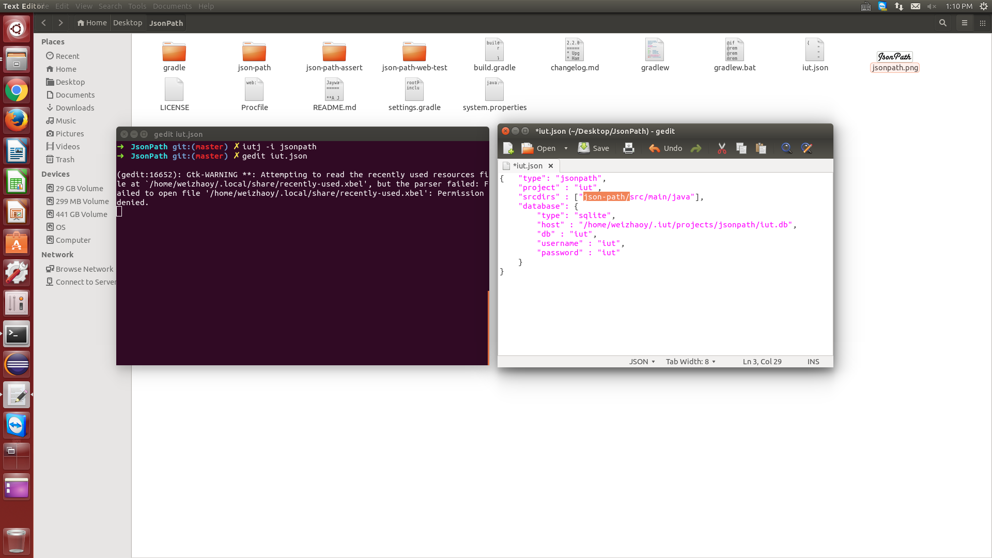

Preprocessing
After initializing the project, we are all good to go. The preprocessing completes several steps including instrumenting the source, run all test cases to find the mapping relationship between test cases and methods and store this information into the database.
To run the preprocessing, we simply run the “-c” option.
Possible commands:
iutj –c jsonpath

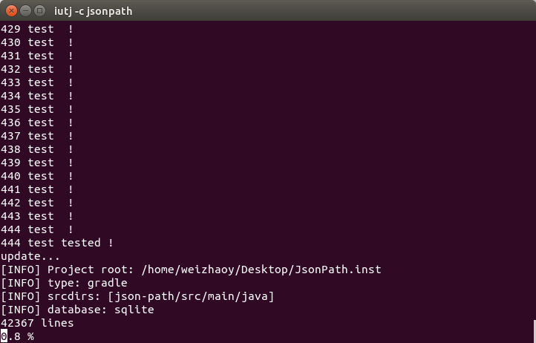

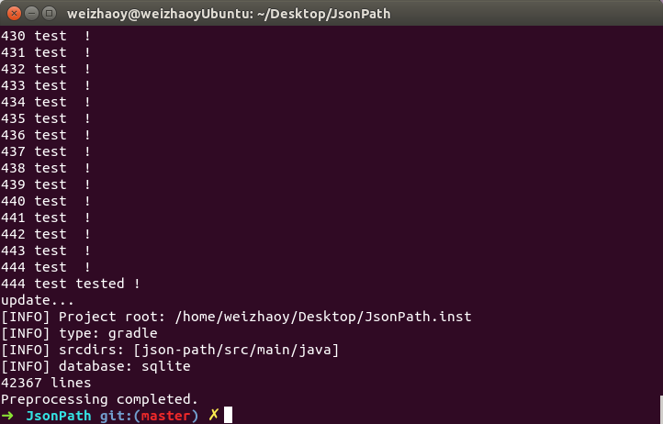

Incremental Testing
When a new version of the project has come, we can do incremental testing, which includes running a diff between the old and the new version to find modified methods, looking up mapping information to find affected test cases and rerunning the affected test cases.
To run the incremental testing, we simply run the “-s” option.
Possible commands:
iutj –s jsonpath {old version path} {new version path}

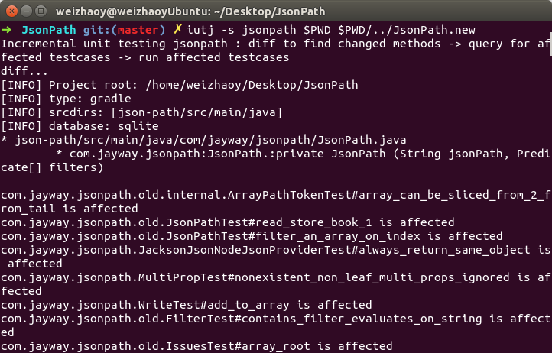

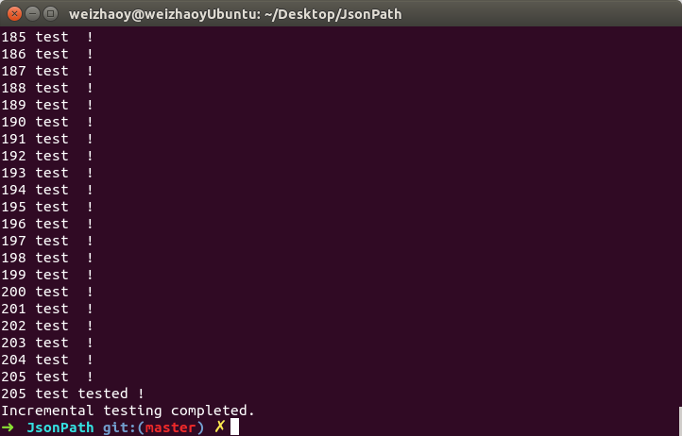

Removing the project
If we are done with the project and no longer want it to have anything to do with incremental testing, we just need to remove the project by simply running the “-r” option.
Possible commands:
iutj –r jsonpath

