Author StuID: 2020215138

Author Name: Huang Kaisheng

# UML Class Relationship Diagram:

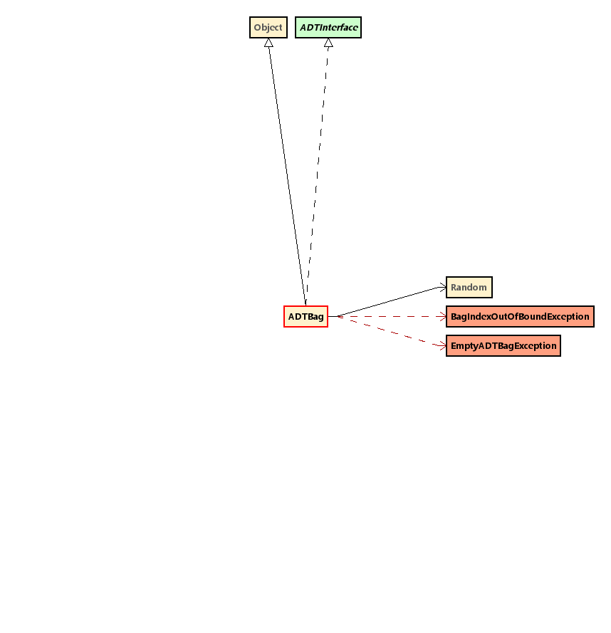

# UML Class Diagram of ADTBag

|  |
| --- |
| **Object**  **ADTBag** |
| Fields  - capacity : int - itemCount : int - randomizer : Random - storage : Object[] |
| Constructors  + ADTBag( int ) : void |
| Methods  + get( Object ) : int + get( int ) : Object + insert( Object ) : void + makeEmpty( ) : void + remove( int ) : Object + removeLast( ) : Object + removeRandom( ) : Object + size( ) : int |

# UML Class Diagram of EmptyADTBagException

|  |
| --- |
| **RuntimeException**  **EmptyADTBagException** |
| Constructors  + EmptyADTBagException( ) : void |

# UML Class Diagram of FullADTBagException

|  |
| --- |
| **RuntimeException**  **FullADTBagException** |
| Constructors  + FullADTBagException( ) : void |

# UML Class Diagram of BagIndexOutOfBoundException

|  |
| --- |
| **IndexOutOfBoundsException**  **BagIndexOutOfBoundException** |
| Constructors  + BagIndexOutOfBoundException( ) : void  + BagIndexOutOfBoundException( int ) : void |