Author StuID: 2020215138

Author Name: Huang Kaisheng

# UML Class Relationship Diagram:

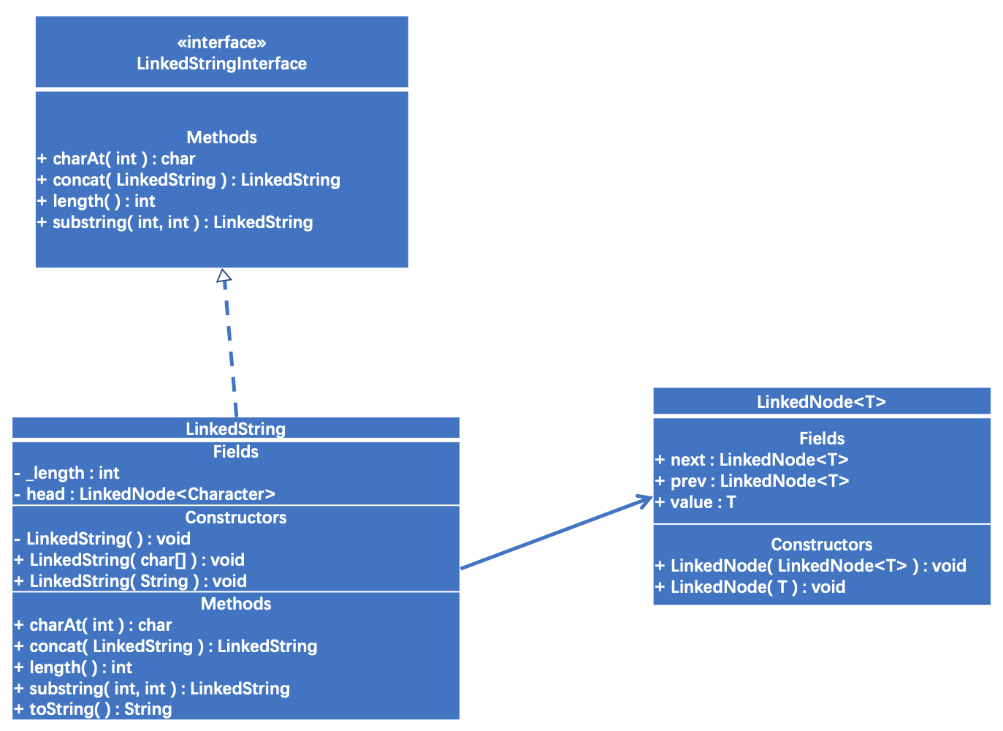

# UML Diagram of LinkedString

|  |
| --- |
| **LinkedString** |
| Fields  - _length : int  - head : LinkedNode<Character> |
| Constructors  - LinkedString( ) : void  + LinkedString( char[] ) : void  + LinkedString( String ) : void |
| Methods  + charAt( int ) : char  + concat( LinkedString ) : LinkedString  + length( ) : int  + substring( int, int ) : LinkedString  + toString( ) : String |

# UML Diagram of LinkedNode

|  |
| --- |
| **LinkedNode<T>** |
| Fields  + next : LinkedNode<T>  + prev : LinkedNode<T>  + value : T |
| Constructors  + LinkedNode( LinkedNode<T> ) : void  + LinkedNode( T ) : void |

# UML Diagram of LinkedStringInterface

|  |
| --- |
| «interface»  ***LinkedStringInterface*** |
| Methods  *+ charAt( int ) : char*  *+ concat( LinkedString ) : LinkedString*  *+ length( ) : int*  *+ substring( int, int ) : LinkedString* |

# UML Diagram of LinkedStringIndexOutOfBoundsException

|  |
| --- |
| **LinkedStringIndexOutOfBoundsException** |
| Constructors  + LinkedStringIndexOutOfBoundsException( ) : void |