Author StuID: 2020215138

Author Name: Huang Kaisheng

# UML Class Relationship Diagram:

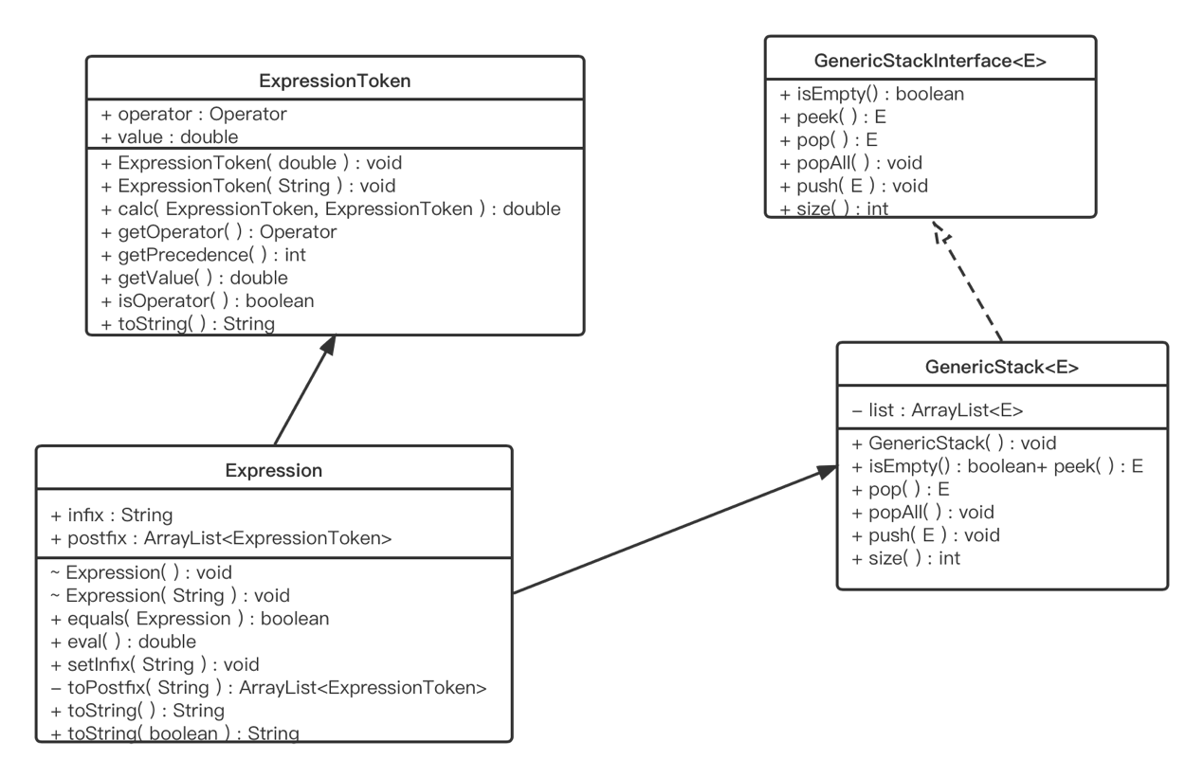

# UML Diagram of GenericStack

|  |
| --- |
| **GenericStack<E>** |
| Fields  - list : ArrayList<E> |
| Constructors  + GenericStack( ) : void |
| Methods  + isEmpty( ) : boolean  + peek( ) : E  + pop( ) : E  + popAll( ) : void  + push( E ) : void  + size( ) : int |

# UML Diagram of Expression

|  |
| --- |
| **Expression** |
| Properties  - cachedValue : double  + infix : String  + postfix : ArrayList<ExpressionToken> |
| Constructors  ~ Expression( ) : void  ~ Expression( String ) : void |
| Methods  + equals( Expression ) : boolean  + eval( ) : double  + setInfix( String ): void  - toPostfix( String ) : ArrayList<ExpressionToken>  + toString( ) : String  + toString( boolean ) : String |

# UML Diagram of ExpressionToken

|  |
| --- |
| **ExpressionToken** |
| Properties  + operator : Operator  + value : double |
| Constructors  + ExpressionToken( double ) : void  + ExpressionToken( String ) : void |
| Methods  + calc( ExpressionToken, ExpressionToken ) : double  + getOperator( ) : Operator  + getPrecedence( ) : int  + getValue( ) : double  + isOperator( ) : boolean  + toString( ) : String |

# UML Diagram of GenericStackInterface

|  |
| --- |
| «interface»  ***GenericStackInterface<E>*** |
| Methods  + isEmpty( ) : boolean  + peek( ) : E  + pop( ) : E  + popAll( ) : void  + push( E ) : void  + size( ) : int |