Author StuID: 2020215138

Author Name: Huang Kaisheng

# UML Class Relationship Diagram:

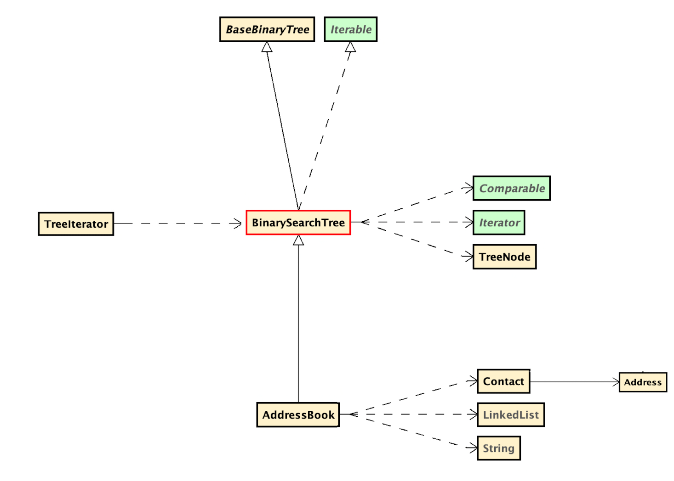

# UML Diagram of BaseBinaryTree

|  |
| --- |
| ***BaseBinaryTree<T>*** |
| Fields  # root : TreeNode<T> |
| Constructors  + BaseBinaryTree( ) : void  + BaseBinaryTree( T ) : void |
| Properties  + isEmpty( ) : boolean  + makeEmpty ( ) : void  + getRoot ( ) : T |

# UML Diagram of BinarySearchTree

|  |
| --- |
| ***BaseBinaryTree***  **BinarySearchTree<T extends Comparable<T>>** |
| Constructors  + BinarySearchTree( ) : void |
| Methods  - get( T, TreeNode<T> ) : T  + get( T ) : T  - insert( T, TreeNode<T> ) : TreeNode<T>  + insert( T ) : void  + iterator( ) : Iterator<T>  - remove( T, TreeNode<T> ) : TreeNode<T>  + remove( T ) : void |

# UML Diagram of TreeNode

|  |
| --- |
| **Object**  **TreeNode<T>** |
| Fields  + left : TreeNode<T>  + right : TreeNode<T> |
| Properties  + value : T |
| Constructors  + TreeNode( ) : void  + TreeNode( T ) : void  + TreeNode( T, TreeNode<T>, TreeNode<T> ) : void |

# UML Diagram of TreeIterator

|  |
| --- |
| **TreeIterator<T>** |
| Fields  ~ stack : Stack<TreeNode<T>>  ~ traversalNode : TreeNode<T> |
| Constructors  + TreeIterator( BaseBinaryTree<T> ) : void |
| Methods  + hasNext( ) : boolean  + next( ) : T |

# UML Diagram of Address

|  |
| --- |
| **Address** |
| Properties  + city : String  + state : String  + street : String  + zipCode : int |
| Constructors  + Address( String, String, String, int ) : void  + Address( String, String, String, String ) : void |
| Methods  + compareTo( Address ) : int     «volatile» «synthetic» «bridge»  + compareTo( Object ) : int  + toString( ) : String |

# UML Diagram of Contact

|  |
| --- |
| **Contact** |
| Fields  ~ firstName : String  ~ lastName : String |
| Properties  + address : Address  + name : String  + phone : long  + phoneAreaCode : long     «readOnly»  + phoneFormatted : String |
| Constructors  + Contact( String, String, Address, String ) : void |

# UML Diagram of AddressBook

|  |
| --- |
| **BinarySearchTree**  **AddressBook** |
| Constructors  + AddressBook( ) : void |
| Methods  + getContactByAreaCode( int ) : LinkedList<Contact>  + getContactByCity( String ) : LinkedList<Contact>  + getContactByZipCode( int ) : LinkedList<Contact> |