Homework 3

(due - 23:59 April 14, 2022)

*Please submit your homework as a PDF file.*

**Questions:**

[1] For each pair of atomic sentences, give the most general unifier if it exists: (20 points)

1. P(A, B, B), P(x, y, z). (5 points)
   1. MGU{x/A, y/B, z/B}
2. Q(y,G(A, B)), Q(G(x, x), y). (5 points)
   1. No unification
      1. After y/G(x,x), x/A, can’t unify A with B.
3. Older(Father (y), y), Older (Father (x), John). (5 points)
   1. MGU{y/John, x/John}
4. Knows(Father (y), y), Knows(x, x). (5 points)
   1. No unification
      1. After x/Father(y), can’t unify y with Father(y)

[2] Suppose you are given the following axioms: (20 points)

1. 0 ≤ 3.

2. 7 ≤ 9.

3. ∀x x ≤ x.

4. ∀x x ≤ x + 0.

5. ∀x x + 0 ≤ x.

6. ∀x,y x + y ≤ y + x.

7. ∀w,x,y,z w ≤ y ∧ x ≤ z ⇒ w + x ≤ y + z.

8. ∀x,y,z x ≤ y ∧ y ≤ z ⇒ x ≤ z

1. Give a backward-chaining proof of the sentence 7 ≤ 3+9. (Be sure, of course, to use only the axioms given here, not anything else you may know about arithmetic.) Show only the steps that leads to success, not the irrelevant steps. (10 points)
   1. 8. 7+ 0 ≤ 7 ∧ 7 ≤ (3 + 9) ⇒ (7+0) ≤ 3 + 9
   2. 6. 3+9 ≤ 9+3
   3. 8. 7+0 ≤ 3+9 ∧ 3+9 ≤ 9+3 => 7+0 ≤9+3
   4. 7. 7 ≤ 9 ∧ 0 ≤ 3 => 7+0 ≤9+3
   5. 1., 2. 7 ≤ 9, 0 ≤ 3
2. Give a forward-chaining proof of the sentence 7 ≤ 3+9. Again, show only the steps that lead to success. (10 points)
   1. 7. 7 < 9 ∧ 0 < 3 => 7+0 ≤ 9+3
   2. 4. 7 ≤ 7+0
   3. 6. 9+3 ≤ 3+9
   4. 8. 7+0 ≤ 9+3 ∧ 9+3 ≤ 3+9 => 7+0 ≤ 3+9
   5. 8. 7 ≤ 7+0 ∧ 7+0 ≤ 3+9 => 7 ≤ 3+9

[3]Consider a vocabulary with the following symbols: (20 points)

*Occupation(p, o)*: Predicate. Person p has occupation o.

*Customer (p1, p2)*: Predicate. Person p1 is a customer of person p2.

*Boss(p1, p2)*: Predicate. Person p1 is a boss of person p2.

*Doctor , Surgeon, Lawyer , Actor*: Constants denoting occupations.

*Emily, Joe*: Constants denoting people.

By using these symbols, write the following assertions in first-order logic:

1. Emily is either a surgeon or a lawyer. (2 points)
   1. Occupation(Emily, Surgeon) V Occupation(Emily, Lawyer)
2. Joe is an actor, but he also holds another job. (3 points)
   1. Occupation(Joe, Actor) ^ ( Occupation(Joe, Doctor) V Occupation(Joe, Surgeon) V Occupation(Joe, Lawyer) )
3. All surgeons are doctors. (3 points)
   1. ∀p Occupation(p, Surgeon) ⇒ Occupation(p, Doctor)
4. Joe does not have a lawyer (i.e., is not a customer of any lawyer). (3 points)
   1. ~Customer(Joe, Lawyer)
5. Emily has a boss who is a lawyer. (3 points)
   1. Boss(Emily, Lawyer)
6. There exists a lawyer all of whose customers are doctors. (3 points)
   1. ∃p1∀p2 Occupation(p1, Lawyer) ⇒ Customer ( p2, p1 ) ^ Occupation (p2, Doctor)
7. Every surgeon has a lawyer. (3 points)
   1. ∀p1∃p2 Occupation(p1, Surgeon) ⇒Customer(p1, p2) ^ Occupation(p2, Lawyer)

[4] Let’s assume that “Person a loves person b” can be expressed as “Love(a,b)”. Give predicate logic expression of the following sentences. (20 points)

1. Sarah loves anyone whom Lia loves. (5 points)
   1. ∀x (Love(Sarah, Love(Lia, x)))
2. If someone loves Sarah, then David loves Sarah. (5 points)
   1. ∀x (Love(x, Sarah) => Love(David, Sarah))
3. Anyone who loves Sarah loves Lia. (5 points)
   1. ∀x(Loves(x, Sarah) ∧ Loves(x, Lia))
4. Everyone loves someone who doesn’t love Sarah. (5 points)
   1. ∀x∃y(Loves(x, y) ∧ ¬Loves(y, Sarah))

[5] From the following sentence in KB, we want to prove W using resolution.

P ∧ ¬Q ∧ (P ⇒ R) ∧ (¬Q ∨ W) ∧ (W ⇒ P) ∧ (¬R ∨ W)

The following table shows the proof process. Write the appropriate sentence for each blank (a), (b), (c), and (d). (20 points)

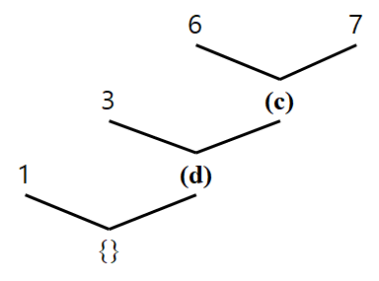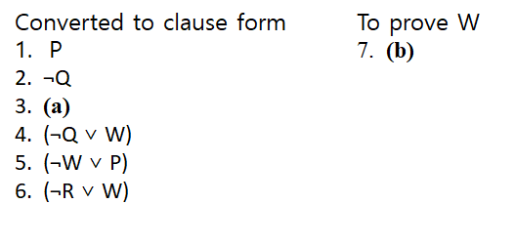

1. ¬P ∨ R
2. ¬W
3. ¬R
4. ¬P

*(Posted on 2022/04/07)*