Homework 1

(due - 23:59 Mar 23, 2022)

*Please submit your homework as a PDF file.*

**Questions:**

[1] Trace the operation of A∗ search applied to the problem of getting to Bucharest from Lugoj using the straight-line distance heuristic. In other words, show the sequence of nodes that the algorithm will consider and the *f*, *g*, and *h* score for each node. (20 points)

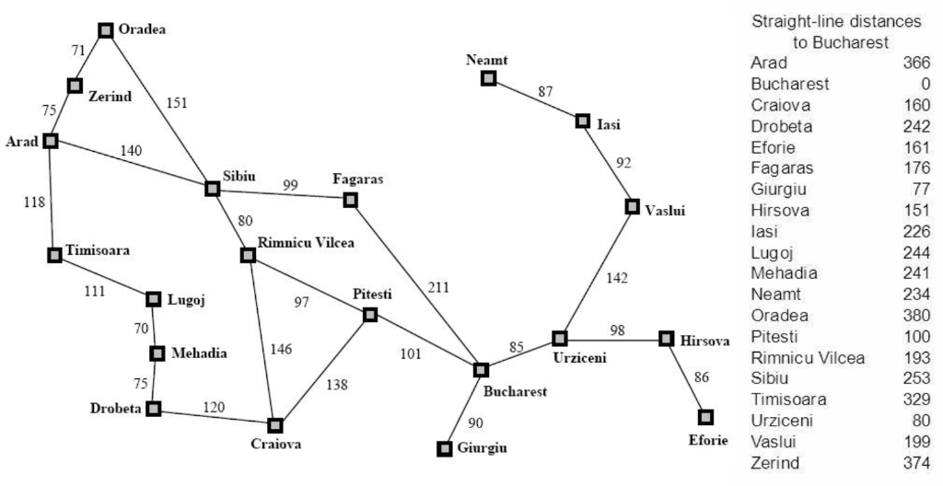

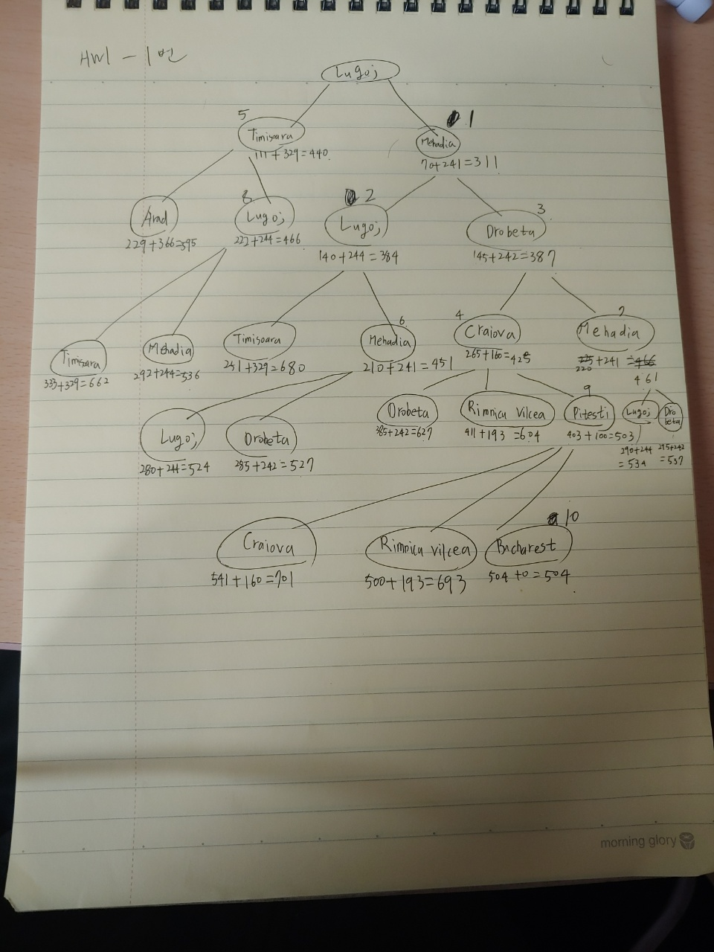

[2] Give a complete problem formulation for each of the following. Choose a formulation that is precise enough to be implemented. (20 points)

1. Using only four colors, you have to color a planar map in such a way that no two adjacent regions have the same color. (6 points)
   1. State –different regions, action – change the color of a particular region
2. A 3-foot-tall monkey is in a room where some bananas are suspended from the 8-foot ceiling. He would like to get the bananas. The room contains two stackable, movable, climbable 3-foot-high crates. (7 points)
   1. State – location of crates, action – change the location of the crates
3. You have three jugs, measuring 12 gallons, 8 gallons, and 3 gallons, and a water faucet. You can fill the jugs up or empty them out from one to another or onto the ground. You need to measure out exactly one gallon. (7 points)
   1. State – water quantity in each jug, action – poor and fill the water into each jugs

I think b and c are precise enough to be implemented. a have no enough numerical data or information to implement it.

[3] Let us deﬁne the relaxation of the 8-puzzle in which a tile can move from square A to square B if B is blank. The exact solution of this problem deﬁnes Gaschnig’s heuristic (Gaschnig, 1979). Explain why Gaschnig’s heuristic is at least as accurate as *h1* (misplaced tiles), and show cases where it is more accurate than both *h1* and *h2* (Manhattan distance). Explain how to calculate Gaschnig’s heuristic efﬁciently. (20 points)

1. Gaschinig’s heuristic can only move the tile to blank space, so Gaschinig’s heuristic needs at least one move to get desired position. Therefore, because h1 only needs one move to get a tile to desired position, Gaschinig dominates h1.

Ex1)

|  |  |  |
| --- | --- | --- |
| 1 | 2 | 3 |
| 4 | 5 | 6 |
| 7 | 8 |  |

|  |  |  |
| --- | --- | --- |
| 5 | 2 | 3 |
| 4 | 6 | 1 |
| 7 | 8 |  |

<goal> <state>

To make state to goal, h1 is 3 (1,5,6) and Gaschinig is 4(5, 1, 6, 5)

Ex2)

|  |  |  |
| --- | --- | --- |
| 1 | 2 | 3 |
| 8 |  | 4 |
| 7 | 6 | 5 |

|  |  |  |
| --- | --- | --- |
| 1 | 2 | 3 |
| 7 |  | 4 |
| 8 | 6 | 5 |

<goal> <state>

To make state to goal, h2 needs 2(7 ->1, 8->1) and Gaschinig is 3(8, 7, 8)

Pseudocode:

Number =0

While not in goal:

If blank is in the right position:

Change blank and any wrong position number

Else

Change blank and the tile whose right position is current blank position

Number++

[4] Consider a state space where the start state is number 1 and each state k has two successors: numbers 2k and 2k + 1. (20 points)

1. Draw the portion of the state space for states 1 to 15. (5 points)
2. Suppose the goal state is 11. List the order in which nodes will be visited for breadth first search, depth-limited search with limit 3, and iterative deepening search. (5 points)
   * 1. BFS – (1,2,3,4,5,6,7,8,9,10,11)
     2. Depth limited search with limit 3 – (1,2,4,8,9,5,10,11)
     3. Iterative deepening search – (1, 1,2,3, 1,2,4,5,3,6,7, 1,2,4,8,9,5,10,11)
3. How well would bidirectional search work on this problem? What is the branching factor in each direction of the bidirectional search? (5 points)
   1. S
      1. This problem can implement bidirectional search because the upper node’s state is n/2(round off) and easy to compute.
      2. From 1 to down: 2, from 11 to up: 1
4. Does the answer to (c) suggest a reformulation of the problem that would allow you to solve the problem of getting from state 1 to a given goal state with almost no search? (5 points)
   1. Maybe yes. We could start from the 11. When we go up from the 11, there is 1 branching factor and it is easy to compute, we don’t have to do search.

[5] Suppose that two friends live in different cities on a map, such as the Romania map. Each turn, we must move two friends simultaneously and we can only move a friend to a neighboring city (e.g. we can move friend in city *x* to city *y* if *adjacent(x,y)* holds). The amount of time needed to move from city *i* to neighboring city *j* is equal to the distance *d(i,j)* between two cities *i* and *j*. But the friend who arrives first to his destination must wait until the other one arrives to his destination before the next turn can begin. We want the two friends to meet as quickly as possible. Solve the following problems. (20 points)

1. Write the states, actions, goal test and path cost for this search problem. (5 points)
   * 1. States – pair of cities
     2. actions – move friend from city a to b
     3. goal test – two friends are in same city when the turn ends.
     4. Path cost – sum of the distances.
2. Suppose that two friends are in city *i* and city *j* respectively. Let *D(i,j)* be the straight-line distance between cities *i* and *j*. Which of the following heuristic functions are admissible? Explain your answers. (5 points)

(i) *D(i,j)* (ii) *2⋅D(i,j)* (iii) *D(i,j)/2*

* 1. I think (iii) *D(i,j)/2* is more admissible because two people are both moving. If one stops and one go, then ii) would be better. but in this case both people are moving, iii) is better.

1. Is there a connected map that no solution exists? If yes, draw such map and describe the situation of the two friends. If no, explain the reason. (5 points)
   1. Yes. In the map of two nodes.

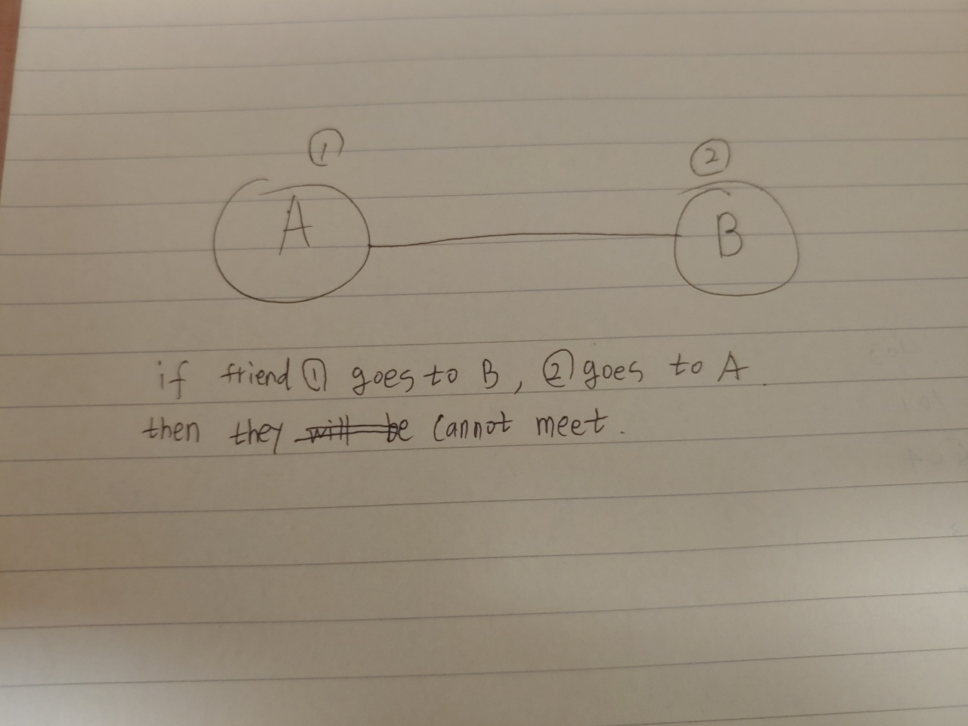

1. Is there a connected map in which all solutions require one friend to visit the same city twice? If yes, draw such map and describe the situation of the two friends. If no, explain the reason. (hint: you can consider the self-loop.) (5 points)
   1. Yes.

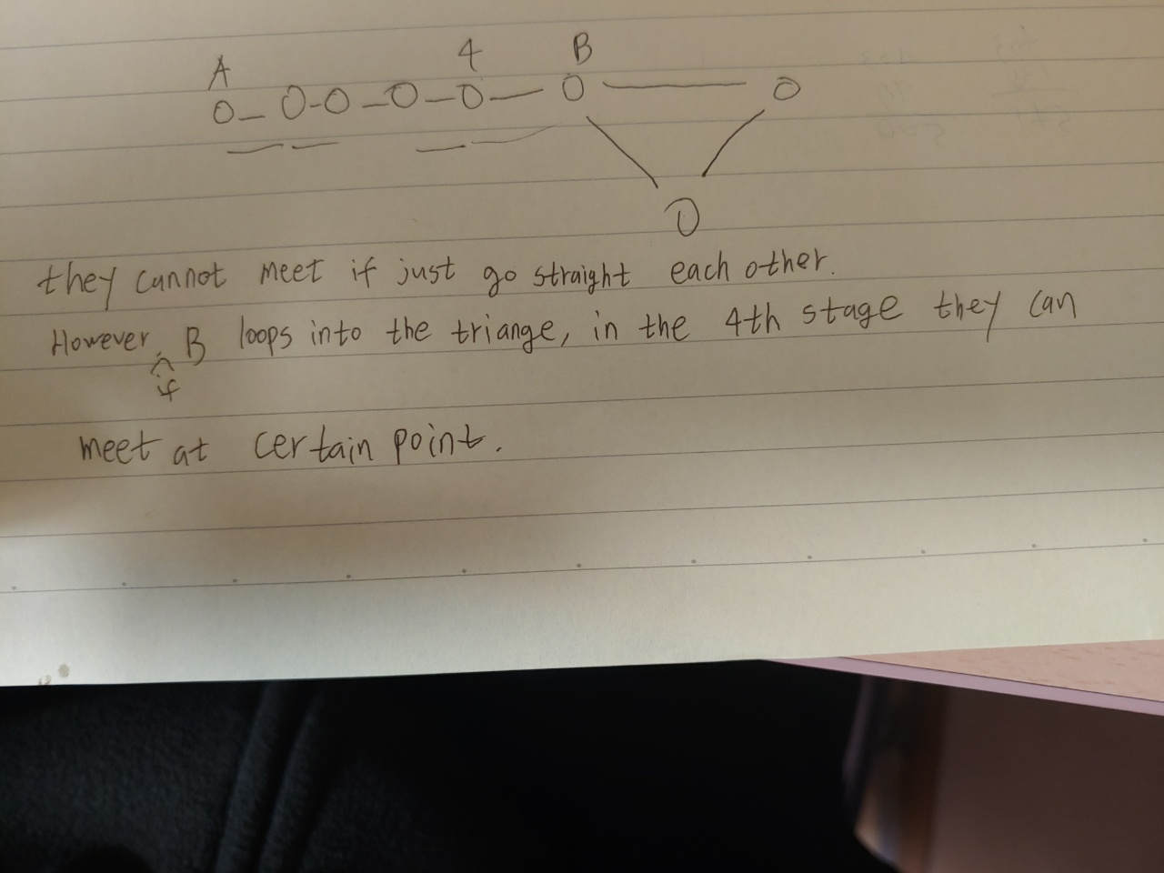

*(Posted on 2022/3/17)*