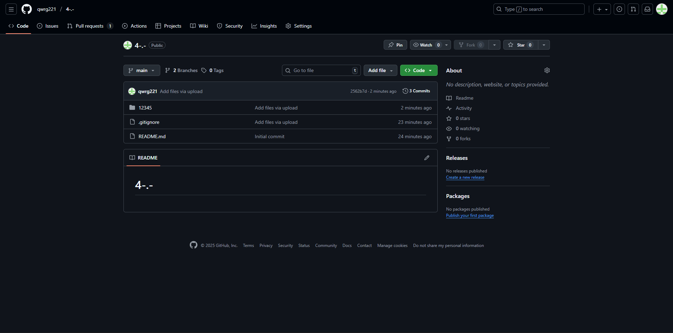
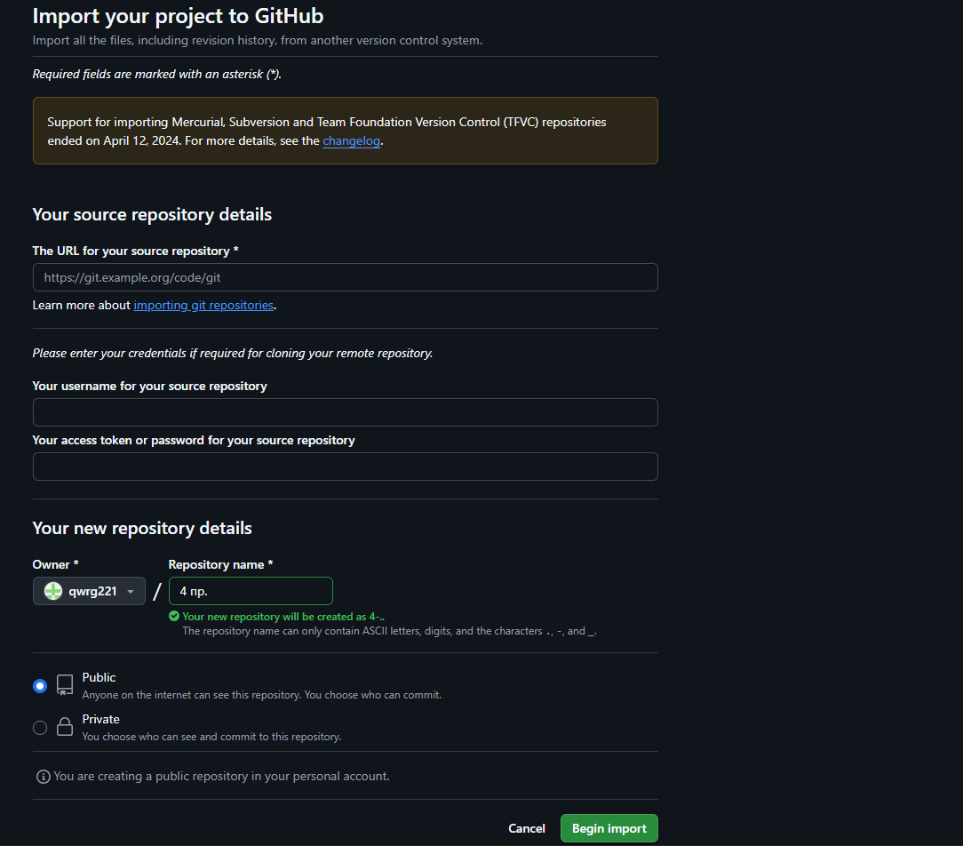
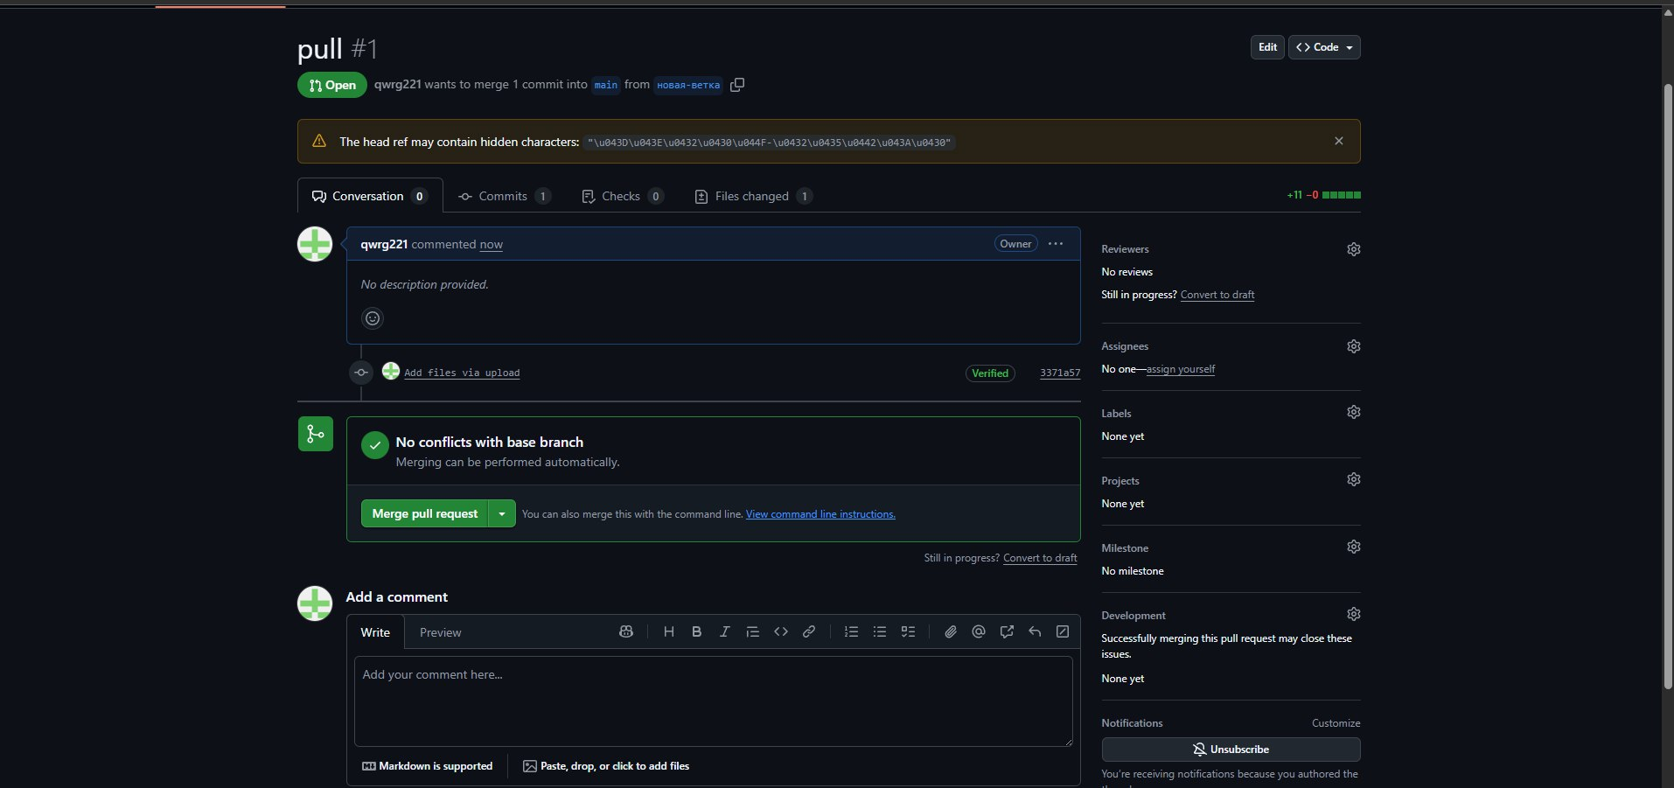
https://github.com/BeCCo2/4-.-2 fork репозеторий https://github.com/qwrg221/4-.- основной

