## Predicting the food/liquid preference

## for running small restaurant in either New York or Toronto

1. Introduction
   1. Background:

If I want to run a restaurant in either Toronto or New York area, I have to answer the two basic questions:

What type of foods people like in either New York or Toronto ?

What type of Liquid people to enjoy ?

The correct answering of above question can help small restaurant owner to gain insight about strategy for running small restaurant. Some people might argue that I can run a restaurant that all people love, like Pizza Hot or McDonalds. However, these need franchise and often costly to obtain. For small budget, it is believed that small restaurant offering unique dinning experience will be profitable. There are many success case across different country. In order to implement such strategy, the first step is to investigate the food preference and comparing people from two cities.

1. Data Acquisition and Feature Selection
   1. Data Acquisition:

Data is originally obtained from foursquare API Call. The data regarding geocoordinates in Both new York and Toronto are obtained from week 3 assignment and saved to csv file.

Due to limitation of free account in Foursquare API call, I only analyzed the limited

Number of Data.

* 1. Feature Selection:

I first extract a list of columns, keep the columns whose name contains ‘Restaurant’, and key words like ‘bar’, ‘wine’, or ‘beer’.

Since I only have Data in Manhattan, in seek of equivalence, I limited the search location exclusively in downtown Toronto only. I assume that Downtown Toronto is equivalent to Manhattan area (I believe it is reasonable assumption since both area has a lot of financial institute).

* 1. Data Transformation

Using group-by through all data, and normalized into frequency as I did in week 3 assignment.

1. Data Analysis
   1. Calculation of Target variable:

First: calculate the correlation between each restaurant variables against ‘city’ attributes. The result is below:

Top 4 correlated Restaurant

French Restaurant 0.507793

Italian Restaurant 0.396527

New American Restaurant 0.359222

Seafood Restaurant 0.348428

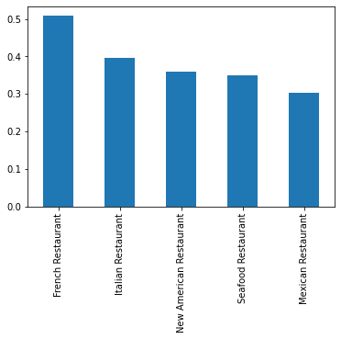

From the graph above: French Restaurant are most correlated to ‘city’ either New York or Toronto. Further analysis, after compute the average frequency occurrence of each borough in Toronto and New York:

The mean value of French Restaurant across different Neighborhoods in Toronto: 0.0018879205707065124

The mean value of French Restaurant across different Neighborhoods in Manhattan: 0.013599374245465576

The above Data show that people in Manhattan is 9 times more like French Restaurant than Toronto.

Similar is true for Italian Restaurant, Seafood Restaurant and New American Restaurant.

What type of food people in Toronto like ?

After calculating the smallest negative correlation, I find that :

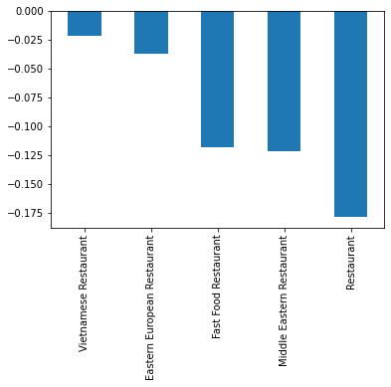

The occurrence of Vietnamese Restaurant, Eastern European Restaurant, Fast food Restaurant, Middle Eastern Restaurant and finally other Restaurant can best explain city is Toronto.

One last question is, What type of Restaurant people in both New York and Toronto like? After I take absolute value of correlation and find a lowest 5, I find that:

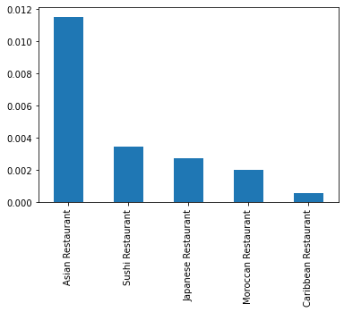

The Restaurant that people all like are: Asian Restaurant, Sushi or Japanese Restaurant, Moroccan Restaurant and Caribbean Restaurant.

* 1. Liquid Data Analysis:

I extract the following Liquid Related venues:

['Beer Store','Cocktail Bar','Sports Bar','Beer Bar', 'Pub', 'Bar','Irish Pub', 'Gay Bar','Sake Bar', 'Gastropub', 'Nightclub', 'Liquor Store']

The absolute correlation against city is below:

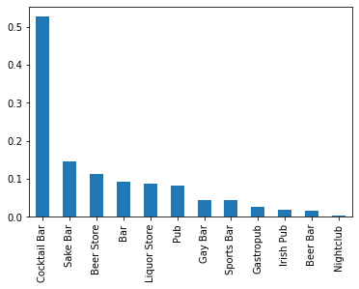

From the graph above, I conclude that Nightclub, beer bar and Irish Pub are widely acceptable in both New York and Toronto.

Cocktail Bar, Sake Bar and Beer Store explains the city attribute.

Further plot the correlation show below:

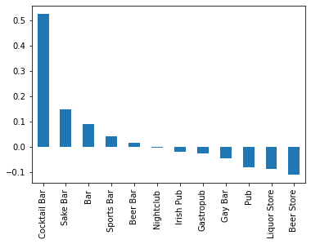

From The Above show that people in New York like Cocktail Bar and Sake Bar.

People in Toronto like Liquid Store and Beer Store.

1. Conclusions:

Here is my conclusion:

1. New York has more French food, Italian food and New American food than Toronto.

Maybe this is because people from west European are more likely to go to New York. Also, these Restaurant are relative expensive, I conclude that people in New York are willing to pay more on Fine Dinner Experience.

1. Toronto has more East European food, Middle-East Food and Fast Food than New York. Maybe it is because people from East Europa, Middle-East are more likely to go Toronto rather than New York. Also, Toronto has more Fast-Food than New York. This imply that people in Toronto are less desired to pay more on Fine-Dinner Experience.
2. Liquid Data show that: in New York, there are more Cocktail and Sake bar. In Toronto, there are more Liquid store and beer store. People in Toronto are more likely to enjoy liquid at home rather than spending money at bar, which it support my conclusion that people in New York are more willing to pay Fine Dinner Experience.
3. Both City are equally like to find a Japanese/ Asian Restaurant which imply that people from Asian are equally like to immigrant to both city.

Based on Observation above, if you find a good location in New York, you shall consider Fine-Dinner Experience, Food style: Italian food, French Food, Asian Shall be considered. However, Fast-food, cost effective style shall be avoided.

If you find a location in Toronto, you shall consider cost-effective food style.